Table.1 E-O link signal Integrity at 100 Gb/s
MUX  output | Bias Tee  output | RF Probe  output | Received Optical  Vg=1V | Received Optical  3 Taps FEE
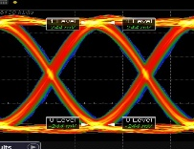 | 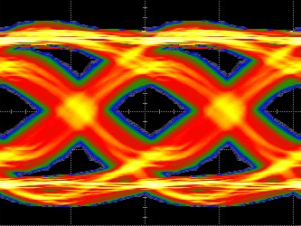 | 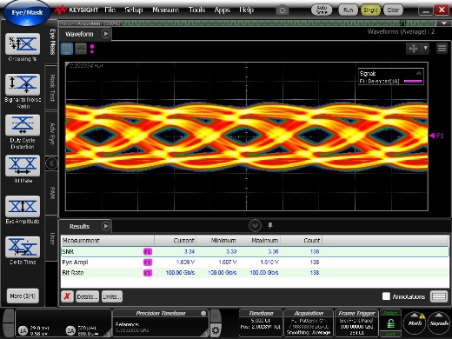 | 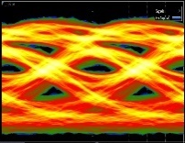 | 