Supplementary results:

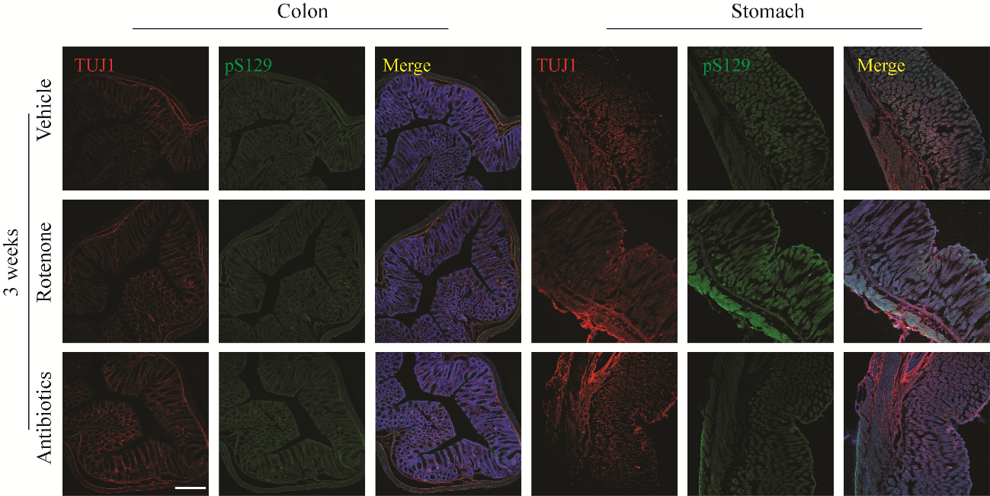
Figure SI1: Three weeks of constant administration of ROT did not induce the pS129-α-syn aggregation in the colon and stomach in wild type (WT). The results were a lack of pS129-α-syn accumulation.

