The procedure for the synthesis of 9-PAHSA and chiral resolution of 9-PAHSA were as follows:
1.1 Synthesis of nonadec-1-en-10-ol:
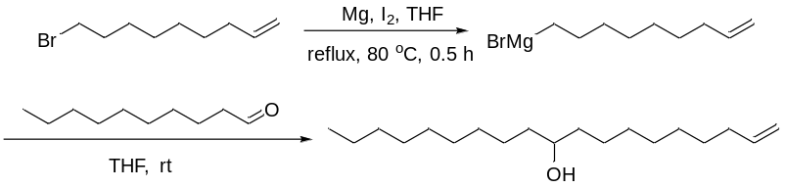
Under an N2 atmosphere, we added 9-bromonon-1-ene (1.09 g, 5 mmol) to a mixture of magnesium turnings (1.3 g, 52 mmol), elemental iodine (20 mg, 0.08 mmol), and THF (100 mL). The mixture was stirred at 50°C until the solution turned colorless. The mixture was refluxed and more 9-bromonon-1-ene (9.8 g, 45 mmol) was slowly added. After refluxing for 0.5 h, the mixture was cooled to room temperature and then was added drop-wise, using a syringe, to a solution of decanal (5.1 g, 33 mmol) in THF (10 mL) at 0°C. The resulting mixture was warmed to room temperature slowly and stirred overnight. The reaction was quenched by the addition of a saturated solution of ammonium chloride (1 mL). The mixture was concentrated and the pure product was isolated by flash-column chromatography (5.58 g, 60% yield).
1H NMR (400 MHz, CDCl3) δ 5.79 (ddt, J = 17.0, 10.3, 6.7 Hz, 1H), 5.01–4.89 (m, 2H), 3.60–3.52 (m, 1H), 2.06–1.98 (m, 2H), 1.45–1.23 (m, 29H), 0.86 (t, J = 6.8 Hz, 3H).

1.2 Synthesis of nonadec-1-en-10-yl palmitate:
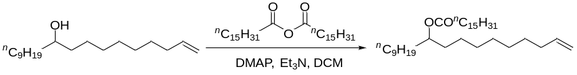
Palmitic anhydride (12 g, 24 mmol), 4-(dimethylamino) pyridine (1.22 g, 10 mmol), and triethylamine (11 mL, 80 mmol) were added to a stirred solution of nonadec-1-en-10-ol (5.7 g, 20 mmol) in CH2Cl2 (100 mL). The solution was stirred for 16 h at room temperature. The reaction was concentrated and the pure product was isolated by flash-column chromatography (7.0 g, 67% yield).
1H NMR (400 MHz, CDCl3) δ 5.84–5.72 (m, 1H), 5.00–4.87 (m, 2H), 4.86–4.80 (m, 1H), 2.25 (t, J = 7.5 Hz, 2H), 2.05–1397 (m, 2H), 1.63–1.56 (m, 2H), 1.52–1.43 (m, 4H), 1.38–1.18 (m, 48H), 0.85 (t, J = 6.7 Hz, 6H).

1.3 Synthesis of 1-oxooctadecan-9-yl palmitate:
Ozone was bubbled into a stirred solution of nonadec-1-en-10-ol palmitate (2.1 g, 4 mmol) in CH2Cl2 (100 mL) at –78°C until the solution turned blue. Then nitrogen was bubbled into the reaction until it became colorless, and triphenyl phosphine (2.1 g, 8 mmol) was added and the reaction was warmed to room temperature. After 2 h, the mixture was concentrated and the pure product was isolated by flash-column chromatography (1.6 g, 80% yield).
1H NMR (400 MHz, CDCl3) δ 9.74 (t, J = 1.6 Hz, 1H), 4.87–4.80 (m, 1H), 2.39 (t, J = 7.0 Hz, 2H), 2.25 (t, J = 7.8 Hz, 2H), 1.64–1.53 (m, 4H), 1.53–1.40 (m, 4H), 1.38–1.04 (m, 46H), 0.85 (t, J = 6.3 Hz, 6H).

1.4 Synthesis of 9-PAHSA:
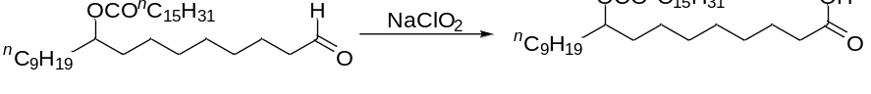
A solution of NaH2PO4 (1.5 g, 12.5 mmol) in water (20 mL) was added to a solution of 1-oxooctadecan-9-yl palmitate (1.5 g, 2.9 mmol) in THF (5 mL). The mixture was cooled to 0°C, and NaClO2 (3 g, 33.2 mmol) was added. The resulting mixture was warmed to room temperature and stirred at this temperature for 4 h. After the starting material was completely consumed, as monitored by TLC, the solvent was removed by concentration. The remaining viscous aqueous solution was diluted with ethyl acetate (20 mL). Then aqueous HCl (1 M) was added to the mixture until the pH of the aqueous phase was adjusted to 3–5. The product was extracted with ethyl acetate (20 mL × 3). The combined organic phase was sequentially washed with water, saturated NaCl aqueous solution, and dried with Na2SO4. After filtration, the solvent was removed by concentration to give the final product (1.38 g, 89% yield).
1H NMR (400 MHz, CDCl3) δ 4.88–4.79 (m, 1H), 2.31 (t, J = 7.5 Hz, 2H), 2.25 (t, J = 7.5 Hz, 2H), 1.64–1.54 (m, 4H), 1.52–1.43 (m, 4H), 1.33–1.19 (m, 46H), 0.85 (t, J = 6.7 Hz, 6H).

1.5 Synthesis process of chiral 9-PAHSA
The auxiliary group is connected to the hydroxyl group of the compound, and the column is analyzed for 10-30 minutes. The different structures of the S- and R-9-PAHSA are distinguished by the color rendering function of the auxiliary group. Then, deprotect and remove the prosthetic group. Finally, pure S-9-PAHSA and R-9-PAHSA yield.
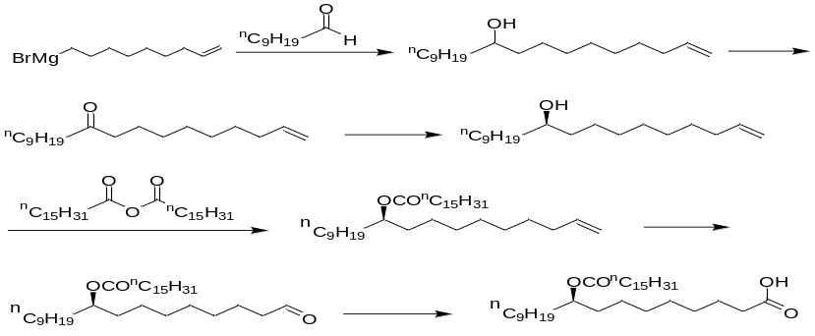
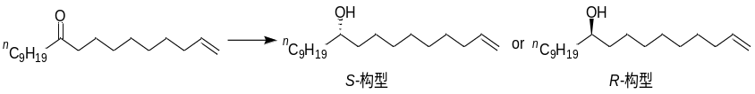

Western blot
Proteins were extracted from cells and experimental mice with radioimmunoprecipitation assay (RIPA) lysis buffer (Epizyme Biotech, Shanghai, China) containing PMSF. This was followed by centrifugation at 13,523 × g at 4°C for 30 min, and the supernatant was then collected for protein quantification using the BCA method. Samples were mixed with 5× loading buffer (Epizyme Biotech) and heated in boiling water for 10 min to denature the proteins. These treated samples were separated on a 12% SDS-PAGE gel (60 V, 30 min, and then 120 V, 90 min), the proteins were transferred to PVDF membranes (Millipore, Darmstadt, Germany) following a wet transfer protocol (270 mA, 90 min). The membranes were then blocked in 5% non-fat milk solution for 2 h at room temperature, and then incubated with primary antibodies against P62 (1:1000, Cell-Signal Technology), LC3(1:1000,Cell-Signal Technology), Beclin1 (1:1000, Cell-Signal Technology), Bcl-2(1:500,Cell-Signal Technology), p-Akt(1:1000,Cell-Signal Technology), Akt(1:1000,Cell-Signal Technology), PI3K(1:1000,Cell-Signal Technology)and β-actin (1:2000, Cell-Signal Technology) overnight at 4°C. The membranes were then washed by TBST buffer for 10 min 3 times and then incubated with specific secondary antibodies (1:2000, Cell-Signal Technology) for 1 h at room temperature. After washing 10 min 3 times, the membranes were incubated with a 1:1 mixture of solution BeyoECL Plus A and BeyoECL Plus B according to the manual of the ECL kit (Epizyme Biotech). The PVDF membranes were then visualized using an Invitrogen iBright Imaging System (FL1000, Thermo Fisher Scientific). The integrated absorbance (IA = mean grey value × area) of the protein bands was measured using Image Lab software. The target protein expression level was presented as the ratio of the IA of the target protein to the IA of β-actin.

