Testing effects of partner support and use of oral contraception during relationship formation on severity of nausea and vomiting in pregnancy
SUPPLEMENTARY MATERIAL
Table S1
Mediation Estimates
Effect |  | Label |  |  |  | Estimate |  |  |  | SE |  |  |  | Z |  |  |  | p |  | % Mediation
Indirect |  | a × b |  |  |  | -0.0111 |  |  |  | 0.00351 |  |  |  | -3.15 |  |  |  | 0.002 |  | 19.7
Direct |  | c |  |  |  | -0.0451 |  |  |  | 0.00910 |  |  |  | -4.96 |  |  |  | < .001 |  | 80.3
Total |  | c + a × b |  |  |  | -0.0562 |  |  |  | 0.00843 |  |  |  | -6.66 |  |  |  | < .001 |  | 100.0
Path Estimates |  |  |  |  |  |  |  |  |  |  |  | Label |  |  |  | Estimate |  |  |  | SE | Z |  |  |  |  |  |  | p
age in pregnancy |  |  |  | → |  |  | Age_oldest_child |  |  |  |  | a |  |  |  | -7.82 |  |  |  | 0.40 |  |  |  | -  19.80 |  |  |  |  | < .001
Time since pregnancy |  |  |  | → |  |  | NVP_score |  |  |  |  | b |  |  |  | 0.001 |  |  |  | 0.000 |  |  |  | 3.19 |  |  |  |  | 0.001
age in pregnancy |  |  |  | → |  |  | NVP_score |  |  |  |  | c |  |  |  | -0.05 |  |  |  | 0.009 |  |  |  | -4.96 |  |  |  |  | < .001

Figure S2
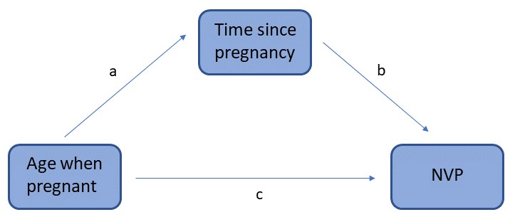
The scheme of mediation model
Note. Age when pregnant is predictor variable, time since pregnancy is mediator variable and NVP is dependent variable.

Table S2
Descriptives of two sub-samples of women according to country
 |  | Czech/Slovakia | UK/US/Canada | t | p
OC use when met | Yes  No | 486 (49.8 %)  489 (50.2 %) | 930 (66.1 %)  463 (33.9 %) | - | <.001
Sex of child | Boy  Girl | 502 (52.9 %)  447 (47.1 %) | 696 (51 %)  668 (49 %) | - | 0.376
Age when pregnant (yrs) | Mean (SD) | 27.8 (4.18) | 26.1 (5.67) | 7.72 | <.001
Time since pregnant (yrs) | Mean (SD) | 7.6 (8.5) | 13.5 (8.3) | -16.6 | <.001
Relationship with father | Still together  Separated | 807 (83 %)  165 (17 %) | 845 (61.8 %)  522 (38.2 %) | - | <.001

Table S3
Descriptives of two sub-samples of women according to their relationship with the father of their child
 |  | Still together | Apart | t | p
OC use when met | Yes  No | 715 (56 %)  909 (44 %) | 220 (32.7 %)  453 (67.3 %) | - | <.001
Sex of child | Boy  Girl | 845 (52.8 %)  756 (47.2 %) | 339 (50.7 %)  330 (49.3 %) | - | 0.178
Age when pregnant (yrs) | Mean (SD) | 27.9 (4.85) | 24.1 (5.07) | 16.8 | <.001
Time since pregnant (yrs) | Mean (SD) | 8.75 (7.7) | 16.6 (9.08) | -21.1 | <.001

