Contents
- Table S1 Changes in DAPP in China from 2017 to 2035
- Table S2 The results of KAYA model
- Table S3 The comparison of predicted DAPP with the GBDMAPS China study
- Figure S1 Changes in DAPP in China from 2017 to 2035
- Figure S2 Study area showing the 31 provinces aggregated into North, Northeast, East, Central, South, Southwest, and Northwest regions.
- Figure S3 Comparison of DAPP estimates between our results with previous studies
- Figure S4 Deconstruction Analysis Diagram
- Texts 1 Constructing the KAYA model

Table S1 Changes in DAPP in China from 2017 to 2035
Province | Change of DAPP(10 thousand) |  |  |  | Change of DAPP(per 100km²)
Province | SSP1 | SSP2 | SSP3 | SSP5 | SSP1 | SSP2 | SSP3 | SSP5
Anhui | -1.27 | -0.67 | 0.31 | -0.58 | -9.06 | -4.8 | 2.21 | -4.11
Beijing | 0.23 | 0.47 | 0.47 | 0.38 | 14.01 | 28.78 | 28.62 | 23.12
Chongqing | -0.62 | -0.41 | -0.19 | -0.54 | -7.46 | -4.92 | -2.33 | -6.6
Fujian | -0.24 | 0.02 | 0.14 | -0.1 | -1.96 | 0.15 | 1.15 | -0.84
Gansu | -0.49 | -0.28 | -0.25 | -0.42 | -1.21 | -0.69 | -0.63 | -1.04
Guangdong | -0.65 | 0.28 | 0.52 | -0.08 | -3.71 | 1.57 | 2.95 | -0.46
Guangxi | -0.87 | -0.43 | -0.14 | -0.74 | -3.67 | -1.8 | -0.6 | -3.11
Guizhou | -0.8 | -0.45 | -0.17 | -0.71 | -4.56 | -2.57 | -0.99 | -4.01
Hainan | 0.05 | 0.1 | 0.13 | 0.07 | 1.58 | 2.86 | 3.71 | 2.22
Hebei | -2.56 | -1.73 | -1.43 | -2.31 | -13.64 | -9.23 | -7.61 | -12.32
Heilongjiang | 0.1 | 0.57 | 0.96 | 0.31 | 0.22 | 1.27 | 2.11 | 0.69
Henan | -3.23 | -2.08 | -1.55 | -2.99 | -19.52 | -12.6 | -9.38 | -18.04
Hubei | -1 | -0.29 | 0.19 | -0.8 | -5.38 | -1.56 | 1 | -4.32
Hunan | -1.82 | -1.03 | -0.41 | -1.62 | -8.6 | -4.84 | -1.94 | -7.65
Inner Mongolia | 0.03 | 0.29 | 0.31 | 0.14 | 0.02 | 0.25 | 0.27 | 0.12
Jiangsu | 0.46 | 1.49 | 1.83 | 0.95 | 4.53 | 14.79 | 18.16 | 9.38
Jiangxi | -0.91 | -0.46 | -0.19 | -0.79 | -5.45 | -2.73 | -1.11 | -4.75
Jilin | 0.17 | 0.59 | 0.84 | 0.3 | 0.86 | 3.1 | 4.38 | 1.57
Liaoning | -0.26 | 0.36 | 0.66 | 0 | -1.76 | 2.47 | 4.54 | 0
Ningxia | -0.15 | -0.1 | -0.1 | -0.13 | -2.81 | -1.98 | -1.9 | -2.49
Qinghai | -0.13 | -0.09 | -0.09 | -0.1 | -0.18 | -0.12 | -0.12 | -0.14
Shaanxi | -0.6 | -0.33 | -0.19 | -0.49 | -2.91 | -1.6 | -0.94 | -2.37
Shandong | -1.63 | -0.28 | 0.39 | -1.2 | -10.65 | -1.8 | 2.56 | -7.82
Shanghai | 0.44 | 0.68 | 0.64 | 0.62 | 72.58 | 112.24 | 105.27 | 102.03
Shanxi | -0.62 | -0.31 | -0.19 | -0.51 | -3.99 | -2 | -1.22 | -3.25
Sichuan | -0.53 | 0.36 | 1.06 | -0.11 | -1.1 | 0.75 | 2.19 | -0.22
Tianjin | -0.23 | -0.02 | 0.09 | -0.22 | -19.65 | -2.14 | 7.63 | -19.04
Tibet | -0.09 | -0.06 | -0.06 | -0.07 | -0.07 | -0.05 | -0.05 | -0.06
Xinjiang | -0.63 | -0.44 | -0.46 | -0.53 | -0.39 | -0.27 | -0.28 | -0.33
Yunnan | -1.02 | -0.63 | -0.58 | -0.88 | -2.67 | -1.64 | -1.52 | -2.31
Zhejiang | 1 | 1.68 | 1.77 | 1.45 | 9.95 | 16.7 | 17.63 | 14.4
Average | -0.58 | -0.1 | 0.14 | -0.38 | -0.86 | 4.12 | 5.61 | 1.56

Table S2 The results of KAYA model
dependent  variable  independent  variable | DAPP  （Model I） | Fossil energy consumption（Model II） | DAPP  （Model III） | Health care spending（Model IV） | DAPP  （Model V）
The proportion of the elderly population | 0.54*** | 0.11* | \ | 0.78*** | \
Population size | 0.21*** | 0.32*** | \ | 0.35*** | \
Mortality | 0.06 | 0.10*** | \ | -0.02 | \
PAF | 0.23 | 0.28*** | \ | -1.06*** | \
Fossil energy consumption | \ | \ | 0.99*** | \ | \
Health care spending | \ | \ | \ | \ | 2.74*
* represents the significance at the 10% level, ** represents the significance at the 5% level, *** represents the significance at the 1% level

Table S3 The comparison of predicted DAPP with the GBDMAPS China study (Group GMW, 2016)
Year | Data resource | Scenarios | DAPP  (10 thousand)
2030 | GBDMAPS  China | BAU1 | 126.74
2030 | GBDMAPS  China | BAU2 | 114.48
2030 | GBDMAPS  China | PC1 | 113.92
2030 | GBDMAPS  China | PC2 | 99.01
2030 | This study | SSP1-2.5 | 77.10
2030 | This study | SSP2-4.5 | 88.18
2030 | This study | SSP3-7.0 | 94.48
2030 | This study | SSP5-8.5 | 80.79
BAU1: Business as usual- Twelfth Five-Year Plan for Environmental Protection
BAU2: Business as usual- Maximum Feasible Emission Controls Regardless of Cost
PC1: Air pollution control-Twelfth Five-Year Plan for Environmental Protection
PC2: Air pollution control- Maximum Feasible Emission Controls Regardless of Cost

Figure S1 Changes in DAPP in China from 2017 to 2035

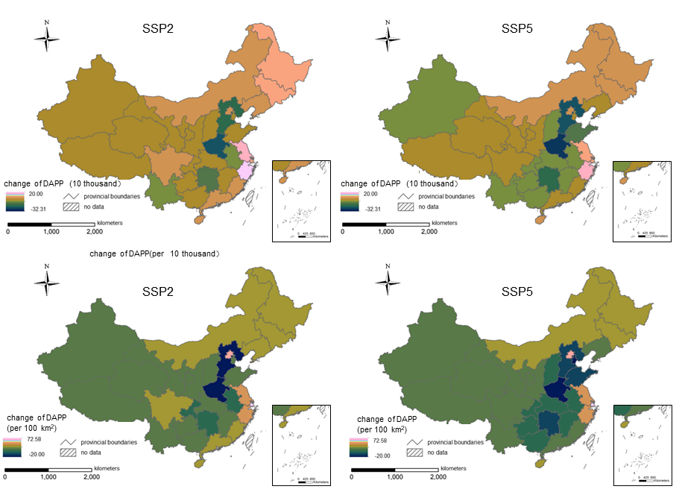
(a. Change in total DAPP in the SSP2 scenario; b. Change in total DAPP in the SSP5 scenario; c. Change in DAPP per unit area in the SSP2 scenario; d. Change in DAPP per unit area in the SSP5 scenario)

Figure S2 Study area showing the 31 provinces aggregated into North, Northeast, East, Central, South, Southwest, and Northwest regions.
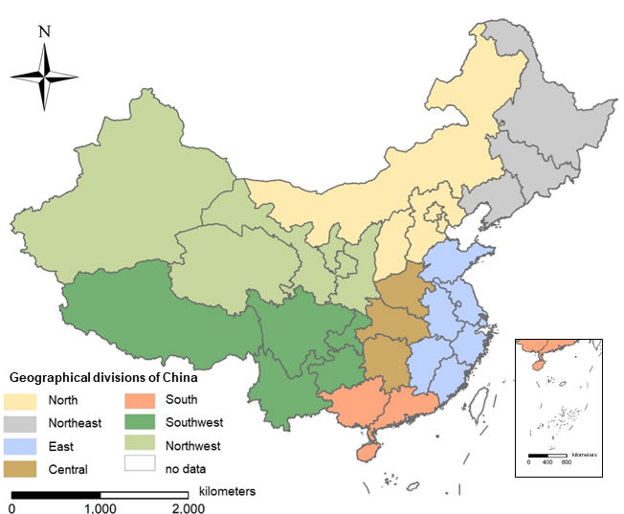

Figure S3 Comparison of DAPP estimates between our results with previous studies
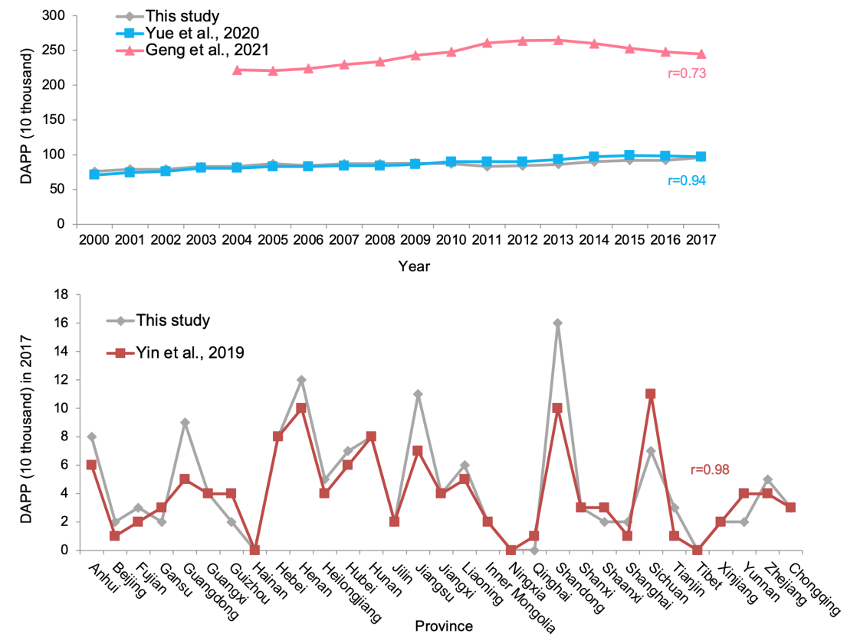
The comparison of historical DAPP with the previous studies

Figure S4 Decomposition Analysis Diagram
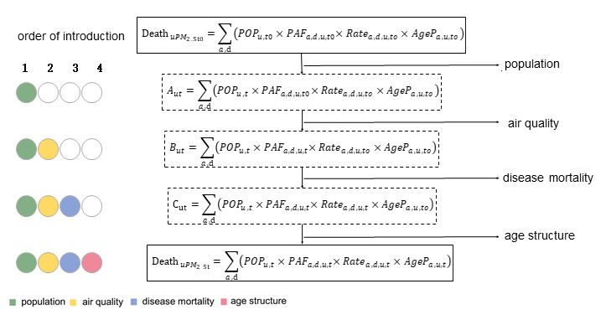
Note: Redrawn from Cohen et al., and 2017 Yue et al., 2020; Note: There are a total of 24 introduction sequences, one of which is in this figure.

Texts 1 Construct the KAYA model
In order to further verify the impact of population aging on DAPP and explore the possible paths in witch population aging affect DAPP, referring to the studies of Zha et al. (2022) and Feng et al. (2019), we constructed a Kaya model and introduced a mediating effect, to analyze the contribution of population aging to DAPP and the affect path. The Kaya model decomposes carbon dioxide emissions into four elements related to human production activities (Kaya, 1989):
$C=P×\frac{GDP}{P}×\frac{E}{GGDPD}×\frac{C}{GED}$ （1）
where C is carbon dioxide emissions; P is population size; GDP is gross domestic product; and E is total energy consumption. In order to explore the impact of population aging on DAPP, we extend Equation (1) based on the KAYA model (Feng et al., 2021)：
$DAPP=Age×\frac{Rate}{Age}×\frac{PAF}{Rate}×\frac{Pop}{PAF}×\frac{DAPP}{Pop}$ （2）
where, age represents the proportion of the elderly over 65 years old; Rate represents the mortality rate; and Pop represents the total population. In order to eliminate the fluctuation trend of the variables and reduce the heteroscedasticity, we took the logarithm of Equation (2), and used Rate, Pop, and PAF as the control variables Z, and rewrote it into the following form to establish the model I (Equation 3),
$lnDAPP=αlnAge+βlnZ+C$ （3）
where,$α、β$ are coefficients, and C is a constant.
In addition, in order to further explore the impact mechanism of population aging on air pollution, we introduced a mediating model to analyze the impact process and mechanism of independent variables on dependent variables. Specifically, it is assumed that the influence of X on Y is realized by M, then M is a function of X, and Y is a function of M. The transmission effect of M is called the mediating effect, and M can be regarded as a mediating variable (Kaya, 1989). Based on this theory and referring to the research of Zha et al. (2022), we constructed the following model with the proportion of fossil energy consumption and health care consumption in household consumption expenditure as mediating variables. Among them, Model II (Equation 4) and Model IV (Equation 6) can be used to test whether there is a significant mediating effect of fossil energy consumption and medical and health expenditure in the effect of population aging on DAPP. If the coefficient of the proportion of the elderly population is significant, then this mediating effect is proved to exist. Model III (Equation 5) and Model V (Equation 7) are used to further analyze the size of this mediating effect. The larger the coefficient before the independent variable, the greater the mediating effect.
$lnFossil=αlnAge+βlnZ+C$ （4）
$lnDAPP=αlnAge+βlnZ+γlnFossil+C$ （5）
$lnMedical=αlnAge+βlnZ+C$ （6）
$lnDAPP=αlnAge+βlnZ+γlnMedical+C$ （7）
where, fossil represents fossil energy consumption, in this paper the proportion of total fossil energy consumption in all energy consumption, Medical represents household medical and health expenditure, in this paper the proportion of medical and health expenditure in total household consumption.

The results of the Kaya model were shown as below. The findings also confirmed that population aging can negatively impact health by affecting fossil energy consumption and exacerbating air pollution, while positively increase health care expenditures.

References
Zha D , Liu P , Shi H . Does population aging aggravate air pollution in China?[J]. Mitigation and Adaptation Strategies for Global Change, 2022, 27(2).
FengDong, BolinYu, YulingPan. Examining the synergistic effect of CO2 emissions on PM2.5 emissions reduction: Evidence from China[J]. Journal of Cleaner Production, 2019.
Feng D A , Jla B , Xz A , et al. Decoupling relationship between haze pollution and economic growth: A new decoupling index[J].2021. Ecological Indicators, 129.
Group GMW. Burden of disease attributable to coal-burning and other air pollution sources in China. Special report 2016; 20.

