Supporting information
Cage-like La₄B₂₄ and Core-Shell La₄B₂₉^{0/+/-}: Perfect Spherically Aromatic Tetrahedral Metallo-Borospherenes

Xiao-Qin Lu, Cai-Yue Gao, Zhi-Hong Wei*, and Si-Dian Li*

Nanocluster Laboratory, Institute of Molecular Science, Shanxi University, Taiyuan 030006, P. R. China.
*E-mail: weizhihong@sxu.edu.cn; lisidian@sxu.edu.cn

Table of Contents
Fig. S1. Relative energies of low-lying isomers of La₄B₂₄.
Fig. S2. Relative energies of low-lying isomers of La₄B₂₉.
Fig. S3. Relative energies of low-lying isomers of La₄B₂₉⁺.
Fig. S4. Relative energies of low-lying isomers of La₄B₂₉⁻.
Table S1. Optimized coordinates (x, y, z) of T_{d} La₄B₂₄ (1), T_{d} La₄[B@B₄@B₂₄] (2), T_{d} La₄[B@B₄@B₂₄]⁺ (3) and T_{d} La₄[B@B₄@B₂₄]⁻ (4) at PBE0 level.

Fig. S1 Relative energies of low-lying isomers of La₄B₂₄ at PBE0, TPSSh (parentheses), and CCSD(T) (square brackets) levels in eV. The B_{n} cores are highlighted in red.

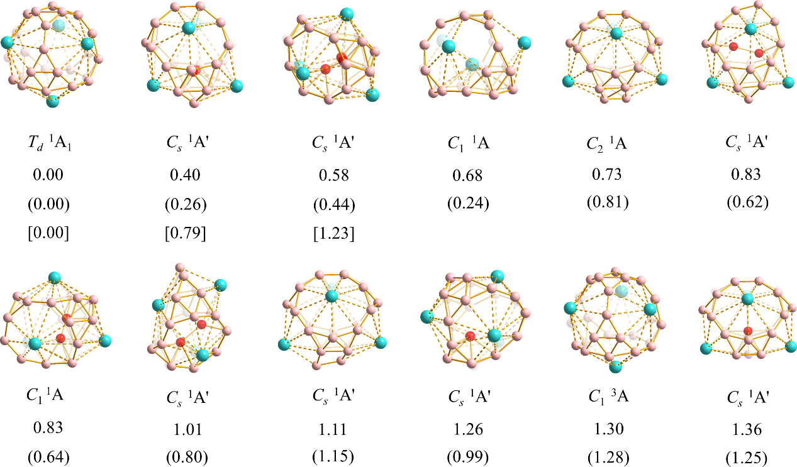

Fig. S2 Relative energies of low-lying isomers of La₄B₂₉ at PBE0 and TPSSh (parentheses) levels in eV. The B_{n} cores are highlighted in red.

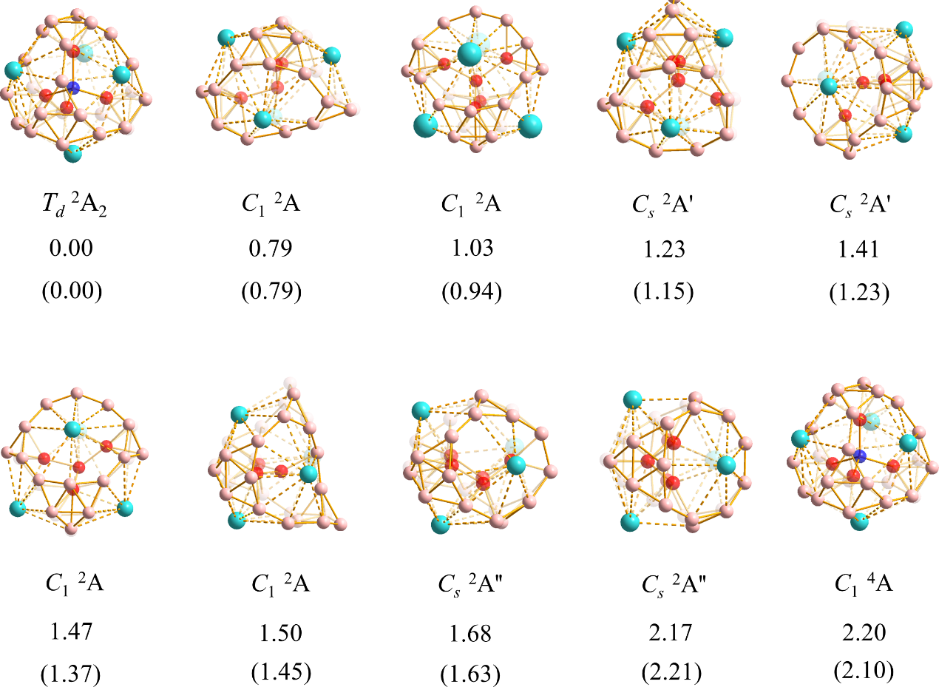

Fig. S3 Relative energies of low-lying isomers of La₄B₂₉⁺ at PBE0, TPSSh (parentheses), and CCSD(T) (square brackets) levels in eV. The B_{n} cores are highlighted in red.

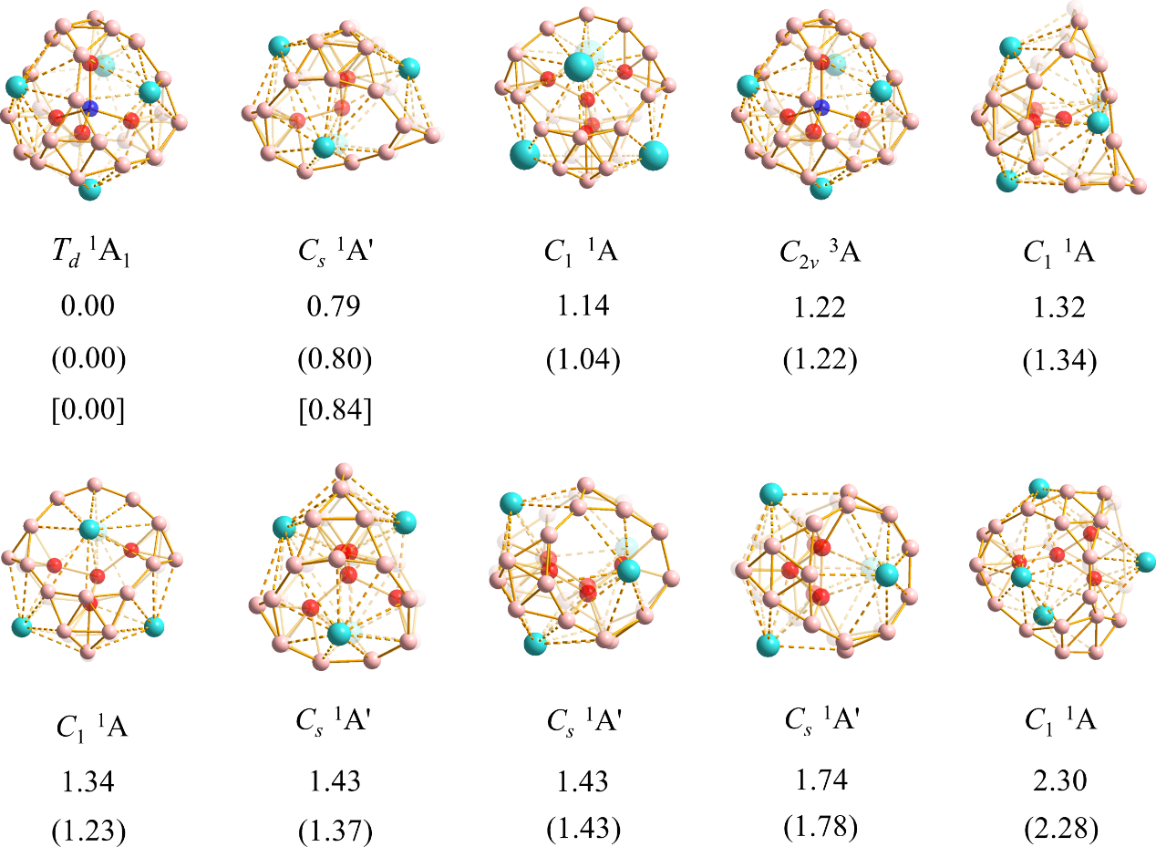

Fig. S4 Relative energies of low-lying isomers of La₄B₂₉⁻ at PBE0 and TPSSh (parentheses) levels in eV. The B_{n} cores are highlighted in red.

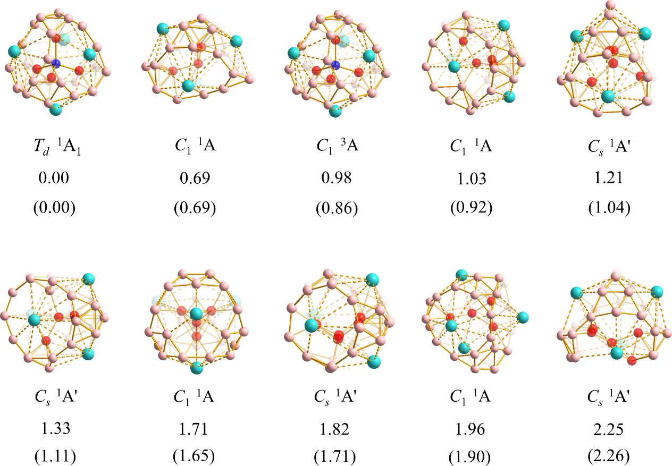

Table S1. Optimized coordinates (x, y, z) of T_{d} La₄B₂₄ (1) at PBE0 level.

T_{d} La₄B₂₄ (1)

B -0.83556400 1.99705500 -1.99705500
B 0.55565000 2.78595700 0.55565000
B -1.99705500 0.83556400 -1.99705500
B 0.83556400 1.99705500 1.99705500
B 0.55565000 0.55565000 2.78595700
B -0.55565000 -2.78595700 0.55565000
B -1.99705500 -1.99705500 0.83556400
B -0.55565000 -0.55565000 2.78595700
B -0.55565000 0.55565000 -2.78595700
B 0.55565000 -2.78595700 -0.55565000
B 2.78595700 0.55565000 0.55565000
B 2.78595700 -0.55565000 -0.55565000
B 1.99705500 0.83556400 1.99705500
B -2.78595700 0.55565000 -0.55565000
B -1.99705500 -0.83556400 1.99705500
B -0.55565000 2.78595700 -0.55565000
B -1.99705500 1.99705500 -0.83556400
B 0.55565000 -0.55565000 -2.78595700
B -2.78595700 -0.55565000 0.55565000
B -0.83556400 -1.99705500 1.99705500
B 0.83556400 -1.99705500 -1.99705500
B 1.99705500 -1.99705500 -0.83556400
B 1.99705500 -0.83556400 -1.99705500
B 1.99705500 1.99705500 0.83556400
La 1.77056100 -1.77056100 1.77056100
La -1.77056100 1.77056100 1.77056100
La 1.77056100 1.77056100 -1.77056100
La -1.77056100 -1.77056100 -1.77056100

T_{d} La₄[B@B₄@B₂₄] (2)

B -0.90778000 -2.17759800 -2.17759800
B 0.62684700 0.62684700 -2.77463600
B -2.17759800 -2.17759800 -0.90778000
B 0.90778000 2.17759800 -2.17759800
B 0.62684700 2.77463600 -0.62684700
B -0.62684700 0.62684700 2.77463600
B -2.17759800 0.90778000 2.17759800
B -0.62684700 2.77463600 0.62684700
B -0.62684700 -2.77463600 -0.62684700
B 0.62684700 -0.62684700 2.77463600
B 2.77463600 0.62684700 -0.62684700
B 2.77463600 -0.62684700 0.62684700
B 2.17759800 2.17759800 -0.90778000
B -2.77463600 -0.62684700 -0.62684700
B -2.17759800 2.17759800 0.90778000
B -0.62684700 -0.62684700 -2.77463600
B -2.17759800 -0.90778000 -2.17759800
B 0.62684700 -2.77463600 0.62684700
B -2.77463600 0.62684700 0.62684700
B -0.90778000 2.17759800 2.17759800
B 0.90778000 -2.17759800 2.17759800
B 2.17759800 -0.90778000 2.17759800
B 2.17759800 -2.17759800 0.90778000
B 2.17759800 0.90778000 -2.17759800
La 1.66462000 1.66462000 1.66462000
La -1.66462000 1.66462000 -1.66462000
La 1.66462000 -1.66462000 -1.66462000
La -1.66462000 -1.66462000 1.66462000
B 0.95332100 -0.95332100 0.95332100
B -0.95332100 0.95332100 0.95332100
B -0.95332100 -0.95332100 -0.95332100
B 0.95332100 0.95332100 -0.95332100
B 0.00000000 0.00000000 0.00000000

T_{d} La₄[B@B₄@B₂₄]⁺ (3)

B -0.93163600 -2.17432700 -2.17432700
B 0.61413300 0.61413300 -2.75321400
B -2.17432700 -2.17432700 -0.93163600
B 0.93163600 2.17432700 -2.17432700
B 0.61413300 2.75321400 -0.61413300
B -0.61413300 0.61413300 2.75321400
B -2.17432700 0.93163600 2.17432700
B -0.61413300 2.75321400 0.61413300
B -0.61413300 -2.75321400 -0.61413300
B 0.61413300 -0.61413300 2.75321400
B 2.75321400 0.61413300 -0.61413300
B 2.75321400 -0.61413300 0.61413300
B 2.17432700 2.17432700 -0.93163600
B -2.75321400 -0.61413300 -0.61413300
B -2.17432700 2.17432700 0.93163600
B -0.61413300 -0.61413300 -2.75321400
B -2.17432700 -0.93163600 -2.17432700
B 0.61413300 -2.75321400 0.61413300
B -2.75321400 0.61413300 0.61413300
B -0.93163600 2.17432700 2.17432700
B 0.93163600 -2.17432700 2.17432700
B 2.17432700 -0.93163600 2.17432700
B 2.17432700 -2.17432700 0.93163600
B 2.17432700 0.93163600 -2.17432700
La 1.68948500 1.68948500 1.68948500
La -1.68948500 1.68948500 -1.68948500
La 1.68948500 -1.68948500 -1.68948500
La -1.68948500 -1.68948500 1.68948500
B 0.94941100 -0.94941100 0.94941100
B -0.94941100 0.94941100 0.94941100
B -0.94941100 -0.94941100 -0.94941100
B 0.94941100 0.94941100 -0.94941100
B 0.00000000 0.00000000 0.00000000

T_{d} La₄[B@B₄@B₂₄]⁻ (4)

B -0.88047800 -2.18470500 -2.18470500
B 0.64159500 0.64159500 -2.79496900
B -2.18470500 -2.18470500 -0.88047800
B 0.88047800 2.18470500 -2.18470500
B 0.64159500 2.79496900 -0.64159500
B -0.64159500 0.64159500 2.79496900
B -2.18470500 0.88047800 2.18470500
B -0.64159500 2.79496900 0.64159500
B -0.64159500 -2.79496900 -0.64159500
B 0.64159500 -0.64159500 2.79496900
B 2.79496900 0.64159500 -0.64159500
B 2.79496900 -0.64159500 0.64159500
B 2.18470500 2.18470500 -0.88047800
B -2.79496900 -0.64159500 -0.64159500
B -2.18470500 2.18470500 0.88047800
B -0.64159500 -0.64159500 -2.79496900
B -2.18470500 -0.88047800 -2.18470500
B 0.64159500 -2.79496900 0.64159500
B -2.79496900 0.64159500 0.64159500
B -0.88047800 2.18470500 2.18470500
B 0.88047800 -2.18470500 2.18470500
B 2.18470500 -0.88047800 2.18470500
B 2.18470500 -2.18470500 0.88047800
B 2.18470500 0.88047800 -2.18470500
La 1.64506400 1.64506400 1.64506400
La -1.64506400 1.64506400 -1.64506400
La 1.64506400 -1.64506400 -1.64506400
La -1.64506400 -1.64506400 1.64506400
B 0.95935600 -0.95935600 0.95935600
B -0.95935600 0.95935600 0.95935600
B -0.95935600 -0.95935600 -0.95935600
B 0.95935600 0.95935600 -0.95935600
B 0.00000000 0.00000000 0.00000000

