Supplementary material
Table S1 Alignment non-coding RNA in GenBank
sample | total | rRNA | scRNA | snRNA | snoRNA | tRNA
all | 163303515 | 5594913(3.43%) | 157393(0.10%) | 106537(0.07%) | 132900(0.08%) | 205255(0.13%)
E12-1 | 14257768 | 798250(5.60%) | 25598(0.18%) | 18178(0.13%) | 16416(0.12%) | 25018(0.18%)
E12-2 | 14795551 | 770048(5.20%) | 20600(0.14%) | 16206(0.11%) | 17618(0.12%) | 17951(0.12%)
E12-3 | 12960780 | 423799(3.27%) | 13678(0.11%) | 14385(0.11%) | 14617(0.11%) | 13572(0.10%)
E16-1 | 12839200 | 211306(1.65%) | 8380(0.07%) | 4961(0.04%) | 6246(0.05%) | 16380(0.13%)
E16-2 | 11612348 | 332993(2.87%) | 9093(0.08%) | 8039(0.07%) | 9501(0.08%) | 19027(0.16%)
E16-3 | 15238234 | 333699(2.19%) | 9561(0.06%) | 8639(0.06%) | 13553(0.09%) | 16968(0.11%)
E19-1 | 13135207 | 526016(4.00%) | 12304(0.09%) | 6871(0.05%) | 9393(0.07%) | 15713(0.12%)
E19-2 | 14707612 | 485370(3.30%) | 15478(0.11%) | 6386(0.04%) | 11245(0.08%) | 17729(0.12%)
E19-3 | 11446699 | 286586(2.50%) | 8146(0.07%) | 4642(0.04%) | 8178(0.07%) | 15283(0.13%)
E21-1 | 15234778 | 837168(5.50%) | 18093(0.12%) | 8953(0.06%) | 9679(0.06%) | 15224(0.10%)
E21-2 | 14992767 | 191815(1.28%) | 5611(0.04%) | 3378(0.02%) | 8175(0.05%) | 11614(0.08%)
E21-3 | 12082571 | 397863(3.29%) | 10851(0.09%) | 5899(0.05%) | 8279(0.07%) | 20776(0.17%)

Table S2 Alignment non-coding RNA in Rfam
sample | total | rRNA | snRNA | snoRNA | tRNA
all | 163303515 | 3082952(1.89%) | 112818(0.07%) | 137984(0.08%) | 373613(0.23%)
E12-1 | 14257768 | 453695(3.18%) | 19920(0.14%) | 16150(0.11%) | 43261(0.30%)
E12-2 | 14795551 | 437354(2.96%) | 18021(0.12%) | 17404(0.12%) | 40094(0.27%)
E12-3 | 12960780 | 286682(2.21%) | 16492(0.13%) | 13946(0.11%) | 31639(0.24%)
E16-1 | 12839200 | 119624(0.93%) | 4855(0.04%) | 7562(0.06%) | 25200(0.20%)
E16-2 | 11612348 | 217801(1.88%) | 7785(0.07%) | 9310(0.08%) | 24972(0.22%)
E16-3 | 15238234 | 220907(1.45%) | 8594(0.06%) | 14008(0.09%) | 26860(0.18%)
E19-1 | 13135207 | 254586(1.94%) | 7446(0.06%) | 8921(0.07%) | 27302(0.21%)
E19-2 | 14707612 | 231672(1.58%) | 5949(0.04%) | 12368(0.08%) | 31678(0.22%)
E19-3 | 11446699 | 142455(1.24%) | 4788(0.04%) | 9446(0.08%) | 23954(0.21%)
E21-1 | 15234778 | 396032(2.60%) | 9486(0.06%) | 10386(0.07%) | 27504(0.18%)
E21-2 | 14992767 | 118912(0.79%) | 3148(0.02%) | 8633(0.06%) | 19349(0.13%)
E21-3 | 12082571 | 203232(1.68%) | 6334(0.05%) | 9850(0.08%) | 51800(0.43%)

Table S3 Alignment the repeat area
sample | total | DNA | LINE | LTR | SINE | others
all | 163303515 | 105878(0.06%) | 12744(0.01%) | 54938(0.03%) | 162(0.00%) | 7646857(4.68%)
E12-1 | 14257768 | 21449(0.15%) | 1930(0.01%) | 7736(0.05%) | 36(0.00%) | 1110910(7.79%)
E12-2 | 14795551 | 17117(0.12%) | 1953(0.01%) | 4999(0.03%) | 27(0.00%) | 1052942(7.12%)
E12-3 | 12960780 | 10081(0.08%) | 1360(0.01%) | 3931(0.03%) | 20(0.00%) | 590175(4.55%)
E16-1 | 12839200 | 11175(0.09%) | 1012(0.01%) | 5829(0.05%) | 14(0.00%) | 328386(2.56%)
E16-2 | 11612348 | 10938(0.09%) | 1035(0.01%) | 4998(0.04%) | 8(0.00%) | 459368(3.96%)
E16-3 | 15238234 | 9256(0.06%) | 1006(0.01%) | 4690(0.03%) | 9(0.00%) | 459970(3.02%)
E19-1 | 13135207 | 5182(0.04%) | 754(0.01%) | 3612(0.03%) | 12(0.00%) | 706712(5.38%)
E19-2 | 14707612 | 4942(0.03%) | 829(0.01%) | 4016(0.03%) | 9(0.00%) | 652715(4.44%)
E19-3 | 11446699 | 4085(0.04%) | 531(0.00%) | 3609(0.03%) | 12(0.00%) | 397824(3.48%)
E21-1 | 15234778 | 4974(0.03%) | 1226(0.01%) | 4509(0.03%) | 4(0.00%) | 1105308(7.26%)
E21-2 | 14992767 | 3656(0.02%) | 496(0.00%) | 1417(0.01%) | 4(0.00%) | 244834(1.63%)
E21-3 | 12082571 | 3023(0.03%) | 612(0.01%) | 5592(0.05%) | 7(0.00%) | 537713(4.45%)

Table S4 Number of identified miRNA and tag abundance statistics
sample | total | mirna num | tags uniq | tags total | ratio(%)
all | 163303515 | 721 | 4975 | 123000951 | 75.32%
E12-1 | 14257768 | 542 | 3110 | 9984074 | 70.03%
E12-2 | 14795551 | 529 | 3027 | 11141910 | 75.31%
E12-3 | 12960780 | 513 | 2945 | 10011724 | 77.25%
E16-1 | 12839200 | 470 | 2883 | 10138709 | 78.97%
E16-2 | 11612348 | 464 | 2785 | 9057056 | 78.00%
E16-3 | 15238234 | 469 | 2879 | 11892779 | 78.05%
E19-1 | 13135207 | 423 | 2619 | 9857529 | 75.05%
E19-2 | 14707612 | 447 | 2707 | 10947594 | 74.43%
E19-3 | 11446699 | 397 | 2467 | 8732308 | 76.29%
E21-1 | 15234778 | 410 | 2633 | 10808475 | 70.95%
E21-2 | 14992767 | 399 | 2540 | 11595721 | 77.34%
E21-3 | 12082571 | 404 | 2491 | 8833072 | 73.11%

Table S5 Base-edited for each sample
sample | total | mirna tag | ratio(%)
all | 163303515 | 12438292 | 7.62%
E12-1 | 14257768 | 1086969 | 7.62%
E12-2 | 14795551 | 864157 | 5.84%
E12-3 | 12960780 | 814795 | 6.29%
E16-1 | 12839200 | 929932 | 7.24%
E16-2 | 11612348 | 840855 | 7.24%
E16-3 | 15238234 | 1116772 | 7.33%
E19-1 | 13135207 | 957735 | 7.29%
E19-2 | 14707612 | 1342338 | 9.13%
E19-3 | 11446699 | 909483 | 7.95%
E21-1 | 15234778 | 1314978 | 8.63%
E21-2 | 14992767 | 1318388 | 8.79%
E21-3 | 12082571 | 941890 | 7.80%

Table S6 Statistics for identifying the known miRNA
sample | total | mirna num | tags uniq | tags total | ratio(%)
all | 163303515 | 1059 | 20654 | 12845504 | 7.87%
E12-1 | 14257768 | 477 | 6359 | 977085 | 6.85%
E12-2 | 14795551 | 441 | 6366 | 907707 | 6.13%
E12-3 | 12960780 | 381 | 5695 | 717123 | 5.53%
E16-1 | 12839200 | 531 | 6496 | 942984 | 7.34%
E16-2 | 11612348 | 387 | 5707 | 809130 | 6.97%
E16-3 | 15238234 | 379 | 6477 | 1225800 | 8.04%
E19-1 | 13135207 | 395 | 6066 | 1077369 | 8.20%
E19-2 | 14707612 | 351 | 6636 | 1246222 | 8.47%
E19-3 | 11446699 | 332 | 5228 | 1016173 | 8.88%
E21-1 | 15234778 | 535 | 6922 | 1216227 | 7.98%
E21-2 | 14992767 | 303 | 6122 | 1452758 | 9.69%
E21-3 | 12082571 | 319 | 5273 | 1256926 | 10.40%

Table S7 Statistics of novel miRNA
sample | total | mirna num | tags uniq | tags total | ratio(%)
all | 163303515 | 267 | 334 | 266267 | 0.16%
E12-1 | 14257768 | 204 | 253 | 31802 | 0.22%
E12-2 | 14795551 | 203 | 254 | 40632 | 0.27%
E12-3 | 12960780 | 215 | 249 | 34269 | 0.26%
E16-1 | 12839200 | 170 | 196 | 17033 | 0.13%
E16-2 | 11612348 | 171 | 204 | 20530 | 0.18%
E16-3 | 15238234 | 182 | 219 | 31803 | 0.21%
E19-1 | 13135207 | 118 | 165 | 15828 | 0.12%
E19-2 | 14707612 | 129 | 162 | 19920 | 0.14%
E19-3 | 11446699 | 104 | 135 | 14342 | 0.13%
E21-1 | 15234778 | 140 | 164 | 10498 | 0.07%
E21-2 | 14992767 | 103 | 140 | 14659 | 0.10%
E21-3 | 12082571 | 122 | 151 | 14951 | 0.12%

Table S8 The primers for the RT-qPCR amplification
Genes | Reverse transcription primer | Forward primer(5’-3’)
gga-miR-130b-5p | GTCGTATCCAGTGCAGGGTCCGAGGTATTCGCACTGGATACGACAGTAGT | CGCCTCTTTCCCTGTTGC
gga-miR-363-5p | GTCGTATCCAGTGCAGGGTCCGAGGTATTCGCACTGGATACGACTCAAAA | CGGTGGATCACGATGCAA
gga-miR-30e-3p | GTCGTATCCAGTGCAGGGTCCGAGGTATTCGCACTGGATACGACGCTGTA | CGCGTTTCAGTCGGATGTT
gga-miR-10b-5p | GTCGTATCCAGTGCAGGGTCCGAGGTATTCGCACTGGATACGACACAAAT | CGCGTACCCTGTAGAACCGA
gga-miR-338-5p | GTCGTATCCAGTGCAGGGTCCGAGGTATTCGCACTGGATACGACACTCAG | GCGCGAACAATATCCTGGTG
gga-miR-499-5p | GTCGTATCCAGTGCAGGGTCCGAGGTATTCGCACTGGATACGACCTAAAC | CGCGCGTTAAGACTTGTAGTGAT
gga-miR-1729-5p | GTCGTATCCAGTGCAGGGTCCGAGGTATTCGCACTGGATACGACGACTAC | CGCGATCCCTTACTCACATGA
gga-miR-26a-5p | GTCGTATCCAGTGCAGGGTCCGAGGTATTCGCACTGGATACGACGCCTAT | GCGCGTTCAAGTAATCCAGG
U6 | CCATATTAGAAGCCCCTTTTTGT | F: TCGCTTCGGCAGCACATA  R: AATATGGAACGCTTCACGAA
Note: miRNAs’ reverse primer(3’-5’) was consensus primer, primer sequence is AGTGCAGGGTCCGAGGTATT.

Figure legends
Figure S1. Sample tags length distribution. (1) E12-1; (2) E12-2; (3) E12-3; (4) E16-1; (5) E16-2; (6); E16-3; (7) E19-1; (8) E19-2; (9) E19-3; (10) E21-1; (11) E21-2; (12) E21-3.
Figure S2. Comparison of reference area statistics. Sample reference ratios distribution (1) E12-1; (2) E12-2; (3) E12-3; (4) E16-1; (5) E16-2; (6); E16-3; (7) E19-1; (8) E19-2; (9) E19-3; (10) E21-1; (11) E21-2; (12) E21-3. Replace different components ratios with different colors.
Figure S3. The first nucleotide bias distribution. Replace different nucleotides with different colors.
Figure S4. The first nucleotide bias with known miRNAs. Replace different nucleotides with different colors.
Figure S5. Tags annotation for all samples. (1) E12-1; (2) E12-2; (3) E12-3; (4) E16-1; (5) E16-2; (6); E16-3; (7) E19-1; (8) E19-2; (9) E19-3; (10) E21-1; (11) E21-2; (12) E21-3. Replace different components ratios with different colors.

Figure S1
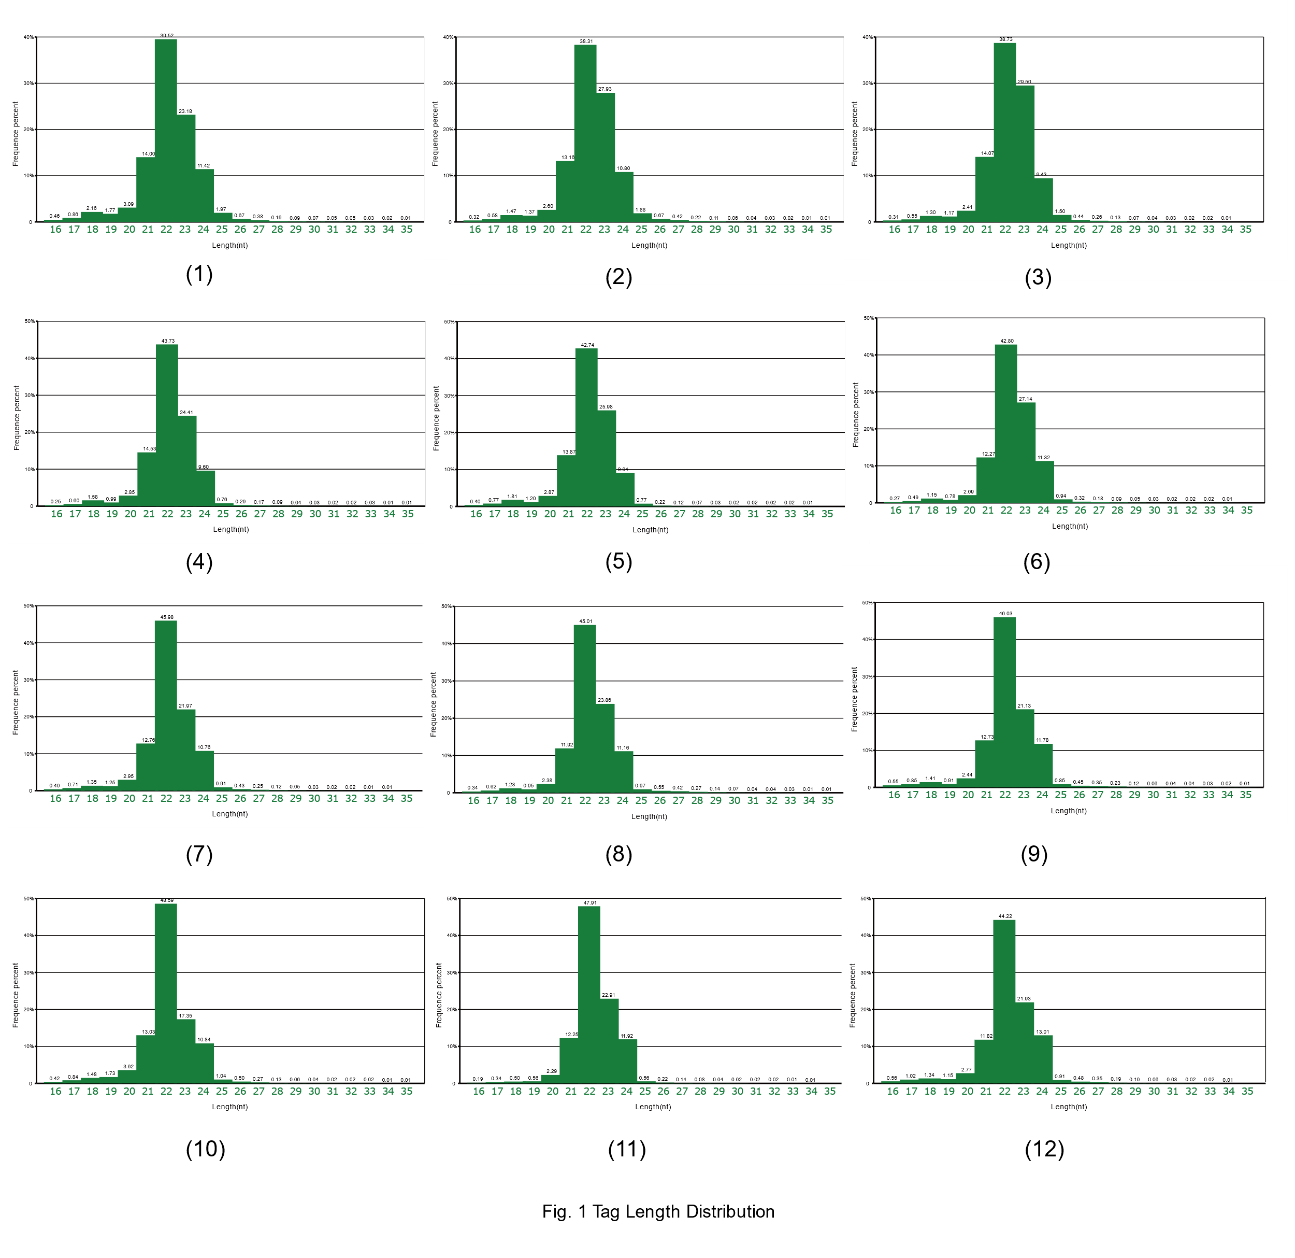
Figure S2
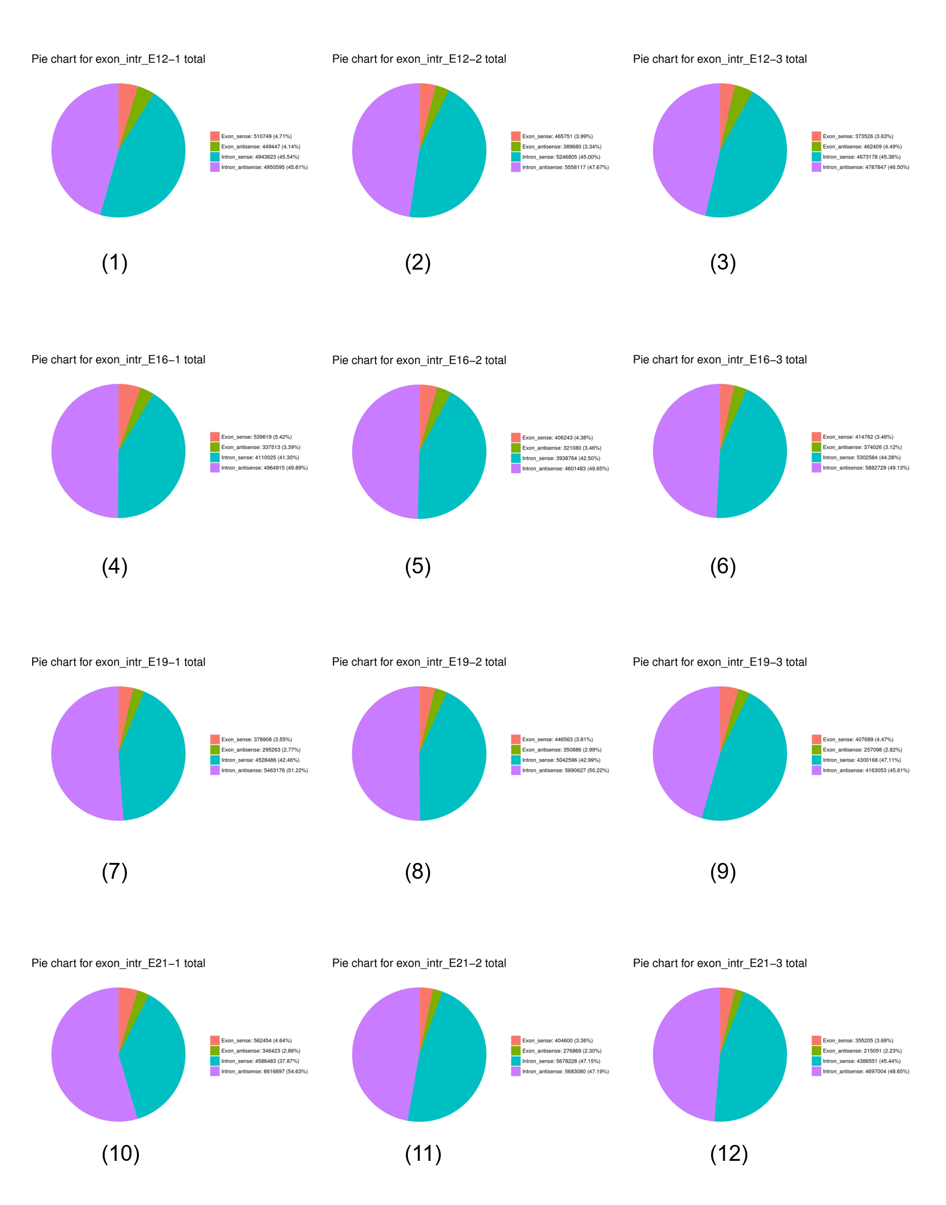

Figure S3
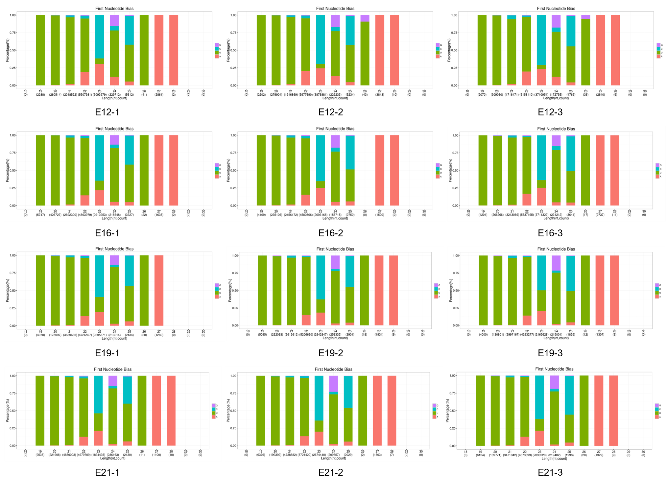
Figure S4
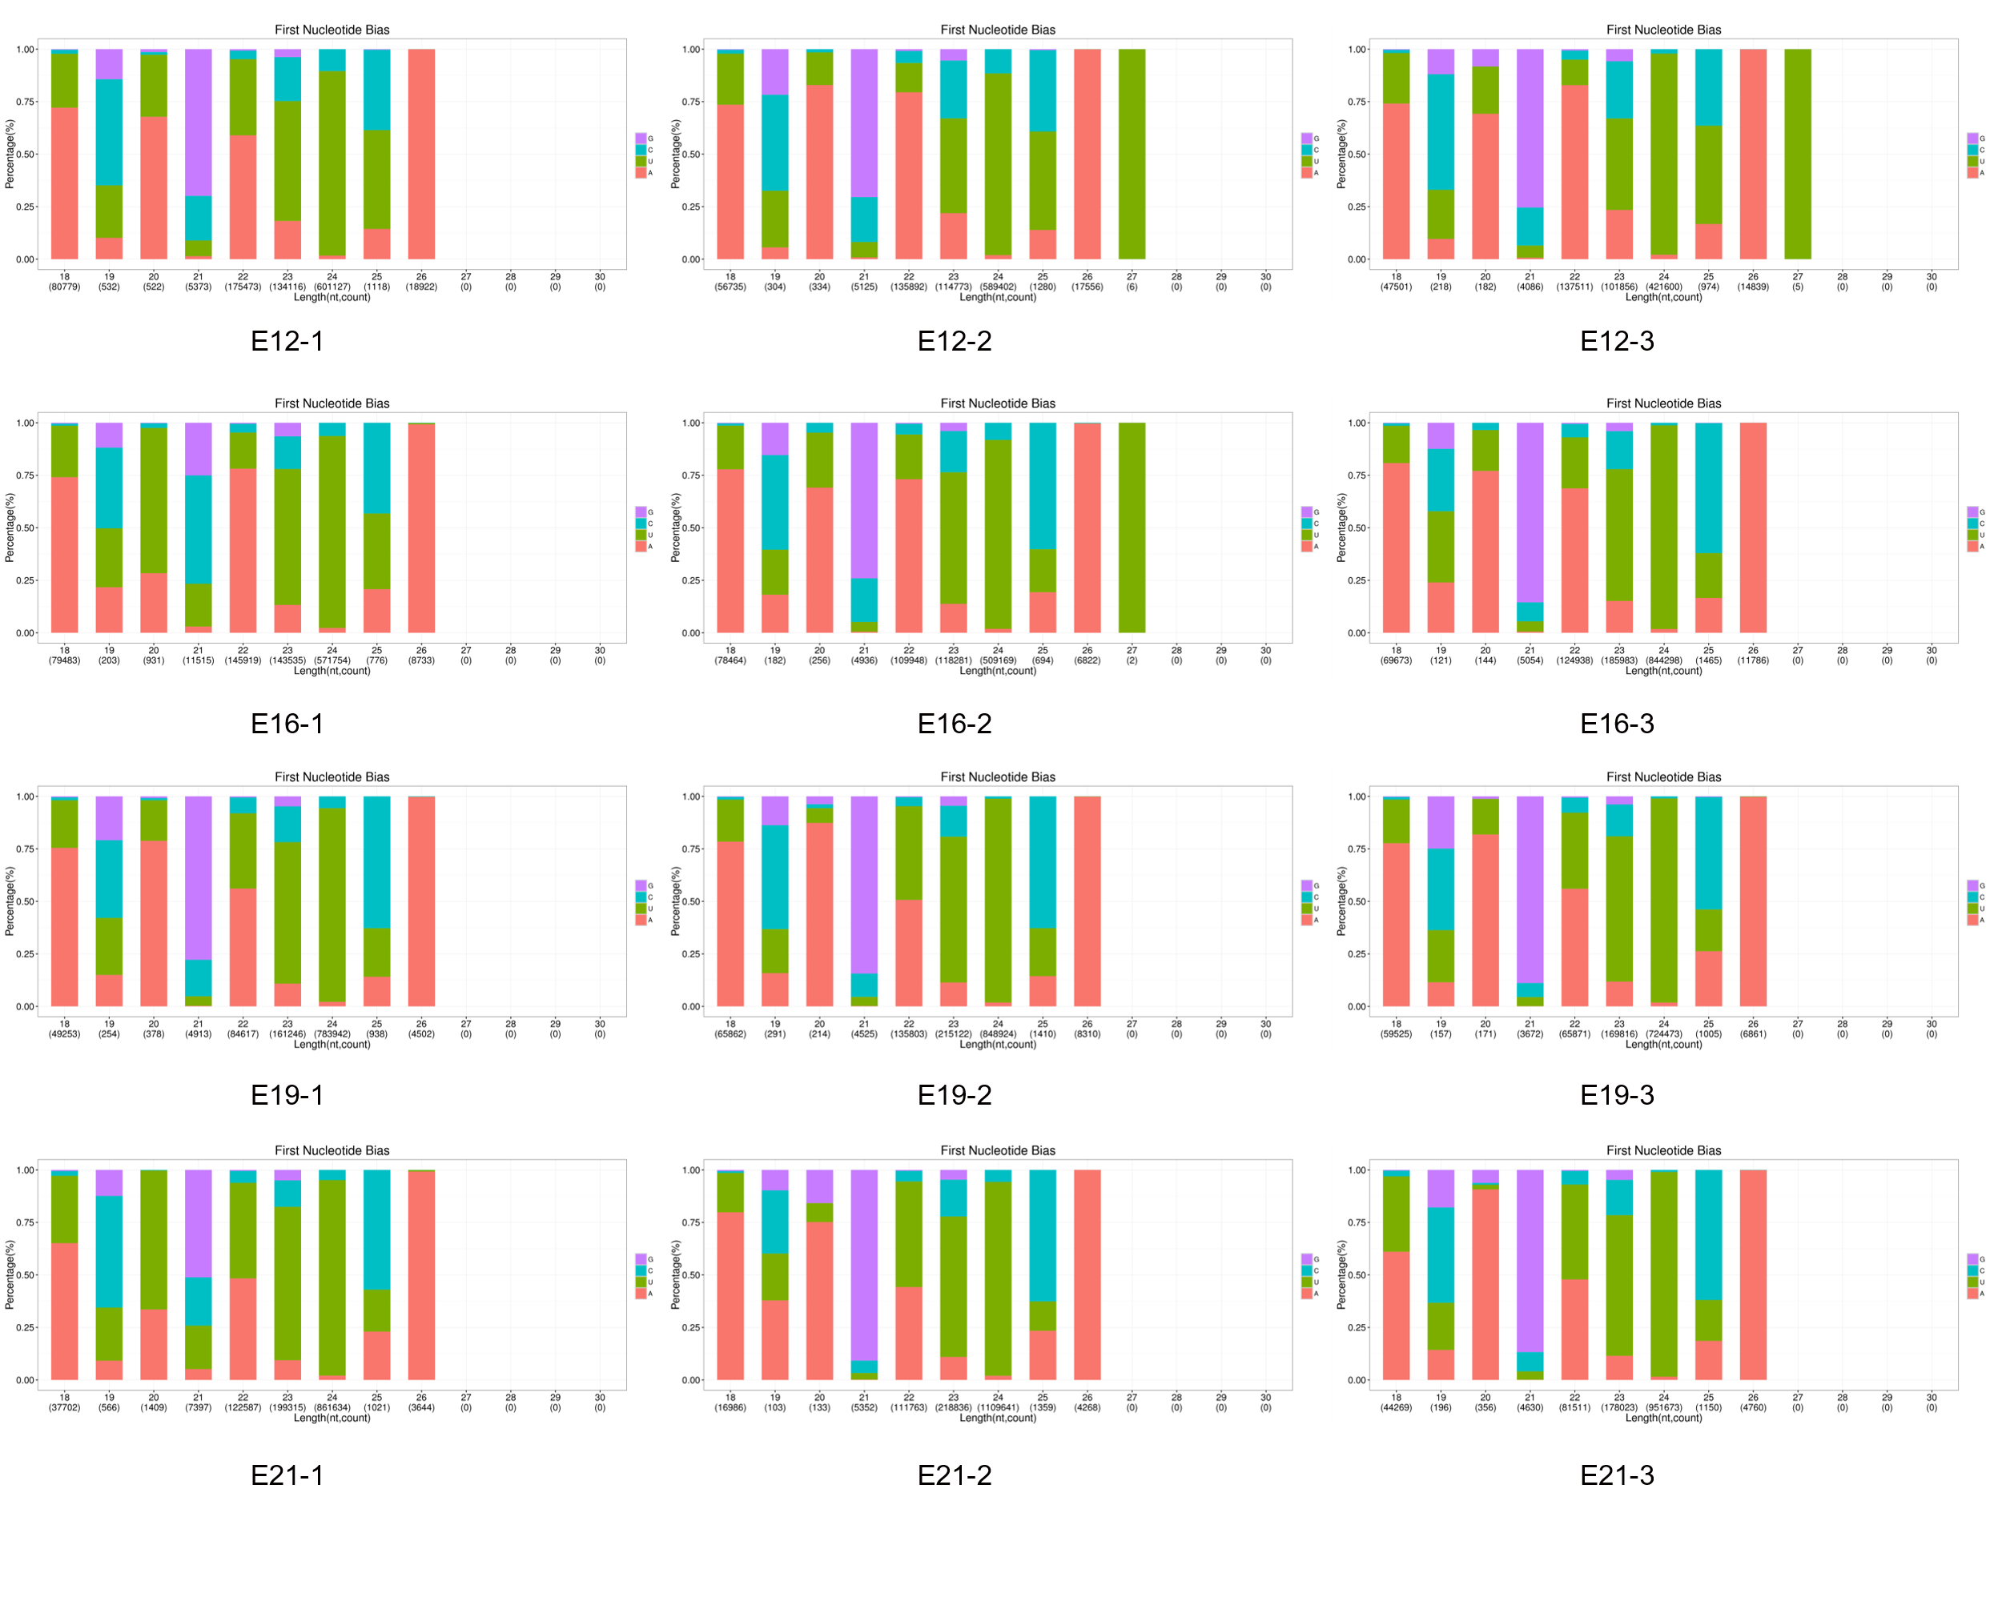

Figure S5
