Supplemental Material

Differences in County-Level Cardiovascular Disease Mortality Rates due to Damage Caused by Hurricane Matthew and the Moderating Effects of Social Capital: A Natural Experiment

List of Supplementary Tables and Figures:
Supplementary Table S1. Spearman's Correlation Coefficients for Social Capital Indicators

Supplementary Figure S1. Distribution of Informal Civil Society Coefficient
Supplementary Figure S2. Distribution of Confidence in Institutions Coefficient

Construction of Social Capital Indices
Family unity. Family unity is comprised of three indicators. The first two family unity indicators, the percent of unmarried women (15-50) who had a birth in the past 12 months and the share of women ages 35-44 who are currently married (and not separated) are derived from the AFF tables S1301 and B12002 (U.S. Census Bureau 2018). The third indicator, share of single-parent households (AFF table B09002 (U.S. Census Bureau, 2018)) was constructed by adding the percentage of male-headed households with children under 18 years (no mother present) and the percentage of female-headed households with children under 18 years (no father present). The result is the total number of single-parent family households.
Informal civil society. The informal civil society index was constructed from two indicators: the rate of nonprofits per 10,000 county residents and the rate of religious organizations per 10,000 county residents. Nonprofits and religious organizations were defined using the 2017 North American Industry Classification codes, and the total number of nonprofit or religious organizations in a county was determined using American Fact Finder’s table of Community Business Patterns (2018). In 2017, non-religious nonprofits had industry codes 8132-8139, and religious organizations were assigned industry code 8131 (North American Industry Classification System, 2017). For each year, the number of nonprofits and religious organizations in a county were added together. County nonprofit and religious organization totals were divided by the county midyear population. The quotients were then multiplied by 10,000, resulting in a rate of nonprofits or religious organizations per 10,000 county residents.
Institutional confidence. This sub-index measures commitment to society and trust in institutions (United States Joint Economic Committee 2018). Institutional confidence was assessed using 2010 census response rates and voter turnout rates from 2012 and 2016. The first indicator in the institutional confidence sub-index, 2010 census return rates, are reported by the US Census Bureau’s table “Rates for all possible geographies, including American Indian Areas” and did not require transformation (US Census Bureau 2020). Average voter rates in 2012 and 2016 were computed by dividing the number of voters in a county (U.S. Election Assistance Commission, 2019) by the county midyear population aged 18 years and older (AFF table B05003). This resulted in the rate of county residents age 18 and older participating in the 2012 and 2016 federal elections.
Collective efficacy. Collective efficacy was calculated using standardized violent crime rates (VCRs). VCRs tend to be a better indicator of crime rates across counties than general crime rates because they are measured and reported more consistently across jurisdictions (United States Joint Economic Committee, 2018). VCRs are calculated using a three-year moving average constructed from the FBI’s UCR data via SimplyAnalytics (2021). For most years, mean county VCRs are calculated using data from several years prior to a given year. For example, 2013 VCRs were calculated using data from 2009-2011. This pattern follows for all years from 2013-2017. However, due to a delayed release, 2016 VCRs are not available. Therefore, for all counties, 2018 VCRs are the same as 2017 VCRs. Standardized VCRs were inverted so that higher scores indicate higher levels of social capital.
Each sub-index was constructed using the most recently available data (see SM, Data availability by sub-index). In addition to individual sub-indices, we created a full social capital index by standardizing and adding the four sub-measures. Higher scores on each measure reflect higher levels of social capital.

Data availability by sub-index
Each sub-index was constructed using the most recently available data. However, not all social capital data are from the same time. The family unity and informal civil society indicators are all available on a yearly basis. Thus, values for these indicators are the same for each month in every calendar year. The institutional confidence indicators do not change over time, so each indicator takes on a single value over the entire course of the study. The collective efficacy indicator is released semi-regularly, so collective efficacy values take on the most recent value and are assigned for each month in the given calendar year (see SM, Construction of social capital indices). This data collection and integration process reflects the methods established by the JEC in their Social Capital Project (JEC 2018). Following these steps will ensure that the data used for this project is similar to the data gathered for the original iteration of the Social Capital Project.

Supplemental Table S1. Spearman’s Correlation Coefficients for Social Capital Indicators
 | Variables | (1) | (2) | (3) | (4) | (5) | (6) | (7) | (8) | (9) | (10) | (11) | (12) | (13) | (14)
 | (1) Monthly CVD Mortality Rate | 1.00
 | (2) Social Capital Index† | -0.01 | 1.00
 | (3) Family Unity† | -0.34 | 0.42 | 1.00
 | (4) Rate of Single Parent Households | 0.32 | -0.36 | -0.95 | 1.00
 | (5) Rate of Unmarried Births | 0.36 | -0.44 | -0.87 | 0.76 | 1.00
 | (6) Rate of Married Women | -0.25 | 0.36 | 0.91 | -0.85 | -0.66 | 1.00
 | (7) Informal Civil Society† | 0.23 | 0.78 | -0.12 | 0.16 | 0.05 | -0.14 | 1.00
 | (8) Rate of Nonprofits* | -0.04 | 0.39 | 0.56 | -0.59 | -0.45 | 0.51 | 0.07 | 1.00
 | (9) Rate of Religious Organizations* | 0.16 | 0.51 | -0.11 | 0.14 | -0.03 | -0.19 | 0.67 | -0.11 | 1.00
 | (10) Institutional Confidence† | 0.26 | 0.59 | -0.09 | 0.14 | 0.11 | -0.03 | 0.75 | 0.17 | 0.09 | 1.00
 | (11) Percent 2010 Census Response | -0.04 | 0.39 | 0.47 | -0.49 | -0.42 | 0.40 | 0.12 | 0.79 | 0.07 | 0.07 | 1.00
 | (12) Percent Voting in 2012 | -0.09 | 0.28 | 0.41 | -0.42 | -0.39 | 0.33 | 0.04 | 0.52 | 0.12 | -0.07 | 0.92 | 1.00
 | (13) Percent Voting in 2016 | 0.04 | 0.33 | 0.26 | -0.27 | -0.26 | 0.20 | 0.21 | 0.49 | 0.19 | 0.10 | 0.90 | 0.95 | 1.00
 | (14) Collective Efficacy † | -0.19 | 0.38 | 0.27 | -0.25 | -0.29 | 0.22 | 0.01 | 0.22 | 0.01 | 0.01 | 0.23 | 0.19 | 0.15 | 1.00
n = 8,893
*Rate per 10,000
†Standardized composite indices

Summary of results in Tables S1

Spearman’s correlation coefficients (Table S1) suggest a mixed relationship between social capital indices and CVD mortality rates. The overall relationship between the full social capital index and CVD mortality rates was very weak and negative (-0.01). Both the relationship between family unity and CVD mortality (-0.34) and the relationship between collective efficacy and CVD mortality (-0.19) were also modest and negative. The relationships between informal civil society and CVD mortality (0.23) as well as institutional confidence and CVD mortality (0.26) were both moderate and positive. There also evidence that the unique social capital sub-indices share unique relationships with CVD mortality that run in different directions, rendering the effect of the full social capital index difficult to detect. The indicators that compose sub-indices tend to be moderately to strongly and positively correlated amongst themselves, and with the scores of their respective sub-indices, indicating that indices and indicators are measuring similar concepts.

Supplementary Figure S1. Distribution of Informal Civil Society Coefficient

Supplemental Figure S2. Distribution of Confidence in Institutions Coefficient

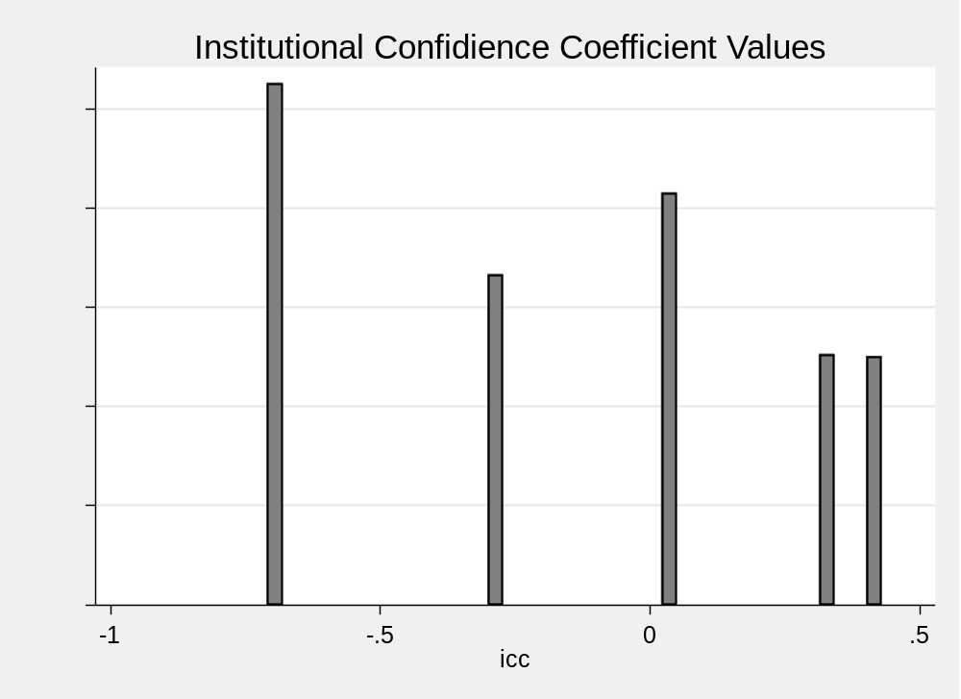
Summary of Figures S1-S2

Figure S1 shows the distribution of the Informal Civil Society Index coefficient for all 106 counties over the course of the 2013-2018 study period. We excluded these data for several reasons. First, these variables were designed to be treated as continuous. However, both variables only take on 6 values over the course of the study. Second, the coefficients represent mean-standardized scores on a scale created to measure state-level social capital. For both coefficients, all values fall within 1.5 standard deviations of the mean coefficient score. The lack of variation within counties over time coupled with little variation between counties across space indicates that these variables capture a static state-level social capital variable, as opposed to the longitudinal county-level measures.

References

“North American Industry Classification System.” 2017. Executive Office of the President & The Office of Management and Budget. census.gov/naics.
Robert Wood Johnson. 2020. “Violent Crime Rates.” County Health Rankings and Roadmaps. 2020. https://www.countyhealthrankings.org/explore-health-rankings/measures-data-sources/county-health-rankings-model/health-factors/social-and-economic-factors/community-safety/violent-crime-rate.
United States Joint Economic Committee. 2018. “The Geography of Social Capital in America - Analysis - United States Joint Economic Committee.” April 11, 2018. https://www.jec.senate.gov/public/index.cfm/republicans/2018/4/the-geography-of-social-capital-in-america.
U.S. Census Bureau. 2018. “American FactFinder - Community Facts,” October. https://factfinder.census.gov/faces/nav/jsf/pages/community_facts.xhtml?src=bkmk.
US Census Bureau. 2019 “2010 Census Participation Rates.” Accessed September 19, 2020. https://www.census.gov/data/datasets/2010/dec/2010-participation-rates.html.
U.S. Election Assistance Commission. 2019. “Surveys and Data.” Election Administration and Voting Survey (EAVS) Datasets, Codebooks, and Survey Instruments. 2019. https://www.eac.gov/research-and-data/datasets-codebooks-and-surveys.

