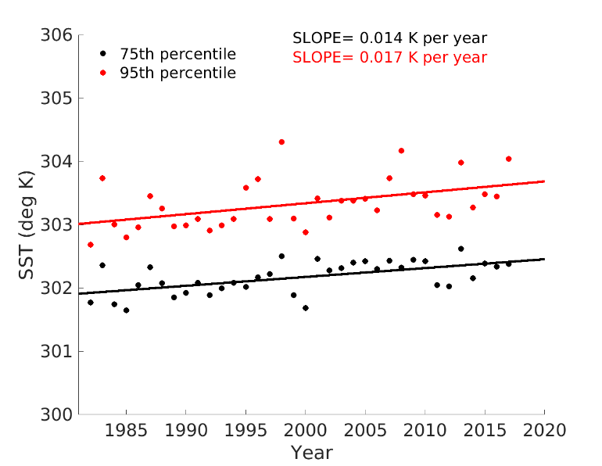
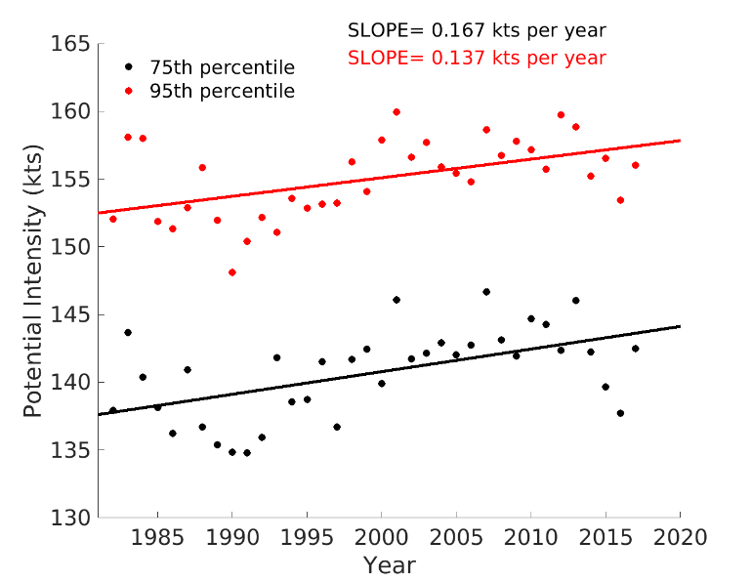
b)
a)

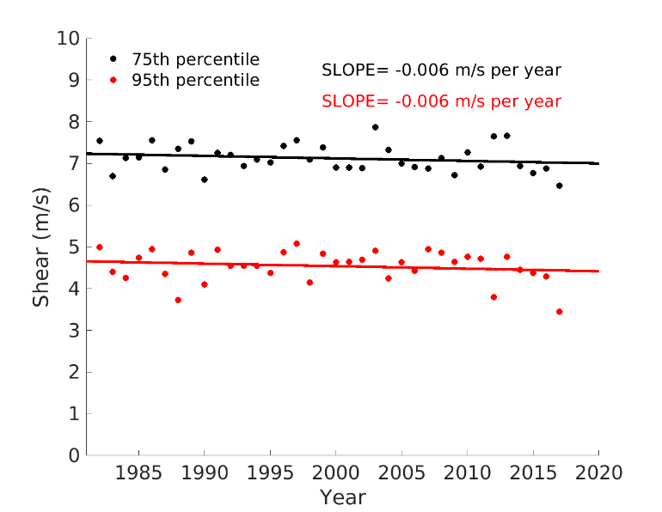
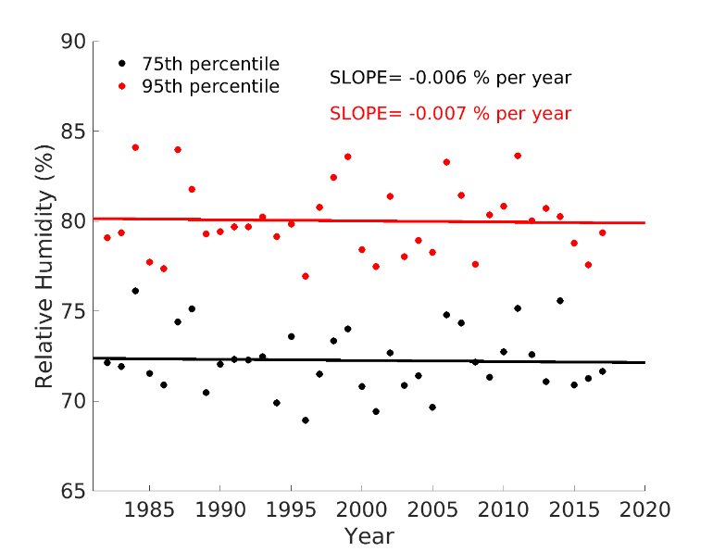
d)
c)

Supplementary Fig. 1: Storm-Local Environment Trends
a-d Observed trends in the 75th (black) and 95th percentile (red) of ERA5 storm-local environments over the 36-year period 1982–2017 using (a) potential intensity (PI) (b) sea surface temperature (SST) (c) relative humidity (RH) (d) vertical wind shear (SHR) data. The methodology to calculate the storm-local environments is detailed in the Methods section. Annual values are denoted by dots, and the slope derived from least squares regression of annual values are included for each percentile and environmental parameter.

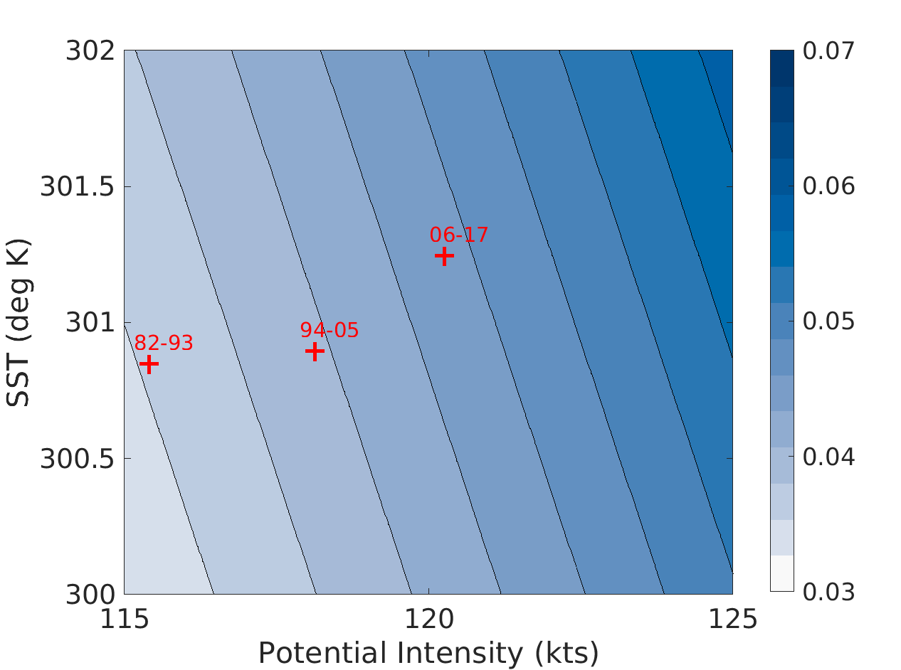
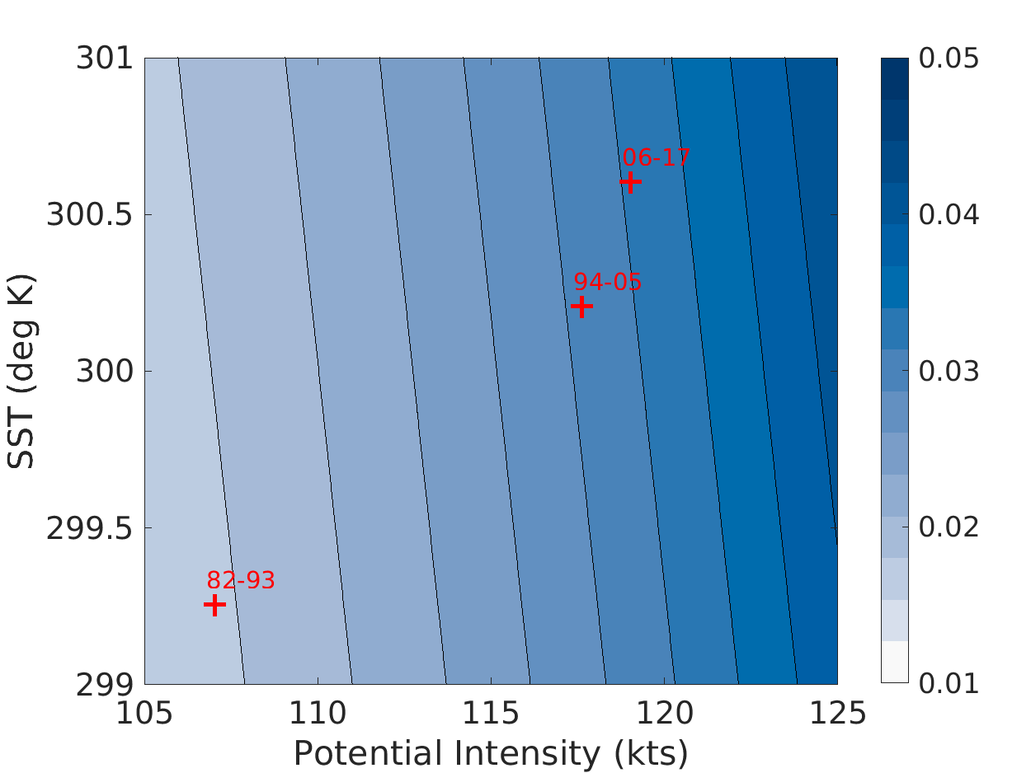
Global
Atlantic
b)
a)
c)

West Pacific
Australian
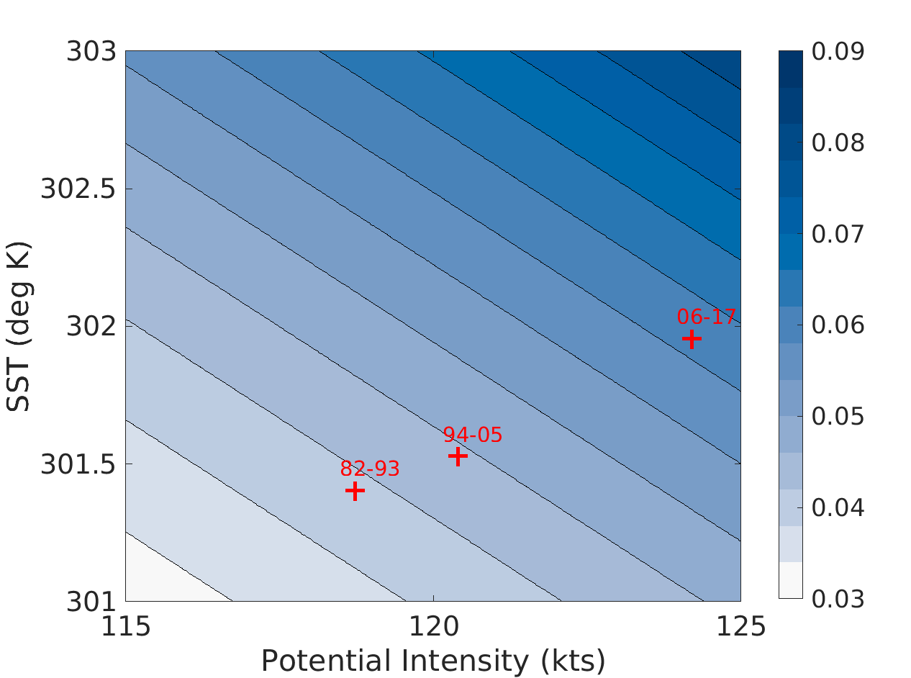
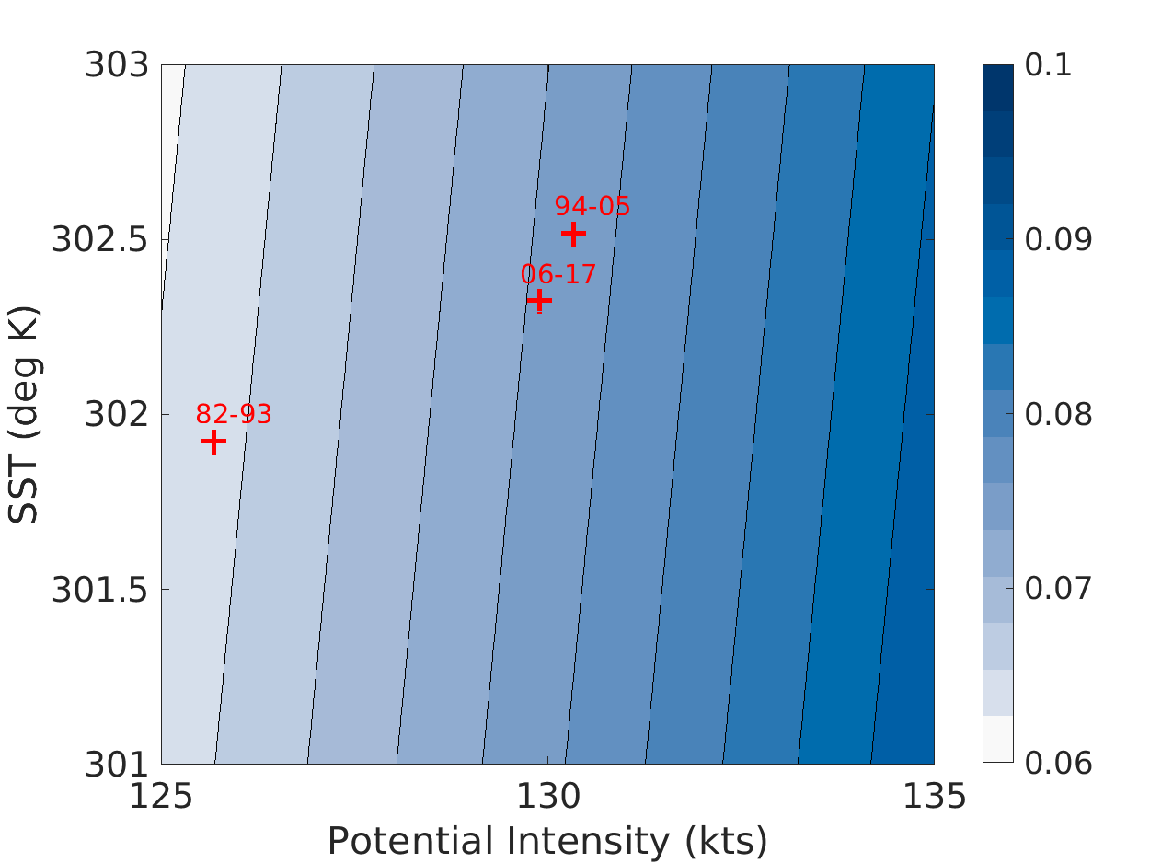
d)

Supplementary Fig. 2: Time Evolution of the Probability of RI vs. SST and PI
a-d The probability of IBTrACS RI in four basins: (a) Global, (b) Atlantic, (c) Australian, (d) West Pacific is contoured based on a logistic regression with two predictors, ERA5 sea surface temperature and potential intensity. The contour shading represents the probability of RI with darker colors corresponding to higher probabilities of RI. The mean values of SST and PI for the first (1982-1993), second (1994-2005), and third (2006-2017) terciles are plotted as red plus signs.

Supplementary Fig. 3: Spectral Filtering Sensitivity Testing
Tropical cyclone tangential wind (Vt) as a function of cyclone radius (R) for the full, native ERA5 resolution (T639) and for truncations in the range T30–T10. Vt was computed on a radial grid and composited for all tropical cyclones. The value in brackets gives the fraction of the T639 circulation remaining in the spectrally filtered field, estimated by taking the difference between the T639 and filtered fields, integrated between 0–5º. T11 was used to prepare storm-local environments because it removed 95% of the composited tropical cyclones’ circulations.

Variable/Basin | AL | EP | WP | SP | AU | GL
RH | 60.4% | 71.9% | 67.8% | 68.4% | 67.8% | 67.4%
SHR | 9.2 m/s | 7.9 m/s | 9.5 m/s | 10.9 m/s | 10.1 m/s | 9.3 m/s
SST | 300.8 K | 300.4 K | 302.0 K | 301.7 K | 302.4 K | 301.4 K
PI | 129.0 kts | 130.6 kts | 132.4 kts | 132.0 kts | 133.6 kts | 131.3 kts
RI | 5.3% | 8.5% | 8.7% | 7.1% | 8.5% | 7.7%

Supplementary Table 1: Critical Environmental Thresholds for Each Basin
Logistic regression is used to determine critical ERA5 environment thresholds for each basin and environmental parameter. The variable “RI” corresponds to the percentage of 24-hour IBTrACS intensity changes that exceed 30 knots in each basin. A critical threshold is defined as the environmental parameter value that yields the mean probability of a 24-hr wind speed exceeding 30 knots between 1982-2017.

Thresholds Met/Basins | AL | EP | WP | SP | AU | GL
0 | 9/715 | 9/627 | 22/1873 | 6/540 | 9/427 | 41/4035
1 | 22/1030 | 51/1617 | 108/2992 | 10/560 | 36/677 | 207/7082
2 | 77/1404 | 121/1541 | 272/3425 | 37/498 | 85/862 | 588/8340
3 | 91/1050 | 176/1082 | 408/2617 | 52/390 | 78/590 | 862/6222
4 | 40/306 | 83/326 | 225/948 | 53/248 | 22/152 | 428/1925
Total Cases | 239/4505 | 440/5193 | 1035/11855 | 158/2236 | 230/2708 | 2126/27604

Supplementary Table 2: RI Ratios for Different Critical Thresholds
Table shows the number of times that the ERA5 storm-local environmental parameters satisfied each number of critical thresholds (second number) and the number of observed RI events (first number) for these situations.

Sea Surface Temperature |  | Potential Intensity |  | Relative Humidity |  | Wind Shear
Model | Ensemble Members  (Total=101 members) | Model | Ensemble  Members  (Total= 87 Members) | Model | Ensemble Members  (Total= 97 Members) | Model | Ensemble Members  (Total= 93 Members)
ACCESS-CM2 | 3 | ACCESS-CM2 | 3 | ACCESS-CM2 | 3 | ACCESS-CM2 | 1
ACCESS-ESM1-5 | 3 | ACCESS-ESM1-5 | 3 | ACCESS-ESM1-5 | 3 | ACCESS-ESM1-5 | 3
BCC-CSM2-MR | 3 | BCC-CSM2-MR | 3 | BCC-CSM2-MR | 3 | BCC-CSM2-MR | 3
CESM2 | 3 | CESM2 | 3 | CESM2 | 1 | CESM2 | 3
CNRM-CM6-1 | 10 | CNRM-CM6-1 | 9 | CNRM-CM6-1 | 10 | CNRM-CM6-1 | 10
CanESM5 | 46 | CanESM5 | 41 | CanESM5 | 45 | CanESM5 | 38
FGOALS-g3 | 1 | FGOALS-g3 | 1 | FGOALS-g3 | 3 | FGOALS-g3 | 3
GFDL-ESM4 | 1 | GFDL-ESM4 | 1 | GISS-E2-1-G | 5 | GFDL-ESM4 | 1
GISS-E2-1-G | 5 | GISS-E2-1-G | 5 | HadGEM3-GC31-LL | 5 | GISS-E2-1-G | 5
HadGEM3-GC31-LL | 5 | HadGEM3-GC31-LL | 5 | IPSL-CM6A-LR | 10 | HadGEM3-GC31-LL | 5
IPSL-CM6A-LR | 10 | IPSL-CM6A-LR | 10 | MIROC6 | 3 | IPSL-CM6A-LR | 10
MIROC6 | 3 | MIROC6 | 3 | MRI-ESM2-0 | 5 | MIROC6 | 3
MRI-ESM2-0 | 5 |  |  | NorESM2-LM | 1 | MRI-ESM2-0 | 5
NorESM2-LM | 3 |  |  |  |  | NorESM2-LM | 3

Supplementary Table 3: CMIP6 Models and Ensemble Members for Analysis
Table shows the CMIP6 models and ensemble members used for tropical-mean comparisons for each environmental variable. To be included in the sample, each model required an ensemble member for historical, hist-nat, and hist-GHG simulations.

