Supplementary Figures

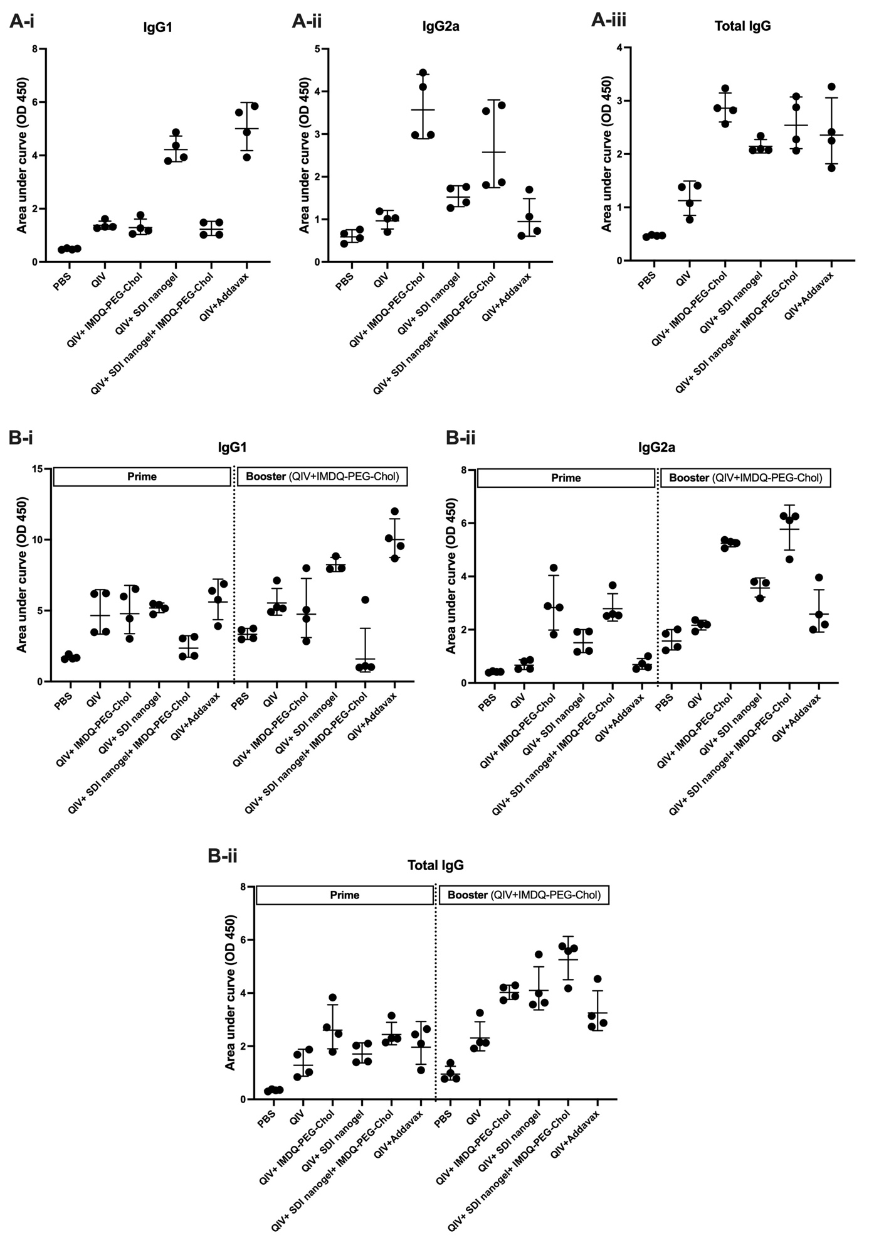
Supplementary Fig 1: SDI+nanogel and IMDQ-PEG-Chol, individual or combined, define IgG subtype profile: Area under curve was calculated from OD₄₅₀ ELISA values for individual mouse (n=4/group). A) Serum ELISA four weeks post-prime, (B) Area under curve eight weeks post-prime and 4 weeks post boost for half of the mice as indicated. ELISA was performed with 3-fold serum dilutions starting with 1:100. Each group presents symbols representing each animal and are represented as geometric mean ± geometric SD.

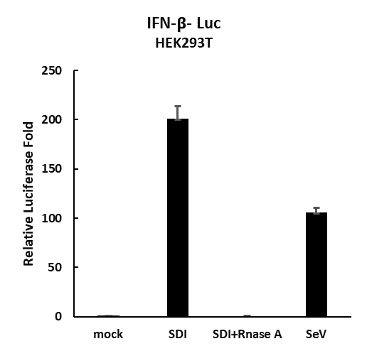
Supplementary Fig 2: In vitro transcribed SDI RNA potently induces IFN-β luciferase activity. HEK293T cells were or transfected with SDI-RNA, before and post treatment with RNase A, along with IFN-β-Luc reporter and pSV-Rluc as an internal control. Live Sendai virus (SeV) was used to infect HEK293T cells and served as a positive control for the assay. The results are represented as fold induction in luciferase activity compared with mock.

Supplementary Fig 3: Schematic representation of recombinant trimeric hemagglutinin for ELISA coating

