SUPPLEMENTARY FIGURES

Epigenomic profiling of glucocorticoid responses identifies cis-regulatory disruptions impacting steroid resistance in childhood acute lymphoblastic leukemia

Brennan P. Bergeron^{1,2,3,§}, Jonathan D. Diedrich^{1,2,§}, Yang Zhang⁴, Kelly R. Barnett^{1,2}, Qian Dong^{1,2}, Daniel C. Ferguson^{1,2}, Robert J. Autry^{1,2,5}, Wenjian Yang^{1,2}, Baranda S. Hansen⁶, Colton Smith^{1,2}, Kristine R. Crews^{1,2}, Yiping Fan⁷, Ching-Hon Pui^{1,5,8}, Shondra M. Pruett-Miller^{3,6}, Mary V. Relling^{1,2,3}, Jun J. Yang^{1,2,3,5}, Chunliang Li^{3,4}, William E. Evans^{1,2,3} and Daniel Savic^{1,2,3,5,*}

¹ Hematological Malignancies Program and Center for Precision Medicine in Leukemia, St. Jude Children’s Research Hospital, Memphis, TN 38105, USA.
²Department of Pharmacy and Pharmaceutical Sciences, St. Jude Children’s Research Hospital, Memphis, TN 38105, USA.
³Graduate School of Biomedical Sciences, St. Jude Children’s Research Hospital, Memphis, TN 38105, USA.
⁴Department of Tumor Cell Biology, St. Jude Children’s Research Hospital, Memphis, TN 38105, USA.
⁵Integrated Biomedical Sciences Program, University of Tennessee Health Science Center, Memphis, TN 38105, USA.
⁶Department of Cell and Molecular Biology and Center for Advanced Genome Engineering, St. Jude Children’s
Research Hospital, Memphis, TN 38105, USA.
⁷Department of Computational Biology, St. Jude Children’s Research Hospital, Memphis, TN 38105, USA.
⁸Department of Oncology, St. Jude Children’s Research Hospital, Memphis, TN 38105, USA.

§ Equal contributions
*Corresponding author

Corresponding Author:

Daniel Savic, Ph.D.
Department of Pharmacy and Pharmaceutical Sciences
Division of Pharmaceutical Sciences
St. Jude Children’s Research Hospital
262 Danny Thomas Place, MS: 313
Phone: 901-595-5346
Email: daniel.savic@stjude.org

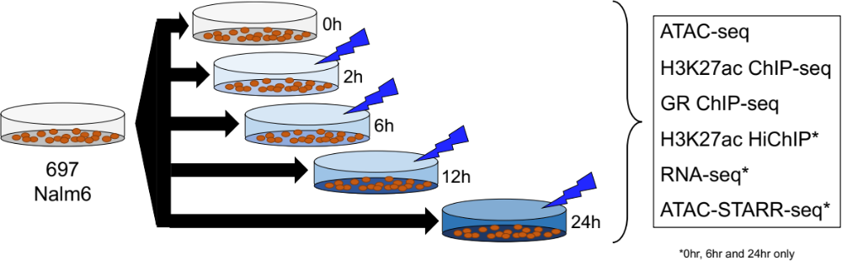

Supplementary Figure 1. Schematic outlining the GC response time course in 697 and Nalm6 cells. ATAC-seq and H3K27ac ChIP-seq were performed to identify changes in chromatin state. GR ChIP-seq was performed to identify sites of GR occupancy. RNA-seq was performed to identify changes in gene expression. H3K27ac HiChIP was used to identify interactions between cis-regulatory elements and promoters of differentially expressed genes. ATAC-STARR-seq was used to functionally validate sites of accessible chromatin. H3K27ac HiChIP, RNA-seq and ATAC-STARR-seq were only performed at 0, 6 and 24hrs.

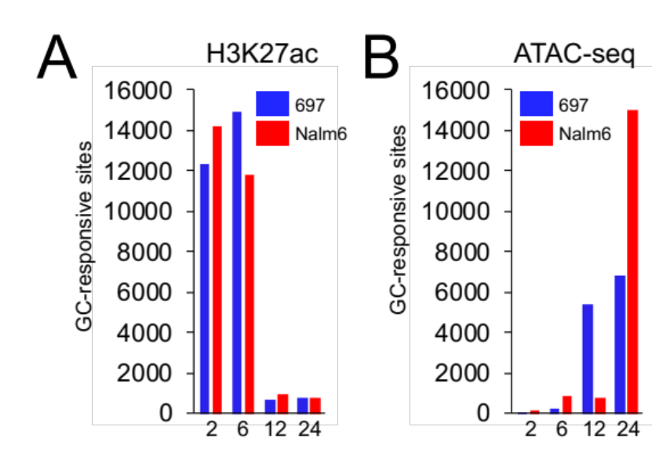

Supplementary Figure 2. (A) Initial GC-responsive changes to H3K27ac enrichment at each site are shown for each timepoint. (B) Initial GC-responsive changes to chromatin accessibility at each site are shown for each timepoint.

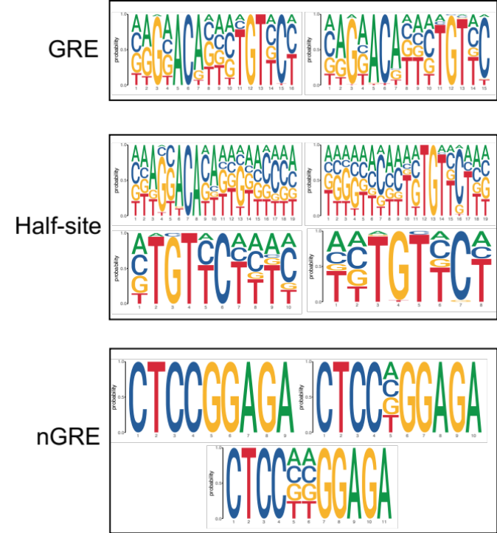

Supplementary Figure 3. GREs, weaker half-site motifs and nGREs used to identify discernable GR motifs at GR ChIP-seq sites.

Supplementary Figure 4. (A) Bar graph depicts the number of GC-responsive ATAC-seq accessible chromatin sites (ATAC) and GC-responsive H3K27ac sites in 697 cells (first) and Nalm6 cells (second). The number of GC-responsive sites that overlap with sites of GR occupancy is shown in 697 cells (blue) and Nalm6 (red) cells and the fraction of total GC-responsive ATAC-seq and H3K27ac sites with GR occupancy is provided above. (B) IGV browser track of 697 GR, ATAC-seq and H3K27ac across the time course at the PDGFRL gene locus. Sites of GR occupancy are present at GC-responsive accessible chromatin sites that exhibit enhanced accessibility following GC treatment and/or GC-responsive H3K27ac sites that exhibit enhanced enrichment following GC treatment.

Supplementary Figure 5. (A) Heatmap depicts all differentially expressed (fold change >2) genes after prednisolone treatment. A majority of genes show linear increases or decreases in expression during the time course. (B) Cumulative distribution functions of GREs exhibiting enhanced H3K27ac enrichment near up-regulated genes at 6hr and 24hr timepoints. All expressed genes are shown in black and used as a background for comparisons. Kolmogorov-Smirnov (K-S) test p-values are provided. (C) Cumulative distribution functions of HGRs exhibiting reduced H3K27ac enrichment near down-regulated genes at 6hr and 24hr timepoints. All expressed genes are shown in black and used as a background for comparisons. Kolmogorov-Smirnov (K-S) test p-values are provided.

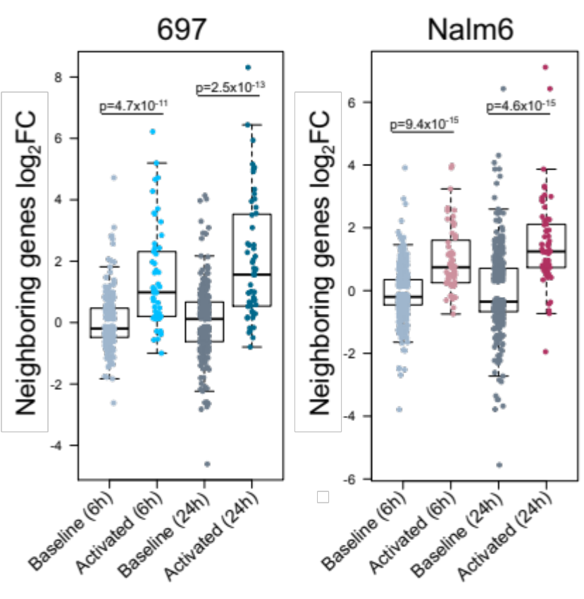

Supplementary Figure 6. Log₂ fold change following GC treatment of genes associated with SEs that are pre-established (Baseline) and genes associated with GC-responsive SEs formed after GC treatment (Activated) in 697 (left) and Nalm6 (right) cells. Log₂ fold changes of DEGs (FDR<0.01) at 6hr and 24hr following GC treatment is provided. Wilcoxon p-values show significant up-regulation of genes associated with GC-responsive SEs compared to pre-established SEs at each timepoint and in each cell.

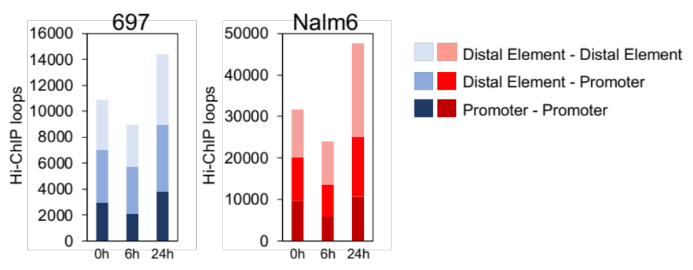

Supplementary Figure 7. H3K27ac HiChIP loops in 697 and Nalm6 cells. The number of HiChIP loops between distal elements, distal elements and promoters and between promoters is provided.

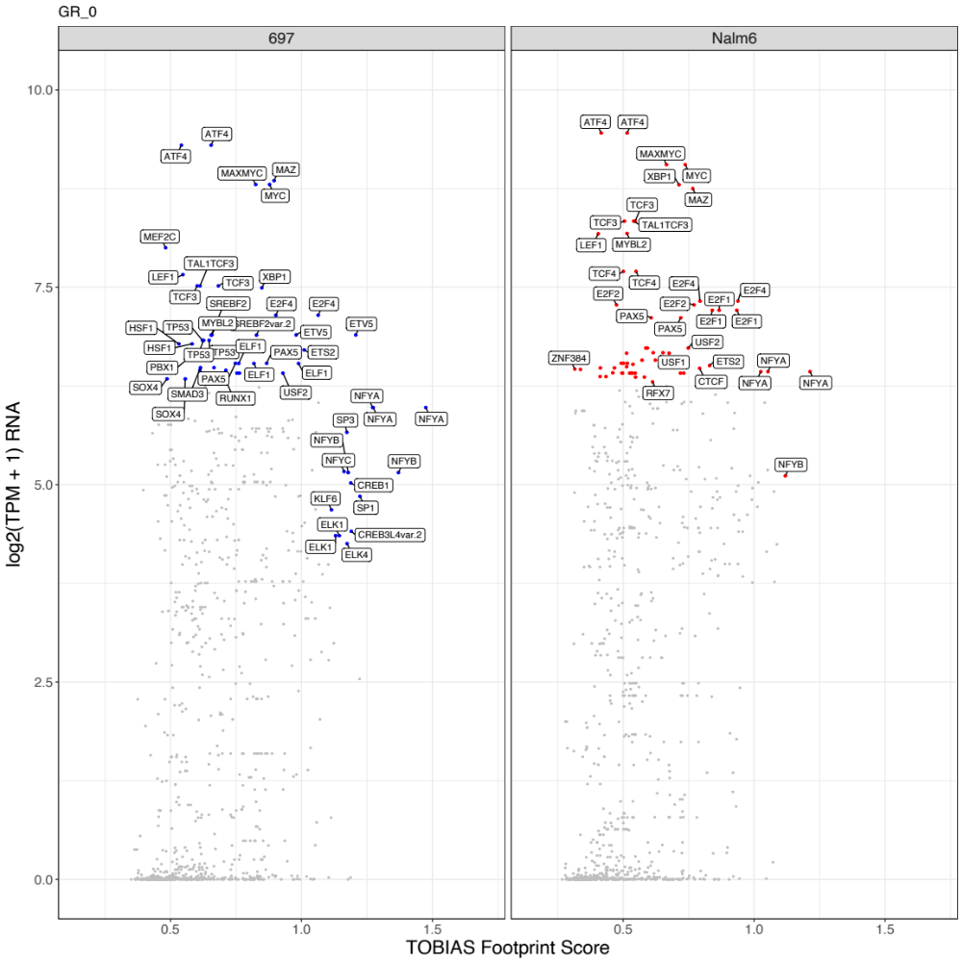

Supplementary Figure 8. Candidate cooperating TFs of GR are shown for 697 (left) and Nalm6 (right) cells. TOBIAS footprint scores (x-axis) were compared to gene expression (y-axis) obtained from 0hr RNA-seq data.

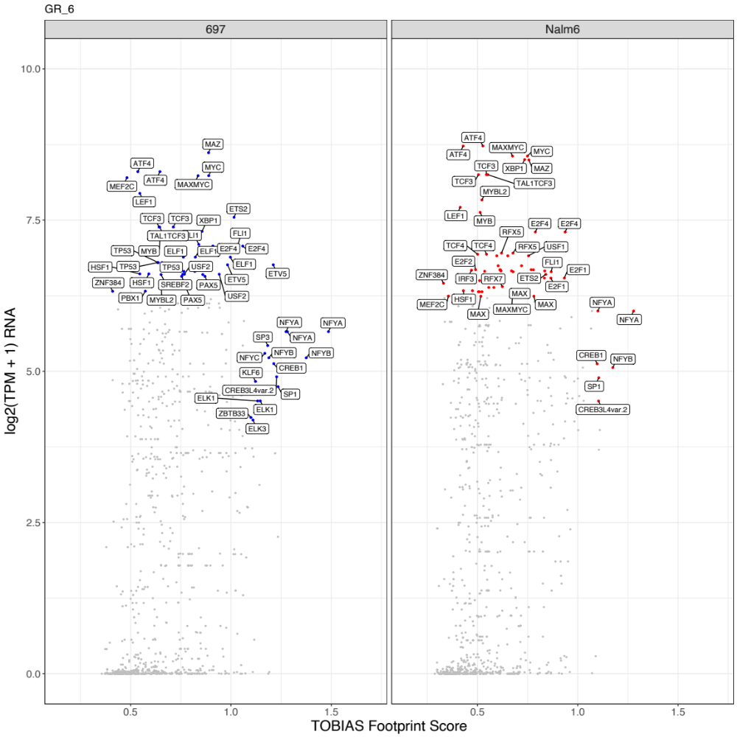

Supplementary Figure 9. Candidate cooperating TFs of GR are shown for 697 (left) and Nalm6 (right) cells. TOBIAS footprint scores (x-axis) were compared to gene expression (y-axis) obtained from 6hr RNA-seq data.

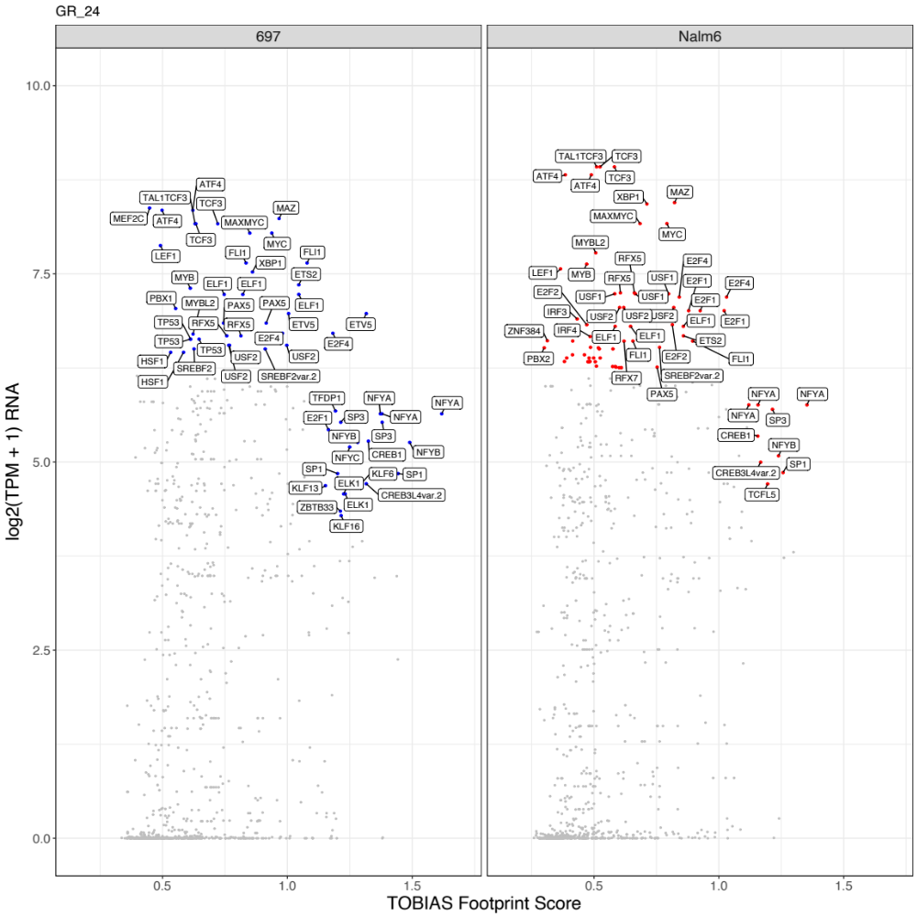

Supplementary Figure 10. Candidate cooperating TFs of GR are shown for 697 (left) and Nalm6 (right) cells. TOBIAS footprint scores (x-axis) were compared to gene expression (y-axis) obtained from 24hr RNA-seq data.

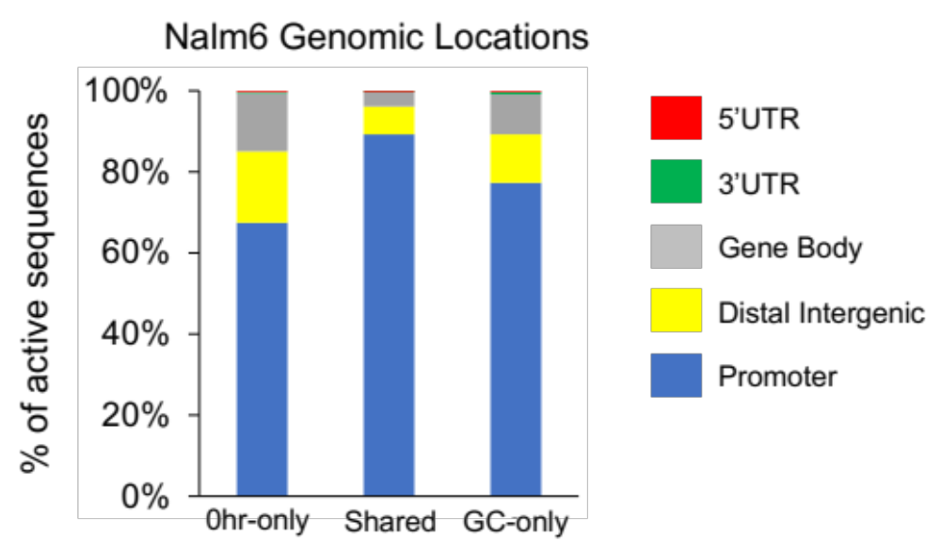

Supplementary Figure 11. Genomic locations of Nalm6 STARR-seq active sites that are shared (Shared) between 0hr and GC (6+24hr) timepoints and that are specific to 0hr (0hr-only) or GC (GC-only) timepoints is provided.

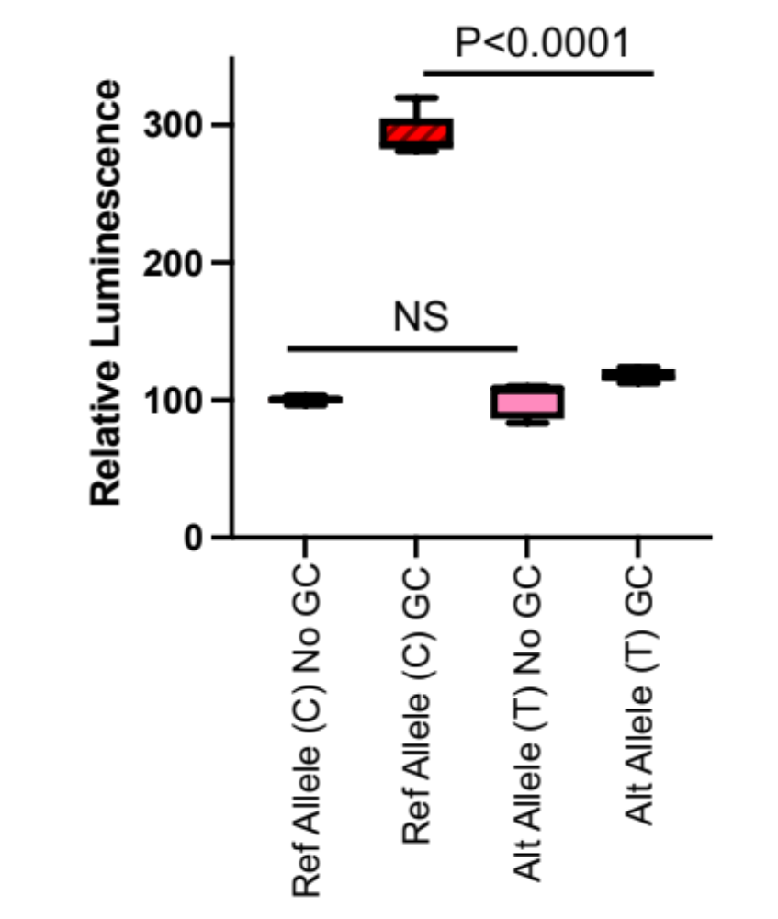

Supplementary Figure 12. Luciferase reporter assay testing a 300-bp fragment of DNA centered on the reference C allele and alternative T allele of rs7045812 in the presence or absence of prednisolone (5uM; n=5 per group).

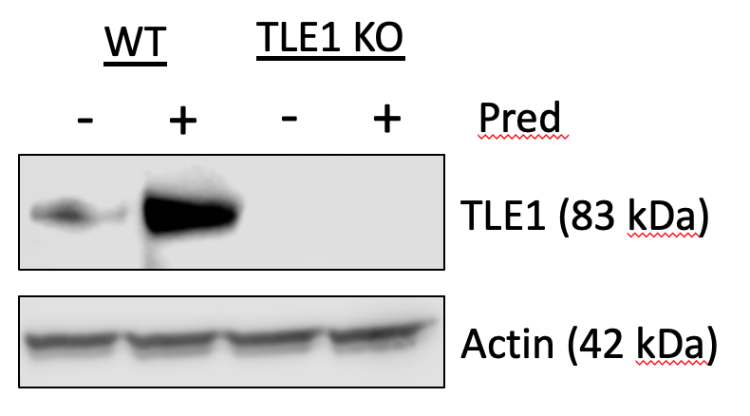

Supplementary Figure 13. Western blot shows TLE1 protein expression from TLE1 knockout Nalm6 cells (KO) and wild-type Nalm6 cells (WT) following prednisolone treatment (5uM).

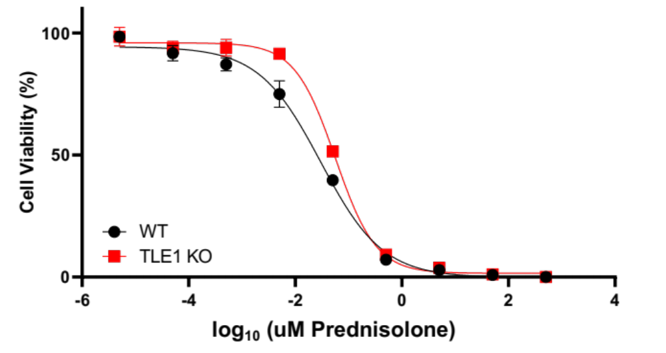

Supplementary Figure 14. Prednisolone drug response curves in TLE1 knockout Nalm6 cells (KO) and wild-type Nalm6 cells (WT). Cell viability is provided on the Y-axis and log₁₀ prednisolone concentration is shown on the X-axis. Concentrations of prednisolone used were: 5pM, 50pM, 0.5nM, 5nM, 50nM, 0.5uM, 5uM, 50uM and 500uM.

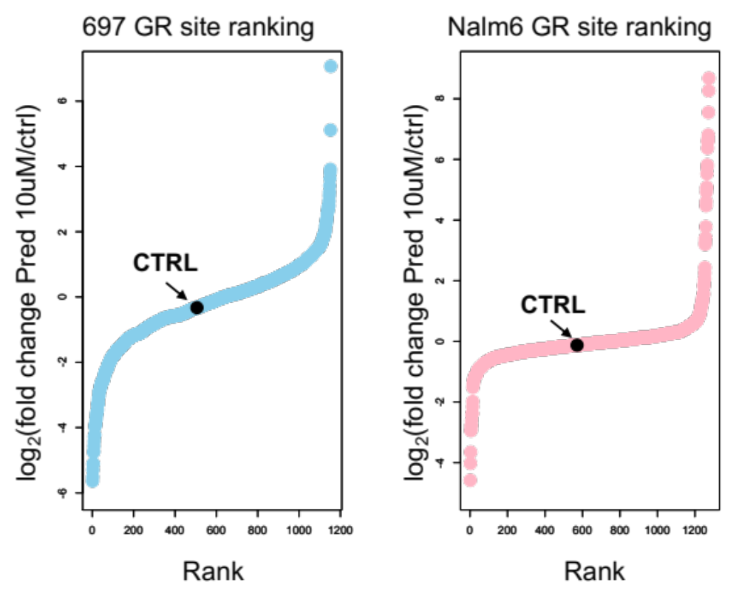

Supplementary Figure 15. Ranking of CRISPRi log₂ fold enrichment through aggregation of sgRNA results at each site of GR occupancy site in 697 (left) and Nalm6 (right) cells by is provided. The aggregate control sgRNA rank is labeled in black. All GR occupancy sites with log₂ fold enrichment >0 were further utilized in integrative analyses.

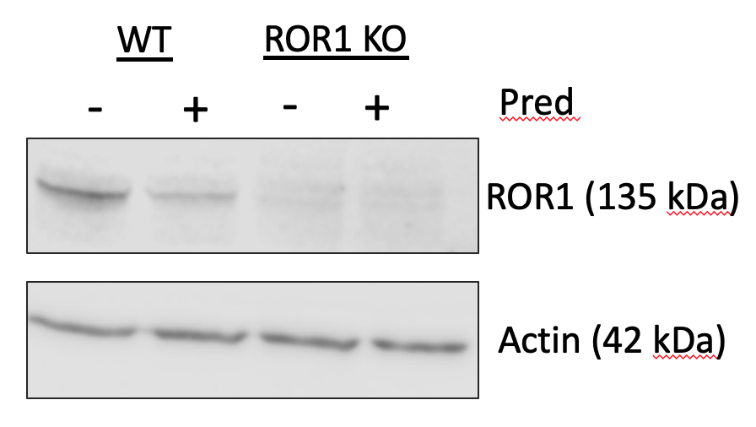

Supplementary Figure 16. Western blot shows ROR1 protein expression from partial ROR1 knockout in 697 cells (KO) and wild-type 697 cells (WT) following prednisolone treatment (10uM).

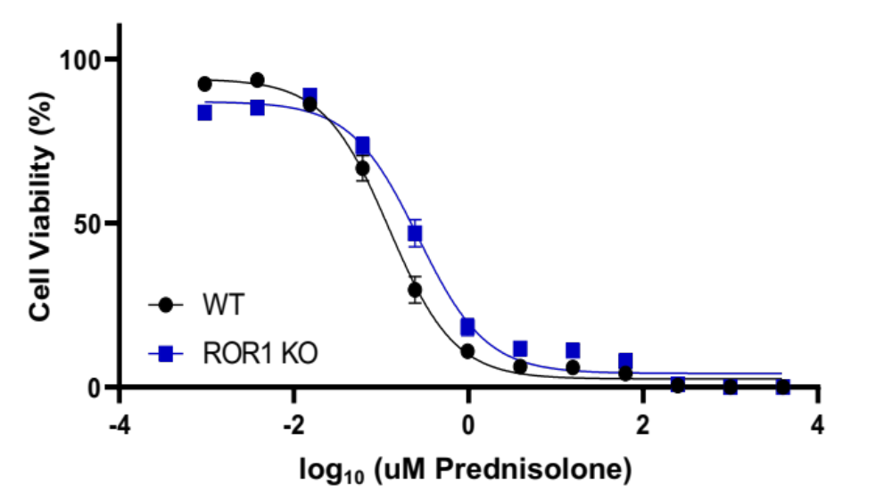

Supplementary Figure 17. Prednisolone drug response curves in partial ROR1 knockout 697 cells (KO) and wild-type 697 cells (WT). Cell viability is provided on the Y-axis and log₁₀ prednisolone concentration is shown on the X-axis (n=4 per group). Concentrations of prednisolone used were: 0.95nM, 3.8nM, 15.2nM, 61nM, 244nM, 976nM, 3.9uM, 15.6uM, 62.5uM, 250uM, 1000uM, 4000uM.

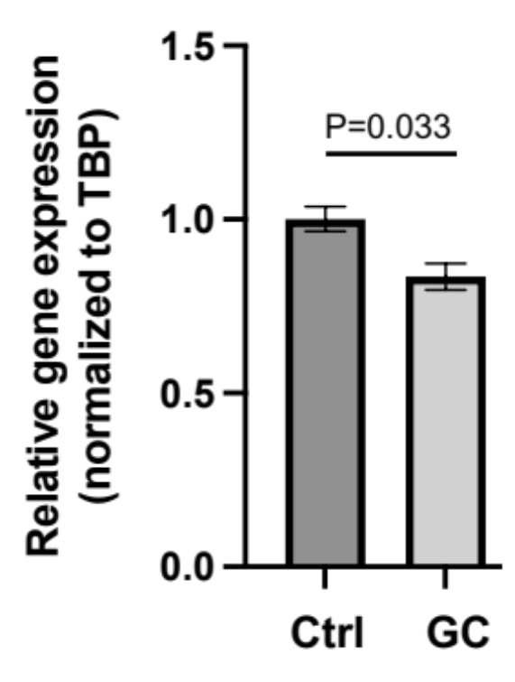

Supplementary Figure 18. RT-qPCR results of ROR1 relative gene expression in wild-type 697 cells treated with vehicle control (Ctrl) or prednisolone (10uM) for 24 hours (n=6 per group).

