7. Image sources
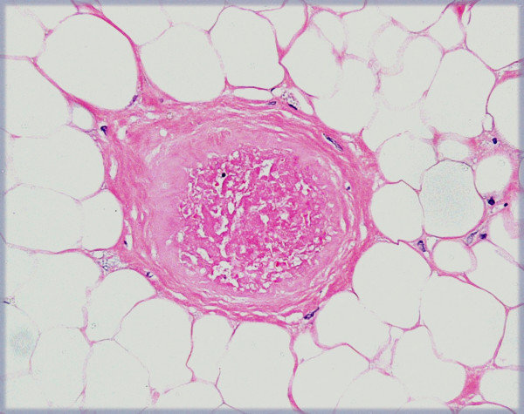
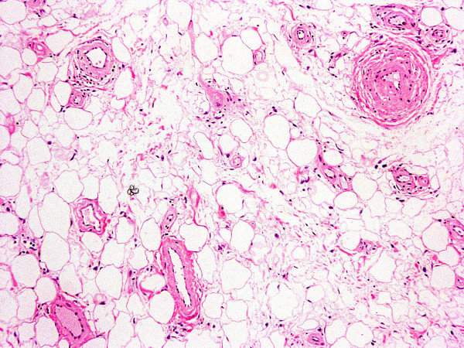

Grivas, Theodoros B., et al. "Forefoot plantar multilobular noninfiltrating angiolipoma: a case report and review of the literature." World journal of surgical oncology 6.1 (2008): 1-7.‏
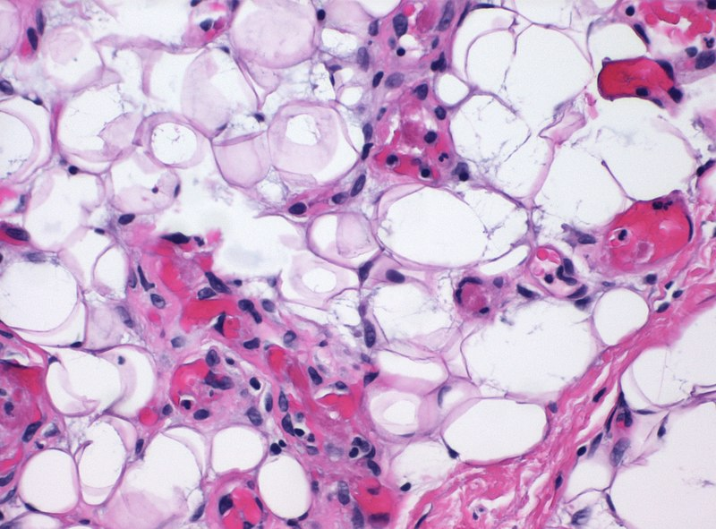

Mikael Häggström,. (9 September 2020). “Histopathology of angiolipoma.jpg”. https://upload.wikimedia.org/wikipedia/commons/thumb/4/44/Histopathology_of_angiolipoma.jpg/800px-Histopathology_of_angiolipoma.jpg?20200909203948

