2-hydroxyethyl methacrylate-derived reactive oxygen species stimulate ATP release via TRPA1 in human dental pulp cells

Ai Orimoto¹, Chiaki Kitamura ¹, and Kentaro Ono²

Supplementary Information
MATERIALS AND METHODS
ROS Detection Assay
HDPSC-K4DT cells that are immortalized DPSCs previously established¹ were seeded in a black tissue culture-treated 96-well plate, cultured to 70% confluence, and incubated at 37°C in osteogenic induction medium for 12 days. For the reactive oxygen species (ROS) detection assay, hDPSC-K4DT cells were pretreated with 6 mM PBN (N-tert-butyl-α-phenylnitrone) for 1h, then stimulated with 2-hydroxyethyl methacrylate (HEMA) (Kanto Chemical, Tokyo, Japan) at 3 or 30 mM for an additional 3 h at 37 ̊C in a humidified 5% CO₂ atmosphere. Then, the medium was aspirated, the cells were rinsed with 150 μl of cell-based assay buffer supplied with the ROS Detection Cell-Based Assay Kit (DCFDA) (Cayman, Ann Arbor, MI, USA), and 100 μl of ROS staining buffer mixed with 10 μM DCFDA was added and incubated for 90 min at 37 ̊C protected from light. After incubation, the ROS staining buffer was aspirated, and after further addition of 100 μl of cell-based assay buffer to each well, fluorescence was read on a TECAN Infinite 200 PRO plate reader (Tecan, Morrisville, NC, USA) at excitation and emission wavelengths of 485 and 535 nm, respectively.

ATP Release Assay
HDPSC-K4DT cells were seeded in 96-well plates, cultured to 70% confluence, and incubated at 37°C in an osteogenic induction medium for 14 days. Following osteogenic differentiation, HDPSC-K4DT cells were treated with HEMA at 0, 3, and 30 mM for 24 h and ATP levels were measured in cell supernatants using luminescence-based commercial kits (TOYO B-Net, Tokyo, Japan). Luminescence was measured using a microplate reader TECAN infinite 200 PRO with i-control 2.0 software (Tecan, Morrisville, NC, USA). To determine the effect of a free radical scavenger or a TRPA1 inhibitor on HEMA-induced ATP release levels, following osteogenic differentiation, the cells were pretreated with PBN (6 mM) or the TRPA1-selective antagonist HC-030031 (30 or 100 μM, FUJIFILM Wako Chemicals, Miyazaki, Japan) for 1 h, then stimulated with 30 mM HEMA for an additional 24 h before measuring ATP levels as above.

Cell viability analysis
To assess the effect of HEMA on the viability of hDPSC-K4DT cells, we used the Cell Counting Kit-8 (CCK-8; Dojindo Molecular Technologies, Gaithersburg, MD, USA). HDPSC-K4DT cells (2.5×10³ cells/well) were seeded in 96-well culture plates, incubated at 37°C for 24 h, and treated with HEMA (Kanto Chemical) at the indicated concentrations for 24 h. Then, 10 μl of the Cell Counting Kit-8 solution containing tetrazolium salt (WST-8) was added to the cell culture medium and incubated at 37°C for 1 h. Absorbance at 450 nm was measured using a microplate reader (Bio-Rad Laboratories, Tokyo, Japan).
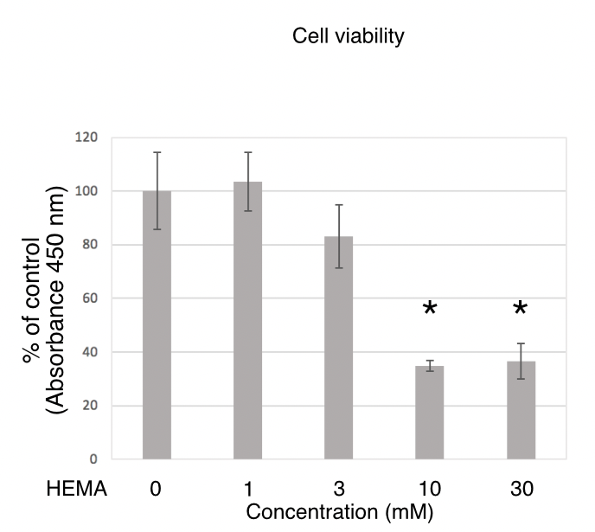

FIGURE LEGENDS
Supplementary Figure S1. Dose dependent effects of increasing concentrations of HEMA on cell viability measured with the WST-8 assay using Cell Counting Kit-8. Cells were incubated for 24 h with the indicated initial concentrations of HEMA, and cell viability was determined using WST-8. Cell viability is expressed as percentage of the control value, taken as 100%. The data are presented as the mean ± SD (n = 4). Differences were assessed by using Dunnett's post hoc test following one-way ANOVA. *P<0.05.

REFERENCES
1. Orimoto, A. et al. Efficient immortalization of human dental pulp stem cells with expression of cell cycle regulators with the intact chromosomal condition. PLoS One 15, 1–18 (2020).

