Supplementary information
FCS characterization

(a)
(b)

Fig S1 comparative TGA and DSC curves of (a) chitosan biopolymer (b) FCS

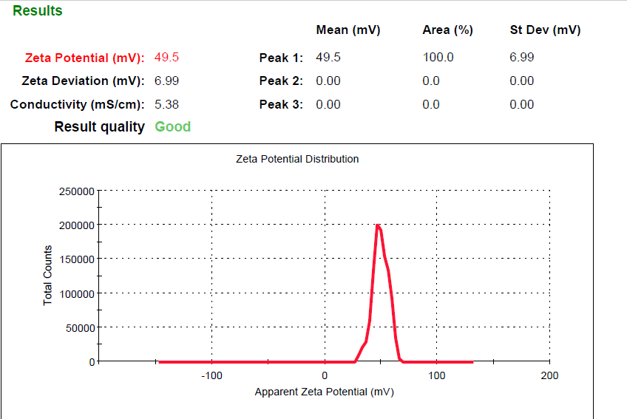
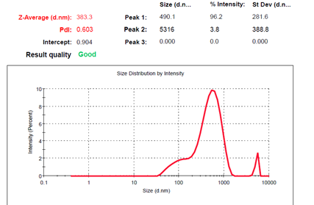
(a)
(b)

Fig S2 (a) Zeta potential (b) Particle size distribution of FCS

Table S1. Adsorption Energy values for 10 most stable poses as obtained from MC.
a) neutral (FCS)
Structures | Total energy | Adsorption energy | Rigid adsorption energy | Deformation energy | FCS: dEad/dNi | Water : dEad/dNi | Chloride ions : dEad/dNi | Hydronium ions : dEad/dNi
Substrate | 0
FCS | 90.47035217
Water | 1.40E-10
Chloride ions | 0
Hydronium ions | 4.81E-10
Pose 1 | -6.83E+03 | -6.92E+03 | -7.15E+03 | 220.77 | -275.65 | -10.88 | -162.79 | -149.71
Pose 2 | -6.83E+03 | -6.92E+03 | -7.15E+03 | 226.77 | -262.09 | -10.16 | -157.38 | -147.33
Pose 3 | -6.83E+03 | -6.92E+03 | -7.14E+03 | 222.83 | -256.74 | -11.04 | -162.48 | -147.29
Pose 4 | -6.83E+03 | -6.92E+03 | -7.14E+03 | 227.10 | -276.75 | -10.13 | -159.35 | -145.80
Pose 5 | -6.82E+03 | -6.91E+03 | -7.14E+03 | 232.15 | -283.17 | -10.09 | -160.71 | -145.24
Pose 6 | -6.82E+03 | -6.91E+03 | -7.13E+03 | 216.16 | -264.62 | -9.96 | -156.66 | -146.55
Pose 7 | -6.82E+03 | -6.91E+03 | -7.13E+03 | 224.09 | -265.66 | -9.80 | -163.33 | -146.67
Pose 8 | -6.82E+03 | -6.91E+03 | -7.14E+03 | 228.32 | -265.35 | -9.59 | -161.22 | -147.86
Pose 9 | -6.82E+03 | -6.91E+03 | -7.13E+03 | 225.21 | -268.98 | -10.91 | -159.13 | -149.09
Pose 10 | -6.82E+03 | -6.91E+03 | -7.13E+03 | 218.37 | -271.06 | -8.90 | -159.94 | -151.29

b) protonated (FCS-H+)
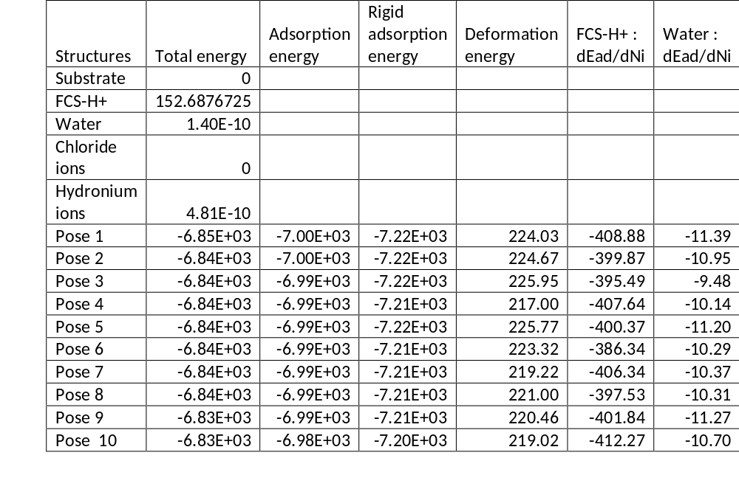

neutral
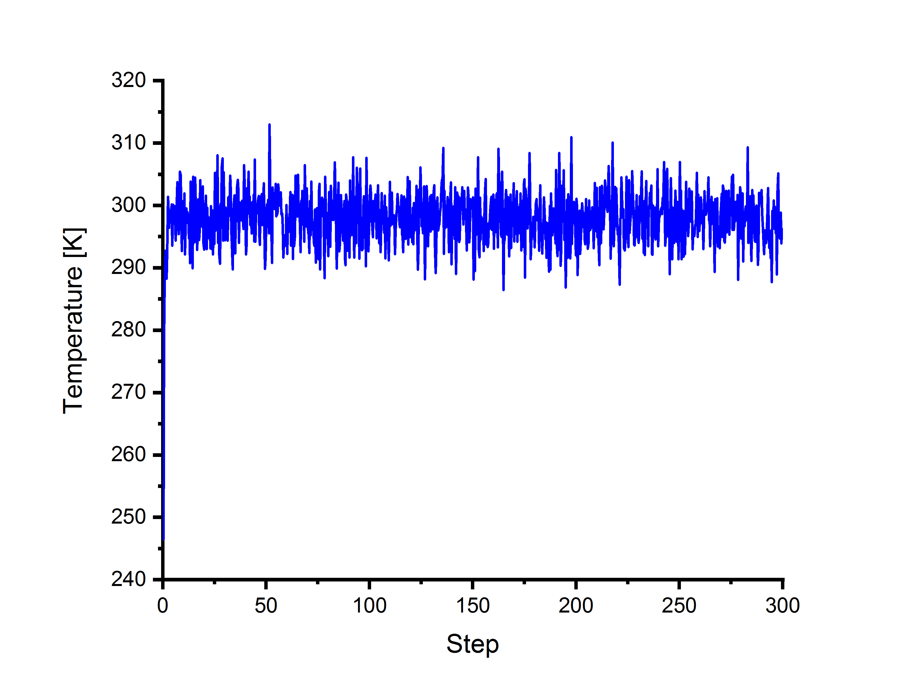
protonated
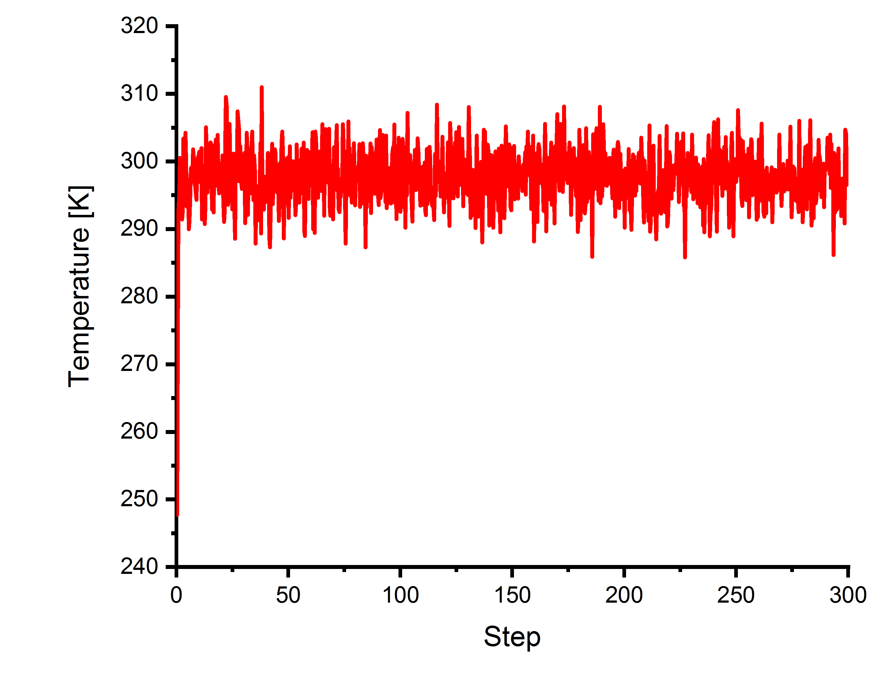
Figure S3. Temperature fluctuation graph during the MD for FCS and FCS-H+ in the simulated corrosion media on the Fe (1 1 0) surface.

Neutral
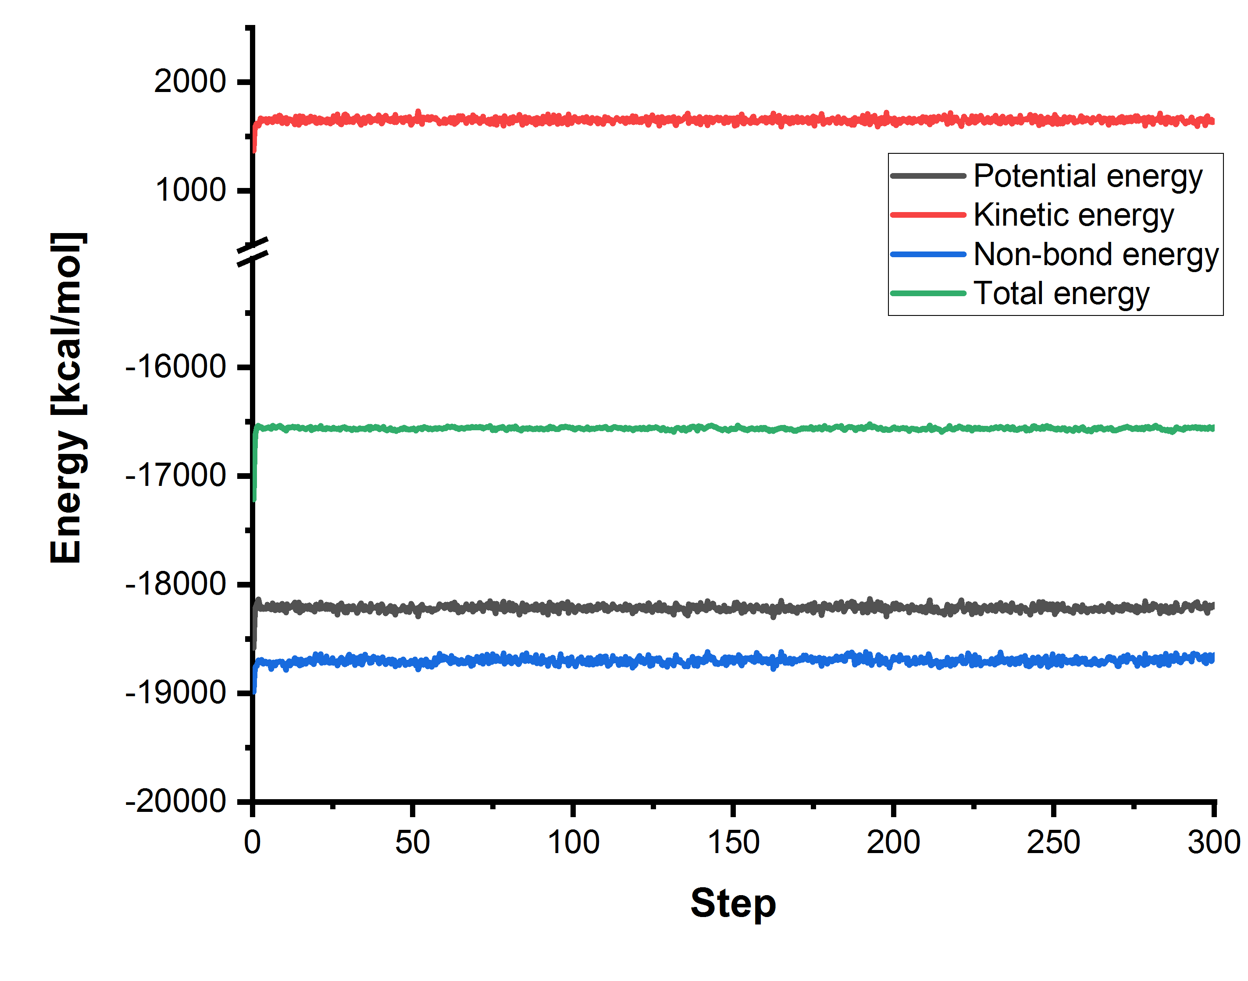
Protonated
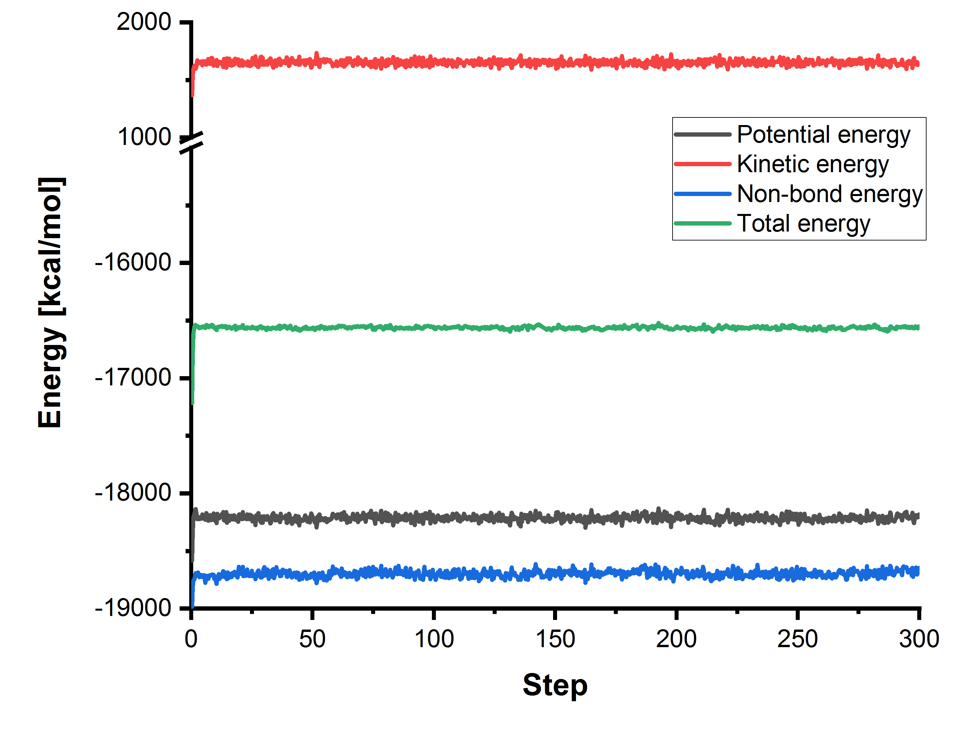
Figure S4. Fluctuation of different energy terms during the MD

