Table 1 Phytochemical screening of different solvent leaf extract of Hardwickia binata Roxb.
S. No | Primary and secondary metabolites | Methanol
1 | Carbohydrate  (Benedict’s test ) | +
2 | Protein  (Biuret test) | _
3 | Alkaloids  (Wagner’s test) | + +
4 | Phenol  (Fecl₃ test) | + + +
5 | Saponins  (Foam test) | + + +
6 | Tannins  (Fecl₃ test) | + + +
7 | Flavonoids  (Lead acetate test) | + + +
8 | Glycosides  (Keller-killani test) | + + +
9 | Steroid (Lieberman  Bur-chard test) | +
10 | Terpenoids  (Sulphuric acid test) | +

+ + + = Strongly Present, + + = Moderately Present, + = Low Present, - = Absent

S. No | RT | Peak Area% | Compound Name | Molecular Formula | Molecular Structure | Biological Activity
- 1 | 3.080 | 3.98 | Hydrazinecarbothioamide | CH₅N₃S | 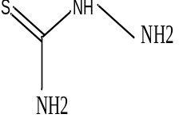 | Anticancer
- 2 | 9.934 | 2.73 | Undecane | C₁₁H₂₄ | 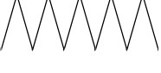 | Anti-Allergic and Anti-Inflammatory
- 3 | 14.997 | 1.22 | Quinoline, 1,2-dihydro-2,2,4-trimethyl- | C₁₂H₁₅N | 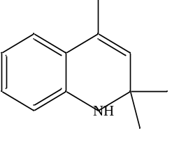 | Antioxidant.
- 4 | 15.750 | 0.66 | Phenol, 2,4-Bis (1,1-Dimethylethyl)- | C₁₄H₂₂₀ | 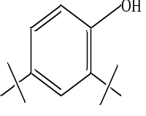 | Antibacterial and anti-inflammatory
- 5 | 18.007 | 1.81 | Tetratriacontane | C₃₄H₇₀ | 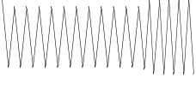 | Antibacterial and antifungal.
- 6 | 19.104 | 0.74 | Heneicosane | C₂₁H₄₄ | 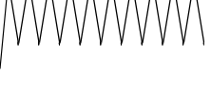 | Anti-asthmatics, urine acidifiers, antimicrobial
- 7 | 20.151 | 1.50 | Heneicosane | C₂₁H₄₄ |  | Anti-asthmatics, urine acidifiers, antimicrobial
- 8 | 20.398 | 0.99 | Hexadecanoic acid, methyl ester | C₁₇H₃₄O₂ | 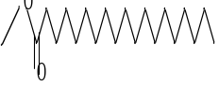 | Antibacterial, antioxidant, antitumor, immunostimulant, lipooxygenase inhibitor
- 11 | 20.749 | 8.76 | n-Hexadecanoic acid | C₁₆H₃₂O₂ | 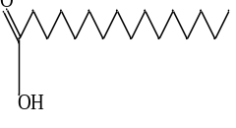 | Anti-oxidant, Hypocholesterolemic, Nematicide, Anti-androgenic, inhibitor, antipsychotic.
- 12 | 21.145 | 1.01 | Eicosane | C₂₀H₄₂ | 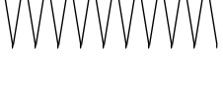 | Antibacterial
- 13 | 22.093 | 2.34 | Manganese, [[1,2-Ethanediylbis[Carbam] | C₄H₆MnN₂S₄ | 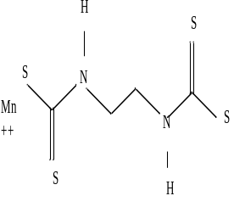 | Antimicrobial.
- 14 | 22.338 | 0.95 | Hexadecanoic acid, 16-methyl-,methyl ester | C₁₉H₃₈O₂ | 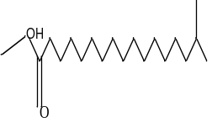 | Antibacterial and antifungal
- 15 | 22.660 | 1.05 | Octadecanoic acid | C₁₈H₃₆O₂ | 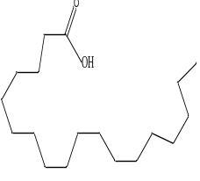 | Antifungal, Antitumor, Antibacterial.
- 16 | 23.007 | 0.70 | Eicosane | C₂₀H₄₂ |  | Antifungal, antitumor antibacterial, larvicidal, antimicrobial, cytotoxic effects.
- 17 | 23.073 | 2.35 | 1-Hexadecanol, Acetate | C₁₈H₃₆O₂ | 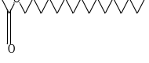 | Antimicrobial
- 18 | 23.878 | 0.67 | Tetracosane | C₂₄H₅₀ | 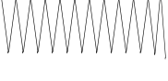 | Antioxidant and Antimicrobial
- 20 | 24.716 | 1.12 | Hexatriacontane | C₃₆H₇₄ | 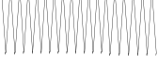 | Radical scavenger.
- 21 | 24.784 | 0.81 | 1-Heptacosanol | C₂₇H₅₆O | 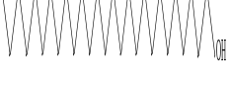 | Antioxidant and Antimicrobial activity
- 22 | 25.193 | 0.92 | 2,2,4,4,6,6,8,8,10,10,12,12,14,14,16,16,18,18,20,20-Icosamethylcyclodecasiloxane | C₂₀H₆₀O₁₀Si₁₀ | 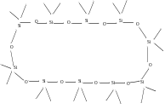 | No previous report
- 23 | 25.807 | 1.74 | Bis (2-ethylhexyl) phthalate | C₂₄H₃₈O₄ | 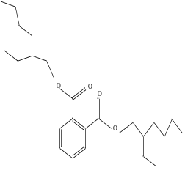 | Antimicrobial, cytotoxic,
- 24 | 26.216 | 0.82 | Tetracosamethyl-cyclododecasiloxane | C₂₄H₇₂O₁₂Si₁₂ | 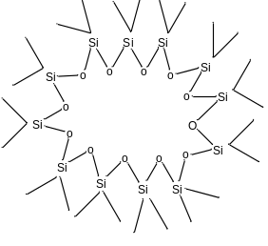 | Antioxidant
- 25 | 26.305 | 0.70 | Dotriacontane | C₃₂H₆₆ | 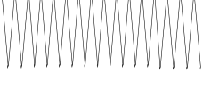 | Antimicrobial, antioxidant, antispasmodic
- 26 | 26.933 | 1.16 | 4,4'-((p-Phenylene)diisopropylidene) diphenol | C₂₄H₂₆O₂ | 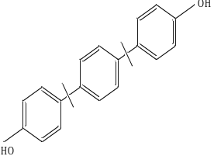 | Antioxidant, antimicrobial, mosquito larvicidal activity.
- 27 | 27.321 | 0.89 | Tetracosamethyl-cyclododecasiloxane | C₂₄H₇₂O₁₂Si₁₂ | 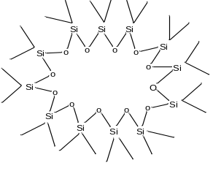 | Antioxidant
- 28 | 27.613 | 5.14 | 1,3-Benzenedicarboxylic acid, bis (2-ethylhexyl) ester | C₂₄H₃₈O₄ | 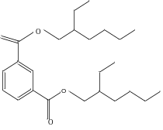 | Anti-asthmatic.
- 29 | 27.750 | 1.20 | 5-Phenyl-2,4-pyrimidinediamine, 2TMS derivative | C₁₆H₂₆N₄Si₂ | 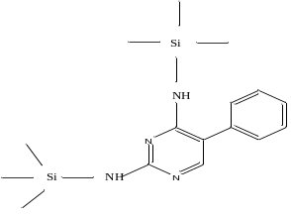 | Cytotoxic activity, antitumor.
- 30 | 28.651 | 0.99 | Tetracosamethyl-cyclododecasiloxane | C₂₄H₇₂O₁₂Si₁₂ | 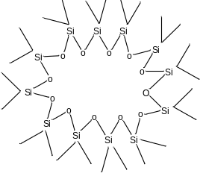 | Antioxidant
Table 2 Phytocompounds identification of MeOH - LE Hardwickia binata

