Table 1. Screening for caspase-8 activation and cytotoxicity in a series of arborinane-type triterpenoids isolated from R. philippinesis.

No | Structure | Mass m/z  (Moleclular formula) | Chemical Name | Caspase-8 activity  (RLU)† | Cytotoxicity‡  (% Cell Death)
1 | 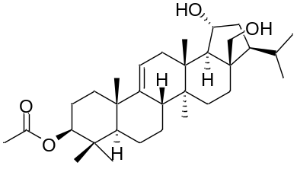 | C₃₂H₅₂O₄  (500.4) | 3-O-acetylrubiarbonol L | 13,259 ± 2,153 | 5.2 ± 1.7
2 | 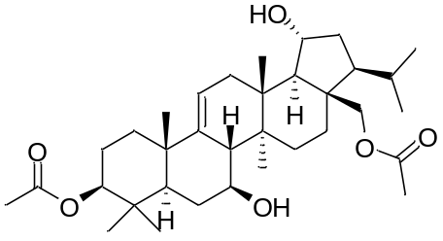 | C₃₄H₅₄O₆  (558.4) | 3-acetylrubianol C | 14,768 ± 4,325 | 3.5 ± 0.4
3 | 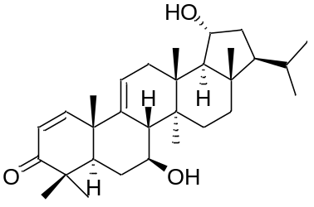 | C₃₀H₄₆O₃  (454.3) | 28-deoxyrubiarbonone E | 22,542 ± 3,164 | 5.1 ± 1.2
4 | 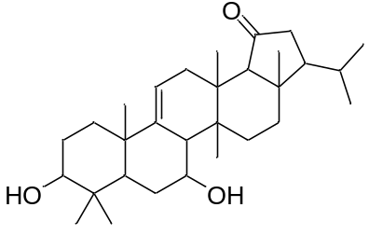 | C₃₀H₄₈O₃  (456.4) | 19-Dedihydrorubiarbonol B | 47,214 ± 2,037 | 15.2 ± 4.6

5 | 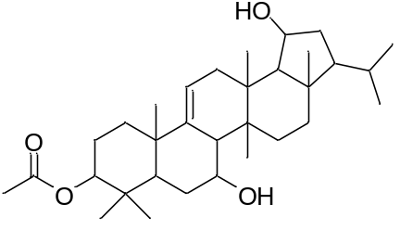 | C₃₂H₅₂O₄  (500.4) | 3-O-acetylrubiarbonol B | 21,891 ± 2,958 | 5.9 ± 0.5
6 | 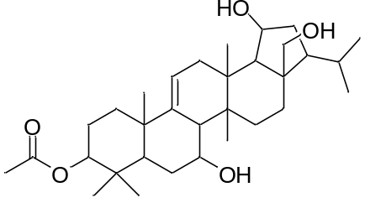 | C₃₂H₅₂O₅  (516.4) | 3-O-acetylrubiarbonol A | 23,984 ± 3,015 | 16.5 ± 3.7
7 | 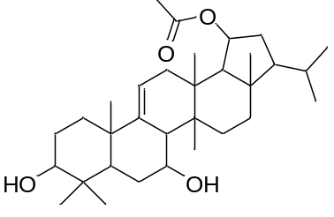 | C₃₂H₅₂O₄  (500.4) | 19-O-acetylrubiarbonol B | 51,032 ± 3,324 | 24.8 ± 4.0
8 | 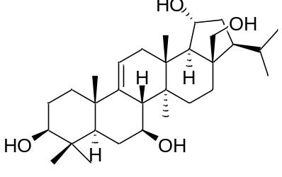 | C₃₀H₅₀O₄  (474.4) | Rubiarbonol A | 34,650 ± 2,367 | 6.5 ± 1.1
9 | 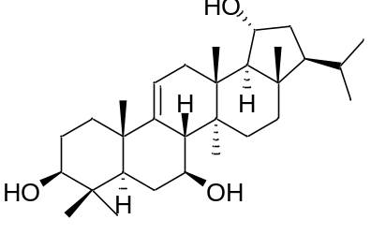 | C₃₀H₅₀O₃  (458.4) | Rubiarbonol B | 146,856 ± 28,250 | 35.4 ± 5.9
10 | 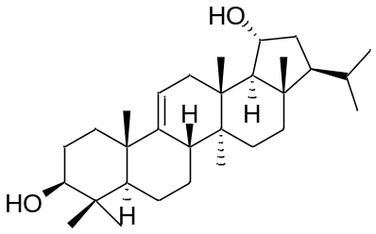 | C₃₀H₅₀O₂  (442.4) | Rubiarbonol K | 30,112 ± 3,016 | 4.9 ± 1.8
11 | 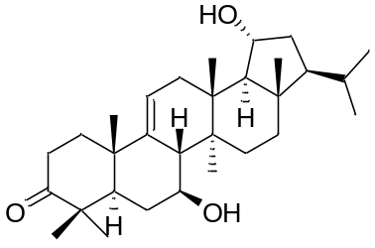 | C₃₀H₄₈O₃  (456.4) | Rubiarbonone D | 37,479 ± 3,654 | 3.6 ± 1.5
12 | 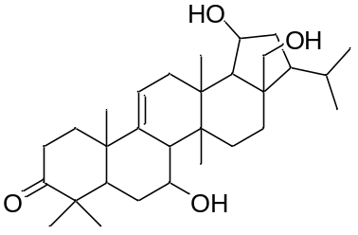 | C₃₀H₄₈O₄  (472.4) | Rubiarbonone B | 38,818 ± 2,872 | 2.6 ± 0.7
13 | 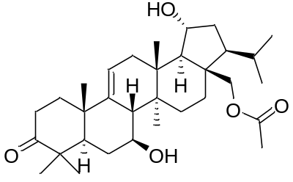 | C₃₂H₅₀O₅  (514.4) | Rubiarbonone C | 52,149 ± 3,607 | 23.1 ± 5.5

† RLU, relative luminescence unit.
‡ HCT116 cells were treated with a series of arboriane-type triterpenoids (10 μM) for 24 h, and cell death was quantified using the cell viability assay kit (Promega) and the results were expressed as mean ± SE.

