Supporting information
Decreasing the melting point? Replacing benzyl chloride with a lignin-degradation product in cellulose etherification.
Cellulose 2022

Mohamed Yahia^{1,2}, Ola Sundman^{1,*}
¹ Department of Chemistry, Umeå University, Umeå, SE-90187, Sweden.
²Chemistry Department, Faculty of Science, Helwan University, 11795, Cairo, Egypt.

Table S1. Theoretical areas of integration assuming that every proton has the area of one (1) and the calculated degree of substitution (DS) using equation (2).
DS | A1 | A2 | Calc DS
0.1 | 0.3 | 7.8 | 0.1
0.5 | 1.5 | 11 | 0.5
1 | 3 | 15 | 1
1.5 | 4.5 | 19 | 1.5
2 | 6 | 23 | 2
2.5 | 7.5 | 27 | 2.5
3 | 9 | 31 | 3

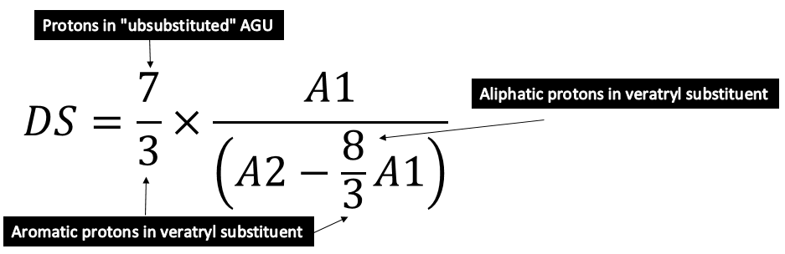
Fig. S1. The equation for calculating the degree of substitution for veratryl cellulose.

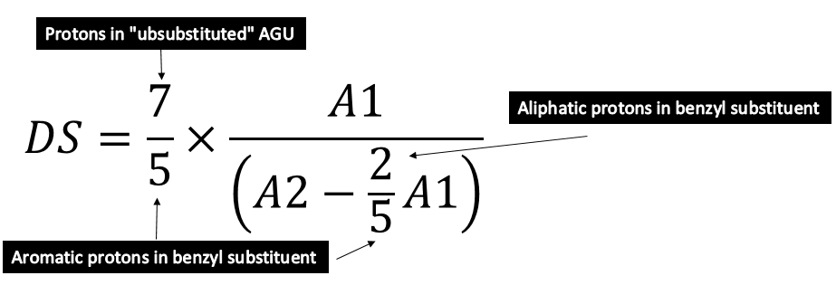
Fig. S2. The equation for calculating the degree of substitution for benzyl cellulose.

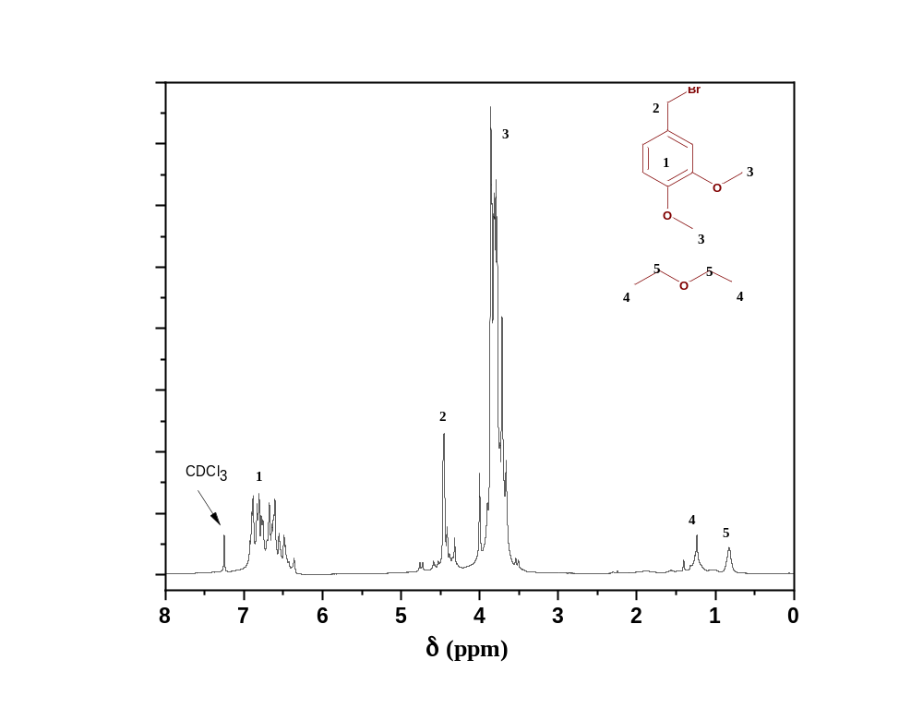
Fig. S3. ¹H NMR spectrum for synthesised (V-Br) using diethyl ether as a solvent instead of CH₂Cl₂.
Fig. S3. displays the H-NMR spectrum for veratryl bromide synthesis using diethyl ether as a solvent instead of CH₂Cl₂. It is clear that the obtained product contains side products. The figure shows that two additional signals appear in the range ( 0.5-1.5 ppm). These peaks are associated with the decomposition of the solvent diethyl ether by the highly aggressive reagent PBr₃. I.e. side products (e.g. ethyl bromide) are formed. Furthermore, some peaks overlapped with the target peaks for veratryl bromide at the range ( 3-5 ppm) associated with the diethyl ether solvent peaks.

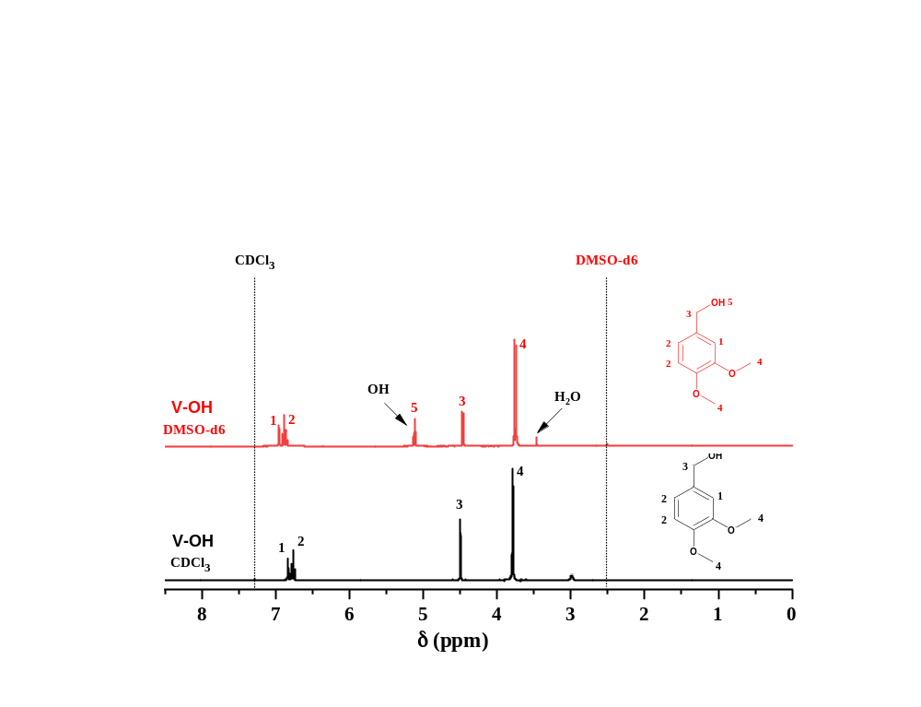
Fig. S4. ¹H NMR spectra for (V-OH) with two different deuterated solvents (CDCl₃ and DMSO-d6).

Fig. S4. represents the ¹H NMR spectra for veratryl alcohol using two different deuterated solvents (CDCl₃ and DMSO-d6). The figure indicates that the peak associated with the hydroxyl group in the veratryl alcohol does not appear when using CDCl₃ solvent but when DMSO-d6 is used. This behaviour is related to the stability of the CCl₃⁻ ion; chloroform is slightly acidic and has a replaceable proton. Thus, phenolic protons do not usually appear in proton NMR when using CDCl₃ because of rapid exchange. Therefore, to see such a signal, the veratryl alcohol sample should be run in DMSO-d6. As an additional comment, neither V-Cl nor V-Br were soluble in DMSO-d6.

