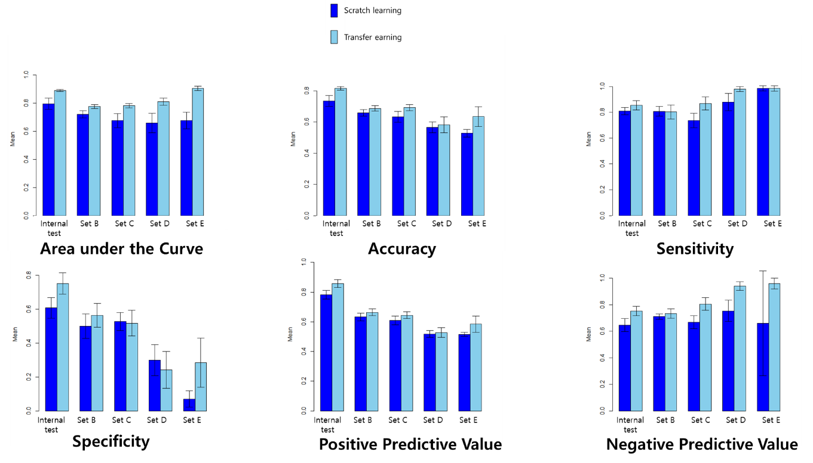

Supplementary Figure 1. Comparing the performances between scratch learning versus transfer learning in 5 data

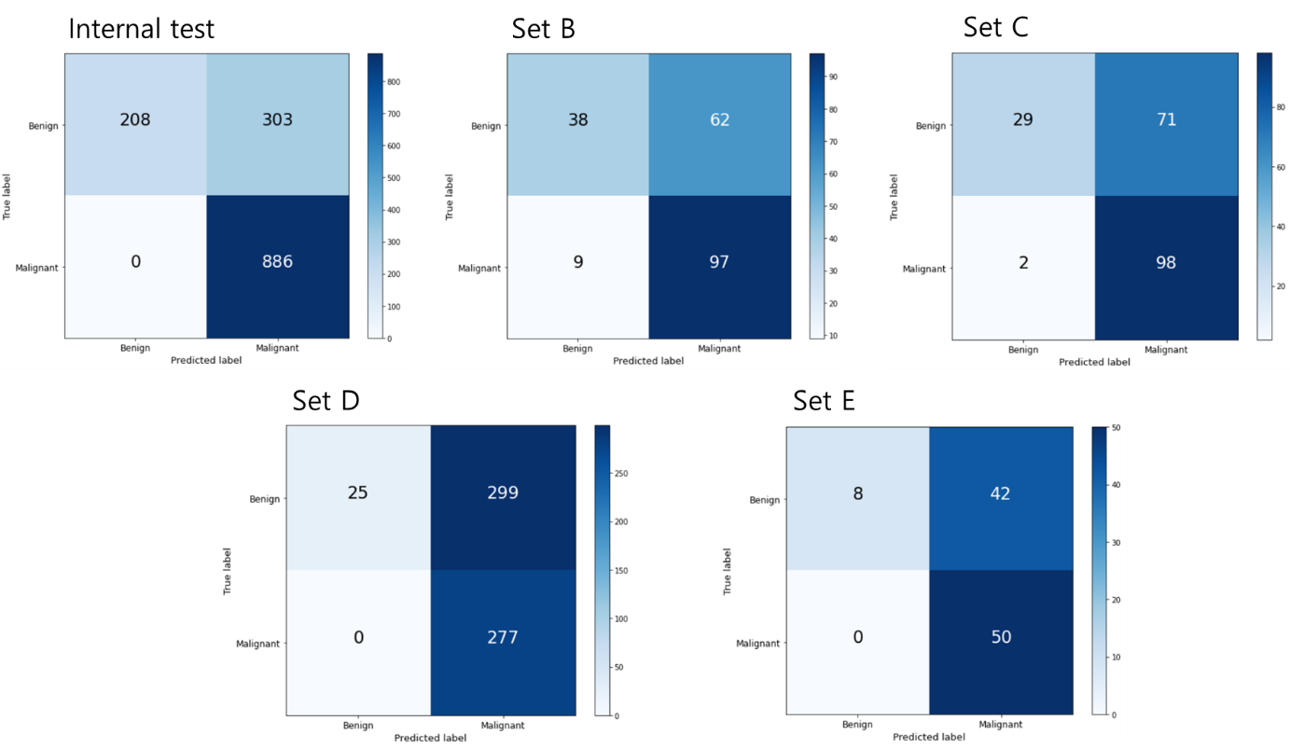
Supplementary Figure 2. Illustration of the missed malignancy and over-diagnosis as malignancy rate according by probability threshold 0.3 using VGG19

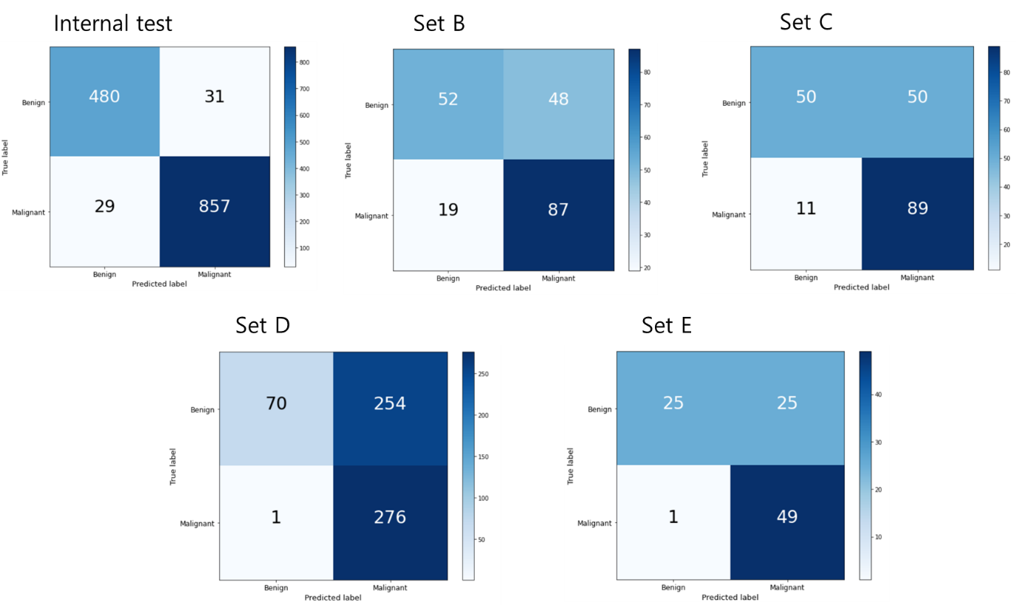
Supplementary Figure 3. Illustration of the missed malignancy and over-diagnosis as malignancy rate according by probability threshold 0.5 using VGG19

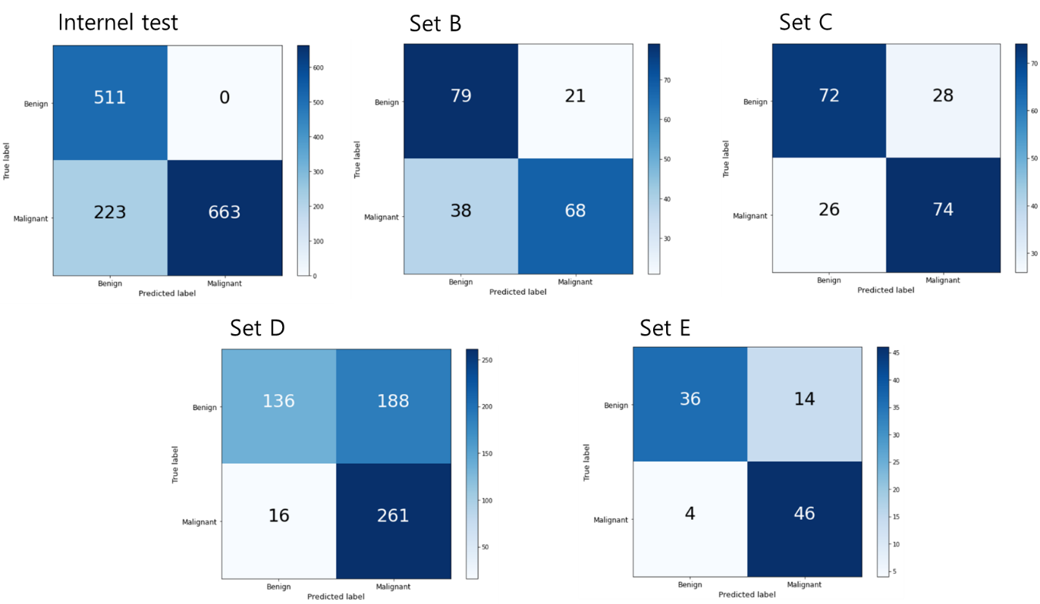
Supplementary Figure 4. Illustration of the missed malignancy and over-diagnosis as malignancy rate according by probability threshold 0.7 using VGG19

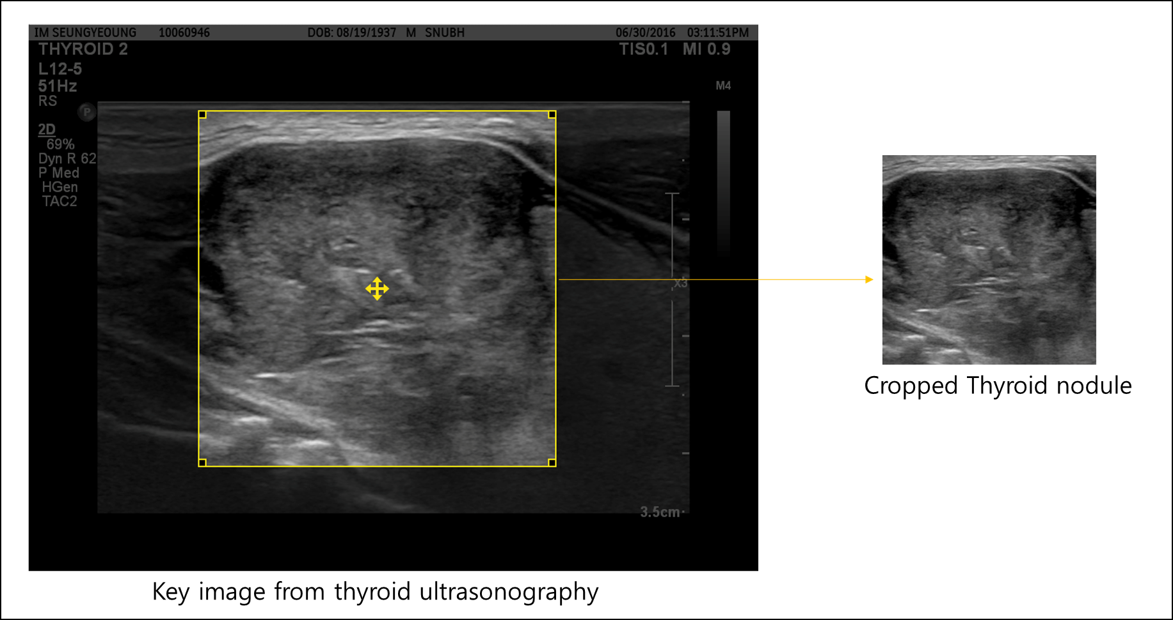
Supplementary Figure 5. Cropping the region of interest from the thyroid US image The yellow box is adjusted to place the thyroid nodule in center. Once the yellow box is placed, “save cropped image” function will save the cropped image automatically.

Supplementary Figure 6. General schematic map of convolutional neural network architecture

