Table 1. Patient characteristics

Parameter | UCB-Haplo Group  (n, Percent %) | Haplo Group  (n, Percent %)
Age at HSCT, years
< 20 | 15/53 (28.30 %) | 9/26 (34.62 %)
20-40 | 27/53 (50.94 %) | 11/26 (42.31 %)
> 40 | 11/53 (20.75 %) | 6/26 (23.08 %)
Gender
Male | 27/53 (50.94 %) | 14/26 (53.85 %)
Female | 26/53 (49.06 %) | 12/26 (46.15 %)
Disease diagnosis
AA | 15/53 (28.30 %) | 4/26 (15.38 %)
MDS | 11/53 (20.75 %) | 6/26 (23.08 %)
AML | 15/53 (28.30 %) | 9/26 (34.62 %)
ALL | 9/53 (16.98 %) | 5/26 (19.23 %)
Others | 3/53 (5.66 %) | 2/26 (7.69 %)
Disease status
CR1 | 18/53 (33.96 %) | 7/26 (26.92 %)
CR2 | 2/53 (3.77 %) | 2/26 (7.69 %)
MRD positive | 2/53 (3.77 %) | 1/26 (3.85 %)
PR | 0/53 (0.00 %) | 5/26 (19.23 %)
NR | 16/53 (30.19 %) | 7/26 (26.92 %)
Donor recipient relationship
Female-male | 4/53 (7.55%) | 4/26 (15.38%)
Second-degree donor | 4/53 (7.55%) | 0/26 (0.00%)
Others | 45/53 (84.90%) | 22/26 (84.62%)
Mismatched HLA
3 loci | 34/53 (64.15%) | 13/26 (50.00%)
2 loci | 9/53 (16.98%) | 5/26 (19.23%)
0-1 locus | 10/53 (18.87%) | 8/26 (30.77%)
ABO match
Matched | 29/53 (54.72%) | 13/26 (50.00%)
Minor mismatched | 10/53 (18.87%) | 4/26 (15.38%)
Major mismatched | 10/53 (18.86%) | 7/26 (26.92%)
Major and minor mismatched | 4/53 (7.55%) | 2/26 (7.69%)
EBMT risk score
0-1 point | 17/53 (32.08%) | 4/26 (15.38%)
2-3 points | 19/53 (35.85%) | 9/26 (34.62%)
4-6 points | 17/53 (32.08%) | 13/26 (50.00%)
Abbreviations: HSCT: hematopoietic stem cell transplantation; UCB-Haplo Group: haploidentical HSCT with an unrelated umbilical cord blood infusion; AA: aplastic anemia; MDS: myelodysplastic syndrome; AML: acute myeloid leukemia; ALL: acute lymphoid leukemia; CR: complete remission; MRD: minimal residual lesion; PR: partial remission; NR: non-remission; HLA: human leukocyte antigen; EBMT: the European group for blood and marrow transplantation.

Table 2. Grafts Data
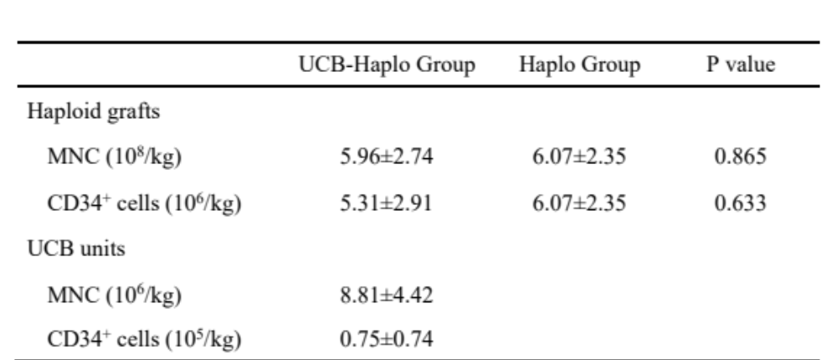
Abbreviations: UCB-Haplo Group: haploidentical hematopoietic stem cell transplantation with an unrelated umbilical cord blood infusion; MNC: mononuclear cell.

Table 3. Univariate analysis of the OS, PFS, TRM, and relapse rate

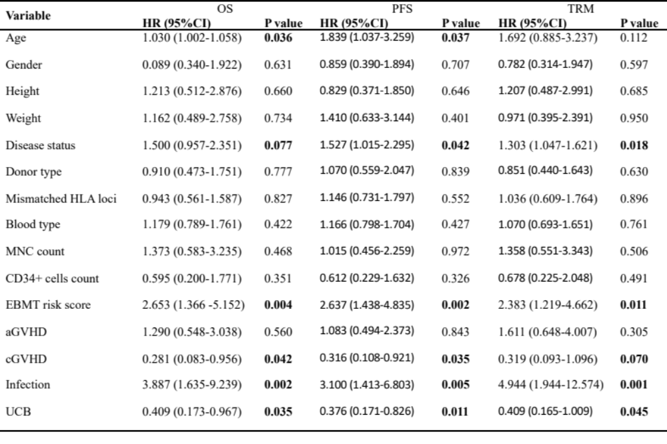
Abbreviations: OS: overall survival; PFS: progression free survival; TRM: transplant-related mortality; HR: hazard ratio; CI: confidence interval; HLA: human leukocyte antigen; MNC: mononuclear cell; EBMT: the European group for blood and marrow transplantation; GVHD: graft versus host disease. Factors with P > 0.10 were excluded.

Table 4. Multivariate analysis of the OS, PFS, TRM, and relapse rate
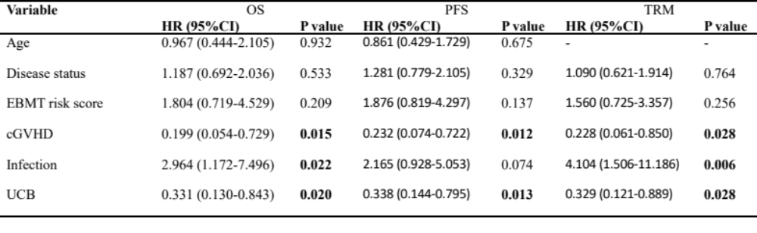
Abbreviations: OS: overall survival; PFS: progression free survival; TRM: transplant-related mortality; HR: hazard ratio; CI: confidence interval; EBMT: the European group for blood and marrow transplantation; GVHD: graft versus host disease. Factors with P > 0.05 were excluded.

