Supplementary Information for
Regulating bimetallic active centers for exploring the structure-activity relationship upon high-performance photocatalytic nitrogen reduction
Supplementary Figures

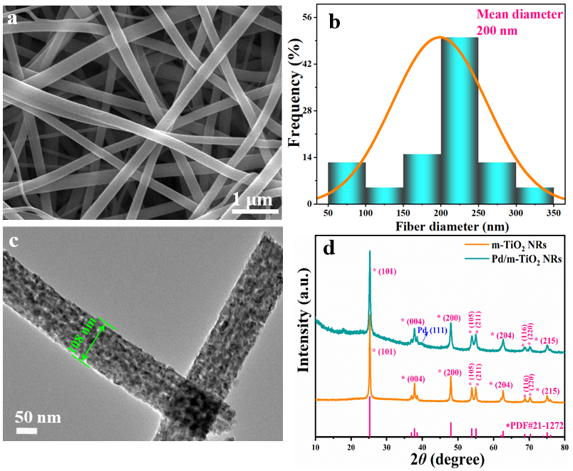
Supplementary Fig. 1 a SEM image and b diameter distribution of TiO₂ NFs. c TEM image of the m-TiO₂ NRs. d XRD patterns of m-TiO₂ NRs and se-Pd/m-TiO₂ NRs.

Supplementary Fig. 2 HAADF-TEM image of se-Au/m-TiO₂ NRs (a), and the TEM EDS elemental mapping of Ti (b), O (c), and Au (d) elements for se-Au/m-TiO₂ NRs.
Supplementary Fig. 3 HAADF-TEM image of se-Pt/m-TiO₂ NRs (a), and the TEM EDS elemental mapping of Ti (b), O (c), and Pt (d) elements for se-Pt/m-TiO₂ NRs.
Supplementary Fig. 4 TEM (a) and HRTEM (b) images of fe-Pd/m-TiO₂ NRs. TEM (c) and HRTEM (d) images of fe-Au/m-TiO₂ NRs. TEM (e) and HRTEM (f) images of fe-Pt/m-TiO₂ NRs. The insets of (a), (c), and (e) are the particle size distribution of fe-Pd, Au, and Pt NPs. Spatial distribution of the LSPR-induced enhancement of the electric field intensity from the FDTD simulations for the fe-Pd/m-TiO₂ NRs (g), fe-Au/m-TiO₂ NRs (h) and fe-Pt/m-TiO₂ NRs (i) at excitation wavelengths of 550 nm.

Supplementary Fig. 5 Time-resolved PL decay spectra of (a) m-TiO₂ NRs, (b) se-Pd/m-TiO₂ NRs, (c) se-Au/m-TiO₂ NRs, (d) se-Pt/m-TiO₂ NRs, (e) fe-Pd/m-TiO₂ NRs, (f) fe-Au/m-TiO₂ NRs and (g) fe-Pt/m-TiO₂ NRs.

Supplementary Fig. 6 N₂ adsorption-desorption isotherms and the corresponding pore size distribution curves (insert) of (a) m-TiO₂ NRs, (b) se-Pd/m-TiO₂ NRs, (c) se-Au/m-TiO₂ NRs, (d) se-Pt/m-TiO₂ NRs, (e) fe-Pd/m-TiO₂ NRs, (f) fe-Au/m-TiO₂ NRs and (g) fe-Pt/m-TiO₂ NRs.

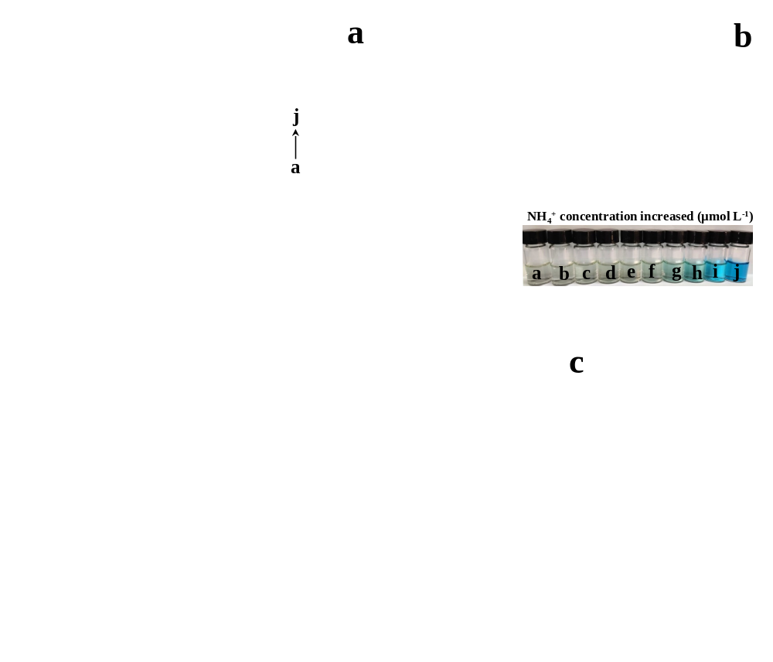
Supplementary Fig. 7 Absolute calibration of the indophenol blue method using NH₄Cl solutions of known concentration as standards. a UV-vis curves of indophenol assays with NH₄⁺ after incubated for 0.5 h at room temperature. b Calibration curve used for estimation of NH₃ by NH₄⁺ concentration. The absorbance at 630 nm was measured by UV-vis spectrophotometer, and the fitting curve shows good linear relation of absorbance with NH₄⁺ concentration (y = 0.01293x + 0.03735, R² = 0.99991) of calibration curves. c Calibration curve of NH₄⁺ with indophenol indicator (y = 0.7185x + 0.03735, R² = 0.99991).

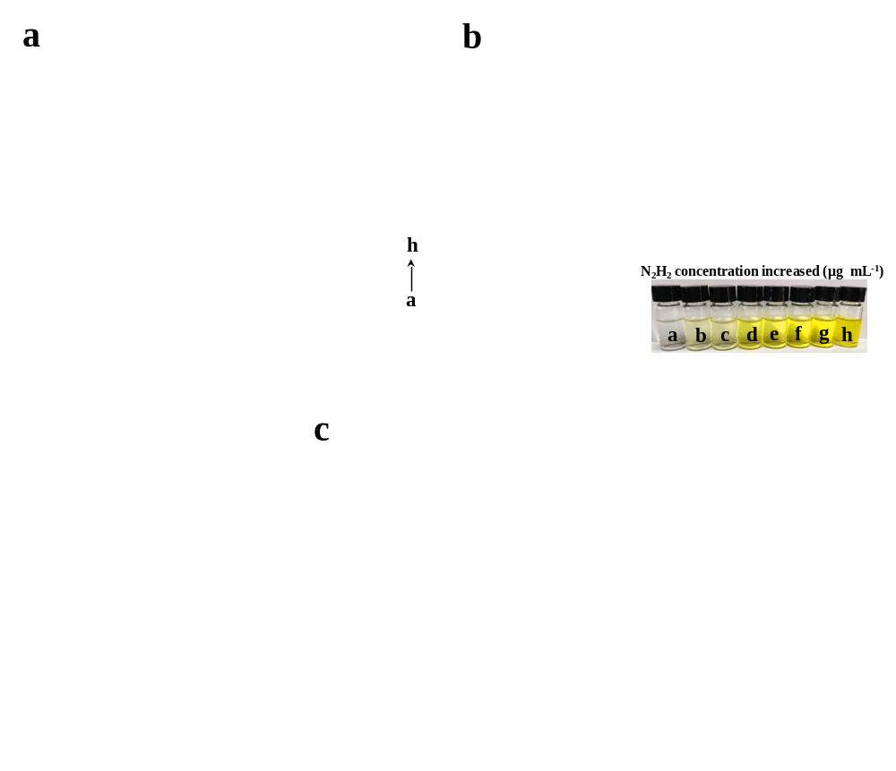
Supplementary Fig. 8 Absolute calibration of the Watt and Chrisp (para-dimethylaminobenzaldehyde) method for the estimating of N₂H₄ concentration using N₂H₄·H₂O solutions with known concentration as standards. a UV-Vis absorption spectra of various N₂H₄ concentrations after incubated for 20 min at room temperature. b Calibration curve used for estimation of N₂H₄ concentration. The absorbance at 458 nm was measured by UV-vis spectrophotometer, and the fitting curve shows good linear relation of absorbance with N₂H₄ concentration (y = 1.042x + 0.01433, R² = 0.99996) of calibration curves. c UV-vis absorption spectra of reaction solution by different catalysts in the first 1 h. No N₂H₄ was detected at 458 nm.
Supplementary Fig. 9 The schematic of the photochemical setup for N₂ fixation.

Supplementary Fig. 10 a AQEs (green pentagram) for pNRR over se-Pd/m-TiO₂ NRs in pure water under monochromatic light irradiation in regard to its UV–vis DRS spectrum (cyan line). b Schematic illustration of the in situ FTIR instrument with a cold white light LED illumination.
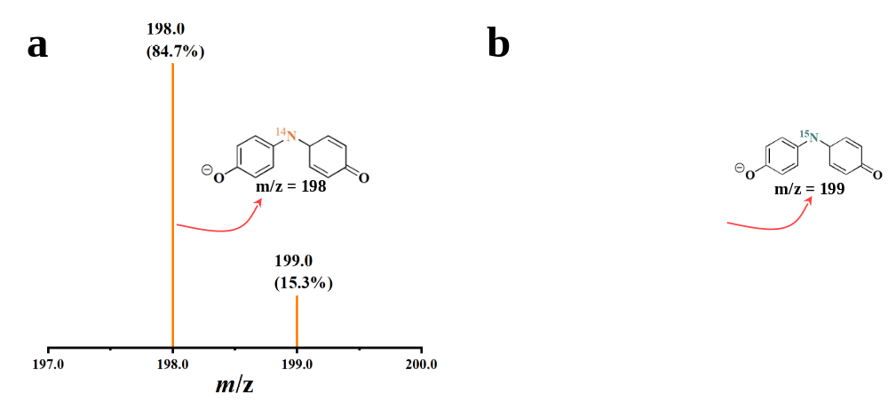
Supplementary Fig. 11 Mass spectral illustrations of the indophenol from (a) ¹⁴N₂ and (b) ¹⁵N₂ atmospheric conditions; the insets of (a) and (b) show the chemical structure of the indophenol anion responsible for the signals at m/z 198 (containing ¹⁴N) and 199 (containing ¹⁵N).

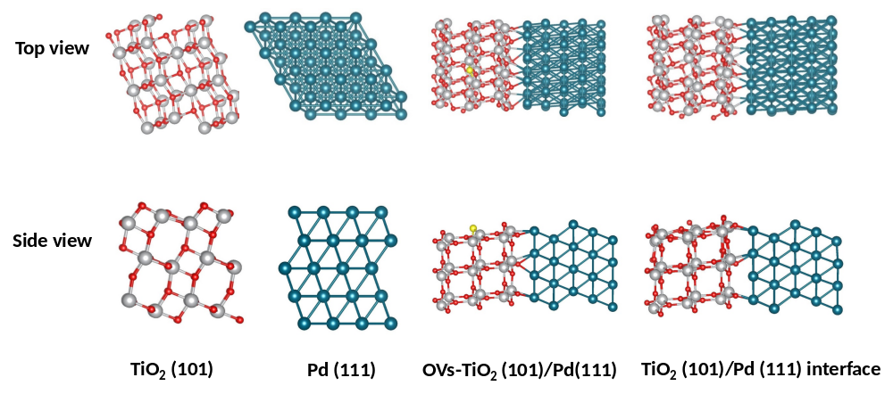
Supplementary Fig. 12 The optimized geometric structures of TiO₂ (101), Pd (111), OVs-TiO₂ (101)/Pd (111), TiO₂ (101)/Pd (111) interface. Color code: Gray, red, dark cyan, and yellow spheres represent Ti atoms, O atoms, Pd atoms, and OVs, respectively.
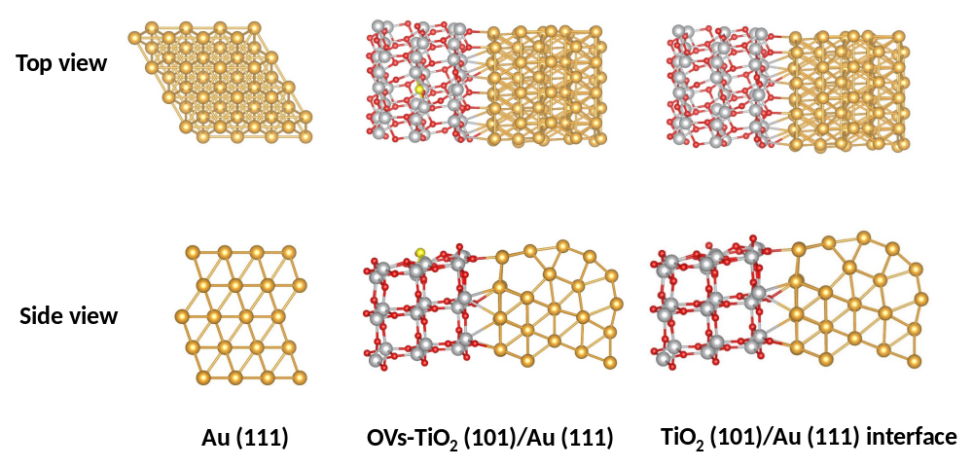
Supplementary Fig. 13 The optimized geometric structures of Au (111), OVs-TiO₂ (101)/Au (111) and TiO₂ (101)/Au (111) interface. Color code: Gray, red, auratus, and yellow spheres represent Ti atoms, O atoms, Pd atoms, and OVs, respectively.
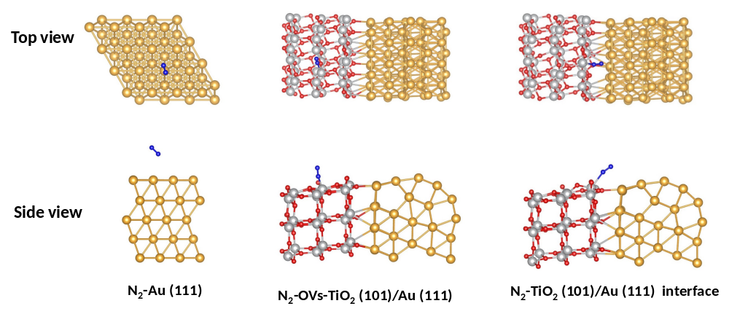
Supplementary Fig. 14 The optimized adsorption configuration of N₂ molecule on Au (111), OVs-TiO₂ (101)/Au (111) and TiO₂ (101)/Au (111) interface.

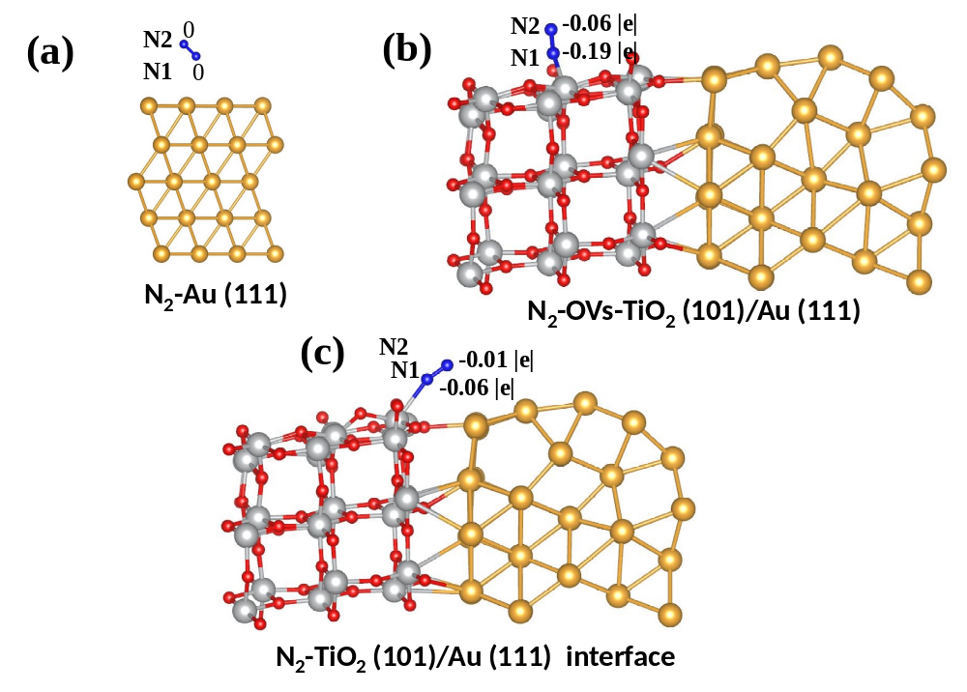
Supplementary Fig. 15 The number of electrons transferred to N₂ molecules on (a) Au (111), (b) OVs-TiO₂ (101)/Au (111) and (c) TiO₂ (101)/Au (111) interface model are illustrated by first-principles simulations.

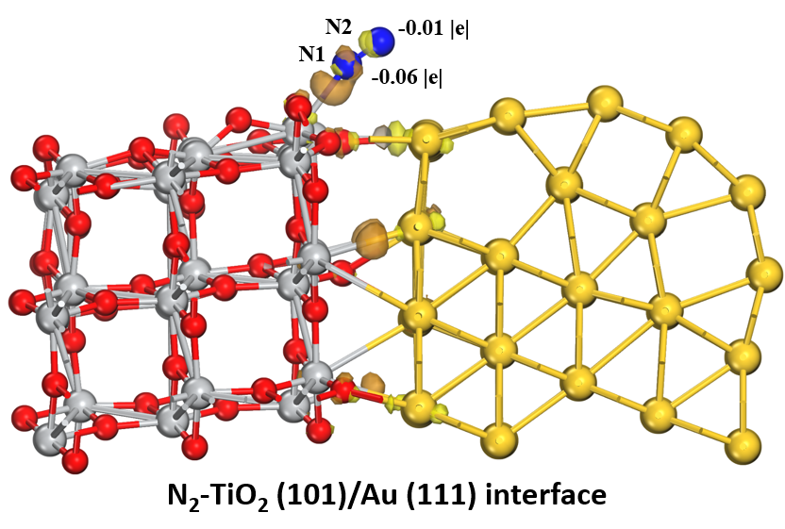
Supplementary Fig. 16 Differential charge density of N₂-TiO₂ (101)/Au (111) interface (yellow and orange red colors illustrate an enhancement and reduction in electron density, accordingly).
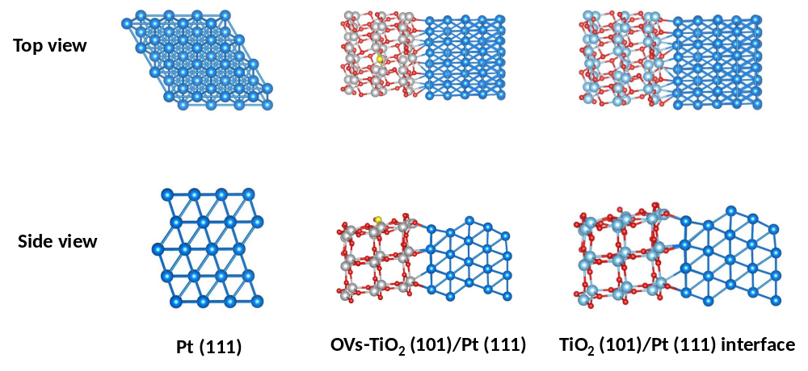
Supplementary Fig. 17 The optimized geometric structures of Pt (111), OVs-TiO₂ (101)/Pt (111) and TiO₂ (101)/Pt (111) interface. Color code: Gray, red, blue, and yellow spheres represent Ti atoms, O atoms, Pd atoms, and OVs, respectively.

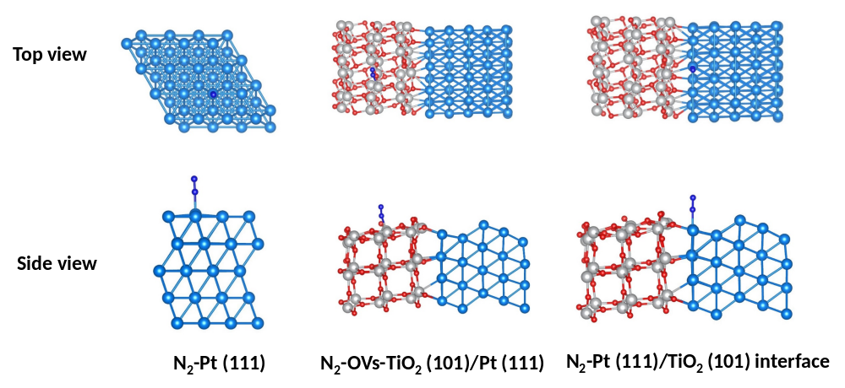
Supplementary Fig. 18 The optimized adsorption configuration of N₂ molecule on Pt (111), OVs-TiO₂ (101)/Pt (111) and TiO₂ (101)/Pt (111) interface.

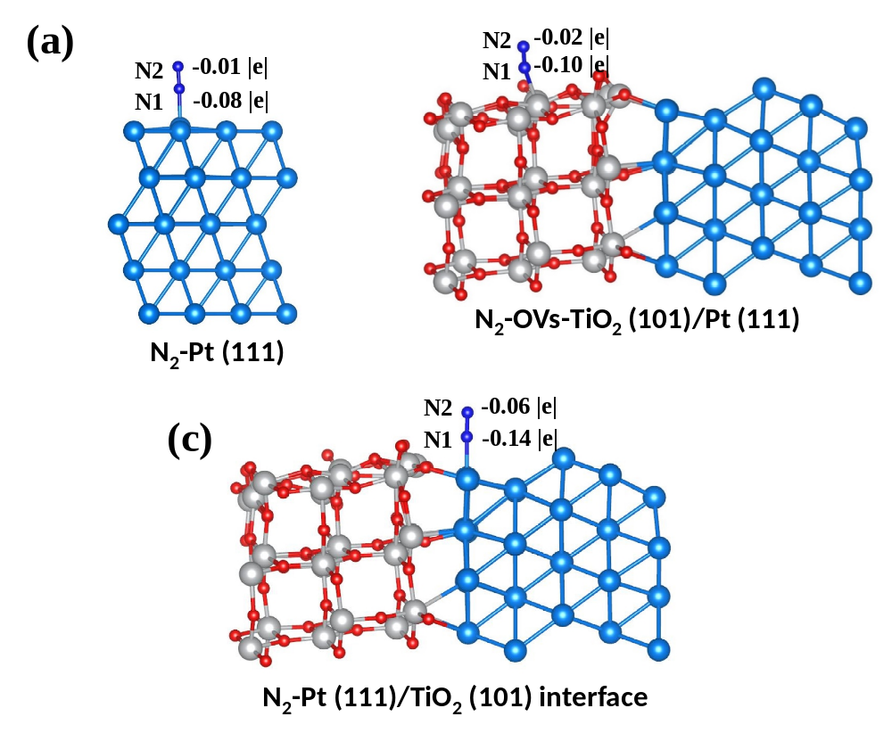
Supplementary Fig. 19 The number of electrons transferred to N₂ molecules on (a) N₂-Pt (111), (b) N₂-OVs-TiO₂ (101)/Pt (111), and (c) N₂-Pt (111)/TiO₂ (101) interface model are illustrated by first-principles simulations.

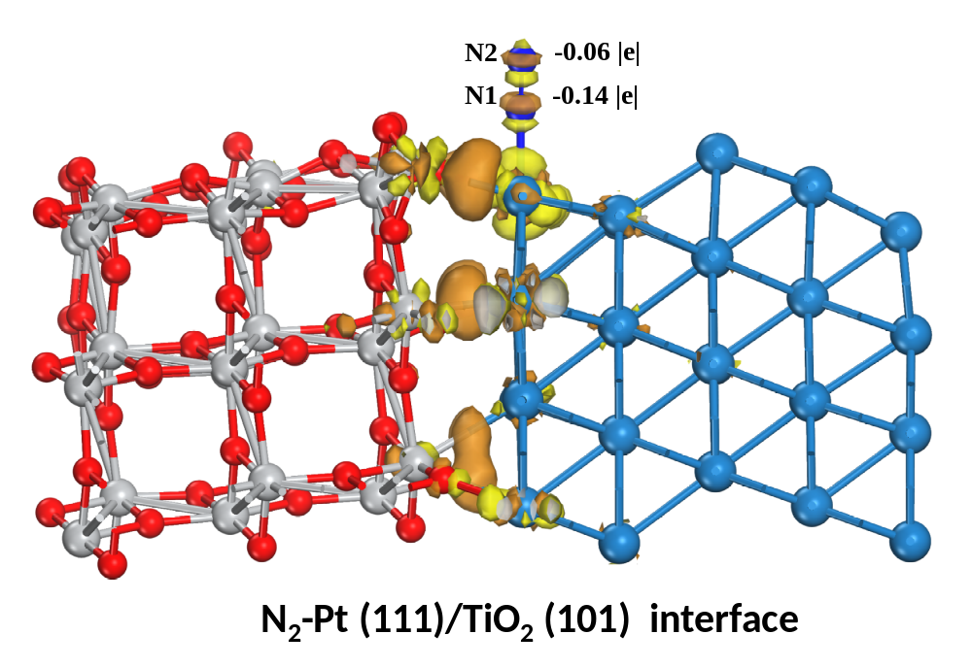
Supplementary Fig. 20 Differential charge density of N₂-Pt (111)/TiO₂ (101) interface (yellow and orange red colors illustrate an enhancement and reduction in electron density, accordingly).
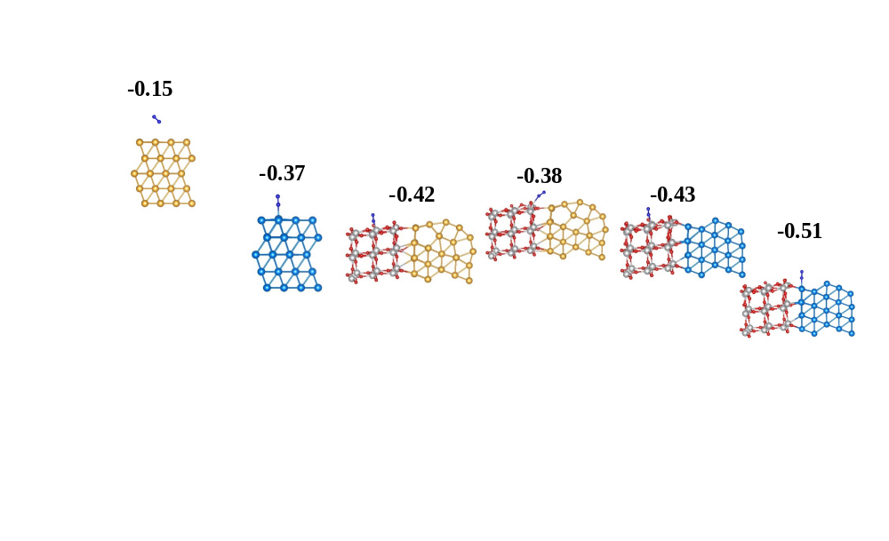
Supplementary Fig. 21 Adsorption energies of N₂ on single site of Au, Pt, OVs of TiO₂ (101)/Au (111), Ti site of TiO₂ (101)/Au (111) interface, OVs of TiO₂ (101)/Pt (111), and on Pt sites at TiO₂ (101)/Pt (111) interface.

Supplementary Fig. 22 N−N distance of *NN on Au (111), Pt (111), OVs in TiO₂ (101)/Au (111), the Ti site at the TiO₂ (101)/Au (111) interface, OVs in TiO₂ (101)/Pt (111), and Pt site at the TiO₂ (101)/Pd (111) interface.

Supplementary Fig. 23 Catalytic measurements for light-driven N₂ fixation using various catalysts. a Photocatalytic NH₃ production rate over the x%-Pd/m-TiO₂ NRs in the first 1 h. b Comparison of NH₃ production rates over m-TiO₂ NRs, se-Pd/m-TiO₂ NRs (2.71%), se-Au/m-TiO₂ NRs (2.92%), se-Pt/m-TiO₂ NRs (2.84%), fe-Pd/m-TiO₂ NRs (2.62%), fe-Au/m-TiO₂ NRs (2.76%) and fe-Pt/m-TiO₂ NRs (2.86%) in N₂-saturated water under light irradiation.
Supplementary Tables

Supplementary Table 1. The amount of noble metal loaded on the m-TiO₂ NRs samples determined by ICP-OES.
Samples | se-Pd/m-TiO₂ NRs (0%) | se-Pd/m-TiO₂ NRs (1%) | noble metal/m-TiO₂ NRs (3%) |  |  |  |  |  |  |  |  |  |  | se-Pd/m-TiO₂ NRs (5%) | se-Pd/m-TiO₂ NRs (7%)
Samples | se-Pd/m-TiO₂ NRs (0%) | se-Pd/m-TiO₂ NRs (1%) | se-Pd | se-Au |  |  | se-Pt | fe-Pd |  |  | fe-Au | fe-Pt |  | se-Pd/m-TiO₂ NRs (5%) | se-Pd/m-TiO₂ NRs (7%)
Metal content  (wt.%) | 0.00 | 1.02 | 2.71 |  | 2.92 | 2.84 |  |  | 2.62 | 2.76 |  |  | 2.86 | 4.76 | 6.66

Supplementary Table 2. EXAFS fitting parameters at the Pd K-edge for various samples (Ѕ₀² = 0.87)
Sample | Shell | CNª | R(Å)^{b} | σ²(Å²)^{c} | ΔE₀(eV)^{d} | R factor
Pd foil | Pd-Pd | 12.00 | 2.74 | 0.0052 | -6.15 | 0.0041
PdO | Pd-O | 4.35 | 2.03 | 0.0021 | -0.46 | 0.0188
PdO | Pd-O-Pd | 4.00 | 3.05 | 0.0034 | -1.22 | 0.0188
PdO | Pd-Pd | 8.00 | 3.44 | 0.0034 | -1.22 | 0.0188
PdO | Pd-O | 8.00 | 3.69 | 0.0021 | -0.46 | 0.0188
se-Pd/TiO₂ NRs | Pd-O | 3.80 | 2.07 | 0.0036 | -7.73 | 0.0177
se-Pd/TiO₂ NRs | Pd-Ti | 2.20 | 3.14 | 0.0024 | -0.34 | 0.0177
se-Pd/TiO₂ NRs | Pd-Pd | 7.40 | 3.39 | 0.0109 | -3.59 | 0.0177
^{a)}CN, coordination number; ^{b}R(Å), distance between absorber and backscatter atoms; ^{c}σ², Debye-Waller factor to account for both thermal and structural disorders; ^{d}ΔE₀, inner potential correction; R factor indicates the goodness of the fit. Fitting range: 3.0 ≤ k (/Å) ≤ 12.4 and 1.0 ≤ R (Å) ≤ 3.0 (Pd foil); 3.0 ≤ k (/Å) ≤ 12.0 and 1.1 ≤ R (Å) ≤ 3.5 (PdO); 3.3 ≤ k (/Å) ≤ 10.0 and 1.2 ≤ R (Å) ≤ 3.4 (se-Pd/TiO₂ NRs).

Supplementary Table 3. The fitted photoluminescence decay components of m-TiO₂ NRs, se-Pd/m-TiO₂ NRs, se-Au/m-TiO₂ NRs, se-Pt/m-TiO₂ NRs, fe-Pd/m-TiO₂ NRs, fe-Au/m-TiO₂ NRs, and fe-Pt/m-TiO₂ NRs.
Samples | Decay Time (ns) |  | Relative amplitude (%) |  | Average lifetime (ns)
Samples | τ₁ | τ₂ | A₁ | A₂ | τ_{A}ª
m-TiO₂ NRs | 1.011 | 5.04 | 42.49 | 57.51 | 4.52
se-Pd/m-TiO₂ NRs | 1.004 | 10.97 | 37.96 | 62.04 | 10.44
se-Au/m-TiO₂ NRs | 1.002 | 9.903 | 40.17 | 59.83 | 9.34
se-Pt/m-TiO₂ NRs | 1.07 | 10.00 | 50.99 | 49.01 | 9.10
fe-Pd/m-TiO₂ NRs | 0.69 | 11.04 | 87.99 | 12.01 | 7.79
fe-Au/m-TiO₂ NRs | 0.298 | 9.05 | 68.25 | 31.75 | 8.47
fe-Pt/m-TiO₂ NRs | 0.6 | 10.01 | 91.06 | 8.94 | 6.44
ªτ_{A} = (A₁τ₁² + A₂τ₂²)/(A₁τ₁ + A₂τ₂)

Supplementary Table 4. The noble metal mean particle size, BET surface area and average pore size of different samples.
Samples | Mean metal  particle sizeª (nm) | BET surface area^{b} (m² g⁻¹) | Average pore size^{c} (nm)
m-TiO₂ NRs | - | 45.18 | 12.7
se-Pd/m-TiO₂ NRs | 12.2 | 32.78 | 14.2
se-Au/m-TiO₂ NRs | 10.1 | 35.49 | 13.4
se-Pt/m-TiO₂ NRs | 9.6 | 40.60 | 12.1
fe-Pd/m-TiO₂ NRs | 4.7 | 44.14 | 13.1
fe-Au/m-TiO₂ NRs | 6.2 | 43.15 | 11.6
fe-Pt/m-TiO₂ NRs | 3.5 | 44.86 | 12.6
ªMean metal particle size statisticsed according to the TEM image.
^{b}S_{BET}, BET surface areas calculated by the adsorption branch of the N₂ isotherm.
^{c}D_{BJH}, pore diameter determined by BJH model.

Supplementary Table 5. The AQE for photocatalytic N₂ fixation in recent reports.
Catalysts | AQE | References
Se-Pd/m-TiO₂ NRs | 0.37% at 375 nm | This work
Mo-doped WO₃ | 0.33% at 400 nm | 13
TiO₂/Au/a-TiO₂ | 0.005% at 254 nm | 14
CuCr-LDH | 0.44% at 380 nm | 15
Bi₅O₇Br | 2.3% at 420 nm | 16
BiOCl NSs-Fe-5% | 1.8% at 420 nm | 17
BiOBr | 0.23% at 420 nm | 18

Supplementary Table 6. Performance comparison of various photocatalysts for N₂ reduction.
Catalysts | Reaction medium | Scavenger | Light source | Detection Method | Ammonia generation rate (μg g_{cat.}⁻¹ h⁻¹) | Ref.
Se-Pd/m-TiO₂ NRs | H₂O (l) | No | Full-spectrum | Indophenol blue method | 635.73 | This work
TiO₂ (P25) | H₂O (l), | No | Full-spectrum | IC | 27 | 19
Ti₃C₂ MXene-P25 | H₂O (l) | No | Full-spectrum | IC | 193.32 | 20
JRC-TiO-6 | H₂O, 38 ℃ | 2-PrOH | λ > 280 nm | IC | 62 | 21
Ti-MOF | H₂O (l), | No | λ > 400 nm | Indophenol blue method and IC | 221.40 | 22
SA Ru/TiO₂-NS | H₂O (l) | CH₃OH | Full-spectrum | Indophenol blue method | 56.34 | 23
Sb/TiO₂ | H₂O (l) | No | Full-spectrum | Indophenol blue method | 579.60 | 24
Fe-Al@graphene | 311 K | No | Full spectrum | Indophenol blue method | 430.1 | 25

Supplementary Methods
Determination of NH₃
The NH₃ in the photocatalytic reaction solution was quantified by the indophenol method according to previous work¹. For calibration in aqueous electrolytes, a known concentration of NH₄Cl was added to 0.1 M KOH, and then neutralized by adding 0.5 M H₂SO₄. 0.5 mL of phenol nitroprusside solution and 0.5 mL of alkaline hypochlorite solution was then added to 2.0 ml of the neutralized sample. The solution was incubated for 30 min at room temperature in the dark, and the sample absorbance was analyzed by UV-vis spectroscopy (UV-17800, Shimadzu). The calibration curve was constructed for NH₃ with the following concentrations:
a: 0 μmol L⁻¹ (0 μg mL⁻¹), b: 0.1 μmol L⁻¹ (0.0018 μg mL⁻¹), c: 0.2 μmol L⁻¹ (0.0036 μg mL⁻¹), d: 0.5 μmol L⁻¹ (0.009 μg mL⁻¹), e: 1.0 μmol L⁻¹ (0.018 μg mL⁻¹), f: 2.0 μmol L⁻¹ (0.036 μg mL⁻¹), g: 5.0 μmol L⁻¹ (0.09 μg mL⁻¹), h: 10 μmol L⁻¹ (0.18 μg mL⁻¹), i: 20 μmol L⁻¹ (0.36 μg mL⁻¹), j: 50 μmol L⁻¹ (0.9 μg mL⁻¹), and a fitted curve of the absorbance peak of each concentration showed a linear regression with an R² value of 0.99991 (see Supplementary Fig. 7).

Determination of hydrazine (N₂H₄)
The hydrazine presented in the photocatalytic reaction solution was estimated by the method of Watt and Chrisp with some modification²⁻⁴, which contains the following steps: (ⅰ) 2.0 mL post-pNRR solution was collected from photochemical reactor with further removal of the photocatalyst by using the 0.22 μm filter. (ⅱ) 2.0 mL of color agent was added into post-pNRR solution. The color reagent solution consists of 5.99 g of para-(dimethylamino) benzaldehyde, 30 mL of HCl, and 300 mL ethanol. After reacting in a dark condition at room temperature for 20 min, the sample absorbance was investigated by UV-vis spectroscopy (UV-17800, Shimadzu). The correction curve was established for N₂H₄ with the following concentrations:
a: 0 μg mL⁻¹, b: 0.05 μg mL⁻¹), c: 0.1 μg mL⁻¹, d: 0.2 μg mL⁻¹, e: 0.4 μg mL⁻¹, f: 0.6 μg mL⁻¹, g: 0.8 μg mL⁻¹), h: 1.0 μg mL⁻¹, and a fitted curve of the absorbance peak at λ = 458 nm of each concentration showed a linear regression with an R² value of 0.99996 (see Supplementary Fig. 8).

Photocatalytic nitrogen fixation
The photocatalytic nitrogen-fixing ammonia synthesis experiment was carried out in self-assembled photocatalytic reaction platform as shown in Supplementary Fig. 9. The photocatalytic N₂ fixation is achieved on the three-phase interface, including N₂ in the gas, H₂O in the liquid and the catalyst in the solid phase. Synthetic ammonia performance experiments were conducted at room temperature and atmospheric pressure. A 300 W Xe lamp (Full-spectrum, 400 mW·cm⁻²) was used as light source and 10 cm away from the light source to the liquid surface. Firstly, 40 mg photocatalyst were dispersed in 100 mL deionized water in a cell equipped with water circulation. Secondly, the mixture was continuously stirred in the dark with high-purity N₂ bubbled at a flow rate of 200 mL·min⁻¹ for 30 min, then turn on the light and 4.0 mL of reaction solution was taken out from the reaction in every 30 min. The reaction mixture was purified by removing the photocatalyst by using the 0.22 μm filter. The obtained solution was used for further analysis.

Determination of apparent quantum efficiency (AQE)
The catalytic experiments for determining AQE were performed in 100 mL pure water, and the irradiation area was 19.63 cm². 40 mg of se-Pd/m-TiO₂ NRs was used as the photocatalyst. To obtain the AQE, the light was filtered by different monochromatic filters (i.e., 320, 375, and 520 nm), and the reaction time was 1 h. The light intensities were measured to be 5.10, 12.32, and 42.20 mW cm⁻², respectively. The AQE was calculated through the following equation:
AQE = $\frac{N_{e}}{N_{p}}$ = $\frac{{3N}_{AM}}{N_{p}}$ = $\frac{{3n}_{AM}N_{A}}{\frac{WAt}{hν}}$ × 100 %
where N_{e}, N_{p} and N_{AM} represent the number of reacted electrons, incident photons and generated ammonia, respectively; n_{AM} represents the molar number of generated ammonia; ν, W, A and t are the incident light frequency, intensity, irradiation area and time, respectively; N_{A} and h are the Avogadro’s constant and Planck constant, respectively.

¹⁵N₂ isotope labeling experiments
Isotopic labeling experiments labeled ¹⁵N₂ gas was purchased from Sigma-Aldrich Chemical Company. It was used to confirm that the detected ammonia originates form N₂. A low-velocity gas flow system was adopted due to the limited supply and high expense of ¹⁵N₂. Firstly, 40 mg photocatalyst were dispersed in 100 mL deionized water in a cell equipped with water circulation. Secondly, the mixture was continuously stirred in the dark with high-purity N₂ bubbled at a flow rate of 100 mL·min⁻¹ for 10 min, then turn on the light and 4.0 mL of reaction solution was taken out after 30 min illumination and further removing the photocatalyst by using the 0.22 μm filter. Estimation of obtained ¹⁵NH₄⁺ was done indirectly using the indophenol method, owing to the low mass of ¹⁵NH₄⁺ for LC-MS studies. The samples for LC-MS analysis were prepared as follows. 0.5 mL phenol nitroprusside solution (P6994, Sigma-Aldrich) and 0.5 mL of alkaline hypochlorite solution (A1727, Sigma-Aldrich) were then added to 2.0 mL of the resulting solution. The MS studies were carried on an Agilent 1260-6460 (LC-MS).

Finite-Difference Time-Domain simulations
To investigate the optical mechanisms behind the structure, Finite-Difference Time-Domain (FDTD) simulations were carried out using FDTD Solutions software (Lumerical Co. Ltd). Plane wave was used as the light source with different wavelength. Periodic boundary was used along the x-axis and y-axis, and the perfect match layer (PML) boundary was used along the z-axis. Mesh size was set as 0.01 nm for the structure during FDTD simulations.

N₂ temperature-programmed desorption (N₂-TPD)
100 mg of catalyst was placed at the bottom of the U-shaped quartz tube and preheated in Ar flow (50 mL min⁻¹) at 300 °C for 0.5 h and then cooled down to 25 °C. After pretreatment, the feeding N₂ flowed through the catalyst bed at 25 °C for 1 h. Then, the physisorption of N₂ was removed by Ar flow (50 mL min⁻¹) at 50 °C for 0.8 h. Finally, the catalyst bed was heated from 50 °C to 600 °C at 10 °C min⁻¹. We monitored a wide range of desorbing species to identify the main products that are generated from reactions of N₂ on catalyst and found that the only species desorbed from the N₂-exposed samples is N₂, as analyzed on-line by a thermal conductivity detector (TCD, Micromeritics AutoChem II 2920).
X-ray absorption spectra collection and data processing
The obtained XAFS data was processed in Athena (version 0.9.26) for background, pre-edge line and post-edge line calibrations⁵. Then Fourier transformed fitting was carried out in Artemis (version 0.9.26). The model of Pd foil and PdO were used to calculate the simulated scattering paths. The four parameters, coordination number, bond length, Debye-Waller factor and ΔE₀ shift (CN, R, σ², ΔE₀) were fitted and partially fixed. For the Wavelet Transform analysis^{6,7}, the χ(k) exported from Athena was imported into the Hama Fortran code. The parameters were listed as follow: R range, 1 – 3.5 Å, k range, 3.0 – 13.9 Å⁻¹; k weight, 3; and Morlet function with κ = 5, σ = 1 was used as the mother wavelet to provide the overall distribution.

In-situ Fourier-transform infrared spectroscopy experiments
In-situ Fourier-transform infrared spectroscopy (FTIR) was performed by adopting a Nicolet-iS50 Fourier-transform infrared spectrometer, equipped with a Harrick Scientific in-situ cell and a mercury-cadmium-telluride (MCT) detector cooled by liquid N₂. The sample (20 mg) was pressed into thin slices by a hydraulic machine and placed in the in-situ cell. Then, the system was evacuated to an internal pressure of 10⁻⁴ mbar and heated at 200 ℃ for 60 min with a heating rate of 8.5 ℃ min⁻¹. When the temperature was cooled to 30 ℃, the molecular pump was closed and then the background was tested. After that, pure N₂ with H₂O vapor was pumped into the in-situ cell. At the same time, the light was turned on to drive the reaction and the IR signal was tested every 5 min.
Density functional theory simulations
The density functional theory (DFT) simulations were performed by using the Cambridge Sequential Total Energy Package (CASTEP) module implemented in the Material Studio 8.0 package⁸⁻¹⁰. The exchange correlation potential was represented by the Perdew–Burke–Ernzerhof (PBE) functional within the generalized gradient approximation (GGA)¹¹. The TiO₂ (101), Pd (111), Au (111) and Pt (111) surfaces were built. Then, TiO₂ (101) with OVs and Pd (111) interface, TiO₂ (101) with oxygen vacancy and Au (111) interface, TiO₂ (101) with oxygen vacancy and Pt (111) interface were built, and the vacuum layer is set to 15 Å. The cutoff energy for the plane-wave-basis expansion is set to be 500 eV, and the convergence tolerances of energy, force and maximum displacement are set to 1.0×10⁻⁵ eV/atom, 5.0×10⁻² eV/Å and 2.0×10⁻³ eV/Å, respectively. The k-points grid sampling of Monkhorst-Pack scheme was set as 1×2×1 in the irreducible Brillouin zone. Meanwhile, the DFT-D correction method is used to describe the long-range van der Waals interaction¹². The adsorption energy (E_{ab}) of N₂ was defined as:
E_{ab} = E(sub+N₂) - E(sub) - E(N₂)
E(sub+N₂) and E(sub) are the total energy of the system with and without N₂. E(N₂) is the total energy of N₂ molecules. The Gibbs free energy change (ΔG) of the elementary step was calculated by:
∆G = ∆E + ∆E_{ZPE} - T∆S
Where ∆E is the total energy difference, ΔE_{ZPE} is the change in the zero-point energy and the entropy, T is the temperature (T = 298.15 K), and ΔS is the entropy change.

Supplementary References
- Andersen, S. Z. et al. A rigorous electrochemical ammonia synthesis protocol with quantitative isotope measurements. Nature, 570, 504−508 (2019).
- Watt, G. W. & Chrisp, J. D. A spectrophotometric method for the determination of hydrazine, Anal. Chem. 24, 2006–2008 (1952).
- Zhao, J. X. et al. Defect-rich ZnS nanoparticles supported on reduced graphene oxide for high-efficiency ambient N₂-to-NH₃ conversion. Appl. Catal., B 284, 119746 (2021).
- Qiu,W. B. et al. High-performance artificial nitrogen fixation at ambient conditions using a metal-free electrocatalyst. Nat. Commun. 9, 3485 (2018).
- Ravel, B. & Newville, M. ATHENA, ARTEMIS, HEPHAESTUS: data analysis for X-ray absorption spectroscopy using IFEFFIT, J. Synchrotron Radiat. 12, 537–541 (2005).
- Funke, H.; Scheinost, A. C.; Chukalina, M. Wavelet analysis of extended X-ray absorption fine structure data. Phys. Rev. B, 71, 094110 (2005).
- Funke, H.; Chukalina, M.; Scheinost, A. C. A new FEFF-based wavelet for EXAFS data analysis. J. Synchrotron Radiat. 14, 426–432 (2007).
- Kresse, G. D. & Joubert, J. From ultrasoft pseudopotentials to the projector augmented wave method. Phys. Rev. 59, 1758 (1999).
- Kresse, G. & Furthmüller, J. Efficiency of ab-initio total energy calculations for metals and semiconductors using a plane-wave basis set. Comp. Mater. Sci. 6, 15–50 (1996).
- Kresse, G. & Furthmüller, J. Efficient iterative schemes for ab initio total-energy calculations using a plane-wave basis set. Phys. Rev. 54, 11169 (1996).
- Perdew, J. P.; Burke, K.; Ernzerhof, M. Generalized gradient approximation made simple. Phys. Rev. Lett. 77, 3865 (1996).
- Grimme, S.; Antony, J.; Ehrlich, S.; Krieg, H. A consistent and accurate ab initio parametrization of density functional dispersion correction (DFT-D) for the 94 elements H-Pu. J. Chem. Phys. 132, 154104 (2010).
- Zhang, N. et al. Refining defect states in W₁₈O₄₉ by Mo doping: A strategy for tuning N₂ activation towards solar driven nitrogen fixation. J. Am. Chem. Soc. 140, 9434–9443 (2018).
- Li, C. et al. Promoted fixation of molecular nitrogen with surface oxygen vacancies on plasmon-enhanced TiO₂ photoelectrodes. Angew. Chem. Int. Ed. 57, 5278–5282 (2018).
- Zhao, Y. et al. Layered-double-hydroxide nanosheets as efficient visible-light-driven photocatalysts fordinitrogen fixation. Adv. Mater. 29, 1703828 (2017).
- Wang, S. et al. Light-switchable oxygen vacancies in ultrafine Bi₅O₇Br nanotubes for boosting solar-driven nitrogen fixation in pure water. Adv. Mater. 29, 1701774 (2017).
- Zhang, N. et al. Fe-doped BiOCl nanosheets with light-switchable oxygen vacancies for photocatalytic nitrogen fixation. ACS Appl. Energy Mater. 2, 8394−8398 (2019).
- Li, H.; Shang, J.; Ai, Z. H.; Zhang, L. Z., Efficient visible light nitrogen fixation with BiOBr nanosheets of oxygen vacancies on the exposed {001} facets. J. Am. Chem. Soc. 137, 6393–6399 (2015).
- Gao, X. et al. Interference effect of alcohol on Nessler’s reagent in photocatalytic nitrogen fixation. ACS Sustain. Chem. Eng. 6, 5342–5348 (2018).
- Liao, Y. et al. 2D-layered Ti₃C₂ MXenes for promoted synthesis of NH₃ on P25 photocatalysts. Appl. Catal., B 273, 119054 (2020).
- Hirakawa, H.; Hashimoto, M.; Shiraishi, Y.; Hirai, T.; Photocatalytic conversion of nitrogen to ammonia with water on surface oxygen vacancies of titanium dioxide. J. Am. Chem. Soc. 139, 10929–10936 (2017).
- Huang, H. et al. Toward visible-light-assisted photocatalytic nitrogen fixation: A titanium metal organic framework with functionalized ligands. Appl. Catal., B 267, 118686 (2020).
- Liu, S.; et al. Photocatalytic fixation of nitrogen to ammonia by single Ru atom decorated TiO₂ nanosheets. ACS Sustain. Chem. Eng. 7, 6813–6820 (2019).
- Zhao, Z. Q. et al. Efficient visible-light driven N₂ fixation over two-dimensional Sb/TiO₂ composites. Chem. Comm. 55, 7171–7174 (2019).
- Yang, Y. et al. Highly enhanced stability and efficiency for atmospheric ammonia photocatalysis by hot electrons from a graphene composite catalyst with Al₂O₃. Carbon 124, 72–78 (2017).

