Supplementary material: Hydrodynamic and heat transfer characteristics of Taylor Flow in pipelines: An extensive bibliometric analysis
Sidique Gawusu^{a*}, Xiaobing Zhang^{a**}, Rhoda Afriyie Mensah^{b}, Oisik Das^{b}, Abubakari Ahmed^{c}
ªSchool of Energy and Power Engineering, Nanjing University of Science & Technology, Nanjing, China
^{b}Department of Civil, Environmental and Natural Resources Engineering
Luleå University of Technology, 971 87 Luleå, Sweden
^{c}Department of Planning, Faculty of Planning and Land Management, SD Dombo University of Business and Integrated Development Studies, Bamahu-Wa, Ghana
Correspondence to; g.sidique@njust.edu.cn/zhangxb680504@163.com
Query
TS=((("Heat Transfer") OR ("Thermal")) OR (“Hydronamics”)AND (("Taylor bubble*") OR ("Taylor Flow*") OR ("Slug Flow*")))
Query Link
https://www.webofscience.com/wos/woscc/summary/623c8e64-ba46-47cf-b806-6ab6abe04467-0b92453f/relevance/1
Timespan: All Years
Initial search results: 975 documents
Indexes: SCI-Expanded
Exclusion
- Select Article: 755 documents
- Select English: 752 documents
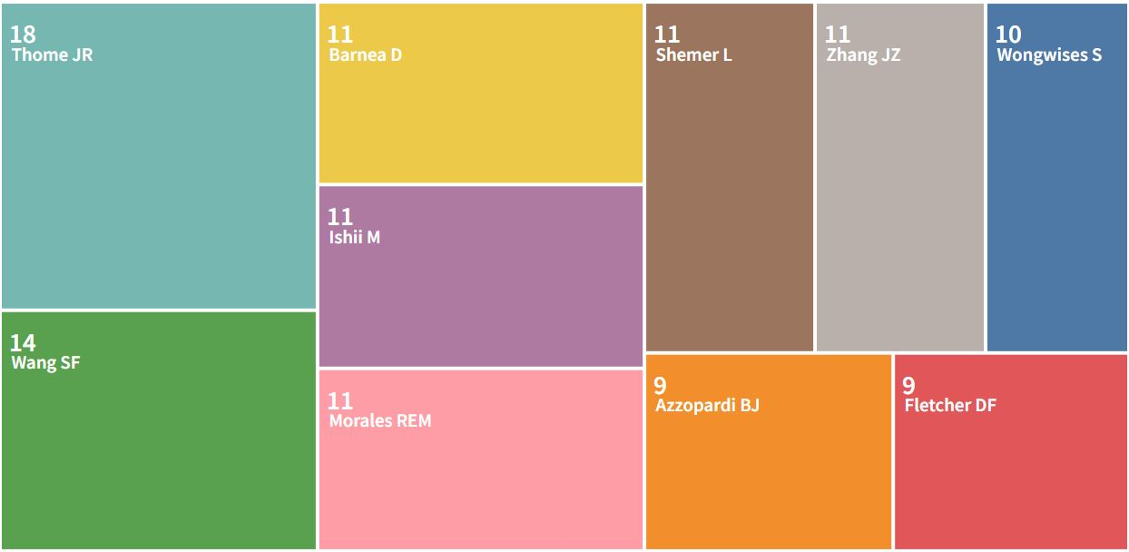
Fig. S1. Distribution of authors researching on heat transfer characteristics of Taylor bubbles

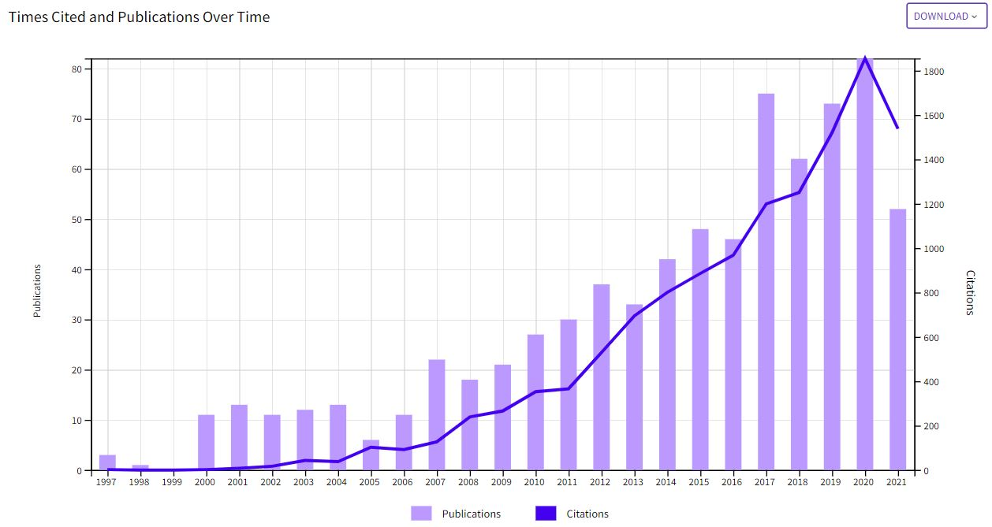
Fig. S2. Yearly publications and citation count on heat transfer characteristics of Taylor bubbles

Table S1. Distribution of yearly publications
Publication years | Record count | Cumulative | % of 752
1997 | 3 | 3 | 0.399
1998 | 1 | 4 | 0.133
2000 | 11 | 15 | 1.463
2001 | 13 | 28 | 1.729
2002 | 11 | 39 | 1.463
2003 | 12 | 51 | 1.596
2004 | 13 | 64 | 1.729
2005 | 6 | 70 | 0.798
2006 | 11 | 81 | 1.463
2007 | 22 | 103 | 2.926
2008 | 18 | 121 | 2.394
2009 | 21 | 142 | 2.793
2010 | 27 | 169 | 3.590
2011 | 30 | 199 | 3.989
2012 | 37 | 236 | 4.92
2013 | 33 | 269 | 4.388
2014 | 42 | 311 | 5.585
2015 | 48 | 359 | 6.383
2016 | 46 | 405 | 6.117
2017 | 75 | 480 | 9.973
2018 | 62 | 542 | 8.245
2019 | 73 | 615 | 9.707
2020 | 82 | 697 | 10.904
2021 | 52 | 749 | 6.915
2022 | 3 | 752 | 0.399

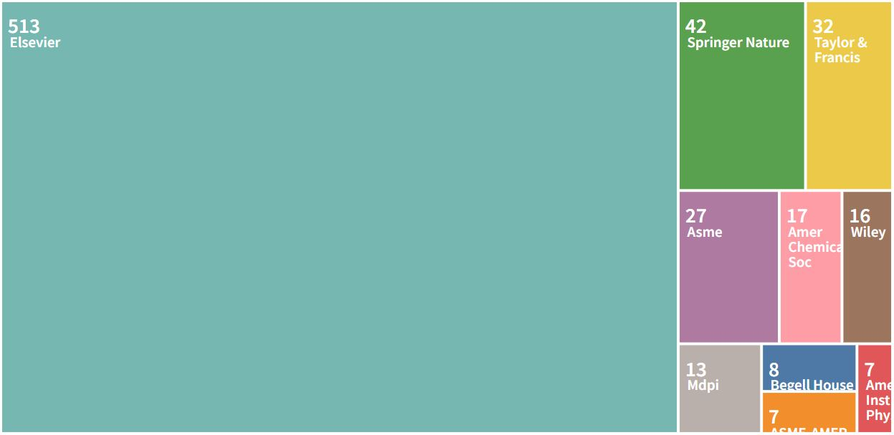
Fig. S3. Distribution of publishers of research on heat transfer characteristics of Taylor bubbles

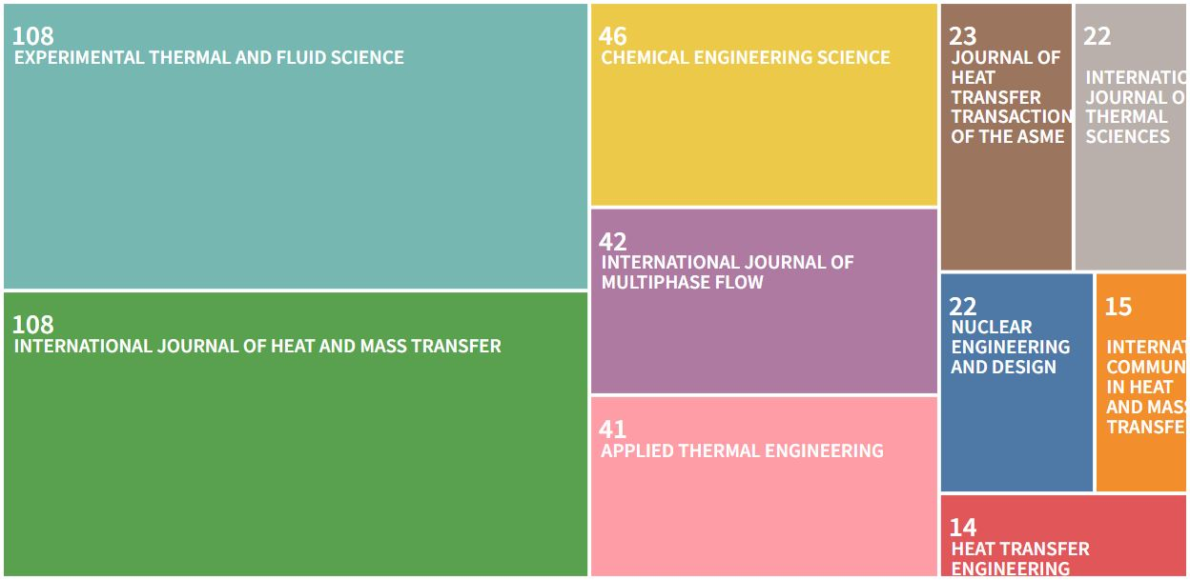
Fig. S4. Distribution of publication titles on heat transfer characteristics of Taylor bubbles

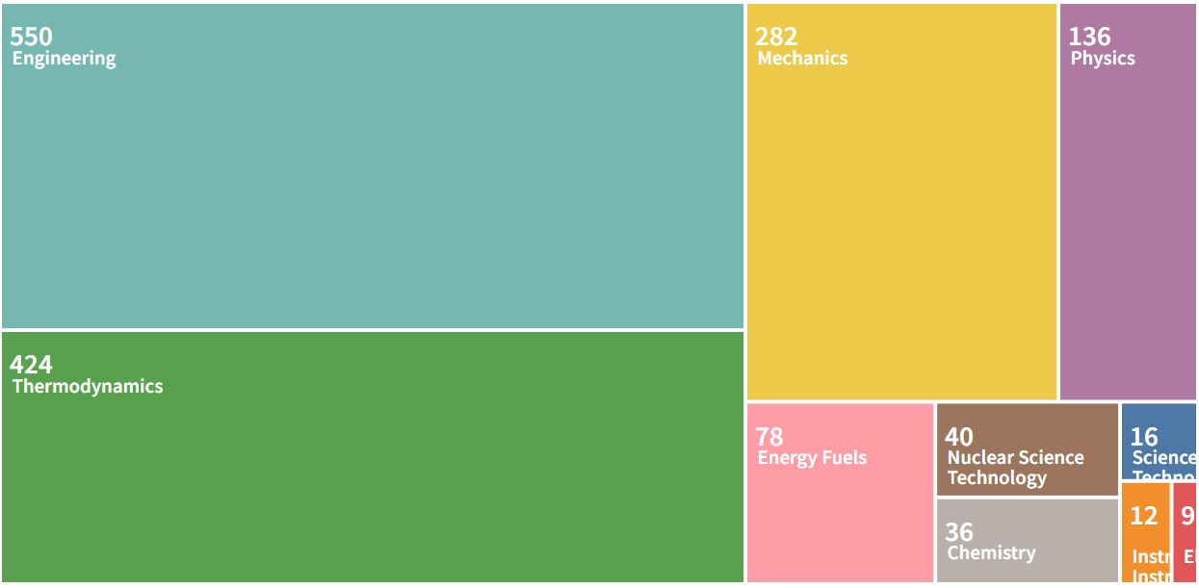
Fig. S5. Distribution of research areas on heat transfer characteristics of Taylor bubbles

Table S1: Bibliographic coupling analysis of articles
Document | Citations | Total Link Strength
Vivekanand (2020a) | 1 | 1140
Gupta (2010) | 96 | 1127
Zhang (2016b) | 35 | 1106
Gawusu (2021) | 1 | 1083
Talimi (2012a) | 92 | 1066
Vivekanand (2020b) | 1 | 1066
Magnini (2016a) | 30 | 1064
Ganapathy (2013a) | 17 | 1053
Kishor (2017) | 2 | 1018
Zhang (2018) | 1 | 993
Zhang (2016c) | 22 | 993
Vivekanand (2019) | 5 | 986
Etminan | 0 | 971
Asadolahi (2011) | 64 | 951
Pan (2015) | 14 | 936
Kumari (2019) | 11 | 925
Majumder (2013) | 22 | 923
Khodaparast (2015) | 27 | 915
Sur (2012) | 33 | 895
Magnini (2016b) | 24 | 874
Talimi (2012b) | 29 | 859
Rattner (2016) | 3 | 852
Magnini (2013) | 45 | 842
Abdollahi (2020b) | 4 | 827
Ganapathy (2013c) | 38 | 811
Howard (2013) | 30 | 799
Mehta (2014b) | 23 | 798
Ganapathy (2013d) | 101 | 795
Younes (2017) | 4 | 756
Gupta (2013) | 63 | 737
Ferrari (2017) | 26 | 733
Silva (2019) | 3 | 726
Leung (2012a) | 34 | 725
Krishnan (2010) | 13 | 723
Talimi (2013) | 25 | 717
Asadolahi (2012) | 52 | 711
Leung (2012b) | 28 | 686
Zhang (2020c) | 2 | 686
Li (2017a) | 35 | 683
Ferrari (2018) | 33 | 681
Wang (2020a) | 3 | 671
Leung (2010) | 48 | 666
Araujo (2013) | 17 | 646
Harirchian (2012) | 70 | 640
An (2016) | 1 | 636
Gregorc (2013) | 16 | 634
Luo (2012b) | 7 | 633
Rodrigues (2019) | 4 | 628
Ganapathy (2013b) | 23 | 624
Ni (2017) | 5 | 617
Liu (2020b) | 1 | 613
Falsetti (2018) | 7 | 600
Kumar (2007) | 56 | 596
Bayareh (2020) | 4 | 595
Smoot (2017) | 1 | 594
Che (2013) | 22 | 593
Kurimoto (2018) | 5 | 582
Jain (2020b) | 1 | 581
Rek (2014) | 7 | 579
Tsoligkas (2007) | 32 | 576
Abdollahi (2020a) | 6 | 563
Magnini (2017a) | 17 | 553
Luo (2012a) | 11 | 550
Moezzi (2019) | 3 | 543
Sankepally | 0 | 533
Kurimoto (2017) | 20 | 533
Kandlikar (2010) | 121 | 532
Pattamatta (2015) | 7 | 522
Yan (2011) | 16 | 521
Bordbar (2020) | 7 | 518
Zaloha (2012) | 56 | 516
Saisorn (2010) | 52 | 514
Martin-Callizo (2010) | 31 | 512
Zhang (2020b) | 6 | 493
Matin (2020) | 1 | 490
Woo (2021) | 3 | 489
Saisorn (2015) | 15 | 486
Keniar (2021) | 2 | 485
Ahmadpour | 0 | 481
Magnini (2017b) | 28 | 477
Li (2018d) | 7 | 472
Godbole (2011) | 59 | 471
Celata (2010) | 34 | 470
He (2017) | 9 | 468
Fu (2008) | 25 | 459
Miao (2017) | 20 | 454
Lei | 0 | 453
Saisorn (2008) | 74 | 447
Qu (2016) | 19 | 447
Yin (2018b) | 12 | 441
Abiev | 0 | 437
Yadav (2016) | 11 | 434
Guo (2020a) | 3 | 429
Gregorc (2021) | 0 | 428
Howard (2011) | 36 | 428
Rattner (2018) | 6 | 425
Jin Zunlong (2021) | 0 | 425
Huang (2013) | 2 | 424
Taha (2004) | 134 | 416
Muramatsu (2015) | 8 | 414
Liang (2017) | 14 | 411
Li (2018b) | 0 | 410
Charnay (2013) | 27 | 407
Youn (2021) | 1 | 402
Liu (2017d) | 5 | 402
Abdulkadir (2021) | 2 | 401
Mehta (2014a) | 33 | 400
Chen (2013b) | 21 | 400
Chen (2009b) | 46 | 397
Serizawa (2002) | 380 | 394
Abadi (2016a) | 10 | 393
Yan (2014) | 4 | 392
Jin (2020) | 1 | 388
Lee (2016b) | 32 | 388
Scammell (2015) | 20 | 386
Revellin (2006) | 163 | 385
Hetsroni (2009) | 28 | 385
Ganapathy (2014) | 50 | 383
Winkler (2012) | 22 | 379
Yang (2017b) | 42 | 379
Mehdizadeh (2011) | 72 | 377
Mehta (2016) | 5 | 375
He (2010) | 42 | 374
Bassani (2016) | 7 | 374
Guo (2021) | 0 | 371
Cook (2001) | 19 | 370
Wang (2014a) | 21 | 370
Chen (2015b) | 18 | 370
Chauris (2015) | 15 | 370
Rojahn (2018) | 13 | 368
Shemer (2003) | 32 | 368
Kingston (2017) | 6 | 367
Li (2018c) | 8 | 364
Duan (2020) | 3 | 364
Guo (2020b) | 3 | 362
Liu (2017b) | 15 | 362
Ong (2011) | 121 | 362
Chen (2014a) | 12 | 361
Liu (2017c) | 20 | 360
Parrales (2014) | 10 | 360
Van Hout (2001) | 78 | 356
Kim (2015) | 1 | 356
De Azevedo (2020) | 1 | 354
Grigoleto (2021) | 1 | 353
Van Hout (2003) | 46 | 352
Santos (2012) | 16 | 350
Agarwal (2020) | 5 | 350
Han (2012) | 24 | 347
Rodrigues (2020) | 3 | 346
Han (2009) | 183 | 344
Prajapati (2016) | 5 | 343
Bassani (2018) | 9 | 338
Zhang (2009c) | 32 | 338
Patel (2017) | 5 | 332
Wang (2021) | 0 | 331
Bressani (2018) | 4 | 330
Alrbee (2020) | 0 | 328
Van Hout (2002b) | 72 | 327
Schilder (2010) | 19 | 326
Rattner (2015) | 10 | 326
Youn (2016) | 7 | 325
Shaban (2018) | 7 | 325
Liu (2017a) | 21 | 320
Chang (2014) | 3 | 320
Shojaeian (2014) | 12 | 317
Youn (2015) | 8 | 317
Albrand (2020) | 2 | 317
Muzychka (2011) | 38 | 316
Xing (2014) | 10 | 315
Wang (2015) | 3 | 312
De Oliveira (2020) | 3 | 312
Talvy (2000) | 38 | 310
Wen (2019) | 16 | 305
Simoes (2014) | 21 | 304
Santana (2020) | 2 | 304
Sharma (2015) | 13 | 303
Abdulkadir (2015) | 20 | 303
Yan (2020) | 1 | 303
Rahim (2011) | 32 | 302
Zhuan (2012) | 42 | 299
Chen (2012) | 27 | 298
Garimella (2004) | 78 | 298
Cairone (2016) | 22 | 297
Ghanta (2016) | 6 | 295
Minakov (2019) | 5 | 294
Mi (2001b) | 38 | 294
Li (2017c) | 9 | 294
Livinus (2021) | 0 | 294
Abdulkadir (2022) | 0 | 293
Rosas (2018) | 3 | 292
Sadaghiani (2021) | 0 | 292
Yin (2019b) | 8 | 290
Revellin (2007) | 54 | 290
Chen (2017c) | 3 | 283
Khadiya (2021) | 0 | 279
Valeh-E-Sheyda (2013) | 46 | 278
Azadi (2021) | 0 | 278
Vermaak (2020) | 2 | 277
Lee (2016a) | 20 | 277
Al-Rawashdeh (2012) | 47 | 276
Abdulkadir (2014) | 17 | 274
Sun (2018c) | 10 | 274
Zhang (2019) | 1 | 273
Lie (2016) | 1 | 272
Pattamatta (2014) | 11 | 271
Ratkovich (2013) | 22 | 271
Xu (2015) | 4 | 271
He (2011b) | 11 | 271
Yao (2017) | 18 | 270
Chen (2013a) | 21 | 265
Taitel (2000a) | 21 | 264
Shah (2018) | 0 | 263
Deendarlianto (2016) | 21 | 261
Eain (2015) | 25 | 259
Sun (2014) | 6 | 258
Huang (2021) | 0 | 257
Ganapathy (2016) | 14 | 254
Fang (2015) | 8 | 254
Kirpalani (2008) | 25 | 253
Bhagwat (2012) | 67 | 253
Abolhasani (2015) | 19 | 252
Dong (2018b) | 8 | 251
Choi (2017) | 4 | 251
Parsi (2015) | 32 | 248
Losi (2016) | 9 | 247
Gawusu | 0 | 247
Zhou (2017b) | 10 | 246
Azzopardi (2015) | 12 | 246
Liu (2019b) | 10 | 246
Patel (2015) | 5 | 245
Andreolli (2017) | 4 | 243
Bertossi (2017) | 3 | 242
Huang (2016) | 4 | 242
Yang (2019a) | 7 | 241
Wang (2017b) | 6 | 241
Shi (2019b) | 2 | 239
Zhao (2013) | 66 | 238
Farsetti (2014) | 20 | 238
Rohilla (2019) | 3 | 236
Wu (2019a) | 5 | 235
Abiev (2020) | 4 | 234
Liedtke (2016) | 13 | 234
Mcneil (2014) | 12 | 233
Bassani (2017) | 14 | 232
Pishbin (2020) | 1 | 231
Babin (2015) | 8 | 231
Talebi (2020) | 0 | 230
Abiev (2019) | 6 | 228
Seshadri (2015) | 9 | 227
Wang (2012) | 5 | 227
Evgenidis (2018) | 2 | 225
Fershtman (2019) | 0 | 224
Barbosa (2005) | 4 | 223
Saisorn (2011) | 12 | 223
Li (2019d) | 5 | 223
Vijayarangan (2007) | 8 | 222
Li (2019a) | 8 | 221
Alrbee | 0 | 221
Mithran (2021) | 1 | 221
Li (2021) | 0 | 220
Yan (2018) | 0 | 220
Akbari (2017) | 8 | 219
Xu (2012) | 25 | 219
Nilpueng (2006) | 39 | 219
Yan (2021a) | 0 | 218
Jagirdar (2020) | 1 | 217
Shao (2011) | 17 | 217
Conte (2017) | 14 | 217
Dong (2019) | 6 | 216
Dong (2021b) | 1 | 216
Kesana (2017) | 20 | 215
Da Hlaing (2007) | 11 | 214
Parsi (2017) | 14 | 214
Abdollahi (2019) | 6 | 213
Tan (2021) | 0 | 213
Nemeth (2015) | 4 | 213
Chen (2014c) | 3 | 213
Zhou (2019b) | 4 | 212
Raimondi (2014) | 60 | 211
Li (2009) | 2 | 209
Dong (2018a) | 14 | 209
Cao (2018) | 2 | 208
Jagirdar (2016) | 9 | 207
Eyo (2019) | 1 | 207
Yun (2003) | 8 | 207
Li (2018a) | 2 | 206
Yang (2021) | 0 | 206
Mehta (2015) | 7 | 206
Rui Zhuan (2013) | 3 | 204
Sun (2015b) | 3 | 204
Yu (2019b) | 1 | 204
Youn (2018) | 6 | 203
Duangprasert (2008) | 21 | 202
Schriener (2021) | 0 | 201
Ahmed (2011) | 17 | 201
Walsh (2010) | 79 | 200
Zhou (2019a) | 7 | 200
Legius (1997) | 34 | 200
Qiu (2014) | 5 | 200
Nemeth (2017) | 0 | 199
Ribatski (2007) | 20 | 197
Medina (2015) | 9 | 197
Mi (2001a) | 100 | 196
Hernandez Cely (2018) | 11 | 196
Chen (2011c) | 43 | 196
Yue (2018) | 30 | 195
Kozulin (2011) | 12 | 194
Lei (2021) | 1 | 192
Agostini (2008) | 52 | 192
Pietrasanta (2020) | 7 | 192
Revellin (2008) | 26 | 192
Sun (2004b) | 23 | 191
Sun (2017b) | 15 | 191
Liu (2015a) | 2 | 190
Yu (2020) | 0 | 190
Barber (2010) | 52 | 187
Feng (2021) | 0 | 187
Yu (2019a) | 9 | 186
Shah (2020) | 3 | 186
Khater (2019) | 8 | 185
Naidek (2017) | 7 | 185
Dinaryanto (2017) | 42 | 184
Deleau (2020) | 1 | 179
Hetsroni (2000) | 17 | 179
Reichmann (2017b) | 4 | 179
Gourma (2016) | 9 | 178
Wu (2018) | 13 | 178
Qu (2004) | 122 | 177
Odaymet (2012) | 5 | 177
Zhou (2021) | 2 | 177
Chinaud (2015) | 19 | 175
Dang (2017) | 24 | 172
Friedemann (2020) | 3 | 172
Li (2019b) | 1 | 171
Assmann (2013) | 96 | 171
Lyu (2018) | 8 | 170
Schwarz (2020) | 1 | 170
Dos Reis (2008) | 9 | 169
Hosokawa (2016) | 2 | 169
He (2019) | 1 | 169
Chen (2001) | 10 | 169
Rao (2015) | 16 | 169
Madanan (2017) | 1 | 169
He (2011a) | 32 | 169
Fershtman (2016) | 8 | 168
Guo (2017) | 3 | 168
Lagus (2012) | 2 | 167
Balasubramanian (2018) | 4 | 166
Son (2001) | 12 | 166
Sun (2004a) | 7 | 165
Wang (2019c) | 1 | 165
Dong (2020b) | 3 | 164
Henry (2021) | 0 | 164
Azadi (2014) | 1 | 163
Soto-Cortes (2019) | 5 | 162
Cui (2021) | 0 | 162
Fontalvo (2020) | 2 | 161
Nakoryakov (2017) | 2 | 161
Keepaiboon (2015) | 37 | 160
Li (2017b) | 10 | 160
Kim (2021) | 0 | 159
Miessner (2020) | 3 | 159
Amidu (2020a) | 2 | 157
Hohmann (2016) | 20 | 157
Zhu (2017) | 8 | 157
Reichmann (2017a) | 10 | 155
Liu (2020c) | 1 | 154
Woo (2018) | 4 | 152
Mori (2017) | 4 | 152
Zhang (2009a) | 0 | 151
Costa-Patry (2013) | 47 | 151
Kurt (2016) | 85 | 151
Qian (2019) | 11 | 151
Puccetti (2015) | 8 | 150
Sondermann (2019) | 14 | 149
Sarrazin (2006) | 99 | 149
Manzoni (2016) | 11 | 148
Mak (2006) | 34 | 147
Yang (2020b) | 1 | 147
Wren (2005) | 35 | 147
Potdar (2019a) | 6 | 147
Hedau (2020) | 5 | 146
Taitel (2000b) | 9 | 146
Rao (2017) | 8 | 146
Yue (2019) | 19 | 145
Fershtman (2018) | 1 | 143
Ratkovich (2012) | 3 | 143
Yang (2019d) | 7 | 141
Gutierrez (2018) | 8 | 140
Feng (2018) | 14 | 140
Dave (2017) | 5 | 139
Zhang (2020a) | 4 | 139
Lima (2009) | 43 | 139
Ender (2014) | 3 | 139
Brandner (2012) | 0 | 139
Grzybowski (2014) | 13 | 138
Yang (2018) | 5 | 138
Daimaru (2017) | 24 | 137
Flouros (2015) | 3 | 137
Wang (2020c) | 1 | 137
Sharma (2019) | 15 | 136
Mameli (2012) | 25 | 136
Hibiki (2001) | 9 | 135
Guo (2020c) | 1 | 135
Schultz (2015) | 22 | 133
Liu (2019a) | 1 | 133
Liu (2019c) | 7 | 132
Wongwises (2006) | 62 | 132
Joshi (2012) | 25 | 131
Celata (2012) | 15 | 131
Datta (2018) | 7 | 130
Voirand (2016) | 0 | 129
Zhang (2013) | 15 | 129
Woerner (2007) | 33 | 129
Pettersen (2004) | 20 | 128
Hoffmann (2018) | 4 | 127
Huh (2007) | 102 | 127
Kim (2019b) | 5 | 127
Qu (2019) | 3 | 127
Han (2016) | 12 | 126
Vieira (2014b) | 26 | 126
De Cerqueira (2019) | 3 | 126
Guan (2019) | 3 | 126
Joshi (2013) | 24 | 125
Dong (2021c) | 0 | 125
Al Ani (2017) | 3 | 124
Khorasani (2019) | 21 | 123
Chang (2009) | 23 | 123
Liu (2016b) | 12 | 123
Guet (2002) | 24 | 123
Markal (2020) | 3 | 123
Poesio (2008) | 7 | 121
D'angelo (2013) | 27 | 120
Amidu (2020b) | 2 | 120
Lin (2016) | 3 | 120
Kuang (2017) | 19 | 119
Yin (2019a) | 11 | 119
Cheng (2007) | 49 | 118
Gasanov (2018) | 3 | 118
Roitberg (2007) | 13 | 117
Franca (2008) | 17 | 117
Kim (2003b) | 21 | 117
Chen (2017a) | 7 | 116
Wang (2017a) | 2 | 115
Saidj (2014) | 26 | 115
Korniliou (2018) | 8 | 115
Ding (2017) | 13 | 115
Asrar (2021) | 0 | 114
Gourma (2020) | 3 | 114
Saieed (2018) | 18 | 112
Wu (2019b) | 4 | 110
Abadi (2016b) | 23 | 110
Cheng (2020) | 0 | 110
Wang (2014b) | 18 | 110
John (2017a) | 15 | 109
Eraghubi (2019) | 4 | 109
Grauso (2013) | 18 | 108
Zhao (2010) | 54 | 108
Strubelj (2010) | 26 | 108
John (2017b) | 17 | 107
Ilyas (2018) | 3 | 106
Wei (2017) | 5 | 106
Capovilla (2019) | 0 | 105
Viet-Anh Phung (2015) | 1 | 105
Zhou (2017a) | 2 | 104
Freire Figueiredo (2020) | 1 | 104
Wang (2020b) | 8 | 104
Kammuang-Lue (2009) | 16 | 103
Hozejowska (2014) | 28 | 103
Wang (2007) | 5 | 102
Zhou (2015) | 22 | 102
Zhang (2016a) | 16 | 101
Brauner (2004) | 11 | 101
Xia (2019) | 21 | 101
Akbar (2003) | 6 | 97
Dong (2020a) | 3 | 96
Adrugi (2017) | 4 | 96
Heo (2020) | 0 | 96
Ahn (2020) | 2 | 95
Li (2020b) | 1 | 95
Nilpueng (2010) | 46 | 94
Vaze (2011) | 15 | 94
Rocha (2008) | 32 | 94
Rysak (2018) | 2 | 93
Hoysall (2019) | 5 | 93
Yang (2019c) | 2 | 92
Ayel (2019) | 6 | 92
Lopez (2016) | 24 | 91
Dong (2021a) | 0 | 91
Wu (2015) | 22 | 91
Liu (2022) | 0 | 90
Rao (2014) | 31 | 90
Fu (2012b) | 29 | 90
Barbosa (2007) | 4 | 90
Shao (2013) | 2 | 89
Wang (2019b) | 13 | 88
Wei (2014) | 4 | 88
Duryodhan (2013) | 8 | 88
Liu (2015c) | 23 | 88
Iwamura (2020) | 0 | 87
Oclon (2015) | 10 | 87
Liu (2015b) | 6 | 86
Abdulrahman (2016) | 5 | 85
Lu (2009) | 133 | 85
Xu (2018) | 11 | 84
Li (2020a) | 4 | 84
Sun (2003) | 9 | 81
Almalki (2020) | 1 | 81
Zhai (2021) | 0 | 81
Liu (2007) | 33 | 81
Maidana (2018) | 7 | 80
Yang (2019b) | 12 | 79
Chang (2012) | 39 | 79
Peng (2014) | 25 | 79
Fu (2012a) | 24 | 78
Liang (2014a) | 14 | 78
Van Hout (2002a) | 73 | 78
Livescu (2010) | 66 | 78
Mo (2014) | 7 | 77
Lu (2018) | 14 | 77
Kuznetsov (2007) | 0 | 77
Grzybowski (2018) | 16 | 77
Wang (2011) | 22 | 76
Soedarmo (2019) | 4 | 76
Yan (2021b) | 1 | 76
Colombo (2016) | 18 | 75
Yang (2020a) | 5 | 74
Periyasamy (2020) | 4 | 74
Barbosa (2010) | 8 | 73
Kuang (2013) | 52 | 73
Sagar (2018) | 1 | 73
Huang (2017) | 3 | 73
Qin (2018) | 1 | 72
Rezazadeh | 0 | 72
Wang (2018b) | 6 | 71
Cha (2003) | 5 | 71
Liu (2012) | 10 | 70
Kashid (2007) | 201 | 70
Kuang (2012) | 37 | 69
Charoensawan (2019) | 2 | 68
Deendarlianto (2019) | 9 | 68
Wang (2019a) | 0 | 67
On-Ai (2019) | 4 | 67
Liang (2014b) | 5 | 66
Daas (2006) | 10 | 65
Spedding (2007) | 39 | 64
Yin (2020) | 4 | 64
Thongdaeng (2016) | 2 | 64
Gao (2017) | 21 | 62
Cao (2021b) | 2 | 62
Zhang (2021) | 2 | 62
Zheng (2020) | 2 | 62
Vanderkluysen (2014) | 25 | 60
Li (2015) | 1 | 60
Rocha (2021) | 0 | 60
Li (2018e) | 2 | 60
Xu (2007) | 11 | 60
Kim (2001) | 26 | 59
Chun (2000) | 27 | 59
Caniere (2010) | 29 | 59
Dang (2020) | 5 | 59
Yin (2016) | 14 | 59
Kim (2003c) | 26 | 57
Yuan (2010) | 34 | 56
Zolfaghary Azizi (2019) | 0 | 56
Yu (2012) | 9 | 55
Kashinskii (2007) | 0 | 55
Stratton (2011) | 18 | 55
Zhu (2015) | 21 | 55
Liu (2020a) | 6 | 54
Kuang (2008) | 77 | 53
Sun (2017a) | 11 | 52
Enoki (2020) | 1 | 52
Schwolow (2019) | 7 | 51
Shokri (2019) | 1 | 51
Yin (2022) | 0 | 51
Celata (2011) | 2 | 51
Khodabandeh (2010) | 59 | 50
Orell (2007) | 12 | 50
Song (1998) | 38 | 49
Cheung (2008) | 36 | 49
Vieira (2014a) | 36 | 49
Muzychka (2010) | 18 | 49
Kong (2018) | 14 | 48
Karmakar (2015) | 5 | 48
Song (2001) | 13 | 48
Yu (2018) | 17 | 48
Fabbri (2004) | 21 | 48
Fabbri (2005) | 6 | 48
Gagliano (2020) | 12 | 47
Sun (2015a) | 1 | 47
Elperin (2000) | 9 | 47
Azizi | 1 | 47
Chen (2020) | 1 | 46
Prasser (2007) | 70 | 46
Biswas (2015) | 10 | 46
Xia Guo-Dong (2012) | 16 | 45
Gao (2020) | 3 | 45
Barletta (2000) | 7 | 45
Lin (2017) | 8 | 45
Li (2011b) | 17 | 45
Koehler (2013) | 48 | 45
Yin (2018a) | 7 | 44
Dedigama (2014) | 75 | 44
Rasche (2016) | 15 | 43
Hibiki (2000) | 19 | 41
Sriudom (2015) | 2 | 41
Shen (2006) | 43 | 40
Su (2019) | 3 | 40
Potdar (2019b) | 5 | 40
Liu (2021) | 0 | 39
Barletta (2007) | 26 | 39
Li (2014) | 3 | 38
Teleszewski (2018) | 16 | 38
Chen (2017b) | 16 | 37
Holley (2005) | 93 | 37
Kim (2019a) | 2 | 35
Dyga (2020) | 4 | 35
Liu (2008) | 71 | 33
Karkri (2008) | 13 | 33
Wu (2016) | 8 | 33
Guo (2008) | 14 | 32
Xu (2013) | 3 | 32
Hammad (2021) | 2 | 32
Xiao (2018) | 4 | 32
Enache (2007) | 9 | 32
Van Dresar (2001) | 17 | 31
Sichamnan (2020) | 6 | 31
Yang (2017a) | 9 | 30
Mghari (2016) | 0 | 29
Satapathy (2010) | 30 | 29
Mukhopadhyay (2009) | 5 | 29
Mochizuki (2011) | 1 | 27
Klement (2021) | 2 | 27
Bitlloch (2020) | 0 | 27
Jamalabadi (2019) | 24 | 26
Liang (2015) | 4 | 26
Yuan (2020) | 0 | 26
Willms (2020) | 2 | 26
Mahin (2020) | 6 | 25
Haji-Sheikh (2008) | 15 | 25
Haji-Sheikh (2010) | 4 | 25
Bhuwakietkumjohn (2010) | 54 | 25
Shabestary (2018) | 0 | 24
Haji-Sheikh (2009) | 10 | 24
Lemonnier (2010) | 3 | 23
Azzopardi (2017) | 1 | 23
Parra (2017) | 6 | 23
Zhang (2017) | 10 | 22
Kim (2017) | 14 | 22
Kiwan (2002) | 11 | 22
Elperin (2003) | 4 | 22
Yoon (2020) | 1 | 21
Xu Hua (2002) | 4 | 20
Dluska (2009) | 14 | 20
Chen (2011b) | 17 | 20
Pipathattakul (2014) | 4 | 20
Escriba-Gelonch (2019) | 4 | 20
Ahn (2005) | 0 | 19
Lu (2011) | 89 | 19
Barleon (2001) | 8 | 19
Hubacz (2004) | 20 | 19
Jacobs (2010) | 1 | 18
Jige (2018) | 12 | 18
Li (2020c) | 4 | 18
Jubran (2005) | 16 | 18
Guo Hang (2009) | 10 | 18
Yu (2009) | 15 | 17
Shi (2019a) | 9 | 17
Lee (2017) | 28 | 17
Ding (2018) | 11 | 17
Hubacz (2013) | 13 | 17
Wu (2003) | 170 | 17
Rabha (2014) | 20 | 16
Chen (2014b) | 38 | 16
Mansouri (2004) | 7 | 16
Chen (2009a) | 58 | 16
Fakoor-Pakdaman (2014a) | 5 | 16
Hubacz (2011) | 5 | 15
Hooman (2008) | 27 | 14
Cai (2020) | 1 | 14
Hubacz (2017) | 0 | 14
Elgue (2012) | 8 | 14
Gasiunas (2012) | 1 | 13
Gasiunas (2011) | 1 | 13
Barleon (2000) | 12 | 13
Fakoor-Pakdaman (2014b) | 3 | 13
Rittirong (2017) | 4 | 12
Cao (2021a) | 0 | 11
Liberati (2009) | 6 | 11
Barletta (2001) | 30 | 11
Morini (2006) | 20 | 11
Yuan (2019) | 7 | 11
Koyfman (2003) | 58 | 10
Sun (2018b) | 12 | 10
Rodrigues (2008) | 35 | 10
Yao (2021) | 0 | 10
Dluska (2004) | 31 | 10
Rodrigues (2011) | 10 | 10
Morley (2000) | 64 | 10
Bajaj (2006) | 2 | 9
Waterkamp (2009) | 22 | 9
Chen (2015a) | 15 | 9
Dukhan (2006) | 30 | 9
Colin (2002) | 6 | 9
Li (2011a) | 30 | 8
Wang (2018a) | 26 | 8
Goes Oliveira (2009) | 51 | 8
Spiegel (2006) | 2 | 8
Zhang (2009b) | 17 | 8
Westheimer (2001) | 14 | 8
Li (2012) | 27 | 7
Ohmura (2018) | 3 | 7
Zun (2002) | 4 | 7
Fu (2018) | 2 | 6
Mohseni (2011) | 18 | 6
Harvel (2000) | 7 | 6
Henriot (2002) | 10 | 6
Chen (2011a) | 34 | 5
Seenivasan (2021) | 0 | 5
Gong (2011) | 35 | 5
Le Corre (2010) | 15 | 5
Kim (2003a) | 14 | 5
Nikulin (2021) | 0 | 5
Song (2019) | 7 | 4
Zuo (2013) | 9 | 4
Jain (2020a) | 0 | 4
Truong (2021) | 0 | 4
Fechter (2020) | 2 | 3
Rittidech (2012) | 7 | 3
Babulal (2021) | 0 | 3
Hari (2002) | 30 | 3
Bello (2021) | 0 | 2
Islam (2017) | 13 | 2
Park (2018) | 5 | 2
Liu (2016a) | 3 | 2
Li (2004) | 66 | 2
Sun (2018a) | 5 | 1
Serre (2002) | 1 | 1
Prasser (2016) | 6 | 1
Stabel (2004) | 57 | 1
King (1997) | 11 | 1
Mamonov (2019) | 0 | 1
Dehghan (2020) | 2 | 1
An (2017) | 7 | 0
Qian Heng (2021) | 0 | 0
Bartosiewicz (2010) | 15 | 0
Christov (2009) | 18 | 0
Li (2019c) | 2 | 0
Kang (2017) | 7 | 0
Dickey (1997) | 2 | 0
Nsoga (2017) | 7 | 0

Table S2: Bibliographic coupling analysis of the authors
Author | Documents | Citations | Total Link Strength
Fletcher, David F. | 9 | 423 | 13403
Zhang, Jingzhi | 11 | 81 | 12938
Gupta, Raghvendra | 8 | 348 | 12067
Haynes, Brian S. | 8 | 388 | 11358
Thome, J. R. | 7 | 275 | 8636
Wang, Shuangfeng | 14 | 196 | 8194
Magnini, M. | 6 | 154 | 8136
Morales, Rigoberto E. M. | 11 | 73 | 7926
Leung, Sharon S. Y. | 5 | 225 | 7177
Li, Wei | 5 | 69 | 7008
Thome, John R. | 10 | 444 | 6961
Muzychka, Y. S. | 6 | 202 | 6561
Raju, V. R. K. | 3 | 7 | 5787
Vivekanand, S. V. B. | 3 | 7 | 5787
Ganapathy, Harish | 4 | 92 | 5588
Kocabiyik, S. | 3 | 146 | 5373
Talimi, V. | 3 | 146 | 5373
Khandekar, Sameer | 7 | 92 | 5121
Al-Hajri, Ebrahim | 3 | 78 | 4887
Garimella, Suresh V. | 6 | 143 | 4874
Shikazono, Naoki | 7 | 237 | 4800
Bassani, Carlos L. | 7 | 50 | 4711
Mehta, Balkrishna | 4 | 81 | 4529
Garimella, Srinivas | 6 | 48 | 4406
Magnini, Mirco | 3 | 83 | 4367
Wang, Xinyu | 4 | 9 | 4114
Ohadi, Michael M. | 3 | 54 | 4068
Han, Youngbae | 6 | 236 | 4054
Chen, Jinfang | 5 | 81 | 3736
Marcelino Neto, Moises A. | 4 | 12 | 3695
Weibel, Justin A. | 4 | 30 | 3650
Xu, Jinliang | 7 | 66 | 3602
Wu, Zan | 5 | 24 | 3594
Wongwises, Somchai | 9 | 303 | 3544
Asadolahi, Azadeh N. | 2 | 116 | 3417
Shemer, L | 6 | 339 | 3403
Hampel, Uwe | 7 | 150 | 3295
He, Kui | 5 | 65 | 3266
Kesana, Netaji R. | 5 | 128 | 3208
Mclaury, Brenton S. | 5 | 128 | 3208
Schleicher, Eckhard | 5 | 128 | 3208
Shirazi, Siamack A. | 5 | 128 | 3208
Vieira, Ronald E. | 5 | 128 | 3208
Revellin, Remi | 6 | 354 | 3190
Abdollahi, Ayoub | 3 | 16 | 3120
Sharma, Rajnish N. | 3 | 16 | 3120
Barnea, D | 6 | 316 | 3074
Lei, Li | 4 | 11 | 3012
Zun, Iztok | 3 | 186 | 3004
Sum, Amadeu K. | 4 | 40 | 2952
Saisorn, Sira | 4 | 153 | 2825
Da Silva, Marco J. | 3 | 21 | 2816
Rattner, Alexander S. | 3 | 19 | 2812
Abdulkadir, M. | 4 | 39 | 2809
Yan, Changqi | 5 | 46 | 2797
Walsh, Patrick A. | 3 | 145 | 2788
Sun, Licheng | 4 | 38 | 2774
Ferrari, Andrea | 2 | 59 | 2773
Liu, Yanchu | 4 | 56 | 2736
Norris, Stuart E. | 2 | 10 | 2729
Pan, Zhenhai | 3 | 15 | 2726
Azzopardi, B. J. | 5 | 83 | 2666
Alshehhi, M. | 2 | 151 | 2663
Dessiatoun, S. | 2 | 151 | 2663
Ganapathy, H. | 2 | 151 | 2663
Ohadi, M. | 2 | 151 | 2663
Shooshtari, A. | 2 | 151 | 2663
Youn, Young Jik | 4 | 22 | 2604
Gawusu, Sidique | 2 | 1 | 2597
Zhang, Xiaobing | 2 | 1 | 2597
Luo, Rui | 3 | 19 | 2568
Torres, Carlos F. | 4 | 108 | 2562
Sunden, Bengt | 4 | 18 | 2518
Dong, Chuanshuai | 8 | 35 | 2496
Howard, James A. | 2 | 66 | 2464
Kumari, Sadhana | 2 | 11 | 2402
Barbuto, Fausto A. A. | 3 | 30 | 2384
Wang, Ling | 2 | 18 | 2359
Parsi, Mazdak | 3 | 66 | 2308
Jia, Li | 6 | 52 | 2305
Muramatsu, Kenshiro | 3 | 23 | 2304
Rodrigues, Romulo L. P. | 2 | 7 | 2280
Sun, Wanchun | 3 | 46 | 2280
Van Hout, R | 4 | 269 | 2260
Cozin, Cristiane | 3 | 13 | 2252
Kurimoto, Ryo | 2 | 25 | 2239
Minagawa, Hisato | 2 | 25 | 2239
Wang, Yang | 3 | 28 | 2235
Schneider, Fabio A. | 2 | 7 | 2232
Hernandez-Perez, V. | 3 | 39 | 2223
Muzychka, Yuri S. | 2 | 79 | 2178
Tian, Maocheng | 2 | 3 | 2129
Wang, Changliang | 2 | 3 | 2129
Zhang, Guanmin | 2 | 3 | 2129
Huang, Nanyan | 2 | 6 | 2082
Kasagi, Nobuhide | 3 | 85 | 2070
Stephan, Peter | 3 | 37 | 2015
Gregorc, Jurij | 2 | 16 | 2002
Angeli, Panagiota | 3 | 71 | 1993
Pope, Kevin | 2 | 4 | 1992
Hibiki, Takashi | 7 | 35 | 1940
Guo, Wei | 3 | 4 | 1888
Liu, Chuanping | 3 | 4 | 1888
Wang, Li | 3 | 4 | 1888
Ishii, M | 8 | 237 | 1870
Pattamatta, Arvind | 3 | 24 | 1863
Peng, Hao | 3 | 27 | 1863
Woerner, Martin | 3 | 40 | 1850
Ayel, Vincent | 4 | 24 | 1836
Bertin, Yves | 4 | 24 | 1836
Ke, Hongfeng | 2 | 30 | 1834
Li, Xuanyou | 2 | 30 | 1834
Mudawar, Issam | 3 | 66 | 1799
Sun, Dongliang | 4 | 34 | 1772
Ling, Xiang | 2 | 2 | 1757
An, Bin | 2 | 5 | 1713
Mehta, Hemant B. | 3 | 23 | 1694
Abiev, Rufat Sh. | 3 | 10 | 1656
Hasegawa, Yosuke | 2 | 50 | 1656
Deutschmann, Olaf | 2 | 7 | 1639
Tischer, Steffen | 2 | 7 | 1639
Woo, Mino | 2 | 7 | 1639
Hrnjak, Pega | 5 | 28 | 1618
An, Zhoujian | 3 | 10 | 1606
Li, Xuejiao | 3 | 10 | 1606
Romestant, Cyril | 3 | 24 | 1574
Yan, Chaoxing | 2 | 25 | 1574
Liu, Dong | 2 | 36 | 1550
Kockmann, Norbert | 6 | 128 | 1544
Huang, Jianzhen | 3 | 46 | 1541
Liang, Fushun | 2 | 10 | 1533
Abdulkareem, L. A. | 2 | 2 | 1530
Tomiyama, Akio | 2 | 7 | 1494
Conte, Marco G. | 2 | 15 | 1470
Zhang, P. | 3 | 73 | 1462
Barnea, D. | 4 | 29 | 1456
Shemer, L. | 4 | 29 | 1456
Liu, Yang | 2 | 57 | 1446
Dang, Chao | 4 | 39 | 1408
Naidek, Bruna P. | 2 | 10 | 1335
Lowndes, I. S. | 2 | 37 | 1325
Fu, X. | 2 | 57 | 1310
Xing, Dianchuan | 2 | 13 | 1282
Qu, Jian | 2 | 34 | 1277
Sun, Qin | 2 | 34 | 1277
Wang, Qian | 2 | 34 | 1277
Kaew-On, Jatuporn | 2 | 64 | 1275
Alves, Rafael F. | 2 | 10 | 1265
Huang, Qian | 3 | 34 | 1263
Fu, Taotao | 2 | 23 | 1261
Ma, Youguang | 2 | 23 | 1261
Yin, Yaran | 2 | 23 | 1261
Zhu, Chunying | 2 | 23 | 1261
Ma, H. B. | 2 | 15 | 1240
Zhou, Mi | 2 | 14 | 1231
Deendarlianto | 3 | 72 | 1223
Indarto | 3 | 72 | 1223
Widyaparaga, Adhika | 3 | 72 | 1223
Walsh, Edmond J. | 2 | 115 | 1205
Hessel, Volker | 3 | 102 | 1203
Nemeth, Marton | 3 | 7 | 1203
Poppe, Andras | 3 | 7 | 1203
Patel, Ravi S. | 2 | 10 | 1181
Sun, Bin | 4 | 38 | 1181
Jin, N. D. | 4 | 44 | 1178
Nigam, Krishna D. P. | 2 | 98 | 1175
Che, Zhizhao | 2 | 24 | 1171
Ursenbacher, Thierry | 2 | 189 | 1152
Wang, Tao | 3 | 7 | 1138
Ghajar, Afshin J. | 2 | 126 | 1114
Poesio, Pietro | 3 | 36 | 1090
Kim, Kyung Chun | 3 | 33 | 1062
Lee, Seunghyun | 2 | 52 | 1057
Li, Houpei | 3 | 14 | 1047
Dinaryanto, Okto | 2 | 63 | 1040
Zhang, H. X. | 4 | 56 | 1030
Banerjee, Jyotirmay | 2 | 12 | 1009
Bonjour, Jocelyn | 2 | 35 | 997
Chen, Gaofei | 2 | 49 | 984
Gong, Maoqiong | 2 | 49 | 984
Zhang, Li-Zhi | 2 | 26 | 982
Yan, Yuying | 2 | 6 | 981
Zhang, Lizhi | 3 | 4 | 979
Li, Hong-Wei | 3 | 16 | 977
Kuhn, Simon | 4 | 43 | 952
Li, Huiling | 2 | 5 | 950
Mi, Y | 2 | 138 | 946
Tsoukalas, Lh | 2 | 138 | 946
Jiang, Yuyan | 2 | 6 | 929
Rahimi, Masoud | 2 | 54 | 916
Yan, Zhe | 2 | 1 | 913
Marengo, Marco | 3 | 38 | 904
Carneiro, Joao N. E. | 2 | 23 | 903
Li, Ji-Wei | 2 | 12 | 903
Nieckele, Angela O. | 2 | 23 | 903
Cao, Xuewen | 4 | 18 | 901
Yin, Liaofei | 2 | 5 | 899
Chen, Qicheng | 2 | 24 | 888
Kandlikar, Satish G. | 2 | 210 | 877
Azzopardi, Barry J. | 2 | 15 | 859
Han, Y. F. | 3 | 37 | 839
Ren, Y. Y. | 3 | 37 | 839
Abadi, Gholamreza Bamorovat | 2 | 33 | 816
Kuang, S. B. | 3 | 166 | 815
Yu, A. B. | 3 | 166 | 815
Siemanond, Kitipat | 2 | 32 | 807
Sirivat, Anuvat | 2 | 32 | 807
Wilkes, James O. | 2 | 32 | 807
Zhang, Dalin | 2 | 18 | 807
Taitel, Y | 2 | 30 | 802
Agostini, Bruno | 2 | 78 | 801
Ender, Ferenc | 2 | 7 | 791
Peles, Yoav | 3 | 48 | 776
Fershtman, A. | 2 | 8 | 773
Qi, Ronghui | 2 | 1 | 768
Zhang, Shuai | 2 | 3 | 754
Verdin, Patrick G. | 2 | 3 | 752
Kurt, Safa Kutup | 2 | 105 | 745
Chang, Shyy Woei | 2 | 26 | 726
Ling, Li | 2 | 49 | 721
Yue, Chang | 2 | 49 | 721
Zhai, Zhiqiang | 2 | 49 | 721
Zhang, Quan | 2 | 49 | 721
Han, Guoqing | 2 | 2 | 707
Ishii, Mamoru | 3 | 25 | 707
Wu, Xiaodong | 2 | 2 | 707
Zhong, Ziyao | 2 | 2 | 707
Yang, Di | 2 | 32 | 699
Chien, Wen-Chen | 3 | 0 | 697
Lue, Shingjiang Jessie | 3 | 0 | 697
Pan, R. H. | 2 | 89 | 697
Wu, She-Huang | 3 | 0 | 697
Yang, Chun-Chen | 3 | 0 | 697
Zou, R. P. | 2 | 89 | 697
Chen, Guangwen | 2 | 72 | 690
Jagirdar, Mrinal | 2 | 10 | 686
Lee, Poh Seng | 2 | 10 | 686
Gao, Puzhen | 2 | 2 | 685
Liu, W. X. | 2 | 21 | 683
Pietrasanta, Luca | 2 | 13 | 679
Mameli, Mauro | 2 | 32 | 671
Wang, Wen | 2 | 61 | 670
Majid, Akmal Irfan | 2 | 51 | 667
Reichmann, Felix | 2 | 14 | 650
Bucolo, Maide | 2 | 34 | 644
Gagliano, Salvina | 2 | 34 | 644
Zhou, Yunlong | 2 | 32 | 641
Sun, Baojiang | 2 | 22 | 636
Bian, Jiang | 3 | 4 | 622
Ratkovich, N. | 2 | 25 | 620
Hewitt, Gf | 2 | 11 | 619
Wang, Kai | 2 | 12 | 611
Yang, Q. Y. | 2 | 16 | 608
Xu, Luyao | 2 | 8 | 591
Liang, Fachun | 3 | 23 | 588
Sarica, Cem | 3 | 13 | 570
Yin, Pengbo | 2 | 4 | 569
Zhang, Pan | 2 | 4 | 569
Zhou, Yun-Long | 2 | 14 | 563
Liu, Lei | 2 | 17 | 560
Pereyra, Eduardo | 2 | 9 | 559
Muzychka, Yuri | 2 | 4 | 547
Sun, X | 2 | 32 | 545
Peng, Qi | 2 | 29 | 538
Huang, Yanping | 2 | 27 | 533
Wang, Junfeng | 2 | 27 | 533
Wang, Yanlin | 2 | 27 | 533
Braeken, Leen | 2 | 32 | 522
John, Jinu Joseph | 2 | 32 | 522
Van Gerven, Tom | 2 | 32 | 522
Chen, Jing | 2 | 19 | 514
Joshi, Narendra | 2 | 49 | 507
Lawal, Adeniyi | 2 | 49 | 507
Ahmed, Wael H. | 2 | 18 | 502
Cai, Weihua | 2 | 26 | 497
Deng, Shuai | 2 | 15 | 497
Jiang, Yiqiang | 2 | 26 | 497
Rao, Sameer Raghavendra | 2 | 47 | 497
Yu, Jiawen | 2 | 26 | 497
Zhao, Li | 2 | 15 | 497
Nilpueng, Kitti | 2 | 85 | 495
Kuznetsov, V. V. | 2 | 12 | 491
Liu, Li | 3 | 7 | 490
Wang, Ke | 3 | 7 | 490
Khorasani, Saleh | 3 | 22 | 489
Jose, Rajan | 2 | 0 | 484
Passos, Julio Cesar | 2 | 54 | 483
Lucas, Dirk | 3 | 75 | 481
Dang, Zhuoran | 2 | 18 | 480
Yang, Xiaohong | 2 | 18 | 480
Feng, Zhenfei | 2 | 18 | 479
Luo, Xiaoping | 2 | 18 | 479
Xiao, Jian | 2 | 18 | 479
Zhang, Jinxin | 2 | 18 | 479
Terdtoon, Pradit | 3 | 22 | 466
Pan, Chin | 3 | 63 | 465
Liu, Xiangdong | 2 | 19 | 458
Beyer, Matthias | 2 | 75 | 452
Macchi, A. | 2 | 27 | 443
Mehrani, P. | 2 | 27 | 443
Liu, Wen | 2 | 1 | 439
Potdar, Aditi | 2 | 11 | 436
Thomassen, Leen C. J. | 2 | 11 | 436
Ohmura, Naoto | 4 | 16 | 434
Bai, Bofeng | 2 | 7 | 428
Wang, Dong | 2 | 17 | 420
Sefiane, Khellil | 2 | 60 | 402
Masuda, Hayato | 3 | 3 | 387
Heo, Jaeseok | 2 | 1 | 371
Kim, Kyung Doo | 2 | 1 | 371
Yoon, Seung Hyun | 2 | 1 | 371
Liu, Zhenyu | 2 | 11 | 370
Qiu, Suizheng | 2 | 11 | 370
Tian, Wenxi | 2 | 11 | 370
Celata, G. P. | 2 | 17 | 367
Cumo, M. | 2 | 17 | 367
Dossevi, D. | 2 | 17 | 367
Jilisen, R. T. M. | 2 | 17 | 367
Saha, S. K. | 2 | 17 | 367
Zummo, G. | 2 | 17 | 367
Fu, B. R. | 2 | 53 | 366
Tsou, M. S. | 2 | 53 | 366
Kammuang-Lue, Niti | 2 | 20 | 364
Sakulchangsatjatai, Phrut | 2 | 20 | 364
Zhu, Yu | 2 | 29 | 345
Grzybowski, H. | 2 | 29 | 340
Mosdorf, R. | 2 | 29 | 340
Yang, Guiyun | 2 | 9 | 333
Raj, Rishi | 2 | 20 | 330
Addad, Yacine | 2 | 4 | 326
Barleon, L | 3 | 84 | 324
Wang, Steven | 2 | 3 | 316
Hibiki, T | 2 | 28 | 315
Morini, Gian Luca | 2 | 28 | 307
Burr, U | 2 | 20 | 304
Mack, Kj | 2 | 20 | 304
Stieglitz, R | 2 | 20 | 304
Jafarmadar, Samad | 2 | 1 | 298
Agar, David W. | 2 | 28 | 290
Xia, G. D. | 2 | 44 | 290
Lin, Falong | 2 | 10 | 286
Liu, Daoping | 2 | 10 | 286
Yang, Liang | 2 | 10 | 286
Louahlia-Gualous, H. | 2 | 5 | 277
Kim, S | 2 | 35 | 275
Ding, Guoliang | 2 | 25 | 266
Horie, Takafumi | 2 | 0 | 265
Gourdon, Christophe | 2 | 107 | 244
Kim, Hy | 2 | 35 | 242
Koyama, S | 2 | 35 | 242
Saha, Bb | 2 | 35 | 242
Yuan, Dazhong | 2 | 38 | 240
Mukhopadhyay, Achintya | 2 | 12 | 237
Liu, Gang | 2 | 13 | 231
Beck, J. V. | 3 | 29 | 220
Haji-Sheikh, A. | 3 | 29 | 220
Kim, Hyoung-Bum | 2 | 11 | 218
Kim, Moo Hwan | 2 | 111 | 218
Yang, Zhen | 2 | 24 | 212
Su, Yuanhai | 2 | 61 | 207
Roeder, Thorsten | 2 | 9 | 201
Rittidech, S. | 4 | 65 | 198
Amos, Donald E. | 2 | 25 | 176
Ahn, Yc | 2 | 5 | 165
Elperin, T | 2 | 13 | 165
Fominykh, A | 2 | 13 | 165
Guo, Hang | 2 | 85 | 165
Kim, Mh | 2 | 5 | 165
Ma, Chong Fang | 2 | 85 | 165
Ye, Fang | 2 | 85 | 165
Cesna, Benediktas | 2 | 2 | 163
Gasiunas, Stasys | 2 | 2 | 163
Laurinavicius, Darius | 2 | 2 | 163
Pabarcius, Raimondas | 2 | 2 | 163
Seporaitis, Marijus | 2 | 2 | 163
Valincius, Mindaugas | 2 | 2 | 163
Cheng, Ping | 2 | 56 | 156
Shokri, Vahid | 2 | 1 | 150
Prasser, Horst-Michael | 2 | 76 | 145
Hubacz, Robert | 3 | 18 | 137
Chompookham, T. | 2 | 8 | 112
Gong, Jing | 2 | 44 | 101
Torrente-Murciano, Laura | 2 | 9 | 99
Rodrigues, Roberta K. | 2 | 45 | 92
Sabadini, Edvaldo | 2 | 45 | 92
Bahrami, Majid | 2 | 8 | 81
Fakoor-Pakdaman, M. | 2 | 8 | 81
Spiga, Marco | 2 | 26 | 40
Barletta, A | 2 | 37 | 24
Chen, Chien-Hsin | 2 | 75 | 14
Fabbri, G | 2 | 27 | 12
Wronski, S | 2 | 51 | 5

