Supplementary Materials for

Groundwater Depletion in California’s Central Valley Accelerates During Megadrought

Pang-Wei Liu, James S. Famiglietti*, Adam J. Purdy, Kyra H. Kim, Avery L. McEvoy, John T. Reager, Rajat Bindlish, David N. Wiese, Cedric H. David, and Matthew Rodell

*Corresponding author. Email: jay.famiglietti@usask.ca

This file includes:

Supplementary Information
Figs. S1 and S2
Table S1

Supplementary Information
We include information on the sub-basin groundwater analyses for the Sacramento, San Joaquin, and Tulare basins in the study region. Figures S1 and S2 present the terrestrial water storage components and the GRACE-derived groundwater storage variations in the three basins. Table S1 summarizes the groundwater loss rates and the total water losses occurring in the three basins during GRACE and GRACE-FO missions.

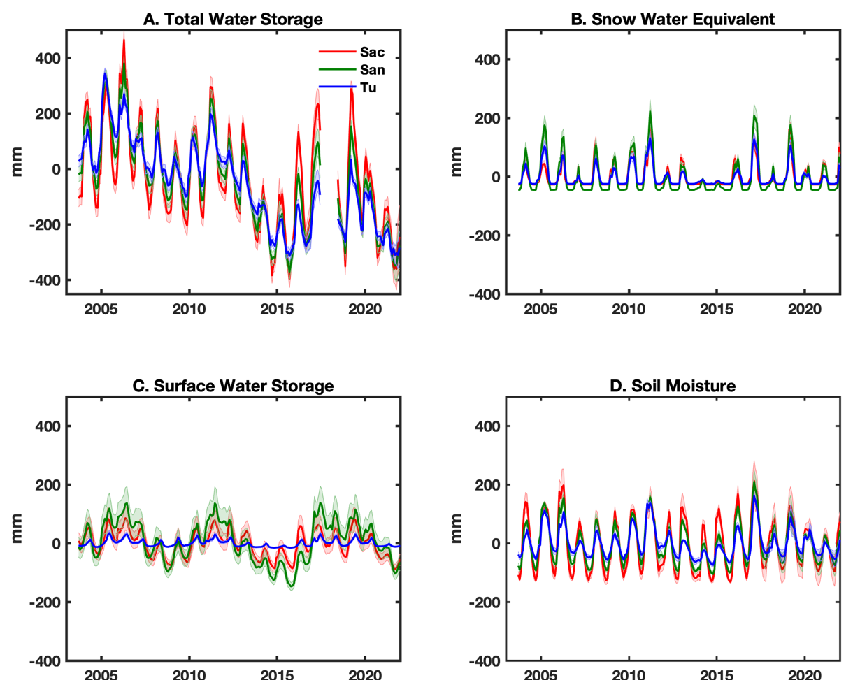
Fig. S1. Water storages components in the three basins of the study region. (A) GRACE/FO derived total water storage anomaly. (B) Snow water equivalent (SWE) anomaly. (C) Surface water storage anomaly (SW). (D) Soil moisture anomaly (SM). Sac, San, and Tu represent Sacramento, San Joaquin, and Tulare basins, respectively.
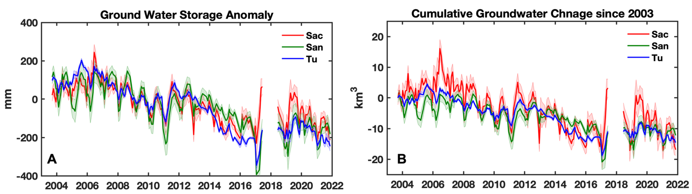
Fig. S2. Groundwater dynamics in the three basins of the study region. (A) Groundwater storage anomalies for the three basins derived from GRACE/FO. (B) the monthly cumulative groundwater changes of the three basins since 2003. Groundwater storage in September 2003 was used as the reference value

Table S1. Groundwater depletion rates in the three basins in the study region. Groundwater loss rates and total loss in Sacramento, San Joaquin, and Tulare basins during the GRACE and GRACE-FO missions (2003-2021).
 | Sacramento  (72,015 km³) |  |  | San Joaquin  (40,986 km³) |  |  | Tulare  (42,512 km³)
 | Loss Rate  (mm/yr) | Loss Rate  (km³/yr) | Volume Loss  (km³) | Loss Rate  (mm/yr) | Loss Rate  (km³/yr) | Volume Loss  (km³) | Loss Rate  (mm/yr) | Loss Rate  (km³/yr) | Volume Loss  (km³)
Aug. 2006 – Feb. 2011 | -43.7 ± 8.7 | -3.15 ± 0.63 | -14.4 ± 1.3 | -44.7 ± 12.9 | -1.83 ± 0.53 | -8.3 ± 1.1 | -40.1 ± 6.3 | -1.70 ± 0.27 | -7.7 ± 0.6
Aug. 2011 – Mar. 2017 | -34.0 ± 8.0 | -2.45 ± 0.58 | -13.8 ± 1.4 | -40.4 ± 9.9 | -1.65 ± 0.41 | -9.3 ± 1.0 | -62.6 ± 4.4 | -2.66 ± 0.18 | -15.1 ± 0.4
Sep. 2019 – Dec. 2021 | -76.1 ± 28.1 | -5.48 ± 2.02 | -12.8 ± 3.1 | -38.1 ± 25.2 | -1.55 ± 1.03 | -3.6 ± 1.7 | -60.1 ± 14.0 | -2.57 ± 0.60 | -6.0 ± 0.9
Sep. 2003 – Aug. 2017  (Lifetime of GRACE) | -16.9 ± 2.6 | -1.22 ± 0.19 | -17.03 ± 0.70 | -17.6 ± 1.6 | -0.72 ± 0.07 | -10.10 ± 0.25 | -25.8 ± 2.2 | -1.10 ± 0.09 | -15.36 ± 0.35
Sep. 2003 – Dec. 2021 | -12.9 ± 1.8 | -0.93 ± 0.13 | -17.05 ± 0.56 | -16.2 ± 2.0 | -0.67 ± 0.09 | -12.28 ± 0.39 | -20.6 ± 1.5 | -0.85 ± 0.07 | -15.58 ± 0.30

