Supplementary material 2

Supplementary Figure 1 – Mean reads of all samples within each group.
Supplementary Figure 2 – Rarefaction curves for each sample within each group.

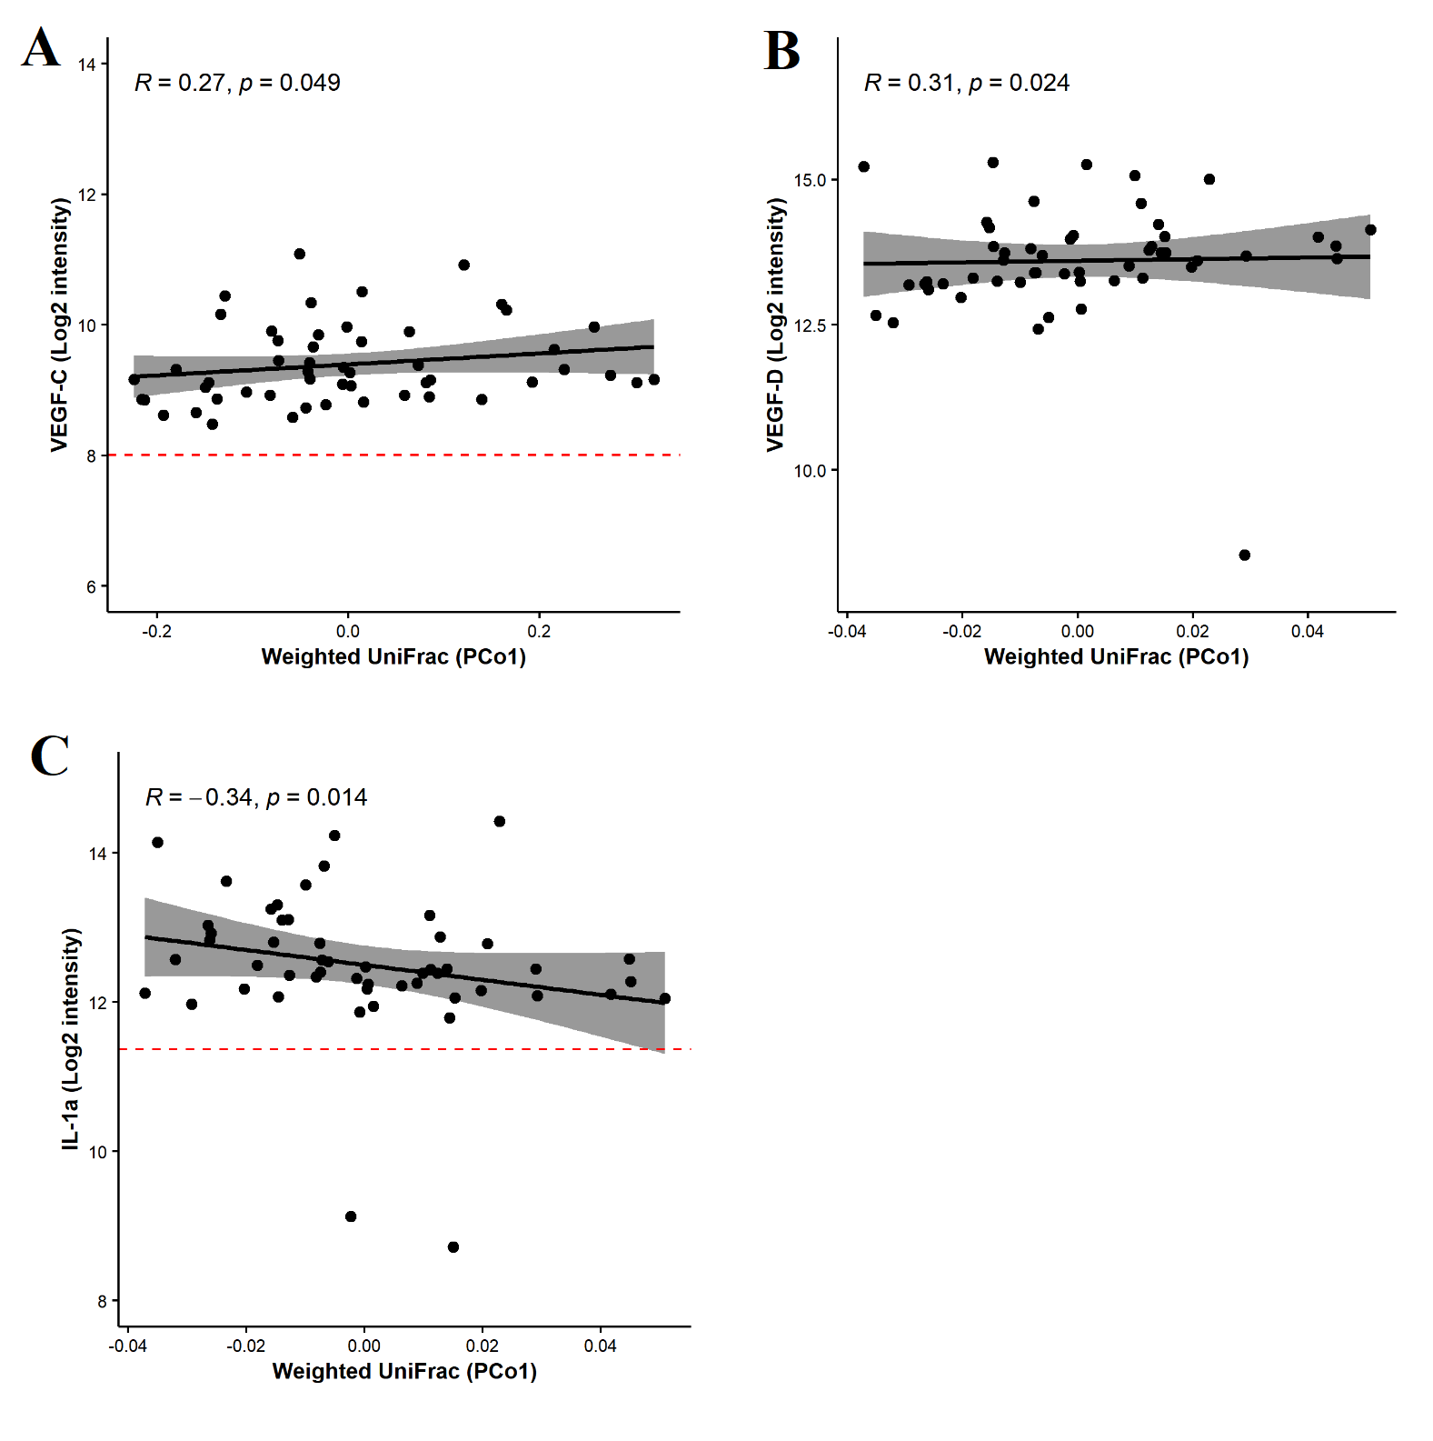
Supplementary Figure 3 – Correlation analyses between immune markers and β-diversity measures. Vascular epithelial growth factor C (VEGF-C) was found to correlate positively with weighted UniFrac (A). VEGF-D was found to correlate positively with weighted UniFrac (B). IL-1a was found to correlate negatively with weighted UniFrac (C).

