Supplementary Tables legends
Supplementary table 1: Primers for amplification of genes.
Supplementary table 2: PCR profile for gene amplification from gDNA.
Supplementary table 3: Protocol for restriction digestion with given restriction enzymes.

Supplementary Figures legends
Supplementary figure 1a: Sequence similarity of UGT76G1.
Supplementary figure 1b: Sequence similarity of UGT85C2.
Supplementary figure 1c: Sequence similarity of UGT74G1.
Supplementary figure 2a: UGT76G1 gene primer design by snapgene.
Supplementary figure 2b: UGT85C2 gene primer design by snapgene.

Supplementary Table 1:
S. No. | Primer | Primer sequences (5΄-3΄)
1 | HHZ76-F | GCTGGATCCATGGAAAATAAAACGGAG
2 | HHZ76-R | GCGAAGCTTTTACAACGATGAAATGTA
3. | HHZ85-F | GCTATCGATATGGATGCAATGGCTACA
4. | HHZ85-R | GCTGCTAGCCTAGTTTCTTGCTAG
5. | HHZ74-F | GCGAAGCTTATGGCGGAACAACAAAAG
6. | HHZ74-R | GCGGAGCTCTTAAGCCTTAATTAGCTC

Supplementary Table 2:
Steps | Temperature (°C) | Time (minute: seconds) | Number of cycles
Initial Denaturation | 95 | 07:00 | 1
Denaturation | 94 | 00:30 | 34
Annealing | 55 | 00:30 | 34
Extension | 72 | 01:30 | 34
Final extension | 72 | 10:00 | 1

Supplementary Table 3:
Reagents | 1X (μL)
UP water | 12
Enzyme buffer (10X) | 2
PCR amplified Product | 5
Enzyme (5 U/μL) | 1
Total Volume | 20

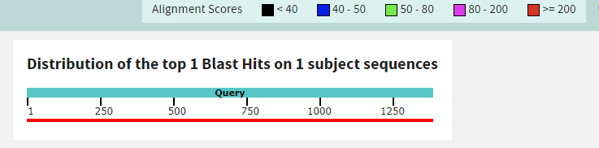
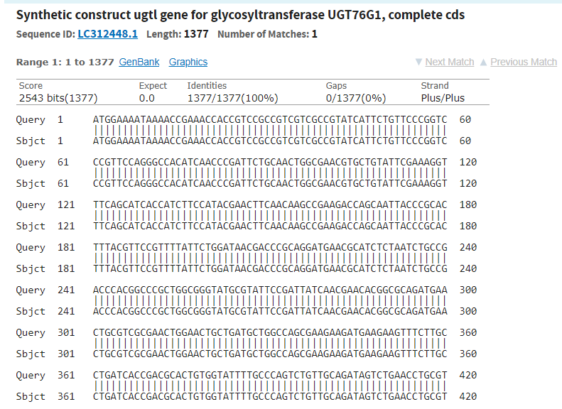

Supplementary Figure 1a
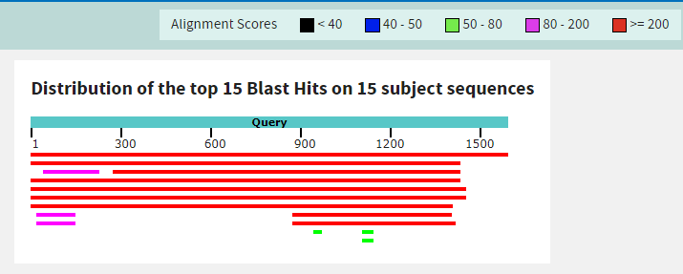
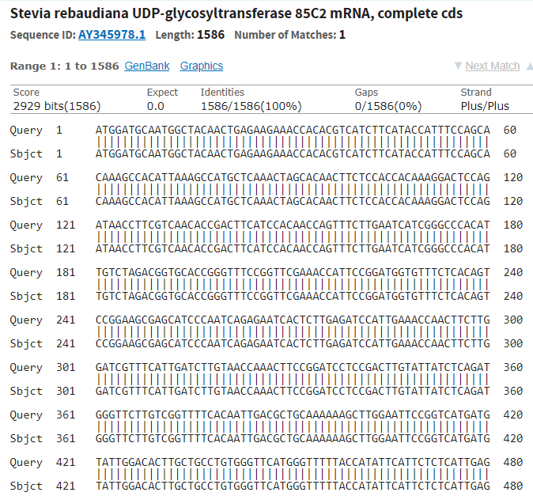

Supplementary Figure 1b

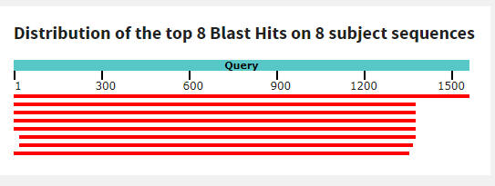
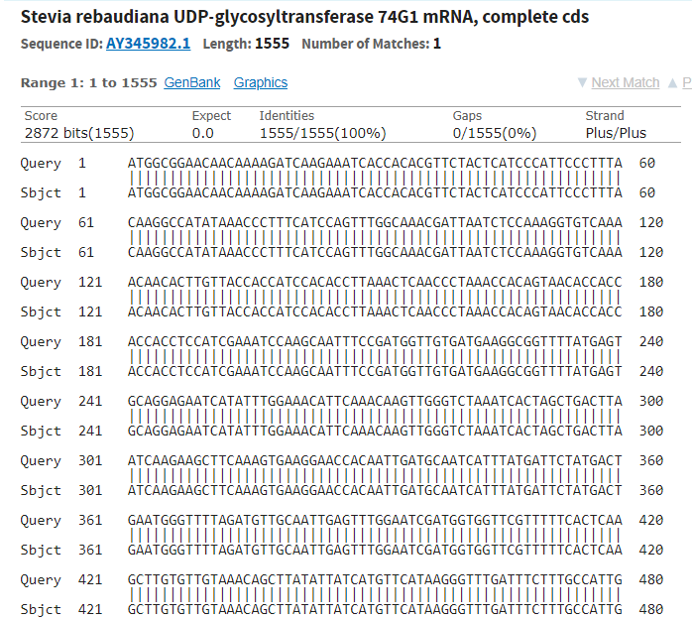

Supplementary Figure 1c

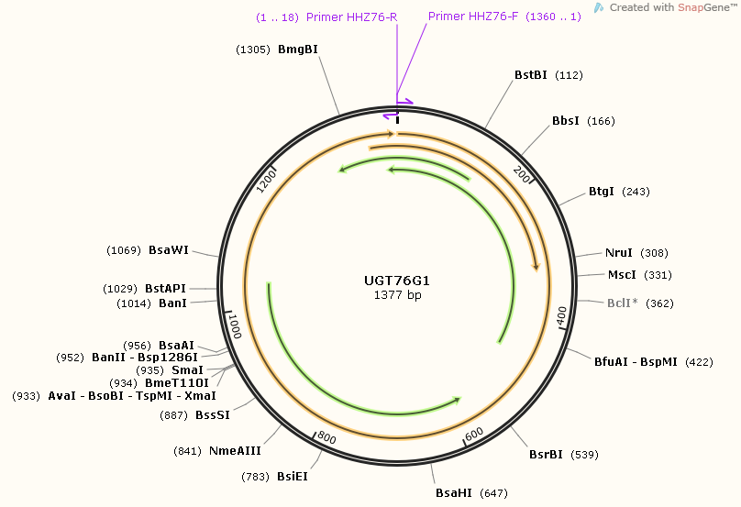

Supplementary Figure 2a
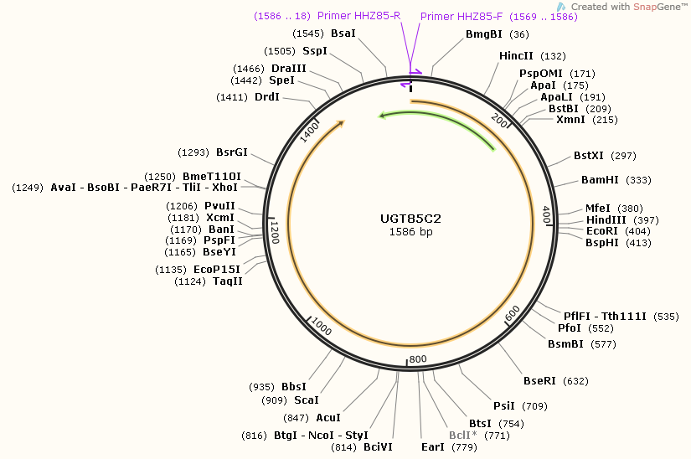

Supplementary Figure 2b
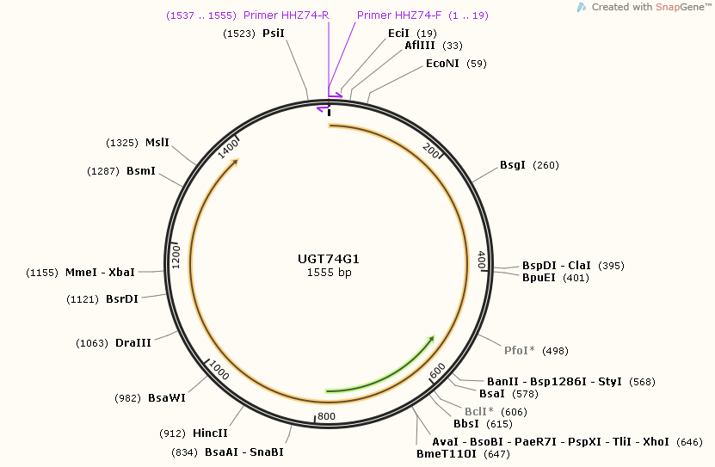

Supplementary Figure 2c

