Supplemental Information

Table S1
Primers used for cloning.
Plasmid and DNA | Sequence (5’→3’)
pYD1-AGA2-ScafI | olpa F: GAGGATCCCGCCTTCGCCTGCACAAACAAACACCATTG  olpa R: GTAACTTTAAGACCGTCTGACGGAACATTTG
pYD1-AGA2-ScafI | sdba F: GTCAGACGGTCTTAAAGTTACAGTAGGAACAG  sdba R: CGATAGCCCATACACTACCGTTTGTCTTAG
pYD1-αMF-XynII-SdbA | xynii F: AGCTTTGTTTAAACTTATATAGTTATAAGTCC  xynii R: TGGAGCCTGTGAAGTGCTGACGGTGATGGA
pYD1-αMF-XynII-SdbA | doc-sdba F: TCCATCACCGTCAGCACTTCACAGGCTCCA  doc-sdba R: AGCTTTGTTTAAACTTACTGTGCGTCGTAA
pYD1-αMF-XylA-OlpA | xyla F: GAGGATCCAAAAGACAAGCAAACCAAAGC  xyla R: CATTAAGCACAACAGGTTGCGGCGCAATCAAC
pYD1-αMF-XylA-OlpA | doc-olpa F: GTTGATTGCGCCGCAACCTGTTGTGCTTAATG  doc-olpa R: AGCTTTGTTTAAACTTATATAGTTATAAGTCC
5’ Delta homologous arms | 5’-δ F: GCCGCGTGTTGGAATAGAAATCAACTATC
5’ Delta homologous arms | 5’-δ R: GAGGAAGCTGAAACGCAATATTTTAGATTCCTGACTTC
3’ Delta homologous arms | 3’-δ F: AATACTACTCAGTAATAAAAAATGATGATAATAATAT
3’ Delta homologous arms | 3’-δ R: CGGCCATGAGAAATGGGTGAATG
PGK | pgk F: GAGGAAGCTGAAACGCAATATTTTAGATTCCTGACTTC
PGK | pgk R1: CAACTTAATAGAAGGCATCGTTTTGTTTTATATTTGTTGTA  pgk R2: GGAAGGGTTAGCAGTCATCGTTTTGTTTTATATTTGTTGTA
XR | xr F: ACAACAAATATAAAACAAAACGATGCCTTCTATTAAG
XR | xr R: GTTATCAGATCAGCGGGTTTAAACTTAGACGAAGATAGGAATC
XDH | xdh F: TACAACAAATATAAAACAAAACGATGACTGCTAACCCTTCC
XDH | xdh R: GTTATCAGATCAGCGGGTTTAAACTTACTCAGGGCCGTCAATG
MATT | MATT F1: GATTCCTATCTTCGTCTAAGTTTAAACCCGCTGATCTGATAA  MATT F2: CATTGACGGCCCTGAGTAAGTTTAAACCCGCTGATCTGATA
MATT | MATT R: TATTATTATCATCATTTTTTATTACTGAGTAGTAT
gRNA1 | gRNA1-F: CCAAAACGCAAGGATTGATAATGTAATGTTTT
gRNA1 | gRNA1-R: CTCTAAAACATTACATTATCAATCCTTGCGTT

Figure S1. A schematic representation of plasmid construction.

Fig. S1A. pDi-CRISPR plasmid for δ-integration CRISPR-Cas9.

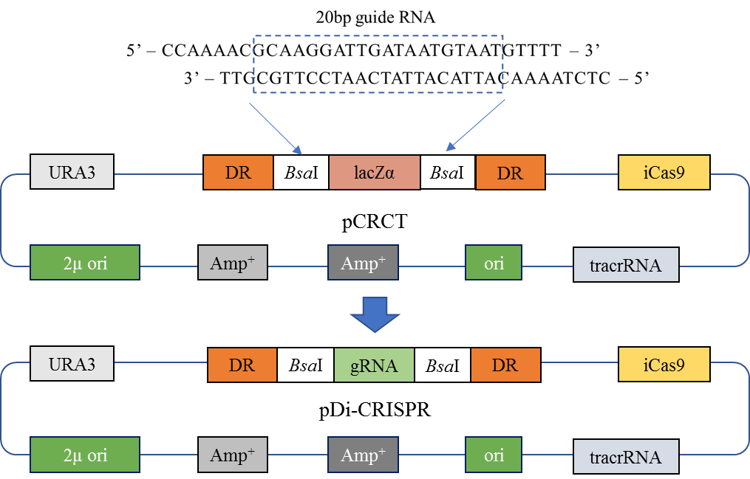

Fig. S1B. Surface displaying plasmid for anchoring scaffoldin.

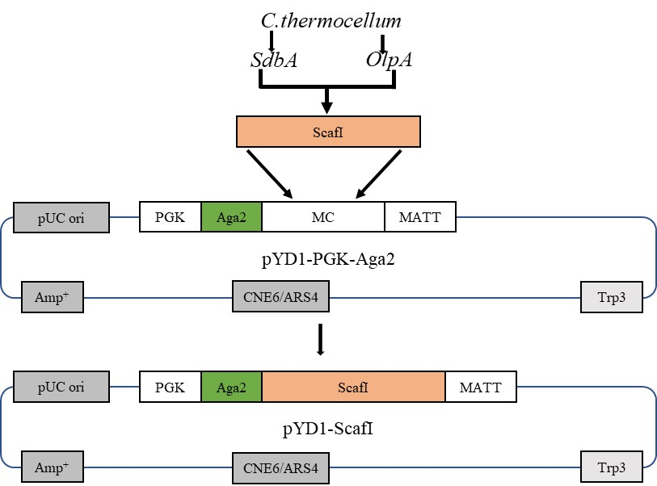

Fig. S1C. Secretion expression plasmids for two types of xylanases.

