Supplementary
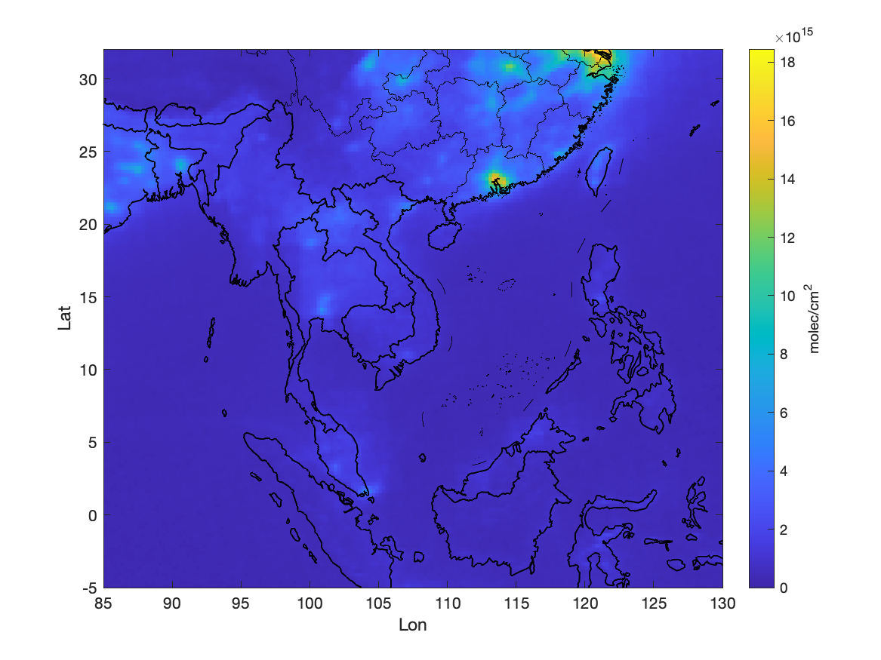
Figure 1 Climatological mean map of daily remotely sensed NO₂

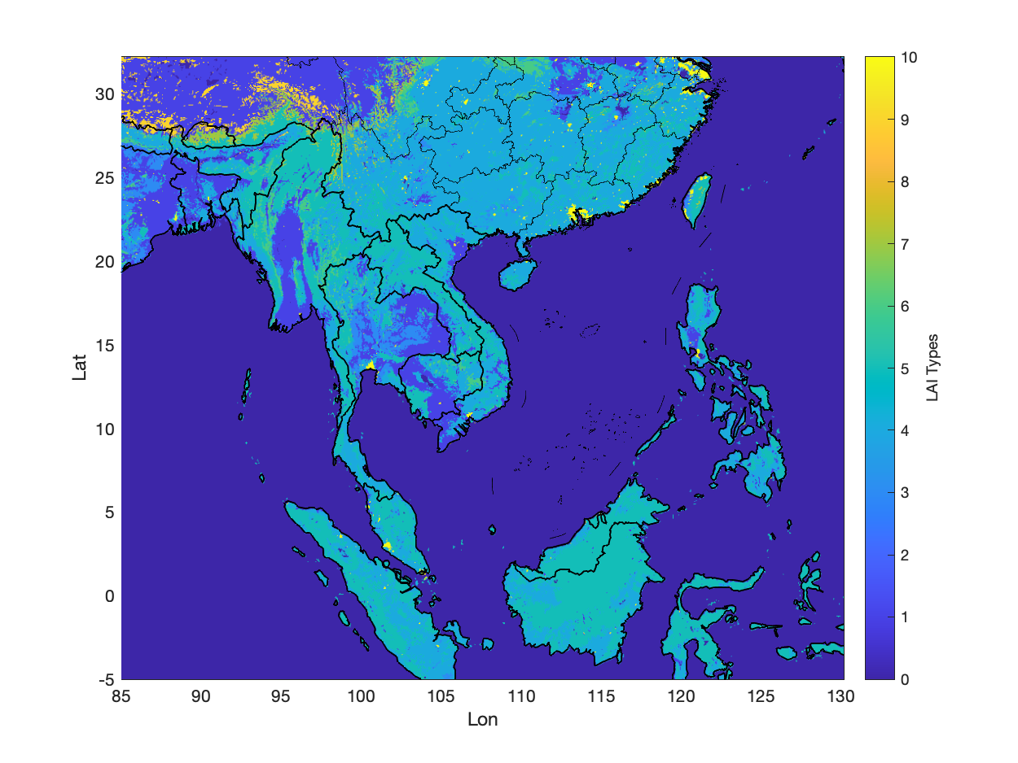
Figure 2 Land Cover Types over ROI
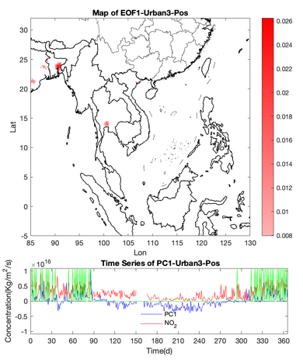(a)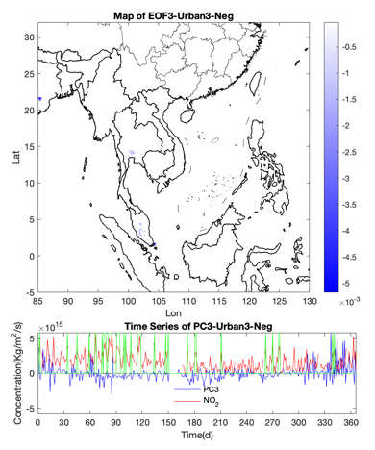(b) 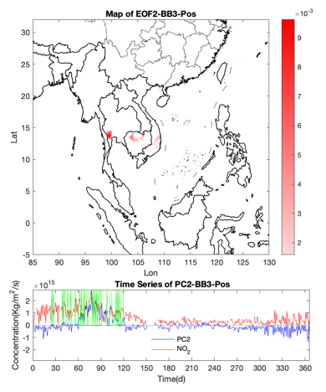(c)
Figure 3 Three typical EOF and PC features in both Urban3 area and BB3 area

