Archives of Microbiology
Supplementary Material
Comparative genomic analysis of the genus Marinomonas and taxonomic study of Marinomonas algarum sp. nov., isolated from red algae Gelidium amansii
Jian-Heng Xue¹ · Bei-Ning Zhang¹ · Feng Zhang³ · Ying-Ying Liu² · Wen-Jie Wu¹ · Zhao-Ming Wu¹ · Yue Si² · Peng-Xi Yang¹ · Xiang Xing² *· Li-Hua Zhao^{2,} *
¹ SDU-ANU Joint Science College, Shandong University, Weihai, Shandong, 264209, PR China.
² Marine College, Shandong University, Weihai, Shandong, 264209, PR China.
³Weihai Ecological and Environmental Monitoring Center (Weihai Motor Vehicle Emission Monitoring Center), Weihai, Shandong, 264209, PR China.
Author for correspondence:
Li-Hua Zhao, Email: lihua_zhao@sdu.edu.cn
Xiang Xing, Email: xingxiang@email.sdu.edu.cn

Supplementary Fig S1. Transmission electron micrograph of cell of E8^{T}. Cell was grown on marine agar 2216 at 28 ℃ for 48 hours. Bar, 500 nm.
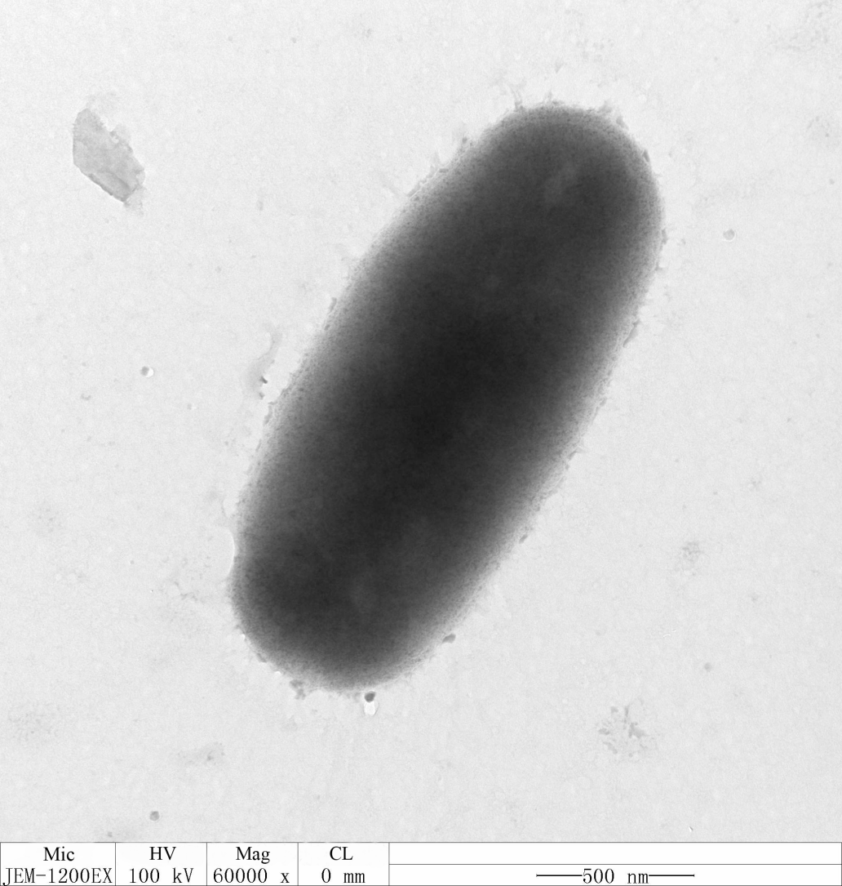

Supplementary Fig S2. Neighbour-joining phylogenetic tree based on 16S rRNA gene sequences of strain E8^{T} and representative of the other members of the family Oceanospirillaceae. All type strains in genus Marinomonas have been concluded. Bootstrap values (>70%) based on 1000 replicates were shown at branch nodes. Zobellella endophytica 59N8^{T} (GenBank accession number MG706141) was used as an outgroup. Bar, 0.01 substitutions per nucleotide position.
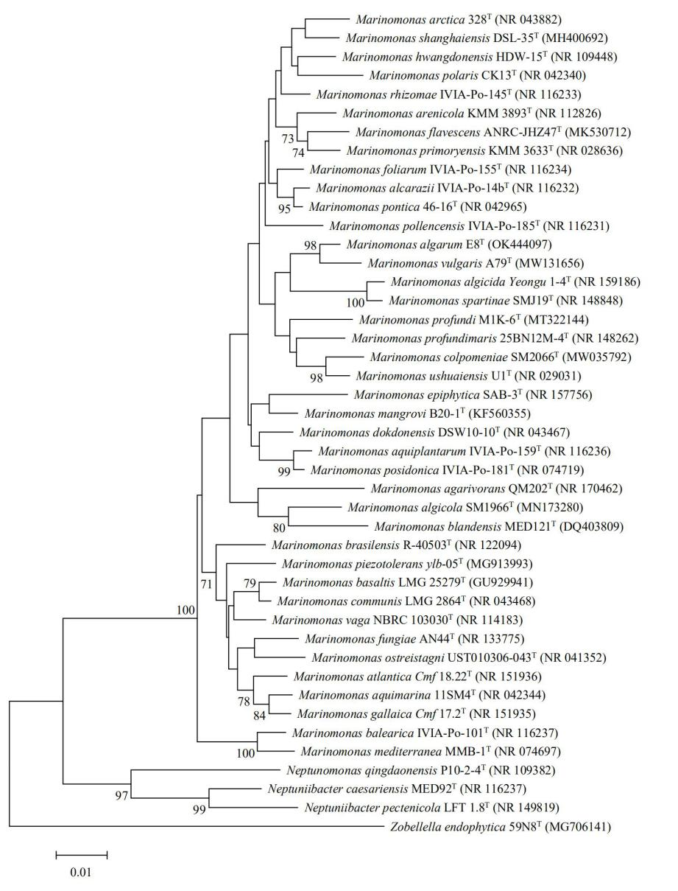

Supplementary Fig S3. Maximum-parsimony phylogenetic tree based on 16S rRNA gene sequences of strain E8^{T} and representative of the other members of the family Oceanospirillaceae. All type strains in genus Marinomonas have been concluded. Bootstrap values (>70%) based on 1000 replicates were shown at branch nodes. Zobellella endophytica 59N8^{T} (GenBank accession number MG706141) was used as an outgroup. Bar, 10.0 substitutions per nucleotide position.
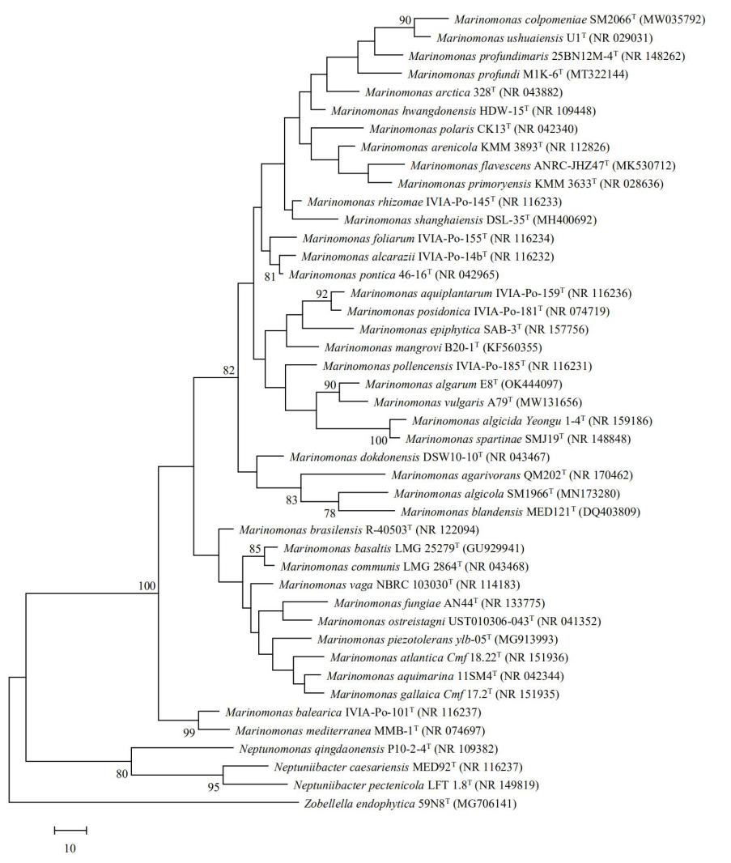
Supplementary Fig S4. Two-dimensional TLC plate of lipids extracted from strain E8^{T} and reference strains. The plate was sprayed with 5% (v/v) molybdatophosphoric acid to show all lipids present.
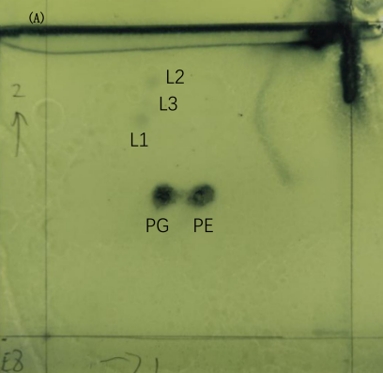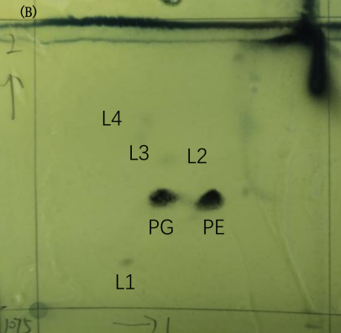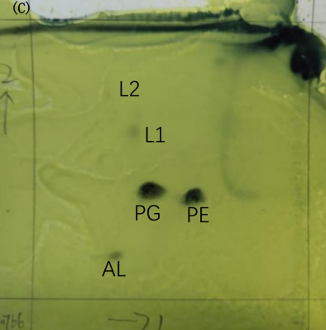
A, strain E8^{T}; B, Marinomonas pontica DSM 17793^{T}; C, Marinomonas communis JCM 20766^{T}.
PG, phosphatidylglycerol; PE, phosphatidylethanolamine; AL, unidentified amino lipid; L, unidentified lipids.

Supplementary Fig S5. The heatmap of pairwise distance between pair genomes.
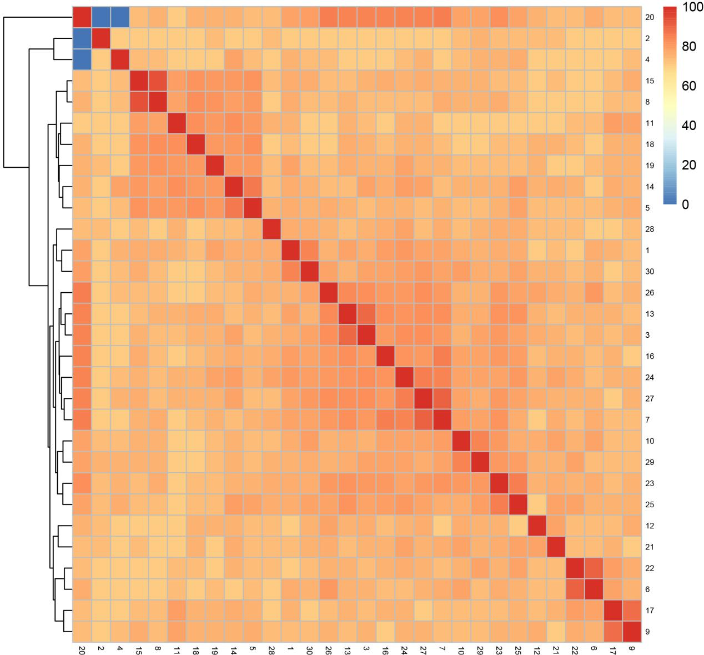
Strains: 1, M.algarum E8^{T}; 2, M.agarivorans QM202^{T}; 3, M.alcarazii CECT 7730^{T}; 4, M.algicola SM1966^{T}; 5, M.aquimarina CECT 5080^{T}; 6, M.aquiplantarum CECT 7732^{T}; 7, M.arctica BSI20414; 8, M.atlantica Cmf 18.22^{T}; 9, M.balearica CECT 7378^{T}; 10, M.colpomeniae SM2066^{T}; 11, M.communis DSM 5604^{T}; 12, M.flavescens ANRC-JHZ47^{T}; 13, M.foliarum JZW; 14, M.fungiae JCM 18476^{T}; 15, M.gallaica CECT 5116^{T}; 16, M.hwangdonensis HDW-15^{T}; 17, M.mediterranea MMB-1^{T}; 18, M.ostreistagni UST010306-043^{T}; 19, M.piezotolerans YLB-05^{T}; 20, M.polaris DSM 16579^{T}; 21, M.pollencensis CECT 7375^{T}; 22, M.posidonica IVIA-Po-181^{T}; 23, M.primoryensis MPKMM3633^{T}; 24, M.profundi M1K-6^{T}; 25, M.profundimaris D104^{T}; 26, M.rhizomae IVIA-Po-145^{T}; 27, M.shanghaiensis DSL-35^{T}; 28, M.spartinae CECT 8886^{T}; 29, M.ushuaiensis DSM 15871^{T}; 30, M.vulgaris A79^{T}.

Supplementary Fig S6. The single copy core protein tree showed the branches of 30 strains confirmed by single-copy orthologue proteins tree.
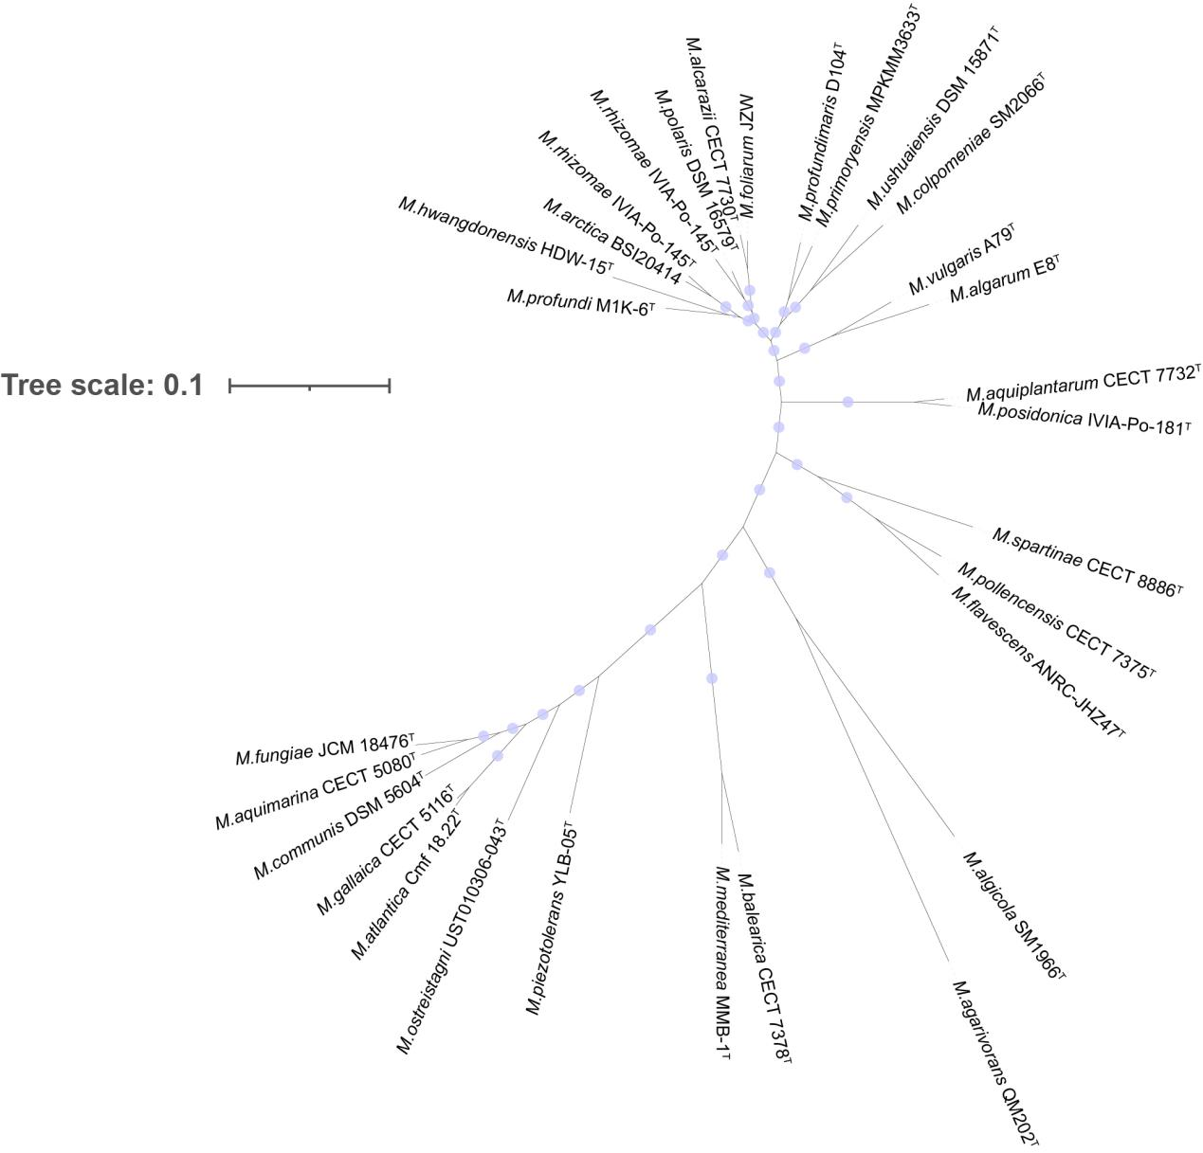

Supplementary Fig S7. The core-pan plot of reference genomes in genus Marinomonas.
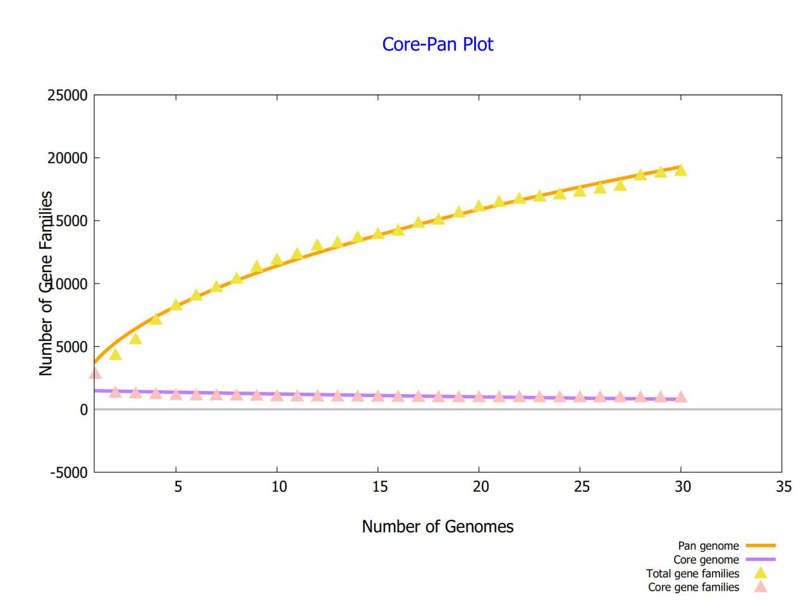
Supplementary Fig S8. The pan-genome phylogenetic tree generated by BPGA pipeline.
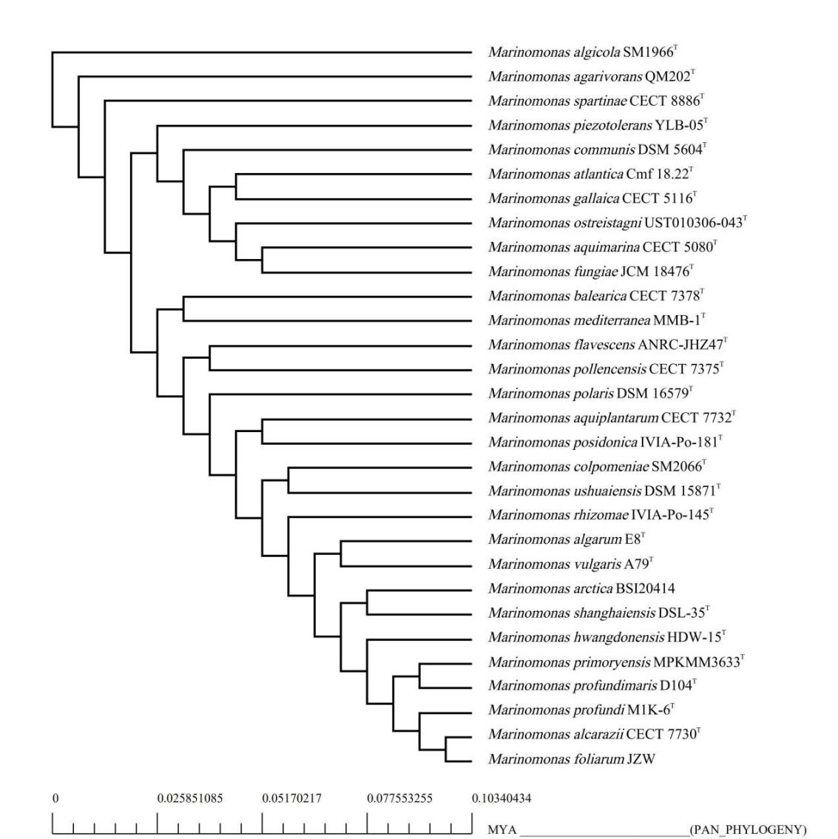

Supplementary Fig S9. The core-genome phylogenetic tree generated by BPGA pipeline.
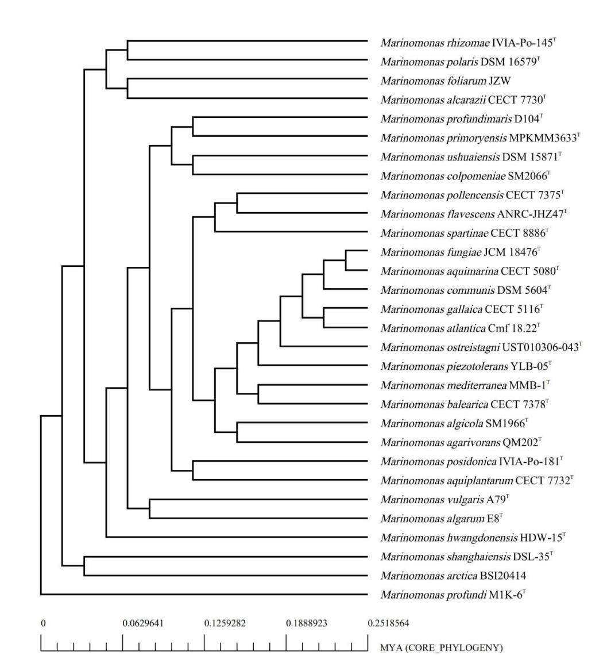

Supplementary Fig S10. The KEGG distribution of core-, accessory- and unique genes in genus Marinomonas.
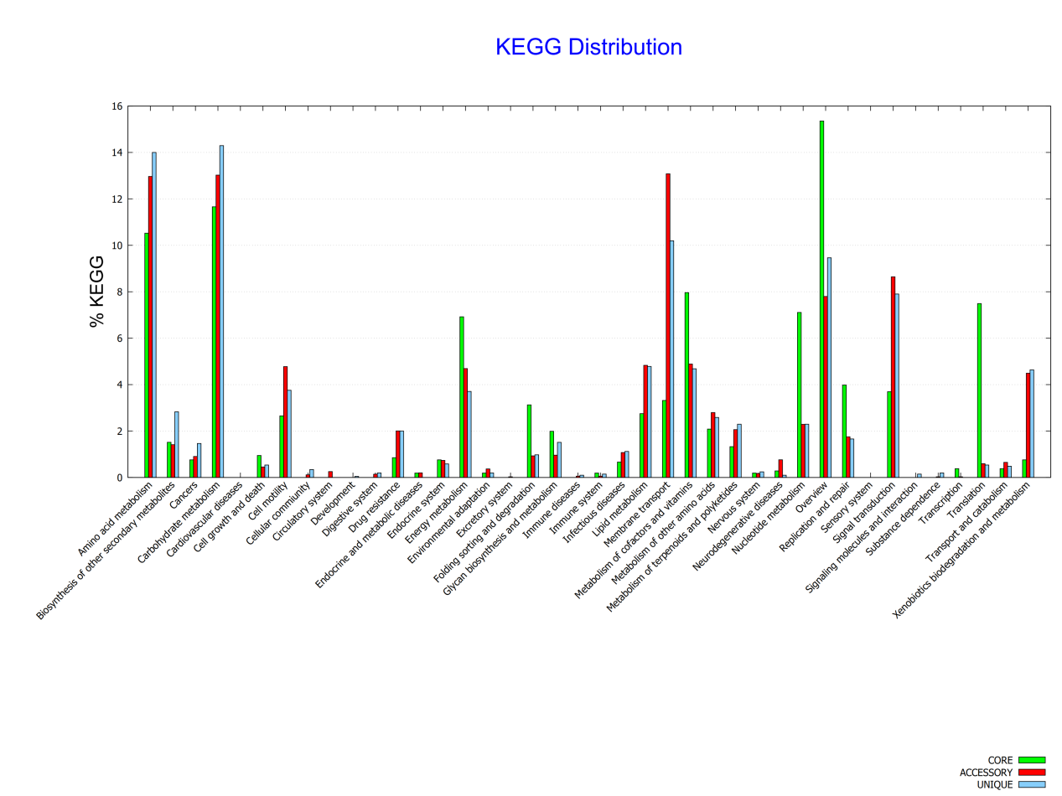

Supplementary Table S1. Negative characteristics of strain E8^{T} in API ZYM, API 20 E, API 50CH and Biolog Gen III microPlates tests.
Kit | Characteristic
API ZYM
 | lipase (C14), cystine arylamidase, trypsin, α-chymotrypsin, α-galactosidase, β-galactosidase, β-glucuronidase, α-glucosidase, β-glucosidase, N-acetyl-β-glucosaminidase, α-mannosidase, β-fucosidase
API 20E
 | o-nitrophenyl-β-d-galactopyranoside, arginine dihydrolase, lysine decarboxylase, ornithine decarboxylase, H₂S production, Urease, tryptophan deaminase, indole production, voges–Proskauer reaction, glucose, mannitol, nositol, sorbitol, rhamnol, sucrose, melibiose, amygdalin
API 50CH
 | glycerol, erythritol, d-arabinose, l-arabinose, d-adonitol, methyl-βd-xylopyranoside, d-galactose, d-glucose, d-mannose, l-rhamnose, dulcitol, Inositol, d-manitol, d-sorbitol, methyl-αd-mannopyranoside, methyl-αd-glucopyranoside, N-acetyl glucosamine, amygdalin, arbutin, salicin, d-cellobiose, d-maltose, d-lactose (bovine origin), d-melibiose, d-saccharose, d-trehalose, inulin, d-melezitose, d-raffinose, amidon, glycogen, d-xylitol, gentiobiose, d-fucose, l-fucose, d-arbaitol, l-arbaitol, potassium gluconate, potassium 2-ketogluconate
Biolog Gen III
 | d-raffinose, α-d-glucose, gelatin, pectin, p-hydroxy-phenylacectic acid, Tween 40, dextrin, d-lactose, glycyl-l-proline, d-galacturonic acid, methyl pyruvate, γ-amino-butyric acid, d-maltose, d-melibiose, d-fructose, d-arabitol, l-alanine, l-galactonic acid lactone, d-lactic acid methyl ester, α-hydroxy-butyric acid, d-trehalose, β-methyl-d-glucose, d-galactose, myo-inositol, l-arginine, d-gluconic acid, β-hydroxy-dl-butyric acid, d-cellobiose, d-salicin, 3-methyl glucose, glycerol, l-aspartic acid, d-glucuronic acid, citric acid, α-keto-butyric acid, gentiobiose, N-acetyl-d-glucosamine, d-fucose, d-glucose-6-PO₄, l-glutamic acid, glucuronamide, α-keto-glutaric acid, acetoacetic acid, sucrose, N-acetyl-β-d-mannosamine, l-fucose, d-fructose-6-PO₄, l-histidine, mucic acid, d-malic acid, propionic acid, N-acetyl-d-galactosamine, l-rhamnose, d-aspartic acid, l-pyroglutamic acid, quinic acid, l-malic acid, acetic acid, stachyose, N-acetyl neuraminic acid, inosine, d-serine, l-serine, d-saccharic acid, bromo-succinic acid, formic acid

Supplementary Table S2. General genomic characteristics of strain E8^{T} and the related strains within the genus Marinomonas.
No | Strains | Accesssion numbers | Number of contigs | Sequencing coverage | Size (Mbp) | G+C content (%) | N50 values | Number of genes | Protein-coding gene | Number of rRNAs | Number of tRNAs
1 | M.algarum E8^{T} | JAJATW000000000 | 79 | 150.0x | 3.29 | 45.1 | 126,031 | 3,085 | 2,926 | 16 | 77
2 | M.agarivorans QM202^{T} | NHNK00000000 | 68 | 255x | 3.17 | 41.4 | 99,644 | 3,069 | 2,979 | 6 | 56
3 | M.alcarazii CECT 7730^{T} | QKLW00000000 | 26 | 365.0x | 3.97 | 43.8 | 255,618 | 3,655 | 3,551 | 5 | 65
4 | M.algicola SM1966^{T} | CP061941 | 1 | 413.1x | 4.49 | 41.6 | 4,341,165 | 4,108 | 3,936 | 28 | 84
5 | M.aquimarina CECT 5080^{T} | FLOC00000000 | 47 | 91x | 3.66 | 48.9 | 164,325 | 3,454 | 3,314 | 9 | 104
6 | M.aquiplantarum CECT 7732^{T} | QNRF00000000 | 31 | 384.0x | 3.77 | 44.5 | 375,709 | 3,602 | 3,507 | 8 | 67
7 | M.arctica BSI20414 | CP061081 | 1 | 252.0x | 4.54 | 44.5 | 4,540,024 | 4,225 | 4,083 | 25 | 80
8 | M.atlantica Cmf 18.22^{T} | LTAW00000000 | 69 | 100.0x | 3.86 | 44.6 | 478,347 | 3,737 | 3,614 | 4 | 73
9 | M.balearica CECT 7378^{T} | SNXC00000000 | 23 | 357.0x | 3.88 | 43.4 | 437,381 | 3,561 | 3,442 | 3 | 71
10 | M.colpomeniae SM2066^{T} | JACYFC000000000 | 23 | 626.0x | 3.71 | 40.3 | 586,646 | 3,470 | 3,314 | 2 | 67
11 | M.communis DSM 5604^{T} | SNZA00000000 | 15 | 295.0x | 3.85 | 45.8 | 461,746 | 3,609 | 3,520 | 11 | 69
12 | M.flavescens ANRC-JHZ47^{T} | SJSB00000000 | 41 | 100x | 3.76 | 42.6 | 213,301 | 3,492 | 3,374 | 9 | 71
13 | M.foliarum JZW | CP070273 | 1 | 705.0x | 3.99 | 43.5 | 3,994,789 | 3,694 | 3,562 | 25 | 80
14 | M.fungiae JCM 18476^{T} | LIQF01000001 | 42 | 358.0x | 4.19 | 46.2 | 268,463 | 3,913 | 3,792 | 16 | 53
15 | M.gallaica CECT 5116^{T} | FLRB00000000 | 41 | 108x | 3.83 | 45.3 | 199,479 | 3,625 | 3,492 | 16 | 87
16 | M.hwangdonensis HDW-15^{T} | RIZG00000000 | 25 | 324.0x | 3.46 | 45.0 | 539,763 | 3,179 | 3,075 | 2 | 72
17 | M.mediterranea MMB-1^{T} | CP002583 | 1 | 30x | 4.68 | 44.1 | 4,684,316 | 4,299 | 4,133 | 21 | 81
18 | M.ostreistagni UST010306-043^{T} | JAFEKF000000000 | 17 | 320.0x | 3.22 | 48.5 | 934,233 | 3,048 | 2,886 | 15 | 89
19 | M.piezotolerans YLB-05^{T} | QKRA00000000 | 29 | 200.0x | 4.00 | 45.7 | 567,345 | 3,790 | 3,674 | 13 | 69
20 | M.polaris DSM 16579^{T} | FQVF00000000 | 59 | 420x | 5.04 | 42.5 | 194,844 | 4,686 | 4,570 | 12 | 57
21 | M.pollencensis CECT 7375^{T} | QUNG00000000 | 49 | 308.0x | 3.87 | 44.9 | 208,413 | 3,601 | 3,502 | 6 | 70
22 | M.posidonica IVIA-Po-181^{T} | CP002771 | 1 | 30x | 3.90 | 44.3 | 3,899,940 | 3,614 | 3,485 | 24 | 80
23 | M.primoryensis MPKMM3633^{T} | CP054301 | 1 | 200.0x | 4.07 | 43.5 | 4,068,722 | 3,780 | 3,640 | 25 | 71
24 | M.profundi M1K-6^{T} | CP073013 | 1 | 600.0x | 3.65 | 46.1 | 3,648,059 | 3,400 | 3,257 | 24 | 77
25 | M.profundimaris D104^{T} | AYOZ00000000 | 62 | 353x | 3.83 | 44.8 | 207,434 | 3,610 | 3,512 | 4 | 62
26 | M.rhizomae IVIA-Po-145^{T} | RIZH00000000 | 50 | 323.0x | 4.41 | 42.8 | 272,655 | 4,093 | 3,999 | 3 | 57
27 | M.shanghaiensis DSL-35^{T} | QGOK00000000 | 58 | 379.0x | 4.31 | 44.4 | 178,452 | 3,991 | 3,882 | 3 | 75
28 | M.spartinae CECT 8886^{T} | FLOB00000000 | 41 | 166x | 4.72 | 44.1 | 404,911 | 4,384 | 4,237 | 15 | 81
29 | M.ushuaiensis DSM 15871^{T} | JAMB00000000 | 39 | 100.0x | 3.34 | 41.1 | 205,043 | 3,146 | 3,050 | 5 | 58
30 | M.vulgaris A79^{T} | JAGSSV000000000 | 63 | 100.0x | 3.45 | 46.0 | 121,375 | 3,147 | 2,997 | 4 | 61

Supplementary Table S3. Fatty acid compositions (%) of strain E8^{T} and reference strains. Branched fatty acid Anteiso-C_{15:0}, Iso-C_{16:0} and Anteiso-C_{16:0} have been traced in three strains which less than 0.5%.
 | 1 | 2 | 3
Saturated
C_{10:0} | 0.8 | TR | 2.0
C_{12:0} | 1.0 | TR | 4.8
C_{14:0} | 0.5 | 1.0 | 1.5
C_{16:0} | 12.6 | 14.9 | 11.0
C_{17:0} | 3.1 | TR | TR
C_{18:0} | 5.3 | 4.7 | 2.4
Hydroxy
C_{10:0} 3-OH | 8.2 | 7.0 | 8.9
C_{12:0} 3-OH | TR | 0.8 | TR
C_{12:1} 3-OH | TR | 9.3 | –
Unsaturated
C_{17:1}ω6c | 1.1 | TR | TR
C_{17:1}ω8c | 0.7 | TR | –
Summed Features*
3 | 15.2 | 24.4 | 21.2
7 | 1.0 | TR | 0.6
8 | 47.8 | 35.3 | 45.7
Strains: 1, E8^{T}; 2, M.pontica DSM 17793^{T}; 3, M.communis JCM 20766^{T}. Values were percentages of the total fatty acids. Major fatty acids (>10%) were highlighted in bold type; fatty acids amounting to less than 0.5 % in all strains were omitted. TR, Traces (<0.5%). –, Not detected.
* Summed Features represent groups of two or three fatty acids that could not be separated by GLC with the MIDI system. Summed Feature 3, C_{16:1}ω7c and/or C_{16:1}ω6c; Summed Feature 7, C_{19:1}ω7c and/or C_{19:1}ω6c; Summed Features 8, C_{18:1}ω7c and/or C_{18:1}ω6c.

Supplementary Table S4. The pairwise comparisons of the digital DDH values between genome sequencing of strain E8^{T} and reference genome sequences in genus Marinomonas.
 | 1 | 2 | 3 | 4 | 5 | 6 | 7 | 8 | 9 | 10 | 11 | 12 | 13 | 14 | 15 | 16 | 17 | 18 | 19 | 20 | 21 | 22 | 23 | 24 | 25 | 26 | 27 | 28 | 29 | 30
1 | 100
2 | 19.8 | 100
3 | 19.7 | 19.6 | 100
4 | 21.8 | 19.7 | 19.9 | 100
5 | 19.5 | 19.9 | 19.0 | 23.1 | 100
6 | 19.1 | 19.0 | 19.2 | 20.0 | 18.8 | 100
7 | 20.4 | 19.2 | 21.9 | 22.1 | 20.1 | 19.1 | 100
8 | 19.7 | 19.5 | 19.2 | 22.2 | 19.6 | 18.7 | 19.8 | 100
9 | 19.6 | 20.3 | 19.3 | 21.6 | 20.1 | 20.9 | 20.5 | 20.1 | 100
10 | 19.4 | 19.9 | 19.7 | 19.7 | 19.7 | 18.6 | 19.7 | 18.9 | 20.0 | 100
11 | 18.9 | 19.1 | 18.9 | 19.9 | 20.9 | 19.2 | 19.5 | 19.0 | 19.9 | 18.9 | 100
12 | 20.3 | 19.7 | 19.4 | 20.0 | 19.2 | 18.9 | 19.8 | 18.9 | 19.7 | 19.6 | 18.7 | 100
13 | 20.1 | 20.7 | 31.2 | 21.2 | 20.3 | 19.0 | 22.3 | 20.1 | 19.8 | 20.0 | 19.6 | 19.6 | 100
14 | 19.6 | 19.0 | 18.8 | 24.8 | 23.3 | 18.7 | 19.0 | 19.3 | 19.5 | 19.1 | 20.8 | 18.7 | 19.3 | 100
15 | 19.5 | 19.7 | 19.7 | 21.1 | 19.8 | 18.8 | 19.5 | 43.2 | 20.5 | 19.3 | 19.3 | 19.7 | 20.0 | 19.8 | 100
16 | 19.3 | 18.9 | 21.2 | 20.2 | 19.7 | 18.9 | 23.7 | 19.1 | 19.7 | 19.3 | 19.3 | 19.5 | 21.2 | 19.6 | 19.7 | 100
17 | 21.6 | 20.8 | 20.2 | 24.2 | 21.8 | 21.8 | 22.0 | 21.3 | 24.4 | 21.0 | 21.9 | 21.0 | 21.3 | 21.3 | 21.3 | 21.5 | 100
18 | 19.7 | 18.9 | 18.9 | 20.2 | 20.2 | 18.6 | 19.5 | 19.2 | 20.2 | 19.5 | 19.8 | 18.8 | 20.0 | 20.0 | 19.3 | 18.8 | 21.9 | 100
19 | 19.4 | 19.7 | 19.1 | 21.1 | 19.0 | 18.6 | 19.6 | 19.8 | 20.2 | 19.5 | 18.8 | 18.6 | 20.2 | 19.4 | 19.5 | 19.0 | 21.1 | 18.9 | 100
20 | 20.2 | 18.9 | 23.7 | 20.3 | 19.1 | 19.0 | 24.0 | 19.1 | 19.2 | 20.1 | 18.7 | 19.5 | 24.7 | 18.8 | 19.3 | 22.4 | 20.5 | 19.1 | 18.9 | 100
21 | 20.1 | 20.1 | 19.4 | 23.0 | 21.2 | 18.9 | 19.8 | 18.9 | 19.9 | 19.3 | 18.9 | 21.3 | 19.7 | 20.7 | 19.8 | 19.2 | 20.8 | 19.2 | 19.0 | 19.4 | 100
22 | 19.3 | 19.7 | 19.5 | 21.4 | 19.8 | 31.4 | 19.5 | 19.5 | 24.0 | 19.0 | 19.9 | 19.4 | 19.4 | 19.3 | 19.4 | 19.4 | 24.7 | 19.5 | 19.7 | 18.9 | 19.4 | 100
23 | 19.9 | 19.9 | 20.7 | 21.3 | 20.0 | 18.9 | 21.2 | 20.1 | 20.7 | 20.7 | 19.2 | 19.8 | 21.0 | 19.3 | 20.3 | 20.3 | 23.0 | 19.5 | 19.3 | 22.2 | 19.4 | 19.4 | 100
24 | 20.6 | 20.4 | 21.9 | 22.3 | 19.9 | 19.4 | 24.0 | 20.0 | 20.5 | 20.0 | 19.6 | 20.2 | 22.7 | 19.7 | 20.2 | 21.9 | 22.2 | 19.7 | 20.2 | 24.0 | 20.4 | 19.9 | 21.8 | 100
25 | 19.7 | 19.8 | 20.4 | 22.8 | 21.9 | 18.9 | 20.8 | 19.1 | 19.4 | 20.1 | 18.6 | 19.8 | 20.8 | 22.2 | 18.5 | 20.0 | 21.3 | 18.8 | 18.7 | 21.6 | 20.4 | 19.2 | 24.3 | 21.3 | 100
26 | 19.6 | 19.3 | 22.8 | 21.4 | 18.8 | 19.8 | 22.5 | 18.6 | 21.2 | 19.7 | 18.9 | 19.4 | 23.7 | 18.7 | 19.2 | 21.0 | 22.1 | 18.9 | 18.8 | 27.8 | 19.6 | 20.0 | 21.3 | 22.4 | 20.8 | 100
27 | 20.0 | 18.9 | 21.6 | 20.1 | 19.0 | 19.0 | 31.0 | 18.9 | 18.9 | 19.4 | 18.6 | 19.5 | 21.9 | 18.7 | 19.2 | 21.7 | 20.7 | 18.6 | 18.9 | 23.4 | 19.4 | 19.2 | 20.7 | 23.5 | 20.4 | 22.0 | 100
28 | 20.1 | 19.4 | 19.9 | 21.3 | 20.3 | 19.3 | 20.5 | 19.7 | 20.5 | 19.0 | 19.2 | 19.4 | 20.6 | 19.2 | 19.8 | 19.9 | 21.7 | 19.4 | 19.7 | 20.5 | 19.4 | 19.9 | 20.1 | 20.9 | 20.0 | 19.7 | 19.9 | 100
29 | 19.5 | 19.6 | 20.2 | 20.8 | 18.8 | 19.1 | 20.3 | 19.1 | 19.6 | 22.7 | 18.6 | 19.9 | 20.5 | 18.4 | 18.7 | 19.7 | 21.5 | 18.4 | 18.5 | 21.0 | 19.5 | 19.5 | 21.0 | 20.7 | 20.4 | 20.4 | 20.1 | 19.4 | 100
30 | 22.0 | 19.5 | 19.9 | 21.1 | 19.0 | 18.9 | 20.3 | 19.4 | 19.7 | 19.2 | 18.8 | 19.8 | 19.9 | 19.0 | 19.0 | 19.5 | 21.0 | 19.3 | 18.9 | 20.8 | 19.9 | 19.2 | 19.8 | 20.6 | 19.8 | 19.9 | 20.0 | 20.1 | 19.7 | 100
Strains: 1, M.algarum E8^{T}; 2, M.agarivorans QM202^{T}; 3, M.alcarazii CECT 7730^{T}; 4, M.algicola SM1966^{T}; 5, M.aquimarina CECT 5080^{T}; 6, M.aquiplantarum CECT 7732^{T}; 7, M.arctica BSI20414; 8, M.atlantica Cmf 18.22^{T}; 9, M.balearica CECT 7378^{T}; 10, M.colpomeniae SM2066^{T}; 11, M.communis DSM 5604^{T}; 12, M.flavescens ANRC-JHZ47^{T}; 13, M.foliarum JZW; 14, M.fungiae JCM 18476^{T}; 15, M.gallaica CECT 5116^{T}; 16, M.hwangdonensis HDW-15^{T}; 17, M.mediterranea MMB-1^{T}; 18, M.ostreistagni UST010306-043^{T}; 19, M.piezotolerans YLB-05^{T}; 20, M.polaris DSM 16579^{T}; 21, M.pollencensis CECT 7375^{T}; 22, M.posidonica IVIA-Po-181^{T}; 23, M.primoryensis MPKMM3633^{T}; 24, M.profundi M1K-6^{T}; 25, M.profundimaris D104^{T}; 26, M.rhizomae IVIA-Po-145^{T}; 27, M.shanghaiensis DSL-35^{T}; 28, M.spartinae CECT 8886^{T}; 29, M.ushuaiensis DSM 15871^{T}; 30, M.vulgaris A79^{T}.

Supplementary Table S5. The summary table of proteins, clusters, singletons among 12 genomes of strains.
Species | Proteins | Clusters | Singletons
M.algarum E8^{T} | 2909 | 2604 | 261
M.agarivoans QM202^{T} | 2874 | 2369 | 444
M. alcarazii CECT 7730^{T} | 3551 | 3307 | 174
M.algicola SM1966^{T} | 3927 | 3325 | 502
M.aquiplantarum CECT 7732^{T} | 3507 | 3225 | 245
M.balearica CECT 7378^{T} | 3442 | 2962 | 422
M.colpomeniae SM2066^{T} | 3314 | 2983 | 286
M.foliarum CECT 7731^{T} | 3718 | 3346 | 287
M.pollencensis CECT 7375^{T} | 3498 | 3105 | 321
M.posidonica IVIA-Po-181^{T} | 3483 | 3278 | 181
M.rhizomae IVIA-Po-145^{T} | 3996 | 3584 | 326
M.spartinae CECT 8886^{T} | 4235 | 3358 | 757

