Massive virtual screening and evaluation of small molecule inhibitors of the Papain-like protease of SARS-Cov-2
Manuel I. Osorio ^{1, 2}, Osvaldo Yañez^{1, 3,4}, Mauricio Gallardo ², Olimpo García-Beltrán ^{5,6}, Fernando González-Nilo¹ and José M. Pérez-Donoso¹.
¹ Center for Bioinformatics and Integrative Biology (CBIB), Facultad de Ciencias de la Vida, Universidad Andres Bello, Av. República 330, Santiago 8370146, Chile
² Facultad de Medicina, Centro de Investigación Biomédica, Universidad Diego Portales, Ejército 141, Santiago 837007, Chile
³ Center of New Drugs for Hypertension (CENDHY), Santiago, Chile
⁴ Department of Pharmaceutical Science and Technology, School of Chemical and Pharmaceutical Sciences, Universidad de Chile, Santiago, Chile
⁵ Facultad de Ciencias Naturales y Matemáticas, Universidad de Ibagué, Carrera 22 calle 67, Ibagué 730002, Colombia
⁶ Universidad Bernardo O′ Higgins, Centro Integrativo de Biología y Química Aplicada (CIBQA), General Gana 1702, Santiago, Chile, 8370854

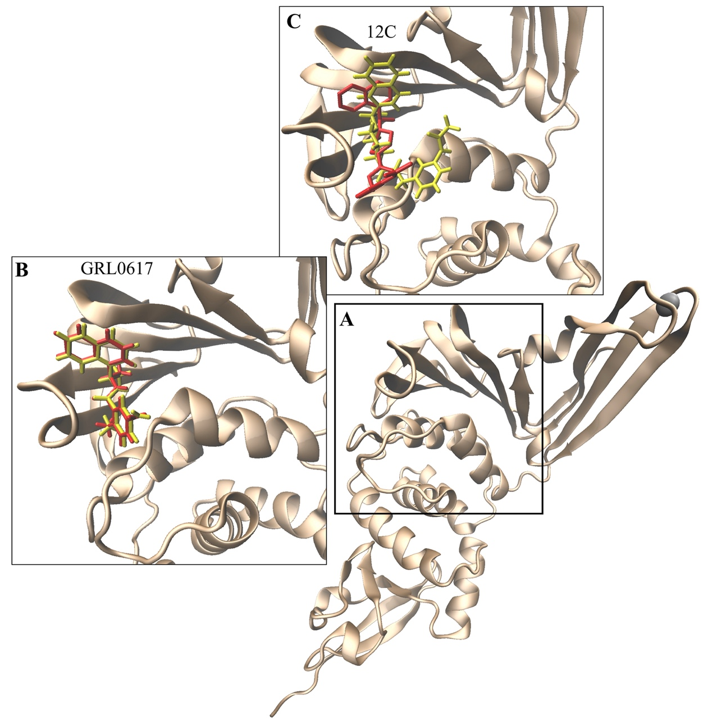
Figure S1. Comparison of structures obtained by molecular docking and crystallography. The binding region for GRL0617 and 12C is highlighted in the PLpro protein (A). Comparison of the lowest energy structures obtained by molecular docking (yellow) and crystallographic (red) published in the PDB database for PLpro/GRL0617 (B) and PLpro12C (C) is shown.
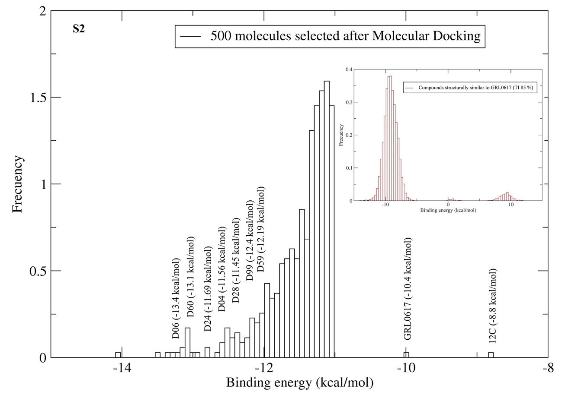
Figure S2. Binding energy distribution of selected compounds and the binding site of GRL0617 in PLpro of SARS-CoV-2. The frequency distribution of the energy calculated by molecular docking of the 20,000 selected compounds (small box) and of the 500 with energy lower than GRL0617 (-10.4 kcal/mol) is shown. The energy of each selected compound D06 (-13.4 kcal/mol), D60 (-13.1 kcal/mol), D24 (-11.69 kcal/mol), D04 (-11.56 kcal/mol), D28 (-11.45 kcal/mol), D99 (-12.4 kcal/mol) and D59 (-12.19 kcal/mol) are indicated in the graph.

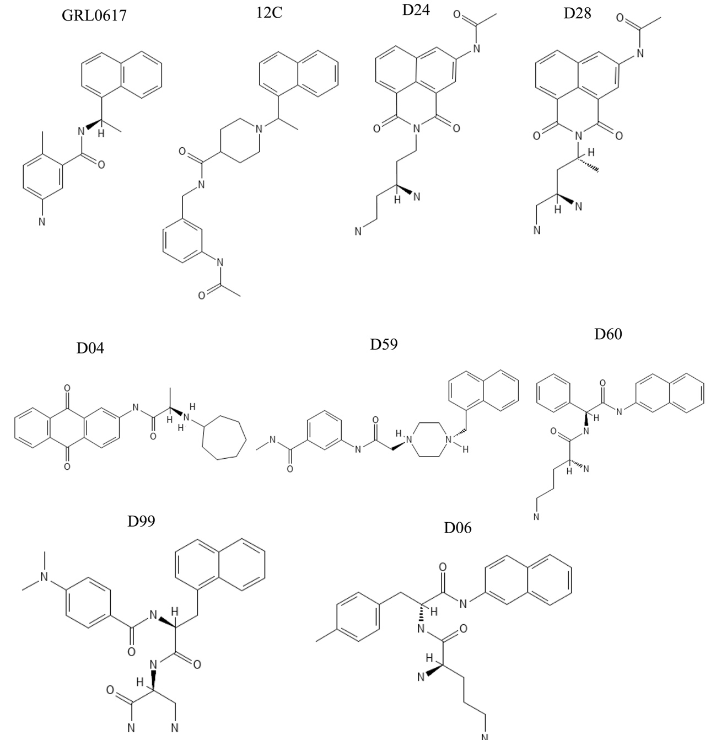
Figure S3. Chemical structures of inhibitors (GRL0617 and C12) and compounds selected by virtual screening

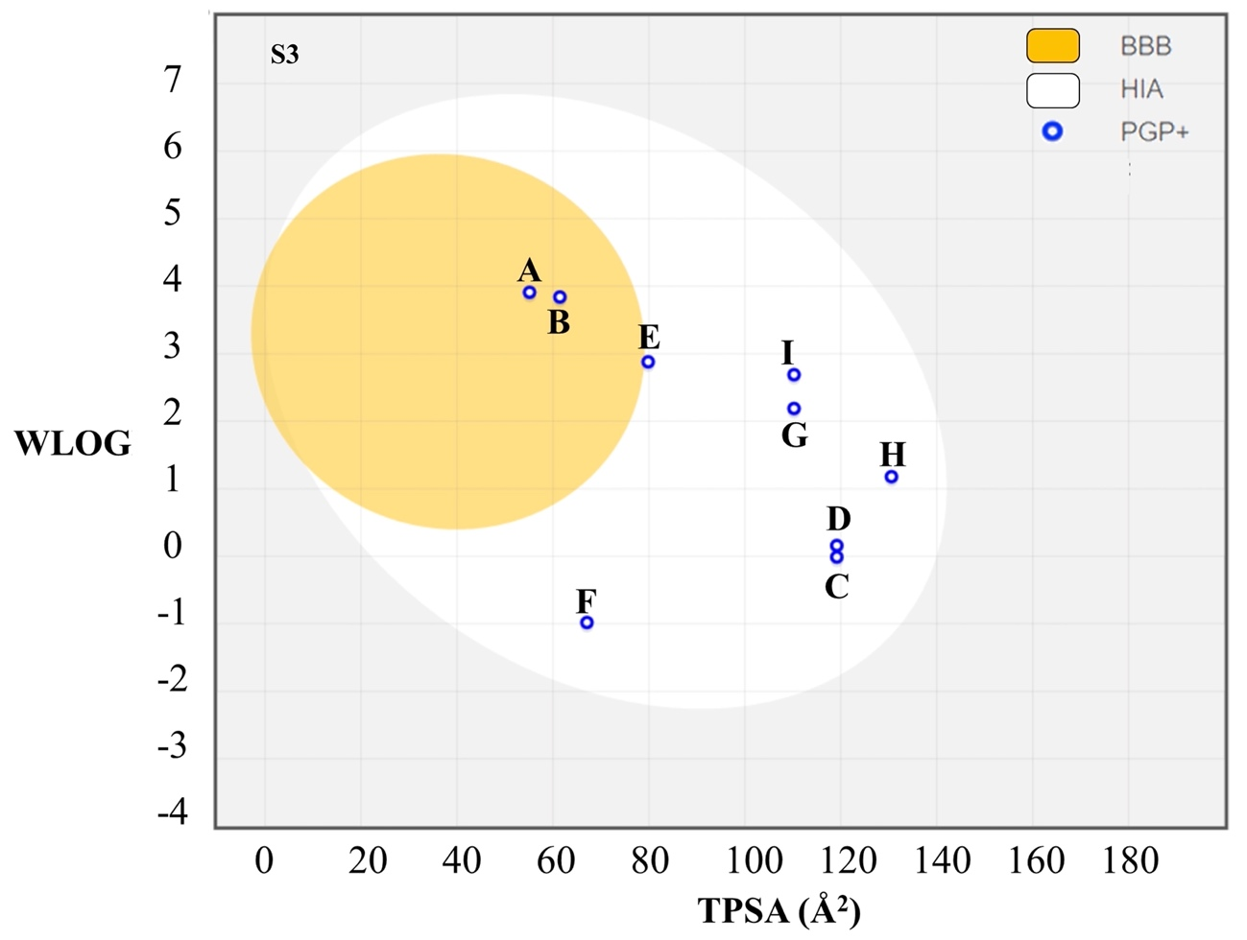
Figure S4. Evaluation of passive gastrointestinal absorption (HIA) and brain penetration (BBB) as a function of molecule position in reference to the lipophilicity descriptor (WLOGP) versus topological polar surface (TPSA). Inhibitors GRL0617 (A), 12C (B) and selected compounds D06 (C), D60 (D), D24 (E), D04 (F), D28 (G), D99 (H) and D59 (I) are identified in the egg plot. In addition, the blue colored dots are predicted as active efflux for P-glycoprotein1 (PGP+).
.
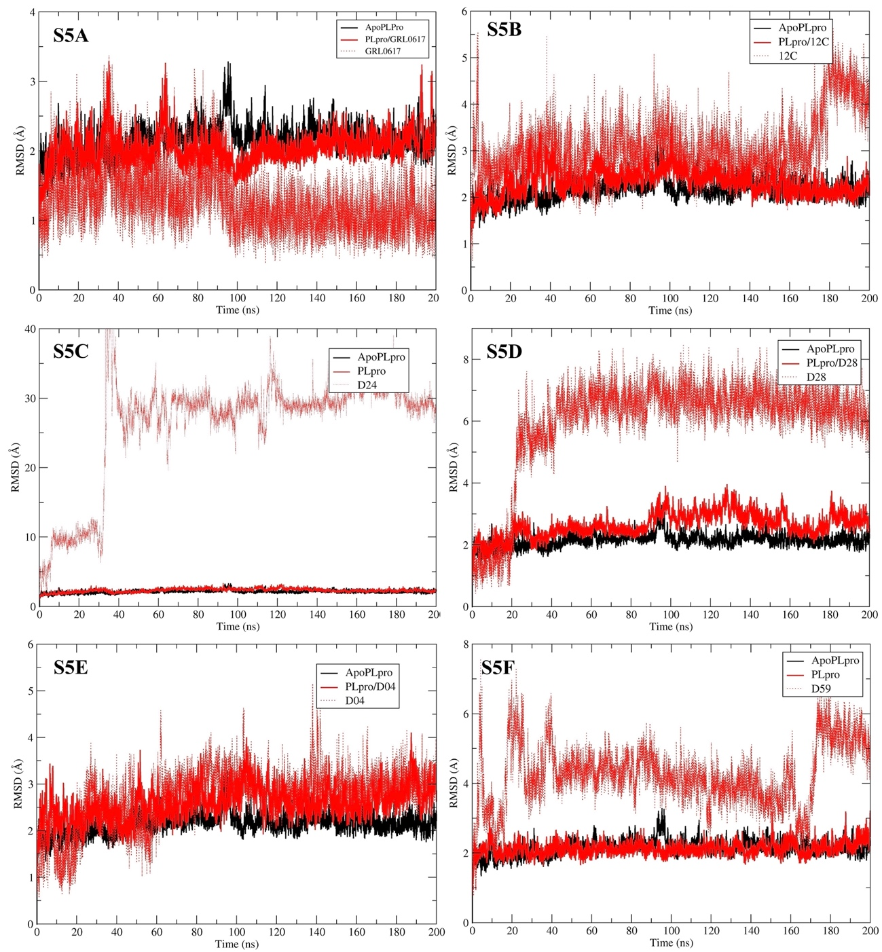
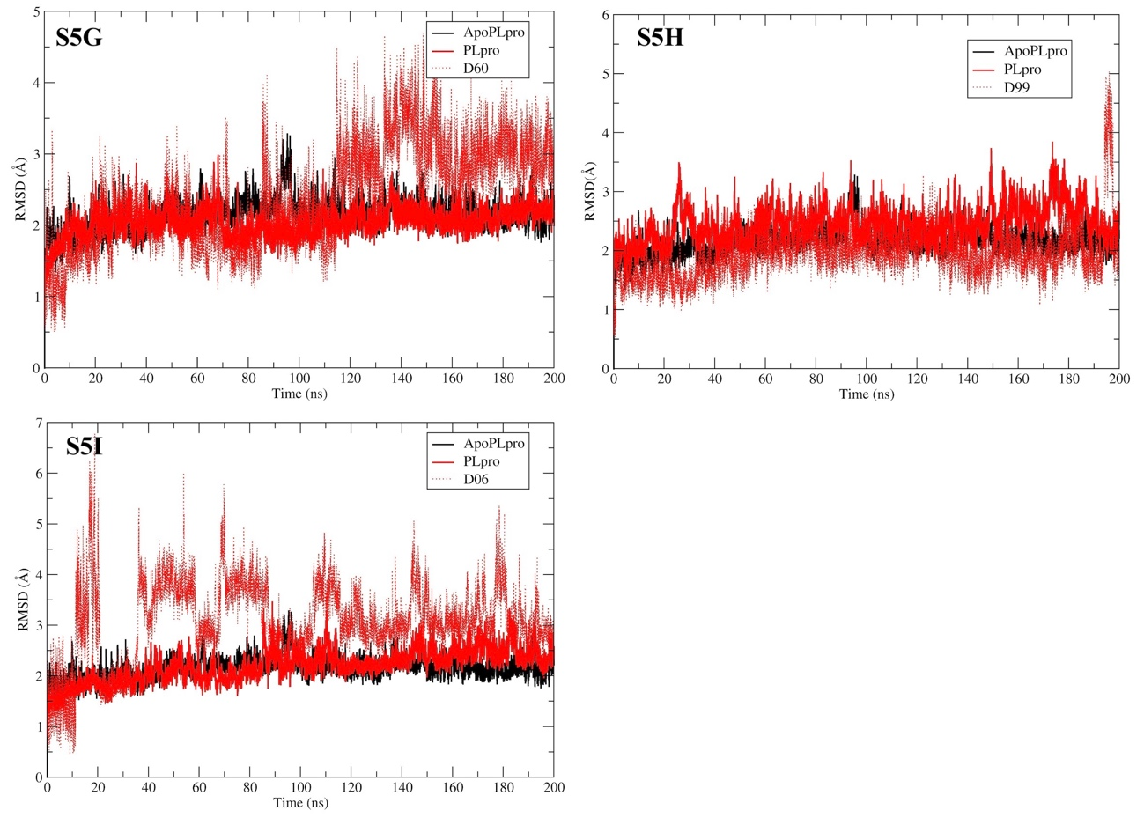
Figure S5. Root mean square deviation (RMSD) of the polypeptide chain (apoPLpro and PLpro/ligand) and ligand carbon skeleton (red broken line). The RMSD of the alpha carbons of the polypeptide chain obtained from 200 ns molecular dynamics simulations in absence (black line) and in complex with the ligands (red solid line): GRL0617 (S5A), 12C(S5B), D06 (S5C), D60 (S5D), D24 (S5E), D04 (S5F), D28 (S5G), D99 (S5H) and D59 (S5I).

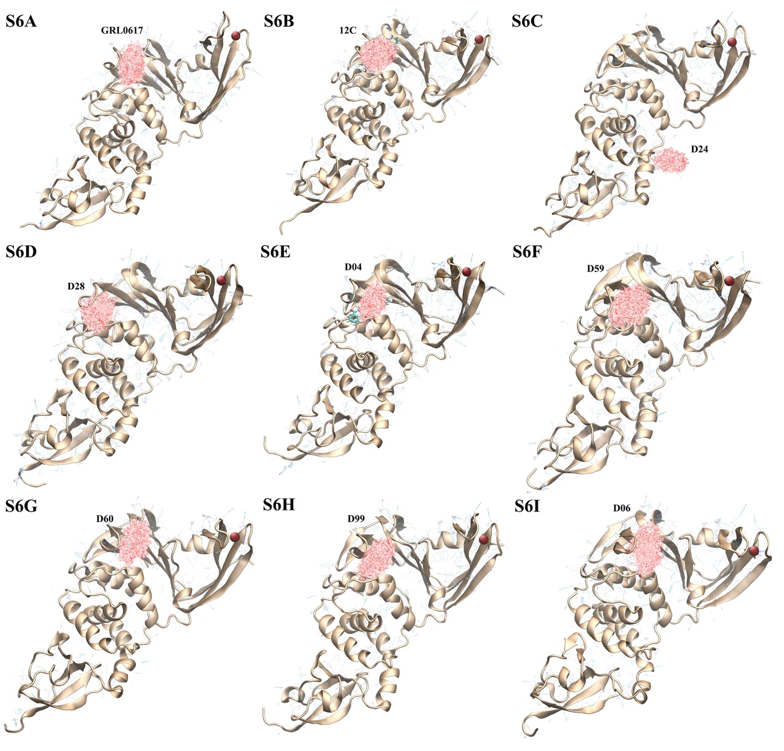
Figure S6. Variation of ligand position in the complex with PLpro during 200 ns molecular dynamics simulation. The simulations were analyzed with the DBScan clustering algorithm, considering a cutoff distance of 1.5 Å based on the root mean square (rmsd) of the ligand atoms other than hydrogen and 5 points minimum for each cluster. The variation of the main cluster representing more than 87 % is observed.

