Supplementary information

Subaqueous bioprinting: a novel strategy for fetal membrane repair with 7-axis robot-assisted minimally invasive surgery

Wenxiang Zhao^{1,2}, Chuxiong Hu^{1,2 *}, Tao Xu³, Shize Lin^{1,2}, Ze Wang^{1,2}, Yu Zhu^{1,2}

¹ State Key Laboratory of Tribology, Department of Mechanical Engineering, Tsinghua University, Beijing 100084, People’s Republic of China
² Beijing Key Laboratory of Precision/Ultra-Precision Manufacture Equipment and Control, Tsinghua University, Beijing 100084, People’s Republic of China
³ Center for Bio-intelligent Manufacturing and Living Matter Bioprinting, Research Institute of Tsinghua University in Shenzhen, Tsinghua University, Shenzhen, 518057, People’s Republic of China.

Correspondence should be addressed to C. H. (cxhu@mail.tsinghua.edu.cn)
Contents
Supplementary methods and discussion
1. Analytical inverse kinematics for 7-DoF manipulator
2. Development of the printing end effector
3. TCP calibration of end effector
4. Derivation of computation model within the extrusion
5. Fetal membranes collection
6. Rheological analysis
7. Mechanical propertie
8. Hydrogel in vitro degradations tests
9. Swelling ratio test
10. Morphological characterization
11. Cell culture, viability, and proliferation assay
12. Path planning method based on point cloud
13. Printing process in PROM sealing
14. Evaluation of incision location
Supplementary references
Supplementary Figure 1. Analytical inverse kinematics for 7-DoF manipulator.
Supplementary Figure 2. Development of the printing end effector.
Supplementary Figure 3. Schematic diagram of the crosslinking principle of GelMA/PEGDA hydrogel.
Supplementary Figure 4. Rheological tests for G20.
Supplementary Figure 5. Mechanical properties tests for GMPD hydrogels.
Supplementary Figure 6. Morphological characterization of GMPD hydrogel.
Supplementary Figure 7. Steady shear experiments conducted on G20 with different PEGDA ratio.
Supplementary Figure 8. Velocity and shear rate distribution in the nozzle’s cross section of different GMPD hydrogels.
Supplementary Figure 9. Extrusion of G15P5 hydrogel through long nozzle.
Supplementary Figure 10. Evaluation of RCM locations through Yoshikawa’s manipulability and GII index.
Supplementary Figure 11. Capture of end effector trajectories.
Supplementary Figure 12. Evaluation of gel patches with gel rivets.
Supplementary Figure 13. Cell viability and proliferation assay.
Supplementary Figure 14. Histology and immunofluorescence.
Supplementary Figure 15. Path planning method based on point cloud.
Supplementary Figure 16. Printing process in PROM sealing.
Supplementary Figure 17. Theoretical analysis of hydrogel adhesion at different printing angles.
Supplementary Video Captions

Supplementary methods and discussion

Analytical inverse kinematics for 7-DoF manipulator
Inverse kinematics (IK) is an important task for bioprinting robots for allowing motion planning and control at the position level. For Franka Emika Panda, the 7-DoF manipulator used in this research, there can be infinite solutions for a same end effector pose and none of them wound have closed form. In addition, the built-in IK algorithm is not open to users, and for safety reason it can only tackle an end effector pose that is very close to the actual one. More importantly, the iterative-based numerical calculation method cannot acquire all solutions for a same end effector pose, and thus makes it incapable to evaluate the manipulability of the configuration where the solutions exist. Based on former studies focusing on IK for manipulators with offset joints, we develope an analytical IK solver and a “case-consistent” solver algorithm for manipulator control and subsequent RCM location evaluation.

1.1 Forward kinematics
The kinematic model of Franka Emika Panda provided in its official documentation is based on the modified Denavit-Hartenberg convention (Figure S1. a). The length parameters are denoted as a_{i}, d_{i}. By calculating the 4 × 4 homogeneous transformation matrices
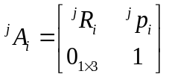 (1.1)
where 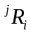 denotes their relative orientation and 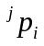 denotes the relative position. The Cartesian pose of the end effector can then be obtained by a chained multiplication, i.e.,
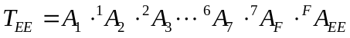 (1.2)

1.2 Inverse kinematics
The IK solving procedure can be generalized in the following.
    - Fix q₇ as redundancy parameter
To obtain a unique IK solution for a 7-DOF manipulator, a redundancy parameter must be specified first. Herein, the calculation starts from the end of the kinematic chain, hence the last joint angle q₇ is a natural alternative choice as the redundancy parameter. Its value will be treated as known in the remaining steps.
    - Investigate ΔO₂O₄O₆ to solve two possible q₄
At first, the positions of vertices of ΔO₂O₄O₆ can be obtained according to the homogeneous transformation relationship between joints and the known joint angle q₇. The normal configuration for q₄ is shown in Figure S1. b. and it is obvious that
(1.3)
where 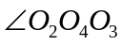, 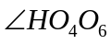and 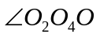can be easily calculated through geometrical relationship.
Theoretically, there is another solution for q₄ that as supplementary angle. However, this case will not occur in realistic due to the angle limitation of joint 4.
    - For each of q₄, solve two possibilities of q₆
To solve q₆, an intermediate variable was constructed as 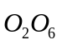, which denote the vector in the Frame based on Joint 6. Let
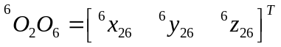 (1.4)
Hence, the possible q₆ can be expressed as
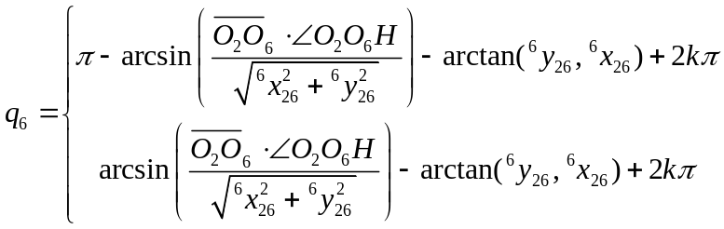 (1.5)
The integer k should be selected based on the joint limit range of q₆, then the two possible q₆ can be obtained.
    - For each q₄-q₆ combination, solve two possibilities of (q₁, q₂) pair
q₁ and q₂ can be derived started from the world frame. Denoting the intersection point of line 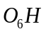and 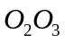 as P, and it is easy to get the two equivalent cases for q₁ and q₂ leading to the same 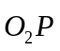. Let
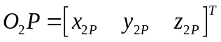 (1.6)
Then, the possible (q₁, q₂) pair can be expressed as
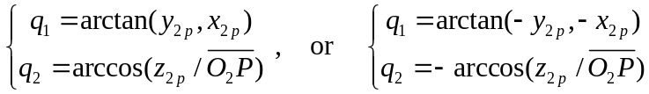 (1.7)
    - For each q₄-q₆- (q₁, q₂) combination, solve the unique q₃ and q₅
With q₁ and q₂ solve above, the orientation of Frame based on joint 2 can be obtained. After transforming x₃ into Frame 2 and extracting its internal elements by
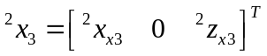 (1.8)
The value of q₃ can be calculated with
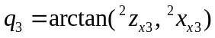 (1.9)
And with other joint angles determined, the solution to q₅ can be obtained in the Frame based on joint 5 as
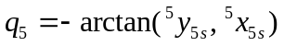 (1.10)
where S represents the projection of O₄ in the X₅-Y₅ plane.

1.3 “case-consistent” solver algorithm
There exist 8 different mathematical solutions that could be generally obtained for a given end effector pose and redundancy parameter. Since one or more of these results may violate the joint limitations, it is necessary to check the rationality of outputs according to the actual conditions. Additionally, the following requirement
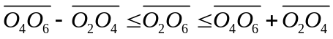 (1.11)
must be examined to guarantee the existence of ΔO₂O₄O₆.
As mentioned in the Method section, in the evaluation experiment of RCM location, the singular value of configurations corresponding to each test point should be calculated. For redundant manipulator, each test point relates to numerous configurations which are calculated through this analytical IK solver, and let the singular value of the optimal configuration represent the value of test points. In actual bioprinting operation, it is not desired that the robot switch between different solutions, which could lead to unexpected robot motion. Thus the actual pose q_{a} should be calculated through forward kinematics, and select the solution closest to q_{a} as the output of the next waypoint.

Development of the printing end effector
The end effector was designed based on the size of existing fetoscopes, with a coaxial structure and a diameter of 4 mm. The outer side of end effector is optical fibers, which are used for light conduction, while the inner side is the printing needle solidified with a screw motor to perform linear movement for high-precision puncture and gel-rivets fabrication (Figure S2. a). In the selection of optical fibers, a 405 nm LED light with 2000 mW/cm² irradiates at the start end and an irradiance detector (Linshang Co., Ltd, China) was used to detect the irradiance at the other end to evaluate the light-guiding efficiency (Figure S2. b). Although the optical fibers are able to guide light lossless through total internal reflection theoretically, a protective layer coated to the fibers can greatly improve the transmission efficiency (Figure S2. e). In addition, the length of fibers within 50 cm has little impact on the light-guiding capacity, and it is linearly related to the number of fibers (Figure S2. c, d). According to the actual design size of end effector, 7 coated optical fibers with a length of 25 cm were selected as the final parameters. The long needle is connected to a micro-syringe pump via Teflon tubing for quantitative control of extrusion.

TCP calibration of end effector
The end effector was integrated at the end of the 7-axis manipulator (Franka Emika, Germany), and the TCP calibration was performed. Briefly, a fixed point was placed in the manipulator’s workspace, and the pose of manipulator was controlled to make the TCP coincide with the fixed point. Repeat the above steps at least four times and ensure the TCP is moved to the same point with different poses, so that the pose and end position of these postures can be recorded as 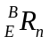 and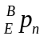, where n is the number of test groups. Solving equation 3.1 with the least squares methods, the TCP parameters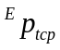can be obtained, i.e.,
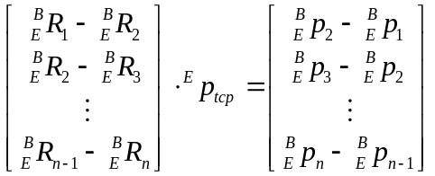 (3.1)

Derivation of computation model within the extrusion
The Herschel-Bulkley computational model was used to simulate rheological behavior of GMPD hydrogel and predict the shear stress and velocity distribution during extrusion-based bioprinting.
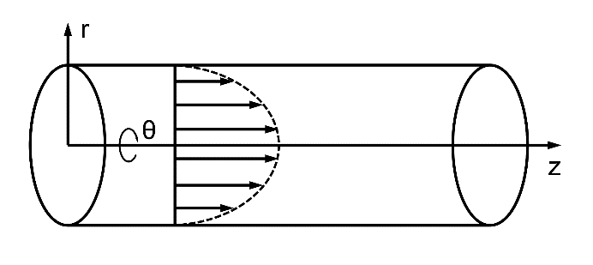
The derivation of computation model is based on the previous studies^{1, 2}. Briefly, for laminar, isothermal flow of an incompressible fluid with no-slip boundary conditions, the equations describing flow in the r and θ directions were simplified to 0, leaving the equations presenting flow in the z direction as
(4.1)
In z-axis direction without regard to r and θ, the equation can be further simplified to
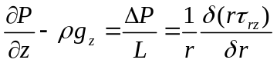 (4.2)
where ΔP and L denotes the pressure drop along z-direction and pipe length.
Integration equation 4.1 to r yields
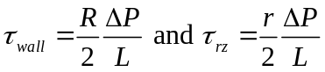 (4.3)
where r denotes the inner radius of printing nozzle.
Combining equation 4.3 with Herschel-Bulkley model leads to
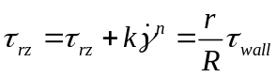 (4.4)
Solving for the shear rate and noting the plug flow region gives
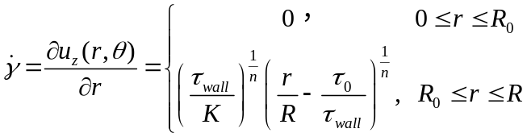 (4.5)
Integration yields the velocity and it gives
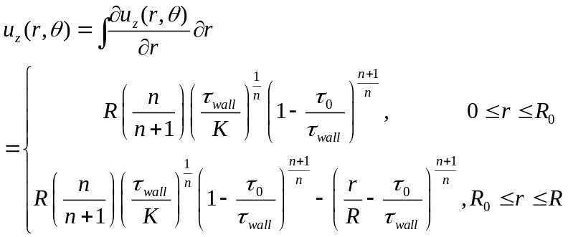 (4.6)
Integration of equation across the tube yields the volumetric flow rate can be acquired as
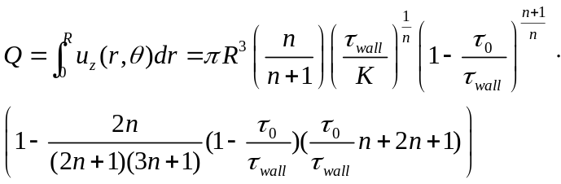 (4.7)
where τ₀ denotes the yield stress, n is the flow index and K is the flow consistency index.

Fetal membranes collection
Fetal membranes were collected after written consent from vaginal delivery at term. Mean gestation age from 37-41 weeks in the absence of preterm rupture of membranes, clinical chorioamnionitis, infections (HIV, hepatitis, syphilis), or chromosomal abnormalities. Fetal membranes were cut approximately 2 cm from the placental disc to avoid non-uniform thickness, rinsed with normal saline and soaked in diluted tobramycin for 15 min. After that, fetal membranes were cut to a size of 6 cm × 6 cm and then sub-packaged in Ringer’s solution.

Rheological analysis
Rheological analysis was performed using an Anton Paar (Ostfidern, Germany) Physical MCR 302 system using a plate-plate geometry (PP25) equipped with a temperature control module and photo-rheological module. In the photo-rheological tests, time sweep oscillatory was performed under the 405-nm LED with variable irradiation at 37℃. The gel point was determined as the time when the storage modulus (G’) surpassed the loss modulus (G”). The temperature-sweep measurement was performed in the oscillation mode from 45℃ to 15 ℃ (cooling rate: 0.1℃/s) using a fixed amplitude of 0.1% and angular frequency of 1.5Hz, and the gel point was also determined as the temperature the G’ and G” curves intersect. For steady shear experiments, the shear rate was controlled from 0.1 to 100 1/s at 20℃, and the viscosity η and shear stress τ were recorded. To investigate the linear viscoelastic region (LVR), amplitude sweeps from 0.1% to 1000% strain deformation was performed at a fixed angular frequency of 1.5Hz. And to further evaluate the structure recovery properties, the deformations were alternated from 0.1% to 300% in cycles and each stage maintains 200 seconds.

Mechanical properties tests
Mechanical properties were tested with an electro force 5500 system (BOSE electro force systems group, Friedrichsdorf, Germany), and the experiments were performed in the static mode using a 250 g load cell. A mold with an array of cylindrical holes with diameters in 8 mm and heights in 6 mm was fabricated and immersed in PBS at 37℃. Hydrogel precursors of different concentrations were extruded into the mold while in situ crosslinked (405 nm, 100 mW/cm²) to obtain compression samples, and those samples in a dry environment are fabricated in situ in air. Young’s modulus was determined using a linear fit function in the linear material response region.

Hydrogel in vitro degradation
Standard hydrogel samples of different concentrations with diameters in 8 mm and heights in 3 mm were prepared through an in situ crosslinking approach (405 nm, 100 mW/cm²) in the mold mentioned above, and then incubated in PBS with 1% penicillin G and streptomycin (Gibco, 10 378-016) at 37℃ for 2 weeks. At different times, the samples were removed from PBS and washed with sterile deionized water, drained surface moistures and weighted.

Swelling ratio test
Standard hydrogel samples were prepared as mentioned above, and then immersed in PBS for 24 h at 37℃, and its swelling weight Ws was recorded. Then, the hydrogel samples were lyophilized to obtain dry weight Wd. The swelling ratio can be calculated as (Ws-Wd)/Ws.

Morphological characterization
Standard hydrogel samples were prepared as mentioned above, and then immersed in PBS for 24h at 37℃. After undergoing gradient freezing, these samples were transferred to a lyophilizer for 48 hours. After lyophilization, the dried samples were fractured in liquid nitrogen, and fixed on the sample stage. To observe the microscopic morphology, the samples were treated with gold sputtering, then the porous structure of samples was observed with scanning electron microscope (SEM, JEOL, Japan) operating at 10 kV. The pore size, porosity and wall thickness were calculated using ImageJ software, and three independent samples were taken for observation and data analysis.

Cell culture, viability, and proliferation assay.
To verify the biocompatibility of GMPD hydrogel at the cellular level, the primary rabbit amniotic epithelial cells (Procell Life Science, Wuhan, China) were cultured in a GMPD hydrogel-substrate environment for 7 days. A 24-well plate was coated with 200 μL G15P5 hydrogels and amniotic epithelial cells were seeded in it with a density of 1.5×10⁵ cells per well. These cells were cultured in DMEM, high glucose (Thermo Fisher Scientific), supplied with 10 % fetal bovine serum (Biological Industrial) and 1 % penicillin G and streptomycin (Gibco, 10 378–016). Cells were cultured in an incubator at 37℃ in 5% CO² and without passage in 7 days. For the control group, cells were cultured normally in well plates without G15P5 hydrogel coated. On Day 0, 3 and 7, cell viability and proliferation assays were conducted under manufacturer’s instruction.
In cell viability assay, calcium acetoxymethylester (calcein-AM) (Sigma) and propidium iodide (PI) (Sigma) were used as LIVE/DEAD assay reagents. Briefly, 1 mg Calcein-AM was dissolved in 1 ml anhydrous dimethylsulfoxide (DMSO) (Sigma) and 1 mg PI was dissolved in 1 ml sterile water to make staining solutions. 2 µl Calcein-AM staining solution and 3 µl PI staining solutions were added into 1 ml sterile phosphate buffer solution (PBS) (Biological Industries) and fully mixed. One cultured sample was gently washed with PBS and incubated with 1 ml staining solutions for 15 min at room temperature in the dark. After incubation, the sample was washed with PBS and observed under a laser scanning confocal microscope (LSCM) (ZEISS). Three random fields were captured and cell viability was calculated by counting cells using ImageJ.
In cell proliferation assay, cultured samples were incubated with a mixture of culture medium and cell counting kit-8 (CCK-8) (Yeasen, Shanghai, China) at a volume ratio of 10:1 to investigate cell proliferation. After 1 h incubation at 37℃, the absorbance of formazan dye was determined at 450 nm using a Microplate Reader (Thermo Fisher Scientific). Three samples were tested at each time point.

Path planning method based on point cloud.
The substrate of in situ bioprinting is the defective tissues, which is irregular and difficult for conventional flat substrate-based 3D printing. Therefore, it is necessary to obtain the 3D topography of the defective tissues before in situ bioprinting was performed. Point cloud is a commonly used data format for characterizing 3D features, and can be acquired through multiple methods including computerized tomography (CT), magnetic resonance imaging (MRI) and 3D scanning etc. Herein, a generalized path planning method based on point cloud data was developed to serve subsequent subaqueous bioprinting procedures. The overall procedure of path planning can be summarized as follows:
  - Acquiring the 3D point cloud of tissues to be printed through different methods.
  - Projecting the 3D point cloud to the X-Y plane to obtain the 2D point cloud.
  - Generating the printing path under different parameters according to the precision requirement and printing process.
  - Generating 3D printing path based on the 2D point cloud. The average value of all the points’ z value in the point cloud was taken as the z value of the path point.
Figure S15. a shows the origin point cloud of a part of human tissues, and it was projected to X-Y plane shown as Figure S15. b. The origin point was nonuniform which go against path generating, thus it undergoes interpolation to acquire the regularized point cloud with different point cloud density according to the printing requirements, shown in Figure S15. c.
The parameters of path planning include line_space, grid_space, retraction and multilayer etc. Among them, line_space denotes the distance between two adjacent paths and its value depends mainly on the diameter of printed filaments. Mismatched line_space and filament width will result in gaps or overlaps in the printed structures, which leads to sealing failure. The results of taking different values of line_space are shown in Figure S15. d. Grid_space represents the distance between the centers of the adjacent grids in the path direction. This parameter was used to divide the continuous path into discontinuous grids, which adjusted the fidelity and the number of grids and the amount of computation. Figure S15. e shows the path with different grid_space. When grid_space enlarges, though the calculated amount decreases, the path cannot reflect the real morphology of printed tissues. As the printed filaments have a certain width, to ensure that the printed boundary coincides with the defect boundary, the boundary of the printing path requires certain retraction. Figure S15. f shows the 2D printing path with double grid_space retraction. In addition, the multilayer parameter is normally used for thick tissues printing, which is shown in Figure S15. g.
The continuous grid method requires a large amount of computation, especially when the defect area is large. The path planning method based on discontinuous point cloud ensures accuracy, reduced the calculated amount and provides necessary pretreatment path planning for in vivo bioprinting for more tissues repair.

Printing process in PROM sealing
In the application of treating PROM, the printed object is the hydrogel patch with rivet structures, which are embedded in the endometrium for robust sealing, and the specific printing process is as follows (Figure S16):
- End effector enters the amniotic sac through the RCM incision and moves to the ruptured site of FM.
- The printing nozzle within the end effector punctures into the endometrium under the drive of screw motor. Meanwhile, the GMPD hydrogel is injected by the syringe pump and cured under the 405 nm LED.
- The printing nozzle is retracted while the hydrogel continued to be injected, which forms a spherical hydrogel rivet in the endometrium. The position of end effector remains unchanged during the process.
- Once the needle moves back inside the amniotic sac, the end effector starts moving under the preset path and printing the hydrogel patch on the curved surfaces.

Evaluation of incision location
Once the tissues to be repaired and the structures to be printed were determined, different incision locations will directly affect the printing angle on the substrate. According to our previous studies³, in the transient state, the droplets in large printing angle and small printing angle present different microscopic morphologies. It has been revealed that friction between hydrogels and the printing plane can occur via a stick-slip phenomenon, which is related to the thickness, contact area, and driving force of the hydrogels^{4, 5}. In small printing angle, droplets are approximately spherical, leading to the centroid h being far from the plane. A larger torque, M, increases the trend for printed threads to roll. Moreover, the bioinks behind the droplet impart a downward extrusion component, F_{e}, which enhances the sliding tendency of the droplet (Figure S17. a). The oblate droplets in large printing angle can effectively avoid the aforementioned issues, whereas a larger contact area with the printing plane can also increase the interface friction, f, with the result that the printed threads stick to the plane regardless of the inclination angle, thus enabling reliable in situ printing for complex surfaces (Figure S17. b).

Supplementary references

1. Ghica MV, Hîrjău M, Lupuleasa D, Dinu-Pîrvu C-E. Flow and thixotropic parameters for rheological characterization of hydrogels. Molecules 21, 786 (2016).

2. Townsend JM, Beck EC, Gehrke SH, Berkland CJ, Detamore MS. Flow behavior prior to crosslinking: the need for precursor rheology for placement of hydrogels in medical applications and for 3D bioprinting. Progress in polymer science 91, 126-140 (2019).

3. Zhao W, et al. Adaptive multi‐degree‐of‐freedom in situ bioprinting robot for hair‐follicle‐inclusive skin repair: a preliminary study conducted in mice. Bioengineering & Translational Medicine, e10303 (2022).

4. Thakre AA, Singh AKJMRE. An experimental study on stick-slip of gelatin hydrogels using fracture mechanics 5, 085301 (2018).

5. Thakre AA, Pawar ROJJoAS, Technology. Study of effect of specimen thickness, gelatin concentration, normal force and sliding velocity on the stick-slip vibrations of gelatin hydrogel 34, 1083-1099 (2020).

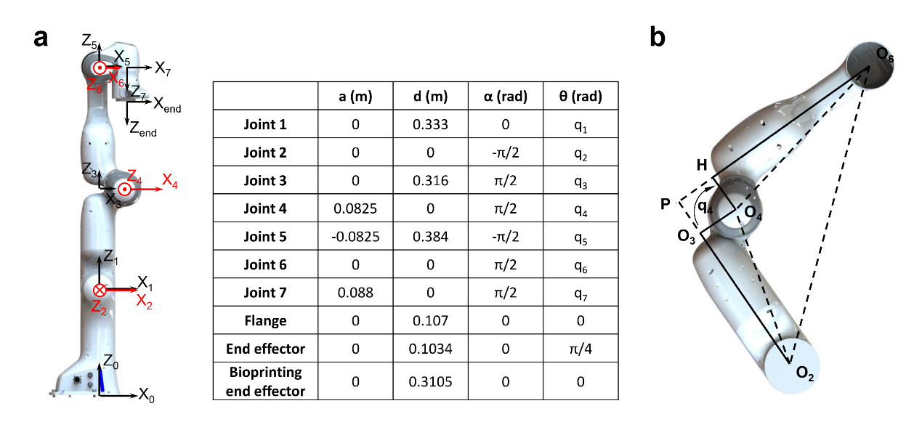
Supplementary Figure 1. Analytical inverse kinematics for 7-DoF manipulator. a, the DH frames and parameter of Franka Emika Panda. b, Configuration when solving joint 4 angle and joint 2 angle.

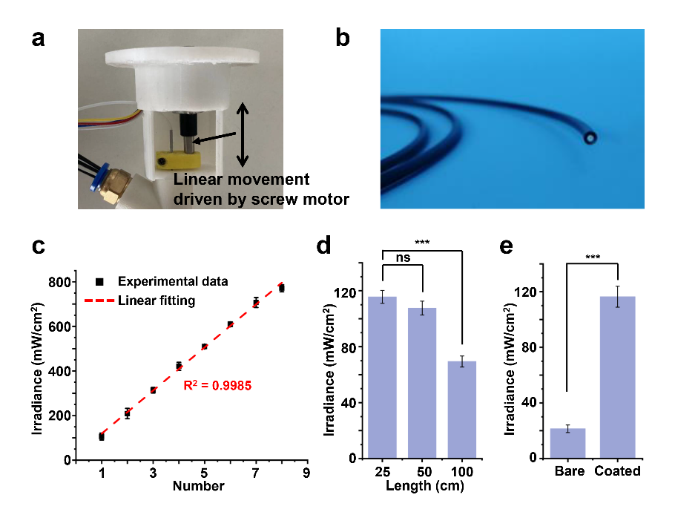
Supplementary Figure 2. Development of the printing end effector. a, integrated screw motor for nozzle’s linear movement. b, Optical fiber coated with protected layer. c, Irradiance conducted through different number of optical fibers. d, Irradiance conducted through a single optical fiber with different length. e, Irradiance conducted through one bare optical fiber and coated optical fiber.

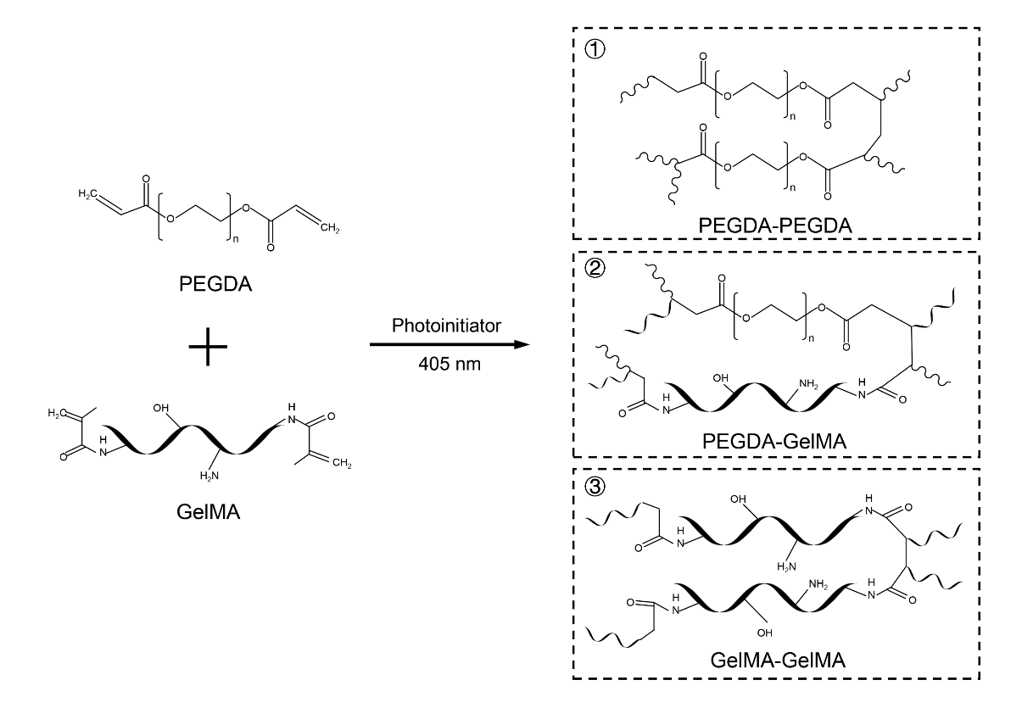 Supplementary Figure 3. Schematic diagram of the crosslinking principle of GelMA/PEGDA hydrogel. The carbon-carbon bond on the backbone undergoes an addition reaction with the action of free radicals to form a covalent bond. And this reaction occurs between GelMA-GelMA, GelMA-PEGDA and PEGDA-PEGDA to form three different types of crosslinked networks.

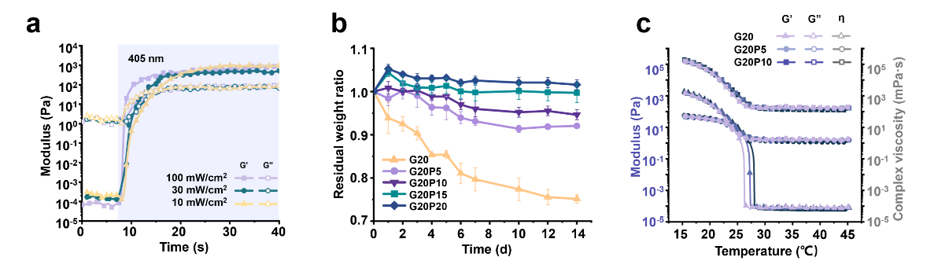
Supplementary Figure 4. a, The photo-rheological tests for G20 with different irradiance. b, In vitro degradation for G20 with different PEGDA ratio. c, The temperature-sweep rheological test for G20 with different PEFDA ratio.

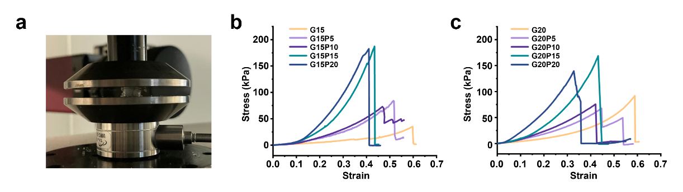
Supplementary Figure 5. Mechanical properties tests for GMPD hydrogels. a, Representative image for hydrogel sample under biaxial compression test. b, Stress-strain curve of G15 hydrogel samples with different PEGDA ratio. c, Stress-strain curve of G20 hydrogel samples with different PEGDA ratio.

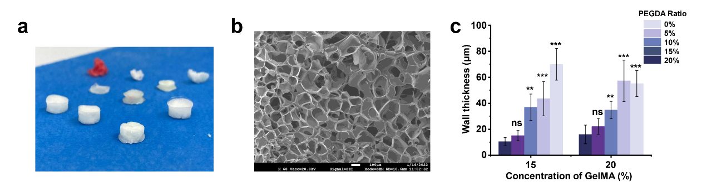
Supplementary Figure 6. Morphological characterization of GMPD hydrogel. a, Representative image for lyophilized hydrogel samples of different ratio. b, Representative SEM image for G15P5 hydrogel. c, Statistic wall thickness of porous structures in different hydrogel samples.

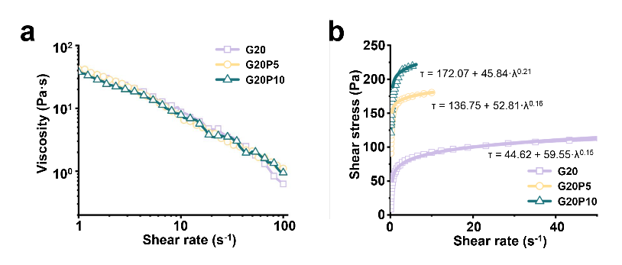
Supplementary Figure 7. Steady shear experiments conducted on G20 with different PEGDA ratio. a, the representative viscosity-shear rate curve. b, the representative shear stress-shear rate curve and fitted with Herschel-Bulkley model.

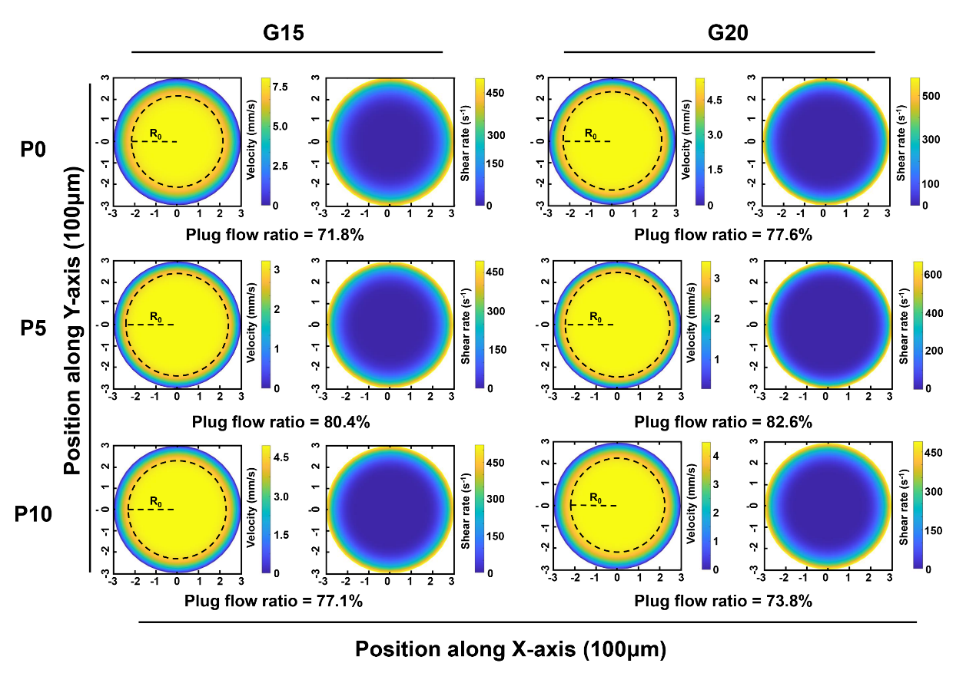
Supplementary Figure 8. Velocity and shear rate distribution in the nozzle’s cross section of different GMPD hydrogels. R_{o} indicates the radius of plug flow. (0.25 ml/min)

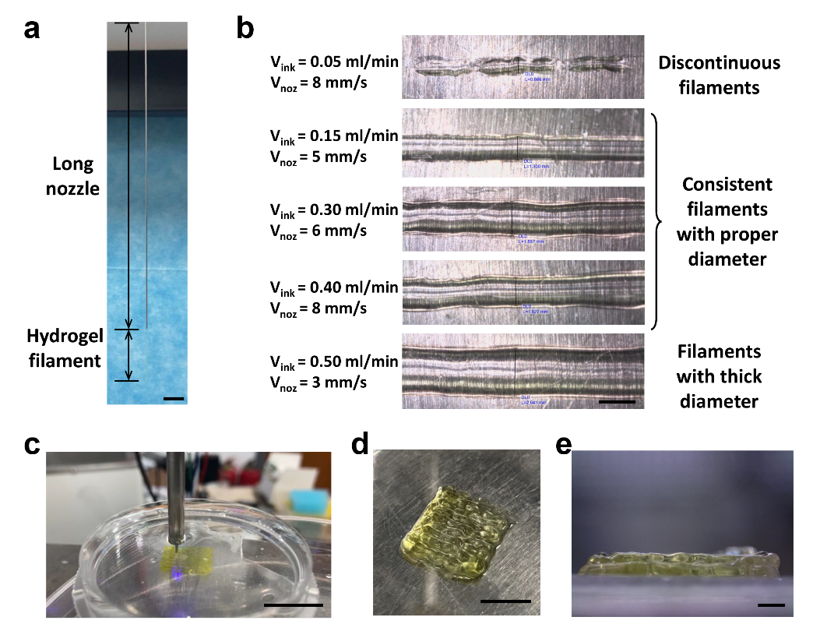
Supplementary Figure 9. Extrusion of G15P5 hydrogel through long nozzle. a, Photograph of the extrusion process through the long nozzle, where the length of nozzle is 300 mm and the length of hydrogel filament is 50 mm. (Scale bar: 2 cm) b, Extruded hydrogel filament in different V_{ink} and V_{noz}, which forms filament with different morphology. (Scale bar: 2 mm) c, Representative image of the end effector performing subaqueous printing in a petri dish filled with 37℃ PBS (Scale bar: 2 cm). d, Photograph of a two-layer gel-patch printed subaqueously and aspirating the water out of a petri dish. (Scale bar: 1 cm) e, microphotograph of the side view of the gel-patch printed subaqueously. (Scale bar: 2 mm)

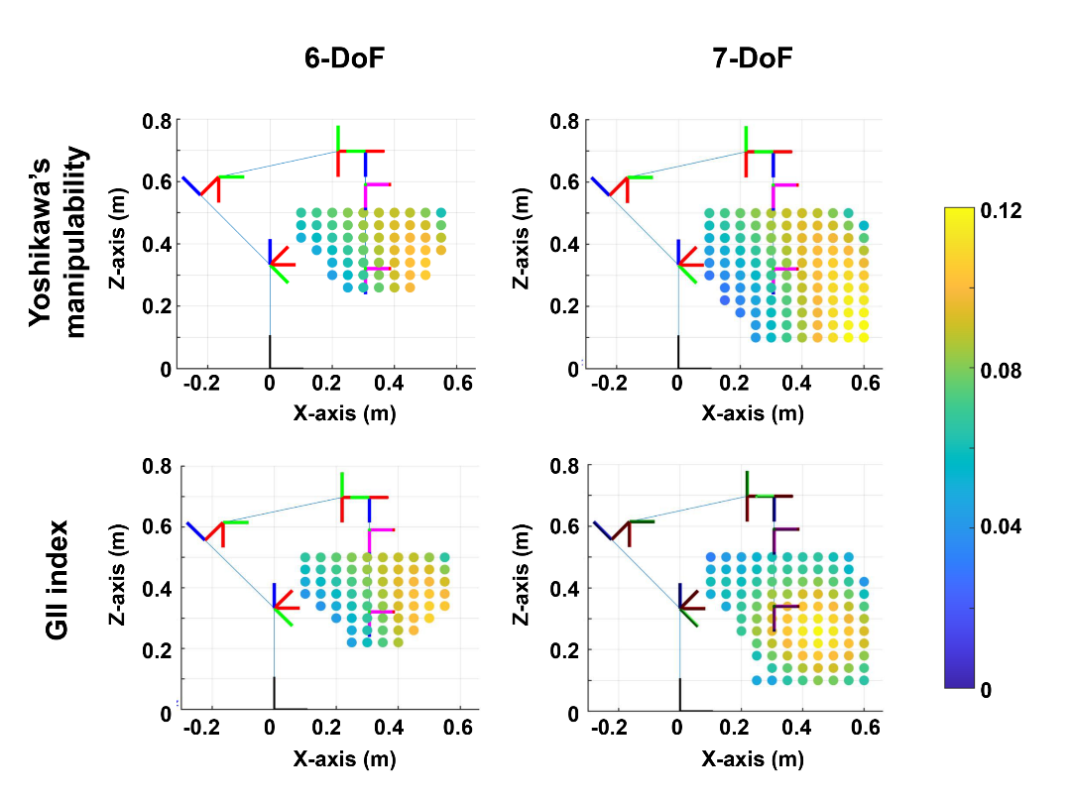
Supplementary Figure 10. Evaluation of RCM locations through Yoshikawa’s manipulability and GII index. The color of dots indicates the manipulability of the manipulator where the RCM point sets and white background indicates RCM locations through which part or all of the workspace was unreachable. It’s obvious that the manipulability and reachable workspace of the 7-DoF robot are better than those of the conventional 6-DoF robot, and the RCM locations evaluation results obtained by GII index match the actual motion accuracy better.

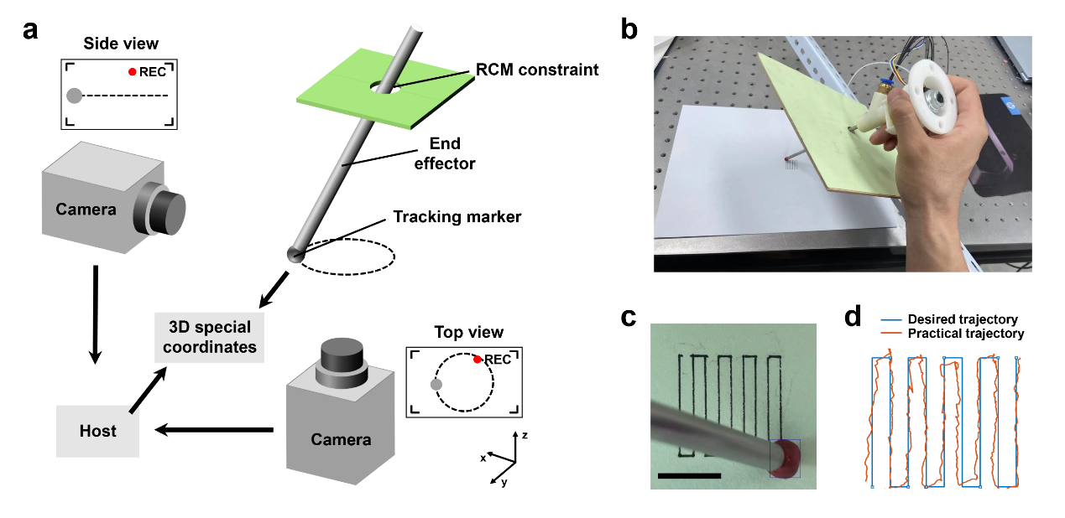
Supplementary Figure 11. Capture of end effector trajectories. a, The schematic diagram of the end effector moves according to the preset path under the constraint of RCM, which was captured by two orthogonal cameras to calculate the 3D coordinates of the trajectory. b, Photograph of a hand-held end effector moving along a defined path under RCM constraints. c, Top view of hand-held end effector moving along a defined path. (Scale bar: 1 cm) d, Comparison between desired trajectory and practical trajectory of hand-held end effector.

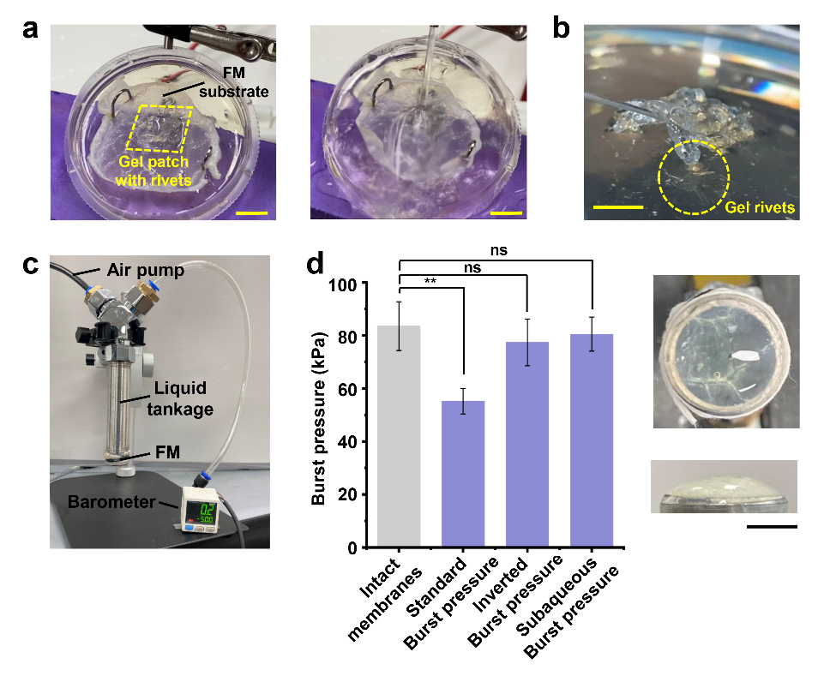
Supplementary Figure 12. a, A gel-patch with rivets was printed on FM substrate and the rivets were embedded in the agarose gel. The gel patch was scoured with high-velocity stream and still adhered well. b, Intuitionistic exhibition of gel rivets that the gel patch was partially lifted but still attached to the substrate by rivets. c, Photograph of the equipment for measuring burst pressure. d, Results and photographs of various burst pressure test with pig intestinal mucosa.

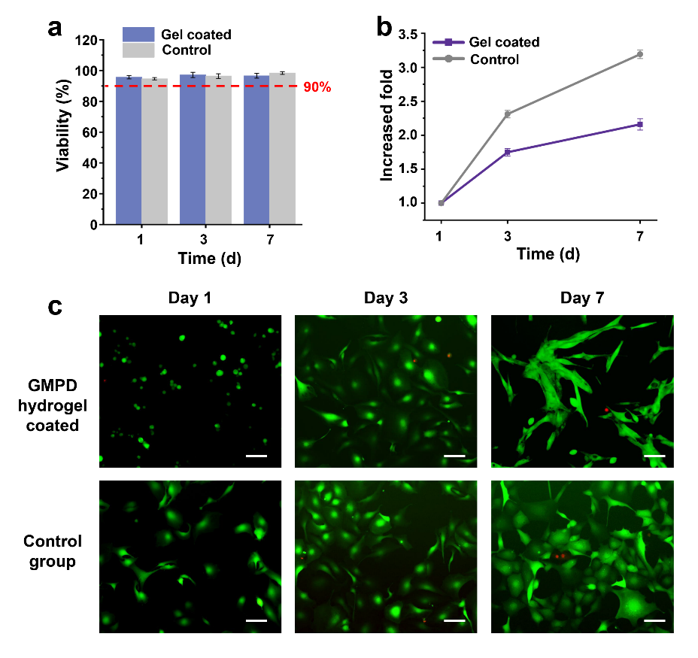
Supplementary Figure 13. Cell viability and proliferation assay. a, Results of cell viability during 7 days culture, where the cell viability are all higher than 90% in both gel-coated and control group. b, Results of cell proliferation during 7 days culture. c, Representative images of AM/PI staining of cultured cells showing the cell viability. (Scale bar: 100 μm)

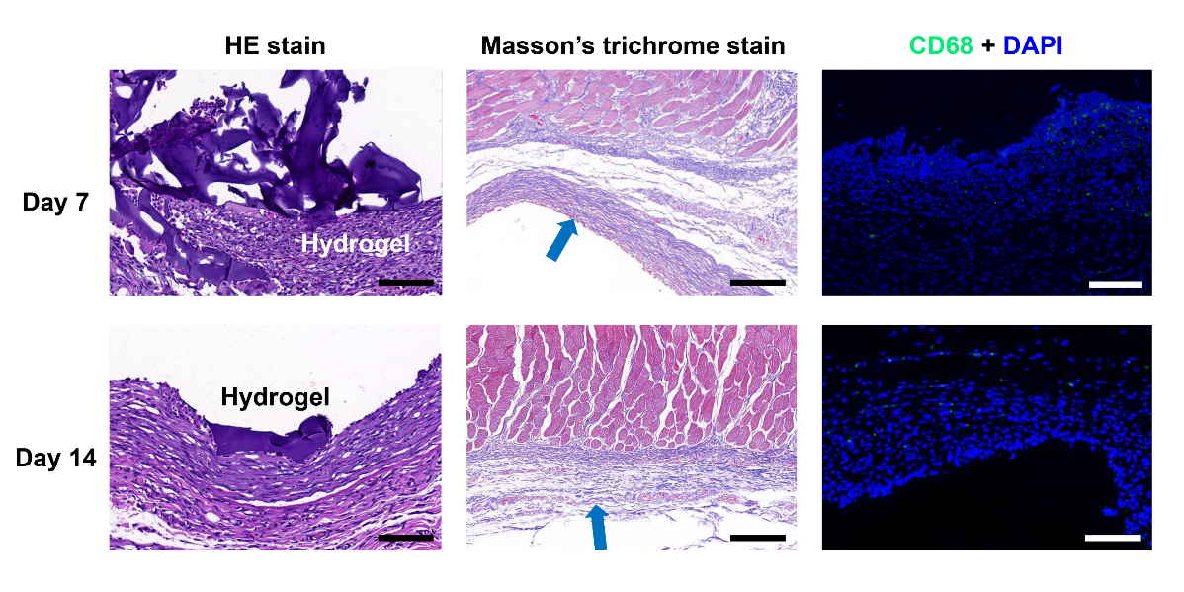
Supplementary Figure 14. Histology and immunofluorescence. a, H&E staining of subcutaneous implantation in Day 7 and Day 14. b, Masson’s trichrome staining of subcutaneous implantation in Day 7 and Day 14, where the blue arrow pointed the fibrous capsule stained as blue. c, Immunofluorescence staining of CD68 and DAPI of subcutaneous implantation in Day 7 and Day 14, where the green denotes macrophages and blue indicates cell nucleus. (Scale bar: 200 μm).

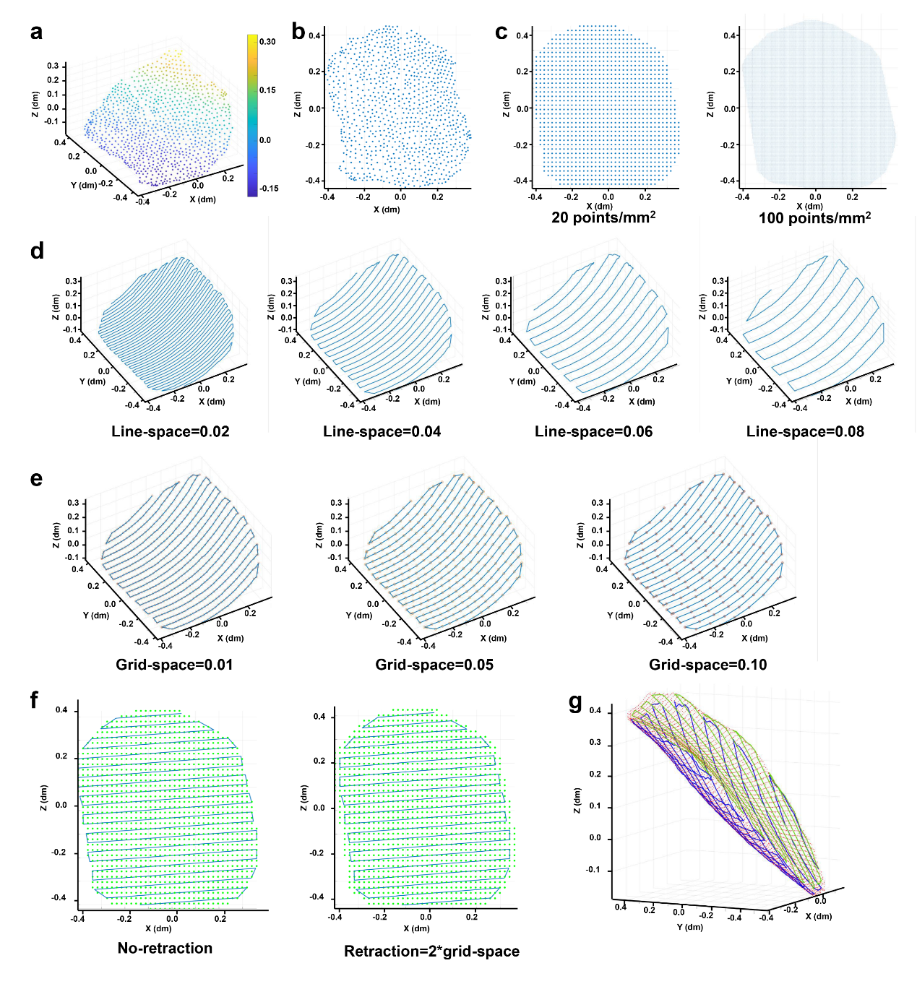
Supplementary Figure 15. Path planning method based on point cloud. a, Original point cloud revealing a part of skin tissues. b, Projecting the 3D point cloud to the X-Y plane to obtain the 2D point cloud. c, Regularizing 2D point cloud with different dots densities. d, Different printing path with variable line_space. e, Different printing path with variable grid_space. f, Different printing path with or without retraction. g, Representative image of printing path with two layers.

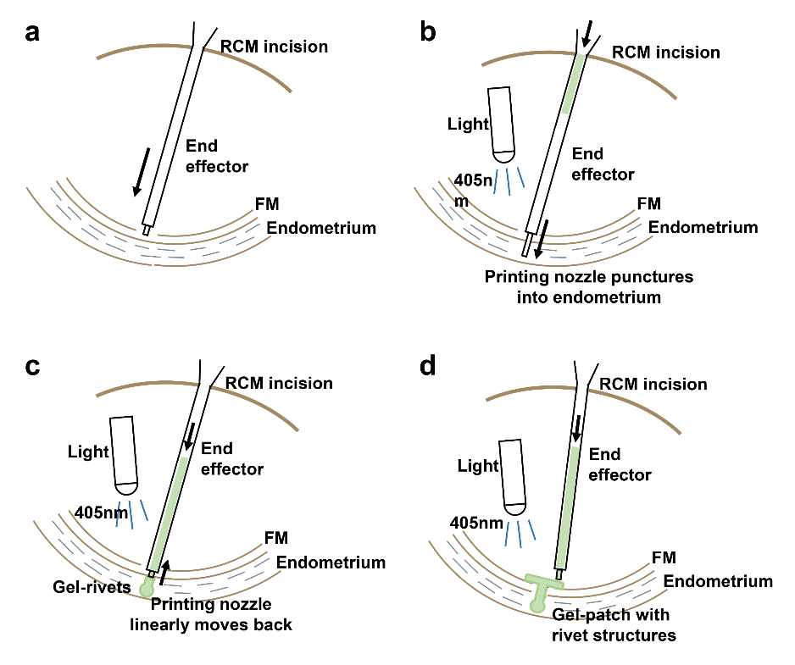
Supplementary Figure 16. Printing process in PROM sealing. a, End effector enters the amniotic sac through the RCM incision and moves to the ruptured site of FM. b, The printing nozzle within the end effector punctures into the endometrium under the drive of screw motor. Meanwhile, the GMPD hydrogel is injected by the syringe pump and cured under the 405 nm LED. c, The printing nozzle is retracted while the hydrogel continued to be injected, which forms a spherical hydrogel rivet in the endometrium. The position of end effector remains unchanged during the process. d, Once the needle moves back inside the amniotic sac, the end effector starts moving under the preset path and printing the hydrogel patch on the curved surfaces.

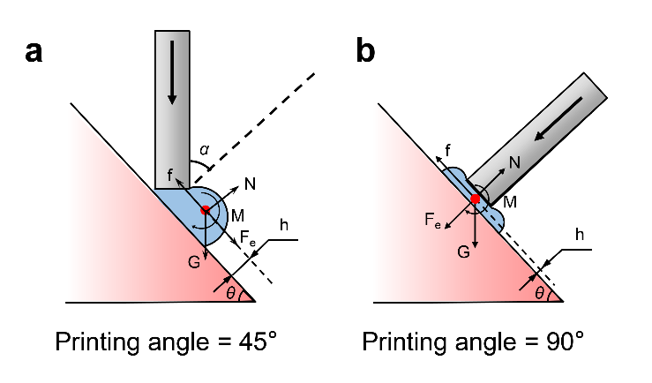
Supplementary Figure 17. Theoretical analysis of hydrogel adhesion at different printing angles. a, In small printing angle, the droplet presents spherical, leading to a greater tendency for printed threads to roll, and the downward extrusion component F_{e} enhances the sliding tendency of the droplet. b, In large printing angle, the droplet presents oblate, which has a small sliding tendency and a larger contact area. In companied with the extrusion force F_{e}, it helps the printed thread increase the interface friction f.

Supplementary Video Captions

Supplementary Video 1. Subaqueous bioprinting of a gel patch in the petri dish
Supplementary Video 2. 7-axis bioprinting robot performs subaqueous printing inside the in vitro amniotic sac model
Supplementary Video 3. Trajectory tracking of the robot-assisted bioprinting under a RCM constraint
Supplementary Video 4. Printing process of gel patch with gel rivets
Supplementary Video 5. Adhesive strength tests of hydrogel patch with or without gel rivets
Supplementary Video 6. Adhesive performance hydrogel patch with gel rivets
Supplementary Video 7. Subaqueous bioprinting for PROM sealing in in vitro uterus model

