SUPPLEMENTARY MATERIAL

2D simulated phantom

Comparison with true injected activity

The 2D simulated phantom was used to assess the performance of GPSF-MLEM for activity recovery. Fig. 1 shows the intensity per iteration measured with all reconstruction techniques for the 2D simulated phantom with a single Poisson noise realization. For all four ROIs, the iterative methods perform within 14.32 ± 0.55 % of the true intensity at the terminal iteration. Overall, MLEM underestimates the intensity to the largest degree as compared to PSF-MLEM and GPSF-MLEM. All three iterative techniques increasingly underestimate the true intensity in the ROI as the size of the ROI decreases. For all the four ROIs, the estimated intensity measured with GPSF-MLEM is closest to the FBP measured activity.
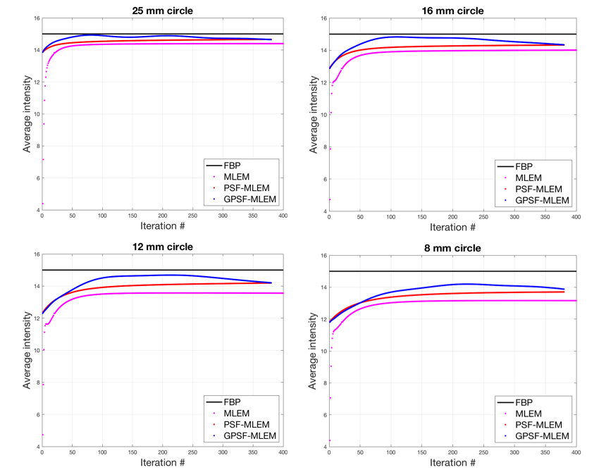
FIGURE 1: Evaluation of estimated intensity in 25, 16, 12, and 8-mm cylinders on the 2D simulated phantom using MLEM, PSF-MLEM, and GPSF-MLEM with the true intensity.

Comparison with larger kernel sizes

As suggested earlier, since studies have demonstrated using differently sized full-width-half-maximum (FWHM) kernel sizes to mitigate edge overshoots, in order to better understand the effect of larger FWHM qualitatively and quantitatively, Fig. 2 denotes the CR_{hot} values obtained with PSF-MLEM and GPSF-MLEM with a range of FWHM kernel sizes. In the figure, PSF: 4.5 mm denotes the contrast recovery curve for a static 4.5 mm PSF FWHM over 380 iterations, and GPSF: 4.5 mm denotes the contrast recovery curve for a gradually decreasing PSF FWHM from 10 mm to 4.5 mm over 380 iterations.

From Fig. 2, it is interesting to note that the for the 16 mm and 12 mm cylinders, the CR_{hot} curves for all PSF FWHM kernel sizes have an upward non-converging trend, whereas the corresponding GPSF-MLEM CR_{hot} curves seem to be have a downward trend at the terminal iteration, especially GPSF: 4.5 mm and GPSF: 6 mm. However, for the 8 mm cylinder, all CR_{hot} curves for various PSF-MLEM and GPSF-MLEM kernel sizes have an upward non-converging trend, except GPSF: 4.5 mm, which still has a downward trend. For the 25, 16, and 12 mm cylinders, the 10 mm FWHM PSF-MLEM seems to yield the highest contrast recovery, whereas for the 8 mm cylinder, the 8 mm FWHM PSF-MLEM is the highest. Overall, it can be observed that the larger the static PSF-MLEM FWHM, the higher the contrast recovery; therefore, the 10 mm FWHM PSF-MLEM seems to yield the highest contrast recovery. The CR_{hot} curves for both gradually decreased and static 4.5 mm FWHMs, although most closely matched with the true FWHM for the ECAT HR+ scanner, in fact yield the lower values of CR_{hot} when compared to the larger sized FWHM counterparts.

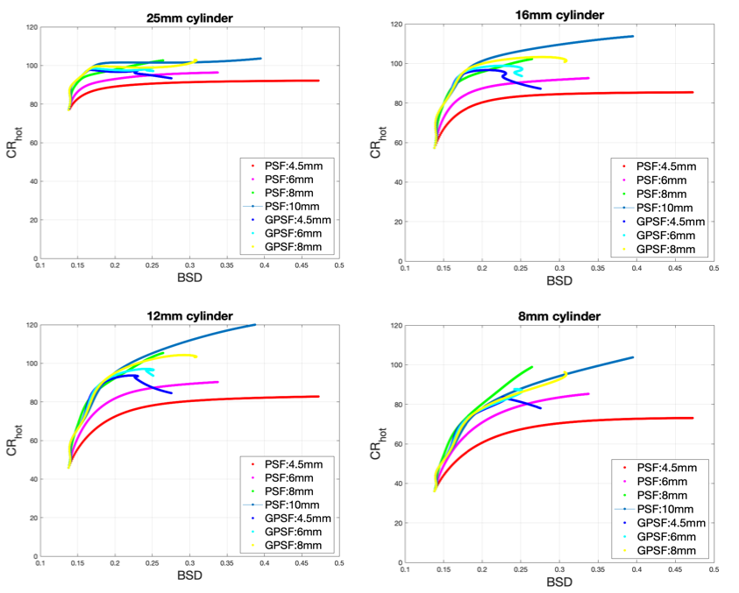 FIGURE 2: Contrast recovery vs. background standard deviation for the 25, 16, 12, and 8-mm cylinders on the simulated phantom obtained with larger kernel sizes between 10 mm and 4.5 mm with PSF-MLEM, and GPSF-MLEM.
CR_{hot} = hot contrast recovery, BSD = background standard deviation.

ACR Phantom

Comparison with larger kernel sizes

As suggested earlier, since studies have demonstrated using differently sized full-width-half-maximum (FWHM) kernel sizes to mitigate edge overshoots, in order to better understand the effect of larger FWHM qualitatively and quantitatively, Fig. 3 denotes the CR_{hot} values obtained with PSF-MLEM and GPSF-MLEM with a range of FWHM kernel sizes. In the figure, PSF: 4.5 mm denotes the contrast recovery curve for a static 4.5 mm PSF FWHM over 380 iterations, and GPSF: 4.5 mm denotes the contrast recovery curve for a gradually decreasing PSF FWHM from 10 mm to 4.5 mm over 380 iterations. From Fig. 3, it is interesting to note that the CR_{hot} curves for all PSF FWHM kernel sizes have an upward non-converging trend, whereas the corresponding GPSF-MLEM CR_{hot} curves seem to be converging to the PSF-MLEM curves at the terminal iteration. Overall, it can be observed that the larger the static PSF-MLEM FWHM, the higher the contrast recovery; therefore, the 10 mm FWHM PSF-MLEM seems to yield the highest contrast recovery. The CR_{hot} curves for both gradually decreased and static 4.5 mm FWHMs, although most closely matched with the true FWHM for the ECAT HR+ scanner, in fact yield the lowest values of CR_{hot} when compared to the larger sized FWHM counterparts.
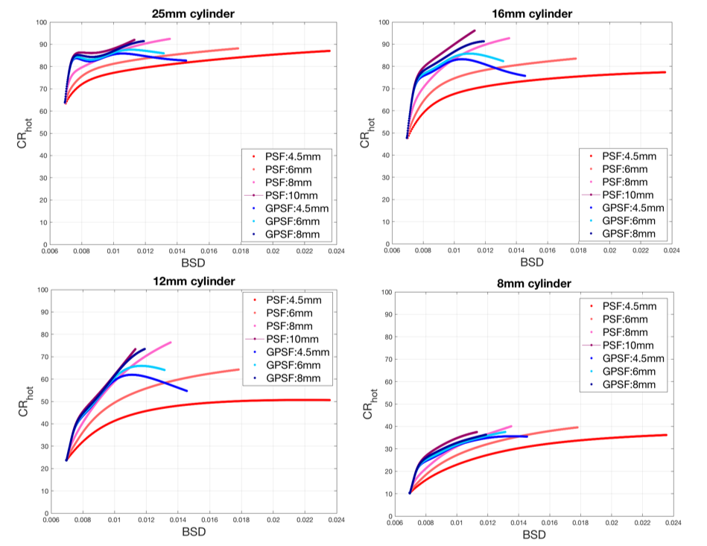FIGURE 3: Contrast recovery vs. background standard deviation for the 25, 16, 12, and 8-mm cylinders on the ACR phantom obtained with larger kernel sizes between 10 mm and 4.5 mm with PSF-MLEM, and GPSF-MLEM.
CR_{hot} = hot contrast recovery, BSD = background standard deviation.
However, when evaluated qualitatively in Fig. 4, irrespective of the FWHM at the terminal iteration, the GPSF-MLEM reconstructed images have better background noise suppression than the 6 mm and 4.5 mm FWHM PSF-MLEM images. The 8 mm FWHM PSF-MLEM reconstructed image is comparable to the GPSF-MLEM images.

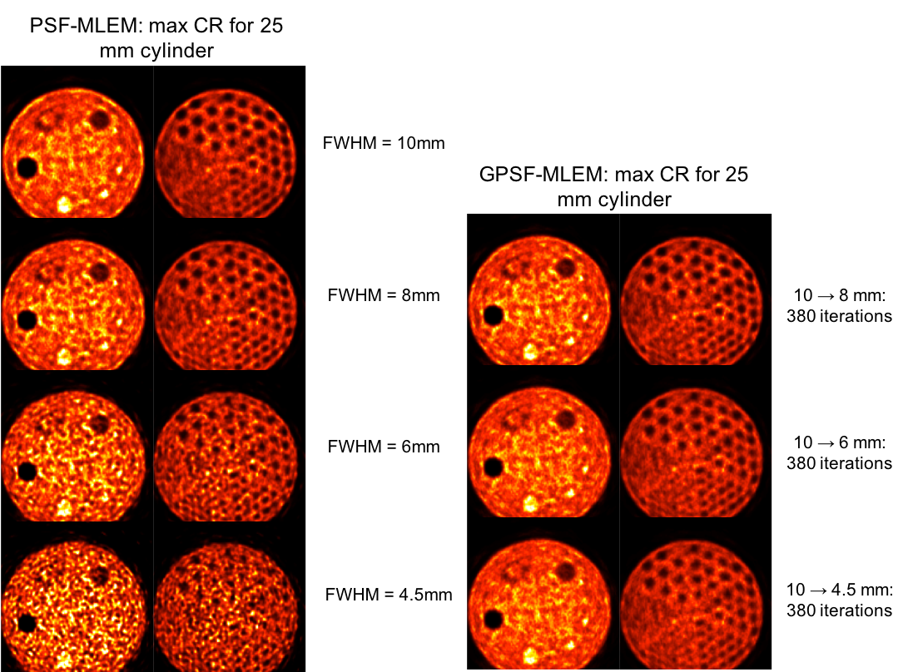
FIGURE 4: Qualitative comparison of ACR phantom images at the maximum contrast recovery (CR) value obtained with larger kernel sizes between 10 mm and 4.5 mm with PSF-MLEM, and GPSF-MLEM.
The left panel shows images for reconstructions with PSF-MLEM using the static FWHM kernel sizes specified next to each image. The right panel shows GPSF-MLEM run with an initial FWHM of 10mm and iterated for 380 iterations until the terminal FWHM specified next to each image was reached.

Comparison with larger kernel sizes

The CR_{hot} curves from the Hoffman phantom reconstructed with PSF-MLEM with larger static FWHM, and GPSF-MLEM larger terminal, are shown in Fig. 5. A similar behavior of the CR_{hot} curves to Fig. 3 can be observed. All PSF-MLEM curves have an upward non-converging trend, whereas the corresponding GPSF-MLEM CR_{hot} curves appears to trend toward the PSF-MLEM curves at the terminal iteration. Similarly, the CR_{hot} curves for both gradually decreased and static 4.5 mm FWHMs yield the lowest values of CR_{hot} when compared to the larger sized FWHM counterparts. However, unlike the ACR phantom, the 10 mm FWHM PSF kernel yields a > 100% value of contrast recovery, possibly due an abnormal increase in measured hot activity due to over-enhancement of the intensities in the small regions. The most significant observation is that GPSF-MLEM with a gradually decreasing FWHM terminating at 8 mm yields a contrast recovery ~100% for both ROIs.

Qualitatively, the observations in Fig. 6 are similar to Fig. 4, such as the 10 mm FWHM PSF-MLEM ACR phantom image has an enhanced outer boundary. GPSF-MLEM reconstructed images have better background noise suppression than the 6 mm and 4.5 mm FWHM PSF-MLEM images irrespective of the FWHM at the terminal iteration, the. The 8 mm FWHM PSF- MLEM reconstructed image is comparable to the GPSF-MLEM images.

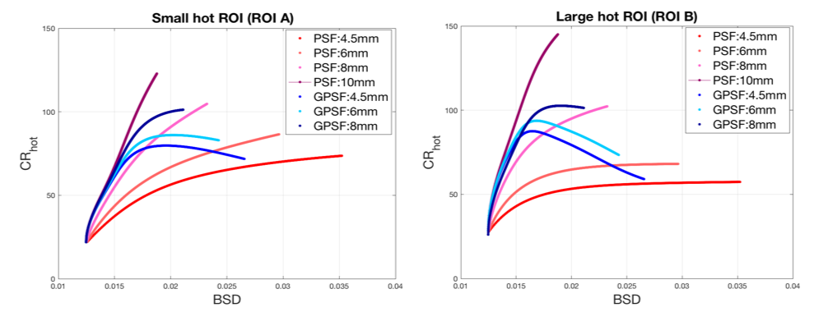FIGURE 5: Contrast recovery vs. background standard deviation on a for the large and small hot ROIs on the Hoffman phantom obtained with larger kernel sizes between 10 mm and 4.5 mm with PSF-MLEM, and GPSF-MLEM.
CR_{hot} = hot contrast recovery, BSD = background standard deviation.

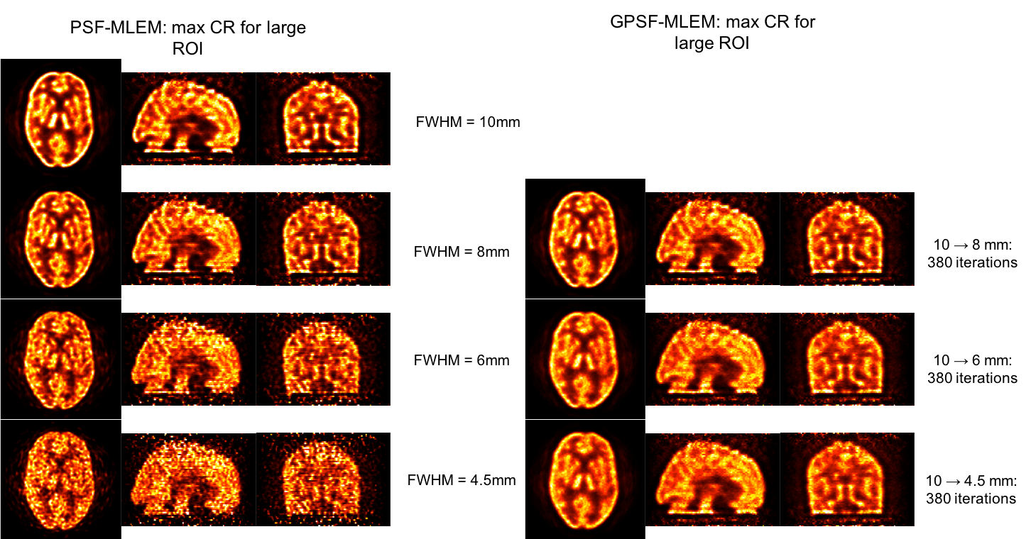

FIGURE 6: Qualitative comparison of ACR phantom images at the maximum contrast recovery (CR) value obtained with larger kernel sizes between 10 mm and 4.5 mm with PSF-MLEM, and GPSF-MLEM.
The left panel shows images for reconstructions with PSF-MLEM using the static FWHM kernel sizes specified next to each image. The right panel shows GPSF-MLEM run with an initial FWHM of 10mm and iterated for 380 iterations until the terminal FWHM specified next to each image was reached.

