Dual-channel ratiometric colorimetric sensor array for quantification and discrimination of o-, m- and p-phenols

Chengwu Lan, Lei Meng, Na Xu*

College of Materials Science and Engineering, Jilin Institute of Chemical Technology, Jilin 132022, China.

* Corresponding author: Na Xu, E-mail: xn_1216@163.com
Chemicals and regents
Copper (II) chloride dihydrate (CuCl₂·2H₂O), 2-methylimidazole, terephthalic acid (TA) phenol, p-Dihydroxybenzene (p-DHB), m-Dihydroxybenzene (m-DHB) and o-Trihydroxybenzene (o-THB) were obtained from Macklin Inc. (Shanghai, China). Isopropanol (IPA) was acquired from Damao chemical reagent factory (Tianjin, China). The ultrapure water was used in all experiments.
Instruments
The crystal structure of Cu₂(OH)₃Cl samples was determined via a D8 X-ray diffractometer (XRD) using with Cu target radiation source (λ=0.154178 nm) (Bruker, Germany). Scanning electron microscope (SEM) was carried out by a JSM-6490LV (JEOL, Japan). Transmission electron micrographs (TEM) and high-resolution transmission electron microscopy (HRTEM) images were obtained by using a JEM F200 (JEOL, Japan). X-ray photoelectron spectroscopy (XPS) measurements were conducted by using an ESCALAB 250 spectrometer with a mono-chromic X-ray source (Al Kɑ line, 1486.6 eV) (Thermo, USA). Electrons spin resonance (ESR) was performed by an A300 spectrometer (Bruker, Germany). TG-DSC was measured by a Discovery SDT650 synchronous thermal analyzer (TA, USA). Fourier transform infrared (FTIR) spectra were obtained using a Spectrum Two spectrometer (PerkinElmer, USA). UV-vis spectra (UV-vis DRS) were carried by UV-2200 (Rayleigh, China). Fluorescence measurements were carried out by using Fluoromax-4 spectrophotometer (Horiba, Japan). Electrochemical analysis was carried out via a CompactStat.h10800 electro-chemical workstation (Ivium, Netherlands).
Electrochemical test
The electrochemical test system employed a standard three-electrode system, which contains graphite rod counter electrode, Ag/AgCl reference electrode and a working electrode. The working electrode was prepared as follow: 1 mg Cu₂(OH)₃Cl samples and 10 µL Nafion aqueous (5 wt.%) were added to 0.2 mL ethanol and 0.8 mL deionized water, then sonicated for 10 min to get slurry mixture. Part of the mixture (160 µL) was dropped onto the 1×2 cm² ITO glass and dried at 60 ℃. The electrolyte was chosen as 0.1 M NaAc-HAc buffer aqueous solution.

Figures and caption
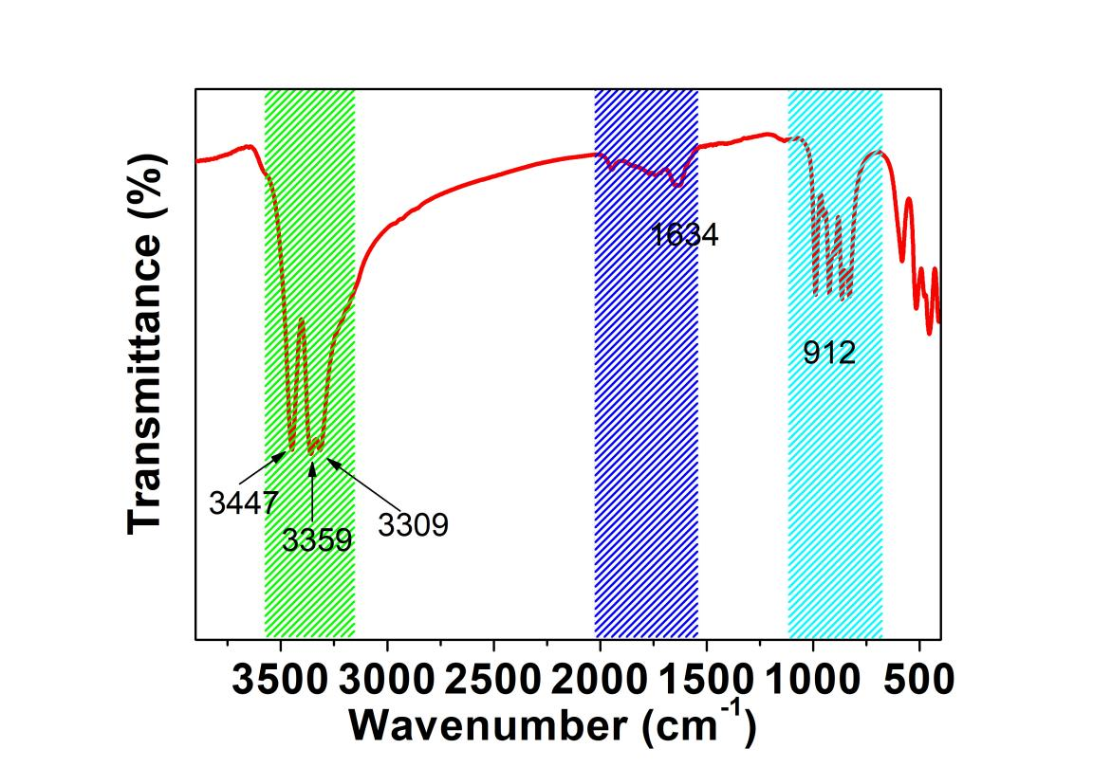
Fig. S1 FTIR spectrum of Cu₂(OH)₃Cl.
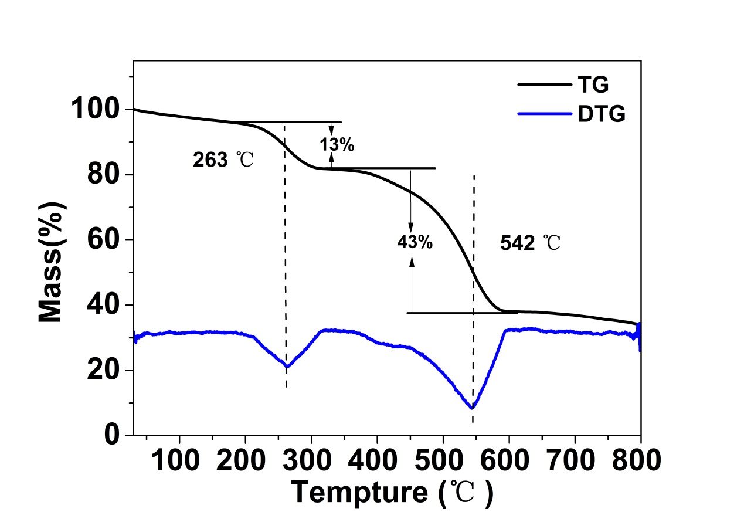
Fig. S2 TG and DTG results of Cu₂(OH)₃Cl.
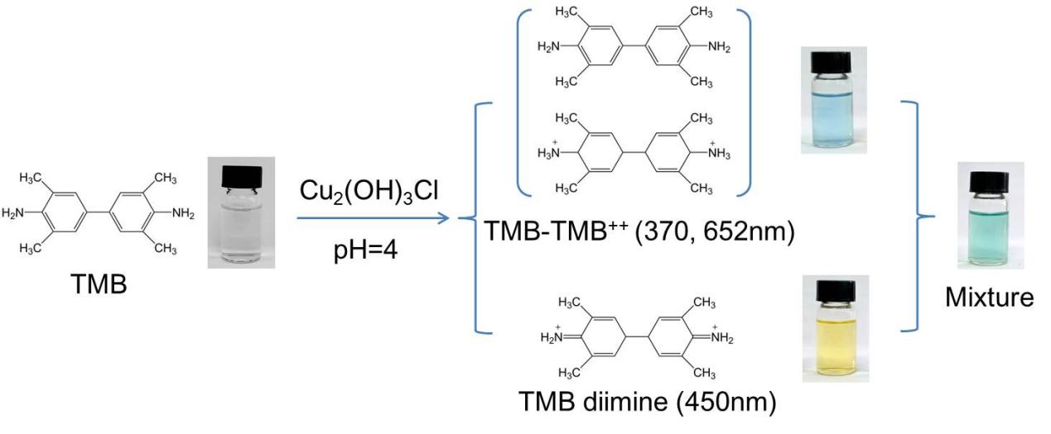
Fig. S3 Illustration of Cu₂(OH)₃Cl-mediated peroxidation of TMB and the corresponding products.

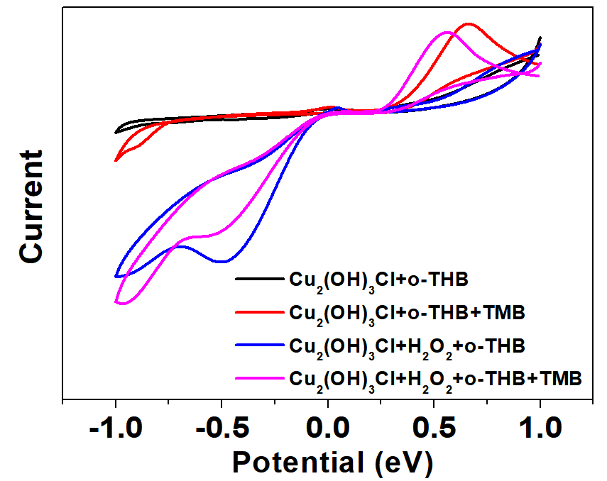
Fig. S4 CV curves of o-THB in the presence of different substances.
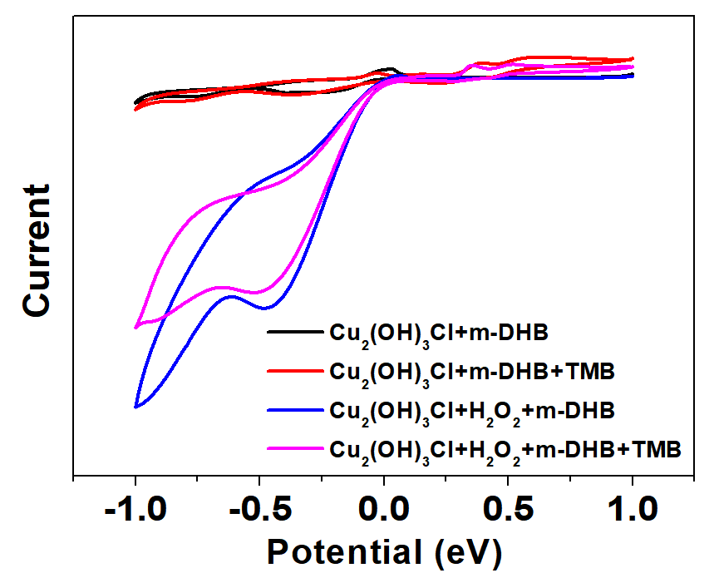
Fig. S5 CV curves of m-DHB in the presence of different substances.

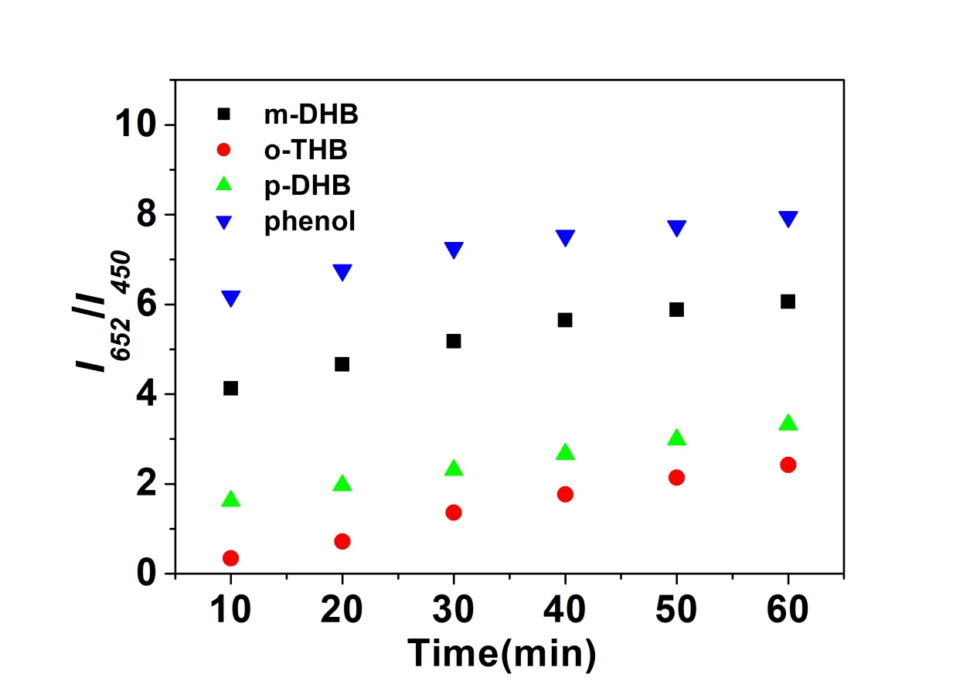
Fig.S6 Time-dependent I₆₅₂/I₄₅₀ changes of Cu₂(OH)₃Cl-catalyzed reaction system with the presence of m-DHB, o-THB, p-DHB and phenol (0.05 mM)
Table S1. Identification of six unknown phenols samples.
Sample | 10 min | 20 min | 30 min | 40 min | 50 min | 60 min | Identity | Prediction accuracy
1# | 1.25464 | 5.35642 | 12.93541 | 14.26547 | 5.15642 | 3.51464 | m-DHB | Yes
2# | 0.10216 | 1.33646 | 1.99466 | 4.06545 | 5.31654 | 5.71531 | p-DHB | Yes
3# | 2.44553 | 3.02254 | 3.64354 | 4.32345 | 4.91345 | 5.77545 | p-DHB | Yes
4# | 3.35262 | 4.05381 | 4.70813 | 6.2693 | 6.57857 | 6.81947 | o-THB | Yes
5# | 0.46958 | 0.64162 | 1.06248 | 1.80208 | 2.31671 | 2.95262 | o-THB | Yes
6# | 6.18523 | 7.22824 | 8.28274 | 9.32068 | 9.99459 | 10.60385 | m-DHB | Yes

