Supplementary Material

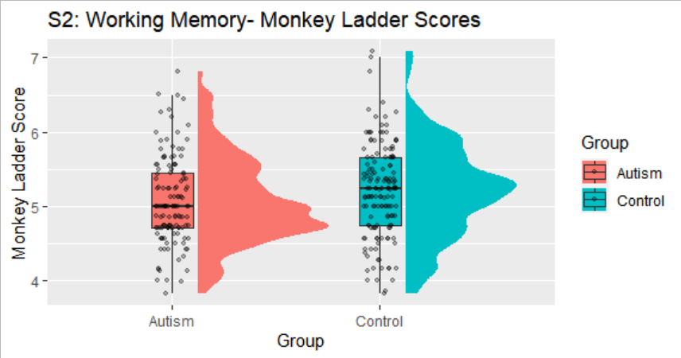
Fig S1. Digit Span Task: Distribution of scores for Autism (pink) and Control (blue). Dots indicate individual data points. Circles indicate outliers. Error bars show the standard error of the mean.
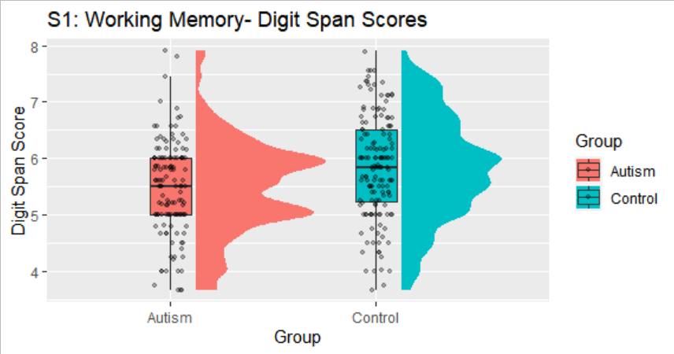
Fig S2. Monkey Ladder Task: Distribution of scores for Autism (pink) and Control (blue). Dots indicate individual data points. Circles indicate outliers. Error bars show the standard error of the mean

Exploratory plots for female-only subset of participants (n=193): 75 Autism and 118 Control.

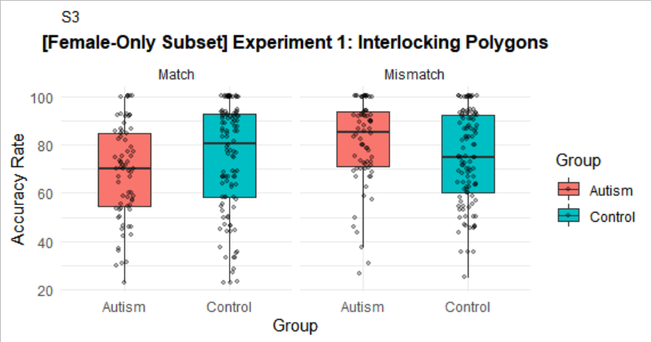
Fig S3: Experiment 1: Interlocking Polygons results in females only: Mean accuracy rates for Autism (pink) and Control (blue), split according to condition. Dots indicate individual data points. Error bars show the standard error of the mean.

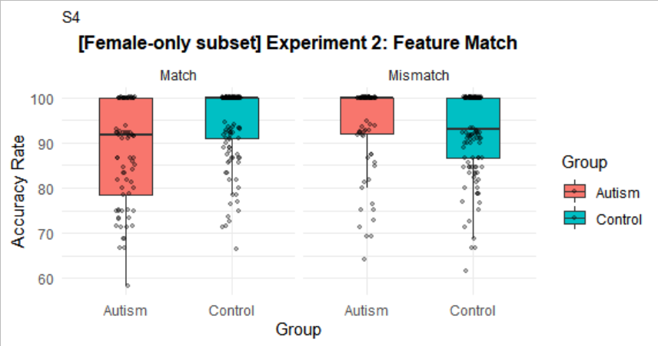
Fig S4: Experiment 2: Feature Match results in females only: Mean accuracy rates for Autism (pink) and Control (blue), split according to condition. Dots indicate individual data points. Error bars show the standard error of the mean.

