Supplementary Data
A new Schiff base derivative based on the ratiometric fluorescent chemosensor for detection of Mg²⁺ ions and Spectroscopy applications
Pitchai Marimuthuª, Andy Ramuª*
ªDepartment of Inorganic Chemistry, School of Chemsitry, Madurai Kamaraj University, Madurai-625 021, Tamil Nadu, India
^{a*}Department of Inorganic Chemistry, School of Chemsitry, Madurai Kamaraj University,Madurai-625 021, Tamil Nadu, India
*E-mail: andyramumku@gmail.com (AR)

*Corresponding Author: Tel: 91+ 9442623835.
*E-mail address: andyramumku@gmail.com (Andy Ramu)

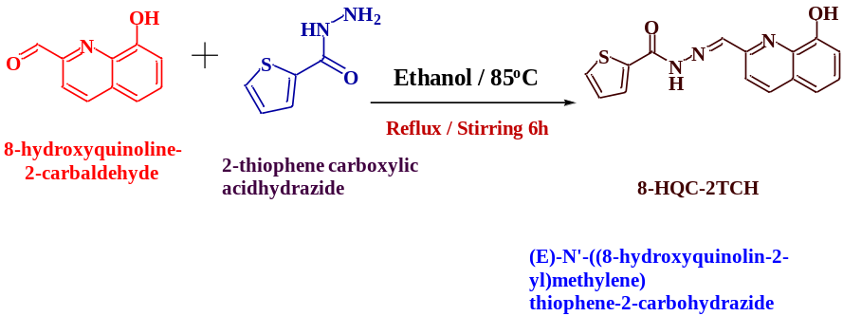
Scheme 1: Synthesis of Probe (E)-N'-((8-hydroxyquinolin-2-yl) methylene) thiophene-2-carbohydrazide (8-HQC-2TCH).

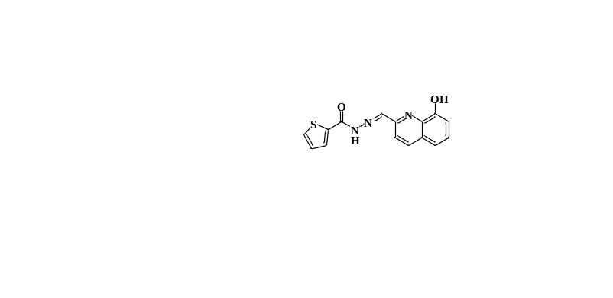
Figure S1. ¹H₁ NMR spectra of (E)-N'-((8-hydroxyquinolin-2-yl) methylene) thiophene-2-carbohydrazide (8- HQC-2TCH).

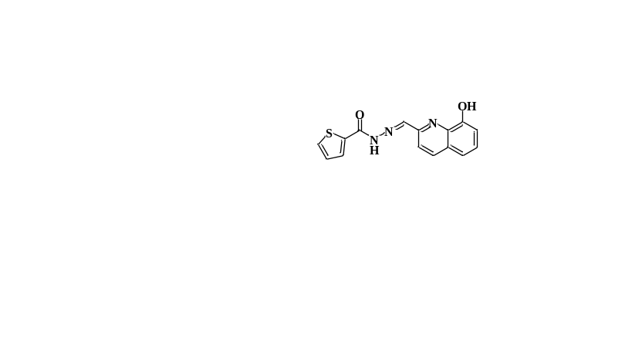
Figure S2. ¹³C-NMR spectra of (E)-N'-((8-hydroxyquinolin-2-yl) methylene) thiophene-2-carbohydrazide (8- HQC-2TCH).

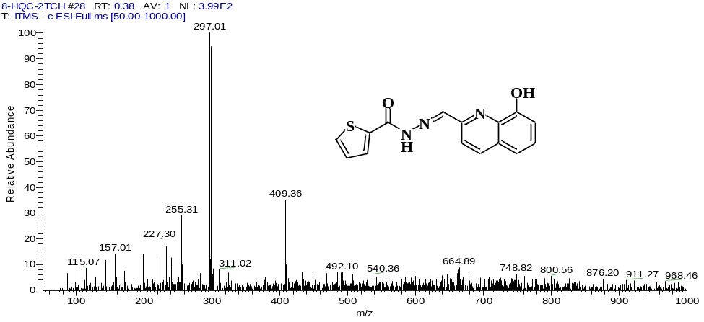
Figure S3. Mass Spectrum of (E)-N'-((8-hydroxyquinolin-2-yl) methylene) thiophene-2-carbohydrazide.

Figure 4A. UV–Vis. Spectra of 8-HQC-2TCH (25 µM) in the presence of various metal ions such as K⁺, Mg²⁺, Ba²⁺, Cu²⁺, Al³⁺, Fe³⁺, Zn²⁺, Cd²⁺, Hg²⁺ and Cr³⁺ (25 µM) in DMSO.

Figure 4B. UV–Vis. Spectra of 8-HQC-2TCH (25 μM) upon the titration of Mg²⁺ 0 to 60 μM in DMSO

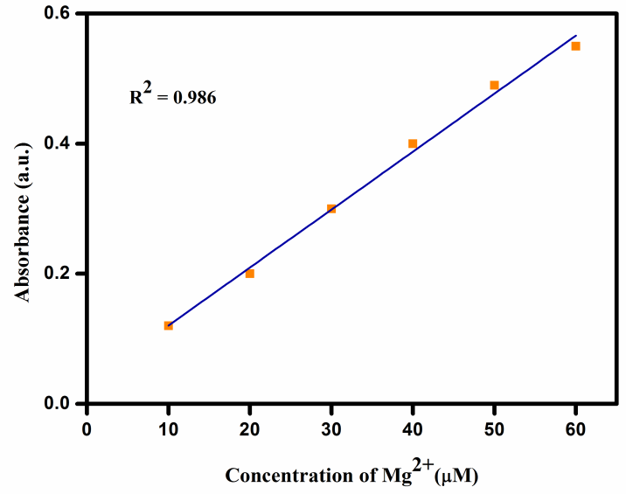
Figure S5. Linear relationship plot obtained from absorptions titration of 8-HQC-2TCH (μM) with concentration of Mg²⁺ ions (0 to 60 μM.).

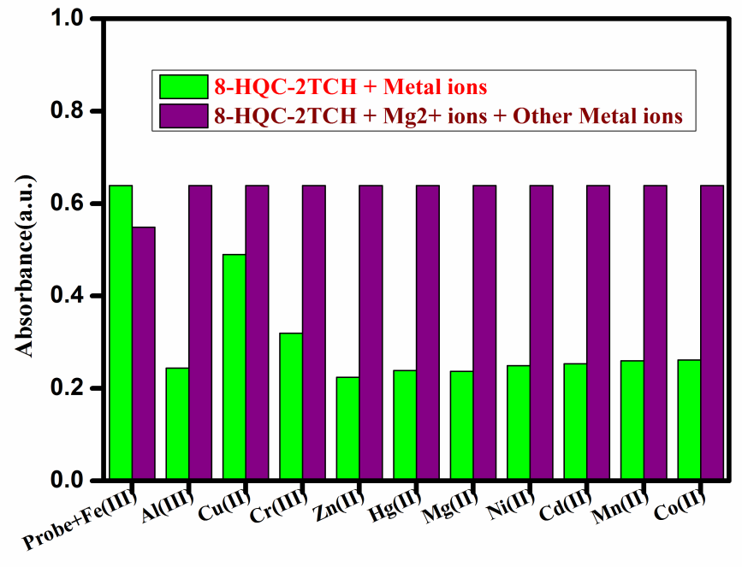
Figure S6. Competitive experiments of 8- HQC-PTH toward Mg²⁺: violet bars represent of various metal ions with an added into an 8-HQC-2TCH + Mg²⁺ in DMSO solution and green bars represent UV–Vis. Spectra of 8-HQC-2TCH + Metal ions, (25µM).

Figure 7A. Fluorescence spectra of 8-HQC-2TCH (25 µM) in the presence of various metal ions such as K⁺, Mg²⁺, Ba²⁺, Cu²⁺, Al³⁺, Fe³⁺, Zn²⁺, Cd²⁺, Hg²⁺ and Cr³⁺ , λ_{ex}370nm (25 µM) in DMSO.

Figure 7B. Fluorescence spectra of 8-HQC-2TCH (25 μM) upon the titration of Mg²⁺ (0 to 70 μM) in DMSO.

Figure 8A. Linear relationship plot obtained from fluorescence titration of 8-HQC-2TCH (μM) with a concentration of Mg²⁺ ions (0 to 70 μM.).

Figure 8B. Benesi-Hildebrand plot, determination of the Binding constant for 8-HQC-2TCH with Mg²⁺ ion.

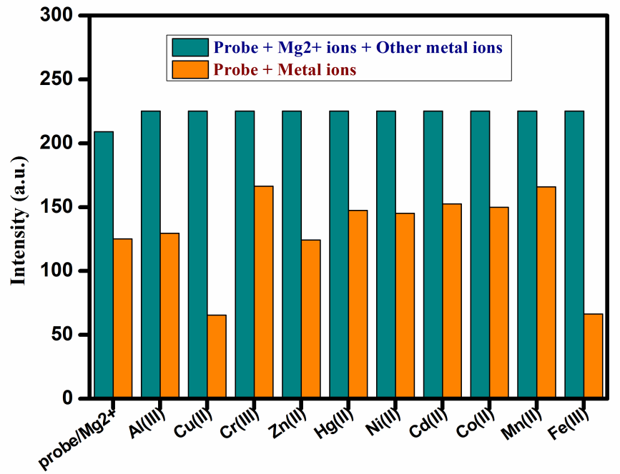
Figure 9. Competitive experiments of 8- HQC-2TCH toward Mg²⁺: Cyan bars represent of various metal ions with an added into an 8-HQC-2TCH + Mg²⁺ in DMSO solution and Orange bars represent fluorescence intensity of 8-HQC-2TCH + Metal ions, λ_{ex}370nm (25µM).

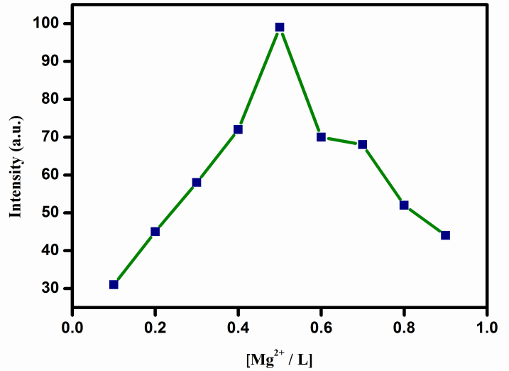
Figure 10. Job’s plot Fluorescence intensity of diagram between 8- HQC-2TCH and Mg²⁺ ion.

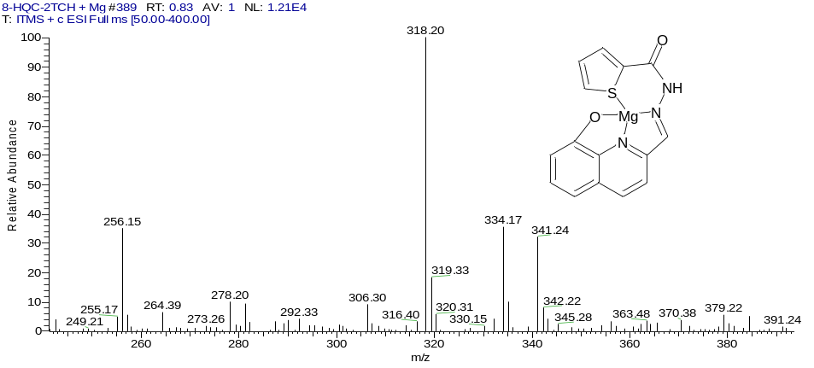
Figure 11. Mass Spectrum of 8- HQC-2TCH + Mg²⁺ ion.

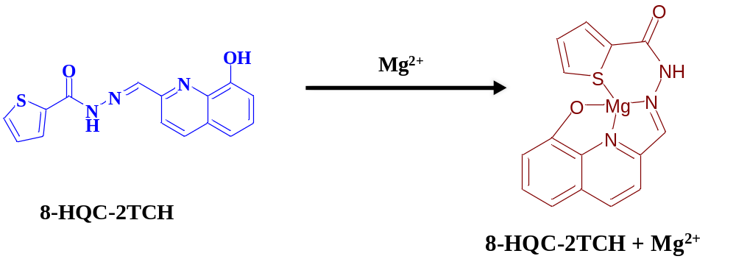
Scheme 2: Proposed interaction of Mg²⁺ ions with 8- HQC-2TCH.

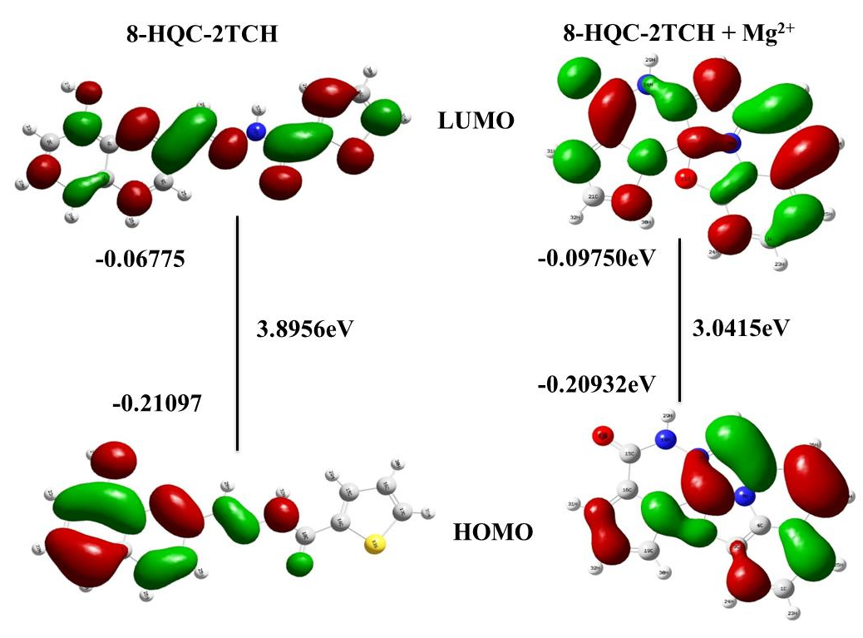
Figure 12. HOMO and LUMO of probe (8-HQC-NH) calculated with DFT/TD-DFT at B3LYP/6-31G (d) level using Gaussian 09.

Table 1. Comparison table for various probes for the detection of Mg^{2+.}
S.N | 8-HQC-2TCH | Metal | Detect limit | Application | Ref
1 | Isatin-3-(7-Methoxychromone-3-methylidene) hydrazone | Mg²⁺ | 5.16 x 10⁻⁷ M | Fluorescent “turn-on” sensor | 45
2 | 4-hydroxy-3-((2-hydroxy-5-methylphenyl)diazenyl)-2H-chromen-2-one | Mg²⁺ &  F⁻ | 2.4 x 10⁻⁸ M  &  2.3 x 10⁻⁸ M | Fluorescent “turn-on-off” sensor | 46
3 | N-(1H-benzo[d]imidazol-2-yl)quinoline-2-carboxamide (QLBM) | Cu²⁺, Fe³⁺ | 1.35× 10⁻⁷ M  &  1.24 × 10⁻⁷ M | Fluorescent sensor and Live cell imaging | 48
4 | N-(quinolin-8-yl)-2-(quinolin-8-yloxy) acetamide | Zn²⁺ & Cd²⁺ | 1.8 × 10⁻⁴ M  &  1.9 x 10⁻⁷ M | Fluorescent “turn-on” sensor | 47
5 | 2-Hydroxyquinoline-3-carbaldehyde | Zn²⁺ & Ni²⁺ | 7.2 x 10⁻⁸ M  &  3.3 x 10⁻⁷ M | Live cell imaging on  lung cancer cell line | 49
6 | (8-HQC-PTH) | Mg²⁺ | 4.9 x 10⁻⁸ M | Ratiometric Fluorescent sensor | This work

