Multi-omics analysis revealed the association of human gut microbiota composition and metabolic functions with the daily diet of the additive Ficus hirta Vahl
Ruiming Xiao ^{ab}, Guangjuan Luo ^{ab}, Wanci Liao ^{ab}, Shuting Chen ^{ab}, Shuangyan Han ^{ab}, Shuli Liang ^{ab}, Ying Lin ^{ab*}
ªSouth China University of Technology South China Univ Technol, School of Biology & Biological Engineering,
^{b}Guangdong Key Lab Fermentation & Enzyme Engineering, Guangzhou 510006, Peoples R China.

*Corresponding author: Ying Lin, South China Univ Technol, Sch Biol & Biol Engn, Guangdong Key Lab Fermentat & Enzyme Engn, Guangzhou 510006, Peoples R China
E-mail: feylin@scut.edu.cn

Table S1. Daily ingredients formula in FHVD (n=25) and NFHVD (n=18) for each people.
Ingredient names | Food weight (g) |  | P value
Ingredient names | FHV Diet | NFHV Diet | P value
Pork chops | 25.08 ± 0.29 | 24.79 ± 0.50 | 0.433
Maize | 13.33 ± 0.33 | 13.14 ± 0.34 | 0.535
Carrot | 13.63 ± 0.52 | 13.58 ± 0.40 | 0.902
FHV dried root | 14.95 ± 0.28 | 0 | < 0.001
The pork chops, maize, and carrot were cut into 2-3 cm of length, the dried root of FHV was cut into 0.2-0.4 cm of slice. Then, all ingredients were mixed and stewed in boiling water for 2 h. After cooking, the ingredients were abandoned and the 250 mL of soup was collected for each participant. The data were presented as Mean ± Standard deviation (SD) and analyzed by Student’s t test, P<0.05 was regarded as a significant difference.

Table S2. Characteristics of participants in FHVD (n=25) and NFHVD (n=18) at baseline.
 | FHV Diet | NFHV Diet | P value
Age (years) | 23.68 ± 2.84 | 23.00 ± 2.81 | 0.423
BMI (kg/m²) | 21.15 ± 2.13 | 20.87 ± 2.29 | 0.506
Urea (mmol/L) | 4.93 ± 1.23 | 4.96 ± 1.21 | 0.956
CRE (μmol/L) | 75.04 ± 15.47 | 79.55 ± 24.37 | 0.356
UA (μmol/L) | 334.82 ± 107.24 | 369.49 ± 117.34 | 0.360
BG (mmol/L) | 5.14 ± 0.38 | 5.23 ± 0.41 | 0.487
TG (mmol/L) | 0.81 ± 0.24 | 0.86 ± 0.35 | 0.648
TC (mmol/L) | 4.50 ± 0.71 | 4.51 ± 0.72 | 0.971
Male/Female | 0.92 | 1.25
BMI: Body mass index; CRE: Creatinine; UA: Uric acid; BG: Blood Glucose; TG: Total triglycerides; TC: Total cholesterol. The data were presented as Mean ± Standard deviation (SD) and analyzed by Student’s t test, P<0.05 was regarded as a significant difference.

Table S3. Macronutrients intake comparation of participants in FHVD and NFHVD at sampling week.
Nutrient | FHVD |  |  |  | NFHVD
Nutrient | Pre | Post | P value |  | Pre | Post | P value
Energy (kj) | 1263.73 ± 432.60 | 1230.94 ± 396.72 | 0.290 |  | 1282.11 ± 270.03 | 1258.25 ± 195.35 | 0.468
Protein (g) | 56.24 ± 22.84 | 51.99 ± 19.31 | 0.143 |  | 53.76 ± 14.62 | 50.57 ± 8.14 | 0.347
Carbohydrate (g) | 186.84 ± 66.03 | 181.87 ± 72.76 | 0.375 |  | 201.15 ± 62.11 | 203.88 ± 43.24 | 0.442
Fat (g) | 31.90 ± 16.11 | 31.23 ± 16.24 | 0.989 |  | 26.68 ± 10.99 | 24.69 ± 9.43 | 0.246
Diet fiber (g) | 6.46 ± 2.61 | 5.61 ± 2.14 | 0.726 |  | 5.02 ± 2.03 | 4.91 ± 1.72 | 0.152
The data were presented as Mean ± Standard deviation (SD) and analyzed by Student’s t test, P<0.05 was regarded as a significant difference.

Table S4. Concentrations of SCFAs in in-vitro incubation solutions at different time points.
SCFAs（mM） | Samples | Anaerobic incubation time (h)
SCFAs（mM） | Samples | 0 | 3 | 6 | 12 | 24
Acetate | Control  FHVD | 0.31±0.02 | 0.34±0.10 a  2.35±0.25 b | 1.99±0.40 a  2.69±0.41 b | 2.07±0.28 a  9.13±0.70 b | 5.79±0.11 a  6.40±0.80 b
Propionate | Control  FHVD | 0.29±0.02 | 0.51±0.02 a  1.67±0.15 b | 1.36±0.19 a  2.67±0.27 b | 1.26±0.10 a  7.38±0.46 b | 3.40±0.07 a  6.04±0.57 b
Butyrate | Control  FHVD | 0.33±0.01 | 0.42±0.02 a  0.88±0.01 b | 0.92±0.06 a  1.59±0.08 b | 1.25±0.10 a  5.54±0.25 b | 2.41±0.02 a  5.46±0.45 b
Different lowercase letters indicate significant differences (P < 0.05) among different groups.

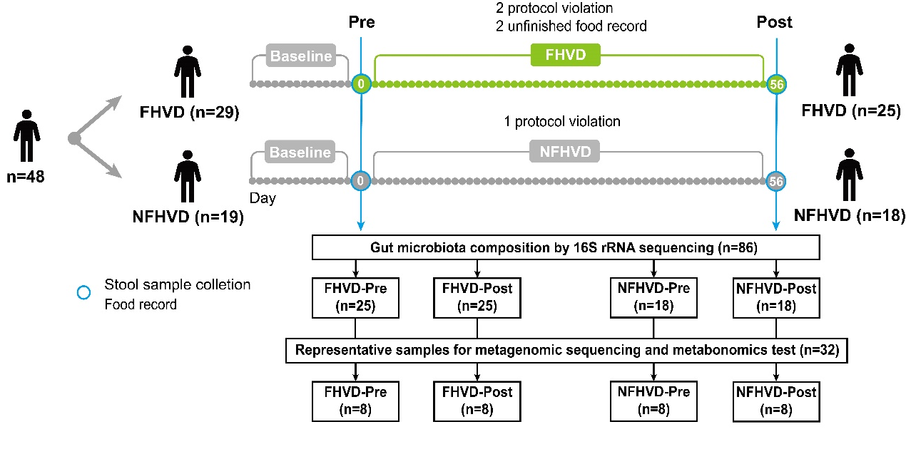
Figure S1. Study design and flow diagram of data collection: Timeline of diet intervention, a two-weeks Run in period was set for stabilization and followed by 8-weeks intervention, fecal samples and corresponding food records was collected before and after intervention; By excluding unfitted samples, a total of 86 samples in FHVD-Pre (n=25), FHVD-Post (n=25), NFHVD-Pre (n=18), and NFHVD-Post (n=18) was involved to analyze gut microbial composition by 16S rRNA sequencing; MicroPITA was used to selected eight representative samples in each group for further metagenomic sequencing and metabolomic test. FHVD, Ficus hirta Vahl diet; NFHVD, non- Ficus hirta Vahl diet; Pre, before intervention; Post, after intervention; MicroPITA, microbiomes Picking Interesting Taxonomic Abundance.
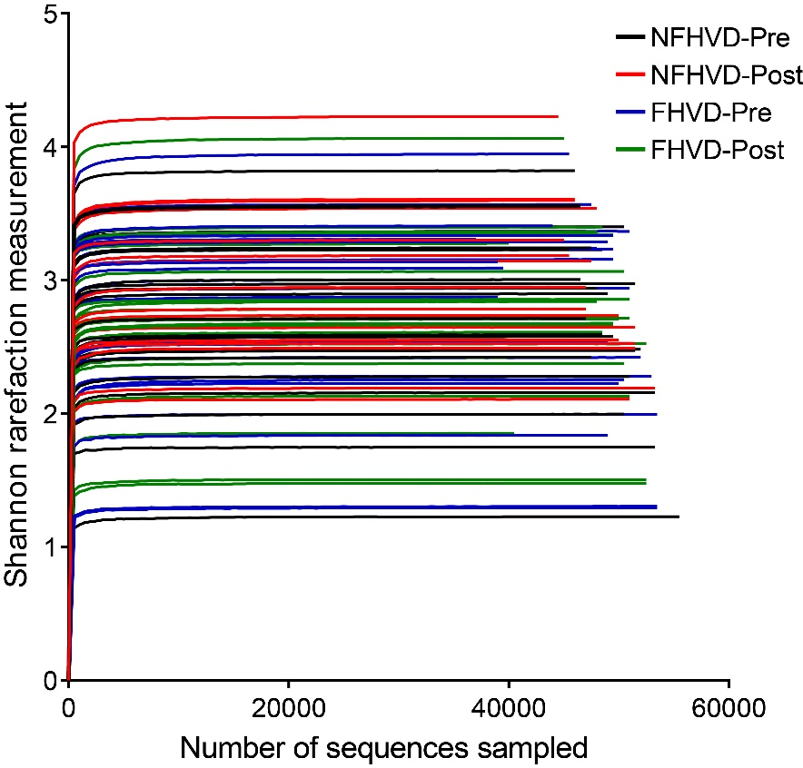
Figure S2. Shannon rarefaction curve of each sample in FHVD and NFHVD.

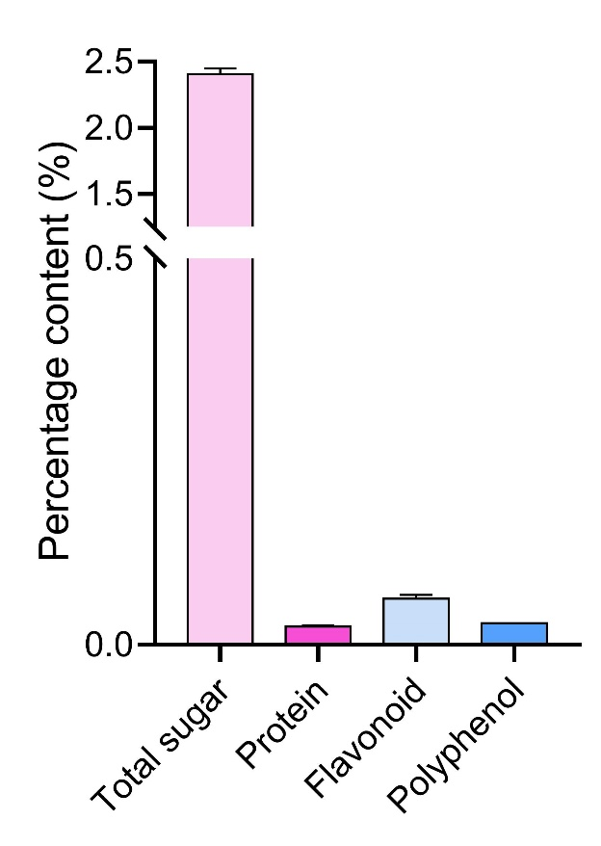
Figure S3. Percentage content of Components in FHV water extract.

