Supplementary Material:

Synergistic effect of titanium dioxide (TiO₂) and ionizing radiation on thermal and mechanical properties of carboxymethyl cellulose (CMC) for potential application in removal of basic dye from wastewater

Yasser H. Gad¹, Hussein E.Ali²and El-Sayed A. Hegazy¹
¹Polymer Chemistry Department, National Center for Radiation Research and Technology, Atomic Energy Authority P.O. Box 29, Nasr City, Cairo, Egypt
²Radiation Chemistry department, National Center for Radiation Research and Technology, Egyptian Atomic Energy Authority P.O. Box 29, Nasr City, Cairo, Egypt.
Contents
1. Figure (1):- FTIR spectra of CMC-20% Glycerol, CMC/1.5% TiO₂ and CMC/1.5% TiO₂ - 10kGy.
2. Scheme (1):- The suggested scheme for preparation of CMC/TiO₂ composite film by ⁶⁰Co g-irradiation.
3. Figure (2):- Effect of Irradiation dose (kGy) and TiO₂ (%) content on the Tensile strength (MPa) of carboxymethyl cellulose (CMC) films.
4. Figure (3):- Effect of Irradiation dose (kGy) and TiO₂ (%) content on the Elongation at break (%) of carboxymethyl cellulose (CMC) films.
5. Figure (4):- The X-ray diffraction patterns of CMC-20% Glycerol, CMC/1.5% TiO₂and
CMC/1.5%TiO₂-10kGy.
6. Figure (5):- SEM of CMC films:(a) CMC-20% Glycerol, (b) CMC/1.5%TiO₂ and (c) CMC/1.5%TiO₂ - 10kGy.
7. Figure (6):- (A)TGA and (B) DTG thermograms of CMC-20%Glycerol, CMC/1.5%TiO₂ and
CMC-1.5% TiO₂ at 10kGy.
8. Table (1):- The weight loss (%) of different prepared samples
9. Figure (7A):- shows the change in the absorbance of the basic violet 7 dye solutions onto
blank CMC, irradiated and unirradiated CMC/TiO₂ composite after 24h.
10. Figure (7b):- Effect of adsorbent type[ (A) pure CMC, (B) Unirradiated CMC/TiO₂ and (C) CMC/1.5% TiO₂-10 kGy] on the removal of the basic violet dye after 24h.

11. Figure (8):- Effect of pH and initial concentration (mg/l) on the removal (%) and amount
adsorbed (mg/g) of basic Violet 7 dye onto CMC/1.5 TiO₂- 10 kGy at conditions;
adsorbent dosage = 0.2 g and contact time = 420 min at room temperature = 298 ºK.
12. Figure (9):- Effect of contact time (min.) and temperature (oK) on the amount adsorbed
(qt)(mg/g) of Basic Violet 7 dye onto CMC/1.5 % TiO2- 10 kGy composite film
at the conditions; initial concentration = 100 mg/l, adsorbent dose = 0.02 g,
solution volume 50 ml and pH = 8.
13. Figure (10):- amount adsorbed of basic violet 7 dye fitted with the Langmuir model and Freundlich models.
14. Table (2):- Parameters fitted from the Langmuir and Freundlich isotherm models, the pseudo-first order and pseudo-second order for the adsorption of basic violet 7 dye onto irradiated CMC/1.5% TiO₂ composite film.
15. Figure (11):- Fitted plots of the pseudo-first-order and pseudo-second-order kinetics of adsorption
for basic violet dye onto CMC/1.5% TiO₂- 10 kGy.
16. Table (3):- of Adsorption Capacities of dyes by CMC polymeric nanocomposite film as Adsorbents.

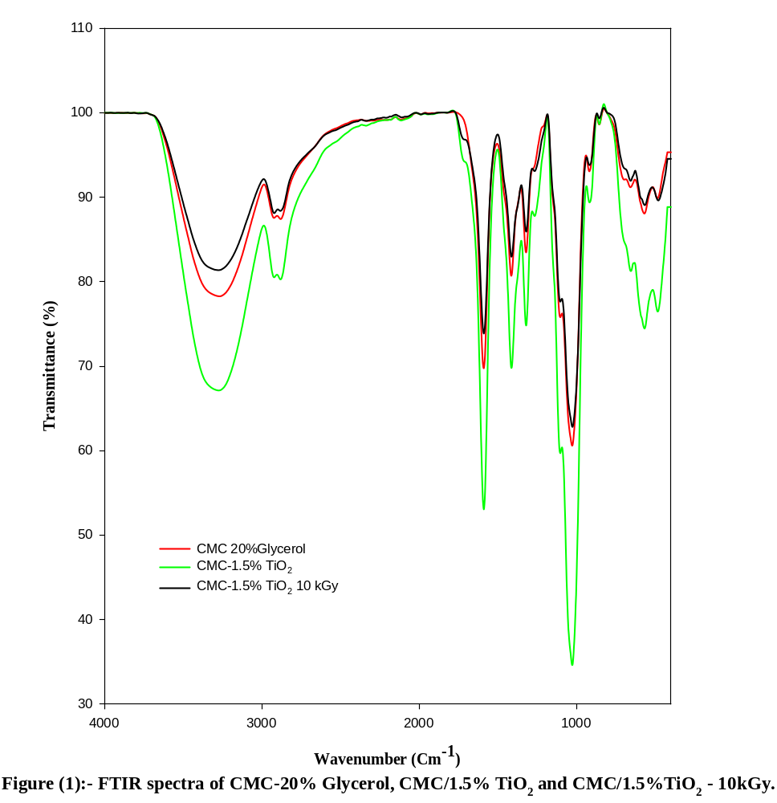

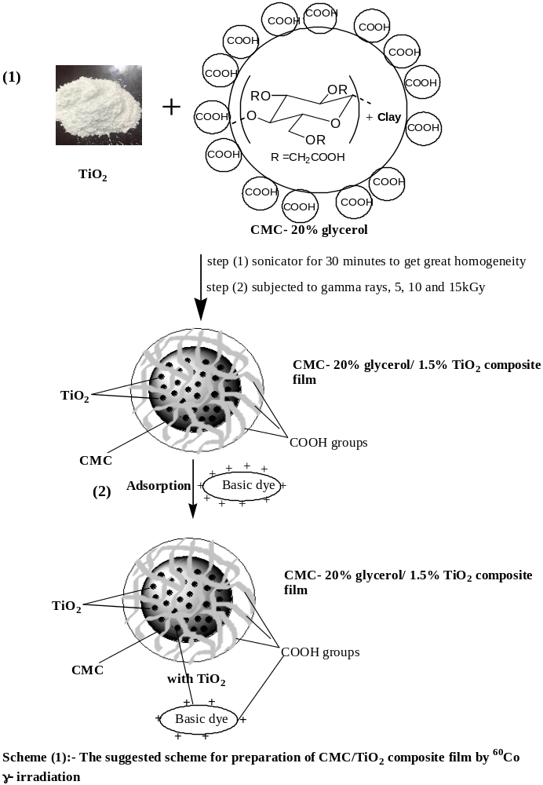
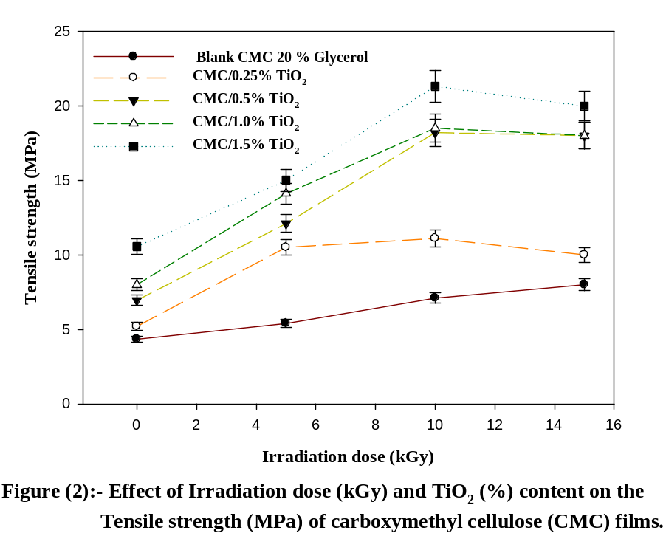

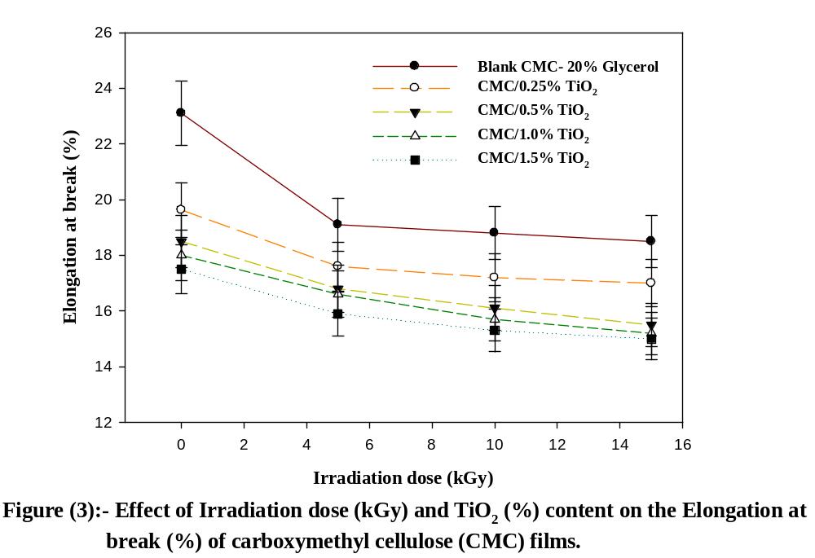

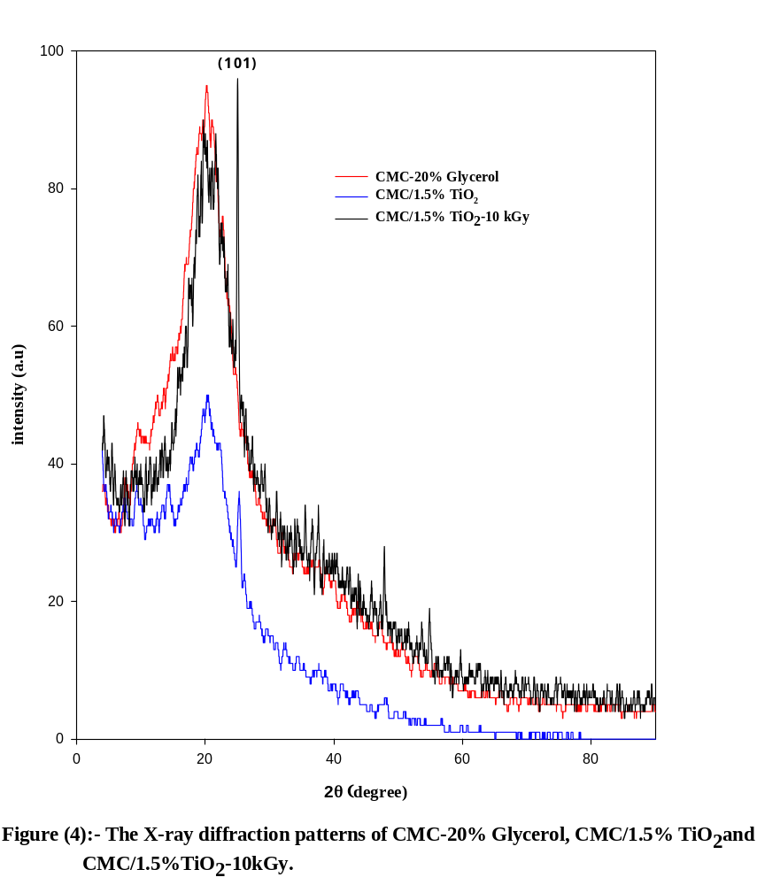

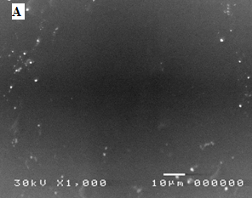 | 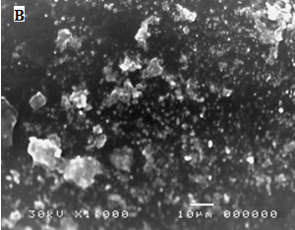
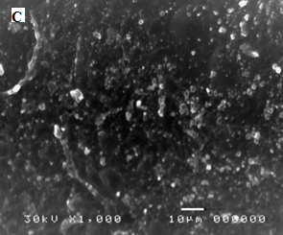
Figure (5):- SEM of CMC films:(a) CMC-20% Glycerol, (b) CMC/1.5%TiO₂ and (c) CMC/1.5%TiO₂ - 10kGy.

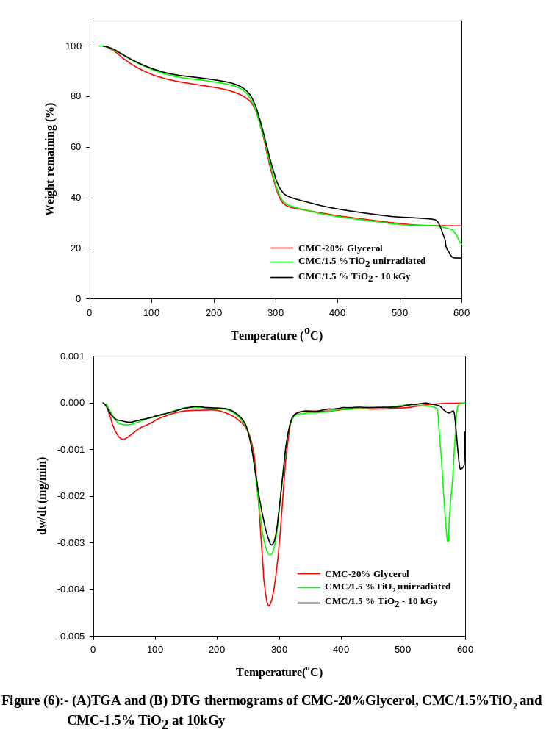
Table (1):- The weight loss (%) of different prepared samples
Sample | Dose  (kGy) | Weight Loss (%) |  |  |  |  | T_{max}
Sample | Dose  (kGy) | 100 ºC | 200 ºC | 300 ºC | 400ºC | 500ºC | T_{max}
PLSTCMC | 0 | 12 | 17 | 56.6 | 67.6 | 70.4 | 284.4
PLSTCMC/TiO₂ | 0 | 9.4 | 14.3 | 54.2 | 67.8 | 70.2 | 287.5
PLSTCMC/TiO₂(10 kGy) | 10 | 9.1 | 13.9 | 53.7 | 64.5 | 67.4 | 289.9

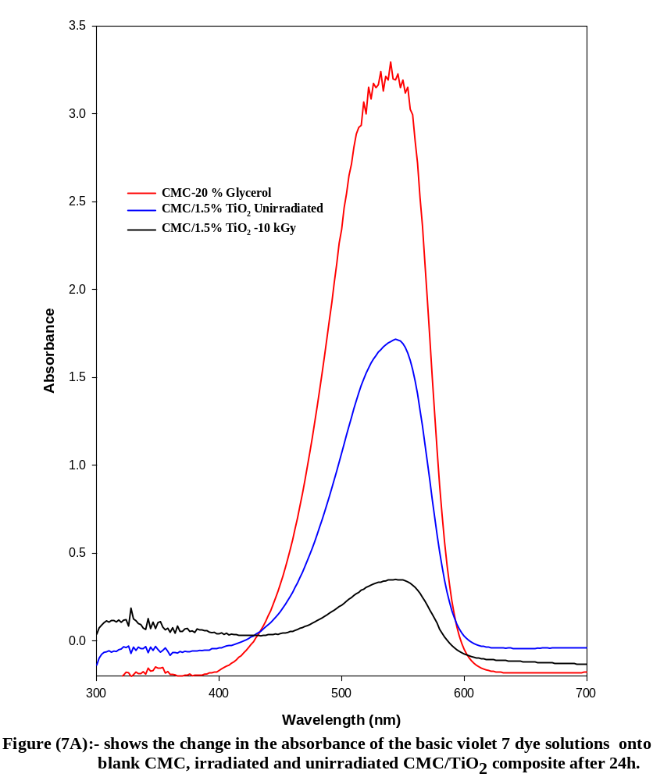
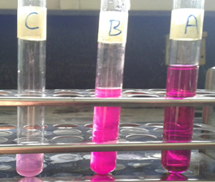
Figure (7b):- Effect of adsorbent type[ (A) pure CMC, (B) Unirradiated CMC/TiO₂ and (C) CMC/1.5% TiO₂-10 kGy] on the removal of the basic violet dye after 24h.

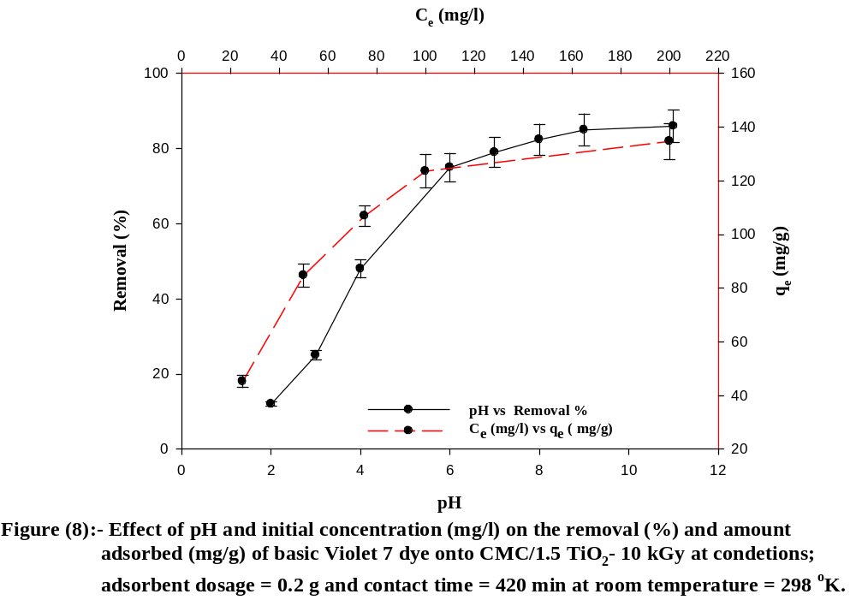
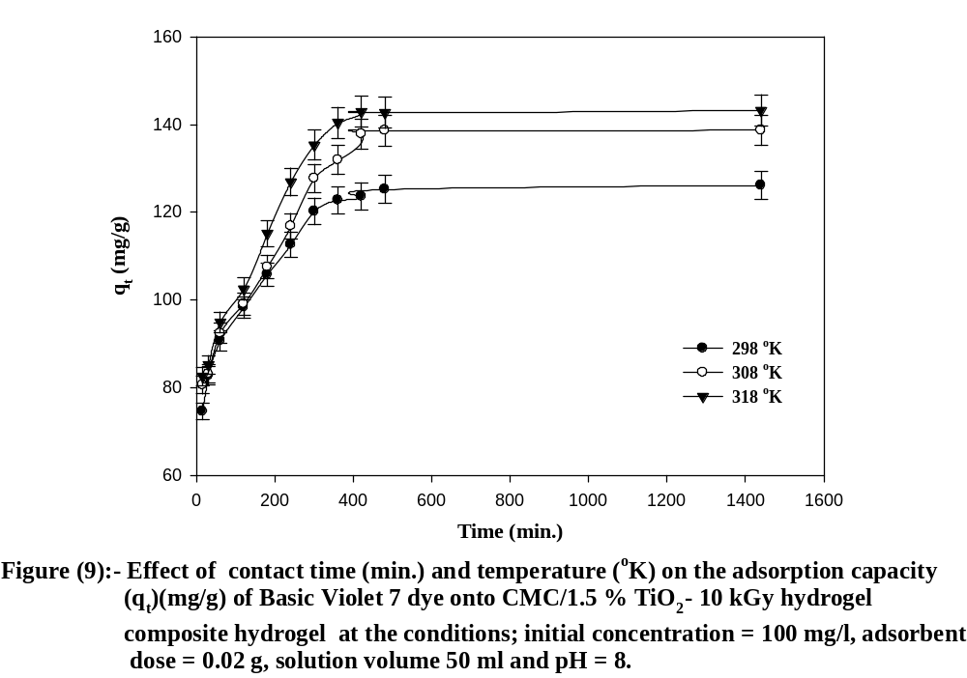
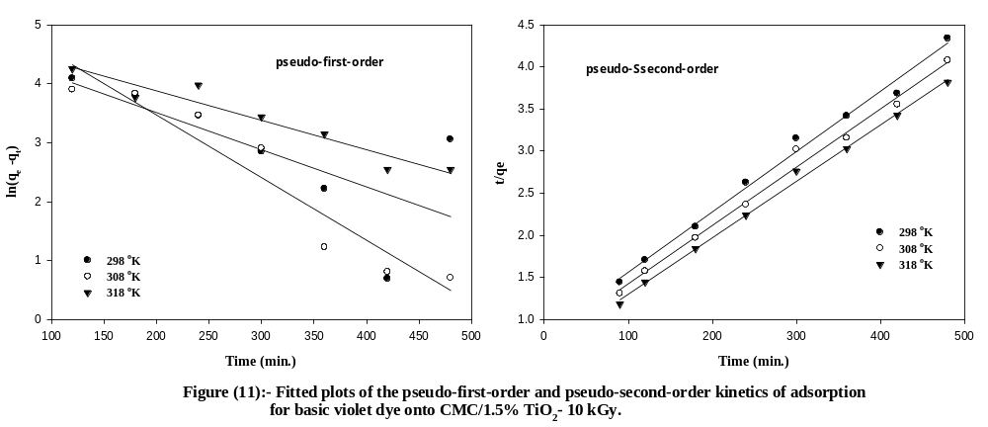

Table (2):- Parameters fitted from the Langmuir and Freundlich isotherm models, the pseudo-first order and pseudo-second order for the adsorption of basic violet 7 dye onto irradiated CMC/1.5% TiO₂ hydrogel composite

Model | Parameters | Temperature (ºK)
 |  | 298 (ºK) | 308 (ºK) | 318 (ºK)
Langmuir | R² | 0.9962 | 0.9969 | 0.9972
Langmuir | q_{e, exp} (mg/g) | 123.6 | 137.8 | 142.9
Langmuir | q_{e, cal} (mg/g) | 137.6 | 112.2 | 101.4
Langmuir | K_{L} (mg/g) | 0.012 | 0.018 | 0.023
Freundlich | R² | 0.7173 | 0.6268 | 0.6878
Freundlich | 1/n | 0.653 | 0.416 | 0.386
Freundlich | K_{F} (L/g) | 3.53 | 22.47 | 24.31
The pseudo-first order | R² | 0.5049 | 0.9141 | 0.9256
The pseudo-first order | K₁ x10⁻² | 0.0145 | 0.0245 | 0.0115
The pseudo-first order | q_{e, cal} (mg/g) | 57.8 | 89.6 | 193.6
The pseudo-second order | R² | 0.9911 | 0.9971 | 0.9909
The pseudo-second order | K₂ x10⁻³ (g/mg.min.) | 0.413 | 0.303 | 0.198
The pseudo-second order | q_{e, cal} (mg/g) | 129.8 | 179.8 | 148.9

