Online Supplementary Data

Supplementary Table S1: Search strategy
Supplementary Table S2: Baseline characteristics of the included studies
Supplementary Table S3: Risk of Bias in Randomized Controlled Trials
Supplementary Table S4: Risk of Bias in Non-randomized Studies
Supplementary Figure S1: Forest plot showing results of Factor Xa inhibitors vs LMWH on recurrence of DVT
Supplementary Figure S2: Forest plot showing results of Factor Xa inhibitors vs LMWH on recurrence of PE
Supplementary Figure S3: Forest plot showing results of Factor Xa inhibitors vs LMWH on clinically relevant non-major bleeding events
Supplementary Figure S4: Forest plot showing results of Factor Xa inhibitors vs LMWH on major bleeding events
Supplementary Figure S5: Forest plot showing results of Factor Xa inhibitors vs LMWH on bleeding-related mortality events
Supplementary Figure S6: Forest plot showing results of Factor Xa inhibitors vs LMWH on overall bleeding events in GI malignancies
Supplementary Figure S7: Forest plot showing results of Factor Xa inhibitors vs LMWH on clinically relevant non-major bleeding events in GI malignancies
Supplementary Figure S8: Forest plot showing results of Factor Xa inhibitors vs LMWH on major bleeding events in GI malignancies

Supplementary Table S1: Search strategy
Medline:

(("Xa"[All Fields] AND ("antagonists and inhibitors"[MeSH Subheading] OR ("antagonists"[All Fields] AND "inhibitors"[All Fields]) OR "antagonists and inhibitors"[All Fields] OR "inhibitors"[All Fields] OR "inhibitor"[All Fields] OR "inhibitor s"[All Fields])) OR ("apixaban"[Supplementary Concept] OR "apixaban"[All Fields] OR "apixaban s"[All Fields]) OR ("rivaroxaban"[MeSH Terms] OR "rivaroxaban"[All Fields])) AND ("heparin, low molecular weight"[MeSH Terms] OR ("heparin"[All Fields] AND "low molecular weight"[All Fields]) OR "low-molecular-weight heparin"[All Fields] OR ("low"[All Fields] AND "molecular"[All Fields] AND "weight"[All Fields] AND "heparin"[All Fields]) OR "low molecular weight heparin"[All Fields]) AND ("bleedings"[All Fields] OR "hemorrhage"[MeSH Terms] OR "hemorrhage"[All Fields] OR "bleed"[All Fields] OR "bleeding"[All Fields] OR "bleeds"[All Fields] OR (("major"[All Fields] OR "majored"[All Fields] OR "majoring"[All Fields] OR "majorities"[All Fields] OR "majority"[All Fields] OR "majors"[All Fields]) AND ("bleedings"[All Fields] OR "hemorrhage"[MeSH Terms] OR "hemorrhage"[All Fields] OR "bleed"[All Fields] OR "bleeding"[All Fields] OR "bleeds"[All Fields])) OR ("non"[All Fields] AND ("major"[All Fields] OR "majored"[All Fields] OR "majoring"[All Fields] OR "majorities"[All Fields] OR "majority"[All Fields] OR "majors"[All Fields]) AND ("bleedings"[All Fields] OR "hemorrhage"[MeSH Terms] OR "hemorrhage"[All Fields] OR "bleed"[All Fields] OR "bleeding"[All Fields] OR "bleeds"[All Fields])) OR (("recurrance"[All Fields] OR "recurrence"[MeSH Terms] OR "recurrence"[All Fields] OR "recurrences"[All Fields] OR "recurrencies"[All Fields] OR "recurrency"[All Fields] OR "recurrent"[All Fields] OR "recurrently"[All Fields] OR "recurrents"[All Fields]) AND ("venous thromboembolism"[MeSH Terms] OR ("venous"[All Fields] AND "thromboembolism"[All Fields]) OR "venous thromboembolism"[All Fields])) OR (("recurrance"[All Fields] OR "recurrence"[MeSH Terms] OR "recurrence"[All Fields] OR "recurrences"[All Fields] OR "recurrencies"[All Fields] OR "recurrency"[All Fields] OR "recurrent"[All Fields] OR "recurrently"[All Fields] OR "recurrents"[All Fields]) AND ("pulmonary embolism"[MeSH Terms] OR ("pulmonary"[All Fields] AND "embolism"[All Fields]) OR "pulmonary embolism"[All Fields])) OR (("recurrance"[All Fields] OR "recurrence"[MeSH Terms] OR "recurrence"[All Fields] OR "recurrences"[All Fields] OR "recurrencies"[All Fields] OR "recurrency"[All Fields] OR "recurrent"[All Fields] OR "recurrently"[All Fields] OR "recurrents"[All Fields]) AND ("venous thrombosis"[MeSH Terms] OR ("venous"[All Fields] AND "thrombosis"[All Fields]) OR "venous thrombosis"[All Fields] OR ("deep"[All Fields] AND "venous"[All Fields] AND "thrombosis"[All Fields]) OR "deep venous thrombosis"[All Fields])) OR ("mortality"[MeSH Terms] OR "mortality"[All Fields] OR "mortalities"[All Fields] OR "mortality"[MeSH Subheading]) OR (("adverse"[All Fields] OR "adversely"[All Fields] OR "adverses"[All Fields]) AND ("outcome"[All Fields] OR "outcomes"[All Fields])) OR ("safety"[MeSH Terms] OR "safety"[All Fields] OR "safeties"[All Fields]) OR ("efficacies"[All Fields] OR "efficacious"[All Fields] OR "efficaciously"[All Fields] OR "efficaciousness"[All Fields] OR "efficacy"[All Fields]))
Number of results: 1430

Scopus:

( ( xa AND inhibitors OR apixaban OR rivaroxaban ) AND ( low AND molecular AND weight AND heparin ) AND ( bleeding OR major AND bleeding OR non AND major AND bleeding OR recurrent AND venous AND thromboembolism OR recurrent AND pulmonary AND embolism OR recurrent AND deep AND venous AND thrombosis OR mortality OR adverse AND outcome OR safety OR efficacy ) )

Number of results: 91

Supplementary Table S2: Baseline characteristics of the included studies

Author | Country | Study duration | Study design | Cancer type | Drug | Age (mean ± SD) | Total sample (N) | Females (N)
Alzghari et al. 2018 (1) | USA | Jun 2013- Sep 2015 | Retrospective, Single center | Mixed | NOAC | 62±13.8 | 48 | 24
 |  |  |  |  | LMWH | 62.4±13.9 | 23 | 14
Simmons et al. 2018 (2) | USA | Jan 2013- Jul 2017 | Retrospective, single center | Mixed | NOAC | 62.6 ±12.1 | 98 | 50
 |  |  |  |  | LMWH | 62.0 ±14.7 | 168 | 58
Nicklaus et al. 2018 (3) | USA | Jan 2012- Aug 2015 | Retrospective, Single center | Mixed | NOAC | 57.9 | 45 | 26
 |  |  |  |  | LMWH | 59.4 | 45 | 25
Chaudhury et al. 2018 (4) | USA | May 2010 - Jun 2015 | Retrospective, Single center | Mixed | NOAC | 62.20 ± 12.34 | 107 | 51
 |  |  |  |  | LMWH | 59.31 ± 12.02 | 179 | 88
Streiff et al. 2018 (5) | USA | Jan 2007- Jun 2015 | Retrospective | Mixed | NOAC | 72.7 ±8.8 | 685 | 353
 |  |  |  |  | LMWH | 72.6 ±10.8 | 682 | 351
Young et al. 2018 (6) | UK | Follow-up of 24 months | Randomized, open-label, multicenter trial | Mixed | NOAC | 67 (Median) | 203 | 87
 |  |  |  |  |  | 22-87 (Range) | 203 | 87
 |  |  |  |  | LMWH | 67 (Median) | 203 | 105
 |  |  |  |  |  | 34-87 (Range) | 203 | 105
Raskob et al. 2018 (7) | Japan | Jul 2015- Dec 2016 | randomized, | Mixed | NOAC | 64.3±11.0 | 522 | 245
Raskob et al. 2018 (7) | Japan | Jul 2015- Dec 2016 | open-label trial | Mixed | LMWH | 63.7±11.7 | 524 | 261
Signorelli et al. 2019 (8) | USA | July 2013- Jun 2015 | Retrospective, | GYN | NOAC | 60.4±13.1 | 18 | N/A
Signorelli et al. 2019 (8) | USA | July 2013- Jun 2015 | Single center
Signorelli et al. 2019 (8) | USA | July 2013- Jun 2015 |  | GYN | LMWH | 60.4±12.7 | 26 | N/A
Lee et al. 2019 (9) | South Korea | Jan 2012- Dec 2016 | Retrospective, Single center | Lung | NOAC | 66.79±11.32 | 78 | 52
 |  |  |  |  | LMWH | 64.25±8.66 | 203 | 30
Recio-Boiles et al. 2019 (10) | USA | Nov 2013- Feb 2017 | Retrospective, Single center | GIT | NOAC | 68 (37-83)* | 66 | 25
 |  |  |  |  | LMWH | 66 (40-80)* | 40 | 22
McBane et al. 2020 (11) | USA | Nov 2015- Oct 2017 | Multicenter, randomized, open-label trial | Mixed | NOAC | 64.4 (11.3) | 145 | 78
 |  |  |  |  | LMWH | 64.0 (10.8) | 142 | 77
Agnelli et al. 2020 (12) | Nine European countries, Israel and USA | Apr 2017- Jun 2019 | Randomized, controlled, open label, noninferiority trial | Mixed | NOAC | 67.2±11.3 | 576 | 284
 |  |  |  |  | LMWH | 67.2±10.9 | 579 | 303
Lee et al. 2020 (13) | South Korea | Jan 2012- Dec 2016 | Retrospective, Single center | GIT | NOAC | 66.5 ± 11.6 | 131 | 39
 |  |  |  |  | LMWH | 63.6 ± 11.1 | 73 | 82
Lee et al. 2020 (2) (14) | South Korea | Jan 2012- Dec 2016 | Retrospective, Single center | GYN | NOAC | 56.90±12.32 | 102 | N/A
 |  |  |  |  | LMWH | 56.27±10.34 | 60 | N/A
Kim et al. 2020 (15) | Korea | Jan 2004- Dec 2014 | Retrospective, Single center | GIT | NOAC | 67 (59-72)* | 69 | 23
 |  |  |  |  | LMWH | 59 (52-66)* | 105 | 58
Yi-chen et al. 2021 (16) | Taiwan | January 1, 2012, to January 31, 2019 | Retrospective, Single center | Mixed | NOAC | 67.7 (13.3) | 529 | 283
 |  |  |  |  | LMWH | 64.6 (12.4) | 580 | 295
Houghton et al. 2021 (17) | USA | March 1, 2013, and April 20, 2020 | Prospective, single center | Mixed | NOAC | 64.8 (12.1) | 474 | 229
 |  |  |  |  | LMWH | 62.4 (11.9) | 494 | 204
Cohen et al. 2021 (18) | USA | March 01, 2014–March 31, 2018 | Retrospective | Mixed | NOAC | 64.6 (12.6) | 3393 | 1772
 |  |  |  |  | LMWH | 63.7 (13.2) | 6108 | 3237
Planquette et al. 2021 (19) | France | Follow-up for 3 months | noninferiority, open-label, randomized clinical trial | Mixed | NOAC | 68.6 | 74 | 37
 |  |  |  |  |  | (Median) | 74 | 37
 |  |  |  |  |  | 62.9-77.8 | 74 | 37
 |  |  |  |  |  | (Range) | 74 | 37
 |  |  |  |  | LMWH | 70.7 | 84 | 44
 |  |  |  |  |  | (Median) | 84 | 44
 |  |  |  |  |  | 62.7–78.7 | 84 | 44
 |  |  |  |  |  | (Range) | 84 | 44
Mokadem et al. 2021 (20) | Egypt | Follow-up of 6 months | Single center, randomized controlled trial | Mixed | NOAC | 61.26 ± 11.23 | 50 | 30
 |  |  |  |  | LMWH | 59.94±9.71 | 50 | 28

*mean (range)

Supplementary Table S3: Risk of Bias in Randomized Controlled Trials
Study name | D1 | D2 | D3 | D4 | D5 | Overall
Raskob et al. 2018 | U | L | L | L | L | L
Young et al. 2018 | U | L | L | L | L | L
Agnelli et al. 2020 | L | L | L | L | L | L
McBane et al. 2020 | L | L | L | L | L | L
Planquette et al. 2021 | L | L | L | L | L | L
Mokadem et al. 2021 | L | L | L | L | L | L

L: Low risk
U: Unclear risk
H: High risk

Domains:
D1: Bias arising from randomization process
D2: Bias due to deviations from intended interventions
D3: Bias due to missing outcome data
D4: Bias in measurement of outcome
D5: Bias in selection of reported results

Supplementary Table S4: Risk of Bias in Non-randomized Studies
Study name | D1 | D2 | D3 | D4 | D5 | D6 | D7 | Overall
Alzghari et al. 2018 | - | + | - | + | ? | X | - | X
Chaudhury et al. 2018 | - | ? | + | ? | - | + | - | -
Nicklaus et al. 2018 | - | - | + | ? | - | + | X | X
Simmons et al. 2018 | - | - | - | + | + | + | + | -
Streiff et al. 2018 | - | + | X | + | + | - | X | X
Recio-Boiles et al. 2019 | - | + | + | - | + | + | + | -
Signorelli et al. 2019 | - | + | - | X | X | + | X | X
Lee et al. 2019 | - | + | - | ? | + | + | + | -
Kim et al. 2020 | - | + | + | - | + | + | - | -
Lee et al. 2020 | - | + | - | + | + | + | + | -
Lee et al. 2020 (2) | - | + | - | ? | + | + | + | -
Cohen et al. 2021 | - | + | + | ? | + | + | + | +
Yi-Chen et al. 2021 | - | - | ? | - | + | ? | - | +
Houghton et al. 2021 | - | + | + | ? | + | ? | - | +

!: Critical
X: Serious
-: Moderate
+: Low
?: No information

Domains:
D1: Bias due to confounding
D2: Bias due to selection of participants
D3: Bias in classification of intervals
D4: Bias due to deviation from intended intervals
D5: Bias due to missing data
D6: Bias in measurement of outcomes
D7: Bias in selection of reported results

Supplementary Figure S1: Forest plot showing results of Factor Xa inhibitors vs LMWH on recurrence of DVT
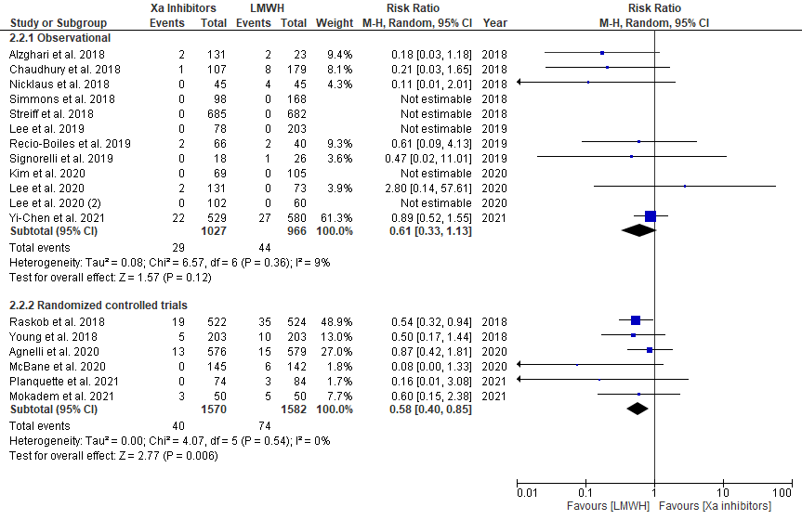

Supplementary Figure S2: Forest plot showing results of Factor Xa inhibitors vs LMWH on recurrence of PE
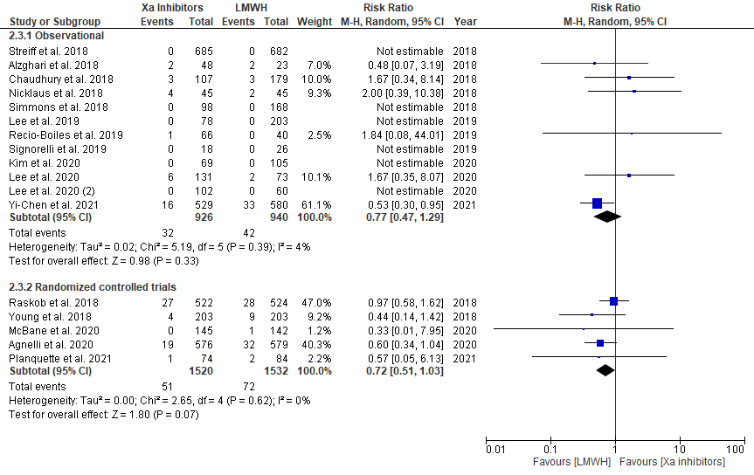

Supplementary Figure S3: Forest plot showing results of Factor Xa inhibitors vs LMWH on clinically relevant non-major bleeding events
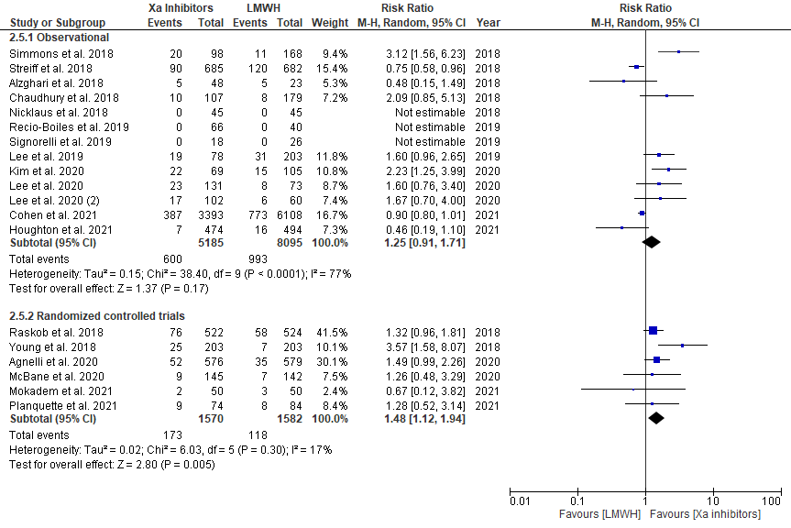

Supplementary Figure S4: Forest plot showing results of Factor Xa inhibitors vs LMWH on major bleeding events
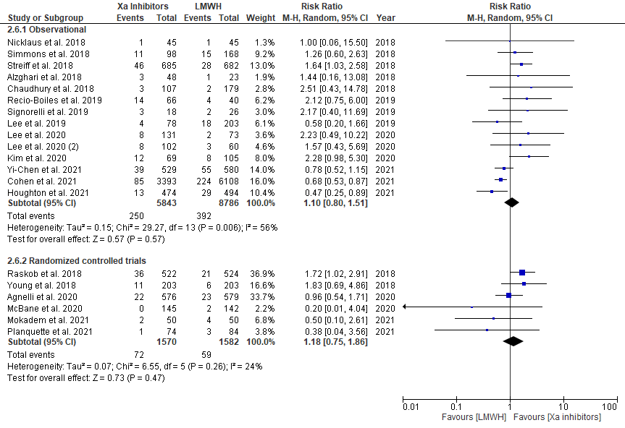

Supplementary Figure S5: Forest plot showing results of Factor Xa inhibitors vs LMWH on bleeding-related mortality events
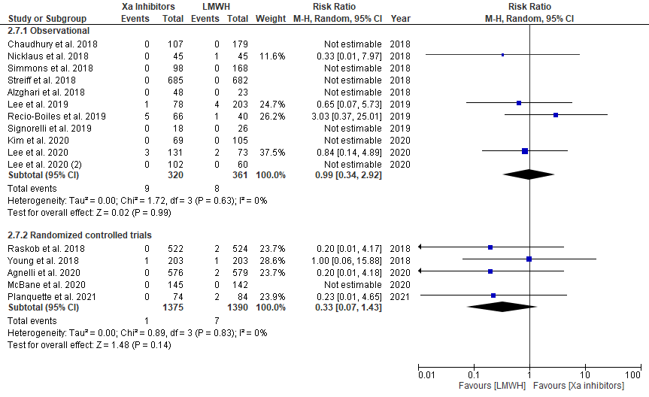

Supplementary Figure S6: Forest plot showing results of Factor Xa inhibitors vs LMWH on overall bleeding events in GI malignancies
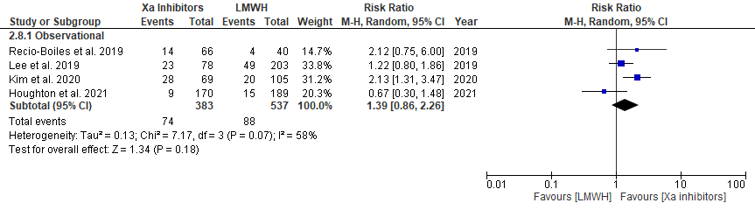

Supplementary Figure S7: Forest plot showing results of Factor Xa inhibitors vs LMWH on clinically relevant non-major bleeding events in GI malignancies
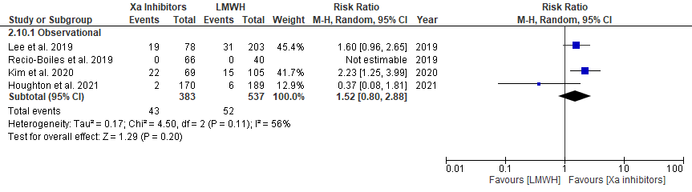

Supplementary Figure S8: Forest plot showing results of Factor Xa inhibitors vs LMWH on major bleeding events in GI malignancies
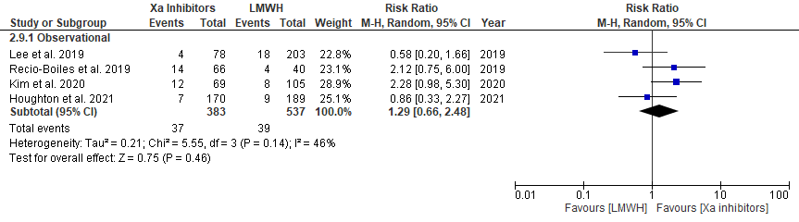

References:
1. Alzghari SK, Seago SE, Garza JE, Hashimie YF, Baty KA, Evans MF, Shaver C, Herrington JD. Retrospective comparison of low molecular weight heparin vs. warfarin vs. oral Xa inhibitors for the prevention of recurrent venous thromboembolism in oncology patients: The Re-CLOT study. Journal of Oncology Pharmacy Practice. 2018 Oct;24(7):494-500.
2. Simmons B, Wysokinski W, Saadiq RA, Bott‐Kitslaar D, Henkin S, Casanegra A, Lenz C, Daniels P, Bjarnason H, Vargas E, Hodge D. Efficacy and safety of rivaroxaban compared to enoxaparin in treatment of cancer‐associated venous thromboembolism. European journal of haematology. 2018 Aug;101(2):136-42.
3. Nicklaus MD, Ludwig SL, Kettle JK. Recurrence of malignancy-associated venous thromboembolism among patients treated with rivaroxaban compared to enoxaparin. Journal of Oncology Pharmacy Practice. 2018 Apr;24(3):185-9.
4. Chaudhury A, Balakrishnan A, Thai C, Holmstrom B, Nanjappa S, Ma Z, Jaglal MV. The efficacy and safety of rivaroxaban and dalteparin in the treatment of cancer associated venous thrombosis. Indian Journal of Hematology and Blood Transfusion. 2018 Jul;34(3):530-4.
5. Streiff MB, Milentijevic D, McCrae K, Yannicelli D, Fortier J, Nelson WW, Laliberté F, Crivera C, Lefebvre P, Schein J, Khorana AA. Effectiveness and safety of anticoagulants for the treatment of venous thromboembolism in patients with cancer. American journal of hematology. 2018 May;93(5):664-71.
6. Young AM, Marshall A, Thirlwall J, Chapman O, Lokare A, Hill C, Hale D, Dunn JA, Lyman GH, Hutchinson C, MacCallum P. Comparison of an oral factor Xa inhibitor with low molecular weight heparin in patients with cancer with venous thromboembolism: results of a randomized trial (SELECT-D). J Clin Oncol. 2018 Jul 10.
7. Raskob GE, van Es N, Verhamme P, Carrier M, Di Nisio M, Garcia D, Grosso MA, Kakkar AK, Kovacs MJ, Mercuri MF, Meyer G. Edoxaban for the treatment of cancer-associated venous thromboembolism. New England Journal of Medicine. 2018 Feb 15;378(7):615-24.
8. Signorelli JR, Gandhi AS. Evaluation of rivaroxaban use in patients with gynecologic malignancies at an academic medical center: a pilot study. Journal of Oncology Pharmacy Practice. 2019 Mar;25(2):362-8.
9. Lee JH, Hyun DG, Choi CM, Lee JC, Kim WS, Oh YM, Lee SD, Lee JS. A retrospective study on efficacy and safety of rivaroxaban and dalteparin for long-term treatment of venous thromboembolism in patients with lung cancer. Respiration. 2019;98(3):203-11.
10. Recio-Boiles A, Veeravelli S, Vondrak J, Babiker HM, Scott AJ, Shroff RT, Patel H, Elquza E, McBride A. Evaluation of the safety and effectiveness of direct oral anticoagulants and low molecular weight heparin in gastrointestinal cancer-associated venous thromboembolism. World Journal of Gastrointestinal Oncology. 2019 Oct 15;11(10):866.
11. McBane II. R, Wysokinski WE, Le-Rademacher JG, Zemla T, Ashrani A, Tafur A, et al. Apixaban and dalteparin in active malignancy associated venous thromboembolism: the ADAM VTE trial. J Thromb Haemost. 2020;18(411):e21.
12. Agnelli G, Becattini C, Meyer G, Muñoz A, Huisman MV, Connors JM, Cohen A, Bauersachs R, Brenner B, Torbicki A, Sueiro MR. Apixaban for the treatment of venous thromboembolism associated with cancer. New England Journal of Medicine. 2020 Mar 29.
13. Lee JH, Oh YM, Lee SD, Lee JS. Rivaroxaban versus low-molecular-weight heparin for venous thromboembolism in gastrointestinal and pancreatobiliary cancer. Journal of Korean Medical Science. 2019 Jun 3;34(21).
14. Lee JH, Lee JH, Jo KW, Huh JW, Oh YM, Lee JS. Comparison of rivaroxaban and dalteparin for the long-term treatment of venous thromboembolism in patients with gynecologic cancers. Journal of Gynecologic Oncology. 2020 Jan 1;31(1).
15. Kim JH, Seo S, Kim KP, Chang HM, Ryoo BY, Yoo C, Jeong JH, Lee JL, Im HS, Jeong H, Bang Y. Rivaroxaban versus low-molecular-weight heparin for venous thromboembolism in advanced upper gastrointestinal tract and hepatopancreatobiliary cancer. in vivo. 2020 Mar 1;34(2):829-37.
16. Chen DY, Tseng CN, Hsieh MJ, Lan WC, Chuang CK, Pang ST, Chen SW, Chen TH, Chang SH, Hsieh IC, Chu PH. Comparison Between Non–vitamin K Antagonist Oral Anticoagulants and Low-Molecular-Weight Heparin in Asian Individuals With Cancer-Associated Venous Thromboembolism. JAMA network open. 2021 Feb 1;4(2):e2036304-.
17. Houghton DE, Vlazny DT, Casanegra AI, Brunton N, Froehling DA, Meverden RA, Hodge DO, Peterson LG, McBane RD, Wysokinski WE. Bleeding in patients with gastrointestinal cancer compared with nongastrointestinal cancer treated with apixaban, rivaroxaban, or enoxaparin for acute venous thromboembolism. InMayo Clinic Proceedings 2021 Nov 1 (Vol. 96, No. 11, pp. 2793-2805). Elsevier.
18. Cohen A, Keshishian A, Lee T, Wygant G, Rosenblatt L, Hlavacek P, Mardekian J, Wiederkehr D, Sah J, Luo X. Effectiveness and safety of apixaban, low-molecular-weight heparin, and warfarin among venous thromboembolism patients with active cancer: a US claims data analysis. Thrombosis and haemostasis. 2021 Mar;121(03):383-95.
19. Planquette B, Bertoletti L, Charles-Nelson A, Laporte S, Grange C, Mahé I, Pernod G, Elias A, Couturaud F, Falvo N, Sevestre MA. Rivaroxaban vs dalteparin in cancer-associated thromboembolism: A randomized trial. Chest. 2021 Oct 8.
20. Mokadem ME, Hassan A, Algaby AZ. Efficacy and safety of apixaban in patients with active malignancy and acute deep venous thrombosis. Vascular. 2021 Oct;29(5):745-50.

