Supplementary Figure 1
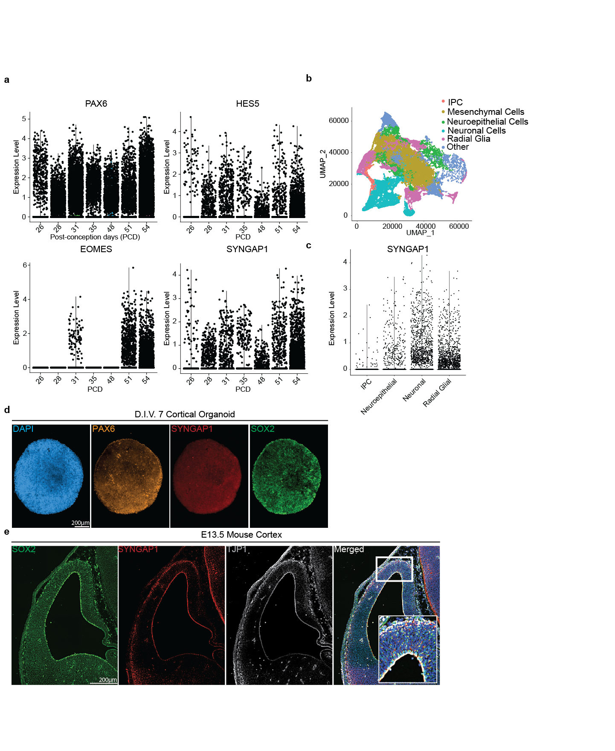

Supplementary Figure 1
- Expression of early forebrain marker genes of PAX6, HES5, EOMES (TBR2) and SYNGAP1 from post-conception day (PCD) 26 to 54 from single cell RNA-seq data.
- UMAP visualization of age-dependent clustering of fetal single cells.
- SYNGAP1 expression at PCD 56 grouped by cell types; intermediate progenitor cells (IPC), neuroepithelial cells (NE), radial glial cells (RGCs) and neurons.
- D.I.V. 7 cortical organoids are composed of cells positive for the neural stem cell marker SOX2, the radial glial progenitor marker PAX6, and SYNGAP1.
- A coronal section from E13.5 mouse brain showing expression of the neural stem cell marker SOX2, the tight junction protein TJP1, and SYNGAP1. SYNGAP1 is highly expressed at the ventricular wall. White box indicates the Region of Interest selected for the merged images showing colocalization of DAPI, TJP1, and SYNGAP1.

Supplementary Figure 2
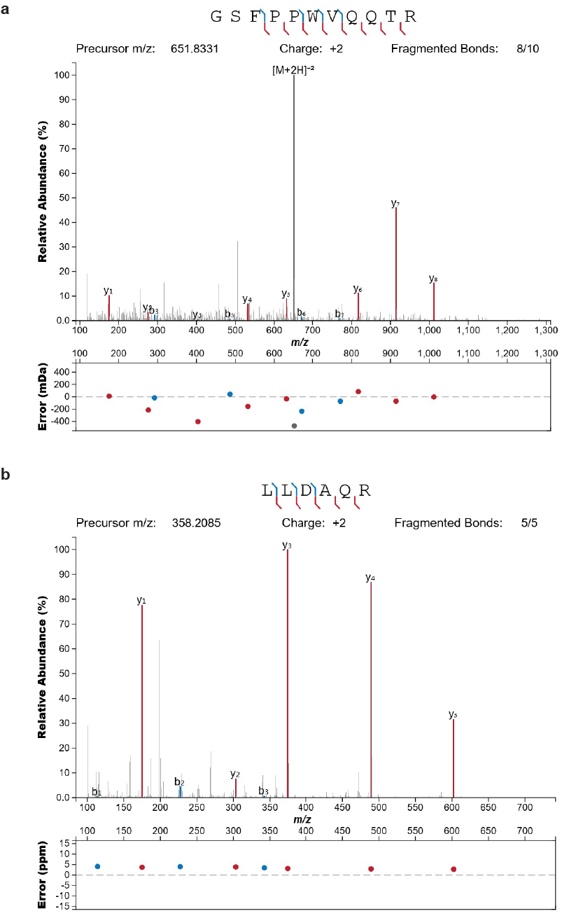

Supplementary Figure 2
- Annotated spectra of the SYNGAP1 isoform alpha 1 specific peptide “GSFPPWQQTR” identified from MS analysis of immune-isolated SYNGAP1 protein from D.I.V. 7 organoids.
- Annotated spectra of the SYNGAP1 isoform alpha 1 specific peptide “LLDAQR” identified from MS analysis of immune-isolated SYNGAP1 protein from D.I.V. 7 organoids.

Supplementary Figure 3
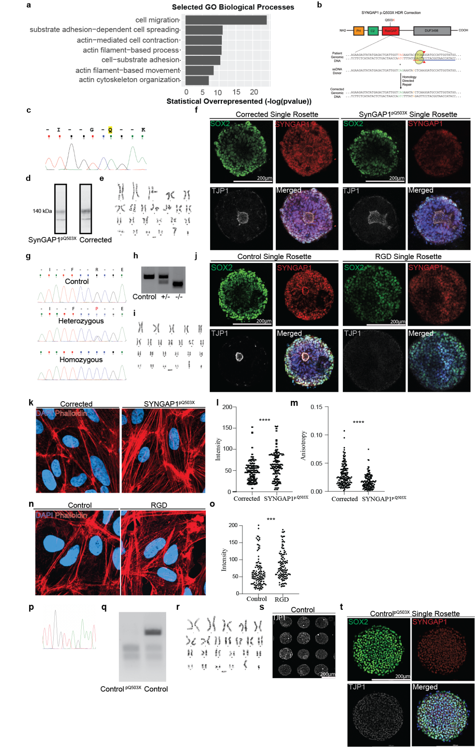

Supplementary Figure 3
- Selected GO terms for biological processes for SYNGAP1 immunoprecipitation data collected from D.I.V. 7 cortical organoids.
- Schematic of line generation details for isogenic control of SYNGAP1^{p.Q503X}.
- Chromatogram of the generated corrected line.
- Western blot for SYNGAP1 in SYNGAP1^{p.Q503X} and corrected line.
- Corrected line with normal karyotype.
- A single rosette generated from corrected and SYNGAP1^{p.Q503X} iPSCs. Both rosettes are composed of cells positive for the neural progenitor marker Sox2 and SYNGAP1. SYNGAP1 is also highly expressed at the apical wall of the lumen. The tight junction protein TJP1 labels the central luminal space of the rosette. Merged images show colocalization of DAPI, SYNGAP1, and TJP1. The TJP1 positive area is often larger and more irregularly shaped as compared to controls.
- Chromatogram of the RasGap Dead-line (RGD) (-/-), Control (+/+) and Heterozygous lines (+/-).
- Western blot for SYNGAP1 in RGD(-/-), Control (+/+) and Heterozygous lines (+/-).
- RGD line with normal karyotype.
- A single rosette generated from control and RGD iPSCs. Both rosettes are composed of cells positive for the neural progenitor marker Sox2 and SYNGAP1. In control rosettes, SYNGAP1 is also highly expressed at the apical wall of the lumen and the tight junction protein TJP1 labels the central luminal space of the rosette. Merged image shows colocalization of DAPI, SYNGAP1, and TJP1. However, in the RGD rosette there is no defined central luminal space and therefore no specific TJP1 labeling.
- 2D human radial glial progenitor cells after being dissociated from corrected and SYNGAP1^{p.Q503X} D.I.V. 7 organoids. Cells are stained with phalloidin to label actin filaments and DAPI to label nuclei.
- Quantification of fluorescent intensity of the phalloidin staining. SYNGAP1p.Q503X cells exhibit higher levels of fluorescent intensity for phalloidin staining, indicating a greater abundance of actin filaments. Unpaired t-test was performed on a total of 211 cells for each condition from 3 independent experiments. P value <0.0001.
- Quantification of the anisotropy, or organization, of the actin filaments. SYNGAP1p.Q503X cells display lower levels of anisotropy, indicating decreased organization of the actin filaments. Unpaired t-test was performed on a total of 202 cells for each condition from 3 independent experiments. P value <0.0001.
- 2D human radial glial progenitor cells after being dissociated from control and RGD D.I.V. 7 organoids. Cells are stained with phalloidin to label actin filaments and DAPI to label nuclei.
- Quantification of fluorescent intensity of the phalloidin staining. RGD cells exhibit higher levels of fluorescent intensity for phalloidin staining indicating a greater abundance of actin filaments. Unpaired t-test was performed on a total of 125 cells for each condition from 3 independent experiments. P value <0.0002.
- Chromatogram of the Control p.Q503X line.
- Western blot for SYNGAP1 in Control p.Q503X and Control line.
- Control p.Q503X line with normal karyotype.
- Array of single rosettes generated from the SYNGAP1p.Q503X line and labeled with TJP1 staining.
- A single rosette generated from Control p.Q503X iPSCs. The rosette is composed of cells positive for the neural progenitor marker Sox2 and SYNGAP1. SYNGAP1 is highly expressed at the apical wall of the lumen, and the tight junction protein TJP1 labels the central luminal space of the rosette. Merged image shows colocalization of DAPI, SYNGAP1, and TJP1.

Supplementary Figure 4

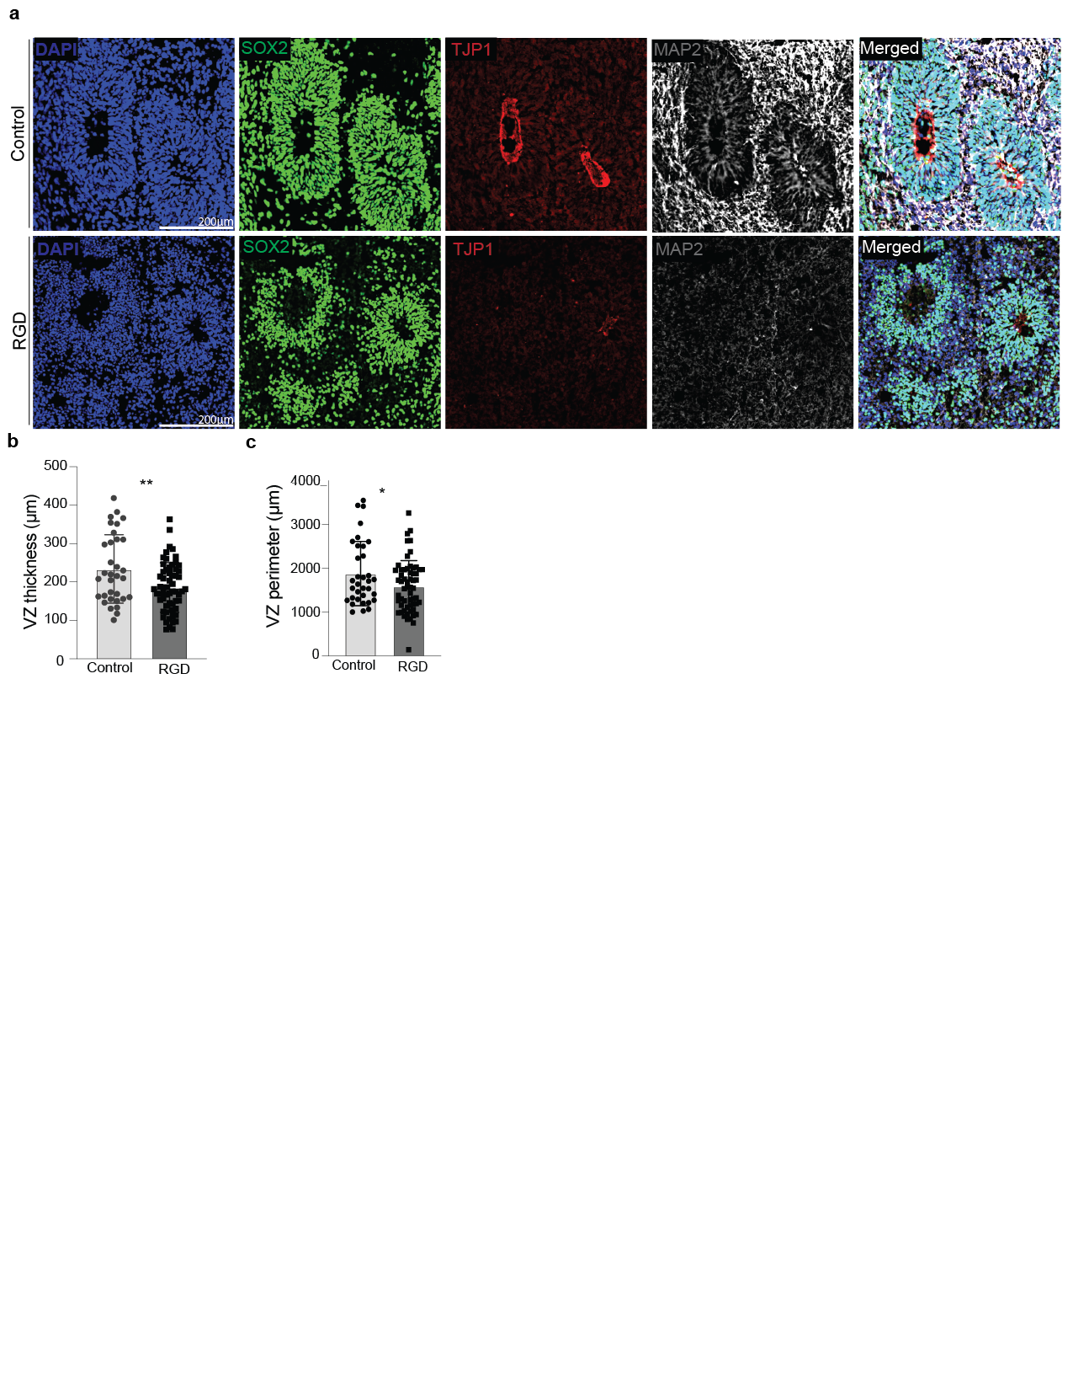

Supplementary Figure 4
- Select regions of 2-month-old control and RGD organoids highlighting the organization of their respective ventricular zones. RGD organoids have little to no specific TJP1 expression and disorganized MAP2 expression as compared to control.
- Quantification of ventricular zone (VZ) thickness as defined by Sox2 labeling. VZ thickness is reduced in RGD organoids. Student’s t-test was performed on 3 independent experiments where 33 control and 59 RGD VZs from 3 organoids were analyzed in total. Single dots represent individual VZs. P value =0.0037.
- Quantification of VZ perimeter as defined by Sox2 labeling. VZ is reduced in RGD organoids. Student’s t-test was performed on 3 independent experiments where 33 control and 59 RGD VZs from 3 organoids were analyzed in total. Single dots represent individual VZs. P value =0.0385.

Supplementary Figure 5
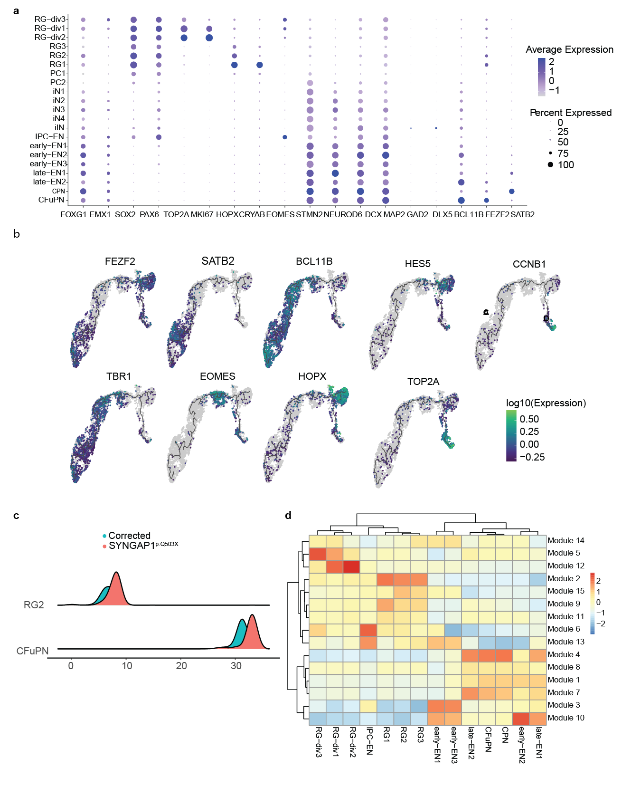

Supplementary Figure 5
- Dot plot showing marker genes used to classify cell clusters identified from single cell sequencing of 3-month-old corrected and SYNGAP1^{p.Q503X} organoids. Size of the dot is indicative of the percent of cells expressing the gene, color of the dot is indicative of the average expression level.
- Pseudotime distribution across individual datasets in RG2 and CFuPN cells with SYNGAP1^{p.Q503X} in red and corrected in blue.
- Pseudotime UMAP with log expression of selected genes. Genes for cycling cells (TOP2A, HES5, CCNB1), radial glial progenitors (FEZF2, HOPX, EOMES), and neurons (TBR1, SATB2 and BCL11B) are highlighted.
- Heatmap for all gene modules across cell types.

Supplementary Table 1
Proteome of 7 D.I.V. Cortical Organoids.

Supplementary Table 2
SynGO analysis of 7 D.I.V. Cortical Organoids Proteome.

Supplementary Table 3
Interactome of SYNGAP1 in 7 D.I.V. Cortical Organoids.

Supplementary Table 4
Differential Expression Analysis (DEGs) from Bulk-RNA sequencing of 7 D.I.V. Cortical Organoids from SYNGAP1^{p.Q503X} and corrected line.

Supplementary Table 5
Differential Expression Analysis (DEGs) from sc-RNA sequencing of 4 month-old Cortical Organoids from SYNGAP1^{p.Q503X} and corrected line.

Supplementary Video 1
Live imaging of corrected rosette formation from day 5 to day 7 after initial seeding.

Supplementary Video 2
Live imaging of SYNGAP1^{p.Q503X} rosette formation from day 5 to day 7 after initial seeding.

Supplementary Video 3
10 minutes video recordings of GCaMP6f corrected organoids.

Supplementary Video 4
10 minutes video recordings of GCaMP6f SYNGAP1^{p.Q503X} organoids.

