Supporting Information
4-Phenylcoumarins from Mesua ferrea with
selective CYP1B1 inhibitory activity
Fengxu Zhou^{1,3＃}, Ruoyue Huang^{2＃}, Tingting Cao¹, Jia Liu¹, ✉Weimin Yang ¹,
✉Fei Li², ✉Xian Li¹
Xian Li
xianlikm@163.com

Fei Li
lifeib@mail.kib.ac.cn

Weimin Yang
15887299927@yeah.net

¹ School of Pharmaceutical Science and Yunnan Key Laboratory of Pharmacology of Natural Products, Kunming Medical University, Kunming, Yunnan, 650000, China

² West China Hospital, Sichuan University, Chengdu, Sichuan, 610000, China

³ Shunde Institute for Drug Control, Foshan, Guangdong, 528000, China,

＃Fengxu Zhou and Ruoyue Huang contributed equally to this manuscript.

contents
Figure S1. HRESIMS spectrum of mesuaferlinns A (1). 1
Figure S2. UV spectrum of mesuaferlinns A (1). 2
Figure S3. OR Valve of mesuaferlinns A (1). 3
Figure S4. IR spectrum of mesuaferlinns A (1). 4
Figure S5. ¹H NMR spectrum of mesuaferlinns A (1) in Acetone-d₆.. 5
Figure S6. ¹³C NMR and DEPT spectrum of mesuaferlinns A (1) in Acetone-d₆. 6
Figure S7. COSY spectrum of mesuaferlinns A (1) in Acetone-d₆. 7
Figure S8. HSQC spectrum of mesuaferlinns A (1) in Acetone-d₆. 8
Figure S9. HMBC spectrum of mesuaferlinns A (1) in Acetone-d₆. 9
Figure S10. ROESY spectrum of mesuaferlinns A (1) in Acetone-d₆. 10
Figure S11. HRESIMS spectrum of mesuaferlinns B (2). 11
Figure S12. UV spectrum of mesuaferlinns B (2). 12
Figure S13 OR Value of mesuaferlinns B (2). 13
Figure S14. IR spectrum of mesuaferlinns B (2). 14
Figure S15. ¹H NMR spectrum of mesuaferlinns B (2) in Acetone-d₆. 15
Figure S16. ¹³C NMR and DEPT spectrum of mesuaferlinns B (2) in Acetone-d₆. 16
Figure S17. COSY spectrum of mesuaferlinns B (2) in Acetone-d₆. 17
Figure S18. HSQC spectrum of mesuaferlinns B (2) in Acetone-d₆. 18
Figure S19. HMBC spectrum of mesuaferlinns B (2) in Acetone-d₆. 19
Figure S20. ROESY spectrum of mesuaferlinns B (2) in Acetone-d₆. 20
Figure S21. HRESIMS spectrum of mesuaferlinns C (3). 21
Figure S22. UV spectrum of mesuaferlinns C (3). 22
Figure S23. OR Value of mesuaferlinns C (3) in MeOH. 23
Figure S24. IR spectrum of mesuaferlinns C (3). 24
Figure S25. ¹H NMR spectrum of mesuaferlinns C (3) in Acetone-d₆. 25
Figure S26. ¹³C NMR and DEPT spectrum of mesuaferlinns C (3) in Acetone-d₆. 26
Figure S27. COSY spectrum of mesuaferlinns C (3) in Acetone-d₆. 27
Figure S28. HSQC spectrum of mesuaferlinns C (3) in Acetone-d₆. 28
Figure S29. HMBC spectrum of mesuaferlinns C (3) in Acetone-d₆. 29
Figure S30. ROESY spectrum of mesuaferlinns C (3) in Acetone-d₆ 30
Figure S31. QPCR result about the expression of CYP1A1 (n=4) 31
Figure S32. Inhibitory activities of CYP1B1 with NADPH and without NADPH. 31

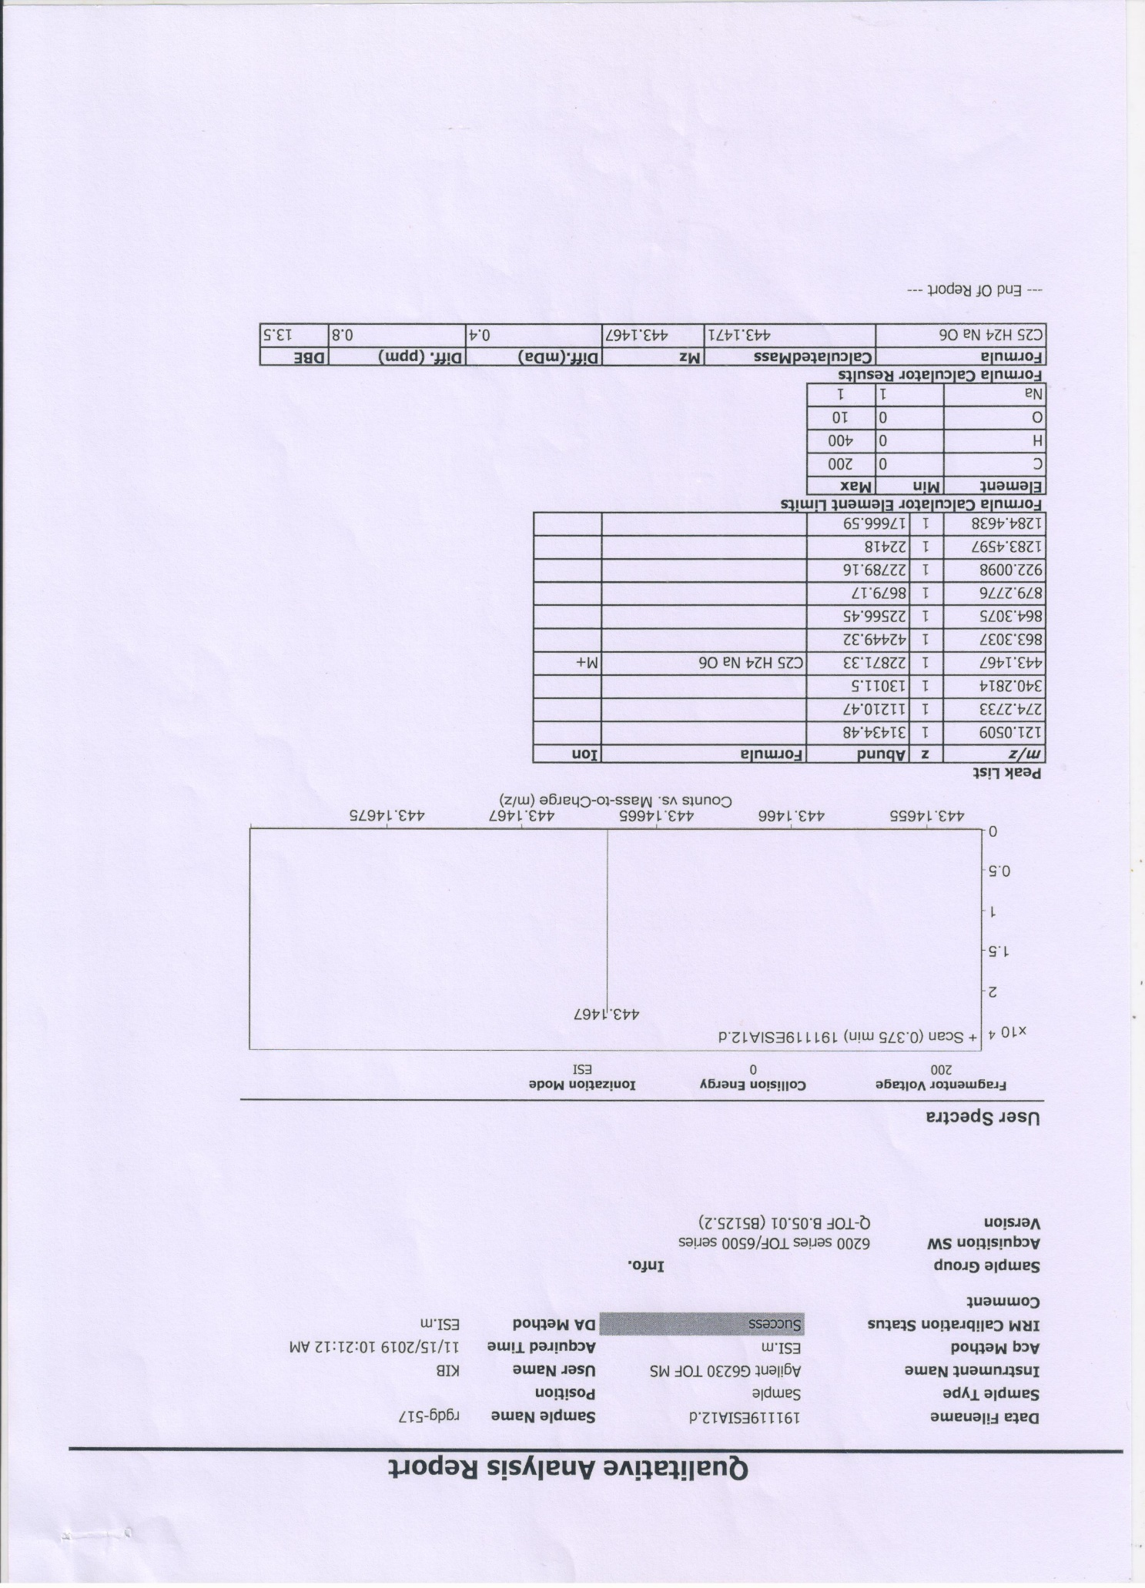

Figure S1. HRESIMS spectrum of mesuaferlinns A (1).
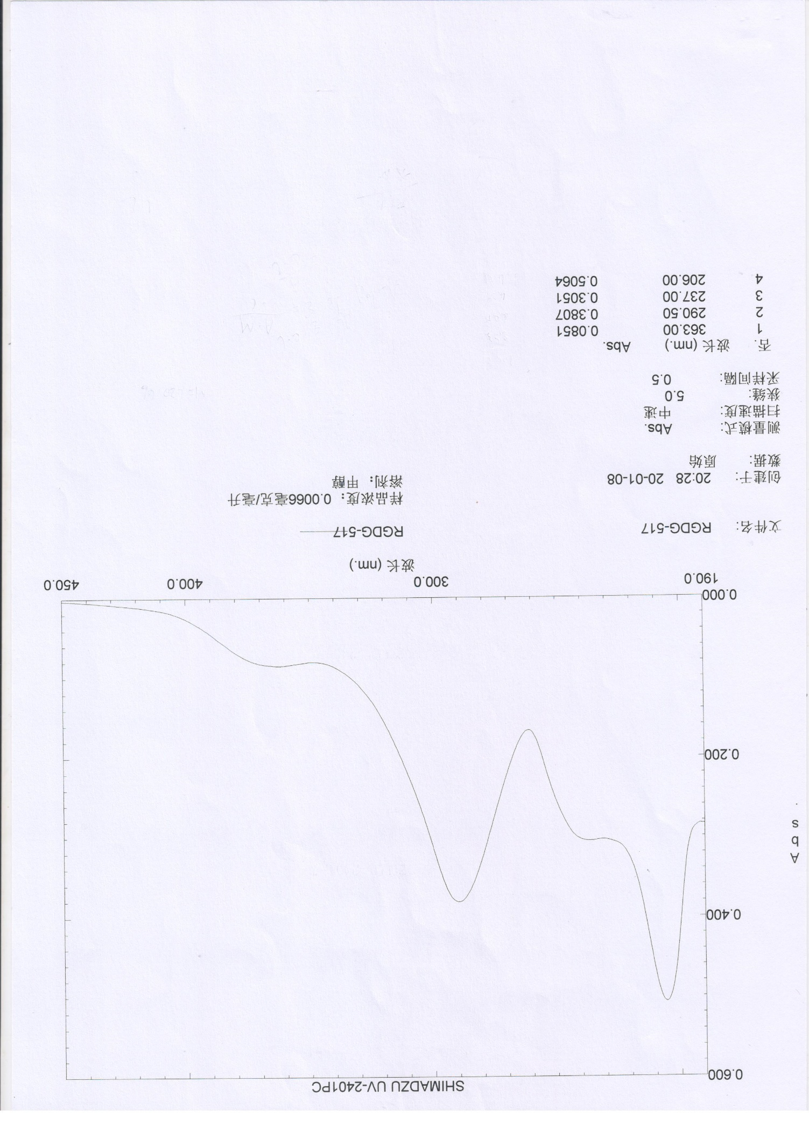

Figure S2. UV spectrum of mesuaferlinns A (1).

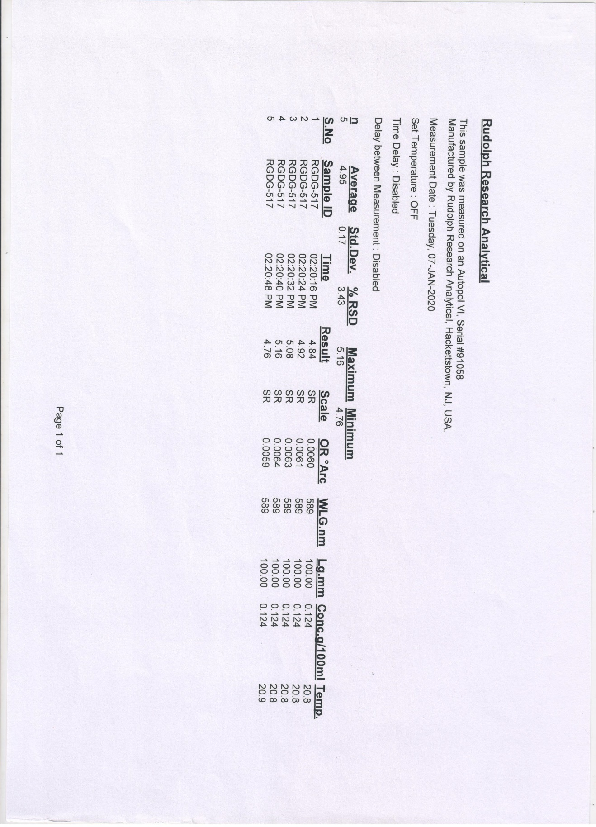

Figure S3. OR Valve of mesuaferlinns A (1).
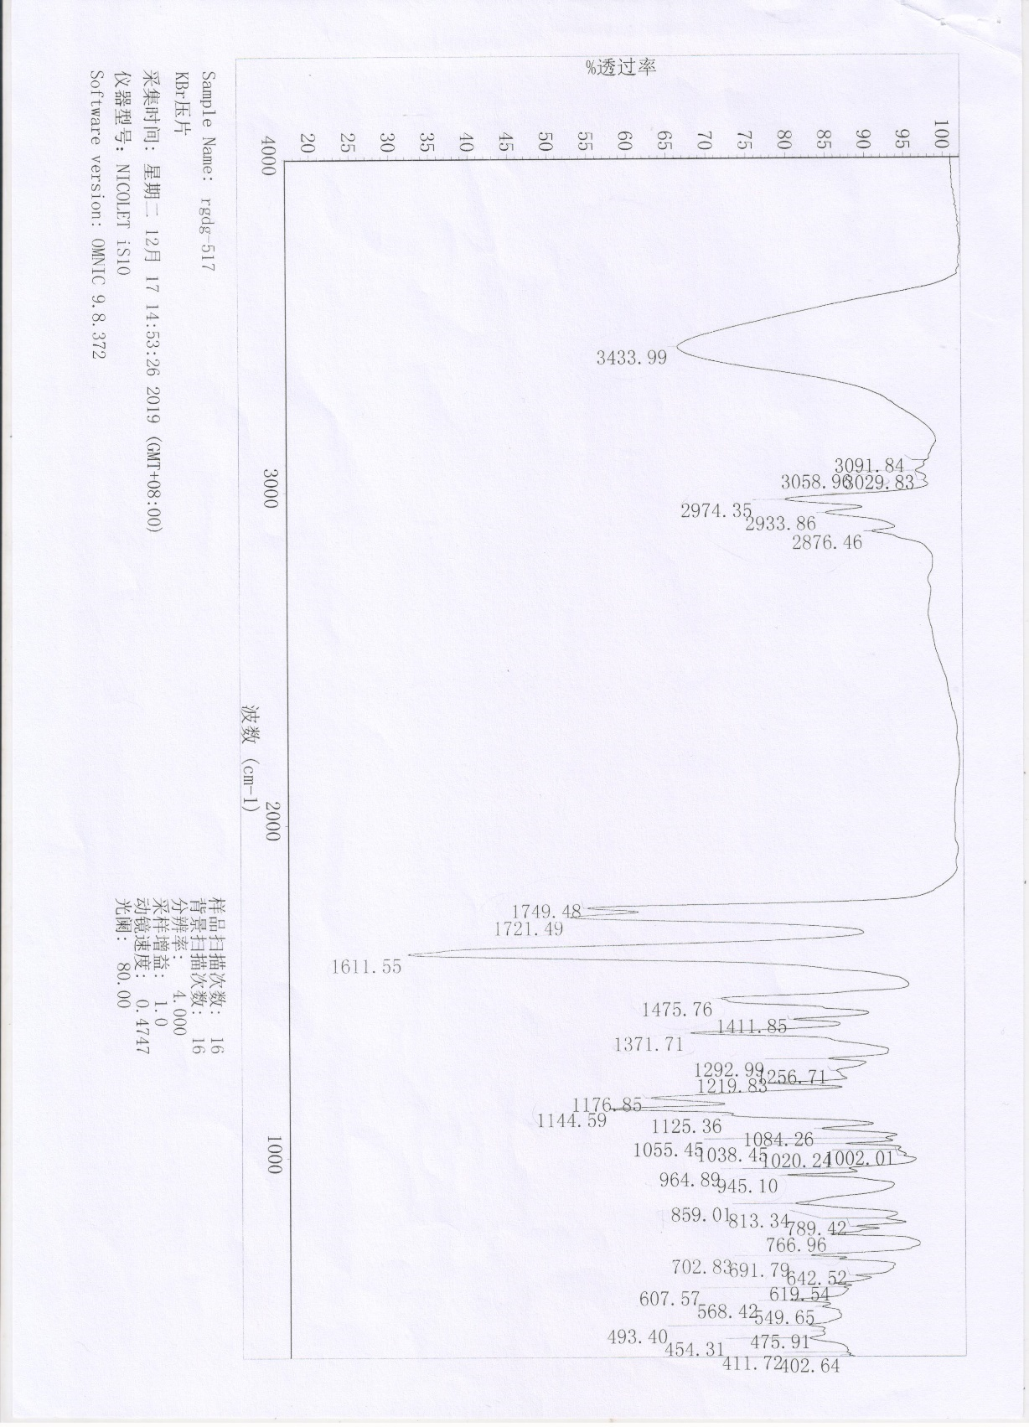

Figure S4. IR spectrum of mesuaferlinns A (1).

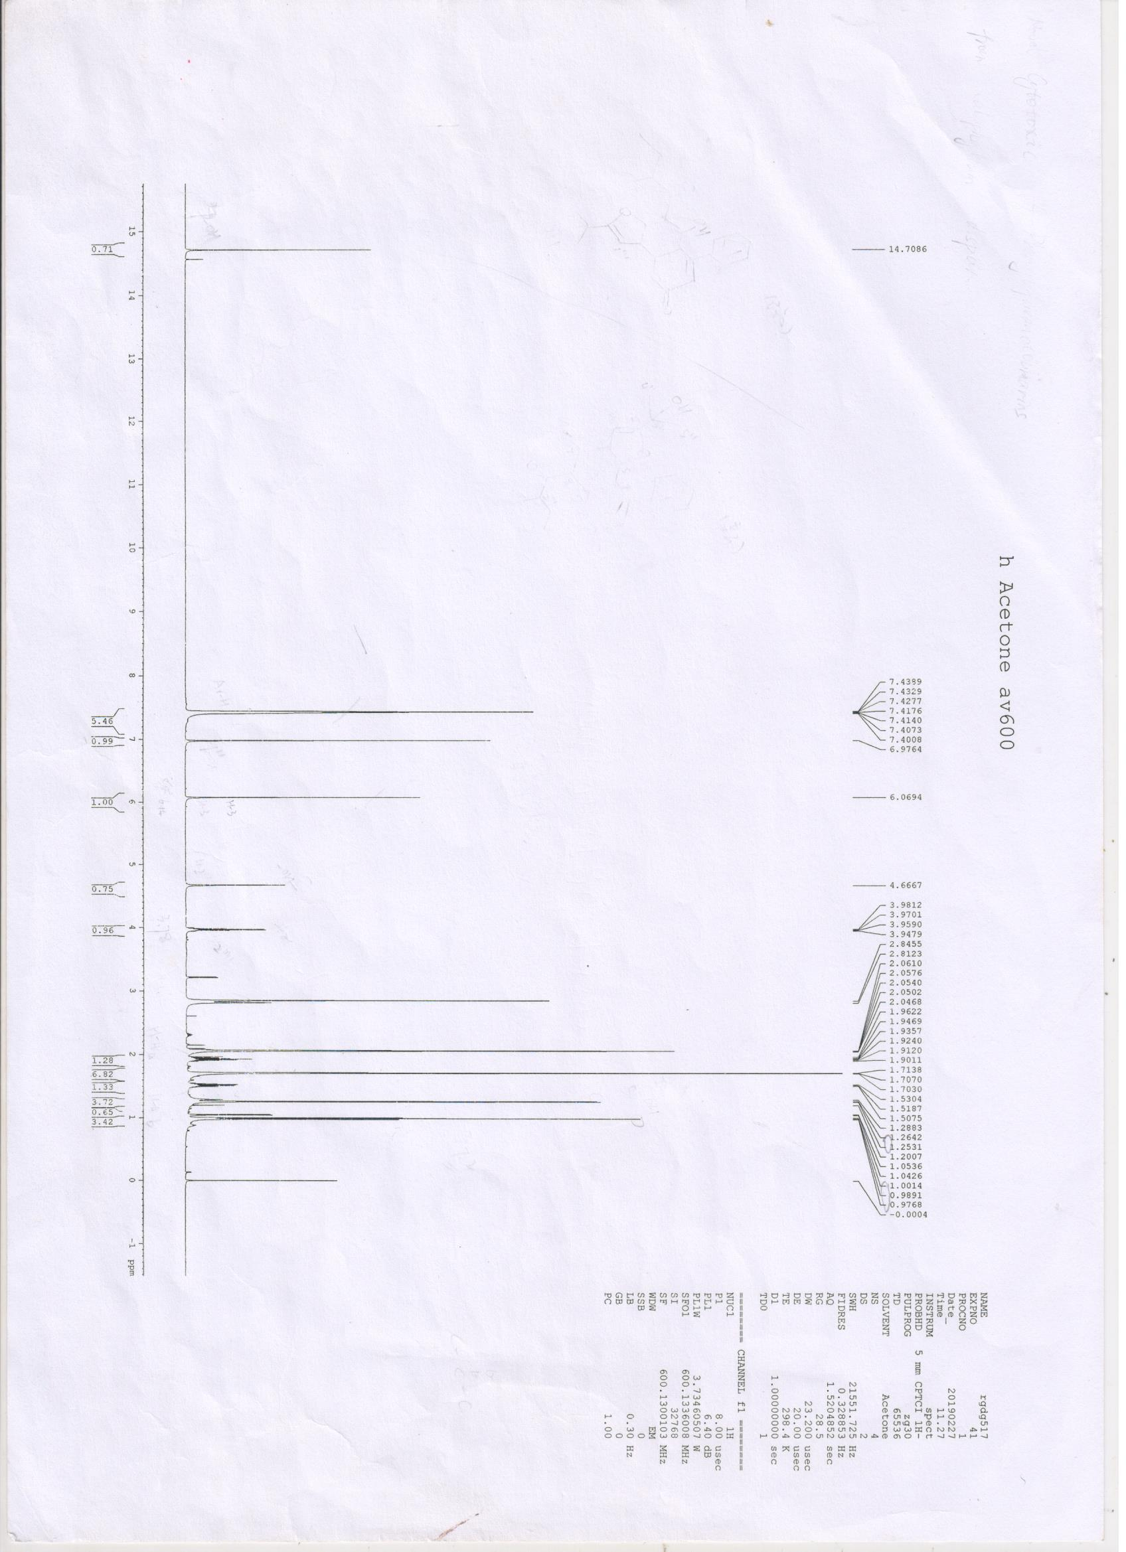

Figure S5. ¹H NMR spectrum of mesuaferlinns A (1) in Acetone-d₆..

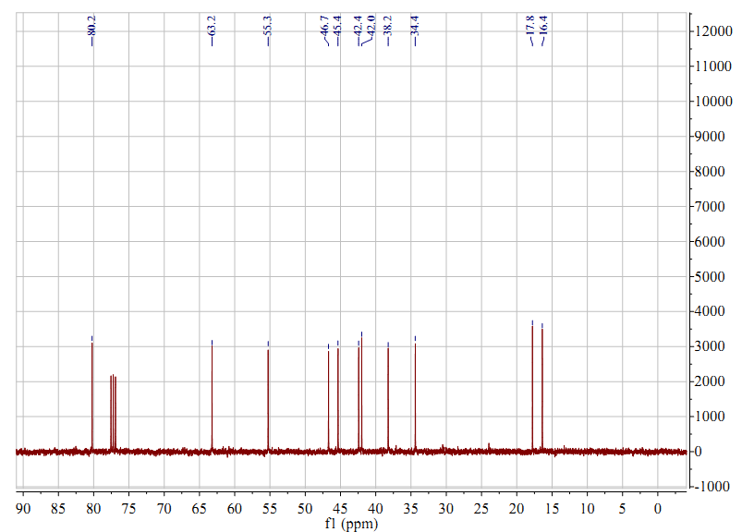

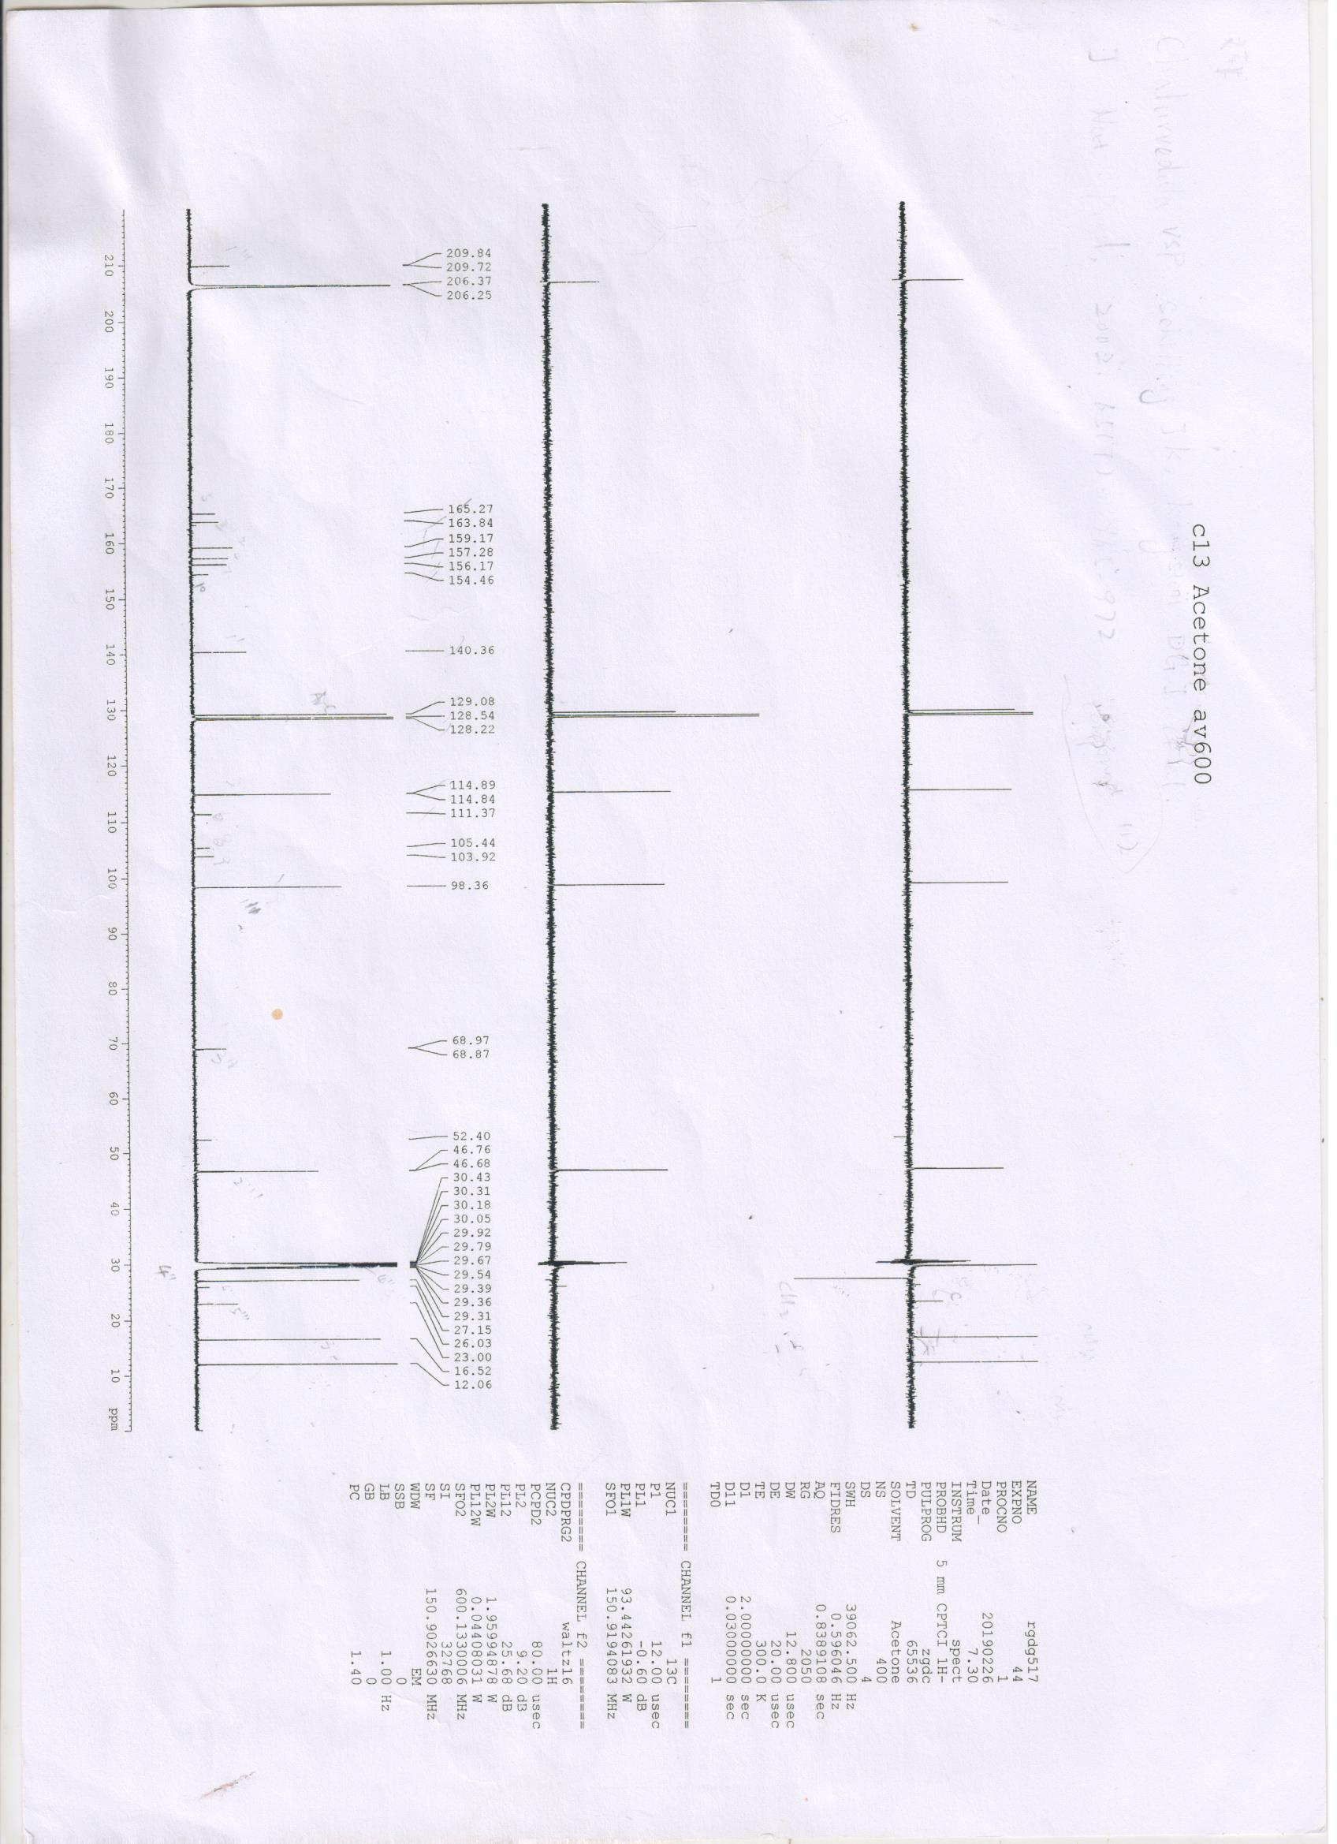

Figure S6. ¹³C NMR and DEPT spectrum of mesuaferlinns A (1) in Acetone-d₆.
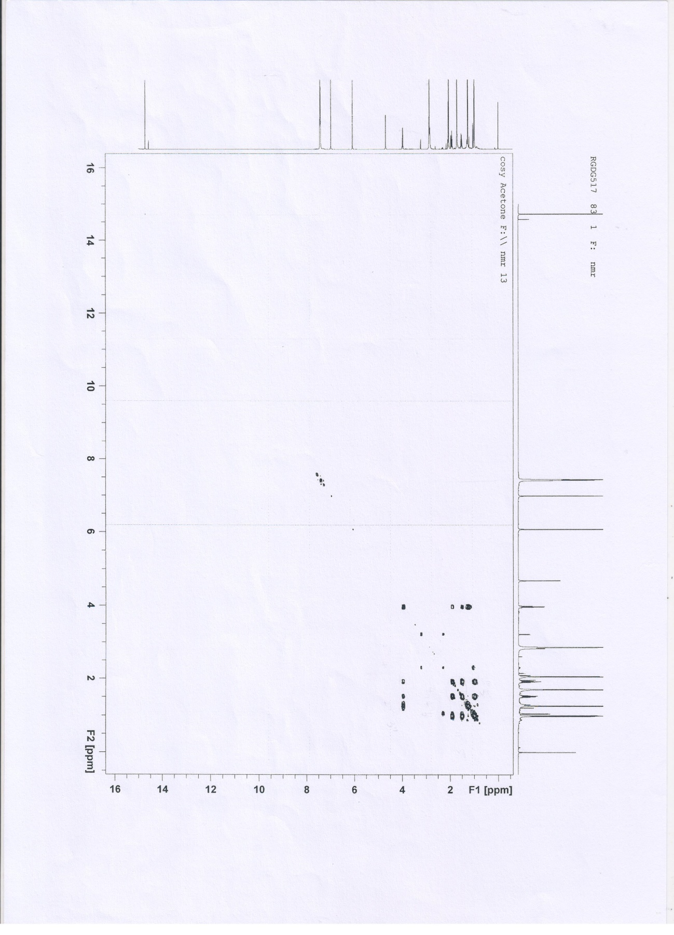

Figure S7. COSY spectrum of mesuaferlinns A (1) in Acetone-d₆.

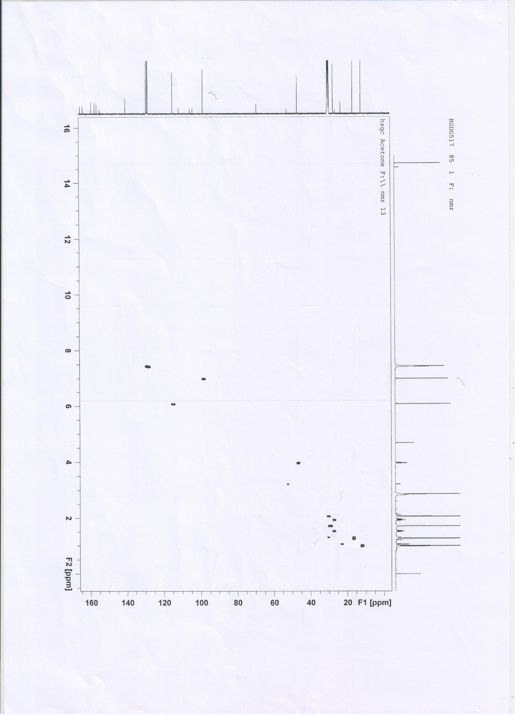

Figure S8. HSQC spectrum of mesuaferlinns A (1) in Acetone-d₆.

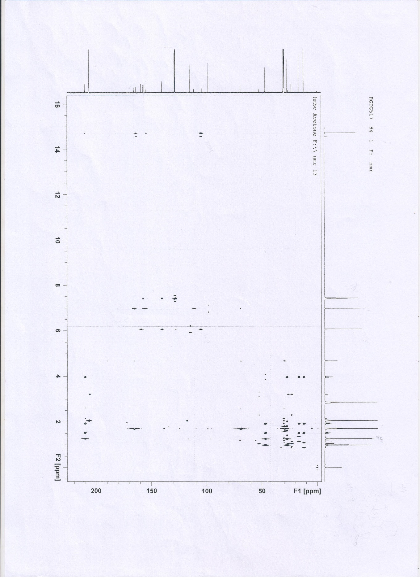

Figure S9. HMBC spectrum of mesuaferlinns A (1) in Acetone-d₆.

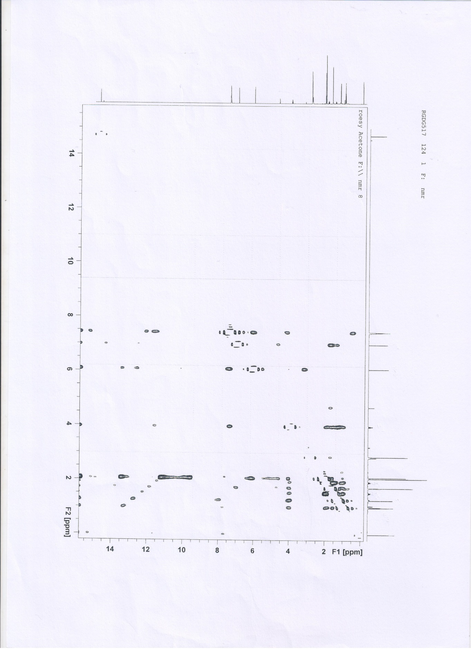

Figure S10. ROESY spectrum of mesuaferlinns A (1) in Acetone-d₆.

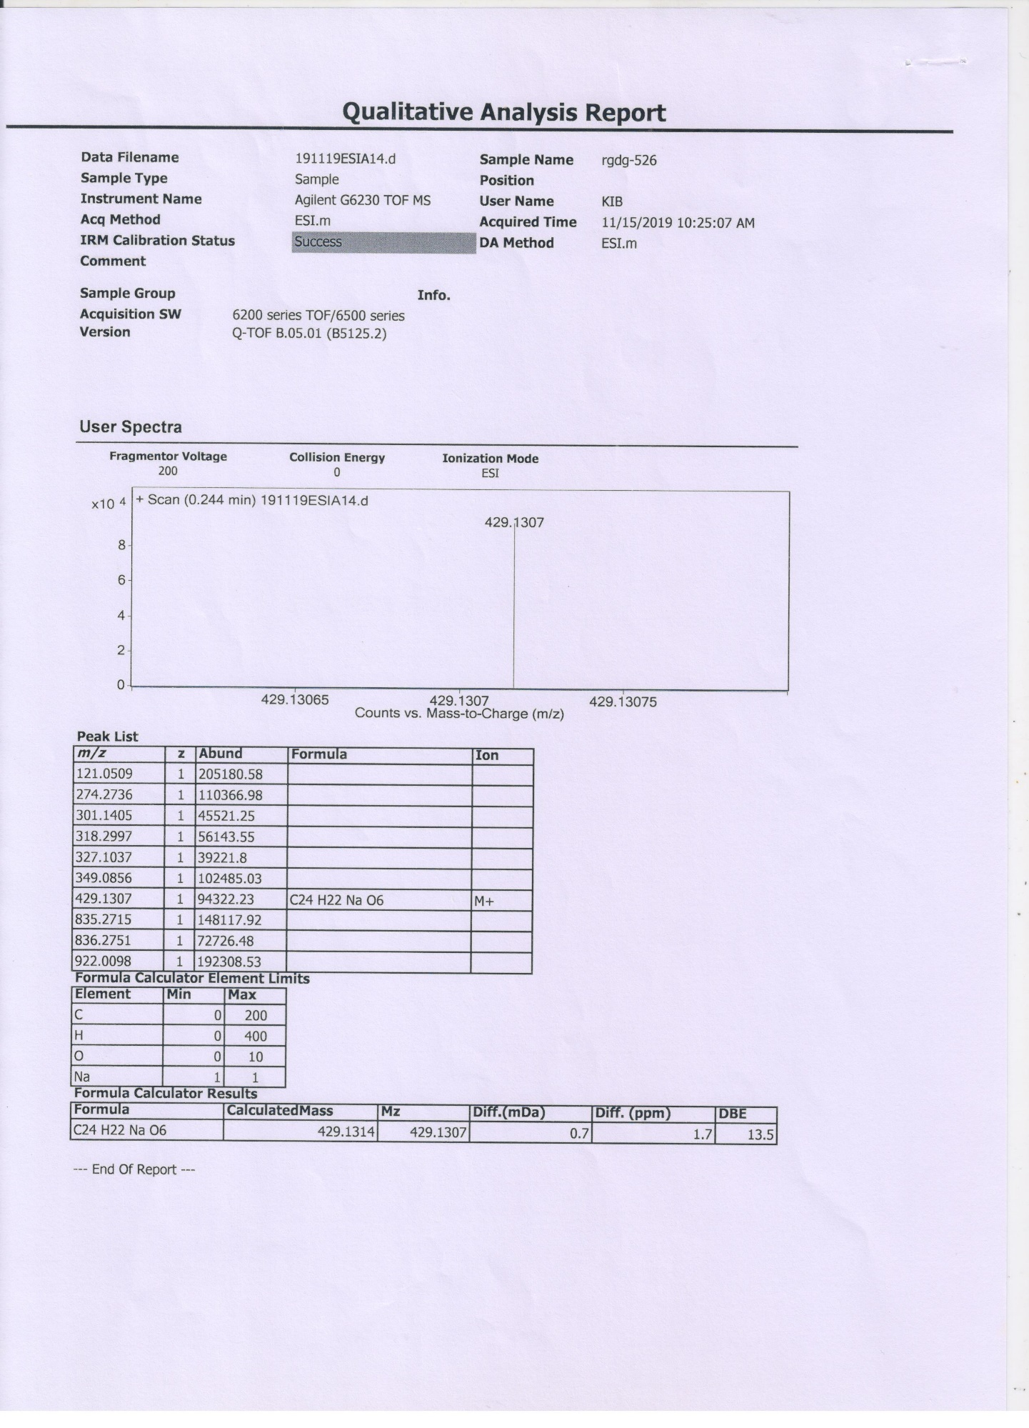

Figure S11. HRESIMS spectrum of mesuaferlinns B (2).

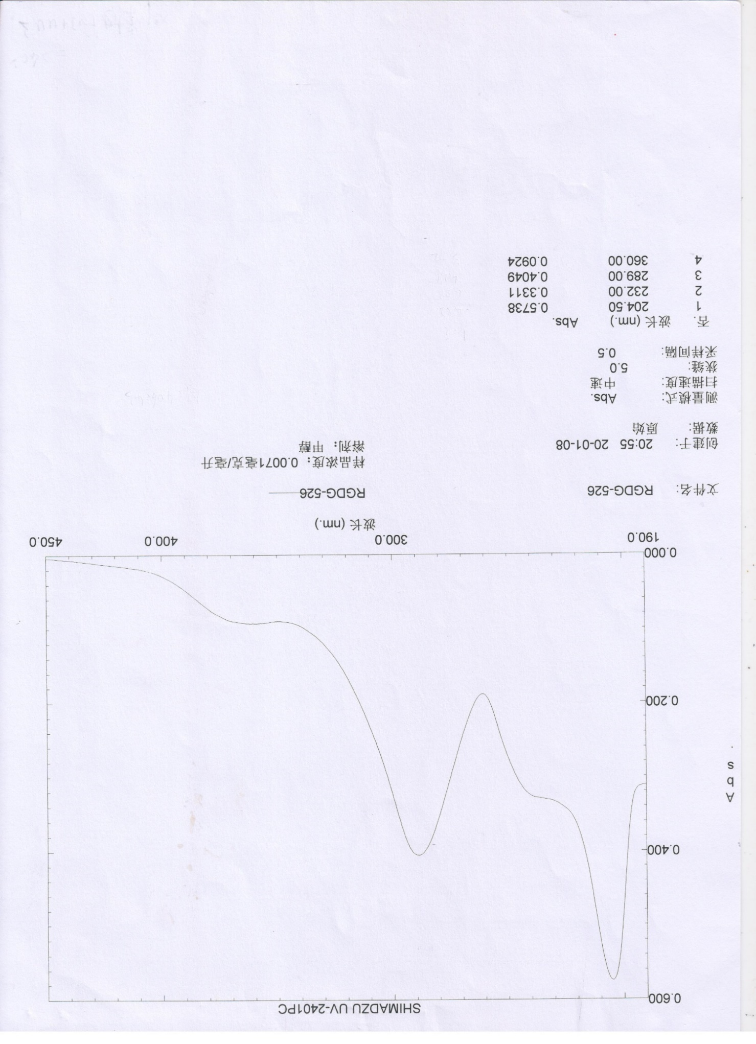

Figure S12. UV spectrum of mesuaferlinns B (2).

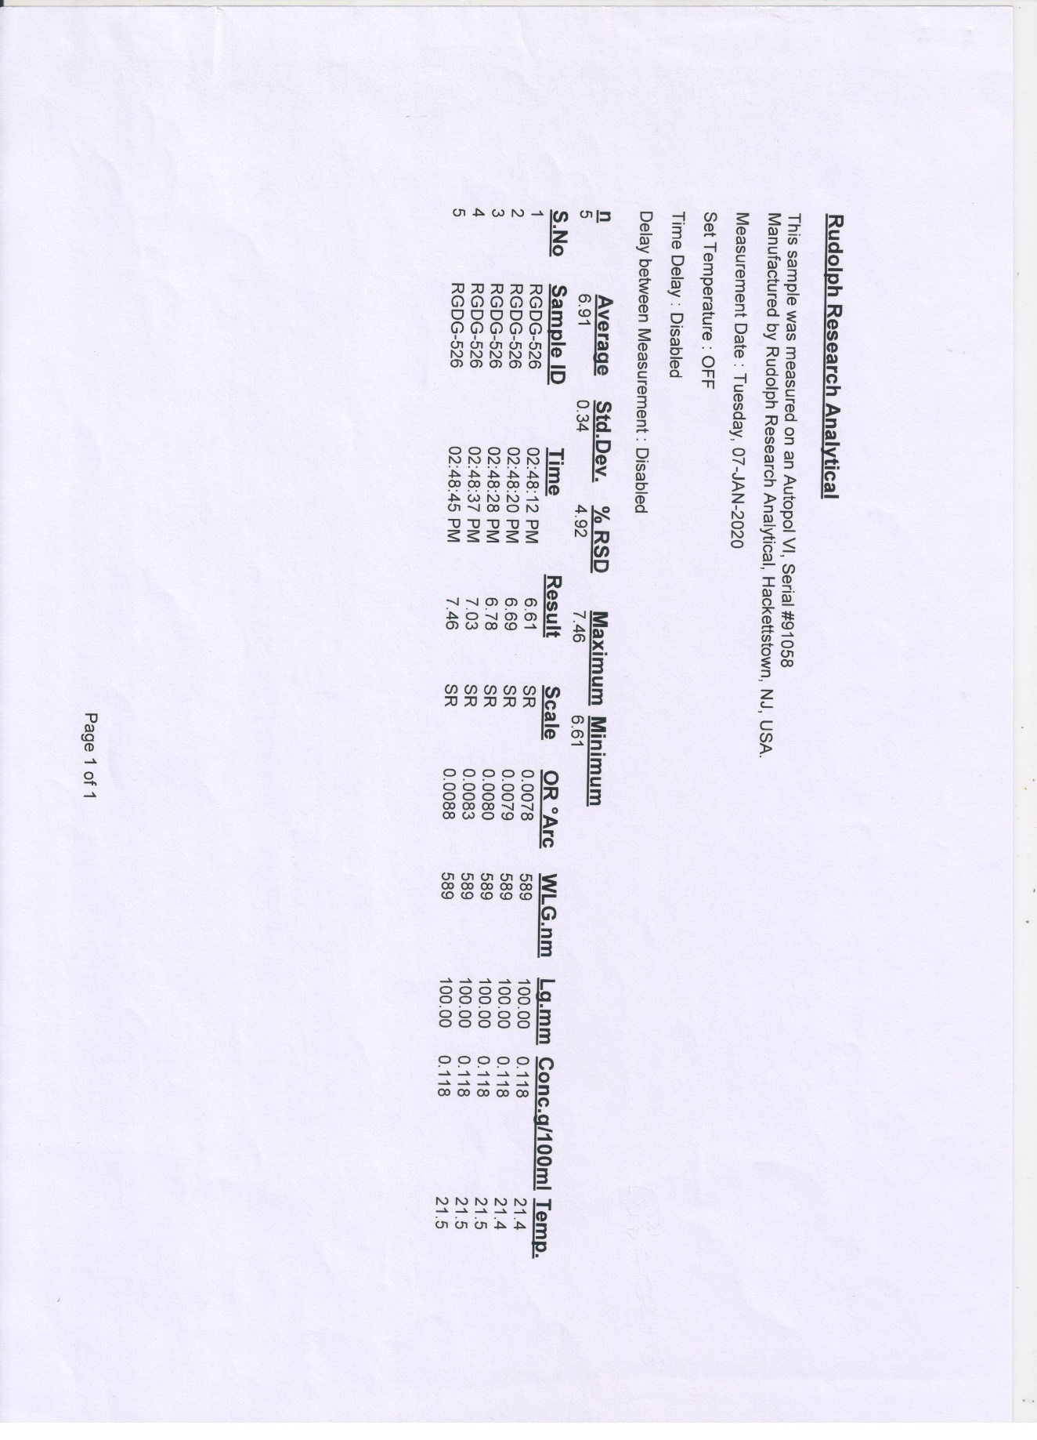

Figure S13 OR Value of mesuaferlinns B (2).

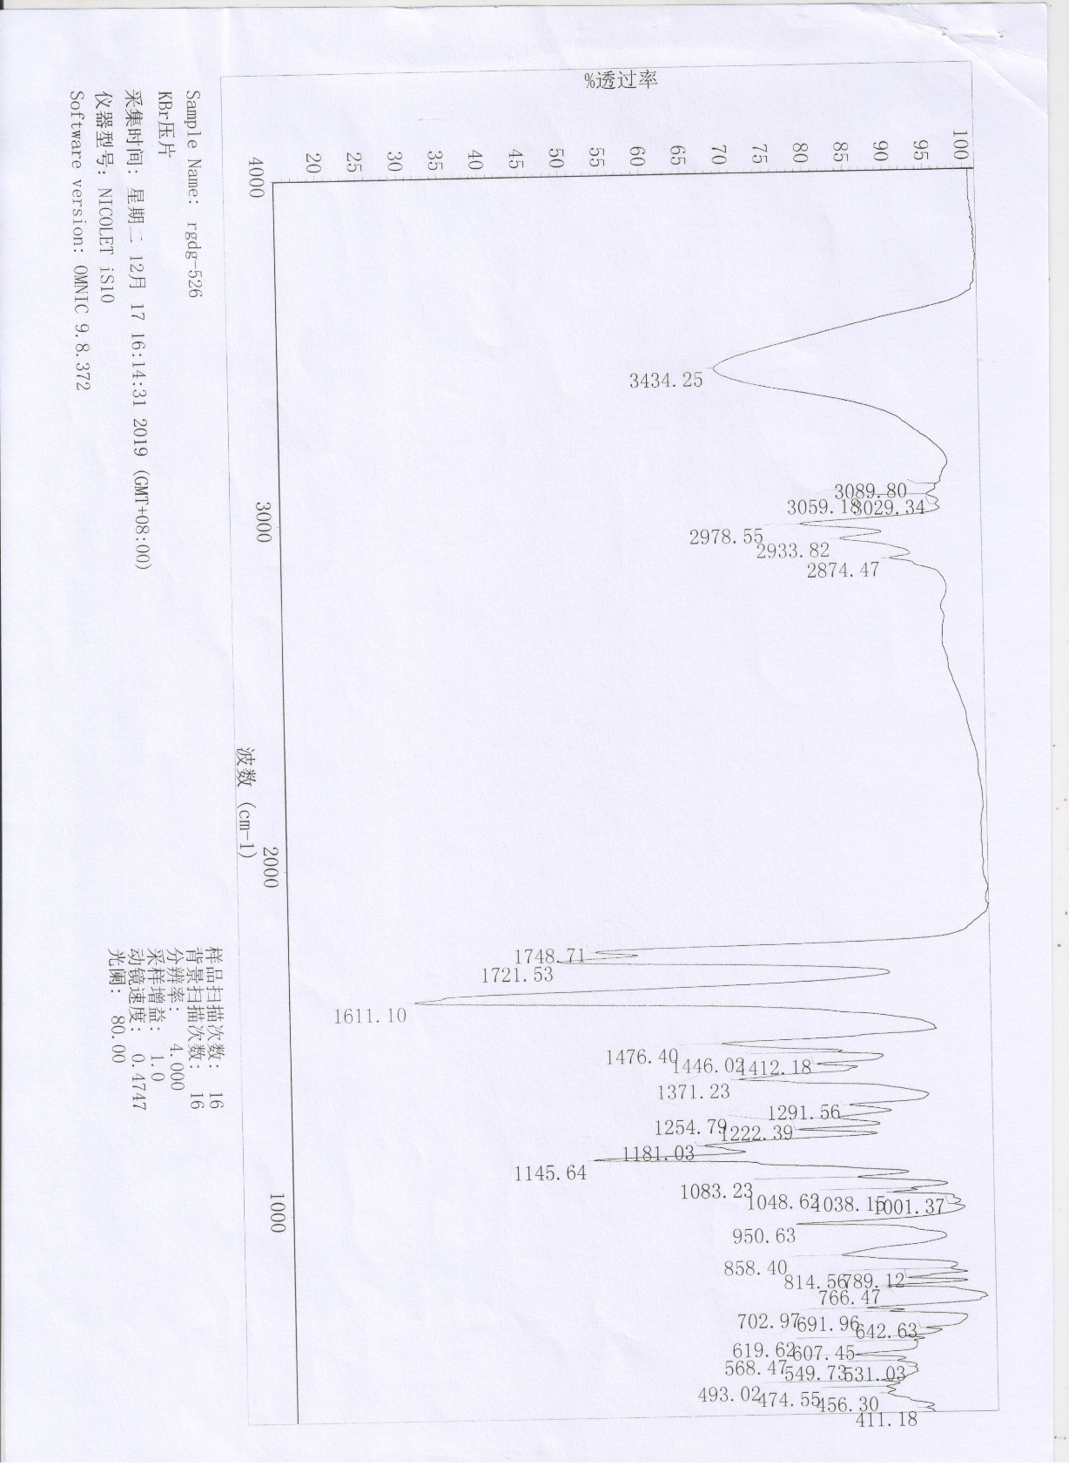

Figure S14. IR spectrum of mesuaferlinns B (2).

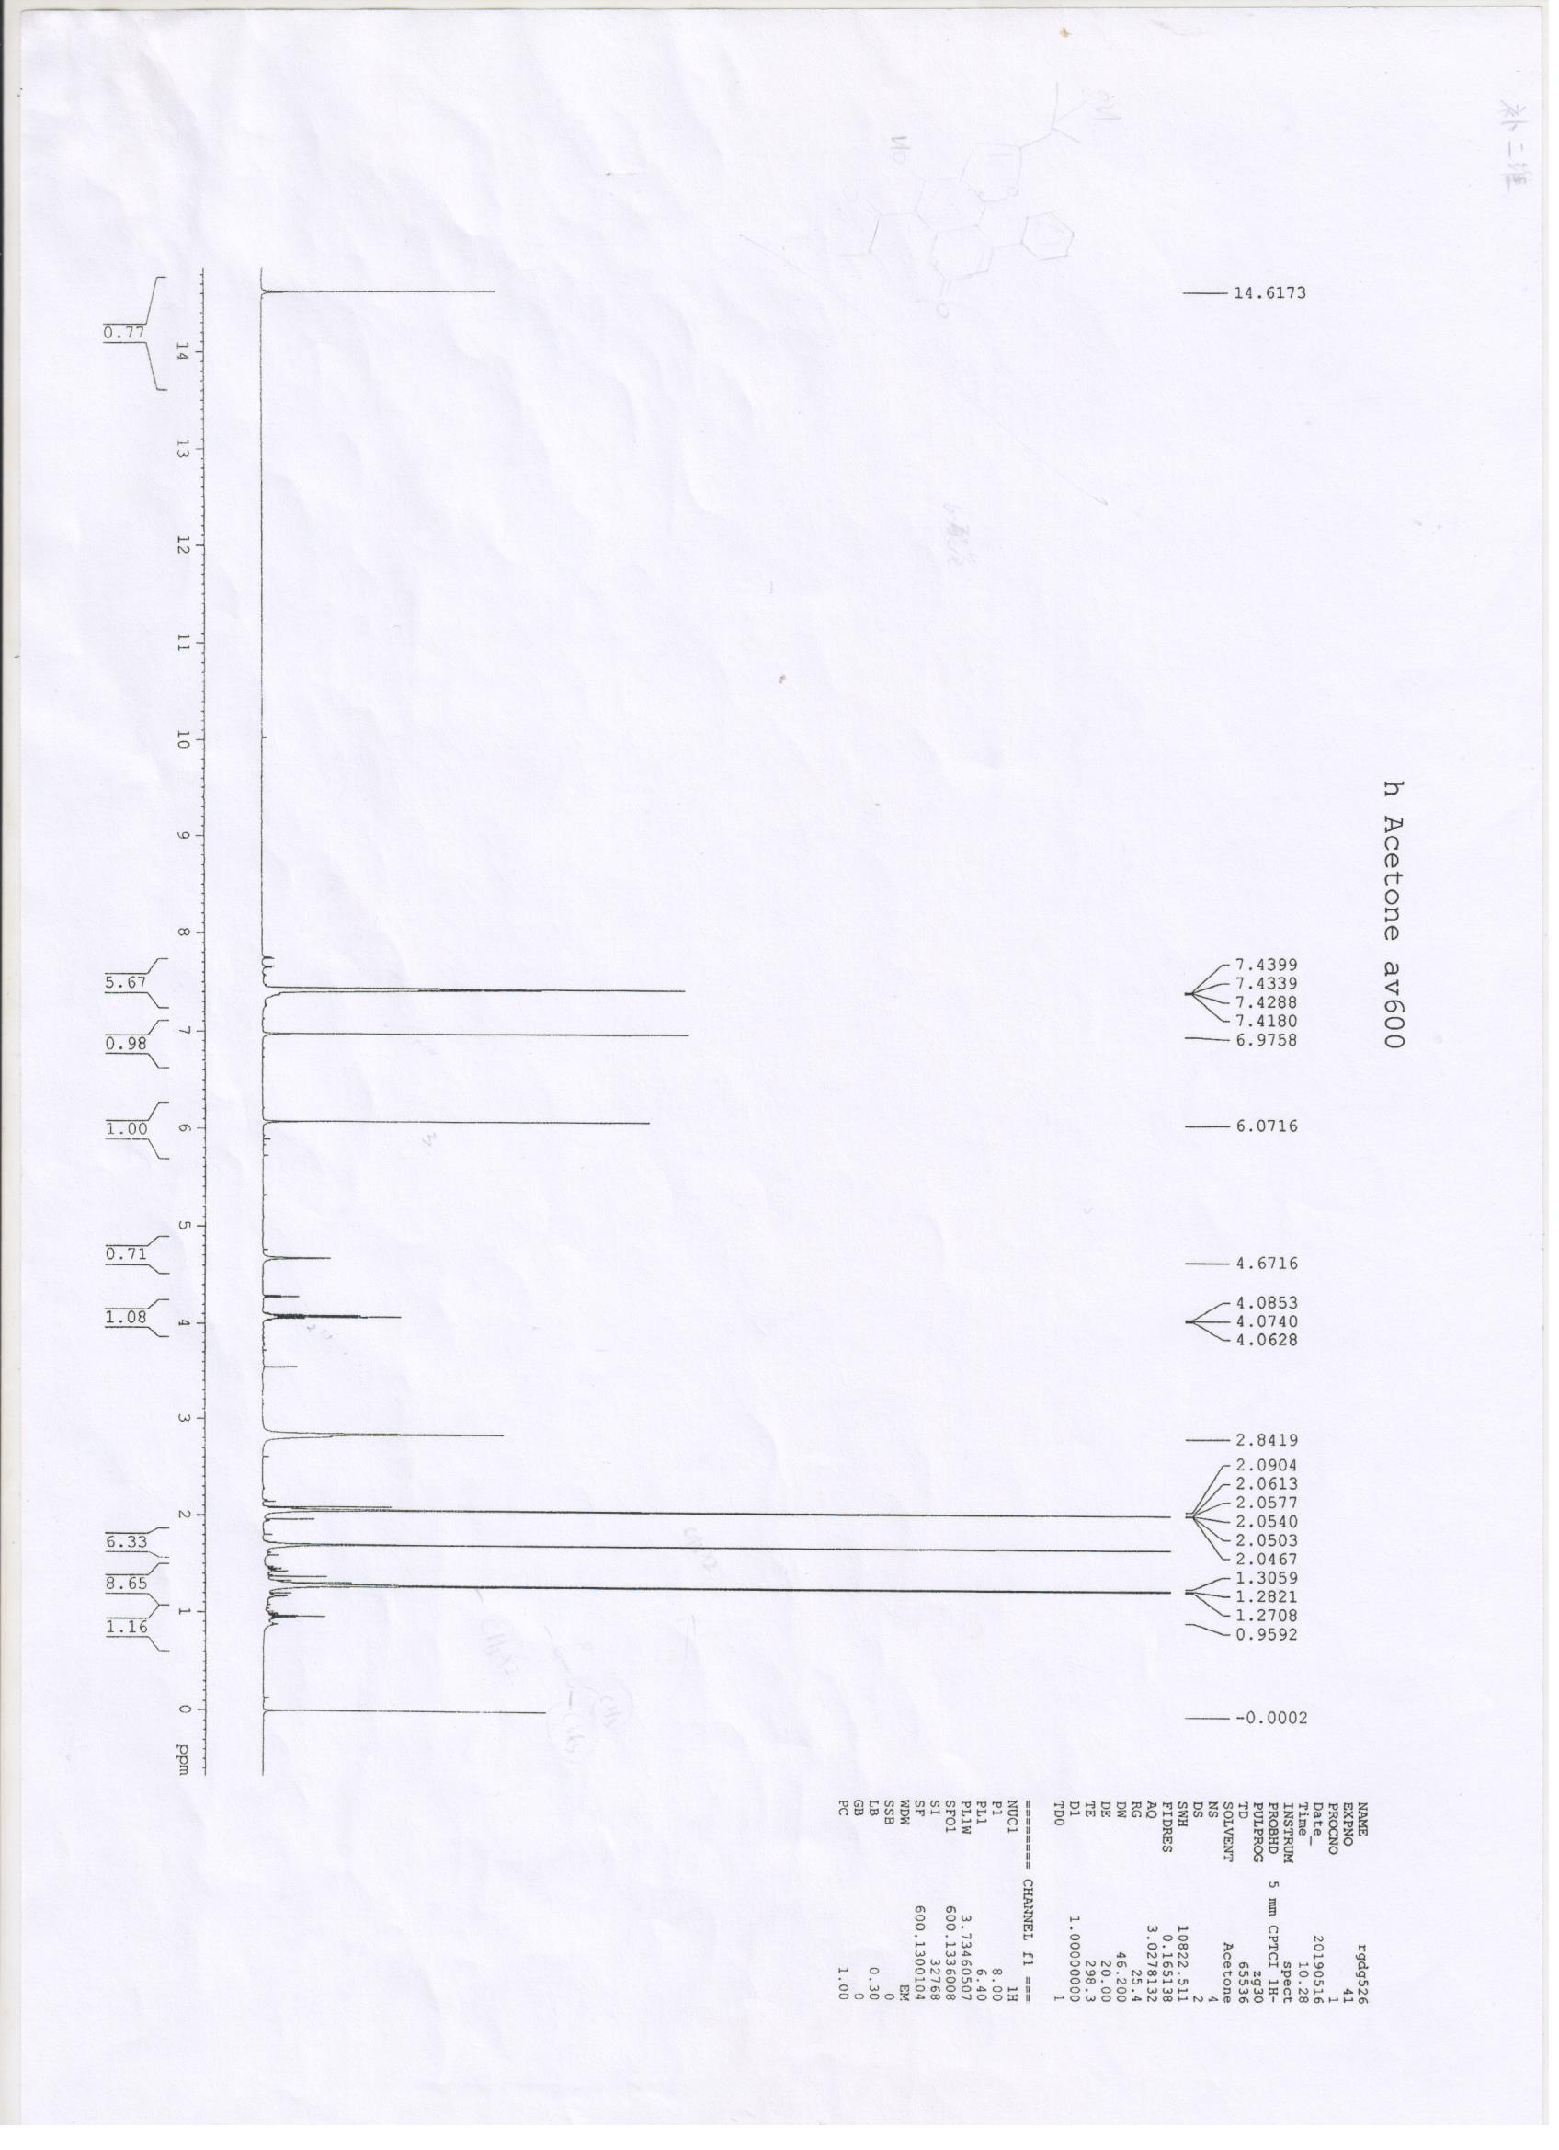

Figure S15. ¹H NMR spectrum of mesuaferlinns B (2) in Acetone-d₆.

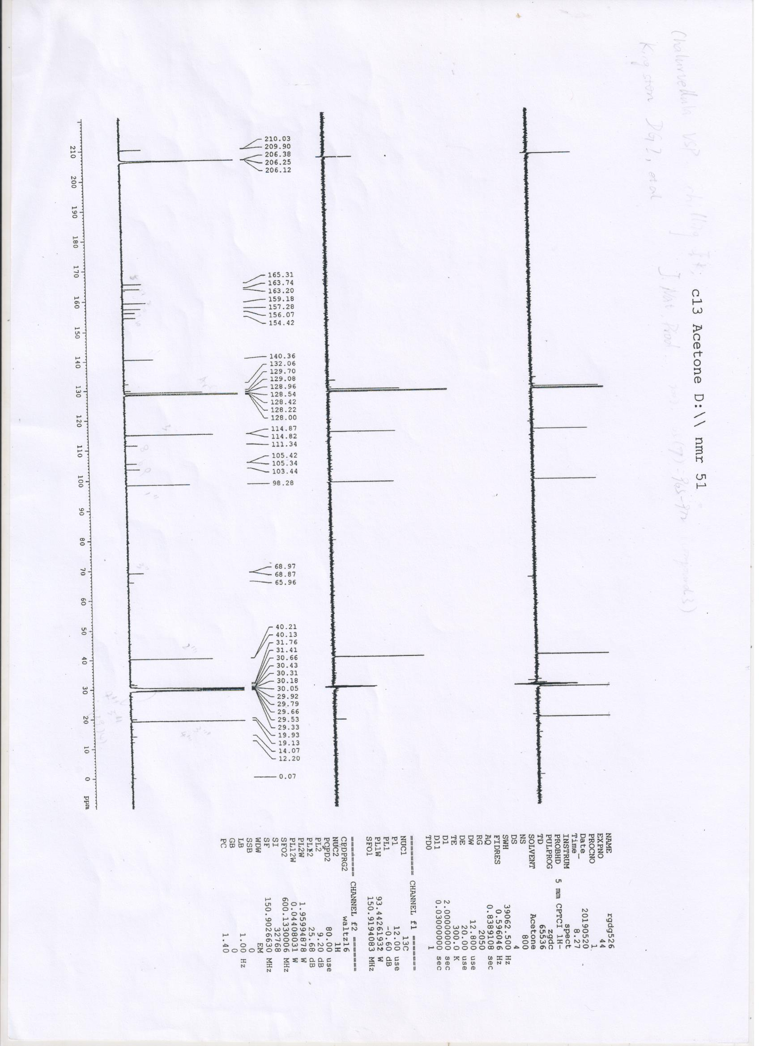

Figure S16. ¹³C NMR and DEPT spectrum of mesuaferlinns B (2) in Acetone-d₆.

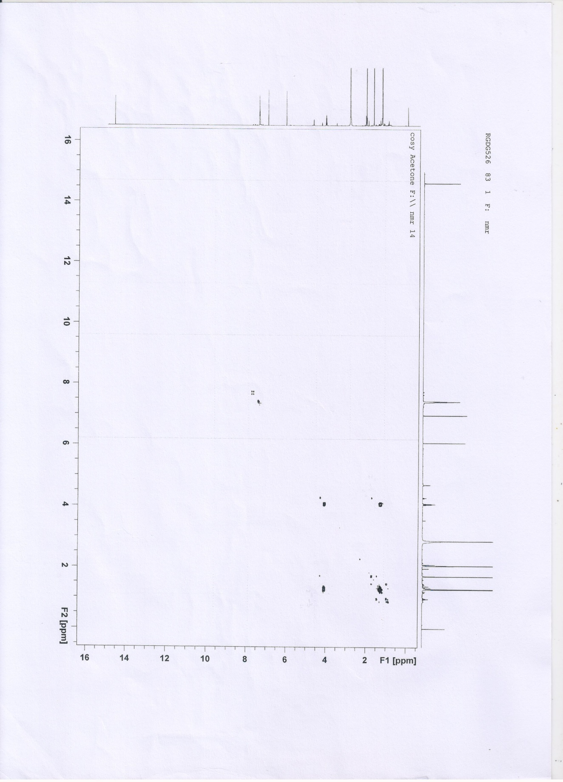

Figure S17. COSY spectrum of mesuaferlinns B (2) in Acetone-d₆.

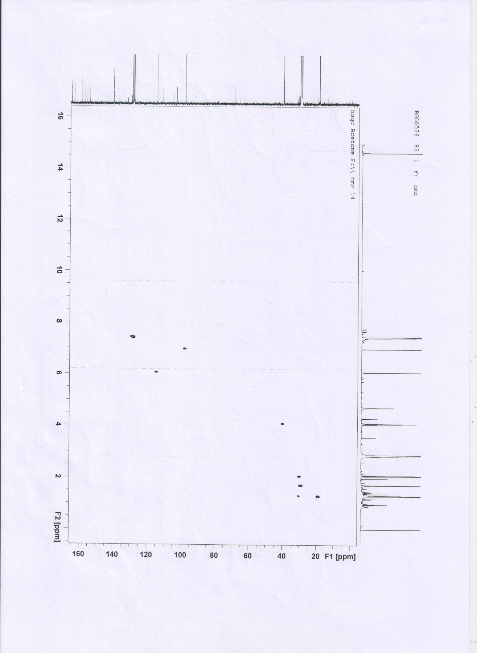

Figure S18. HSQC spectrum of mesuaferlinns B (2) in Acetone-d₆.

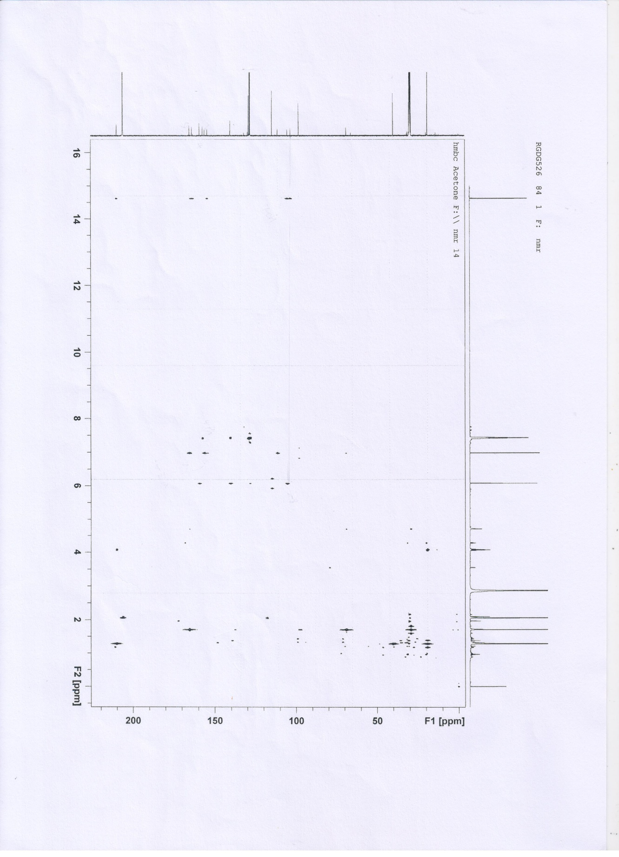

Figure S19. HMBC spectrum of mesuaferlinns B (2) in Acetone-d₆.

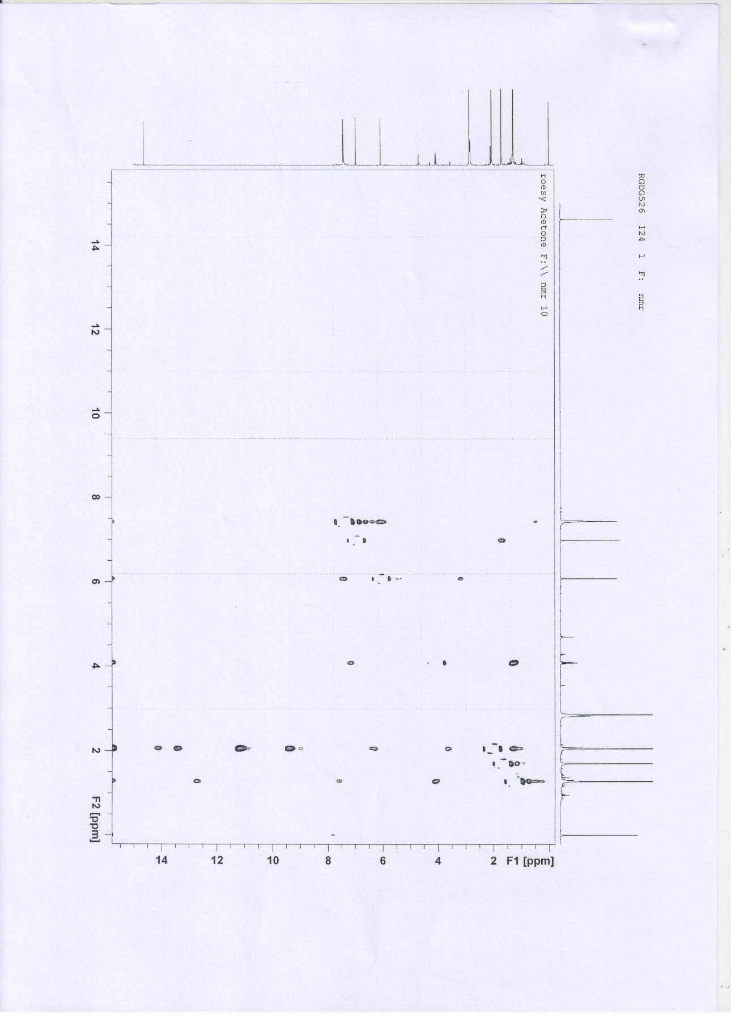

Figure S20. ROESY spectrum of mesuaferlinns B (2) in Acetone-d₆.

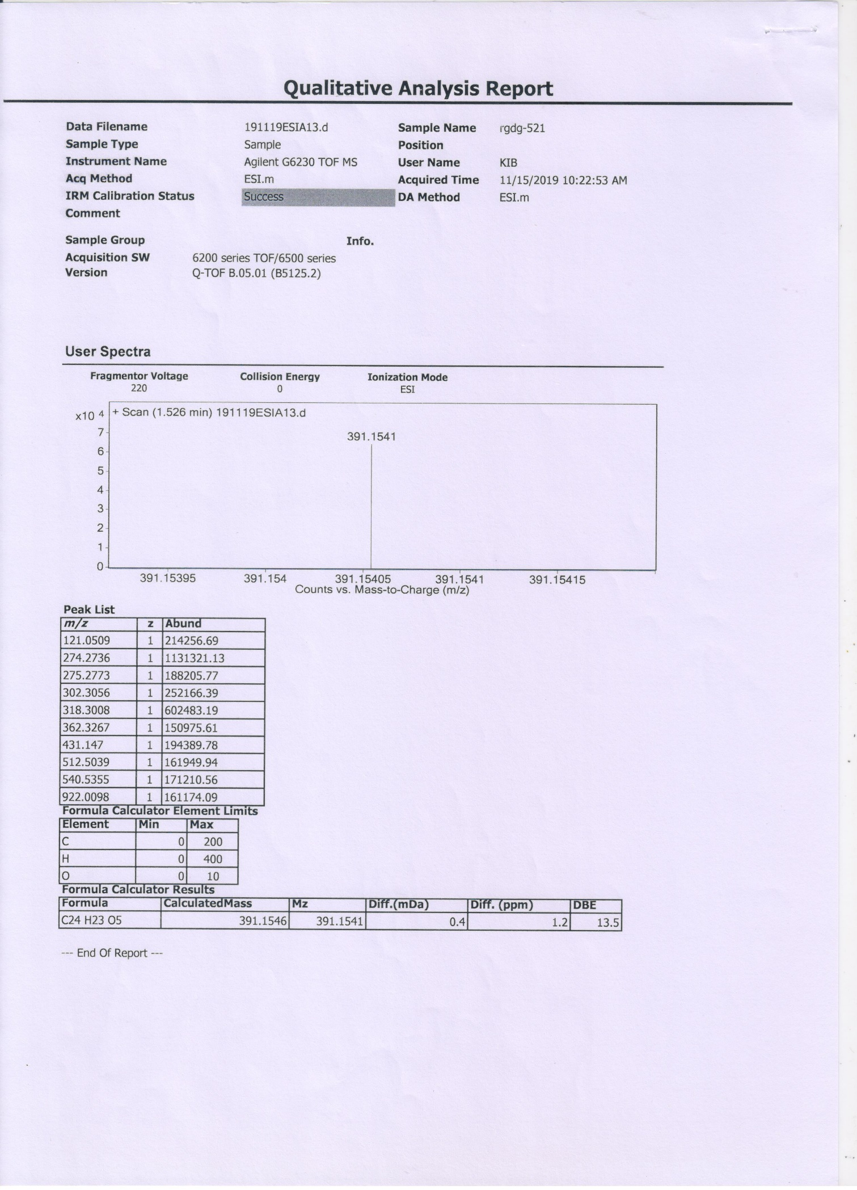

Figure S21. HRESIMS spectrum of mesuaferlinns C (3).

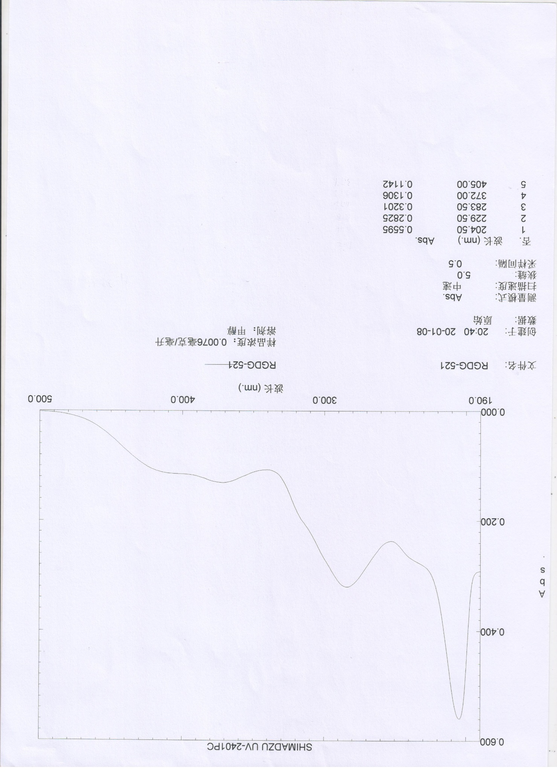

Figure S22. UV spectrum of mesuaferlinns C (3).

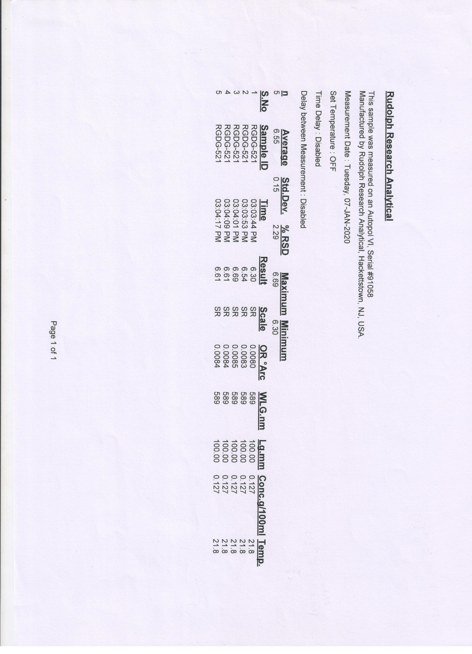

Figure S23. OR Value of mesuaferlinns C (3) in MeOH.
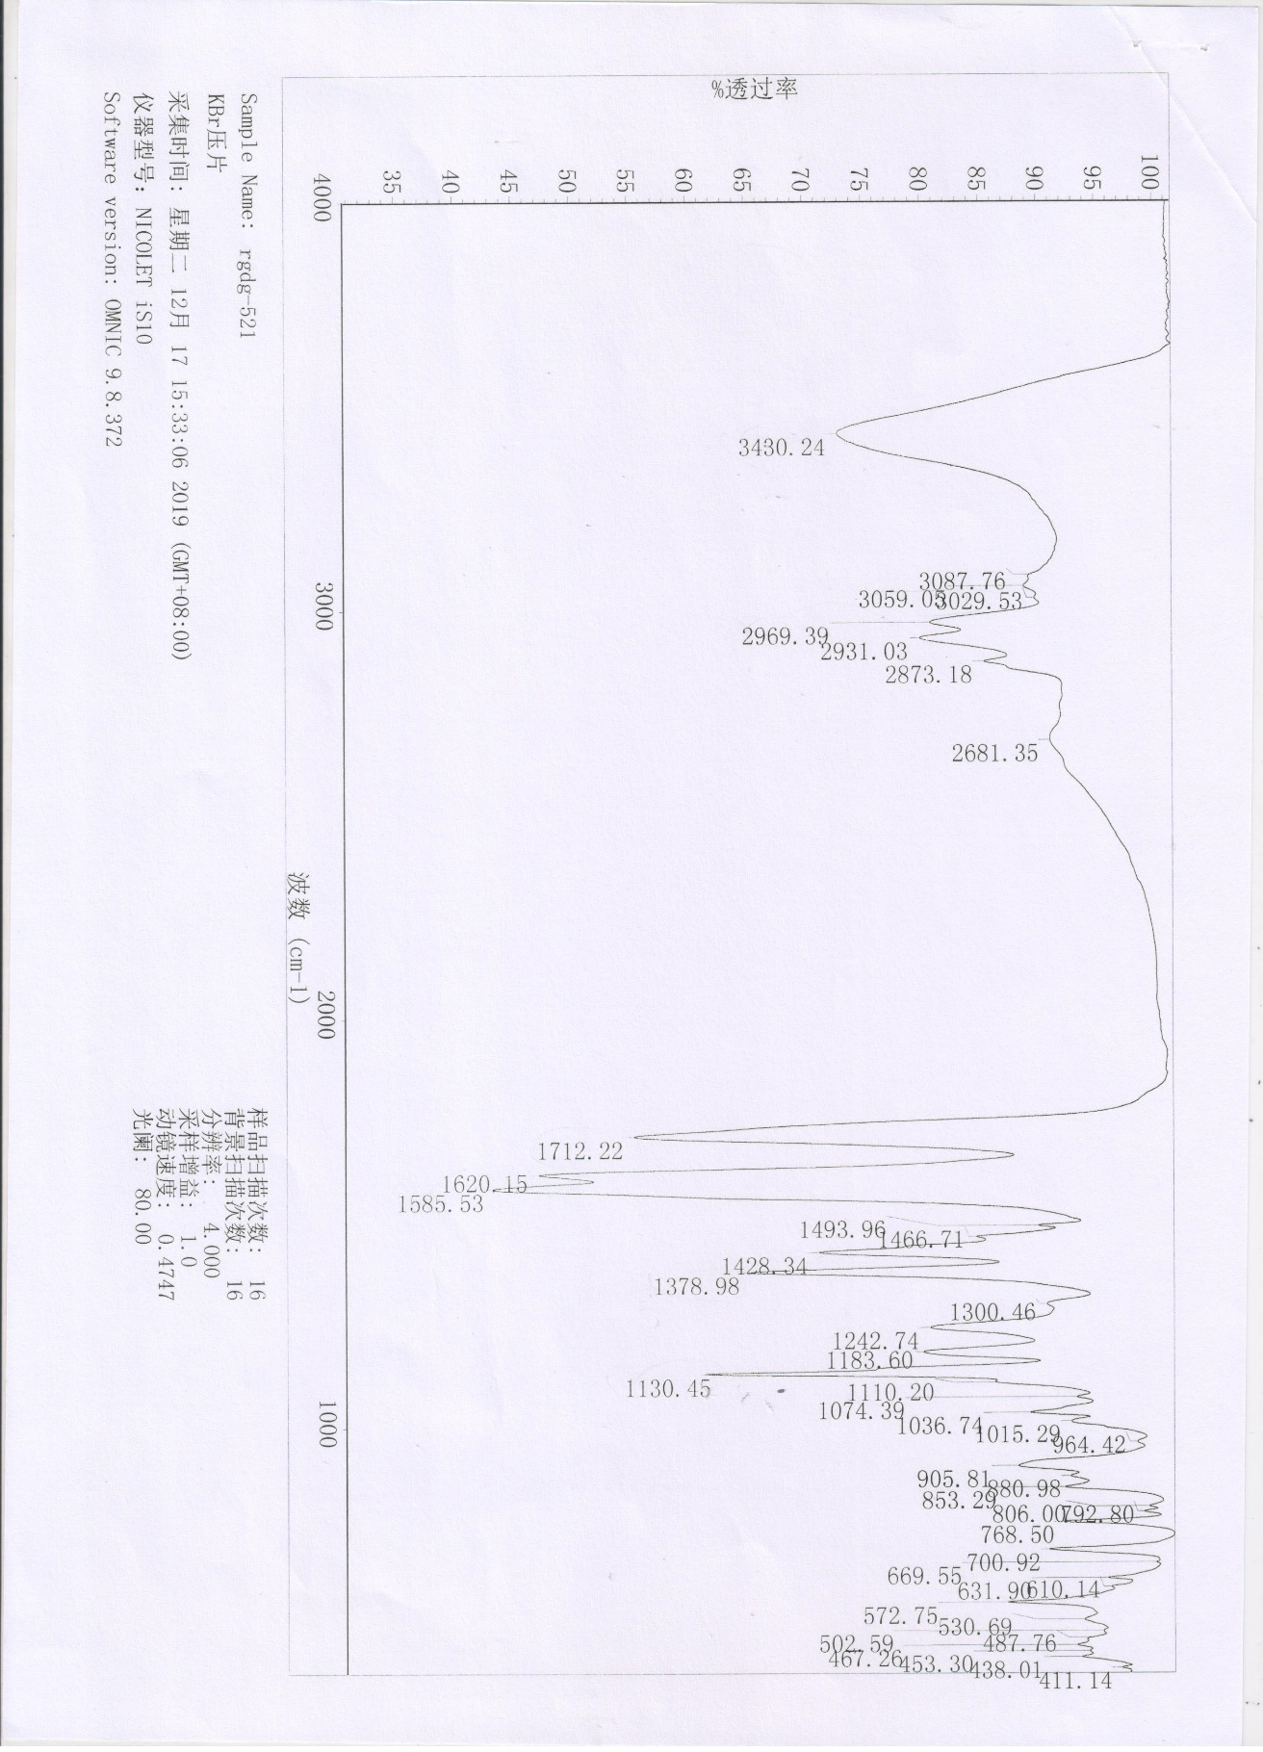

Figure S24. IR spectrum of mesuaferlinns C (3).

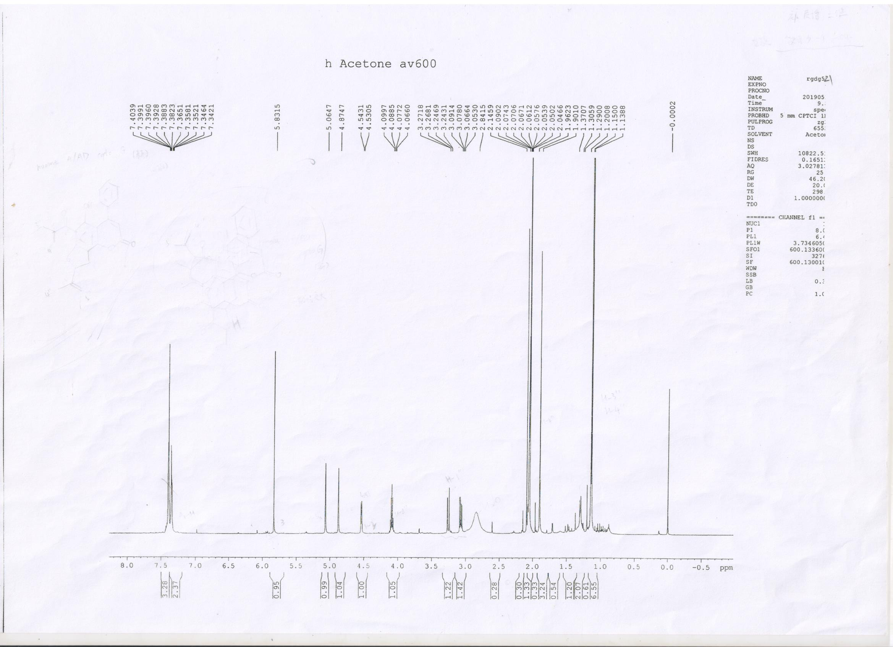

Figure S25. ¹H NMR spectrum of mesuaferlinns C (3) in Acetone-d₆.

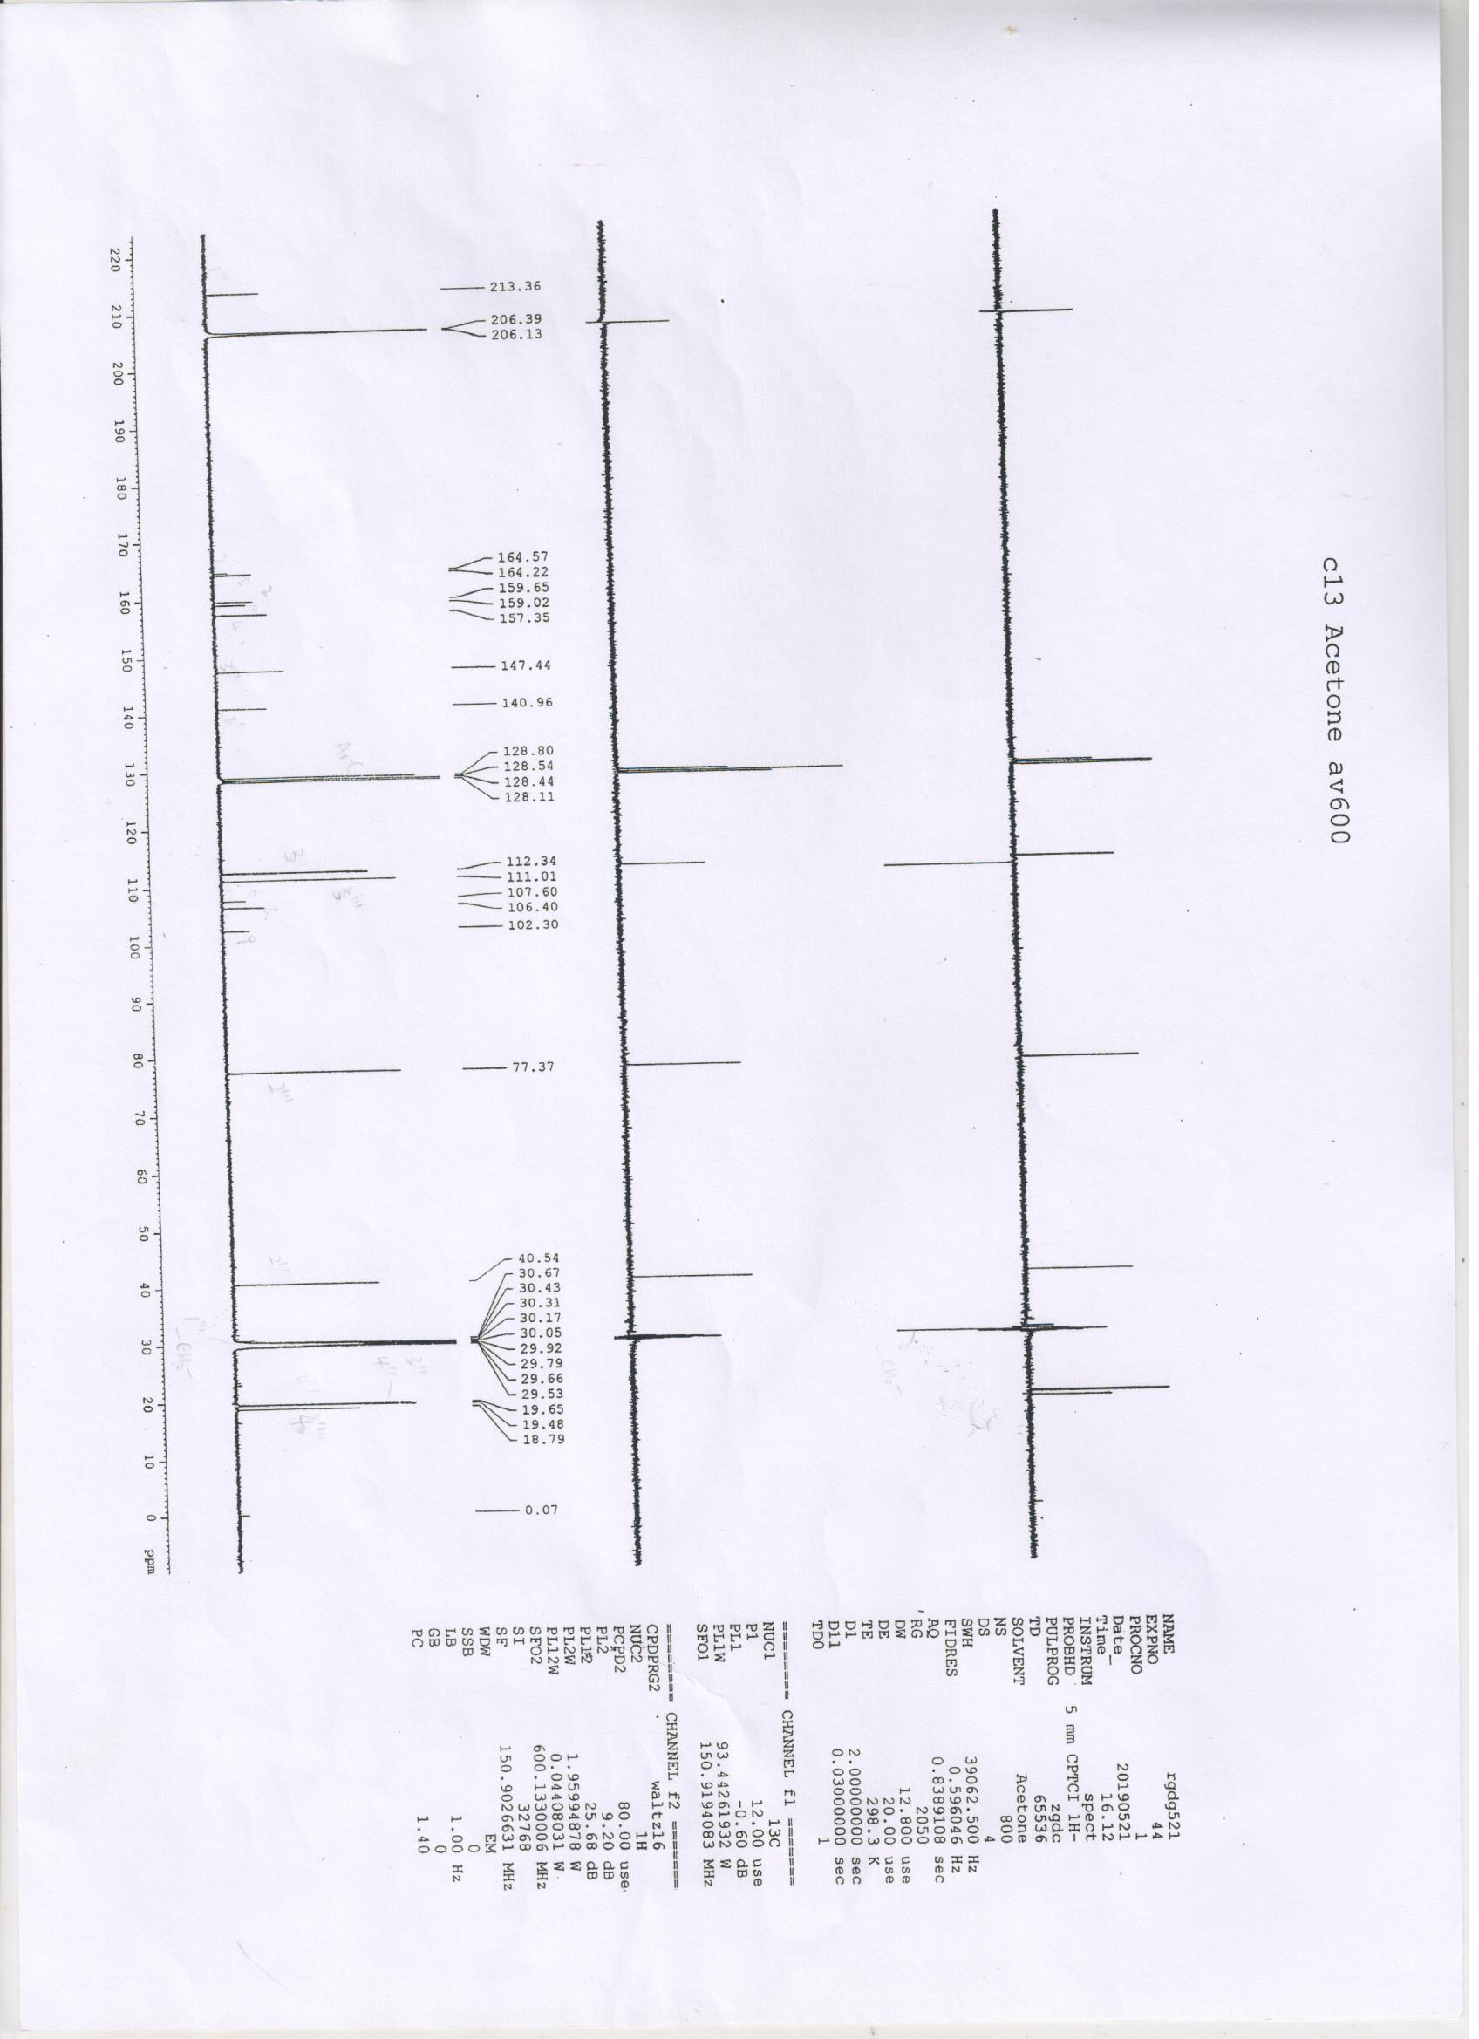

Figure S26. ¹³C NMR and DEPT spectrum of mesuaferlinns C (3) in Acetone-d₆.

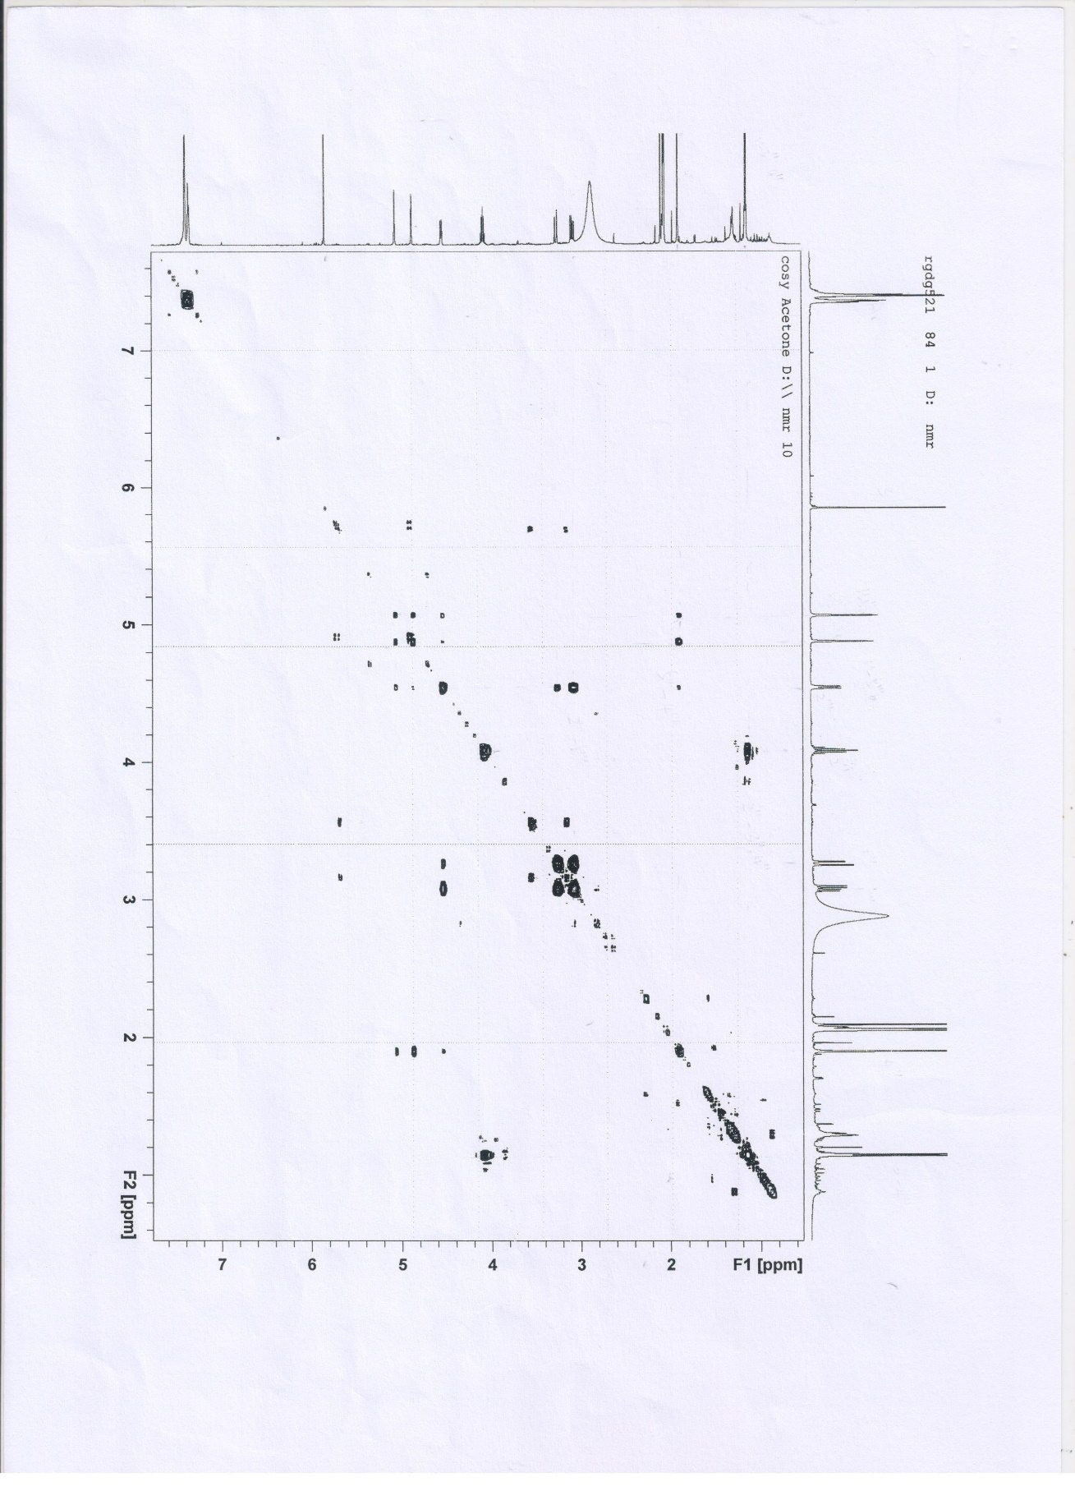

Figure S27. COSY spectrum of mesuaferlinns C (3) in Acetone-d₆.

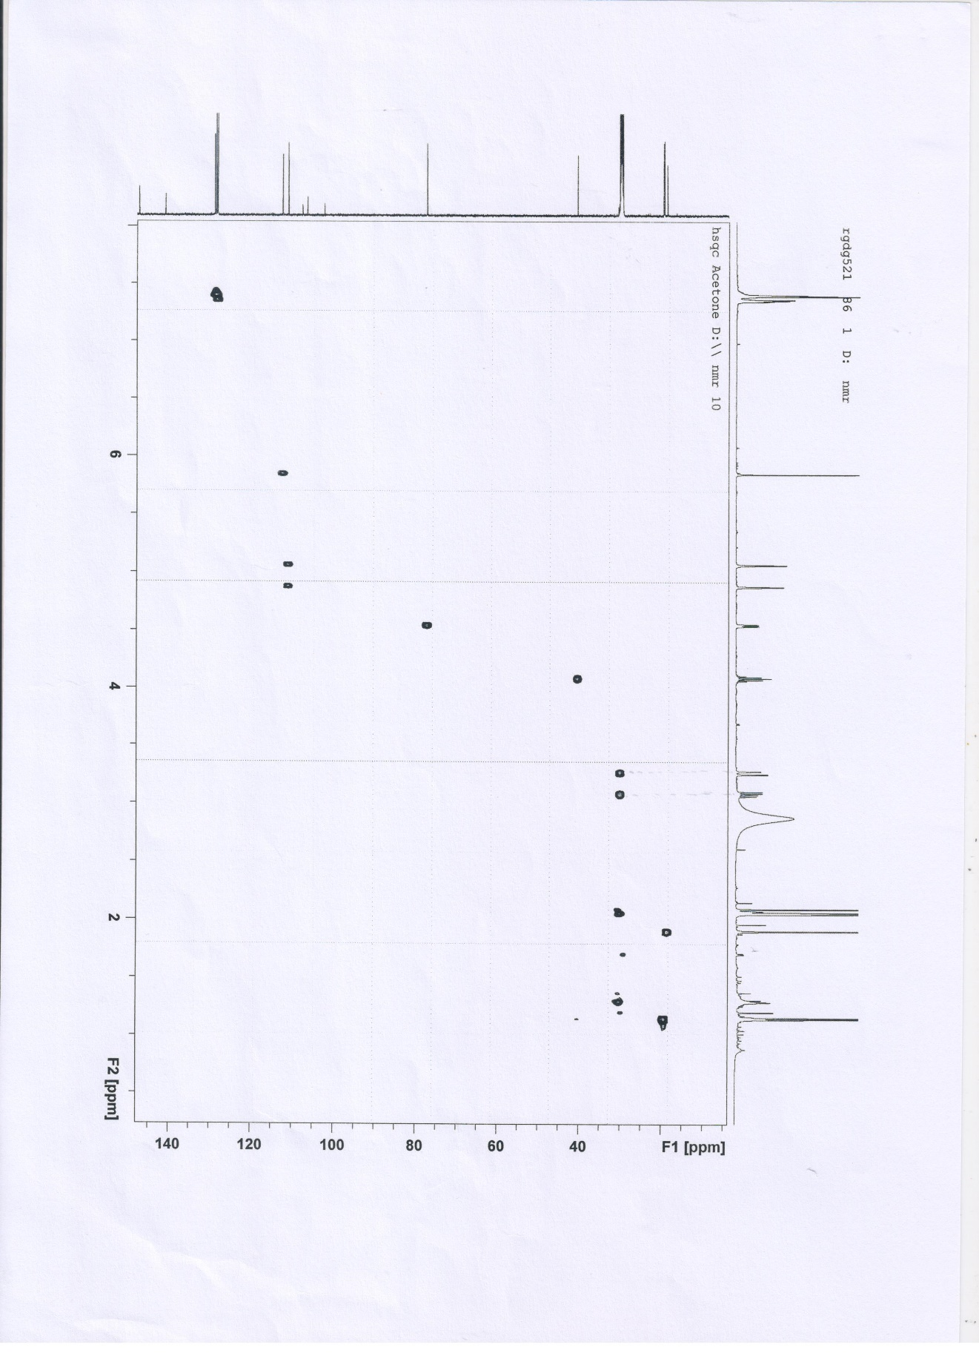

Figure S28. HSQC spectrum of mesuaferlinns C (3) in Acetone-d₆.

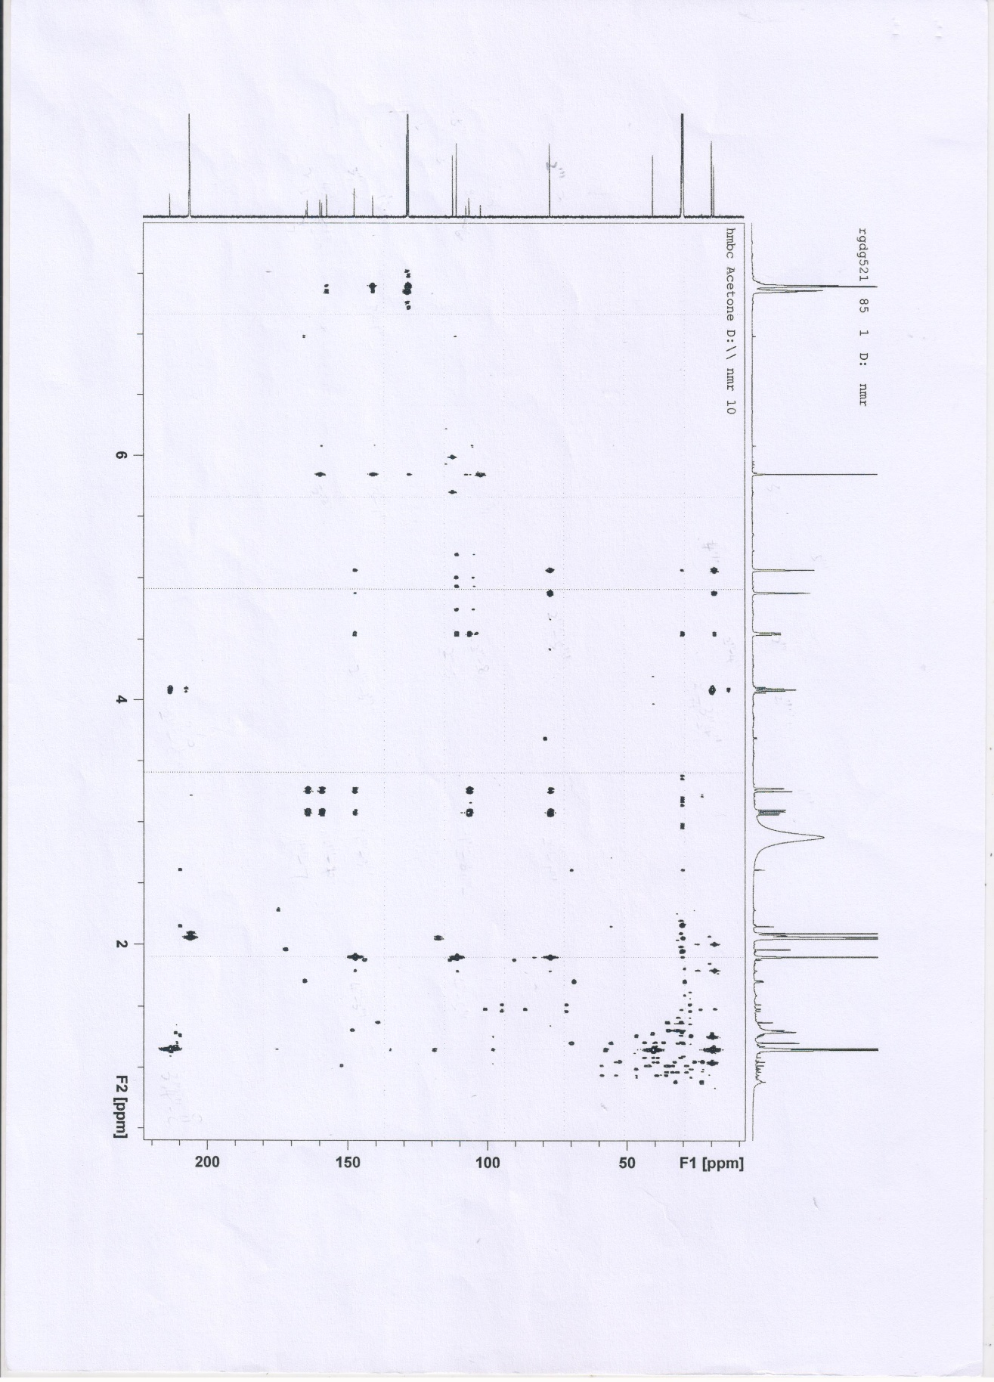

Figure S29. HMBC spectrum of mesuaferlinns C (3) in Acetone-d₆.

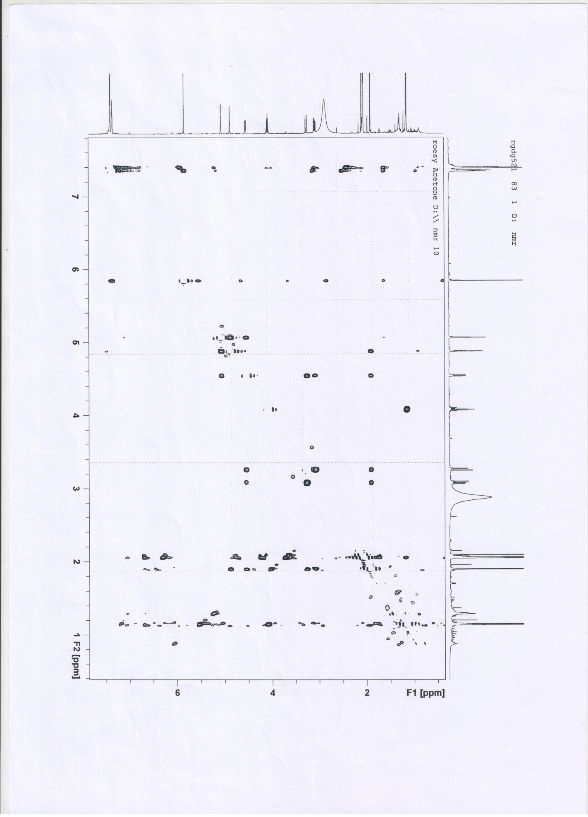

Figure S30. ROESY spectrum of mesuaferlinns C (3) in Acetone-d₆
Figure S31. QPCR result about the expression of CYP1A1 (n=4)
*P<0.05, compared with the control group, there is significant difference as indicated
Figure S32. Inhibitory activities of CYP1B1 with NADPH and without NADPH.
*P<0.05, compared with the control group, there is significant difference as indicated

