Highly Antibacterial Activity Against Methicillin-resistant Staphylococcus aureus of Silver Nanoparticles Synthesized by Citrus maxima Peel Extract

Thu Ha Bui¹, Ngoc Dai Nghia Tran¹, Phung Anh Nguyen², Nhat Linh Duong³, Van Minh Nguyen³,
Dinh Hong Nguyet Nguyen³, Phuong Thao Nguyen³, Trung Dang-Bao^{4,5}, Hong Phuong Phan^{4,5}, Tri Nguyen^{2,3*}

*Corresponding author: ntri@ict.vast.vn

EXPERIMENTAL

Materials

In this work, the Citrus maxima peel (CMP) was collected in Ben Tre province of Vietnam. After washing and shredding, CMP were dried at 60 °C for 24 hours. Afterward, CMP was milled and dispersed in deionized water with the CMP powder/deionized water ratio of 1/30 (w/v) and heated to 70 °C for 2 hours under stirring. Finally, the CMP extract was filtered, centrifuged to remove any suspended solids and then preserved at 4 °C for further experiments. Silver nitrate (AgNO₃, > 99.8%) was purchased from Merck and directly used without purifications.

Synthesis of silver nanoparticles

Inherited from our previous studies, in the biosynthesis AgNPs using various extract as a reducing agents, AgNPs using CMP extract will be synthesized under the light illumination and the stirring rate of 300 rpm at room temperature. The effects of synthetic conditions including the AgNO₃ concentration, the volume ratio of AgNO₃ solution/CMP extract, and the duration on AgNPs formation were also surveyed.

Characterization of silver nanoparticles

The formation of AgNPs in the aqueous solution was monitored by UV-Vis spectrophotometer (UV–1800, Shimadzu) at a wavelength of 200−800 nm. The samples were diluted 4 times before being analyzed. The presence of phytochemicals of CMP extract on the AgNPs surface was confirmed by Fourier transform infrared spectroscopy (FT-IR), carried out on a Tensor 27-Bruker spectrophotometer operating in the range of 400–4,000 cm⁻¹ at a resolution of 2 cm⁻¹. Crystalline phases of prepared AgNPs powder dried at 60 ºC were investigated by X–ray diffraction (XRD) using Bruker D2 Phaser powder diffractometer. The morphology of AgNPs was characterized by high-resolution transmission electron microscopy (HR-TEM) using JEOL JEM2100 instrument and EDS mapping and EDX spectrum on JEOL JST-IT 200 instrument. The size distribution and electrochemical equilibrium on interfaces and molecular vibrations were determined via particle size and zeta potential spectra using the Partica Horiba SZ-100 instrument.

Antibacterial activity of silver nanoparticles

The obtained AgNPs samples have been tested for antibacterial activity against Methicillin-resistant Staphylococcus aureus by the zone of inhibition test and the minimum inhibitory concentration (MIC) and minimum batericidal concentration (MBC).

RESULTS

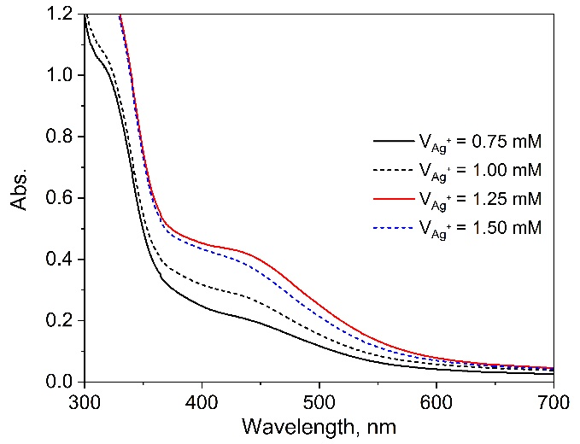 | 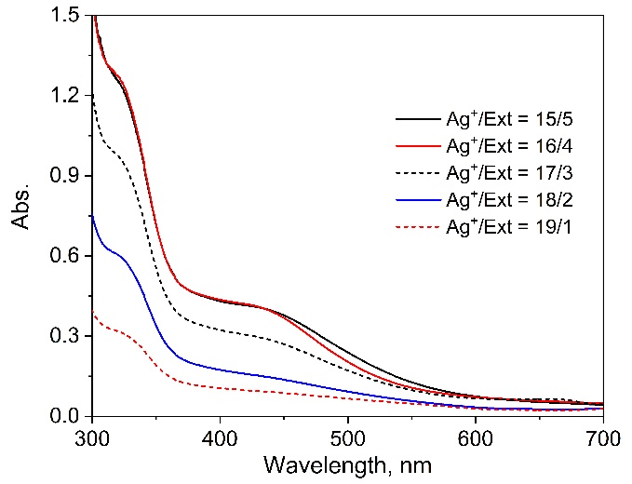
a) | b)
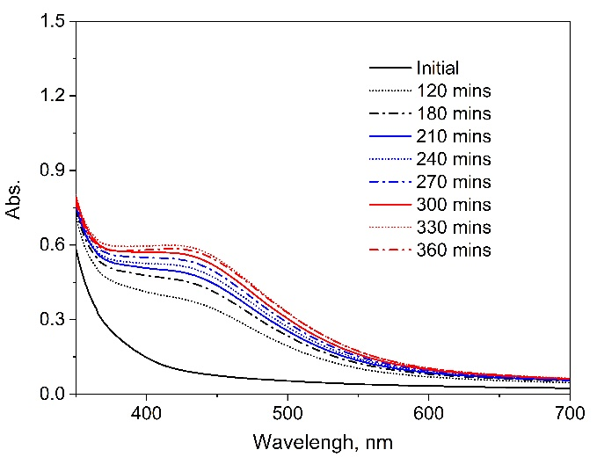
c)
Fig. S1 UV-Vis spectra of AgNPs solutions under various conditions: a) Effect of AgNO₃ concentration, b) Effect of V_{Ag+}/V_{Ext} volume ratio, c) Effect of synthesis duration

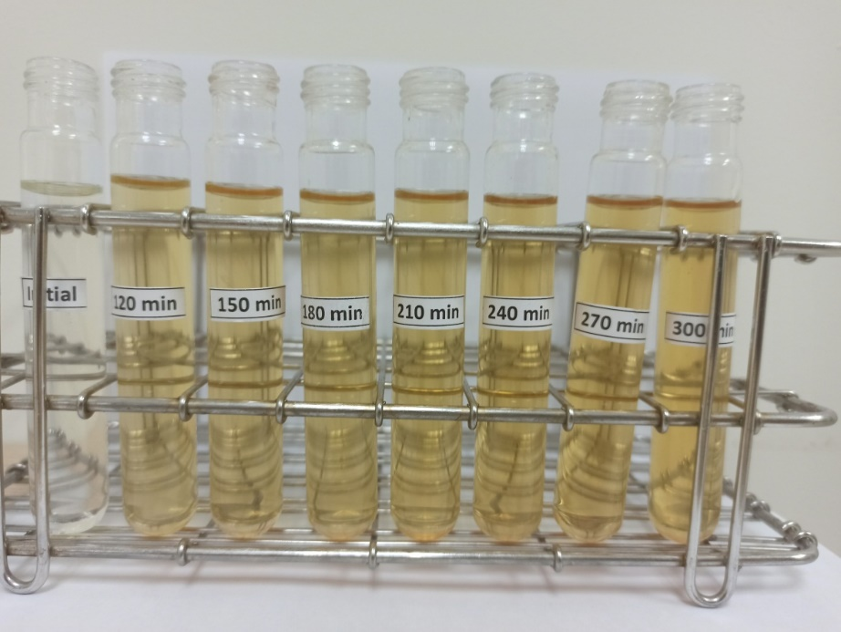
Fig. S2 The color changes of AgNPs solution (diluted 4 times) by the time.
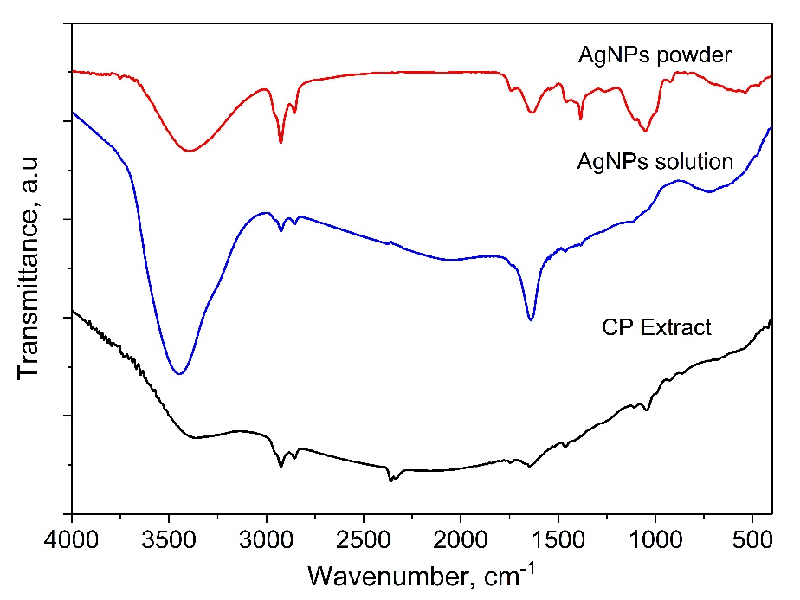

Fig. S3 FT-IR spectra of CMP extract and AgNPs synthesized at the optimized conditions.

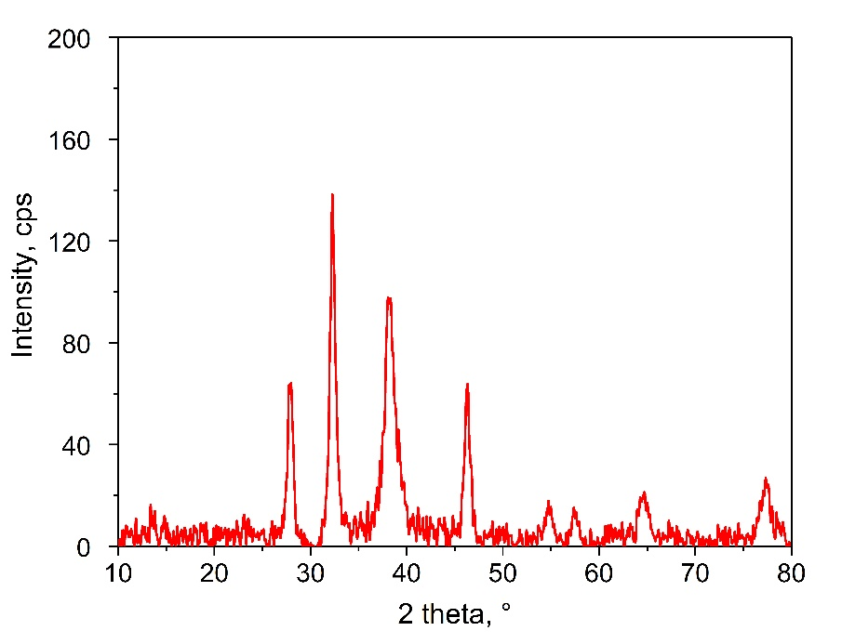
Fig. S4 XRD pattern of AgNPs synthesized at the optimized conditions.

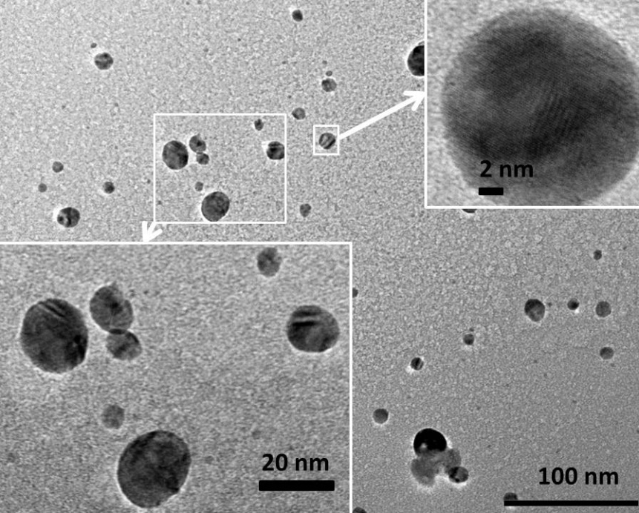
Fig. S5 HR-TEM images of AgNPs synthesized at the optimized conditions.

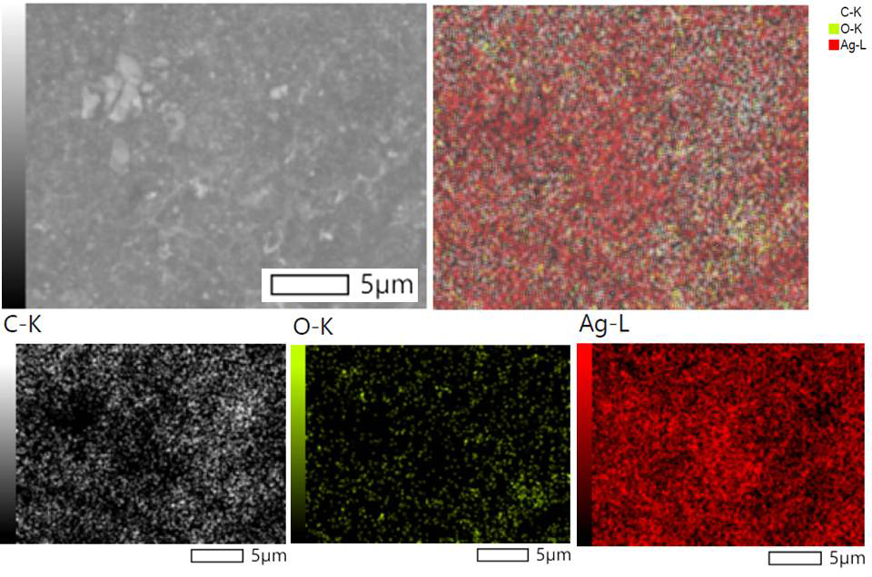
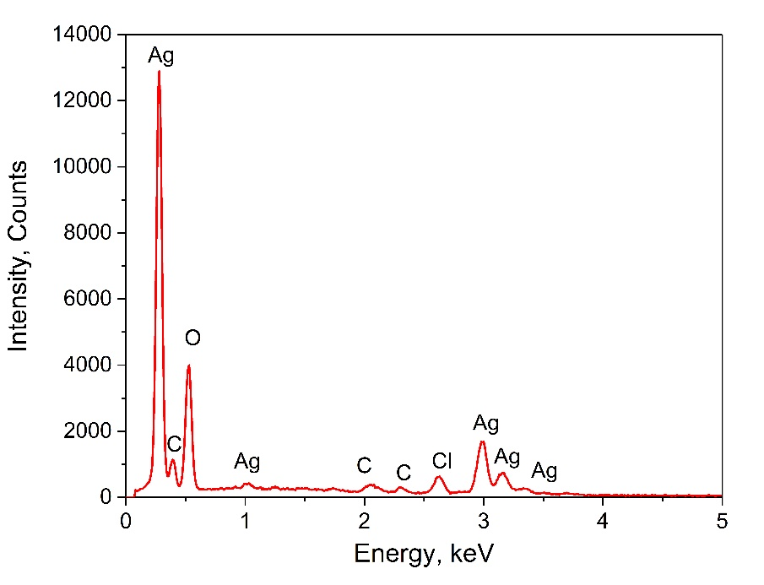b)
Fig. S6 EDS mapping (a) and EDX spectrum (b) of AgNPs synthesized at the optimized conditions.

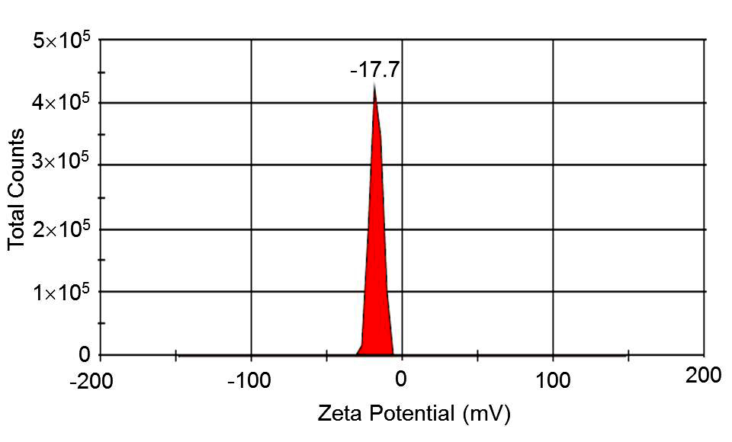
a)
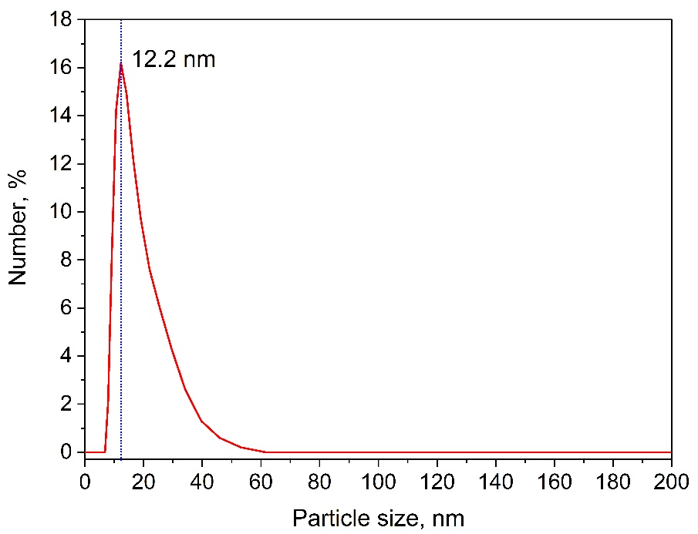 b)
Fig. S7 Zeta potential (a) and size distribution (b) of AgNPs synthesized at the optimized conditions.

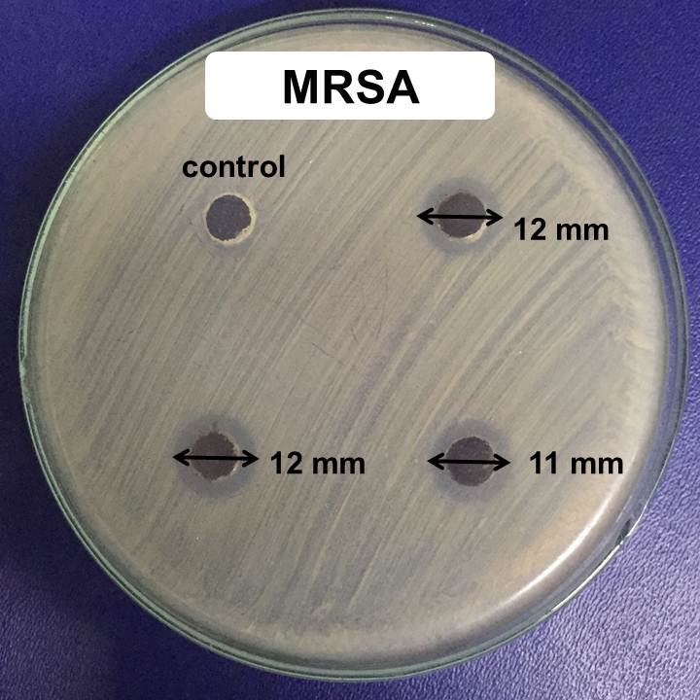
Fig. S8. Inhibition zone of AgNPs against Methicillin-resistant Staphylococcus aureus

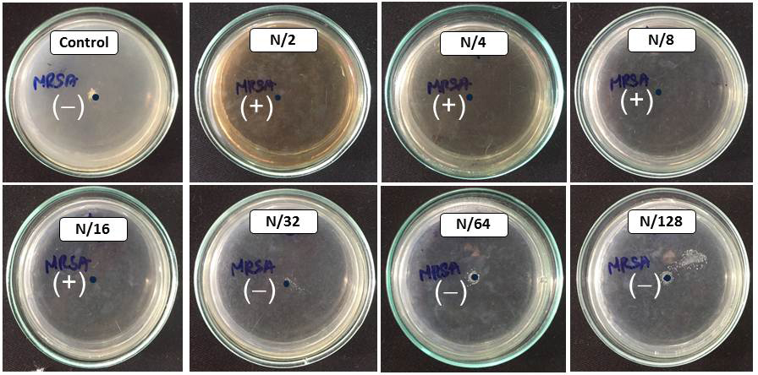
a)
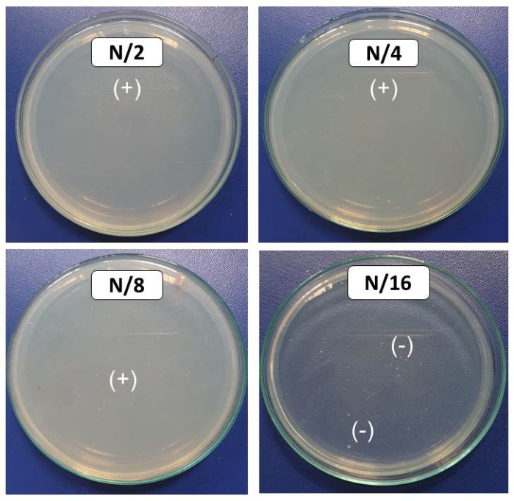
b)
Fig. S9 The minimum inhibitory concentration (a) and minimum batericidal concentration (b) of AgNPs against Methicillin-resistant Staphylococcus aureus

