Supplementary Table S1 Genomic information on strains used in this study.

Organism Name | Strain | Assembly | Size (Mb) |  | G+C%
escherichia coli  Ponticaulis-koreensi  Henriciella aquimari  Henriciella pelagia  Henriciella litorali  Henriciella marina  Henriciella algicola  Henriciella barbaren  Hyphomonas adhaerens  Hyphomonas jannaschiana  Hyphomonas atlantica  Hyphomonas pacifica  Hyphomonas beringens  Hyphomonas neptunium  Hyphomonas polymorph  Hyphomonas johnsonii  Hyphomonas oceanitis  Hyphomonas chukchien  Hyphomonas marinisedimentorum | JCM 1649^{T} | GCF_003697165.2 |  | 4.6 | 50.8
 | DSM 19734^{T} | GCF_000420665.1 |  | 3.4 | 54.8
 | LMG 24711^{T} | GCF_000376805.1 |  | 4.3 | 62.2
 | CGMCC 1.15928^{T} | GCF_002088945.1 |  | 3.4 | 59.9
 | DSM 22014^{T} | GCF_002088935.1 |  | 3.8 | 58.9
 | DSM 19595^{T} | GCF_000376805.1 |  | 3.3 | 59.9
 | CCUG67844^{T}  CCUG66934^{T}  MHS-3^{T}  VP2^{T}  22II1-22F38^{T}  T16B2  25B14_1^{T}  ATCC 15444^{T}  PS728^{T}  MHS-2^{T}  SCH89^{T}  BH-BN04-4^{T}  WL0036^{T} | GCF_003576245.1  GCF_003576345.1  GCF_000685235.1  GCF_000685215.1  GCF_000682715.1  GCF_000682675.1  GCF_000682755.1  GCF_000013025.1  GCF_000685315.1  GCF_000685275.1  GCF_000685295.1  GCF_000013025.1  GCF_019679475.1 |  | 3.2  3.3  3.7  3.6  3.6  3.4  3.8  3.7  4.1  3.6  4.3  3.9  3.5 | 60.4  59.2  61.3  61.4  58.2  58.5  58.4  61.9  62.3  62.5  60.2  61.0  61.8

Supplementary Table S2 Differential characteristics between strain WL0036^{T} and closely related species in BIOLOG GEN III micro test.
Characteristic | 1 | 2 | 3
Aztreonam | - | + | -
Fusidic acid | - | - | +
Lincomycin | - | + | +
D-Serine | - | + | -
Tetrazolium blue | - | + | +
Troleandomycin | - | + | +
Vancomycin | - | + | +
Assimilation of
Acetic acid | - | - | +
Acetoacetic acid | - | - | +
N-Acetyl-β-dmannosamine | - | + | -
N-Acetyl-D-glucosamine | - | + | -
L-Alanine | + | - | -
L-Aspartic acid | + | + | -
D-Cellobiose | - | + | -
D-Fructose-6-PO₄ | + | + | -
D-Fucose | + | + | -
L-Fucose | + | + | -
Gelatin | + | - | -
Gentiobiose | - | + | -
D-Glucose-6-PO₄ | - | + | -
Glycyl-L-proline | + | + | -
L-Histidine | + | + | -
α-Keto-butyric acid | - | - | +
α-Keto-glutaric acid | + | - | +
L-Lactic acid | - | - | +
D-Malic acid | - | + | +
L-Malic acid | - | + | +
D-Melibiose | - | + | -
β-Methyl-D-glucoside | - | + | -
Methyl-pyruvate | - | - | +
L-Rhamnose | - | + | -
Taxa: 1, WL0036^{T}; 2, Hyphomonas neptunium ATCC 15444^{T}; 3, Hyphomonas polymorpha PS728^{T}. +, positive; -, negative. All data from this study.
BIOLOG GEN III micro tests, strain WL0036^{T}, Hyphomonas neptunium ATCC 15444^{T} and Hyphomonas polymorpha PS728^{T} were all negative for utilization of the following as carbon sources: N-acetyl neuraminic acid, N-acetyl-D-galactosamine, γ-amino-butryric acid, L-arginine, D-aspartic acid, D-atrabitol, bromo-succinic acid, citric acid, dextrin, formic acid, D-fructose, D-galactose, L-galactonic acid lactone, D-galacturonic acid, D-gluconic acid, α-D-glucose, D-glucuronic acid, glucuronamide, glycerol, α-hydroxy-butyric acid, p-hydroxy-phenylacetic acid, inosine, D-lactic acid methyl ester, α-D-lactose, D-maltose, D-mannitol, D-mannose, 3-methyl glucose, mucic acid, myo-inositol, pectin, propionic acid, L-pyroglutamic acid, quinic acid, D-raffinose, D-saccharic acid, D-salicin, D-serine, D-sorbitol, stachyose, sucrose, D-trehalose and D-turanose. All strains were positive for utilization of the following as carbon sources: L-glutamic acid, β-hydroxy-D,L butyric acid, L-serine and tween 40.
Strain WL0036^{T}, Hyphomonas neptunium ATCC 15444^{T} and Hyphomonas polymorpha PS728^{T} were not resistant to guanidine HCl, minocycline, niaproof 4, sodium bromate, 1% sodium lactate and tetrazolium violet. All strains were resistant to lithium chloride, potassium tellurite, rifamycin SV, sodium butyrate and tonalidixic acid.

Supplementary Table S3 The compositions (%) of cellular fatty acid contents (>1%) of bacterium WL0036^{T} and closely related species.
Fatty acid | 1 | 2 | 3
Straight-chain
C_{16:0} | 27.58 | 26.36 | 10.8
C_{17:0} | 4.79 | 6.15 | 19.52
C_{18:0} | 1.39 | 1.27 | 1.54
Unsaturated
C_{17:1}ω8c | 4.2 | 6.36 | 14.29
C_{17:1}ω6c | 2.04 | 1.38 | 8.53
Branched
iso-C_{15:0} | 1.2 | - | -
anteiso-C_{15:0} | 1.5 | - | -
Hydroxy
C_{12:1} 3-OH | 1.36 | - | -
11-methyl-C_{18:1}ω7c | 12.09 | 15.35 | 10.85
Summed features
3 | 3.36 | 5.01 | -
4 | 1.04 | 1.5 | 1.18
8 | 35.04 | 31.28 | 29.01

Taxa: 1, WL0036^{T}; 2, Hyphomonas neptunium MCCC 1A09418^{T}; 3, Hyphomonas polymorpha DSM 2665^{T}. All data from this study. Values are shown as percentages; fatty acids amounting to less than 1.0% in all strains are not shown. -, not detected or trace amount (less than 1%).
Summed features represent two or three fatty acids that cannot be separated by the Microbial Identification System. Summed feature 3 contained C_{16:1} ω7c and/or C_{16:1} ω6c. Summed feature 4 contained iso-C_{17:1} and/or anteiso-C_{17:1}. Summed feature 8 contained C_{18:1}ω6c and/or C_{18:1}ω7c.

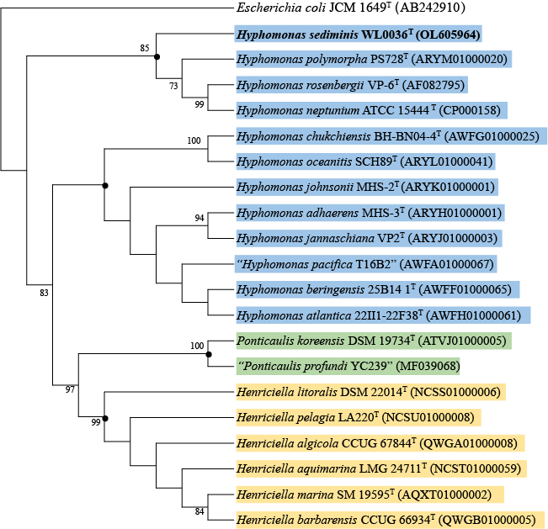
Supplementary Fig. S1 Maximum-parsimony phylogenetic tree based on 16S rRNA gene sequence showing the relationship between strain WL0036^{T} and its closest relatives. Bootstrap values (expressed as percentages of 1000 replications) of above 70% are shown at the branch nodes. The black dots indicate branches that were also recovered using the minimum-evolution and neighbor-joining methods. The GenBank/EMBL/DDBJ accession numbers are indicated in the brackets at the end of the tip labels. Escherichia coli JCM 1649^{T} is used as out group.

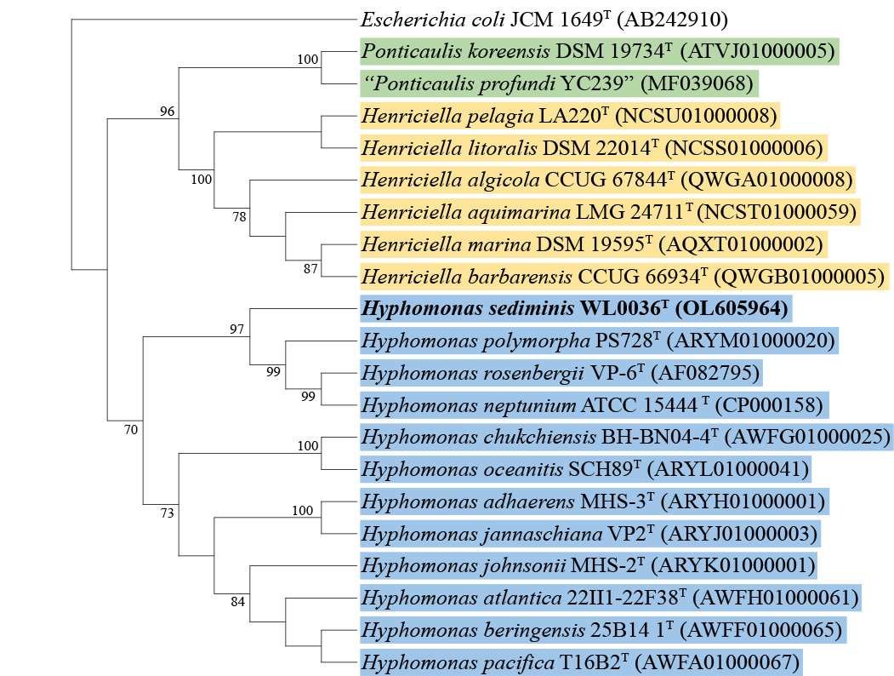
Supplementary Fig. S2 Minimum-evolution phylogenetic tree based on 16S rRNA gene sequence showing the relationship between strain WL0036^{T} and its closest relatives. Bootstrap values (expressed as percentages of 1000 replications) of above 70% are shown at the branch nodes. The black dots indicate branches that were also recovered using the maximum-parsimony and neighbor-joining methods. The GenBank/EMBL/DDBJ accession numbers are indicated in the brackets at the end of the tip labels. Escherichia coli JCM 1649^{T} is used as out group.

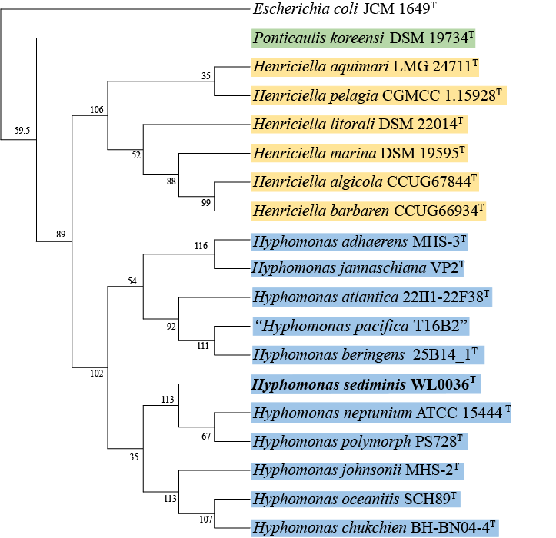

Supplementary Fig. S3 Supertree showing the phylogenetic relationship of strain WL0036^{T} and its closest relatives. The tree was generated from maximum-likelihood trees based on each of 119 hourse-keeping genes universally present in all the taxa. Branching confidence was indicated by frequency of gene number (119 gene in total). Escherichia coli JCM 1649^{T} is used as out group. The accession number of the strain is listed in Table S1.

Supplementary Fig. S4 Transmission electron microscopy showing cell of strain WL0036^{T} after being grown on TSA agar medium with 2.5% sea salt for 2 days at 28 °C.
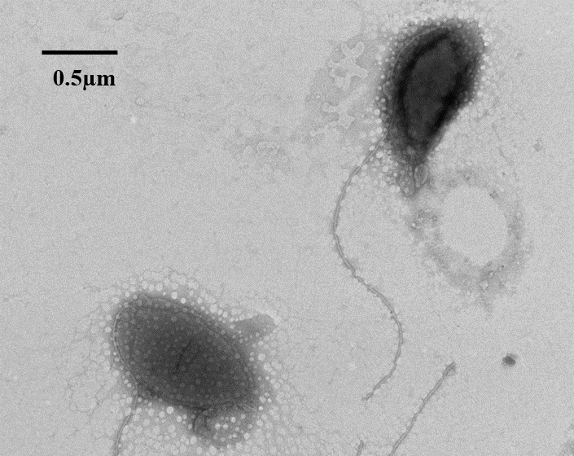

Supplementary Fig. S5 Two-dimensional thin-layer chromatogram of all polar lipids in the cells of strain WL0036^{T} and its reference strain. a, WL0036^{T}; b, Hyphomonas neptunium MCCC 1A09418^{T}; c, Hyphomonas polymorpha DSM 2665^{T}.
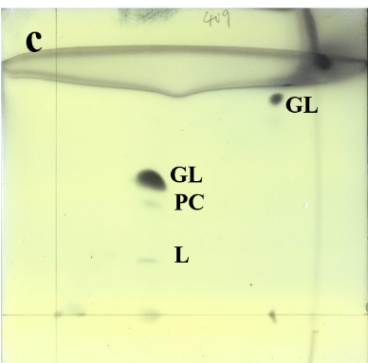
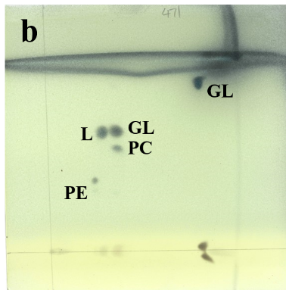
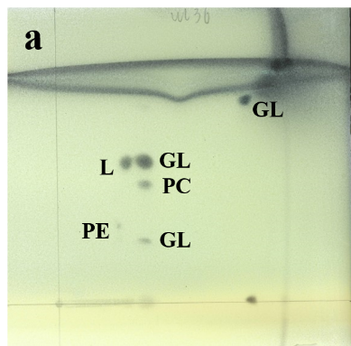
PC, phosphatidylcholine; PE, phosphatidylethanolamine; GL, glycolipid; L, unidentified lipid.

