Supplementary
Search strategy
PubMed
No. | Query | Results | Date
#1 | relapsed Filters: Clinical Trial, in the last 10 years | 17905 | 25-Jan-21
#2 | refractory Filters: Clinical Trial, in the last 10 years | 5351 | 25-Jan-21
#3 | #1 OR #2 | 20994 | 25-Jan-21
#4 | (Lymphoma, Large Lymphoid, Diffuse [Title/Abstract]) OR (Lymphoma, Histiocytic, Diffuse [Title/Abstract]) OR (Lymphoma, Large Cell, Diffuse [Title/Abstract]) OR (Lymphoma, Large-Cell, Diffuse [Title/Abstract]) OR (Lymphoma, Diffuse Large-Cell [Title/Abstract]) OR (Lymphoma, Diffuse Large Cell [Title/Abstract]) OR (Diffuse, Large B-Cell, Lymphoma [Title/Abstract]) OR (Histiocytic Lymphoma [Title/Abstract]) OR (Histiocytic Lymphomas [Title/Abstract]) OR (Lymphomas, Histiocytic [Title/Abstract]) OR (Histiocytic Lymphoma, Diffuse [Title/Abstract]) OR (Diffuse Histiocytic Lymphoma [Title/Abstract]) OR (Diffuse Histiocytic Lymphomas [Title/Abstract]) OR (Histiocytic Lymphomas, Diffuse [Title/Abstract]) OR (Lymphoma, Diffuse Histiocytic [Title/Abstract]) OR (Lymphomas, Diffuse Histiocytic [Title/Abstract]) OR (Large Lymphoid Lymphoma, Diffuse [Title/Abstract]) OR (Large-Cell Lymphoma, Diffuse [Title/Abstract]) OR (Large Cell Lymphoma, Diffuse [Title/Abstract]) OR (Lymphoma, Histiocytic [Title/Abstract]) OR (Diffuse Large-Cell Lymphoma [Title/Abstract]) OR (Diffuse Large Cell Lymphoma [Title/Abstract]) OR (Diffuse Large-Cell Lymphomas [Title/Abstract]) OR (Diffuse Large Cell Lymphomas [Title/Abstract]) OR (Large-Cell Lymphomas, Diffuse [Title/Abstract]) OR (Lymphomas, Diffuse Large-Cell [Title/Abstract]) Filters: Clinical Trial, in the last 10 years | 495 | 25-Jan-21
#5 | #3 AND #4 | 233 | 25-Jan-21

Embase
No. | Query | Results | Date
#1 | ('refractory':ab,ti OR 'relapsed':ab,ti) AND [2010-2021]/py | 170893 | 25-Jan-21
#2 | ('lymphoma, large lymphoid, diffuse':ab,ti OR 'lymphoma, histiocytic, diffuse':ab,ti OR 'lymphoma, large cell, diffuse':ab,ti OR 'lymphoma, large-cell, diffuse':ab,ti OR 'lymphoma, diffuse large-cell':ab,ti OR 'lymphoma, diffuse large cell':ab,ti OR 'diffuse, large b-cell, lymphoma':ab,ti OR 'histiocytic lymphoma':ab,ti OR 'histiocytic lymphomas':ab,ti OR 'lymphomas, histiocytic':ab,ti OR 'diffuse histiocytic lymphoma':ab,ti OR 'histiocytic lymphoma, diffuse':ab,ti OR 'diffuse histiocytic lymphomas':ab,ti OR 'histiocytic lymphomas, diffuse':ab,ti OR 'lymphoma, diffuse histiocytic':ab,ti OR 'lymphomas, diffuse histiocytic':ab,ti OR 'large lymphoid lymphoma, diffuse':ab,ti OR 'large-cell lymphoma, diffuse':ab,ti OR 'large cell lymphoma, diffuse':ab,ti OR 'lymphoma, histiocytic':ab,ti OR 'diffuse large-cell lymphoma':ab,ti OR 'diffuse large cell lymphoma':ab,ti OR 'diffuse large-cell lymphomas':ab,ti OR 'diffuse large cell lymphomas':ab,ti OR 'large-cell lymphomas, diffuse':ab,ti OR 'lymphomas, diffuse large-cell':ab,ti) AND [2010-2021]/py AND ('clinical study'/de OR 'clinical trial'/de OR 'phase 1 clinical trial'/de OR 'phase 2 clinical trial'/de OR 'phase 3 clinical trial'/de) AND 'article'/it | 433 | 25-Jan-21
#3 | #1 AND #2 | 194 | 25-Jan-21

Cochran library
No. | Query | Results | Date
#1 | (Relapsed):ti,ab,kw | 8683 | 25-Jan-21
#2 | (Refractory):ti,ab,kw | 18003 | 25-Jan-21
#3 | #1 OR #2 | 22839 | 25-Jan-21
#4 | (Large-Cell Lymphomas, Diffuse):ti,ab,kw OR (Lymphoma, Large B-Cell, Diffuse):ti,ab,kw OR (Lymphoma, Diffuse Large Cell):ti,ab,kw OR (Diffuse, Large B-Cell, Lymphoma):ti,ab,kw OR (Large Lymphoid Lymphoma, Diffuse):ti,ab,kw OR (Diffuse Large Cell Lymphoma):ti,ab,kw OR (Large Cell Lymphoma, Diffuse):ti,ab,kw OR (Histiocytic Lymphomas):ti,ab,kw OR (Lymphoma, Diffuse Histiocytic):ti,ab,kw OR (Diffuse Large-Cell Lymphomas):ti,ab,kw OR (Histiocytic Lymphoma, Diffuse):ti,ab,kw OR (Histiocytic Lymphoma):ti,ab,kw OR (Histiocytic Lymphomas, Diffuse):ti,ab,kw OR (Lymphomas, Diffuse Histiocytic):ti,ab,kw OR (Diffuse Large-Cell Lymphoma):ti,ab,kw OR (Lymphoma, Histiocytic):ti,ab,kw OR (Lymphoma, Large-Cell, Diffuse):ti,ab,kw OR (Lymphoma, Large Cell, Diffuse):ti,ab,kw OR (Large-Cell Lymphoma, Diffuse):ti,ab,kw OR (Lymphomas, Diffuse Large-Cell):ti,ab,kw OR (Lymphoma, Histiocytic):ti,ab,kw OR (Lymphoma, Large-Cell, Diffuse):ti,ab,kw OR (Lymphoma, Large Cell, Diffuse):ti,ab,kw OR (Large-Cell Lymphoma, Diffuse):ti,ab,kw OR (Lymphomas, Diffuse Large-Cell):ti,ab,kw OR (Lymphoma, Histiocytic, Diffuse):ti,ab,kw | 1560 | 25-Jan-21
#5 | #3 AND #4 with Cochrane Library publication date from Jan 2010 to Feb 2021, in Trials | 427 | 25-Jan-21

List of included studies
[1] Neelapu Sattva S., Locke Frederick L., Bartlett Nancy L., Lekakis Lazaros J., Miklos David B., Jacobson Caron A., et al.(2017). Axicabtagene Ciloleucel CAR T-Cell Therapy in Refractory Large B-Cell Lymphoma. N Engl J Med, 377(26), 2531-2544.
[2] Czuczman, M. S. , Marek Trněný, Davies, A. , Rule, S. , Linton, K. M. , & Wagnerjohnston, N. , et al. (2017). A Phase 2/3 Multicenter, Randomized, Open-Label Study to Compare the Efficacy and Safety of Lenalidomide Versus Investigator's Choice in Patients with Relapsed or Refractory Diffuse Large B-Cell Lymphoma.
[3] Jurczak, W. , Zinzani, P. L. , Gaidano, G. , Goy, A. , Provencio, M. , & Nagy, Z. , et al. (2018). Phase iia study of the cd19 antibody mor208 in patients with relapsed or refractory b-cell non-hodgkin's lymphoma. Annals of Oncology.
[4] Salles, G. , Duell, J. , Barca, E. G. , Tournilhac, O. , & Maddocks, K. . (2020). Tafasitamab plus lenalidomide in relapsed or refractory diffuse large b-cell lymphoma (l-mind): a multicentre, prospective, single-arm, phase 2 study. The Lancet Oncology, 21(7).
[5] Schuster Stephen J., Svoboda Jakub., Chong Elise A., Nasta Sunita D., Mato Anthony R., Anak Özlem., et al. (2017). Chimeric Antigen Receptor T Cells in Refractory B-Cell Lymphomas. N Engl J Med, 377(26), 2545-2554.
[6] Wang M., Fowler N., Wagner-Bartak N., Feng L., Romaguera J., Neelapu S S., et al. (2013). Oral lenalidomide with rituximab in relapsed or refractory diffuse large cell, follicular and transformed lymphoma: a phase II clinical trial. Leukemia, 27(9), 1902-9.
[7] Herrera Alex F., Goy Andre., Mehta Amitkumar., Ramchandren Radhakrishnan., Pagel John M., Svoboda Jakub., et al. (2020). Safety and activity of ibrutinib in combination with durvalumab in patients with relapsed or refractory follicular lymphoma or diffuse large B-cell lymphoma. Am J Hematol, 95(1), 18-27.
[8] Ansell, S. M. , Minnema, M. C. , Johnson, P. , Timmerman, J. M. , Armand, P. , & Shipp, M. A. , et al. (2019). Nivolumab for relapsed/refractory diffuse large b-cell lymphoma in patients ineligible for or having failed autologous transplantation: a single-arm, phase ii study. Journal of Clinical Oncology, 37(6), JCO.18.00766.
[9] Viardot Andreas., Goebeler Marie-Elisabeth., Hess Georg., Neumann Svenja., Pfreundschuh Michael., Adrian Nicole., et al. (2016). Phase 2 study of the bispecific T-cell engager (BiTE) antibody blinatumomab in relapsed/refractory diffuse large B-cell lymphoma. Blood, 127(11), 1410-6.
[10] Mounier, N. , El Gnaoui, T. , Tilly, H. , Canioni, D. , Sebban, C. , & Casasnovas, R. O. , et al. (2013). Rituximab plus gemcitabine and oxaliplatin in patients with refractory/relapsed diffuse large b-cell lymphoma who are not candidates for high-dose therapy. a phase ii lymphoma study association trial. Haematologica, 98(11), 1726-1731.
[11] Advani, R. , Flinn, I. , Popplewell, L. , Forero, A. , Bartlett, N. L. , & Ghosh, N. , et al. (2018). Cd47 blockade by hu5f9-g4 and rituximab in non-hodgkin's lymphoma. The New England journal of medicine, 379(18), 1711.
[12] De, V. S. , Swinnen, L. J. , Wang, D. , Reid, E. , Fowler, N. , & Cordero, J. , et al. (2018). Venetoclax, bendamustine, and rituximab in patients with relapsed or refractory nhl: a phase ib dose-finding study. Annals of Oncology, 29, 1932-1938.
[13] Ohmachi Ken., Niitsu Nozomi., Uchida Toshiki., Kim Seok Jin., Ando Kiyoshi., Takahashi Naoki., et al. (2013). Multicenter phase II study of bendamustine plus rituximab in patients with relapsed or refractory diffuse large B-cell lymphoma. J Clin Oncol, 31(17), 2103-9.
[14] Gilles, Salles, Ajay, K, Gopal, & Monique, et al. (2019). Phase 2 study of daratumumab in relapsed/refractory mantle-cell lymphoma, diffuse large b-cell lymphoma, and follicular lymphoma. Clinical Lymphoma Myeloma & Leukemia.
[15] Trnĕný Marek., Verhoef Gregor., Dyer Martin Js., Ben Yehuda Dina., Patti Caterina., Canales Miguel. , et al. (2018). A phase II multicenter study of the anti-CD19 antibody drug conjugate coltuximab ravtansine (SAR3419) in patients with relapsed or refractory diffuse large B-cell lymphoma previously treated with rituximab-based immunotherapy. Haematologica, 103(8), 1351-1358.
[16] Phillips, T. J. , Forero-Torres, A. , Sher, T. , Diefenbach, C. S. , Johnston, P. , & Talpaz, M. , et al. (2018). Phase 1 study of the pi3kd inhibitor incb040093 6 jak1 inhibitor itacitinib in relapsed/refractory b-cell lymphoma. Blood, blood-2017-10-812701.
[17] Holkova, B. , Perkins, E. B. , & Sokol, L. . (2018). A phase ii trial of bortezomib and vorinostat in mantle cell lymphoma and diffuse large b-cell lymphoma. Clinical Lymphoma Myeloma & Leukemia, 118(21), 353-354.
[18] Zaja Francesco., Salvi Flavia., Rossi Maura., Sabattini Elena., Evangelista Andrea., Ciccone Giovannino., et al.(2018). Single-agent panobinostat for relapsed/refractory diffuse large B-cell lymphoma: clinical outcome and correlation with genomic data. A phase 2 study of the Fondazione Italiana Linfomi. Leuk Lymphoma, 59(12), 2904-2910.
[19] Stathis, A. , Flinn, I. W. , Madan, S. , Maddocks, K. , Freedman, A. , & Weitman, S. , et al. (2018). Safety, tolerability, and preliminary activity of imgn529, a cd37-targeted antibody-drug conjugate, in patients with relapsed or refractory b-cell non-hodgkin lymphoma: a dose-escalation, phase i study. Investigational New Drugs.
[20] Kalakonda, N. , Maerevoet, M. , Cavallo, F. , Follows, G. , & Canales, M. A. . (2020). Selinexor in patients with relapsed or refractory diffuse large b-cell lymphoma (sadal): a single-arm, multinational, multicentre, open-label, phase 2 trial. The Lancet Haematology, 7(7), e511-e522.
[21] Vacirca, J. L. , Acs, P. I. , Tabbara, I. A. , Rosen, P. J. , Lee, P. , & Lynam, E. . (2014). Bendamustine combined with rituximab for patients with relapsed or refractory diffuse large b cell lymphoma. Annals of Hematology, 93(3), 403-409.
[22] Kuhnl, A. , Peckitt, C. , Patel, B. , Ardeshna, K. M. , Macheta, M. P. , & Radford, J. , et al. (2017). R-GEM-Lenalidomide Versus R-GEM-P As Second-Line Treatment of Diffuse Large B-Cell Lymphoma: Results from the UK NCRI Phase II Randomized Legend Trial.
[23] Eric, D, Jacobsen, Jeff, P, & Sharman, et al. (2015). Brentuximab vedotin demonstrates objective responses in a phase 2 study of relapsed/refractory dlbcl with variable cd30 expression. Blood.
[24] A Martín, Redondo, A. M. , Dlouhy, I. , Salar, A. , E González-Barca, & Canales, M. , et al. (2016). Lenalidomide in combination with r‐eshap in patients with relapsed or refractory diffuse large b‐cell lymphoma: a phase 1b study from geltamo group. British Journal of Haematology, 173(2), 245.
[25] Coiffier Bertrand., Thieblemont Catherine., de Guibert Sophie., Dupuis Jehan., Ribrag Vincent., Bouabdallah Réda., et al. (2016). A phase II, single-arm, multicentre study of coltuximab ravtansine (SAR3419) and rituximab in patients with relapsed or refractory diffuse large B-cell lymphoma. Br J Haematol, 173(5), 722-30.
[26] Flinn Ian W., Bartlett Nancy L., Blum Kristie A., Ardeshna Kirit M., LaCasce Ann S., Flowers Christopher R., et al. (2016). A phase II trial to evaluate the efficacy of fostamatinib in patients with relapsed or refractory diffuse large B-cell lymphoma (DLBCL). Eur J Cancer, 54(undefined), 11-17.
[27] Timmerman, J. , Herbaux, C. , Ribrag, V. , Zelenetz, A. D. , Houot, R. , & Neelapu, S. S. , et al. (2020). Urelumab alone or in combination with rituximab in patients with relapsed or refractory b‐cell lymphoma. American Journal of Hematology, 95(5).
[28] Zinzani, P. L. , Pellegrini, C. , Gandolfi, L. , Stefoni, V. , Quirini, F. , & Derenzini, E. , et al. (2011). Combination of lenalidomide and rituximab in elderly patients with relapsed or refractory diffuse large b-cell lymphoma: a phase 2 trial. Clinical Lymphoma Myeloma & Leukemia, 11(6), 462-466.
[29] Younes Anas., Salles Gilles., Martinelli Giovanni., Bociek Robert Gregory., Barrigon Dolores Caballero., Barca Eva González., et al.(2017). Pan-phosphatidylinositol 3-kinase inhibition with buparlisib in patients with relapsed or refractory non-Hodgkin lymphoma. Haematologica, 102(12), 2104-2112.
[30] Eyre Toby A., Hildyard Catherine., Hamblin Angela., Ali Ayesha S., Houlton Aimee., Hopkins Louise., et al. (2019). A phase II study to assess the safety and efficacy of the dual mTORC1/2 inhibitor vistusertib in relapsed, refractory DLBCL. Hematol Oncol, 37(4), 352-359.
[31] Wagner-Johnston Nina D., Goy Andrè., Rodriguez Maria A., Ehmann W Christopher., Hamlin Paul A., Radford John., et al. (2015). A phase 2 study of inotuzumab ozogamicin and rituximab, followed by autologous stem cell transplant in patients with relapsed/refractory diffuse large B-cell lymphoma. Leuk Lymphoma, 56(10), 2863-9.
[32] David, J., Straus, Paul, A., & Hamlin, et al. (2014). Phase i/ii trial of vorinostat with rituximab, cyclophosphamide, etoposide and prednisone as palliative treatment for elderly patients with relapsed or refractory diffuse large b-cell lymphoma not eligible for autologous stem cell transplantation. British Journal of Haematology.
[33] Vose Julie M., Carter Shelly., Burns Linda J., Ayala Ernesto., Press Oliver W., Moskowitz Craig H., et al. (2013). Phase III randomized study of rituximab/carmustine, etoposide, cytarabine, and melphalan (BEAM) compared with iodine-131 tositumomab/BEAM with autologous hematopoietic cell transplantation for relapsed diffuse large B-cell lymphoma: results from the BMT CTN 0401 trial. J Clin Oncol, 31(13), 1662-8.
[34] Friedberg, J. W. , Mahadevan, D. , Cebula, E. , Persky, D. , Lossos, I. , & Agarwal, A. B. , et al. (2014). Phase ii study of alisertib, a selective aurora a kinase inhibitor, in relapsed and refractory aggressive b- and t-cell non-hodgkin lymphomas. Journal of Clinical Oncology, 32(1), 44-50.
[35] Batlevi, C. L. , Crump, M. , Andreadis, C. , D Rizzieri, Assouline, S. E. , & Fox, S. , et al. (2017). A phase 2 study of mocetinostat, a histone deacetylase inhibitor, in relapsed or refractory lymphoma. Br J Haematol.
[36] Kang Hye J., Lee Seung S., Kim Kyeong M., Choi Tae H., Cheon Gi J., Kim Won S., Suh Cheolwon., Yang Sung H., Lim Sang M.(2011). Radioimmunotherapy with (131)I-rituximab for patients with relapsed/refractory B-cell non-Hodgkin's lymphoma (NHL). Asia Pac J Clin Oncol, 7(2), 136-45.
[37] Barnes, J. A. , Robert, R. , Fisher, D. C. , Hochberg, E. P. , Tak, T. , & Donna, N. , et al. (2018). Panobinostat in combination with rituximab in heavily pretreated diffuse large b-cell lymphoma: results of a phase ii study. Hematological Oncology, 36.
[38] Elstrom, R. L. , Andemariam, B. , Martin, P. , Ruan, J. , Shore, T. B. , & Coleman, M. , et al. (2012). Bortezomib in combination with rituximab, dexamethasone, ifosfamide, cisplatin and etoposide chemoimmunotherapy in patients with relapsed and primary refractory diffuse large b-cell lymphoma. Leukemia & Lymphoma, 53(8), 1469-1473.
[39] Briones Javier., Novelli Silvana., García-Marco José A., Tomás José F., Bernal Teresa., Grande Carlos., et al.(2014). Autologous stem cell transplantation after conditioning with yttrium-90 ibritumomab tiuxetan plus BEAM in refractory non-Hodgkin diffuse large B-cell lymphoma: results of a prospective, multicenter, phase II clinical trial. Haematologica, 99(3), 505-10.
[40] Barnes, J. A. , Jacobsen, E. , Yang, F. , Freedman, A. , & Abramson, J. S. . (2012). Everolimus in combination with rituximab induces complete responses in heavily pretreated diffuse large b-cell lymphoma. Haematologica, 98(4), 615-619.
[41] Cai, Y. , Wan, L. , Yang, J. , Zhu, J. , Jiang, J. , & Li, S. , et al. (2019). High-dose etoposide could discriminate the benefit from autologous peripheral blood stem cell transplantation in the patients with refractory diffuse large b cell lymphoma. Annals of Hematology.
[42] Coiffier Bertrand., Radford John., Bosly André., Martinelli Giovanni., Verhoef Gregor., Barca Gabriela., et al. (2013). A multicentre, phase II trial of ofatumumab monotherapy in relapsed/progressive diffuse large B-cell lymphoma. Br J Haematol, 163(3), 334-42.
[43] Gyan, E. , Damotte, D. , Stéphane Courby, Delphine Sénécal, Quittet, P. , & Aline Schmidt㏕anguy, et al. (2013). High response rate and acceptable toxicity of a combination of rituximab, vinorelbine, ifosfamide, mitoxantrone and prednisone for the treatment of diffuse large b-cell lymphoma in first relapse: results of the r-nimp goelams study. British Journal of Haematology, 162(2), 240-249.
[44] Advani, R. H. , L Eb Ovic, D. , Chen, A. , Brunvand, M. , Goy, A. , & Chang, J. E. , et al. (2016). Phase i study of the anti-cd22 antibody–drug conjugate pinatuzumab vedotin with/without rituximab in patients with relapsed/refractory b-cell non-hodgkin lymphoma. Clinical Cancer Research.
[45] Eyre, T. A. , Collins, G. P. , Radford, J. , Linton, K. , & Hatton, C. . (2014). A Phase 2 Trial of AZD1152 in Relapsed/Refractory Diffuse Large B-Cell Lymphoma. American Soc. of Hematology 2014.
[46] Cheson, B. D. , Bartlett, N. L. , Vose, J. M. , Lopez-Hernandez, A. , Seiz, A. L. , & Keating, A. T. , et al. (2011). A phase ii study of the survivin suppressant ym155 in patients with refractory diffuse large b-cell lymphoma. Cancer.
[47] Greenwald, D. R. , Li, H. , Luger, S. M. , Go, R. S. , D King, & Patel, T. , et al. (2013). A phase ii study of sorafenib (bay 43–9006) in recurrent diffuse large b cell lymphoma: an eastern cooperative oncology group study (e1404). Journal of Hematology & Oncology.
[48] Sang Wei., Shi Ming., Yang Jingjing., Cao Jiang., Xu Linyan., Yan Dongmei., , et al.(2020). Phase II trial of co-administration of CD19- and CD20-targeted chimeric antigen receptor T cells for relapsed and refractory diffuse large B cell lymphoma. Cancer Med, 9(16), 5827-5838.
[49] A Avilés, Neri, N. , J Huerta-Guzmán, & Nambo, M. . (2010). Eshap versus rituximab-eshap in frail patients with refractory diffuse large b-cell lymphoma. Clinical Lymphoma Myeloma & Leukemia, 10(2), 125-128.
[50] Aribi, M. , Mesli, N. , Remla, N. , Sari, B. E. , & Meguenni, K. . (2010). Gemcitabine and treatment of diffuse large b-cell lymphoma in relapsed or refractory elderly patients: a prospective randomized trial in algeria. Journal of Cancer Research & Therapeutics, 6(1), 41-46.
[51] Sharman, J. , Hawkins, M. , Koli Baba , K. , Boxer, M. , Klein, L. , & Wu, M. , et al. (2015). An open-label phase 2 trial of entospletinib (gs-9973), a selective spleen tyrosine kinase inhibitor, in chronic lymphocytic leukemia. Blood, 125(15), 2336-2343.
[52] Advani, A. , Coiffier, B. , Czuczman, M. S. , Dreyling, M. , & Fayad, L. . (2010). Safety, pharmacokinetics, and preliminary clinical activity of inotuzumab ozogamicin, a novel immunoconjugate for the treatment of b-cell non-hodgkin's lymphoma: results of a phase i study. Journal of Clinical Oncology Official Journal of the American Society of Clinical Oncology, 28(12), 2085-93.
[53] Christian, G. , Bertram, G. , Nicolas, M. , Devinder, S. G. , Linch, D. C. , & Marek, T. , et al. (2010). Salvage regimens with autologous transplantation for relapsed large b-cell lymphoma in the rituximab era. Journal of Clinical Oncology Official Journal of the American Society of Clinical Oncology, 28(27), 4184-90.
[54] Smith, S. M. , Besien, K. V. , Karrison, T. , Dan Ce Y, J. , Mclaughlin, P. , & Younes, A. , et al. (2010). Temsirolimus has activity in non–mantle cell non-hodgkin's lymphoma subtypes: the university of chicago phase ii consortium. Journal of Clinical Oncology, 28(31), 4740-4746.
[55] Fayad Luis., Offner Fritz., Smith Mitchell R., Verhoef Gregor., Johnson Peter., Kaufman Jonathan L., et al. (2013). Safety and clinical activity of a combination therapy comprising two antibody-based targeting agents for the treatment of non-Hodgkin lymphoma: results of a phase I/II study evaluating the immunoconjugate inotuzumab ozogamicin with rituximab. J Clin Oncol, 31(5), 573-83.
[56] El Bary Naser Abd., Hashem Tarek., Metwally Hasan., Ghany Ashraf Abd., El Mageed Hager Abd. (2010). A phase II study of high-dose celecoxib and metronomic 'low-dose' cyclophosphamide and methotrexate in patients with relapsed and refractory lymphoma. Hematol Oncol Stem Cell Ther, 3(1), 13-8.
[57] Morschhauser, F. , Flinn, I. W. , Advani, R. , Sehn, L. H. , Diefenbach, C. , & Kolibaba, K. , et al. (2019). Polatuzumab vedotin or pinatuzumab vedotin plus rituximab in patients with relapsed or refractory non-hodgkin lymphoma: final results from a phase 2 randomised study (romulus). Lancet Haematology.
[58] Van Den Neste E., Schmitz N., Mounier N., Gill D., Linch D., Trneny M., et al. (2017). Outcomes of diffuse large B-cell lymphoma patients relapsing after autologous stem cell transplantation: an analysis of patients included in the CORAL study. Bone Marrow Transplant, 52(2), 216-221.

Supplementary Table S1 Summary of included studies.
Study | Treatment  Regimen | kinds of treatment | Target | Age  (year) | Male  (%) | Lines  (frequency) | Pre-study stem cell transplantation (%) | Sample size
Zaja 2018 | Panobinostat | Targeted therapy | HDAC | 73 | 60 | 2 | 37 | 35
Kalakonda 2020 | Selinexor | Targeted therapy | Selective nuclear export protein inhibitor | 67 | 59 | 2 | 30 | 127
Flinn 2016 | Fostamatinib | Targeted therapy | Syk | 64 | 57 | 3 | NA | 68
Younes 2017 | Buparlisib | Targeted therapy | P13K | 64 | 69.2 | 3 | 23.1 | 26
Eyre 2019 | Vistusertib | Targeted therapy | mTOR | 68 | 42 | 3 | 17 | 36
Friedberg 2014 | Alisertib | Targeted therapy | Aurora A Kinase Inhibitor | 67.5 | 73 | 3 | NA | 21
Batlevi 2017 | Mocetinostat | Targeted therapy | HDAC | 60 | 65.9 | 3 | 34.1 | 41
Eyre 2014 | Barasertib | Targeted therapy | Aurora A Kinase Inhibitor | 65 | 53.3 | NA | 40 | 15
Cheson 2011 | YM155 | Targeted therapy | Survivin | 61 | 63.4 | 3 | 26.8 | 41
Greenwald 2013 | Sorafenib | Targeted therapy | VEGFR-2/PDGFR-ß and Ras/Raf/MEK/ERK | 69.5 | 64 | NA | 21 | 14
Smith 2010 | Temsirolimus | Targeted therapy | mTOR | 67 | 53 | 2 | 22 | 32
Phillips 2018 | INCB040093+  Itacitinib | Targeted+Targeted | P13K+JAK | 60.5 | 61 | 3 | 29 | 23
Holkova 2018 | Vorinostat+  Bortezomib | Targeted+Targeted | HDAC+Proteasome inhibitor | 57 | 66.67 | 2 | 25.64 | 39
Barnes 2012 | R+Everolimus | Targeted+Immuno | Mtor+CD20 | 65 | 58 | 4 | 21 | 24
De 2018 | R+Venetoclax+  Bendamustine | Chemo+Targeted+ Immuno | Bcl-2+CD20 | 62 | 67 | 3 | NA | 22
Elstrom 2012 | R+Bortezomib+  VIPE | Chemo+Targeted+ Immuno | Proteasome inhibitor+CD20 | 64 | NA | 1 | NA | 15
Herrera 2020 | Ibrutinib+  Durvalumab | Targeted+Immuno | BTK+PD-L1 | 67 | 62 | 2.5 | NA | 32
Barnes 2018 | R+Panobinostat | Targeted+Immuno | HDAC+CD20 | 18 | 11 | 5 | 22 | 18
A Avilés 2010 | ESHAP | Chemotherapy | / | 53 | 62 | 1,81%;  2,19% | NA | 53
Aribi 2010 | ESHAP | Chemotherapy | / | 48 | 55 | NA | NA | 48
Aribi 2010 | GPD | Chemotherapy | / | 48 | 63 | NA | NA | 48
Van 2017 | ICE/DHAP/gemcitabine-containing/CHOP-like and other | Chemotherapy | / | 58 | 36.2 | NA | 100 | 58
Cai 2019 | BEAM/CBV/LACE+Etoposide+G-CSF+ASCT | Chemotherapy+ASCT | / | 40 | 70 | NA | NA | 40
Van 2017 | ICE/DHAP/gemcitabine-containing/CHOP-like and other+ASCT | Chemotherapy+ASCT | / | 16 | 68.7 | NA | 100 | 16
Briones 2014 | yttrium-90 Ibritumomab tiuxetan+BEAM+ASCT | Chemo+Immuno+ASCT | CD20 | 30 | 70 | 3 | NA | 30
Neelapu 2017 | Fludarabine+ Cyclophosphamide+Axicabtagene Ciloleucel | Chemo+Immuno | CD19 | 77 | 82 | NA | NA | 77
Czuczman 2017 | R+Gemcitabine +etoposide/oxaliplatin | Chemo+Immuno | CD20 | 51 | 11.8 | NA | 33.3 | 51
Mounier 2013 | R+Gemcitabine+Oxaliplatin | Chemo+Immuno | CD20 | 48 | 61 | NA | NA | 48
Ohmachi 2013 | R+Bendamustine | Chemo+Immuno | CD20 | 59 | 62.7 | NA | NA | 59
Vacirca 2014 | R+Bendamustine | Chemo+Immuno | CD20 | 59 | 45.8 | NA | 8 | 59
Kuhnl 2017 | R-GEM-P | Chemo+Immuno | CD20 | 16 | 37.5 | NA | NA | 16
David 2014 | R-CVEP | Chemo+Immuno | CD20 | 29 | 51.7 | NA | NA | 29
Gyan 2013 | R-NIMP | Chemo+Immuno | CD20 | 50 | 66 | NA | 8 | 50
Schuster 2017 | Lymphodepleting chemotherapy+  CAR-T | Chemo+Immuno | CD19 | 58 | 79 | 3 | 50 | 14
A Avilés 2010 | R-ESHAP | Chemo+Immuno | CD20 | 48.3 | 42.5 | 1,85%;  2,15% | NA | 47
Christian 2010 | R-ICE | Chemo+Immuno | CD20 | 54 | 62 | NA | NA | 202
Christian 2010 | R-DHAP | Chemo+Immuno | CD20 | 55 | 61 | NA | NA | 194
Kuhnl 2017 | R-GEM-Lenalidomide | Chemo+Immuno+  Immuno | CD20 | 58 | 61.9 | NA | NA | 18
A Martín 2016 | R-ESHAP- Lenalidomide | Chemo+Immuno+  Immuno | CD20 | 58 | 63.2 | NA | NA | 19
Sang 2020 | Fludarabine+ Cyclophosphamide+ CAR-T+ CAR-T | Chemo+Immuno+  Immuno | CD19+CD20 | 55 | 61.9 | 3 | NA | 21
Czuczman 2017 | Lenalidomide | Immunotherapy | / | 69 | 58.8 | NA | 25 | 51
Jurczak 2018 | Tafasitamab | Immunotherapy | CD19 | 71 | 69 | 2 | 11 | 35
Ansell 2019 | Nivolumab | Immunotherapy | PD-1 | 62 | 64 | 3 | NA | 87
Ansell 2019 | Nivolumab | Immunotherapy | PD-1 | 68 | 62 | 3 | NA | 34
Viardot 2016 | Blinatumomab | Immunotherapy | CD19/CD3 | 66 | 52.2 | 3 | 26.1 | 21
Gilles 2019 | Daratumumab | Immunotherapy | CD38 | 69 | 60 | NA | NA | 15
Eric 2015 | Brentuximab vedotin | Immunotherapy | CD30 | 62 | 57 | 3 | 20 | 48
Coiffier 2013 | Ofatumumab | Immunotherapy | CD20 | 68 | 56 | 3 | 31 | 81
Timmerman 2020 | Urelumab | Immunotherapy | 4-1BB | 70 | 58 | 1,39%;  2,10%;  3,52% | NA | 31
Trnĕný 2018 | Coltuximab ravtansine | Immunotherapy | CD19 | 69 | 50.8 | 2 | 19.7 | 41
Stathis 2018 | IMGN529 | Immunotherapy | CD37 | 65 | 65.3 | 3 | 32.7 | 18
Advani 2016 | Pinatuzumab vedotin | Immunotherapy | CD22 | 66 | 51.1 | NA | 10.6 | 38
Advani 2010 | Inotuzumab ozogamicin | Immunotherapy | CD22 | NA | NA | NA | NA | 35
Kang 2011 | 131I-Rituximab | Immunotherapy | CD20 | 63 | 75 | 2 | NA | 11
Salles 2020 | Tafasitamab+  Lenalidomide | Immuno+Immuno | CD19 | 72 | 54 | 2 | 11 | 80
Wang 2013 | R+Lenalidomide | Immuno+Immuno | CD20 | 65 | 59 | 3 | NA | 32
Advani 2018 | R+Hu5F9-G4 | Immuno+Immuno | CD47+CD20 | 60 | 47 | 4 | 13 | 15
Zinzani 2011 | R+Lenalidomide | Immuno+Immuno | CD20 | 74.2 | 52 | 3 | NA | 23
Wagner 2015 | R+Inotuzumab ozogamicin | Immuno+Immuno | CD22+CD20 | 60 | 75 | 2 | 6 | 63
Timmerman 2020 | R+Urelumab | Immuno+Immuno | 4-1BB+CD20 | 63 | 59 | 1,0%;  2,31%;  3,69% | NA | 29
Fayad 2013 | R+Inotuzumab ozogamicin | Immuno+Immuno | CD22+CD20 | 72 | 60 | 1,40%;  2,51%;  ≥3,9% | 19 | 42
Coiffier 2016 | R+Coltuximab ravtansine | Immuno+Immuno | CD19+CD20 | 66.5 | 50 | 2 | 13.5 | 45
Morschhauser 2019 | R+pinatuzumab vedotin | Immuno+Immuno | CD20+CD22 | 69 | 62 | 3 | 17 | 42
Morschhauser 2019 | R+polatuzumab vedotin | Immuno+Immuno | CD20+CD79b | 68 | 64 | 3 | 18 | 39
Vose 2013 | iodine-131 Tositumomab-BEAM+AHCT | Chemo+Immuno+ASCT | CD20 | 56.8 | 61.3 | 2 | NA | 111
Vose 2013 | R-BEAM+AHCT | Chemo+Immuno+ASCT | CD20 | 58.5 | 65.5 | 2 | NA | 113
Sharman 2015 | Entospletinib | Targeted therapy | syk | 68 | 65 | 2 | NA | 43
El 2010 | Celecoxib+  Cyclophosphamide+Methotrexate | Chemotherapy | / | 57 | 51.2 | 2 | NA | 41
R: Rituximab
NA: not reported.

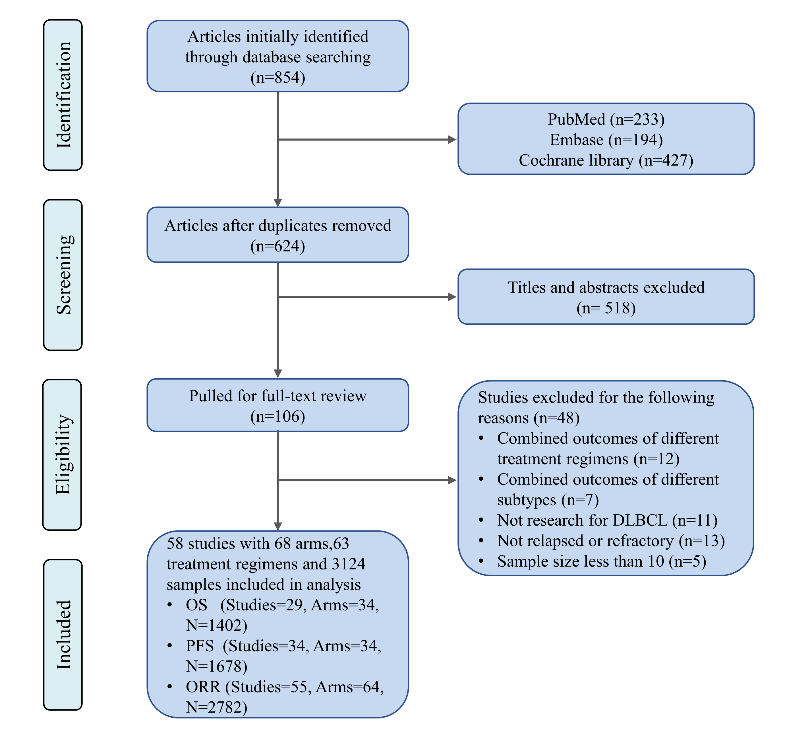
Figure S1. Flow chart demonstrating the inclusion and exclusion of studies into the analysis.

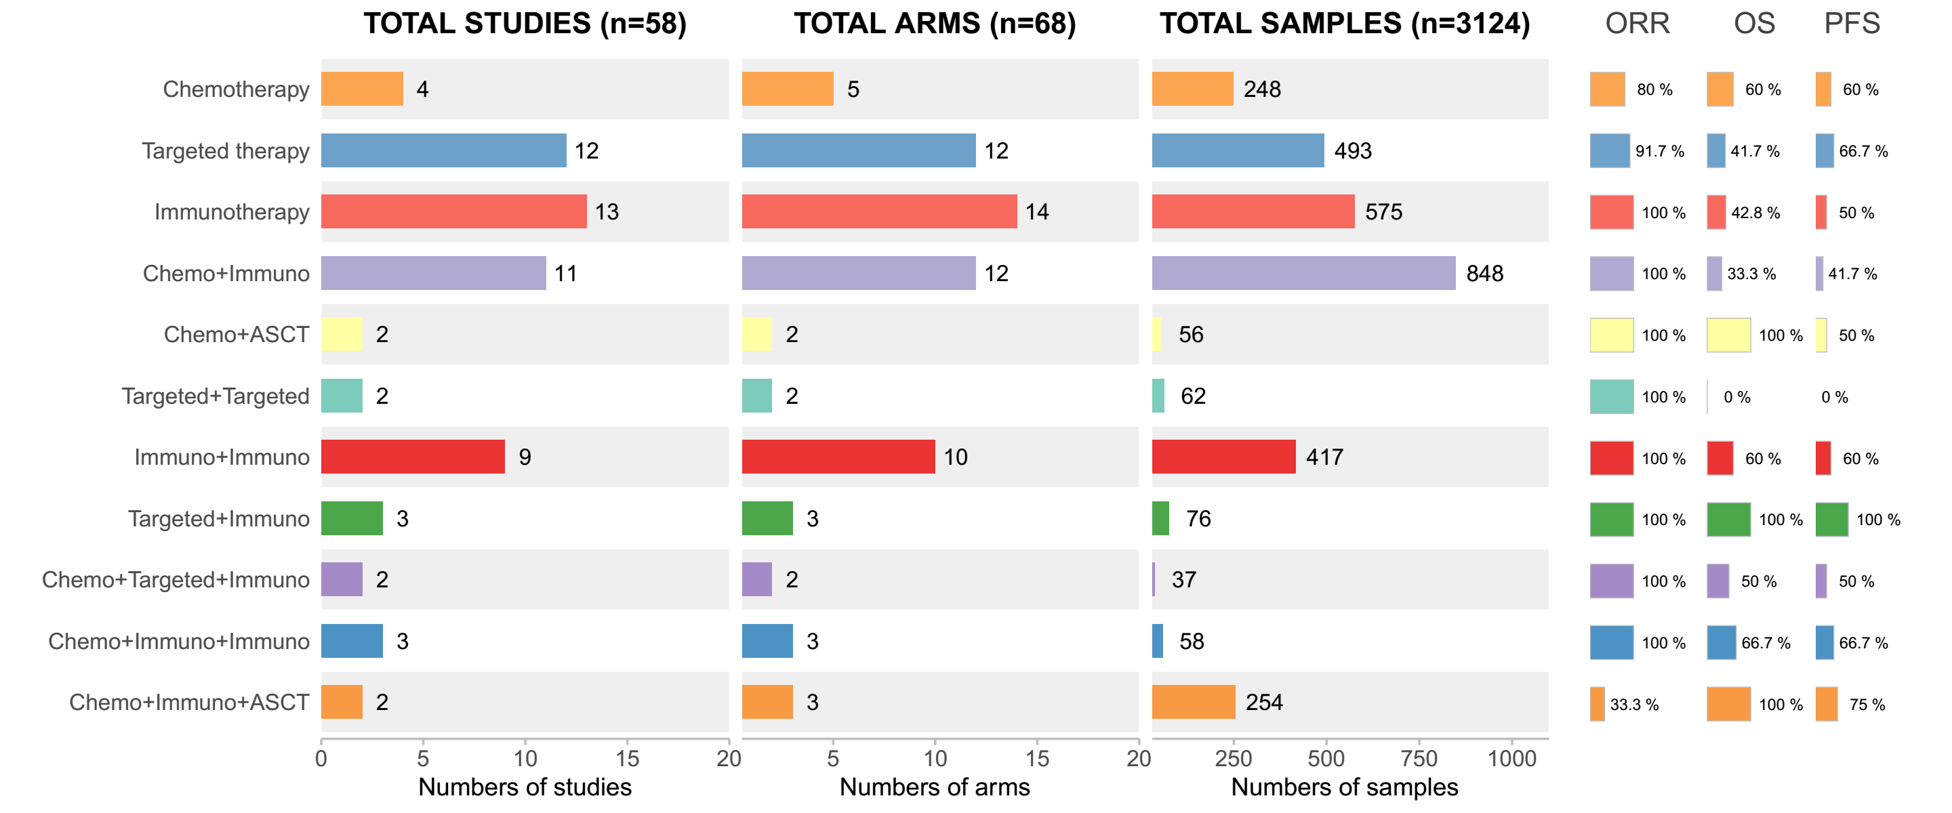
Figure S2. Overview of the analysis database of different treatment strategies, with Percentage of coverage for different endpoints. Immuno: Immunotherapy; Chemo: chemotherapy; Target: Targeted therapy; ASCT: Autologous Stem Cell Transplant.

PFS
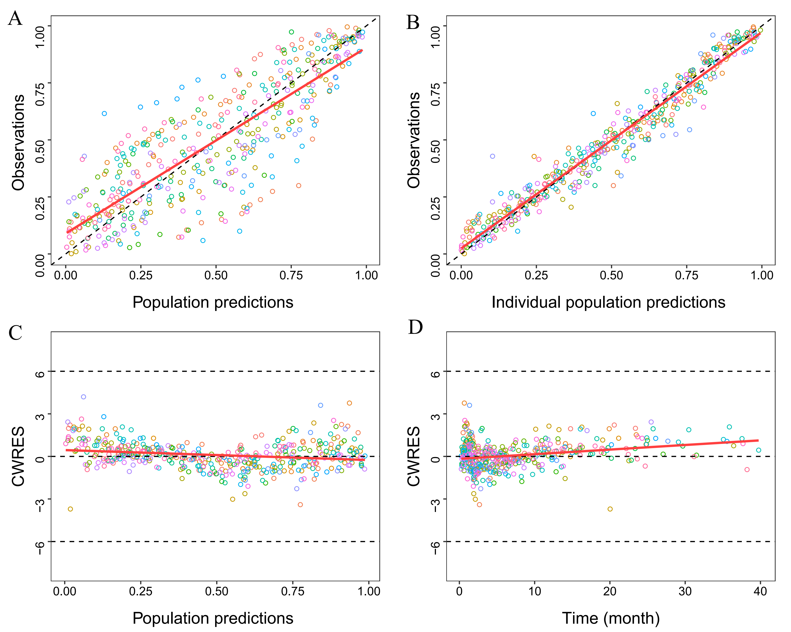
OS
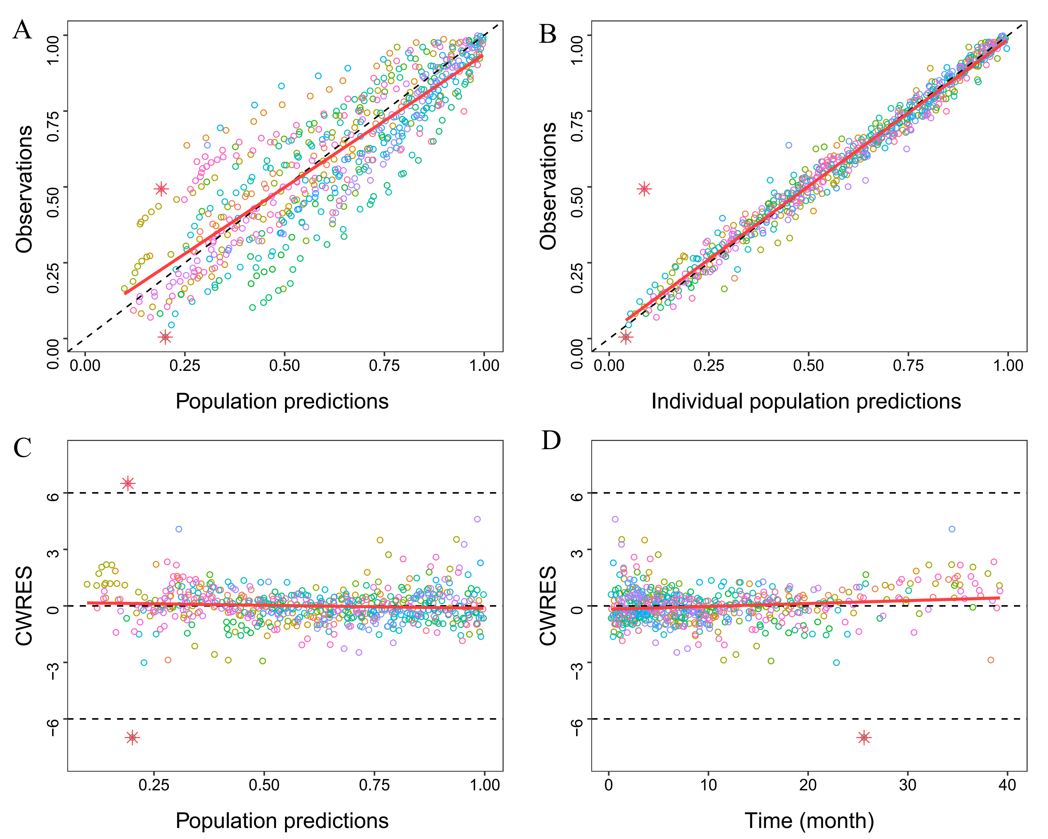

Figure S3 Goodness of fit of PFS and OS. (A) Population predicted value versus observed value. (B) Individual predicted value versus observed value. (C) Conditional weighted residuals versus population predicted value. (D) Conditional weighted residuals versus time. The dashed and solid lines in (A) and (B) represent identity and regression lines, respectively, whereas in (C) and (D), the black lines are the position where conditional weighted residual equal 0 and the red lines are the regression lines.
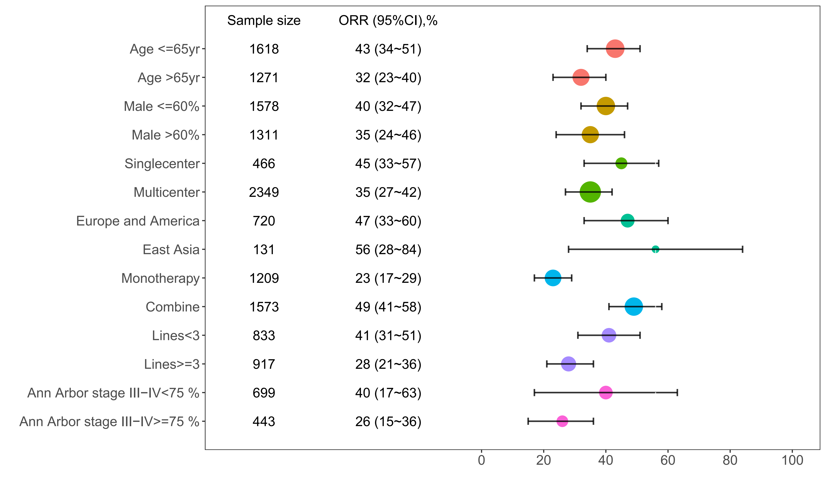
Figure S4. Subgroup analysis of ORR under different factors

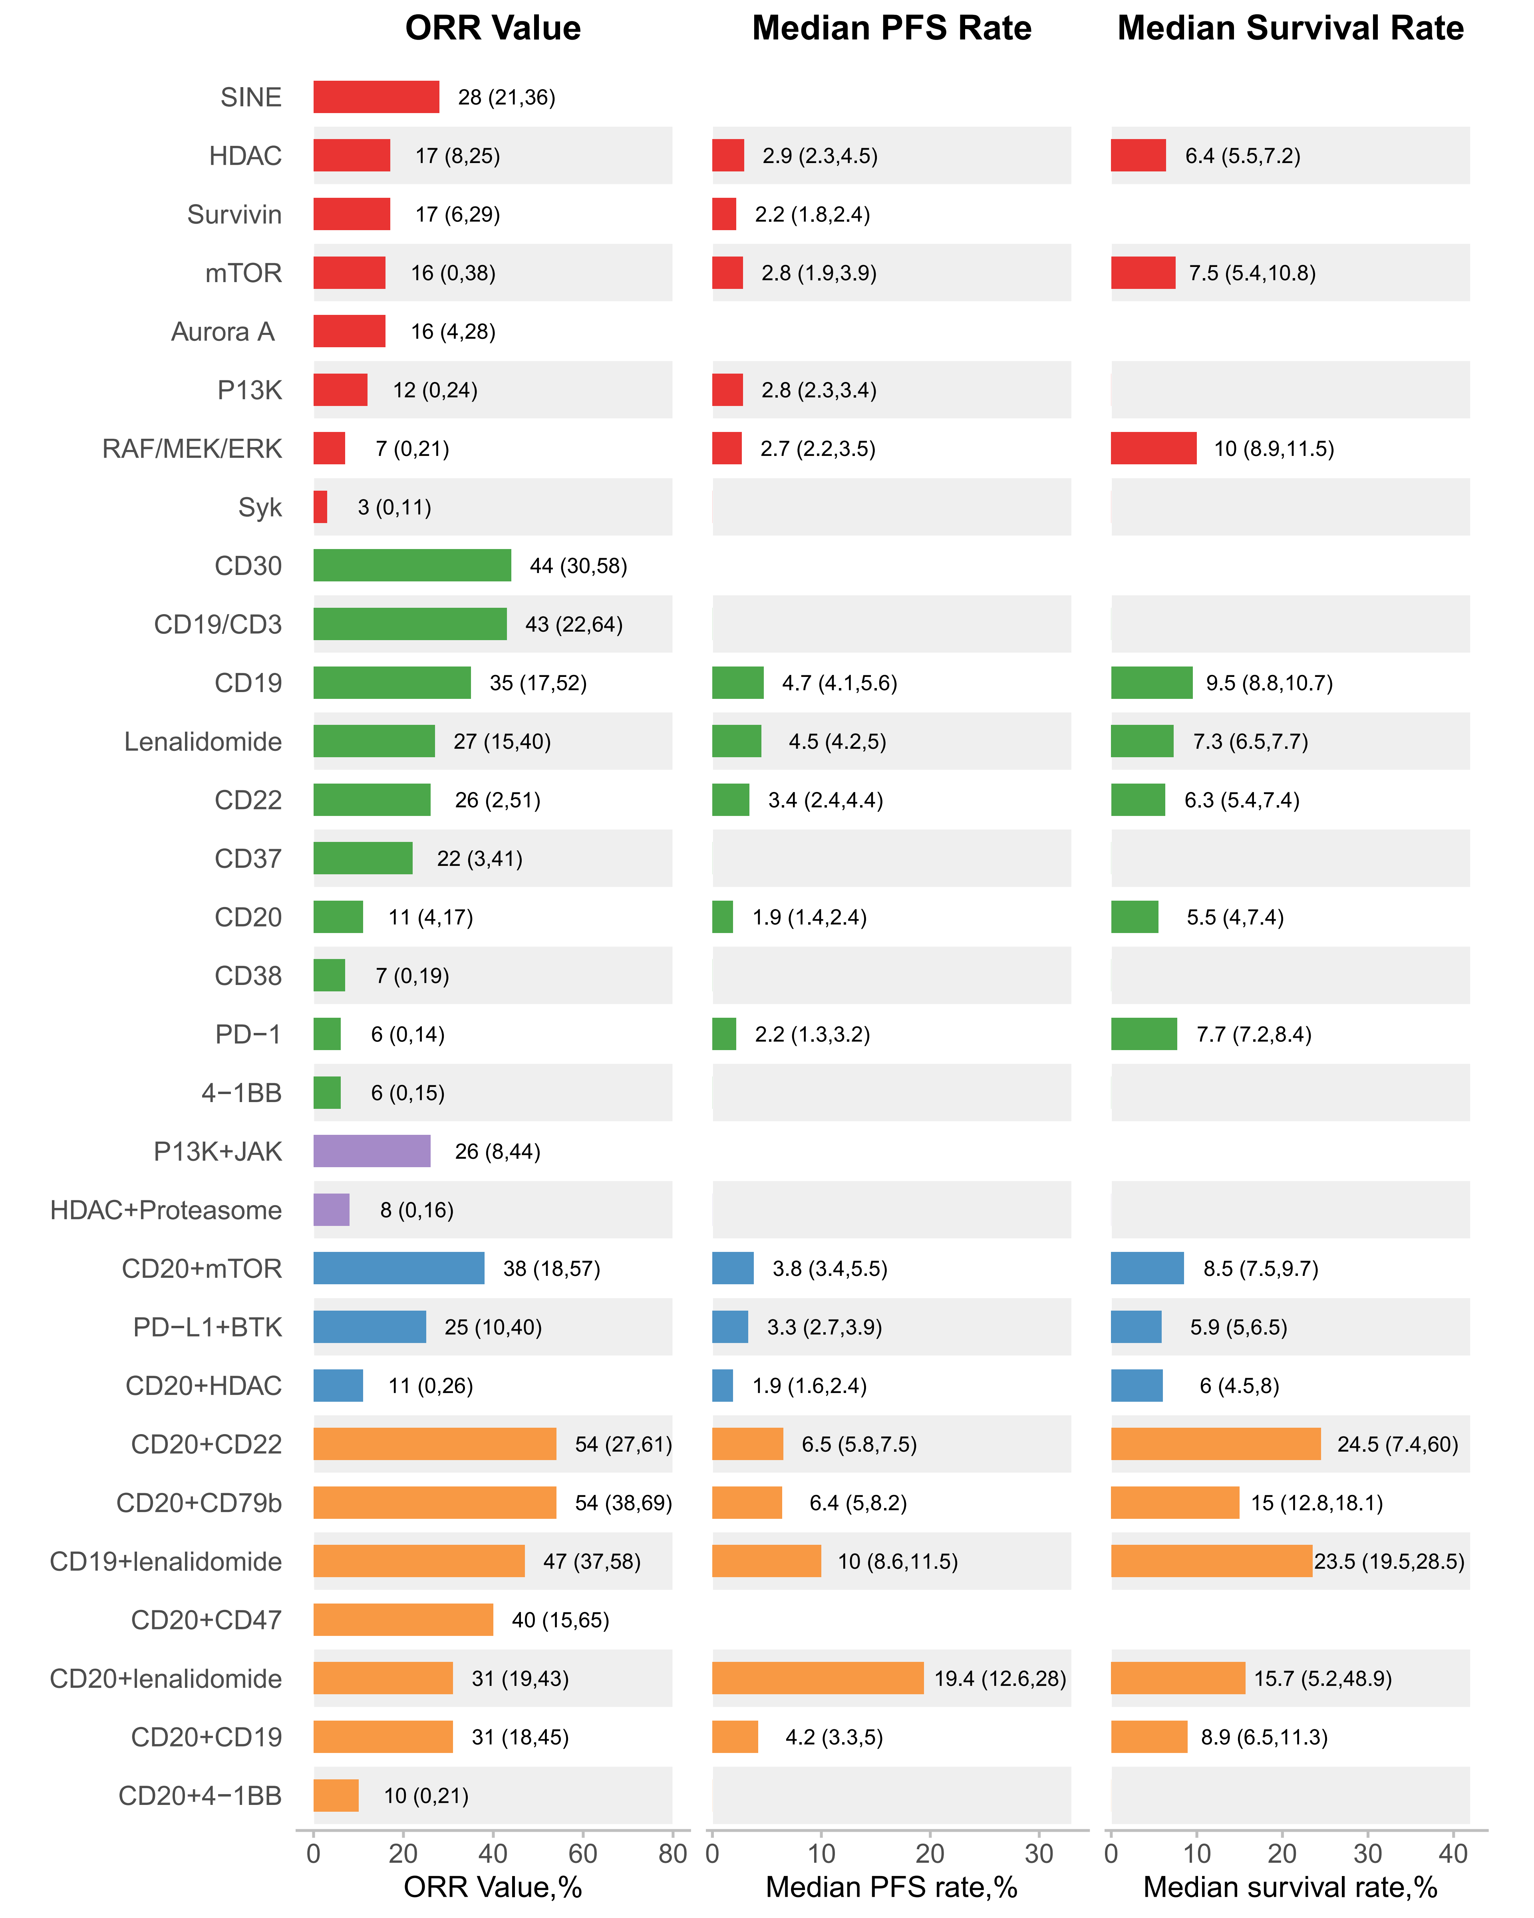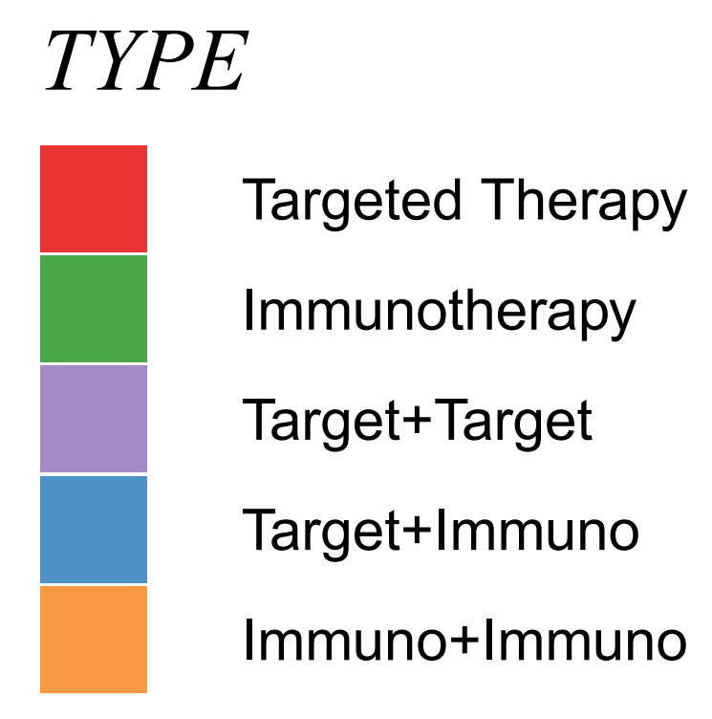

Figure S5. Simulated ORR value, median OS and median PFS of different targets. The text in the figure represents the typical value and 95% CI of the simulation. Immuno: Immunotherapy; Chemo: chemotherapy; Target: Targeted therapy.

