Additional file 1

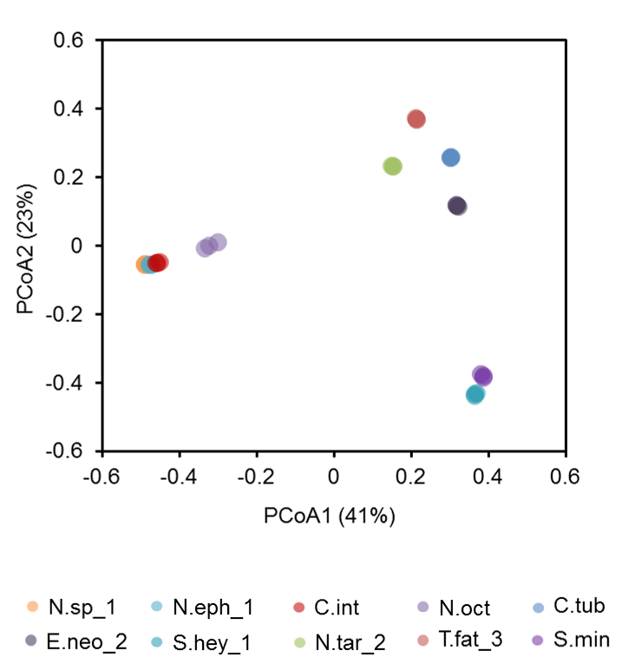
Fig. S1 16S rRNA gene amplicon sequencing results for triplicates, presented for 10 selected samples. PCoA ordination of the calculated Bray-Curtis dissimilarities in bacterial community structures at the OTU level showed close grouping of triplicates.

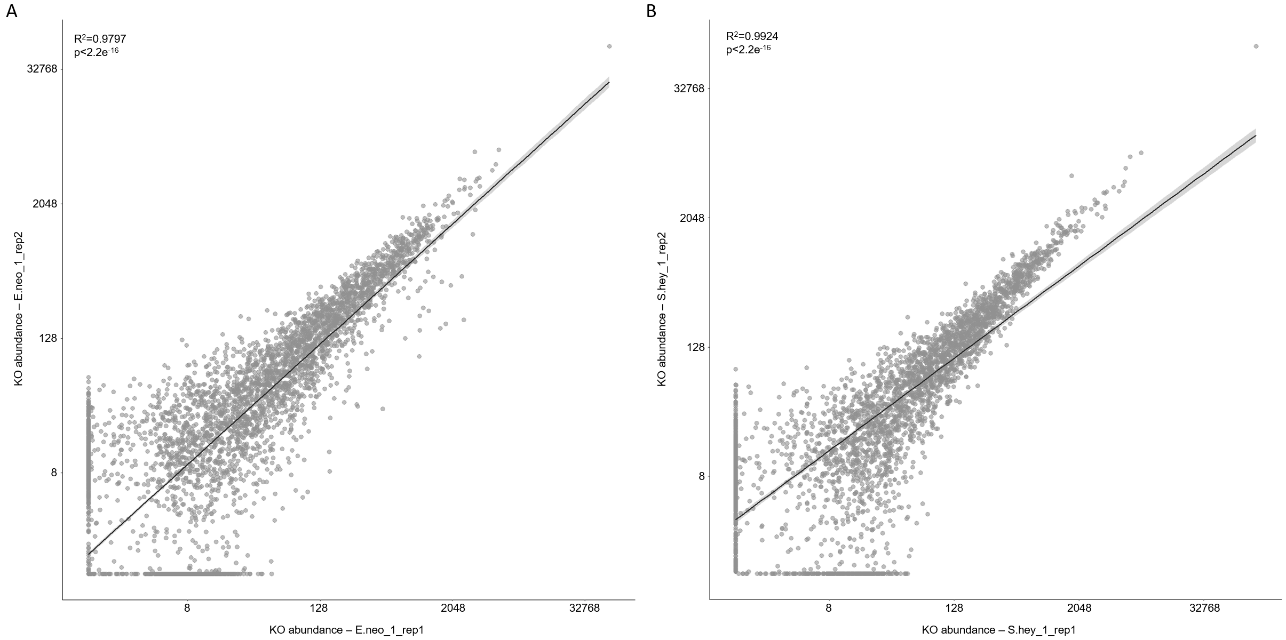

Fig. S2 Duplicates (biological replicates) of metatranscriptomic libraries for two selected colonies (E.neo_1, S.hey_1). A. Cumulative abundance of all transcripts annotated to KEGG Ontology categories (KO abundance), for E.neo_1_rep1 versus E.neo_1_rep2 (R²=0.9797, p-value< 2.2e⁻¹⁶). B. Cumulative abundance of all transcripts annotated to KEGG Ontology categories (KO abundance), for S.hey_1_rep1 versus S.hey_1_rep2 (R²=0.9797, p-value< 2.2e⁻¹⁶).

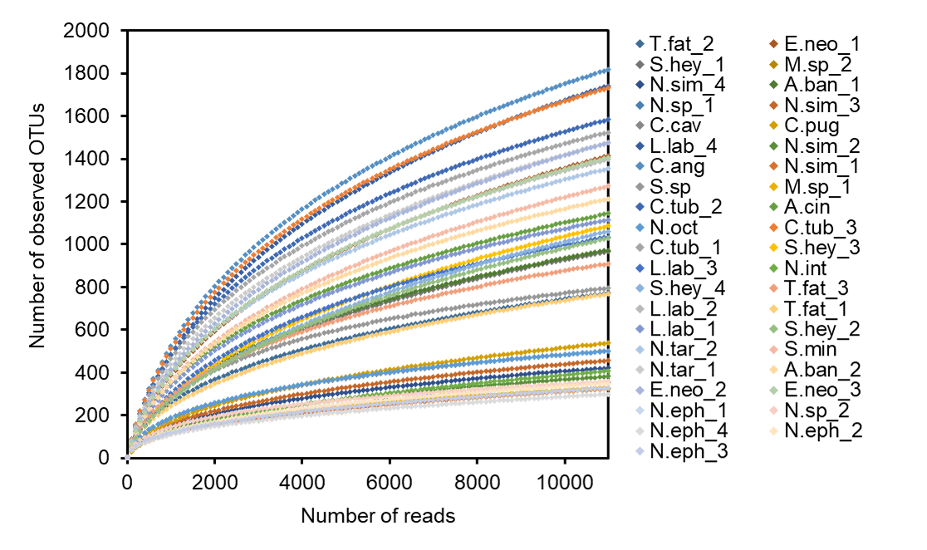
Fig. S3 The observed richness estimator rarefaction curves based on high-throughput amplicon sequencing of 16S rRNA gene for 41 tested samples of termite gut bacteria.

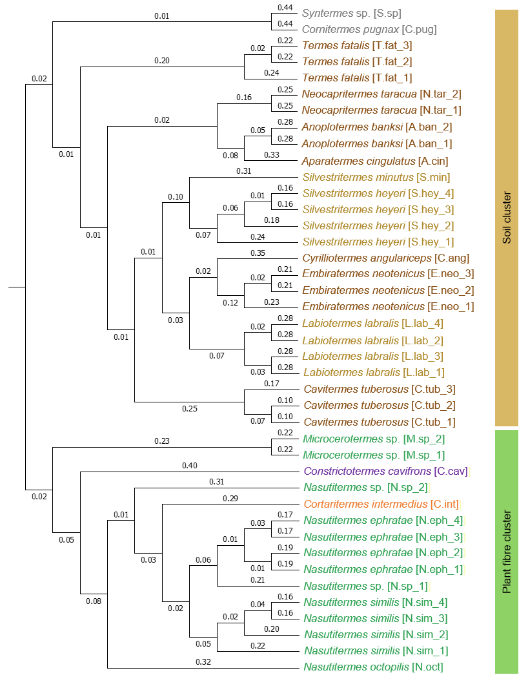
Fig. S4 Tree based on the calculated Jaccard similarity in bacterial community membership, based on 16S rRNA gene amplicon sequencing; ANOSIM R for the two clusters was equal to 0.98 with p < 0.001.
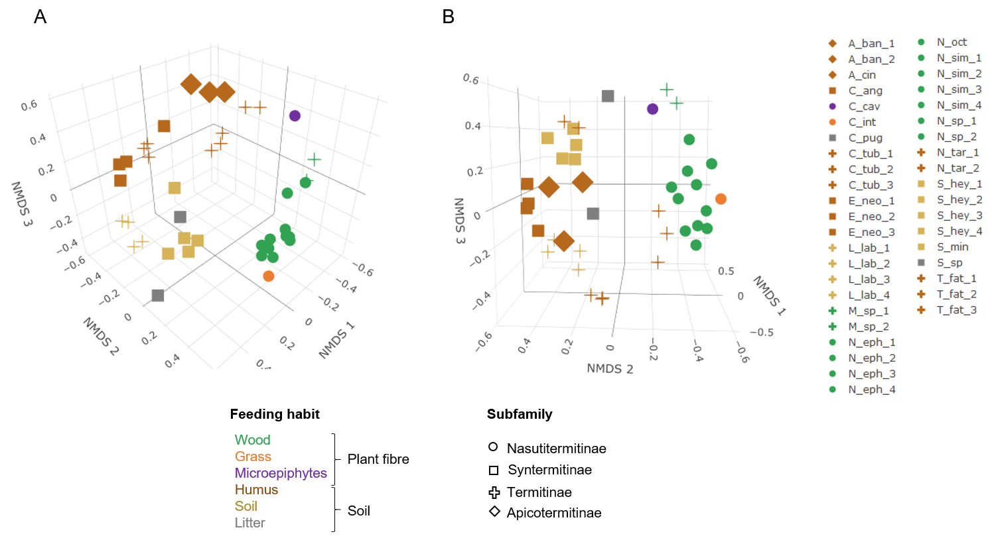
Fig. S5 3D-NMDS ordination of the calculated Bray-Curtis (A) and Jaccard (B) dissimilarities in bacterial community structures at the OTU level. Stress values: 0.21, R²=0.66 (Bray-Curtis) and 0.23, R²=0.63 (Jaccard).

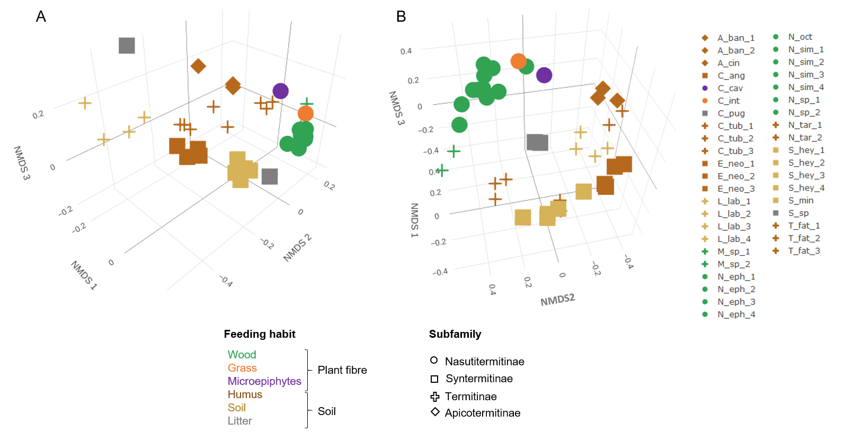

Fig. S6 3D-NMDS ordination of the weighted (A) and unweighted (B) UniFrac-calculated pairwise distance across all samples. Stress values: 0.09, R²=0,96 (weighted) and 0.21, R²=0.73 (unweighted).

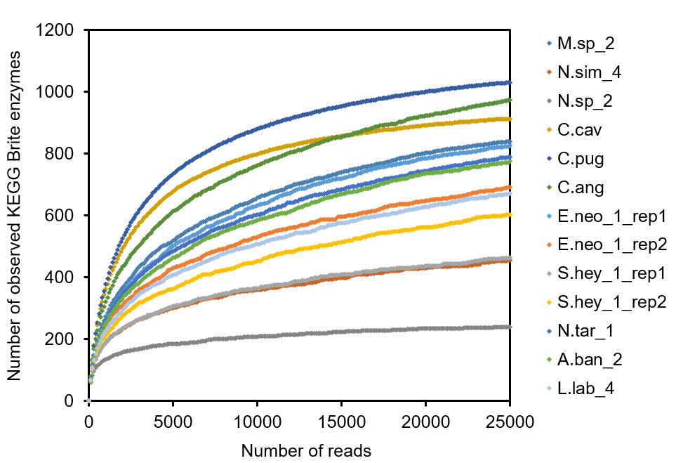
Fig. S7 The calculated rarefaction curves of all the captured enzymatic annotations (reflected by the assigned KEGG BTITE enzyme numbers).

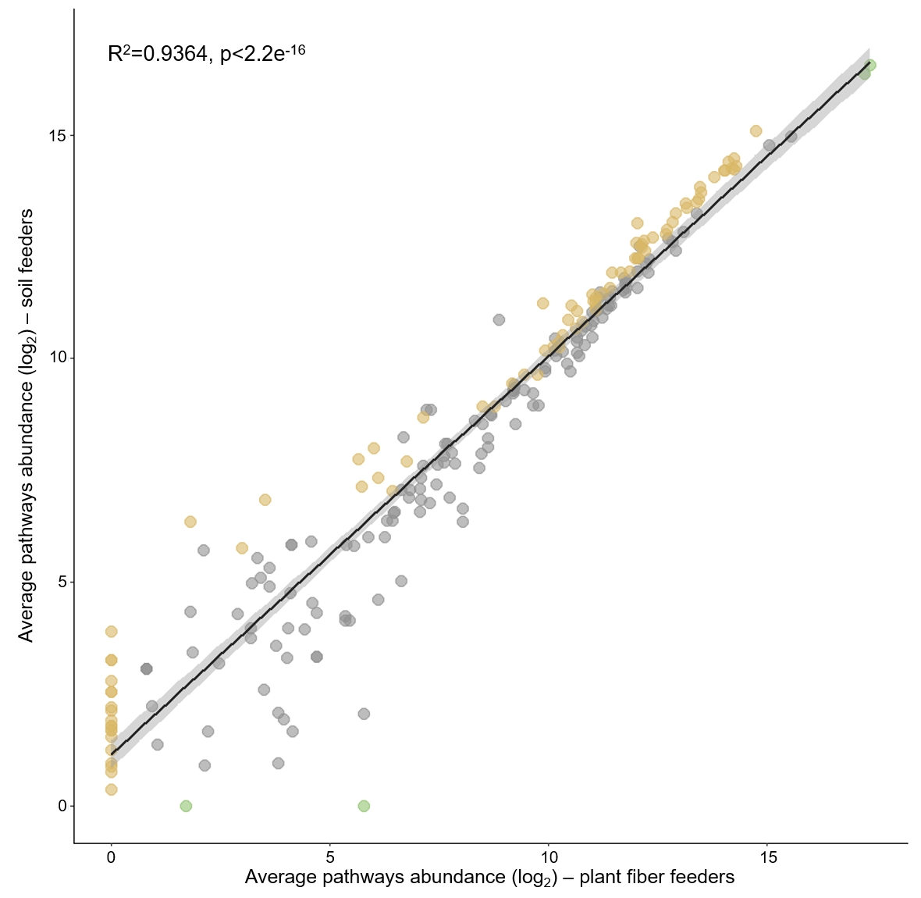
Fig. S8 Average expression of pathways (cumulative abundance of transcripts assigned to given pathway) across prokaryotic microbiomes of plant fibre- and soil-feeding termites. Pathways enriched (LEfSE analysis) or present exclusively in plant fibre- or soil feeders are marked in green and brown colour, respectively. R²=0.9364; p-value <2.2e⁻¹⁶

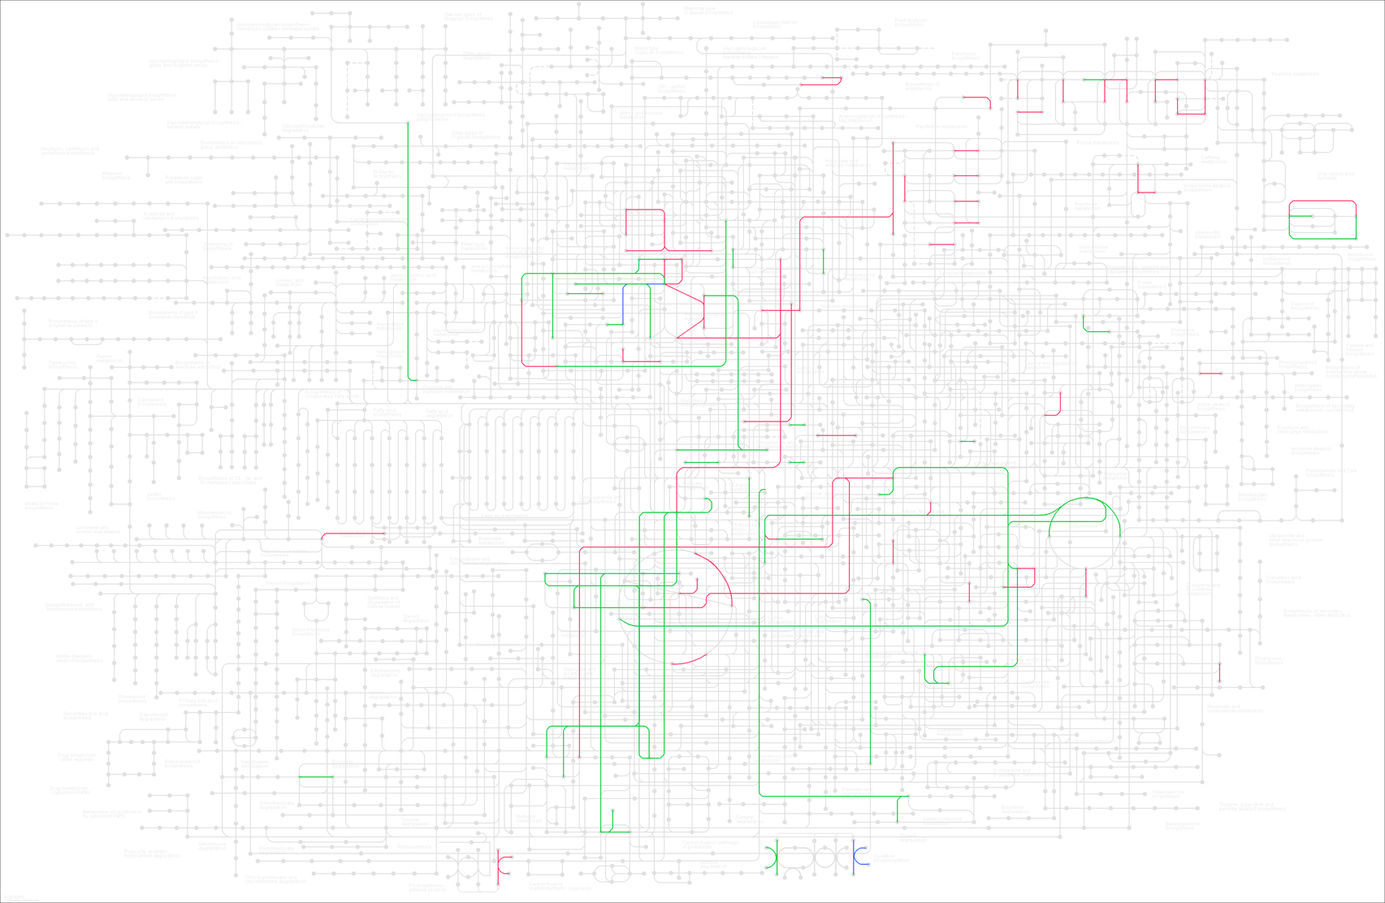
Fig. S9 Illustration of the overrepresented KEGG Ontology categories showing low metabolic overlap between the two clusters in terms of cluster-specific functionalities. Functionalities specific to plant fibre- or soil-feeding termite cluster are marked in green and red, respectively. Overlapping functions are marked with blue.
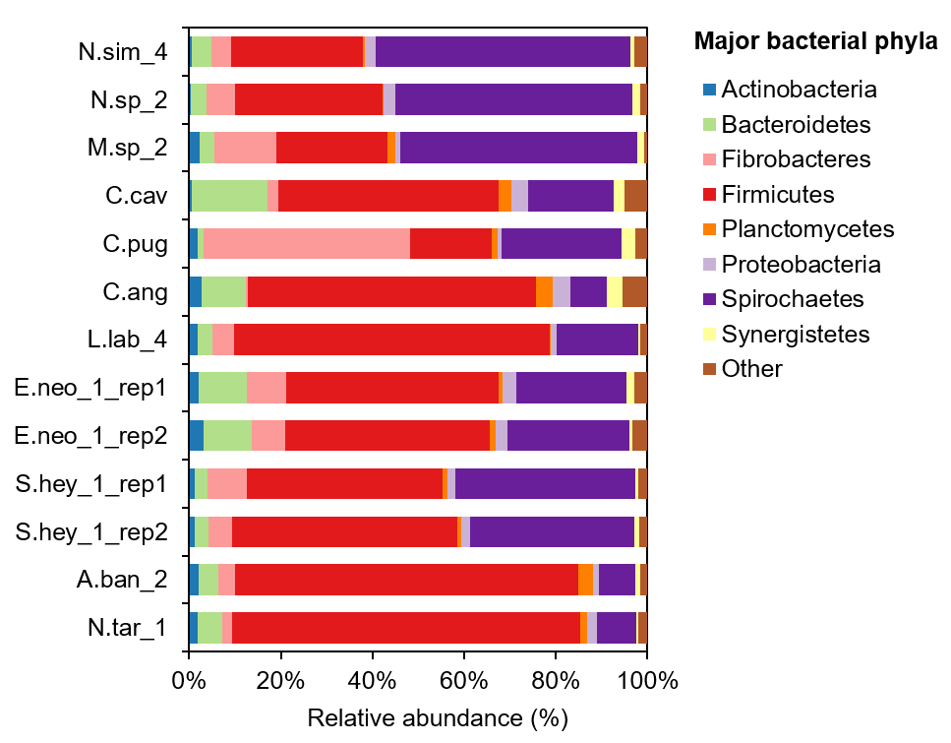
Fig. S10 Taxonomic prediction of prokaryotic groups contributing the putative CAZymes expression in plant fibre- and soil-feeding termites.

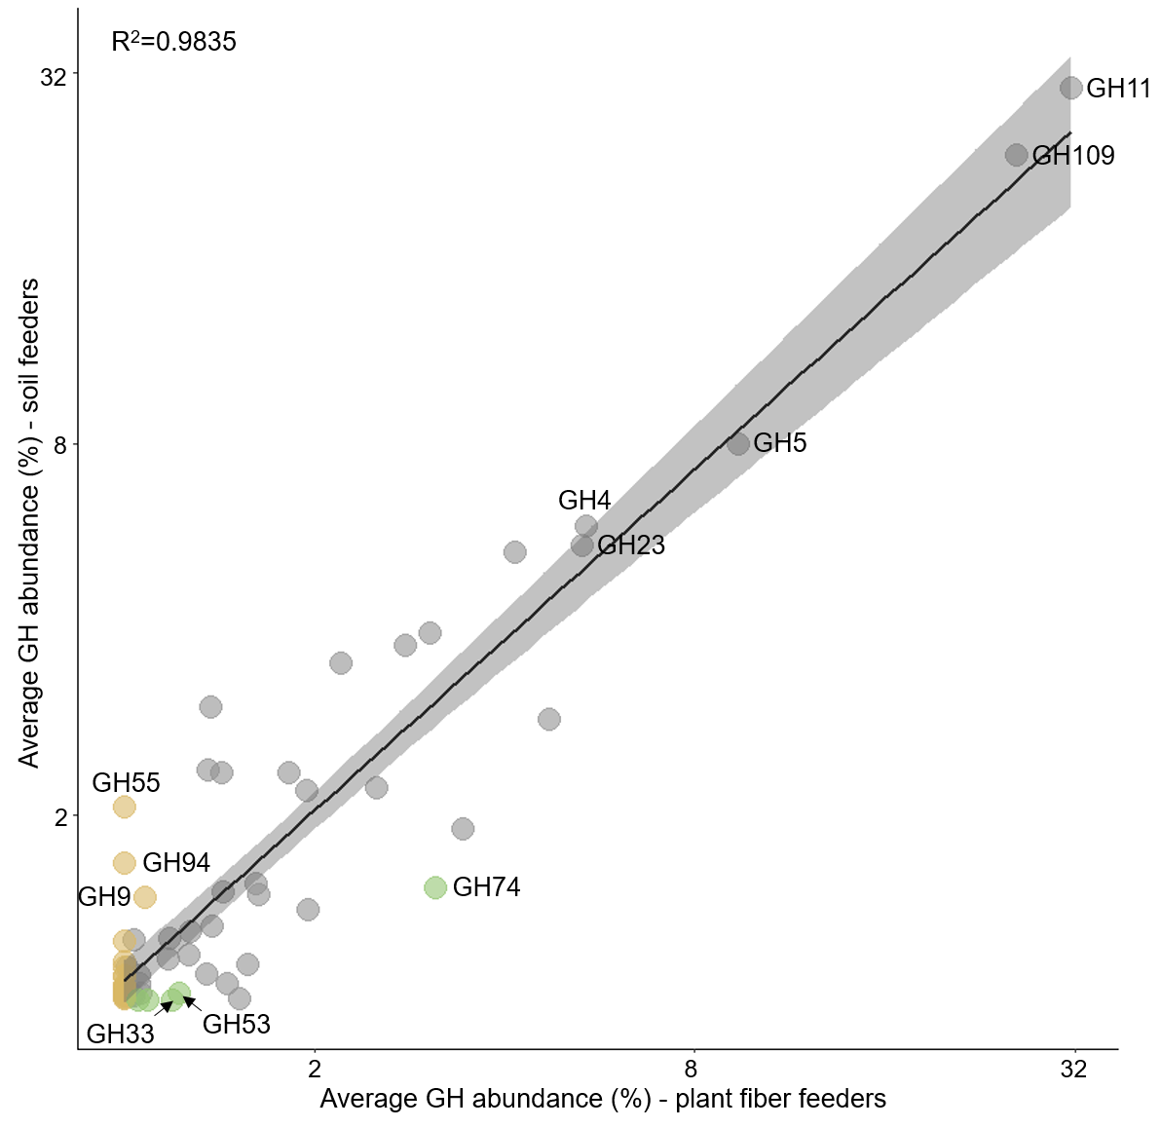

Fig. S11 Average GH expression in prokaryotic gut microbiomes of plant fibre- and soil-feeding termites (results without application of the dbCAN tool threshold of e-value <10⁻¹⁸ and coverage >0.35); GHs enriched (LEfSE analysis) or present exclusively in plant fibre- or soil-feeding termite cluster are marked in green and brown colour, respectively.

Fig. S12 Correlation between the number of gene transcripts assigned to a gene category and its cumulative expression per sample.
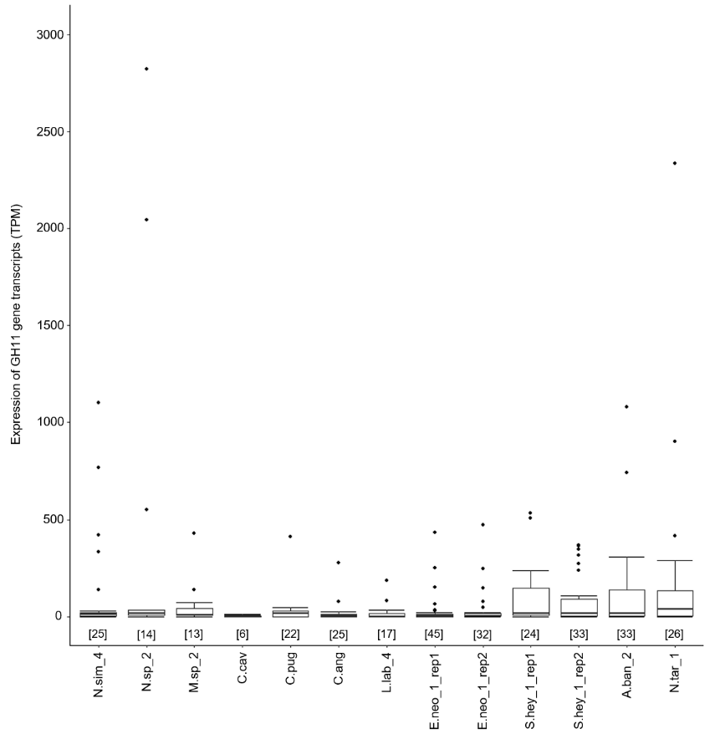
Fig. S13 Expression of the gene transcripts assigned to GH11 CAZy family across all prokaryotic microbiomes. Number in the square bracket corresponds to the number of gene transcripts per each sample.

