3D Bi-layered hydrogel and nanofiber multifunctional sponge dressing: an efficacious healing agent for chronic and deep open wounds

Nanditha C.K^{1, 2}, Manan Rakesh Shah¹, Priya P^{b}, Harikrishnan K^{b} and G.S. Vinod Kumar^{1*}
¹Nano Drug Delivery Systems (NDDS), Bio-Innovation Center (BIC), Rajiv Gandhi Centre for Biotechnology, Thycaud P.O, Poojappura, Thiruvananthapuram, Kerala, India-695014.
²Research Centre, University of Kerala, Thiruvananthapuram, Kerala, India
^{b}Environmental Biology Laboratory, Rajiv Gandhi Centre for Biotechnology, Thycaud P.O, Poojappura, Thiruvananthapuram, 695014, Kerala, India.

Additional file 1

Figure S1: Characterisation of Peptides [A] MALDI-TOF showing mass of LLKKK18 Peptide, [B] MALDI-TOF showing mass of Tylotoin Peptide and HPLC profile of Tylotoin Peptide

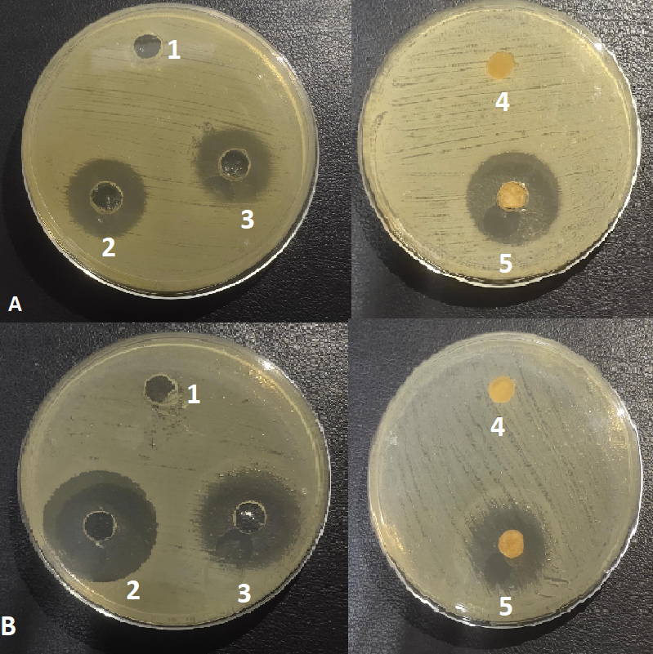
Figure S2: Antibacterial activities (Disc diffusion assay- representative image) against S. aureus (A) and P. aeruginosa (B). Test materials: 1- PBS (pH 7.4), 2- Ciprofloxacin (broad spectrum antibiotic), 3- LLKKK18 Peptide, 4- 3D sponge without LLKKK18, 5- LLKKK18 with 3D Sponge.

Organism | Test materials | Zone of inhibition  (Mean± S.D)
S.aureus  ATCC 25923 | PBS (pH 7.4) | Nil
S.aureus  ATCC 25923 | Ciprofloxacin (Antibiotic) | 26.5 ± 3.5 mm
S.aureus  ATCC 25923 | LLKKK18 Peptide | 22 ± 0.2 mm
S.aureus  ATCC 25923 | 3D sponge without LLKKK18 | Nil
S.aureus  ATCC 25923 | LLKKK18 with 3D Sponge | 20.6 ± 4 mm
P.aeruginosa  ATCC 27853 | PBS (pH 7.4) | Nil
P.aeruginosa  ATCC 27853 | Ciprofloxacin (Antibiotic) | 32.5 ± 0.7mm
P.aeruginosa  ATCC 27853 | LLKKK18 Peptide | 28 ± 1.4 mm
P.aeruginosa  ATCC 27853 | 3D sponge without LLKKK18 | Nil
P.aeruginosa  ATCC 27853 | LLKKK18 with 3D Sponge | 24.6 ± 4.1 mm

Table S1: Antibacterial activities (Disc diffusion assay) of 3D bilayered sponge against S. aureus and P. aeruginosa. Data are represented as Mean ± SD of three separate experiments.

