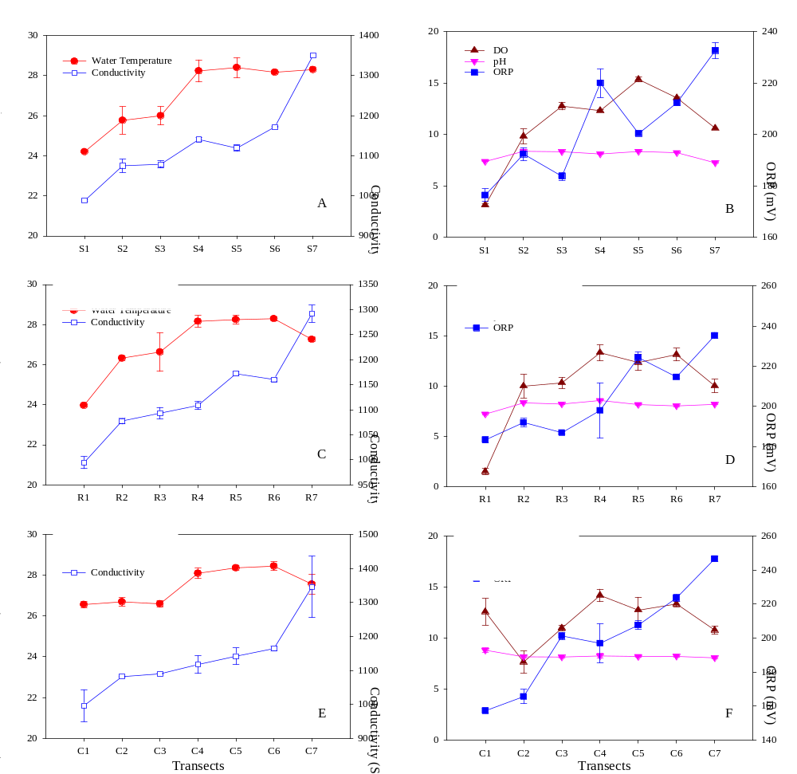

Fig. S1 Physicochemical properties of surface water in open water area (A, B), reed community area (C, D) and cattail community area (E, F).

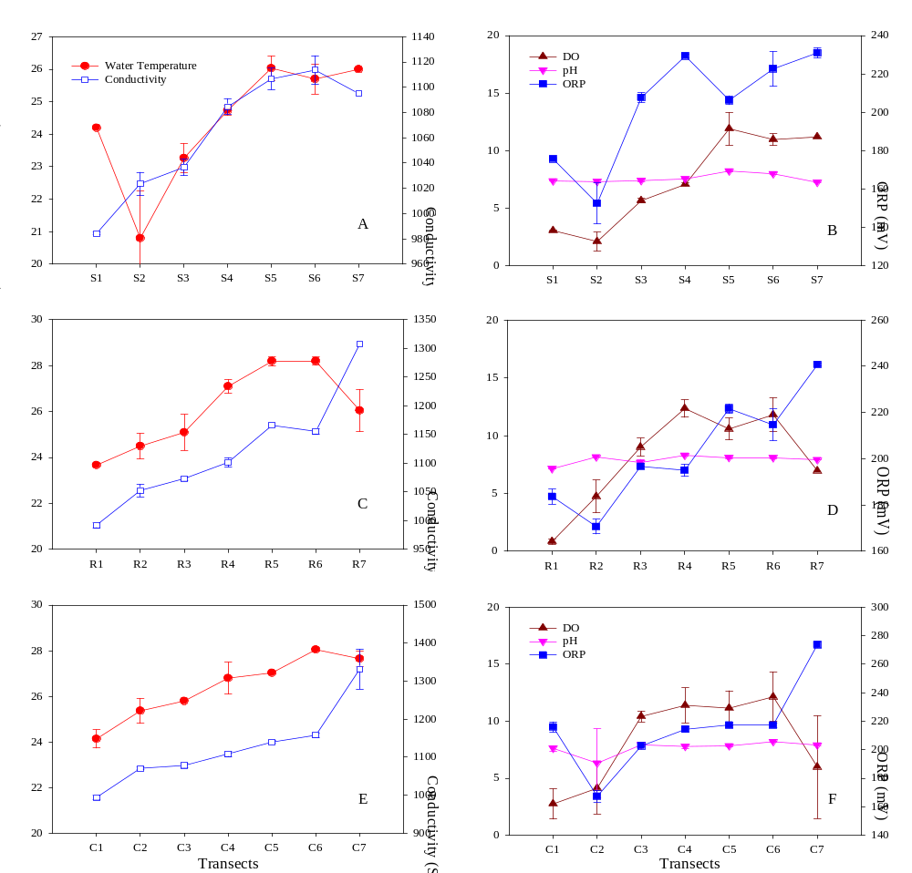

Fig. S2 Physicochemical properties of overlying water in open water area (A, B), reed community area (C, D) and cattail community area (E, F).

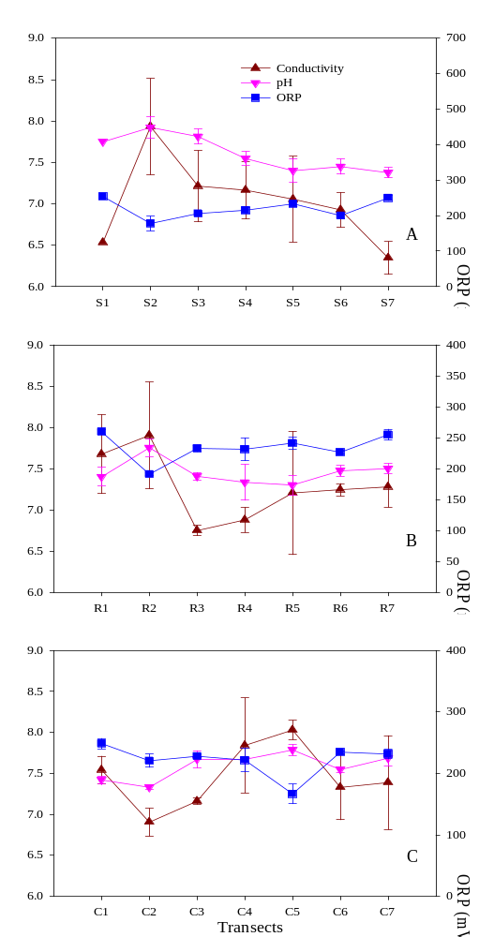

Fig. S3 Physicochemical properties of o interstitial water in open water area (A, B), reed community area (C, D) and cattail community area (E, F).

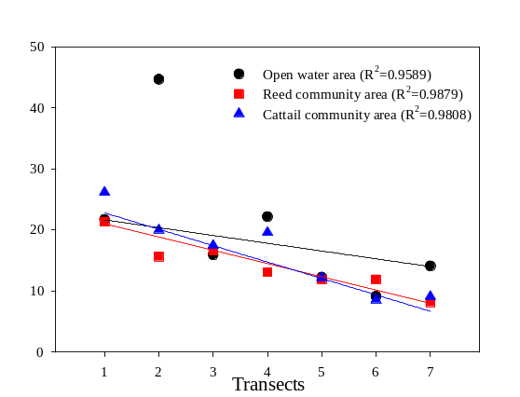

Fig. S4 NaOH-P to TP ratios (NaOH-P/TP, %) in sediments of the open water area reed community area and cattail community area. R² indicates the coefficients of linear regression results (y = ax + b) using Sigmaplot 12.5 (Systat Software, Inc., Chicago, IL, USA).

