Supplementary Material

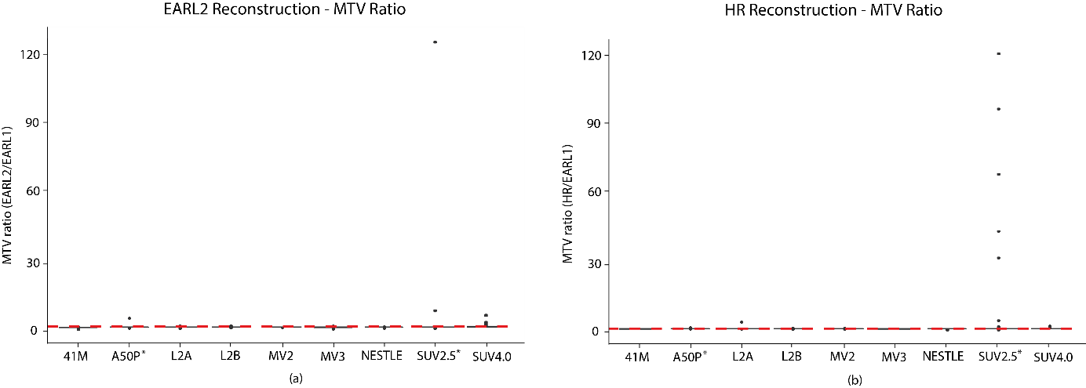
Fig S1. MTV Ratio values across segmentation methods including outliers. Each boxplot illustrates the set of MTV ratio values obtained with a particular segmentation method: 41M, A50P, L2A, L2B, MV2, MV3, NESTLE, SUV2.5 or SUV4.0. In (a) MTV ratios are given for EARL2 reconstruction and in (b) for HR reconstruction. SUV2.5 is the segmentation method with the greatest number of outliers and also with the highest values.

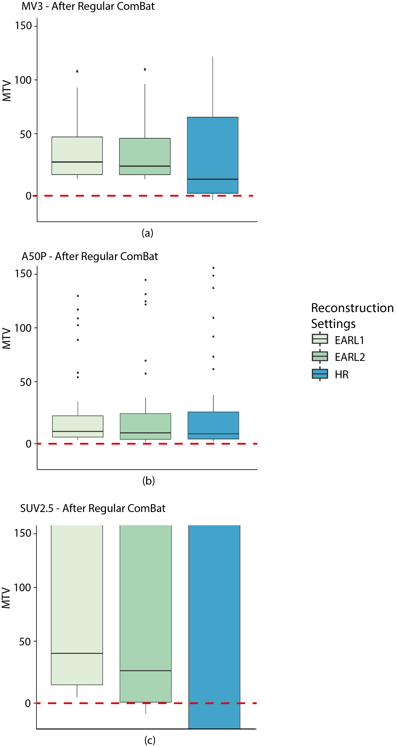
Fig S2. MTVs after ComBat obtained using different segmentations across reconstructions. (a) Results obtained from MV3 segmentation. HR reconstruction shows negative MTVs. (b) Results obtained from L2B segmentation. The EARL2 reconstruction shows negative MTVs. (c) Results obtained from SUV2.5 segmentation. Both HR and EARL2 reconstructions show negative MTVs.

