Size-Dependent Adsorption Performance of ZnO Nanoclusters for Drug Delivery Applications

Mustafa Kurban¹ and İskender Muz²
¹Department of Electrical and Electronics Engineering, Kırşehir Ahi Evran University, 40100 Kırşehir, Turkey.
²Department of Mathematics and Science Education, Nevşehir Hacı Bektaş Veli University, 50300, Nevşehir, Turkey.

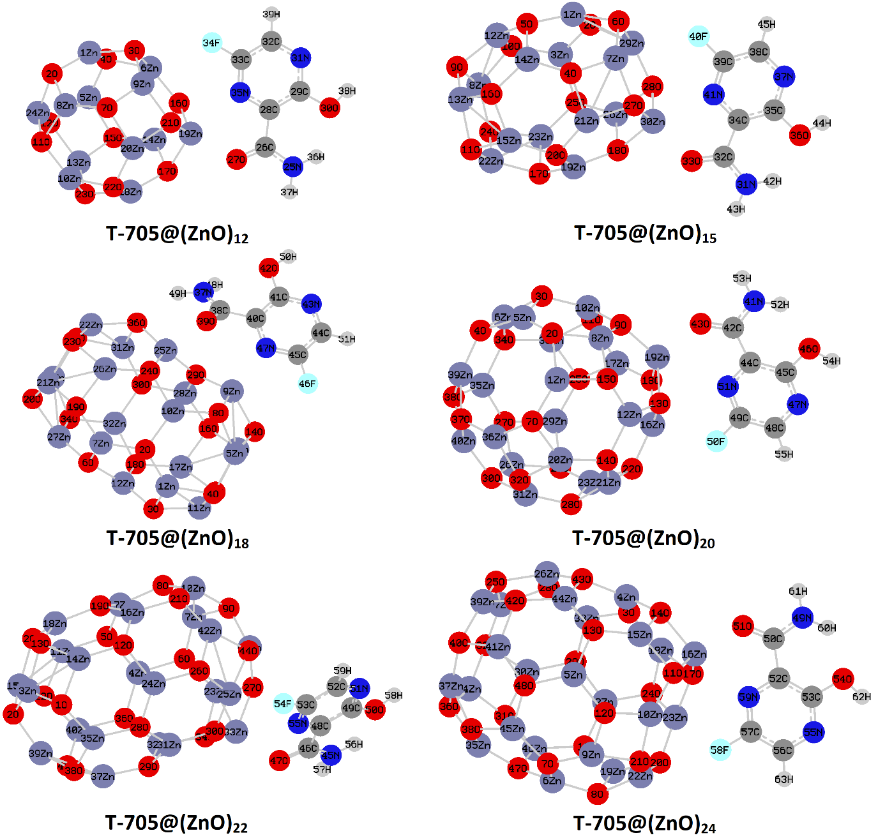
Fig. S1. (Colour online) Bond orders and Mulliken charges based on interactions between (a) O – Zn, (b) N – Zn and (c) F – Zn atoms for favipiravir adsorbed ZnO NCs. (The O, N, and F atoms indicate favipiravir, the Zn (NCs) is the closest neighbors to these atoms.

