Appendix: supplementary tables and figures

Supplementary Table 1 Adverse events resulting in dose interruption, dose reduction, or treatment discontinuation

 | Total | Chronic phase | Accelerated phase
Patient number | 165 | 127 | 38
Adverse events resulting in dose interruption, n (%) | 86 (52.1) | 58 (45.7) | 28 (73.7)
Hematologic | 66 (40.0) | 44 (34.6) | 22 (57.9)
Thrombocytopenia | 59 (35.8) | 42 (33.1) | 17 (44.7)
Leukopenia | 9 (5.5) | 4 (3.1) | 5 (13.2)
Anemia | 8 (4.8) | 3 (2.4) | 5 (13.2)
Neutropenia | 5 (3.0) | 1 (0.8) | 4 (10.5)
Febrile neutropenia | 1 (0.6) | 1 (0.8) | 0
Nonhematologic | 48 (29.1) | 34 (26.8) | 14 (36.8)
Increased alanine aminotransferase | 4 (2.4) | 3 (2.4) | 1 (2.6)
Increased creatine phosphokinase | 4 (2.4) | 3 (2.4) | 1 (2.6)
Hypertriglyceridaemia | 4 (2.4) | 3 (2.4) | 1 (2.6)
Increased aspartate aminotransferase | 3 (1.8) | 2 (1.6) | 1 (2.6)
Hypocalcemia | 3 (1.8) | 3 (2.4) | 0
Pyrexia | 3 (1.8) | 1 (0.8) | 2 (5.3)
Atrial fibrillation | 2 (1.2) | 1 (0.8) | 1 (2.6)
Hyperbilirubinaemia | 2 (1.2) | 2 (1.6) | 0
Hypertension | 2 (1.2) | 1 (0.8) | 1 (2.6)
Hypokalemia | 2 (1.2) | 0 | 2 (5.3)
Increased lipase | 2 (1.2) | 2 (1.6) | 0
Pneumonia | 2 (1.2) | 2 (1.6) | 0
Sinus tachycardia | 2 (1.2) | 1 (0.8) | 1 (2.6)
Upper-respiratory-tract infection | 2 (1.2) | 1 (0.8) | 1 (2.6)
Acute myocardial infarction | 1 (0.6) | 1 (0.8) | 0
Increased amylase | 1 (0.6) | 1 (0.8) | 0
Anal abscess | 1 (0.6) | 0 | 1 (2.6)
Atrial septal defect | 1 (0.6) | 1 (0.8) | 0
Chest pain | 1 (0.6) | 1 (0.8) | 0
Cholecystitis acute | 1 (0.6) | 1 (0.8) | 0
Cholelithiasis | 1 (0.6) | 1 (0.8) | 0
Increased γ-glutamyl transferase | 1 (0.6) | 1 (0.8) | 0
Glaucoma | 1 (0.6) | 1 (0.8) | 0
Hemorrhoids | 1 (0.6) | 1 (0.8) | 0
Hepatocellular injury | 1 (0.6) | 0 | 1 (2.6)
Hyperglycaemia | 1 (0.6) | 1 (0.8) | 0
Hyperkalemia | 1 (0.6) | 0 | 1 (2.6)
Hyperuricaemia | 1 (0.6) | 1 (0.8) | 0
Hypoesthesia | 1 (0.6) | 1 (0.8) | 0
Hyponatremia | 1 (0.6) | 1 (0.8) | 0
Influenza like illness | 1 (0.6) | 1 (0.8) | 0
Iridocyclitis | 1 (0.6) | 0 | 1 (2.6)
Lacunar infarction | 1 (0.6) | 1 (0.8) | 0
Liver disorder | 1 (0.6) | 1 (0.8) | 0
Musculoskeletal pain | 1 (0.6) | 0 | 1 (2.6)
Myocardial strain | 1 (0.6) | 1 (0.8) | 0
Pain | 1 (0.6) | 1 (0.8) | 0
Pain in extremity | 1 (0.6) | 1 (0.8) | 0
Pericardial effusion | 1 (0.6) | 0 | 1 (2.6)
Peripheral swelling | 1 (0.6) | 1 (0.8) | 0
Proteinuria | 1 (0.6) | 1 (0.8) | 0
Pulmonary arterial hypertension | 1 (0.6) | 1 (0.8) | 0
Increased pulmonary arterial pressure | 1 (0.6) | 1 (0.8) | 0
Pulmonary tuberculosis | 1 (0.6) | 0 | 1 (2.6)
Rash | 1 (0.6) | 0 | 1 (2.6)
Refraction disorder | 1 (0.6) | 1 (0.8) | 0
Sinus bradycardia | 1 (0.6) | 1 (0.8) | 0
Skin mass | 1 (0.6) | 1 (0.8) | 0
Superior mesenteric artery syndrome | 1 (0.6) | 1 (0.8) | 0
Supraventricular extrasystoles | 1 (0.6) | 0 | 1 (2.6)
Swelling | 1 (0.6) | 1 (0.8) | 0
Urinary sediment present | 1 (0.6) | 1 (0.8) | 0
Adverse events resulting in dose reduction, n (%) | 50 (30.3) | 36 (28.3) | 14 (36.8)
Hematologic adverse events | 30 (18.2) | 20 (15.7) | 10 (26.3)
Thrombocytopenia | 26 (15.8) | 19 (15) | 7 (18.4)
Anemia | 3 (1.8) | 2 (1.6) | 1 (2.6)
Neutropenia | 3 (1.8) | 2 (1.6) | 1 (2.6)
Leukopenia | 2 (1.2) | 0 | 2 (5.3)
Nonhaematologic | 21 (12.7) | 16 (12.6) | 5 (13.2)
Increased creatine phosphokinase | 2 (1.2) | 2 (1.6) | 0
Hyperbilirubinaemia | 2 (1.2) | 1 (0.8) | 1 (2.6)
Hyperglycaemia | 2 (1.2) | 1 (0.8) | 1 (2.6)
Hypertension | 2 (1.2) | 2 (1.6) | 0
Retinal-vein occlusion | 2 (1.2) | 2 (1.6) | 0
Acute coronary syndrome | 1 (0.6) | 1 (0.8) | 0
Arteriosclerosis coronary artery | 1 (0.6) | 1 (0.8) | 0
Arthralgia | 1 (0.6) | 0 | 1 (2.6)
Asthenia | 1 (0.6) | 1 (0.8) | 0
Atrial fibrillation | 1 (0.6) | 0 | 1 (2.6)
Cerebral infarction | 1 (0.6) | 1 (0.8) | 0
Chest discomfort | 1 (0.6) | 1 (0.8) | 0
Dyspnea | 1 (0.6) | 1 (0.8) | 0
Electrocardiogram QT prolonged | 1 (0.6) | 1 (0.8) | 0
Glaucoma | 1 (0.6) | 1 (0.8) | 0
Hypertriglyceridaemia | 1 (0.6) | 1 (0.8) | 0
Hypokalemia | 1 (0.6) | 0 | 1 (2.6)
Proteinuria | 1 (0.6) | 1 (0.8) | 0
Seronegative arthritis | 1 (0.6) | 0 | 1 (2.6)
Subileus | 1 (0.6) | 1 (0.8) | 0
Adverse events resulting in treatment discontinuation, n (%) | 13 (7.9) | 9 (7.1) | 4 (10.5)
Hematologic | 7 (4.2) | 4 (3.1) | 3 (7.9)
Thrombocytopenia | 6 (3.6) | 3 (2.4) | 3 (7.9)
Febrile neutropenia | 1 (0.6) | 1 (0.8) | 0
Nonhaematologic | 6 (3.6) | 5 (3.9) | 1 (2.6)
Acute myocardial infarction | 1 (0.6) | 1 (0.8) | 0
Breast cancer | 1 (0.6) | 1 (0.8) | 0
Lacunar infarction | 1 (0.6) | 1 (0.8) | 0
Pericardial effusion | 1 (0.6) | 0 | 1 (2.6)
Proteinuria | 1 (0.6) | 1 (0.8) | 0
Retinal-vein occlusion | 1 (0.6) | 1 (0.8) | 0

Supplementary Table 2 Treatment-related cardiovascular events

Event | Total |  | Chronic phase |  | Accelerated phase
 | Any grade | G 3/4 | Any grade | G 3/4 | Any grade | G 3/4
Patient number | 165 | 165 | 127 | 127 | 38 | 38
Treatment-related cardiovascular events, n (%) | 53 (32.1) | 19 (11.5) | 44 (34.6) | 15 (11.8) | 9 (23.7) | 4 (10.5)
Hypertension | 22 (13.3) | 9 (5.5) | 19 (15.0) | 7 (5.5) | 3 (7.9) | 2 (5.3)
Pericardial effusion | 14 (8.5) | 2 (1.2) | 11 (8.7) | 1 (0.8) | 3 (7.9) | 1 (2.6)
Ventricular extrasystoles | 7 (4.2) | 0 | 7 (5.5) | 0 | 0 | 0
Atrial fibrillation | 5 (3.0) | 2 (1.2) | 2 (1.6) | 1 (0.8) | 3 (7.9) | 1 (2.6)
Supraventricular extrasystoles | 5 (3.0) | 0 | 3 (2.4) | 0 | 2 (5.3) | 0
Retinal-vein occlusion | 3 (1.8) | 2 (1.2) | 3 (2.4) | 2 (1.6) | 0 | 0
Palpitations | 2 (1.2) | 0 | 1 (0.8) | 0 | 1 (2.6) | 0
Acute coronary syndrome | 1 (0.6) | 1 (0.6) | 1 (0.8) | 1 (0.8) | 0 | 0
Acute myocardial infarction | 1 (0.6) | 1 (0.6) | 1 (0.8) | 1 (0.8) | 0 | 0
Angina pectoris | 1 (0.6) | 0 | 1 (0.8) | 0 | 0 | 0
Arrhythmia | 1 (0.6) | 1 (0.6) | 1 (0.8) | 1 (0.8) | 0 | 0
Arteriosclerosis coronary artery | 1 (0.6) | 1 (0.6) | 1 (0.8) | 1 (0.8) | 0 | 0
Atrial tachycardia | 1 (0.6) | 0 | 1 (0.8) | 0 | 0 | 0
Cardiomegaly | 1 (0.6) | 0 | 1 (0.8) | 0 | 0 | 0
Cerebral infarction | 1 (0.6) | 1 (0.6) | 1 (0.8) | 1 (0.8) | 0 | 0
Lacunar infarction | 1 (0.6) | 1 (0.6) | 1 (0.8) | 1 (0.8) | 0 | 0

Supplementary Table 3 Univariate analysis results of variables associated with treatment response
 | MCyR |  | CCyR |  | MMR |  | MR^{4.0} |  | MR^{4.5}
Variables | HR  (95% CI) | P value | HR  (95% CI) | P value | HR  (95% CI) | P value | HR  (95% CI) | P value | HR  (95% CI) | P value
In 164 evaluable patients
Baseline BCR-ABL1 mutation status by SS |  | 0.010 |  | 0.004 |  | 0.003 |  | 0.002 |  | <0.0001
Single T315I mutation (ref.)
T315I + additional mutations | 0.5  (0.3-0.8) | 0.01 | 0.5  (0.3-1.0) | 0.03 | 0.7  (0.4-1.2) | 0.15 | 0.4  (0.2-0.9) | 0.02 | 0.4  (0.2-1.0) | 0.04
Other mutations | 0.5  (0.3-0.9) | 0.03 | 0.4  (0.2-0.9) | 0.02 | 0.6  (0.3-1.4) | 0.25 | 0.5  (0.2-1.2) | 0.12 | 0.3  (0.1-1.1) | 0.07
No mutation | 0.6  (0.3-1.0) | 0.06 | 0.5  (0.3-0.8) | 0.007 | 0.1  (0.0-0.3) | <0.001 | 0.1  (0.0-0.4) | 0.003 | 0.0  (0.0-0.0) | <0.0001
Accelerated phase (ref. chronic phase) | 0.5  (0.3-0.8) | 0.009 | 0.6  (0.3-0.9) | 0.02 | 0.7  (0.4-1.1) | 0.15 | 0.8  (0.4-1.3) | 0.36 | 0.8  (0.5-1.5) | 0.51
Additional chromosomal abnormalities  (ref. none) | 0.5  (0.3-0.8) | 0.009 | 0.5  (0.3-0.9) | 0.02 | 0.6  (0.3-1.1) | 0.08 | 0.6  (0.3-1.2) | 0.17 | 0.6  (0.3-1.2) | 0.13
Time from diagnosis to olverembatinib treatment, years (continuous) | 0.9  (0.9-1.0) | <0.0001 | 0.9  (0.9-0.9) | <0.0001 | 0.9  (0.8-0.9) | <0.0001 | 0.9  (0.8-0.9) | <0.0001 | 0.9  (0.8-0.9) | <0.0001
Number of prior TKIs (continuous) | 0.7  (0.5-0.9) | 0.010 | 0.6  (0.5-0.8) | 0.001 | 0.5  (0.3-0.7) | <0.0001 | 0.5 (0.4-0.8) | <0.001 | 0.5  (0.4-0.8) | 0.001
Age (10 years) | 0.9  (0.8-1.1) | 0.20 | 0.8  (0.7-1.0) | 0.02 | 0.8  (0.7-1.0) | 0.08 | 0.9  (0.7-1.1) | 0.15 | 1.0  (0.8-1.2) | 0.68
In 118 evaluable patients
Baseline BCR-ABL1 mutation status by NGS |  | 0.09 |  | 0.03 |  | 0.003 |  | <0.0001 |  | <0.0001
Single T315I mutation (ref.)
T315I + additional mutations | 0.6  (0.3-1.3) | 0.19 | 0.7  (0.3-1.4) | 0.27 | 0.5  (0.2-1.0) | 0.05 | 0.5  (0.2-1.2) | 0.12 | 0.7  (0.3-1.4) | 0.30
Other mutations | 0.6  (0.3-1.0) | 0.06 | 0. 5  (0.2-0.9) | 0.03 | 0.6  (0.3-1.3) | 0.20 | 0.5  (0.2-1.2) | 0.14 | 0.3  (0.1-1.1) | 0.06
Compound mutations | 0.5  (0.2-1.0) | 0.05 | 0.5  (0.2-1.1) | 0.10 | 0.5  (0.3-1.1) | 0.08 | 0.3  (0.1-1.0) | 0.05 | 0.4  (0.1-1.2) | 0.08
No mutation | 0.5  (0.3-1.0) | 0.05 | 0.4  (0.2-0.8) | 0.008 | 0.0  (0.0-0.3) | <0.001 | 0.0  (0.0-0.0) | <0.0001 | 0.0  (0.0-0.0) | <0.0001
Accelerated phase (ref. chronic phase) | 0.4  (0.2-0.7) | 0.002 | 0.4  (0.2-0.8) | 0.01 | 0.5  (0.3-1.0) | 0.05 | 0.6  (0.3-1.3) | 0.24 | 0.7  (0.3-1.5) | 0.36
Additional chromosomal abnormalities  (ref. none) | 0.5  (0.3-0.9) | 0.02 | 0.5  (0.3-1.0) | 0.04 | 0.6  (0.3-1.1) | 0.11 | 0.6  (0.3-1.3) | 0.22 | 0.5  (0.2-1.3) | 0.17
Time from diagnosis to olverembatinib treatment, years (continuous) | 0.9  (0.8-0.9) | <0.0001 | 0.9  (0.8-0.9) | <0.0001 | 0.8  (0.8-0.9) | <0.0001 | 0.8  (0.8-0.9) | <0.001 | 0.8  (0.8-0.9) | <0.001
Number of prior TKIs (continuous) | 0.6  (0.4-0.8) | 0.003 | 0.5  (0.4-0.7) | <0.001 | 0.5  (0.3-0.6) | <0.0001 | 0.5  (0.3-0.7) | <0.001 | 0.5  (0.3-0.8) | 0.002
Age (10 years) | 0.8  (0.7-1.0) | 0.09 | 0.8  (0.6-1.0) | 0.03 | 0.8  (0.6-1.0) | 0.06 | 0.8  (0.6-1.0) | 0.10 | 0.9  (0.7-1.2) | 0.60

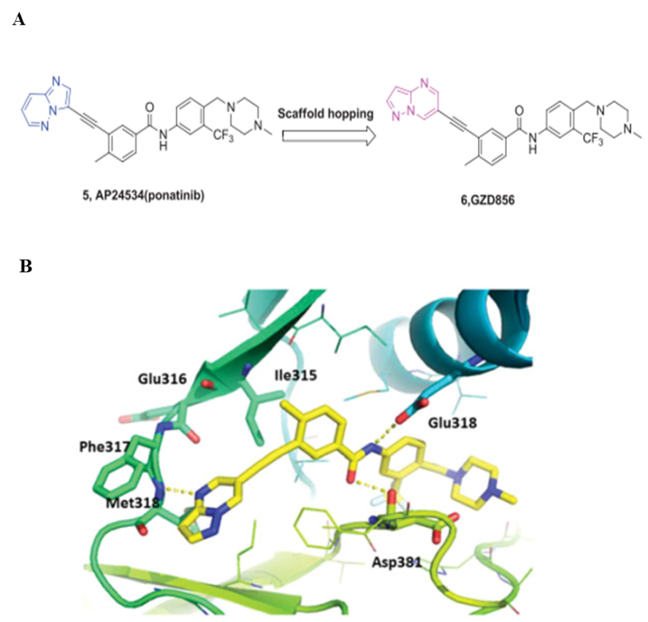

Supplementary Figure 1 Design of olverembatinib and predicted binding mode of olverembatinib and BCR-ABL1 T3151.

A) Design of olverembatinib (HQP1351; GZD856) as a new BCR-ABL1 inhibitor by scaffold hopping based on ponatinib. B) Predicted binding mode of GZD856 with BCR-ABL1T315I. Hydrogen bonds are indicated by yellow hatched lines to key amino acids. Reprinted (adapted) with permission from (Ren X et al. Identification of GZD824 as an orally bioavailable inhibitor that targets phosphorylated and nonphosphorylated breakpoint cluster region–Abelson (BCR-ABL1) kinase and overcomes clinically acquired mutation-induced resistance against imatinib. J Med Chem 2013; 56:879-894. Copyright (©2013) American Chemical Society.

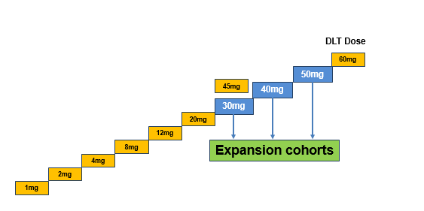

Supplementary Figure 2 Study design.

Olverembatinib was administered orally on alternate days, according to the schema shown above
(one cycle = 28 days). The first dose was given on October 26, 2016.
Other key points:
Dose escalation
- 3+3 dose escalation design across 11 dose cohorts
- A total of 15 subjects in the maximum tolerated dose (MTD) dose cohort
- Intrapatient dose escalation permitted unless the olverembatinib regimen exceeded the MTD
Dose expansion
- Up to 60 subjects

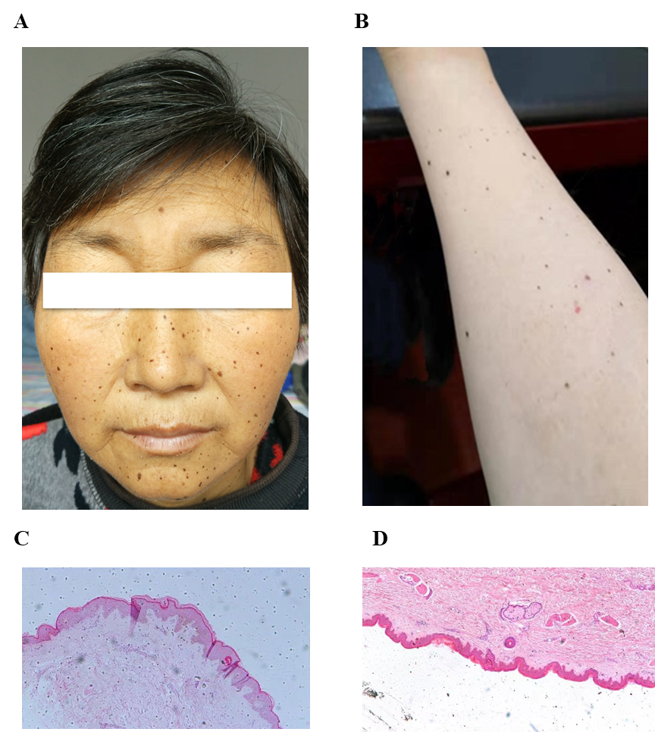

Supplementary Figure 3 Skin pigmentation (A, B) and lentiginous nevus (C,D).

