Table S1. Geographic distribution range, geographic coordinates, voucher specimens, and the Genbank accession number of analyzed sequences. *Hybrid individuals and their respective crosses suggested by genetic data are shown in the voucher tissue column.
Taxa | Locality | Voucher tissue | cytb | cox1 | atpase8/6 | RAG1
Ictalurus sp. Mezquital | 1. Tunal River at Melones bridge, | CPUM-1790 | ON008811 | ON023863 | ON008558 | --
 | Nombre de Dios town; Mezquital | CPUM-1791 | ON008812 | ON023864 | ON008559 | ON008696
 | basin, Durango, Mex. | CPUM-1792 | ON008813 | ON023865 | ON008560 | ON008697
 |  | CPUM-1794 | ON008814 | ON023866 | ON008561 | ON008698
 |  | CPUM-4988 | ON008815 | ON023867 | ON008562 | ON008699
 |  | CPUM-4989 | ON008816 | -- | -- | --
 |  | CPUM-4990 | ON008817 | -- | -- | --
 |  | CPUM-4991 | ON008818 | -- | -- | --
 |  | CPUM-4992 | ON008819 | -- | -- | --
 |  | CPUM-4993 | ON008820 | ON023868 | ON008563 | ON008700
 | 2. Mezquital River at west of Ruiz | CPUM-5133 | ON008821 | -- | -- | --
 | town; Mezquital basin, Durango, | CPUM-5134 | ON008822 | -- | -- | --
 | Mex.
 | 3. Mamey River, 11 km northwest | CPUM-5156 | ON008823 | ON023869 | ON008564 | ON008701
 | of the Mecatan town | CPUM-5157 | ON008824 | ON023870 | ON008565 | --
 |  | CPUM-5158 | ON008825 | ON023871 | ON008566 | ON008702
Ictalurus cf. dugesii Santiago | 4. Verde River at Belen del | CPUM-1744 | ON008826 | ON023872 | ON008567 | --
 | Refugio town; Verde basin, | CPUM-5898 | ON008827 | -- | -- | --
 | Jalisco, Mex. | CPUM-5899 | ON008828 | ON023873 | ON008569 | ON008703
 |  | CPUM-5900 | ON008829 | ON023874 | ON008570 | --
 |  | CPUM- | ON008830 | ON023875 | ON008571 | --
 |  | CPUM-5904 | ON008831 | ON023876 | ON008572 | --
 |  | CPUM-5905 | ON008832 | -- | -- | --
 | 5. Juchipila River at Jalpa Town; | CPUM-5791 | ON008833 | ON023877 | ON008573 | ON008704
 | Juchipila basin, Zacatecas, Mex. | CPUM-5792 | ON008834 | -- | -- | --
 |  | CPUM-5793 | ON008835 | -- | -- | --
 |  | CPUM-5794 | ON008836 | ON023878 | ON008574 | --
 |  | CPUM-5795 | ON008837 | -- | -- | --
 |  | CPUM-5796 | ON008838 | -- | -- | --
 | 6. Juchipila River at the northwest of | CPUM-20870 | ON008839 | ON023879 | ON008575 | --
 | Alameda Juarez town; Juchipila | CPUM-20872 | ON008840 | ON023880 | ON008576 | ON008705
 | basin, Zacatecas, Mex.
 | 7. Juchipila River at Tabachines II | CPUM-5745 | ON008841 | ON023881 | ON008577 | ON008706
 | bridge, Tabasco Town; Juchipila | CPUM-5746 | ON008842 | -- | -- | --
 | basin, Zacatecas, Mex. | CPUM-5747 | ON008843 | ON023882 | ON008578 | ON008707
 |  | CPUM-5748 | ON008844 | ON023883 | ON008579 | ON008708
Ictalurus pricei | 8. Bavispe River at Hondables, | CPUM-7963 | ON008845 | ON023884 | ON008580 | --
 | 8.85 km at east of Colonia
 | Morelos, Agua Prieta town; Yaqui
 | basin, Sonora, Mex.
 | 9. Bavispe River, 7.2 km northeast | CPUM-8002 | ON008846 | ON023885 | ON008581 | ON008709
 | of Huachinera town; Yaqui basin, | CPUM-8003 | ON008847 | ON023886 | ON008582 | --
 | Chihuahua, Mex.
 | 10. Bavispe River, east of San. | CPUM-8011 | ON008848 | ON023887 | ON008583 | ON008710
 | Miguelito town; Yaqui basin,
 | Chihuahua, Mex
 | 11. Guerachi River, 27 km | CPUM-7058 | ON008849 | ON023888 | ON008584 | ON008711
 | southwest of Guachochi; Fuerte | CPUM-7059 | ON008850 | ON023889 | ON008585 | ON008712
 | basin, Chihuahua, Mex. | CPUM-7060 | ON008851 | ON023890 | ON008586 | ON008713
 |  | CPUM-7064 | ON008852 | ON023891 | ON008587 | ON008714
 |  | CPUM-7073 | ON008853 | ON023892 | ON008588 | ON008715
 |  | CPUM-7124 | ON008854 | ON023893 | ON008589 | ON008716
 | 12. Batopilas River at Batopilas, | -- | EF590206 | -- | -- | --
 | Fuerte Basin, Chihuahua, Mex. | -- | -- | KF536995 | -- | --
 |  | -- | -- | KF536996 | -- | --
 |  | -- | -- | KF536997 | -- | --
 |  | -- | -- | KF536999 | -- | --
 |  | -- | -- | KF537000 | -- | --
Ictalurus cf. pricei | 13. Stream at Rodeo Town; | -- | EF5902207 | KJ019216 | -- | --
Culiacan/San Lorenzo | Culiacan basin, Durango, Mex. | -- | -- | KJ019217 | -- | --
 | 14. San Lorenzo River at Igualamo | -- | EF5902208 | KJ019218 | -- | --
 | town; San Lorenzo basin,
 | Durango, Mex.
Ictalurus cf. lupus | 15. Ramos River at Allende town; | CPUM-2402 | ON008855 | ON023894 | ON008590 | ON008717
Cuatro Cienegas | Bravo basin, Nuevo Leon, Mex.
 | 16. Charco Prieto pool at Cuatro | CPUM-6374 | ON008856 | ON023895 | ON008591 | ON008718
 | Cienegas valley; endorheic basin, | CPUM-6377 | ON008857 | ON023896 | ON008592 | ON008719
 | Coahuila, Mex.
Ictalurus cf. lupus Conchos | 17. Porvenir River 11 km | CPUM-7022 | ON008858 | ON023897 | ON008593 | ON008720
 | southeast of Balleza town; Bravo | CPUM-7023 | ON008859 | ON023898 | ON008594 | ON008721
 | basin, Chihuahua, Mex. | CPUM-7024 | ON008860 | ON023899 | ON008595 | ON008722
 |  | CPUM-7025 |  | -- | ON008596 | ON008723
 |  | CPUM-7026 | ON008861 | ON023900 | ON008597 | ON008724
Ictalurus lupus | 18. San Felipe Creek, Del Rio Val | -- | AY458885 | -- | -- | --
 | Verde Co., Texas, USA.
 | 19. Devil River, Val Verde | -- | -- | JN026910 | -- | --
 | County, Texas, USA. | -- | -- | JN026911 | -- | --
 |  | -- | GQ396783 | -- | -- | --
 |  | -- | GQ396797 | -- | -- | --
 | 20. Frio River near the city of | -- | GQ396774 | -- | -- | --
 | Leakey, Texas, USA. | -- | GQ396781 | -- | -- | --
Ictalurus cf. lupus Soto | 21. Stream at the north of la Nutria | CPUM-1746 | ON008862 | ON023901 | ON008568 | ON008725
la Marina | town; Soto la Marina basin, | CPUM-1747 | ON008863 | -- | ON008598 | --
 | Tamaulipas, Mex.
 | 22. Troncones River at Ciudad | RP-137 | ON008864 | ON023902 | ON008599 | ON008726
 | Victoria; Soto la Marina basin, | RP-138 | ON008865 | ON023903 | ON008600 | ON008727
 | Mex. | RP-139 | ON008866 | ON023904 | ON008601 | ON008728
 |  | RP-140 | ON008867 | ON023905 | ON008602 | ON008729
 |  | RP-146 | ON008868 | -- | -- | --
 | 23. El Chorrito River, road to el Ojo | RP-435 | ON008869 | ON023906 | ON008603 | ON008730
 | de la Virgen Church at Hidalgo | RP-436 | ON008870 | ON023907 | ON008604 | ON008731
 | town, Soto la Marina Basin, | RP-437 | ON008871 | ON023908 | ON008605 | ON008732
 | Tamaulipas, Mex. | RP-438 | ON008872 | ON023909 | ON008606 | ON008733
 | 24. Stream at Novillo canyon at | RP-524 | ON008873 | ON023910 | ON008607 | ON008734
 | southeast of Ciudad Victoria; Soto
 | la Marina Basin, Tamaulipas,
 | Mex.
Ictalurus dugesii | 25. Lerma River at Pateo town; | CPUM-45605 | ON008874 | -- | ON008608 | --
 | upper Lerma basin, Michoacan,
 | Mex.
 | 26. Angulo River at Sabino town; | CPUM-6182 | ON008875 | ON023911 | ON008609 | ON008735
 | middle Lerma basin, Michoacan, | CPUM-6224 | ON008876 | ON023912 | ON008610 | ON008736
 | Mex. | CPUM-6225 | ON008877 | ON023913 | ON008611 | ON008737
 |  | CPUM-6226 | ON008878 | ON023914 | ON008612 | ON008738
 | 27. Angulo River at Botello town; | CPUM-9212 | ON008879 | -- | -- | --
 | middle Lerma basin, Michoacan, | CPUM-9213 | ON008880 | -- | -- | --
 | Mex.
 | 28. San Juanico Lake at Cotija | CPUM-6295 | ON008881 | ON023915 | ON008613 | ON008739
 | town; endorheic basin, Michoacan,
 | Mex.
 | 29. Ameca River at San Blasito | CPUM-1813 | ON008882 | ON023916 | ON008614 | ON008740
 | town; Ameca basin, Nayarit, Mex. | CPUM-2245 | ON008883 | ON023917 | ON008615 | ON008741
 |  | CPUM-2246 | ON008884 | -- | -- | --
 |  | CPUM-2247 | ON008885 | -- | -- | --
 | 30. Stream at Ahuilota pharm, | CPUM-18949 | ON008886 | ON023918 | ON008616 | --
 | Mascota town; Ameca basin, Jal. | CPUM-18950 | ON008887 | ON023919 | ON008617 | --
 | Mex. | CPUM-18951 | ON008888 | ON023920 | ON008618 | --
 |  | CPUM-18952 | ON008889 | -- | -- | --
 |  | CPUM-18953 | ON008890 | -- | -- | --
 | 31. Ameca River at Amado Nervo; | CPUM-101 | ON008891 | ON023921 | ON008619 | ON008742
 | Ameca Basin, Nayarit, Mex. | CPUM-102 | ON008892 | ON023922 | -- | --
 |  | CPUM-103 | ON008893 | ON023923 | ON008620 | --
 |  | CPUM-104 | ON008894 | -- | -- | --
 |  | CPUM-106 | ON008895 | ON023924 | ON008621 | ON008743
 | 32. El Limon stream at Atenguillo | CPUM-44580 | ON008896 | ON023925 | ON008622 | --
 | town; Ameca basin, Jalisco, Mex. | CPUM-44582 | ON008897 | ON023926 | ON008623 | --
 | 33. Spring at Teuchitlan town; | CPUM-42901 | ON008898 | -- | -- | --
 | Ameca basin, Jalisco, Mex. | CPUM-42902 | ON008899 | -- | -- | --
 |  | CPUM-42903 | ON008900 | -- | -- | --
Ictalurus cf. dugesii Armeria | 34. Armeria River at Aguacate | CPUM-5174 | ON008901 | ON023928 | ON008624 | ON008744
 | town, El Grullo; Armeria basin, | CPUM-5175 | ON008902 | -- | -- | --
 | Jalisco, Mex. | CPUM-5176 | ON008903 | -- | -- | --
 | 35. Armeria River at Las | CPUM-18723 | ON008904 | ON023929 | ON008625 | ON008745
 | Ventanas town, El Grullo; Armeria | CPUM-18724 | ON008905 | ON023930 | ON008626 | ON008746
 | basin, Jalisco, Mex. | CPUM-18726 | ON008906 | ON023931 | ON008627 | ON008747
 |  | CPUM-18727 | ON008907 | ON023932 | ON008628 | ON008748
Ictalurus ochoterenai | 36. Chapala Lake at Chapala town; | CPUM-401 | ON008908 | -- | -- | --
 | Lerma-Chapala basin, Jalisco, | CPUM-402 | ON008909 | -- | -- | --
 | Mex. | CPUM-5014 | ON008910 | ON023933 | ON008629 | ON008749
 |  | CPUM-5015 | ON008911 | -- | -- | --
 |  | CPUM-5018 | ON008912 | ON023934 | ON008630 | ON008750
 |  | CPUM-5019 | ON008913 | ON023935 | ON008631 | ON008751
 |  | CPUM-5021 | ON008914 | -- | -- | --
Ictalurus sp. Nazas | 37. Ramos River, 1.4 km north of | CPUM-1796 | ON008915 | ON023936 | ON008632 | ON008752
 | Ramos town; Nazas basin, | CPUM-1800 | ON008916 | ON023937 | ON008633 | ON008753
 | Durango, Mex. | CPUM-1805 | ON008917 | ON023938 | ON008634 | ON008754
 | 38. El Olote town, Santiago | CPUM-5987 | ON008918 | ON023939 | ON008635 | ON008755
 | Papasquiaro; Nazas basin, | CPUM-6819 | ON008919 | ON023940 | ON008636 | ON008756
 | Durango, Mex.
 | 39. El Colorado near El Olote | CPUM-2022 | ON008920 | ON023941 | ON008637 | ON008757
 | town, Santiago Papasquiaro;
 | Nazas Basin, Durango, Mex.
Ictalurus mexicanus | 40. Gallinas River at Jabali town; | MNCN-2872 | ON008921 | ON023942 | ON008638 | ON008758
 | Panuco Basin, San Luis Potosi, | MNCN-2873 | ON008922 | ON023943 | ON008639 | ON008759
 | Mex.
Ictalurus australis | 41. Verde River at north of Rio | MNCN-2901 | ON008923 | ON023944 | ON008640 | ON008760
 | Verde town; Panuco Basin, San
 | Luis Potosi, Mex.
 | 42. Channel 800m | CPUM-4800 | ON008924 | ON023945 | ON008641 | ON008761
 | northwest of Plazuela town;
 | Panuco River, San Luis Potosi, Mex.
 | 43. Guayalejo River at Llera town; | RP-469* | ON008925 | ON023946 | ON008642 | ON008762
 | 43. Guayalejo River at Llera town; | mtDNA = I. punctatus, nDNA = I. australis
 | Panuco Basin, Tamaulipas, Mex. | RP-470* | ON008926 | ON023947 | ON008643 | ON008763
 | Panuco Basin, Tamaulipas, Mex. | mtDNA = I. punctatus, nDNA = I. australis
Ictalurus punctatus | 44. Mud River, Logan Co. KY, | -- | AY184254 | -- | -- | --
 | USA.
 | 45. Grande River at Brewster | -- | GQ396793 | -- | -- | --
 | County, Texas, USA.
 | 46. Dark canyon, Eddy County, | -- | AY327267 | -- | -- | --
 | New Mexico, USA.
 | 47. Brazos River at Walter | -- | GQ396770 | -- | -- | --
 | County, Texas, USA.
 | 48. LaMoine River at Highway 61 | -- | AY184253 | -- | -- | --
 | bridge, McDonough County.
 | Illinois, USA.
 | 49. Concho River, Concho | -- | GQ396767 | -- | -- | --
 | County, Texas USA.
 | 50. Sabinas River 9.8 km | CPUM-2298 | ON008927 |  | --
 | northwest of Ciudad Muzquiz; Bravo basin, Coahuila, Mex. | CPUM-2299* | ON008928 | ON023948 | ON008644 | ON008764
 | northwest of Ciudad Muzquiz; Bravo basin, Coahuila, Mex. | mtDNA = I. punctatus
 | northwest of Ciudad Muzquiz; Bravo basin, Coahuila, Mex. | nDNA = I. lupus
 |  | CPUM-2300 | ON008929 | ON023949 | ON008645 | --
 | 51. Falcon Dam 1.4 km north of. | CPUM-1699 | ON008930 | -- | -- | --
 | Nueva Ciudad Guerrero; Bravo | CPUM-1707 | ON008931 | ON023950 | ON008646 | ON008765
 | basin, Tamaulipas, Mex.
 | 52. Salado River 2.5 km southeast | CPUM-1711 | ON008932 | ON023951 | ON008647 | --
 | of Rancho La Peñita; Bravo River,
 | Coahuila, Mex.
 | 53. Vicente Guerrero Dam; Soto la | CPUM-1692 | ON008933 | ON023952 | ON008648 | ON008766
 | Marina Basin, Tamaulipas, Mex.
 | 54. Oyul Dam 2 km southeast of | CPUM-1714 | ON008934 | -- | -- | --
 | Antiguo Morelos town; Panuco | CPUM-1715 | ON008935 | ON023953 | ON008649 | ON008767
 | River, Tamaulipas, Mex
 | 55. Tampaon River south of | CPUM-1717 | ON008936 | ON023954 | ON008650 | ON008768
 | Tamuin town; Panuco basin, San | CPUM-1725 | ON008937 | -- | -- | --
 | Luis Potosi, Mex.
 | 56. Tamasopo River at Agua | CPUM-1826 | ON008938 | -- | -- | --
 | Buena town; Panuco basin, San
 | Luis Potosi, Mex.
 | 57. Amajac River 245 m south of | CPUM-3656 | ON008939 | -- | -- | --
 | Zacatipan town; Panuco basin, San
 | Luis Potosi, Mex.
 | 58. San Pedro River east of | CPUM-3643 | ON008940 | -- | -- | --
 | Orizatlan town; Panuco basin, San
 | Luis Potosi, Mex.
 | 59. Santa Maria River at Salitrillo | MNCN-2902* | ON008941 | ON023955 | ON008651 | ON008769
 | 59. Santa Maria River at Salitrillo | mtDNA = I. punctatus
 | 59. Santa Maria River at Salitrillo | nDNA = I. mexicanus
 | town; Panuco basin, San Luis
 | Potosi, Mex.
 | 60. Pantepec River 480 m | CPUM-3236 | ON008942 | ON023956 | ON008652 | ON008770
 | northeast of Nuevo Carrizal town, | CPUM-3237 | ON008943 | ON023957 | ON008653 | ON008771
 | road Pantepec-Mecalapa; Tuxpan | CPUM-3475 | ON008944 | -- | ON008654 | --
 | basin,Veracruz, Mex. | CPUM-3474* | ON008945 | ON023958 | ON008654 | ON008772
 | basin,Veracruz, Mex. | mtDNA = I. punctatus
 | basin,Veracruz, Mex. | nDNA = I. mexicanus
 | 61. Vinazco River north of | CPUM-5507 | ON008946 | -- | -- | --
 | Aguacate de Vinazco town;
 | Tuxpan basin,Veracruz, Mex.
 | 62. Moctezuma River south of | CPUM-7956 | ON008947 | ON023959 | ON008655 | ON008773
 | Caserio de Terapa town; Yaqui | CPUM-7957 | ON008948 | ON023960 | ON008656 | ON008774
 | basin, Chihuahua, Mex.
 | 63. Nazas River in Peñasco at San | CPUM-6063 | ON008949 | ON023961 | ON008657 | ON008775
 | Rafael de Jicorica; Nazas basin, | CPUM-6064 | ON008950 | ON023962 | ON008658 | ON008776
 | Durango, Mex. | CPUM-6083 | ON008951 | ON023963 | ON008659 | ON008777
 | 64. Nazas River at bridge 5.3 km | CPUM-6176 | ON008952 | ON023964 | ON008660 | ON008778
 | west of Nazas town; Nazas basin,
 | Durango, Mex.
 | 65. Ramos River south of the | CPUM-5985 | ON008953 | ON023965 | ON008661 | ON008779
 | Olote town; Nazas basin, Durango,
 | Mex.
 | 66. Ramos River Road to the Olote | CPUM-2021 | ON008954 | -- | -- | --
 | town to Colorado; Nazas basin, | CPUM-2023 | ON008955 | ON023966 | ON008662 | ON008780
 | Durango, Mex.
 | 67. San Pedro Lagunillas dam; | CPUM-108 | ON008956 | -- | ON008663 | ON008781
 | Huicicila-San Blas basin, Nayarit, | CPUM-109 | ON008957 | ON023967 | ON008664 | ON008782
 | Mex. | CPUM-110 | ON008958 | ON023968 | ON008665 | ON008783
 |  | CPUM-111 | ON008959 | ON023969 | ON008666 | --
 |  | CPUM-112 | ON008960 | ON023970 | ON008667 | ON008784
 | 68. Animas River 2.5 km | CPUM-1749 | ON008961 | -- | -- | ON008785
 | southwest of Cebadilla town;
 | Balsas basin, Michoacan, Mex.
 | 69. Balsas River 7 km south of | CPUM-1775 | ON008962 | -- | -- | ON008786
 | Ciudad Altamirano town; Balsas
 | basin, Guerrero, Mex.
 | 70. El Tesorero dam; Santiago | CPUM-5724 | ON008963 | ON023971 | ON008668 | --
 | basin, Zacatecas, Mex.
 | 71. Tetiteco River, Road Amado | CPUM-103 | ON008964 | -- | -- | ON008787
 | Nervo to Valle Verde; Ameca
 | basin Nayarit, Mex.
 | 72. Fleuve St-Laurent, riviere St- | -- | EU524677 | -- | -- | --
 | Nicolas, Quebec, Canada. | -- | EU524678 | -- | -- | --
 | 73. Thames River, Ontario, | -- | EU524679 | -- | -- | --
 | Canada. | -- | EU524680 | -- | -- | --
 |  | -- | EU524683 | -- | -- | --
 | 74. Fleuve St-Laurent, riviere | -- | EU524685 | -- | -- | --
 | Richelieu, Quebec, Canada
 | 75. Baie Mississippi, Quebec, | -- | EU524106 | -- | -- | --
 | Canada.
 | 76. Pennsylvania, USA. | -- | EU490865 | -- | -- | --
 | 77. Sipsey River, Tuscaloosa, | -- | JN026912 | -- | -- | --
 | Alabama, USA.
Ictalurus furcatus | 78. Mississippi River, Ramsey | -- | KM264126 | -- | -- | --
 | Co., Mississippi basin, MO, USA.
 | 79. Tamasopo River at Agua | CPUM-1873 | ON008965 | ON023972 | ON008669 | ON008788
 | Buena town; Panuco basin, San
 | Luis Potosi, Mex.
 | 80. Tampaon River south of | MNCN-2963 | ON008966 | ON023973 | ON008670 | --
 | Tamuin town; Panuco basin, San
 | Luis Potosi, Mex.
 | 81. Papaloapan River at | CPUM-3226 | ON008967 | ON023974 | ON008671 | ON008789
 | Tlacotalpan; Papaloapan basin, | CPUM-3227 | -- | ON023975 | ON008672 | --
 | Veracruz, Mex. | CPUM-3228 | ON008968 | ON023976 | ON008673 | ON008790
 |  | CPUM-3229 | -- | ON023977 | ON008674 | --
 | 82. Corte at Coatzacoalcos River, | CPUM-264 | ON008969 | -- | -- | ON008791
 | west of Cuauhtémoc; Coatzacoalcos
 | basin, Veracruz, Mex.
 | 83. Conchos River northeast of | CPUM-2030 | ON008970 | ON023978 | ON008675 | ON008792
 | Zaragoza town; Conchos basin,
 | Chihuahua, Mex.
 | 84. Louisiana, Cameron Parish, | -- | -- | KF929995 | -- | --
 | Superior Canal, Calcasieu Lake.
Ictalurus meridionalis | 85. Lagoon at Crooked Tree | CPUM-4567 | ON008971 | ON023979 | ON008676 | ON008793
 | causeway, Crooked Tree, Rio
 | Hondo Basin, Belize.
 | 86. Peten, Guatemala. | -- | -- | EU751844 | -- | --
Ictalurus balsanus | 87. Amacuzac River at Huixastla; | UAEM-1IB | ON008972 | ON023980 | ON008677 | ON008794
 | Balsas basin, Morelos, Mex. | UAEM-2IB | ON008973 | ON023981 | ON008678 | ON008795
 |  | UAEM-3IB | ON008974 | ON023982 | ON008679 | ON008796
 |  | UAEM-4IB | ON008975 | ON023983 | ON008680 | ON008797
 |  | CPUM-3251 | ON008976 | -- | -- | --
 |  | CPUM-3259 | ON008977 | -- | -- | --
 | 88. Mixteco River west of | MNCN-1912 | ON008978 | ON023984 | ON008681 | --
 | Tecomatlan town; Balsas basin, | MNCN-1915 |  | ON023985 | ON008682 | --
 | Morelos, Mex.
 | 89. Poliutla River at San José | MNCN-2031 | ON008979 | ON023986 | -- | --
 | Poliutla town; Balsas basin,
 | Guerrero, Mex.
 | 90. Placeres de Oro River at | MNCN-2032 | ON008980 | -- | -- | --
 | Zihuaquio bridge; Balsas basin, | MNCN-2038 | ON008981 | -- | -- | --
 | Guerrero, Mex.
 | 91. Mixteco River at Coatlan del Rio. | MNCN-1893 | ON008982 | -- | -- | --
 | town; Balsas basin, Morelos, Mex
 | 92. Tlapaneca River at Tlapa town; | MNCN-1957 | ON008983 | -- | -- | ON008798
 | Balsas basin, Guerrero, Mex.
 | 93. Zitacuaro River at Tuzantla | MNCN-3092 | -- | -- | -- | ON008799
 | town; Balsas basin, Michoacan, | MNCN-3094 | ON008984 | -- | -- | --
 | Mex. | MNCN-1309 | ON008985
 | 94. Tuxpan River at Jungapeo | CPUM-45461 | ON008986 | -- | -- | --
 | Town; Balsas basin, Michoacan, | CPUM-45464 | ON008987 | ON023987 | ON008683 | ON008800
 | Mex. | CPUM-45466 | ON008988 | ON023988 | ON008684 | ON008801
 |  | CPUM-45467 | ON008989 | ON023989 | ON008685 | ON008802
 |  |  | ON008990 |  | ON008686
 | 95. El Marquez River at south of | CPUM-4994 | ON008991 | ON023990 | ON008687 | ON008803
 | Chauz town; Balsas basin,
 | Michoacan, Mex.
 | 96. Las Trojes River at Las Trojes | CPUM-1752 | ON008991 | ON023991 | ON008687 | ON008804
 | town; Balsas basin, Michoacan,
 | Mex.
 | 97. Huetamo River at La Florida | CPUM-1762 | ON008992 | -- | -- | --
 | bridge; Balsas basin, Michoacan, | CPUM-1773 | ON008993 | -- | -- | --
 | Mex.
Prietella phreatophila | 98. Sotano de Amezcua at Ciudad | -- | AY458884 | -- | -- | --
 | Acuña; Bravo basin, Coahuila,
 | Mex.
Pylodichthys olivaris | 99. Porvenir River at 3.2 km | CPUM-7031 | ON008994 | ON023992 | ON008688 | ON008805
 | southeast of Balleza town; Bravo
 | basin, Chihuahua, Mex.
 | 100. Guayalejo River, Llera town; | RP-468 | ON008995 | ON023993 | ON008689 | ON008806
 | Panuco basin, Tamaulipas, Mex.
 | 101. Laboratorio de Genética para la Conservación, Centro de Investigaciones Biológicas del Noroeste, La Paz, Baja California Sur, México, | LGC_ADN2186 | ON008996 | ON023994 | ON008690 | ON008807
 |  | (PyOR970720-5)
Noturus gyrinus | 102. Cummins Creek, Colorado Co, | -- | AY458890 | -- | -- | --
 | Texas, USA.
 | 103. Laboratorio de Genética para la Conservación, Centro de Investigaciones Biológicas del Noroeste, La Paz, Baja California Sur, México, | LGC_ADN2182 (Noturus89704XX-3) | ON008997 | -- | -- | --
Noturus flavus | 104. Laboratorio de Genética para la Conservación, Centro de Investigaciones Biológicas del Noroeste, La Paz, Baja California Sur, México, | LGC_ADN 2177(NFw470530-2) | ON008998 | ON023995 | ON008691 | ON008808
Noturus insignis | 105. Laboratorio de Genética para la Conservación, Centro de Investigaciones Biológicas del Noroeste, La Paz, Baja California Sur, México, | LGC_ADN2180 (NINC970526-2) | ON008999 | -- | ON008692 | ON008809
Ameiurus natalis | 106. Pin Oak Creek, Bastrop Co., | -- | AY458888 | -- | -- | --
 | Texas, USA.
 | 107. Laboratorio de Genética para la Conservación, Centro de Investigaciones Biológicas del Noroeste, La Paz, Baja California Sur, México, | LGC_ADN2174(AnBA9706176) | ON009000 | ON023996 | ON008693 | ON008810
Cranoglanis bouderius | 108. Hongshui River in Guangxi | -- | NC_008280 | NC_008280 | NC_008280 | DQ492514
 | province, China
Arius arius | 109. El Corte Coatzacoalcos, | 263 | ON009002 | -- | -- | --
 | Coatzacoalcos Basin, Veracruz, Mex.
Pangasianodon | 110. Guangzhou, China | -- | NC_021752 | NC_021752 | NC_021752 | KR080265
hypophthalmus
Rita rita | 111. Southern Asia | DQ119457 | -- | -- | -- | --

Supporting information
Appendix S2. Time calibrated analysis procedure performed in BEAST
A time-calibrated tree was reconstructed for 13 individuals, including all described species and all populations that show a genetic divergence ≥ 1.5% in the cytb gene (except Ictalurus lupus and I.cf. pricei Culiacan/San Lorenzo due to the lack of sequences for the atpase8/6 and RAG1), plus Noturus flavus, Pylodictis olivaris, and Ameirus natalis as the outgroup using BEAST v.1.8.4 (Drummond et al., 2012). We use the best fit models of nucleotide substitution estimated for each locus (cytb: GTR+G, cox1: HKY+I+G, atpase8/6: GTR+G, RAG1: HKY), implement a relaxed clock with an uncorrelated lognormal model, and a Yule speciation process. Four fossil constraints were used as calibration points; the fossil of †Ictalurus rhaeas dated at Eocene-Oligocene (37-30 Ma) (Prothero, 1995) is regarded as the oldest fossil of the genus Ictalurus, accordingly was used to constrain the crown group of the genus to a hard minimum bound of 30 Ma; in addition, and based on the information that the stem group of Ictalurus was located at ̴ 40 Ma (sensu Arce-H et al., 2016), a soft upper bound of 40 Ma was included using a lognormal prior. The fossil †Ictalurus lambda dated at the middle-late Miocene (10.3-13.6 Ma, Arce-H et al., 2016) that shares many features with I. furcatus, but, as well present exclusive diagnostic features (Lundberg, 1975), was used as a calibration point for the crown clade of furcatus group, setting a hard minimum bound of 10 Ma. For the third calibration point, we use the record fossil of the extant species Ictalurus punctatus dated at early-middle Miocene (15.9-18.9 Ma, Arce-H et al., 2016) to constrain the most recent common ancestor of the I. punctatus to a hard minimum bound of 16 Ma. For the last calibration point (C4), the species fossil †Ictalurus spodius found in Chapala Lake (Smith, 1987), dated at the Late Pleistocene (1.0-1.5 Ma, Arce-H et al., 2016) and highly related with the extant species I. dugesii (Smith, 1987), was used to constrain the most recent common ancestor of this species (C4) to a hard minimum bound of 1 Ma with a soft upper bound of 11 Ma based on the formation of the ancient Chapala Lake (Late Miocene, Israde-Alcántara, 1999). Since the lack of appropriate information to determine the shape of the lognormal distribution (Ho and Phillips, 2009), for the case of the latter three calibration points, C2, C3, and C4, a soft upper bound of 40 Ma was established using an exponential prior. We conducted three independent analyses of 300 million generations, sampling every 3000 generations. Convergence and stationary distribution of the runs were verified by the effective sample size for all parameters (ESS >200) as visualized in Tracer 1.5. Ten percent of the generations were discarded as burn-in and pooled using the module Log-Combiner in the BEAST package. The maximum clade credibility species tree was obtained by the module Tree-Annotator in the BEAST package.
References
Arce-H M., J. G. Lundberg and M. A. O’Learya. 2016. Phylogeny of the North American catfish family Ictaluridae Teleostei: Siluriformes) combining morphology, genes and fossils. Cladistics 1-23.
Drummond A.J., Suchard M.A., Xie D., Rambaut A. 2012. Bayesian phylogenetics with BEAUti and the BEAST 1.7. Molecular Biology and Evolution, 29, 1969-1973.
Ho S.Y.W.,and Phillips M.J. 2009. Accounting for calibration uncertainty in phylogenetic estimation of evolutionary divergence times. Systematic Biology, 58:367-380.
Israde-Alcántara I. 1999. Los lagos volcánicos y tectónicos de Michoacán. En Garduño-Monroy V.H., Corona-Chávez P., Israde-Alcántara I., Menella,L. Arreyque E., Bigioggero B., Chiesa S. eds. Carta Geológica de Michoacán. Universidad Michoacana de San Nicolas de Hidalgo. 45-73.
Lundberg, J.G., 1975. The fossil catfishes of North America. University of Michigan Papers on Paleontology 11: 61.
Prothero, D.R., 1995. Geochronology and magnetostratigraphy of Paleogene North American land mammal ‘ages’: an update. Society of Economic Paleontolgists and Minerallogists. Special Publication, 54, 305–315.
Smith M.L., 1987. Osteology and systematics of the fossil catfishes (genus Ictalurus) of Central Mexico. Journal of Paleontology 61: 380–387.

Table S2. Uncorrected genetic distances based on cytb between distinct species and lineages within the genus Ictalurus. Mean values ± standard deviation.
 | 1 | 2 | 3 | 4 | 5 | 6 | 7 | 8 | 9 | 10 | 11 | 12 | 13 | 14 | 15 | 16 | 17
1. I. dugesii
2. I. ochoterenai | 0.002 ± 0.001
3. I. cf. dugesii Armeria | 0.009 ± 0.003 | 0.007 ± 0.003
4. I. lupus | 0.022 ± 0.005 | 0.022 ± 0.005 | 0.027 ± 0.005
5. I. cf. lupus Cuatro Cienegas | 0.025 ± 0.005 | 0.023 ± 0.005 | 0.029 ± 0.006 | 0.020 ± 0.004
6. I. cf. lupus Conchos | 0.029 ± 0.005 | 0.028 ± 0.005 | 0.033 ± 0.006 | 0.027 ± 0.005 | 0.019 ± 0.004
7. I. pricei | 0.024 ± 0.005 | 0.023 ± 0.005 | 0.028 ± 0.005 | 0.030 ± 0.005 | 0.026 ± 0.005 | 0.032 ± 0.005
8. I. mexicanus | 0.048 ± 0.007 | 0.047 ± 0.007 | 0.053 ± 0.007 | 0.056 ± 0.007 | 0.059 ± 0.008 | 0.062 ± 0.008 | 0.056 ± 0.007
9. I. australis | 0.051 ± 0.007 | 0.049 ± 0.007 | 0.055 ± 0.007 | 0.058 ± 0.008 | 0.061 ± 0.008 | 0.064 ± 0.008 | 0.058 ± 0.007 | 0.005 ± 0.002
10. I. punctatus | 0.073 ± 0.009 | 0.072 ± 0.009 | 0.075 ± 0.009 | 0.078 ± 0.009 | 0.082 ± 0.009 | 0.087 ± 0.009 | 0.076 ± 0.008 | 0.075 ± 0.008 | 0.076 ± 0.008
11. I. furcatus | 0.096 ± 0.009 | 0.095 ± 0.010 | 0.099 ± 0.010 | 0.102 ± 0.010 | 0.099 ± 0.009 | 0.105 ± 0.010 | 0.102 ± 0.010 | 0.108 ± 0.010 | 0.109 ± 0.010 | 0.098 ± 0.009
12. I. meridionalis | 0.098 ± 0.010 | 0.097 ± 0.010 | 0.100 ± 0.010 | 0.103 ± 0.010 | 0.102 ± 0.010 | 0.107 ± 0.010 | 0.102 ± 0.010 | 0.111 ± 0.010 | 0.113 ± 0.010 | 0.100 ± 0.010 | 0.015 ± 0.004
13. I. balsanus | 0.110 ± 0.010 | 0.109 ± 0.010 | 0.112 ± 0.010 | 0.116 ± 0.010 | 0.113 ± 0.010 | 0.121 ± 0.010 | 0.109 ± 0.010 | 0.111 ± 0.010 | 0.112 ± 0.010 | 0.106 ± 0.010 | 0.090 ± 0.009 | 0.089 ± 0.009
14. I. cf. lupus Soto La Marina | 0.023 ± 0.005 | 0.021 ± 0.005 | 0.026 ± 0.005 | 0.028 ± 0.005 | 0.030 ± 0.006 | 0.034 ± 0.006 | 0.033 ± 0.006 | 0.061 ± 0.008 | 0.063 ± 0.008 | 0.082 ± 0.009 | 0.102 ± 0.010 | 0.101 ± 0.010 | 0.115± 0.010
15. Ictalurus sp. Mezquital | 0.024 ± 0.005 | 0.022 ± 0.005 | 0.027 ± 0.005 | 0.034 ± 0.006 | 0.030 ± 0.006 | 0.035 ± 0.006 | 0.018 ± 0.004 | 0.058 ± 0.008 | 0.060 ± 0.008 | 0.072 ± 0.008 | 0.092 ± 0.009 | 0.091 ± 0.009 | 0.105± 0.010 | 0.033± 0.006
16. I. dugesii Santiago | 0.021 ± 0.005 | 0.020 ± 0.004 | 0.025 ± 0.005 | 0.033 ± 0.006 | 0.029 ± 0.005 | 0.035 ± 0.006 | 0.019 ± 0.004 | 0.058 ± 0.008 | 0.060 ± 0.008 | 0.076 ± 0.009 | 0.104 ± 0.010 | 0.102 ± 0.010 | 0.112± 0.010 | 0.033± 0.006 | 0.018± 0.004
17. I. cf. pricei Culiacan/San Lorenzo | 0.021 ± 0.004 | 0.020 ± 0.004 | 0.025 ± 0.005 | 0.032 ± 0.006 | 0.024 ± 0.005 | 0.031 ± 0.005 | 0.017 ± 0.004 | 0.056 ± 0.007 | 0.057 ± 0.007 | 0.075 ± 0.008 | 0.100 ± 0.009 | 0.095 ± 0.009 | 0.104± 0.009 | 0.031± 0.005 | 0.016± 0.004 | 0.019 ± 0.004
18. Ictalurus sp. Nazas | 0.020 ± 0.004 | 0.017 ± 0.004 | 0.021 ± 0.005 | 0.031 ± 0.006 | 0.032 ± 0.006 | 0.037 ± 0.006 | 0.032 ± 0.006 | 0.051 ± 0.007 | 0.053 ± 0.007 | 0.073 ± 0.008 | 0.099 ± 0.010 | 0.102 ± 0.010 | 0.109± 0.010 | 0.030± 0.006 | 0.031± 0.005 | 0.033 ± 0.006 | 0.031 ± 0.006

Table S3. Uncorrected genetic distances based on cox1 between distinct species and lineages within the genus Ictalurus. Mean values ± standard deviation.
 | 1 | 2 | 3 | 4 | 5 | 6 | 7 | 8 | 9 | 10 | 11 | 12 | 13 | 14 | 15 | 16 | 17
1. I. dugesii
2. I. ochoterenai | 0.001 ± 0.001
3. I. cf. dugesii Armeria | 0.004 ± 0.002 | 0.003 ± 0.002
4. I. pricei | 0.026 ± 0.006 | 0.026 ± 0.006 | 0.025 ± 0.006
5. I. cf. lupus Conchos | 0.022 ± 0.005 | 0.022 ± 0.005 | 0.022 ± 0.005 | 0.023 ± 0.005
6. I. cf. lupus Cuatro Cienegas | 0.027 ± 0.006 | 0.027 ± 0.007 | 0.027 ± 0.007 | 0.032 ± 0.007 | 0.011 ± 0.003
7. I. australis | 0.047 ± 0.008 | 0.047 ± 0.008 | 0.043 ± 0.008 | 0.058 ± 0.009 | 0.050 ± 0.008 | 0.051 ± 0.009
8. I. mexicanus | 0.044 ± 0.008 | 0.044 ± 0.008 | 0.041 ± 0.008 | 0.055 ± 0.009 | 0.047 ± 0.008 | 0.051 ± 0.009 | 0.003 ± 0.002
9. I. punctatus | 0.057 ± 0.009 | 0.057 ± 0.009 | 0.057 ± 0.009 | 0.067 ± 0.010 | 0.051 ± 0.008 | 0.053 ± 0.009 | 0.069 ± 0.010 | 0.067 ± 0.010
10. I. furcatus | 0.090 ± 0.012 | 0.089 ± 0.012 | 0.089 ± 0.012 | 0.101 ± 0.012 | 0.094 ± 0.012 | 0.097 ± 0.012 | 0.094 ± 0.012 | 0.091 ± 0.011 | 0.090 ± 0.012
11. I. meridionalis | 0.093 ± 0.012 | 0.092 ± 0.012 | 0.092 ± 0.012 | 0.105 ± 0.012 | 0.099 ± 0.012 | 0.103 ± 0.013 | 0.100 ± 0.012 | 0.097 ± 0.012 | 0.090 ± 0.011 | 0.013 ± 0.004
12. I. balsanus | 0.108 ± 0.013 | 0.108 ± 0.013 | 0.108 ± 0.013 | 0.109 ± 0.013 | 0.104 ± 0.012 | 0.103 ± 0.013 | 0.107 ± 0.013 | 0.104 ± 0.012 | 0.095 ± 0.012 | 0.087 ± 0.012 | 0.093 ± 0.012
13. I. cf. lupus Soto La Marina | 0.027 ± 0.006 | 0.027 ± 0.007 | 0.027 ± 0.007 | 0.036 ± 0.007 | 0.018 ± 0.005 | 0.018 ± 0.006 | 0.055 ± 0.009 | 0.053 ± 0.009 | 0.053 ± 0.009 | 0.092 ± 0.012 | 0.099 ± 0.012 | 0.102 ± 0.013
14. Ictalurus sp. Mezquital | 0.023± 0.006 | 0.023 ± 0.006 | 0.023 ± 0.006 | 0.020 ± 0.005 | 0.023 ± 0.006 | 0.029 ± 0.007 | 0.059 ± 0.010 | 0.057 ± 0.010 | 0.061 ± 0.010 | 0.095 ± 0.012 | 0.098 ± 0.012 | 0.106 ± 0.013 | 0.033 ± 0.007
15. I. cf. dugesii Santiago | 0.026 ± 0.006 | 0.026 ± 0.006 | 0.026 ± 0.006 | 0.018 ± 0.005 | 0.021 ± 0.005 | 0.025 ± 0.006 | 0.056 ± 0.009 | 0.053 ± 0.009 | 0.062 ± 0.010 | 0.092 ± 0.012 | 0.099 ± 0.012 | 0.101 ± 0.013 | 0.029 ± 0.007 | 0.016 ± 0.005
16. I. cf. price Culiacan/San Lorenzo | 0.024 ± 0.006 | 0.024 ± 0.006 | 0.020 ± 0.005 | 0.016 ± 0.004 | 0.022 ± 0.005 | 0.028 ± 0.007 | 0.055 ± 0.009 | 0.053 ± 0.009 | 0.062 ± 0.009 | 0.095 ± 0.012 | 0.098 ± 0.012 | 0.104 ± 0.013 | 0.033 ± 0.007 | 0.018 ± 0.005 | 0.017 ± 0.005
17. Ictalurus sp. Nazas | 0.024 ± 0.006 | 0.024 ± 0.006 | 0.024 ± 0.006 | 0.029 ± 0.007 | 0.017 ± 0.005 | 0.020 ± 0.006 | 0.049 ± 0.009 | 0.046 ± 0.008 | 0.056 ± 0.009 | 0.091 ± 0.012 | 0.095 ± 0.012 | 0.102 ± 0.012 | 0.020 ± 0.006 | 0.026 ± 0.007 | 0.026 ± 0.007 | 0.026 ± 0.006
18. I. lupus | 0.028 ± 0.007 | 0.028 ± 0.007 | 0.028 ± 0.007 | 0.034 ± 0.007 | 0.012 ± 0.004 | 0.011 ± 0.004 | 0.051 ± 0.009 | 0.049 ± 0.009 | 0.050 ± 0.009 | 0.093 ± 0.012 | 0.100 ± 0.012 | 0.103 ± 0.013 | 0.019 ± 0.006 | 0.030 ± 0.007 | 0.025 ± 0.006 | 0.030 ± 0.007 | 0.021 ± 0.006

Table S4. Uncorrected genetic distances based on atpase8/6 between distinct species and lineages within the genus Ictalurus. Mean values ± standard deviation.
 | 1 | 2 | 3 | 4 | 5 | 6 | 7 | 8 | 9 | 10 | 11 | 12 | 13 | 14 | 15
1. I. ochoterenai
2. I. dugesii | 0.001 ± 0.001
3. I. cf. dugesii Armeria | 0.006 ± 0.002 | 0.005 ± 0.002
4. I. pricei | 0.023 ± 0.005 | 0.022 ± 0.005 | 0.027 ± 0.005
5. I. cf. lupus Conchos | 0.024 ± 0.005 | 0.025 ± 0.005 | 0.030 ± 0.006 | 0.035 ± 0.006
6. I. cf. lupus Cuatro Cienegas | 0.021 ± 0.005 | 0.021 ± 0.005 | 0.026 ± 0.005 | 0.034 ± 0.006 | 0.011 ± 0.003
7. I. australis | 0.056 ± 0.008 | 0.055 ± 0.008 | 0.060 ± 0.008 | 0.058 ± 0.008 | 0.059 ± 0.008 | 0.057 ± 0.008
8. I. mexicanus | 0.059 ± 0.008 | 0.058 ± 0.008 | 0.061 ± 0.008 | 0.058 ± 0.008 | 0.067 ± 0.009 | 0.063 ± 0.009 | 0.018 ± 0.004
9. I. punctatus | 0.063 ± 0.008 | 0.063 ± 0.008 | 0.069 ± 0.009 | 0.072 ± 0.009 | 0.073 ± 0.009 | 0.069 ± 0.009 | 0.072 ± 0.009 | 0.079 ± 0.009
10. I. furcatus | 0.092 ± 0.010 | 0.093 ± 0.010 | 0.093 ± 0.010 | 0.096 ± 0.010 | 0.092 ± 0.010 | 0.092 ± 0.010 | 0.104 ± 0.010 | 0.104 ± 0.010 | 0.078 ± 0.009
11. I. meridionalis | 0.094 ± 0.010 | 0.094 ± 0.010 | 0.095 ± 0.010 | 0.097 ± 0.010 | 0.093 ± 0.010 | 0.094 ± 0.010 | 0.103 ± 0.010 | 0.105 ± 0.010 | 0.080 ± 0.009 | 0.005 ± 0.002
12. I. balsanus | 0.122 ± 0.011 | 0.122 ± 0.011 | 0.121 ± 0.011 | 0.127 ± 0.011 | 0.127 ± 0.011 | 0.119 ± 0.011 | 0.122 ± 0.011 | 0.122 ± 0.011 | 0.114 ± 0.010 | 0.089 ± 0.009 | 0.090 ± 0.009
13. I. cf. lupus Soto La Marina | 0.032 ± 0.006 | 0.031 ± 0.006 | 0.036 ± 0.006 | 0.039 ± 0.006 | 0.039 ± 0.007 | 0.040 ± 0.007 | 0.065 ± 0.009 | 0.070 ± 0.009 | 0.076 ± 0.009 | 0.096 ± 0.010 | 0.098 ± 0.010 | 0.127 ± 0.011
14. Ictalurus sp.  Mezquitalr | 0.020 ± 0.005 | 0.019 ± 0.005 | 0.024 ± 0.005 | 0.021 ± 0.004 | 0.031 ± 0.006 | 0.033 ± 0.006 | 0.059 ± 0.009 | 0.060 ± 0.008 | 0.074 ± 0.009 | 0.099 ± 0.010 | 0.100 ± 0.010 | 0.124 ± 0.011 | 0.039 ± 0.006
15. I. cf. dugesii Santiago | 0.020 ± 0.005 | 0.019 ± 0.005 | 0.024 ± 0.005 | 0.014 ± 0.004 | 0.032 ± 0.006 | 0.028 ± 0.006 | 0.054 ± 0.008 | 0.060 ± 0.008 | 0.068 ± 0.009 | 0.093 ± 0.010 | 0.094 ± 0.010 | 0.121 ± 0.011 | 0.037 ± 0.006 | 0.015 ± 0.004
16. Ictalurus sp. Nazas | 0.021 ± 0.005 | 0.022 ± 0.005 | 0.025 ± 0.005 | 0.029 ± 0.005 | 0.035 ± 0.006 | 0.029 ± 0.006 | 0.060 ± 0.008 | 0.064 ± 0.008 | 0.071 ± 0.009 | 0.098 ± 0.010 | 0.100 ± 0.010 | 0.119 ± 0.011 | 0.041 ± 0.007 | 0.028 ± 0.005 | 0.021± 0.005

Table S5. Uncorrected genetic distances based on RAG1 between distinct species and lineages within the genus Ictalurus. Mean values ± standard deviation.
 | 1 | 2 | 3 | 4 | 5 | 6 | 7 | 8 | 9 | 10 | 11 | 12 | 13 | 14 | 15
1. I. dugesii
2. I. ochoterenai | 0.002± 0.001
3. I. cf. dugesii Armeria | 0.002± 0.001 | 0.0003± 0.0003
4. I. pricei | 0.002± 0.001 | 0.0004± 0.0003 | 0.0001± 0.0001
5. I. cf. lupus Conchos | 0.005± 0.002 | 0.004± 0.002 | 0.003± 0.002 | 0.003± 0.002
6. I. cf. lupus Cuatro Cienegas | 0.007± 0.002 | 0.006± 0.002 | 0.005± 0.002 | 0.005± 0.002 | 0.002± 0.001
7. I. mexicanus | 0.008± 0.002 | 0.007± 0.002 | 0.007± 0.002 | 0.007± 0.002 | 0.005± 0.002 | 0.007± 0.002
8. I. australis | 0.006± 0.002 | 0.005± 0.002 | 0.005± 0.002 | 0.005± 0.002 | 0.003± 0.002 | 0.005± 0.002 | 0.005± 0.001
9. I. punctatus | 0.008± 0.003 | 0.006± 0.003 | 0.006± 0.003 | 0.006± 0.003 | 0.005± 0.002 | 0.007± 0.002 | 0.008± 0.003 | 0.006± 0.002
10. I. balsanus | 0.017± 0.004 | 0.016± 0.004 | 0.016± 0.004 | 0.016± 0.004 | 0.015± 0.004 | 0.017± 0.004 | 0.018± 0.004 | 0.016± 0.004 | 0.013± 0.004
11. I. furcatus | 0.016± 0.004 | 0.015± 0.004 | 0.015± 0.004 | 0.015± 0.004 | 0.014± 0.004 | 0.016± 0.004 | 0.017± 0.004 | 0.015± 0.004 | 0.012± 0.004 | 0.004± 0.002
12. I. meridionalis | 0.017± 0.004 | 0.016± 0.004 | 0.015± 0.004 | 0.016± 0.004 | 0.014± 0.004 | 0.016± 0.004 | 0.018± 0.004 | 0.016± 0.004 | 0.013± 0.004 | 0.005± 0.002 | 0.002± 0.001
13. I. cf. lupus Soto La Marina | 0.005± 0.002 | 0.004± 0.002 | 0.004± 0.002 | 0.004± 0.002 | 0.001± 0.0003 | 0.003± 0.001 | 0.006± 0.002 | 0.004± 0.002 | 0.005± 0.002 | 0.015± 0.004 | 0.014± 0.004 | 0.014± 0.004
14. Ictalurus sp. Mezquital | 0.003± 0.001 | 0.001± 0.0005 | 0.0011± 0.0004 | 0.001± 0.000 | 0.004± 0.002 | 0.006± 0.002 | 0.008± 0.002 | 0.006± 0.002 | 0.007± 0.003 | 0.017± 0.004 | 0.016± 0.004 | 0.016± 0.004 | 0.005± 0.002
15. I. cf. dugesii Santiago | 0.002± 0.001 | 0.0005± 0.0003 | 0.0002± 0.0002 | 0.0003± 0.0002 | 0.003± 0.002 | 0.005± 0.002 | 0.007± 0.002 | 0.005± 0.002 | 0.006± 0.003 | 0.016± 0.004 | 0.015± 0.004 | 0.015± 0.004 | 0.004± 0.002 | 0.001± 0.000
16. Ictalurus sp. Nazas | 0.005± 0.002 | 0.004± 0.002 | 0.004± 0.002 | 0.004± 0.002 | 0.004± 0.002 | 0.006± 0.002 | 0.008± 0.002 | 0.006± 0.002 | 0.006± 0.002 | 0.016± 0.004 | 0.015± 0.004 | 0.016± 0.004 | 0.005± 0.002 | 0.005± 0.002 | 0.004± 0.002

Figure S1 Maximum likelihood hypothesis of the genus Ictalurus based on the mitochondrial gene cytb. Presumed hybrid I. australis x I. punctatus (a x p) and I. lupus x I. punctatus (l x p), as well as non-native populations (^{I}) are indicated in tip labels.
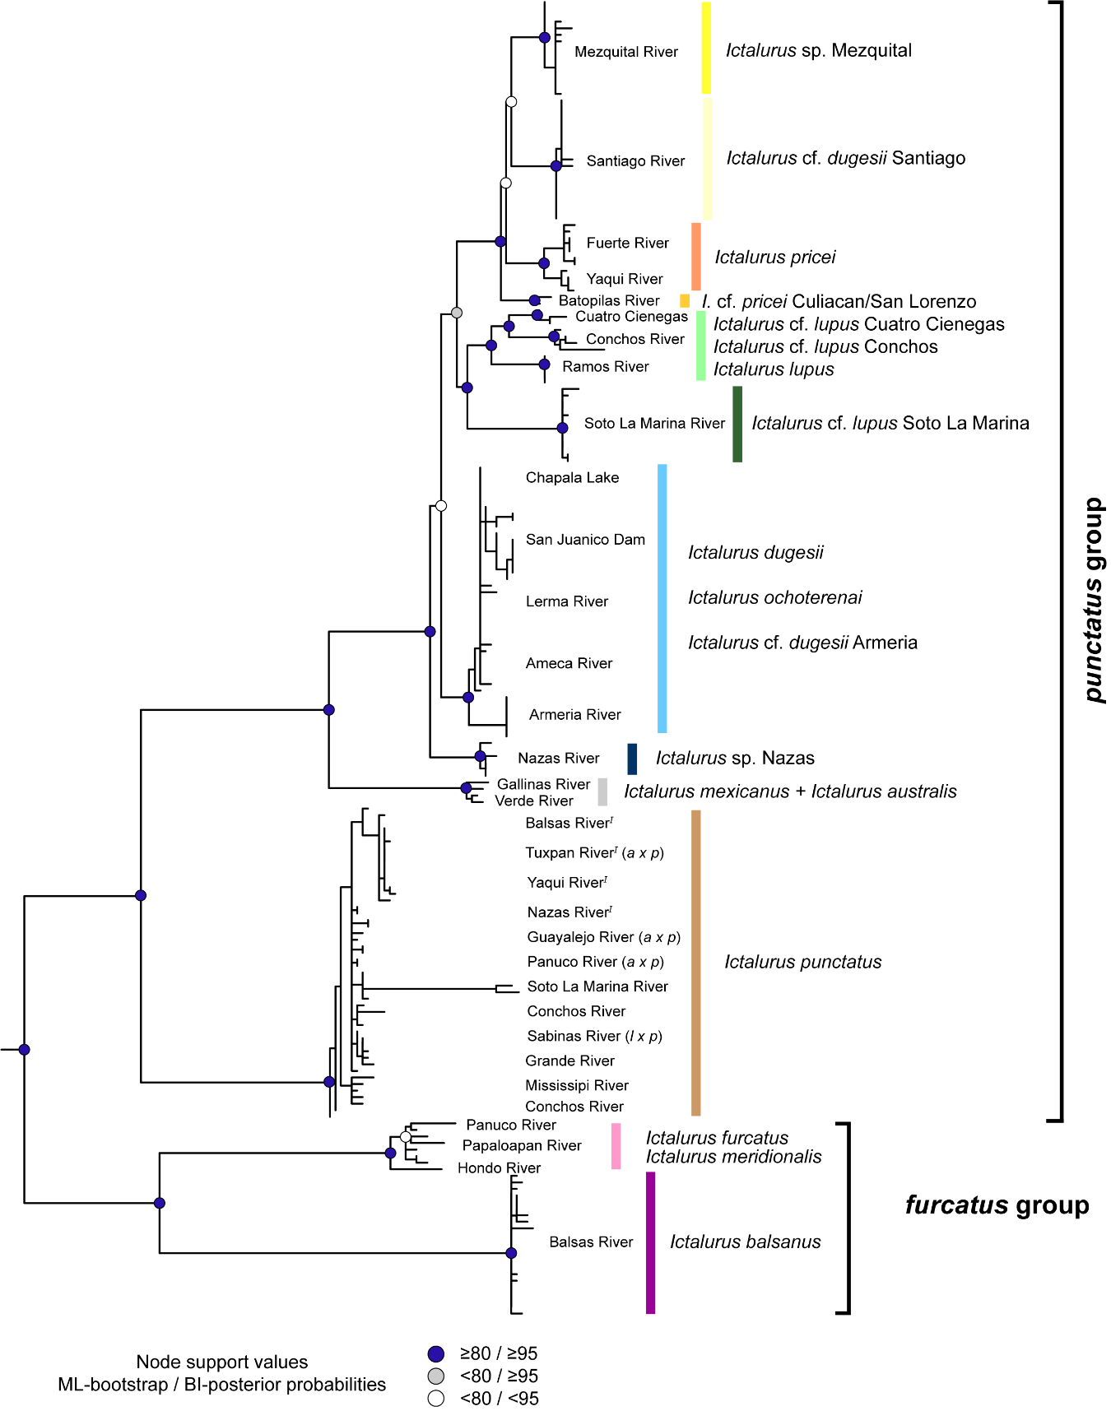
Figure S2 Maximum likelihood hypothesis of the genus Ictalurus based on the mitochondrial gene cox1. Presumed hybrid I. australis x I. punctatus (a x p) and I. lupus x I. punctatus (l x p), as well as non-native populations (^{I}) are indicated in tip labels.
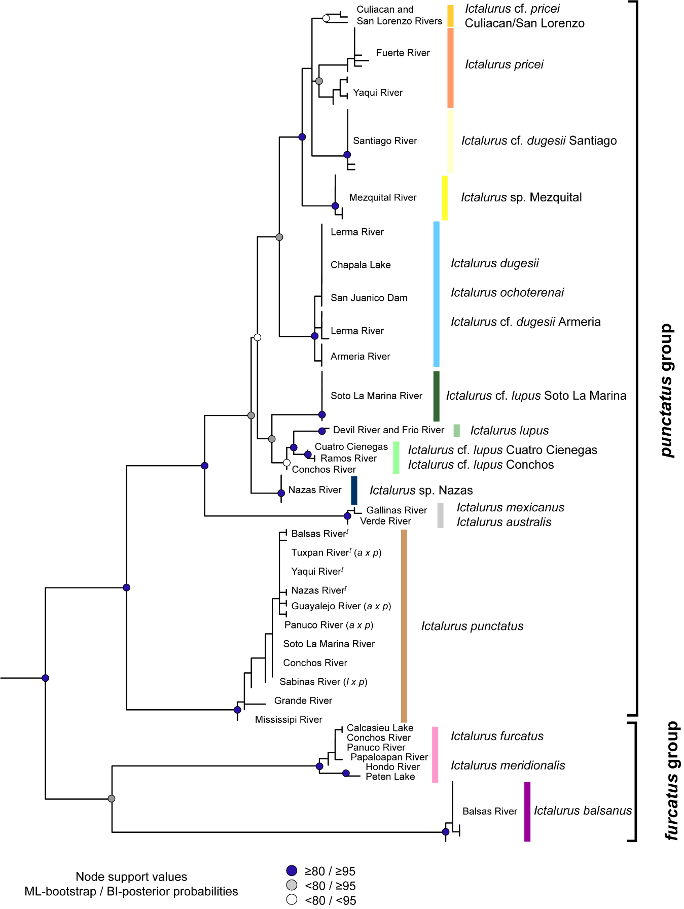
Figure S3 Maximum likelihood hypothesis of the genus Ictalurus based on the nuclear gene RAG1. Presumed hybrid I. australis x I. punctatus (a x p), as well as non-native populations (^{I}) are indicated in tip labels.
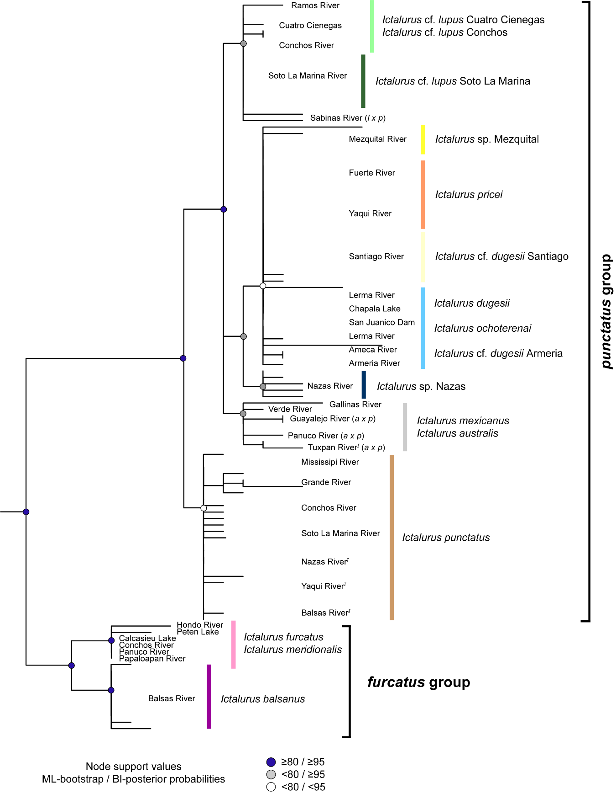
Figure S4. Maximum likelihood hypothesis of the genus Ictalurus based on the mitochondrial gene atpase8/6. Presumed hybrid I. australis x I. punctatus (a x p) and I. lupus x I. punctatus (l x p), as well as non-native populations (^{I}) are indicated in tip labels.
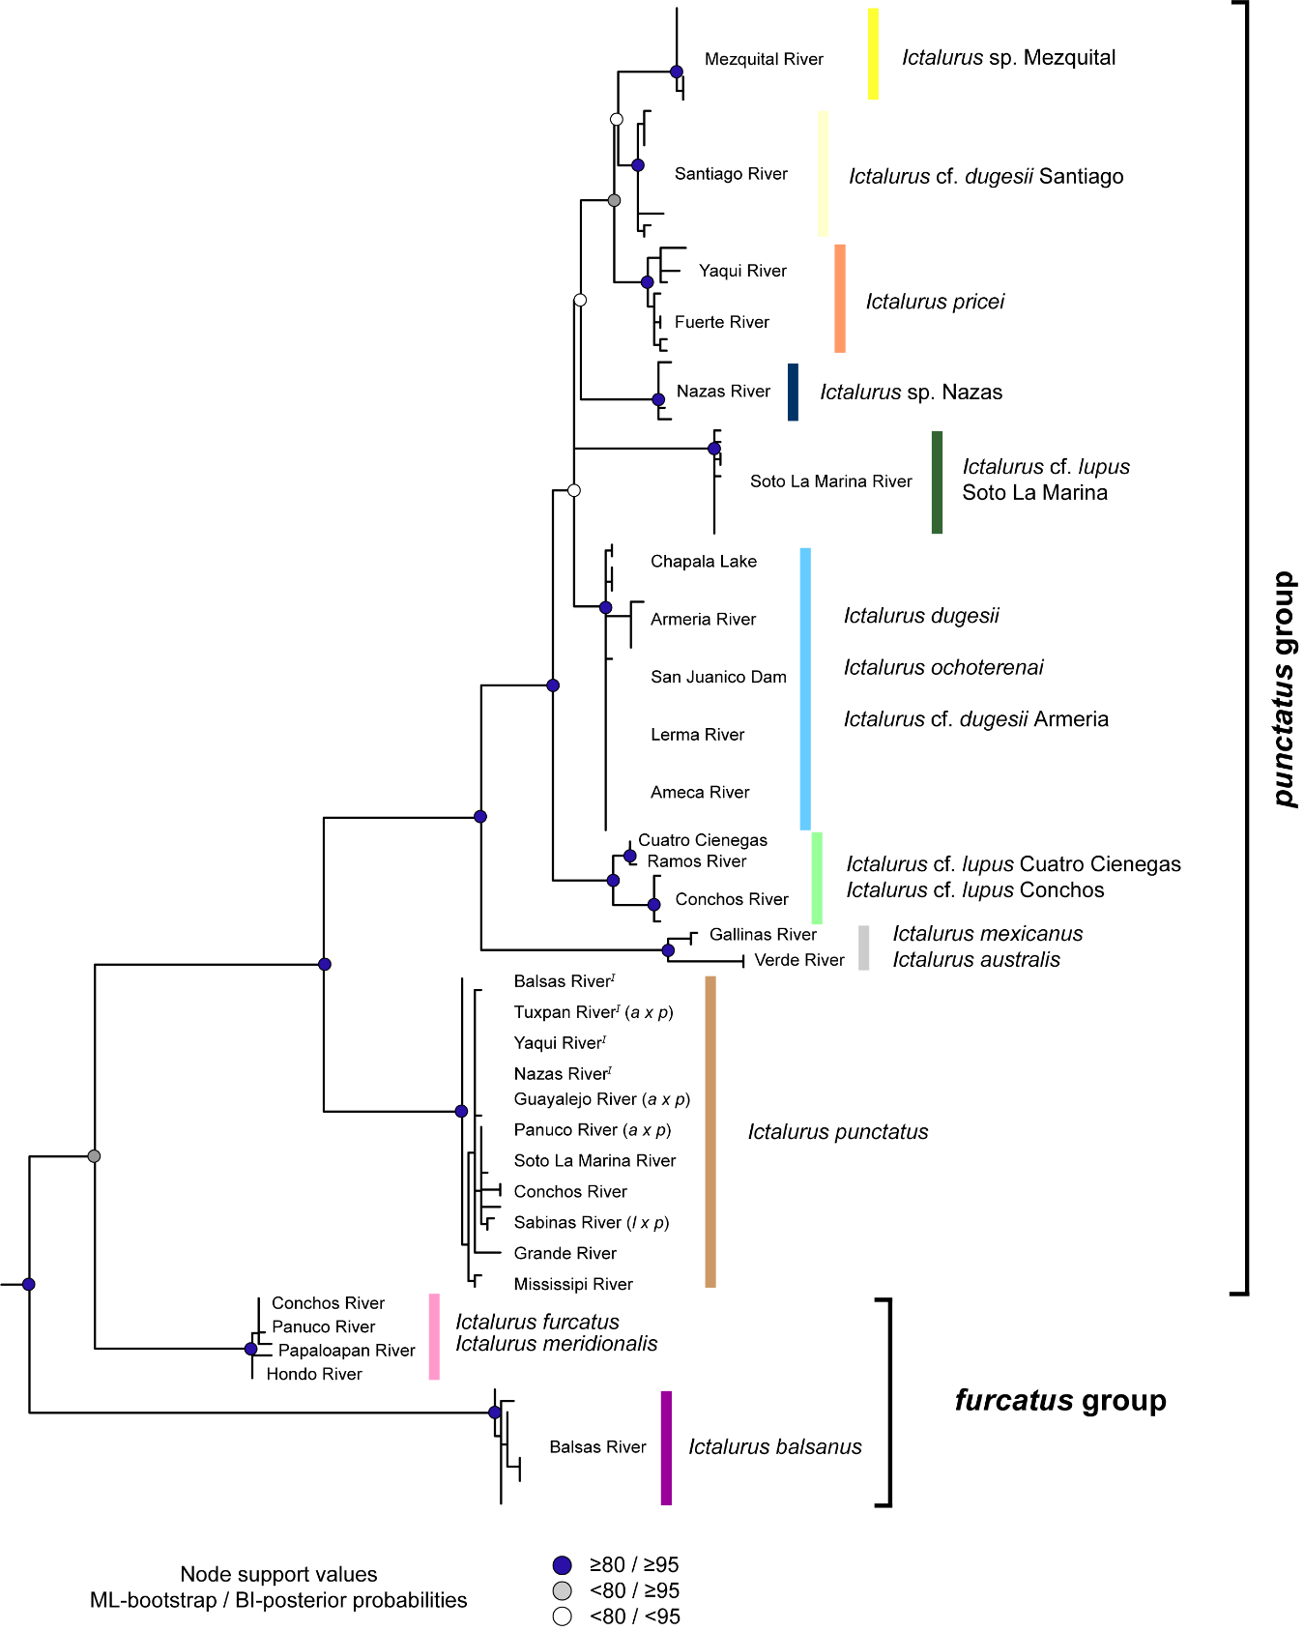

Figure S5. Time calibrated tree of the genus Ictalurus, using BEAST. Node values indicate the age in millions of years; Blue node bars correspond to the 95% highest posterior density.
