Supplementary Information:

Plasma metabolomic profiles reveal sex- and maturation-dependent metabolic strategies in sea lamprey (Petromyzon marinus)
Sonam Tamrakar^{*,1}, Belinda Huerta^{*,2}, Yu-Wen Chung-Davidson¹, Weiming Li¹

¹Michigan State University, Department of Fisheries & Wildlife, East Lansing, Michigan, U.S.A.

²Dublin City University, DCU Water Institute, School of Chemical Sciences, Dublin, Ireland

*These authors contributed equally.

E-mail for the Corresponding Author: liweim@msu.edu

The supplementary data contains:
- Detailed Methods.
- Table S1. Targeted analysis of bile acids - MRM parameters
- Fig. S1. Workflow for data processing and identification of metabolites in sea lamprey plasma during sexual maturation
- Fig. S2.PCA analyses of all groups in positive mode
- Fig. S3. PLS-DA analyses of all groups in positive mode
- Fig. S4. PLS-DA analyses of all groups in negative mode
- Table S2. PCA and PLS-DA fit and prediction parameters
- Table S3. Concentrations of plasma bile acids by targeted analyses
- Table S4. Fold change of plasma bile acids from targeted analyses in male and female sea lamprey in different maturation states
- Table S5. Pathways impacted during sexual maturation in sea lamprey
- Fig. S5. Metabolic pathway map for prespermiating and spermiating male sea lampreys
- Fig. S6. Metabolic pathway map for preovulatory and ovulatory female sea lampreys
- Fig. S7. Metabolic pathway map for ovulatory female and spermiating male sea lampreys
- Fig. S8. Metabolic pathway map for preovulatory female and prespermiating male sea lampreys

Methods:

Animals
Prespawning migratory sea lampreys were collected from Ocqueoc River in the summer of 2019 by agents of the US Geological Survey at Hammond Bay Biological Station, Great Lakes Science Center, Millersburg, Michigan, USA. Prespermiating males were visually identified and separated from preovulatory females by carefully applying pressure to the lower abdomen to feel for eggs. Ovulatory females and spermiating males were obtained by holding pre-spawning animals in cages (0.25~1.0 m³) in the lower Ocqueoc River (at US23 bridge, Millersburg, MI, USA) to induce maturation (Brant et al., 2013). They were checked daily for gamete release by applying gentle pressure to the lower abdomen. All animals were then transferred to Michigan State University where sample collections were performed immediately upon arrival. Standard operating procedures for transporting, maintaining, handling, anesthetizing, and euthanizing sea lampreys were approved by the Institutional Committee on Animal Use and Care of Michigan State University and in compliance with standards defined by the National Institutes of Health Guide for the Care and Use of Laboratory Animals (Institute for Laboratory Animal Research, 2011). All applicable international, national, and/or institutional guidelines for the care and use of animals were followed.

Optimization of untargeted analyses
Samples were analyzed on a UPLC-Q Exactive-Orbitrap system equipped with a heated electrospray ionization source (HESI). Three LC-MS/MS conditions were tested: (1) HSS T3 column (2.1 x 100 mm; 1.8 µm); solvent A: 0.1 % formic acid in water; solvent B: 0.1% formic acid in acetonitrile; solvent program: 0 min (0% B), 1 min (0% B), 11 min (99% B), 13 min (99% B), 13.01 min (0% B), and 15 min (stop); flow rate: 0.3 ml/min; column temperature: 40°C; injection volume: 10 µl; mass range: 80~1200; acquisition mode: DDA, (2) HSS T3 column (2.1 x 100 mm; 1.8 µm); solvent A: 10 mM ammonium formate in water; solvent B: 10 mM ammonium formate in IPA: acetonitrile (90:10) with 0.1% formic acid; solvent program: 0 min (0% B), 1 min (0% B), 11 min (99% B), 13 min (99% B), 13.01 min (0% B), and 15 min (stop); flow rate: 0.3 ml/min; column temperature: 55°C; injection volume: 10 µl; mass range: 80~1200; acquisition mode: DDA, and (3) BEH C18 column (2.1 x 100 mm; 1.7 µm); solvent A: 10 mM ammonium acetate in water; solvent B: acetonitrile; solvent program: 0 min (5% B), 1 min (38% B), 7 min (55% B), 10 min (70% B), 15 min (95% B), 18 min (100% B), 18.5 min (5% B), and 20 min (stop); flow rate: 0.3 ml/min; column temperature: 55°C; injection volume: 10 µl; mass range: 80~1200; acquisition mode: DDA. Chromatographic separations were optimized using a modified condition (3). The injection volume was 10 µl. The mobile phase gradient was maintained as follows: 0 min (5% B), 5 min (38% B); 7 min (55% B); 10 min (70% B); 16 min (95% B); 21 min (100% B); and 21.5~25 min (5% B). The flow rate was maintained at 0.3 ml/min and the column temperature at 55 °C throughout the analysis. Samples were analyzed in both positive and negative ionization modes using the full scan MS with data dependent (dd)-MS2 acquisition mode. The Orbitrap parameters for the full scan acquisition were set as follows: resolution 17,500, AGC target 3e⁶, maximum injection time (IT) 50 ms, and scan range 80 to 1200 m/z. The parameters for dd-MS2 were set as follows: resolution 17,500, AGC target 1e⁵, maximum injection time (IT) 50 ms, scan range 200 to 2000 m/z, and normalized collision energy 10, 30 and 60. Source parameters were as follows: sheath gas flow rate 48 AU, spray voltage 3.5 kV, capillary temperature 256 °C, auxiliary gas flow rate 11, sweep gas flow rate 2, and auxiliary gas heater temperature 413 °C.

Table S1. Targeted analysis of bile acids - MRM parameters

Metabolite | Ionization | Precursor ion | Product ion | Cone (V) | Collision (V)
3kPZS | - | 471.29 | 96.97 | 10 | 48
PZS | - | 473.35 | 96.82 | 62 | 49
PAMS-24 | - | 623.48 | 96.55 | 10 | 62
ACA | - | 407.35 | 361.23 | 62 | 36
3kACA | - | 405.34 | 361.23 | 10 | 23
CA | - | 407.18 | 343.12 | 49 | 36
DCA | - | 391.18 | 345.12 | 36 | 36
TCDCA | - | 498.20 | 79.65 | 62 | 62

Fig. S1. Workflow for data processing and identification of metabolites in sea lamprey plasma
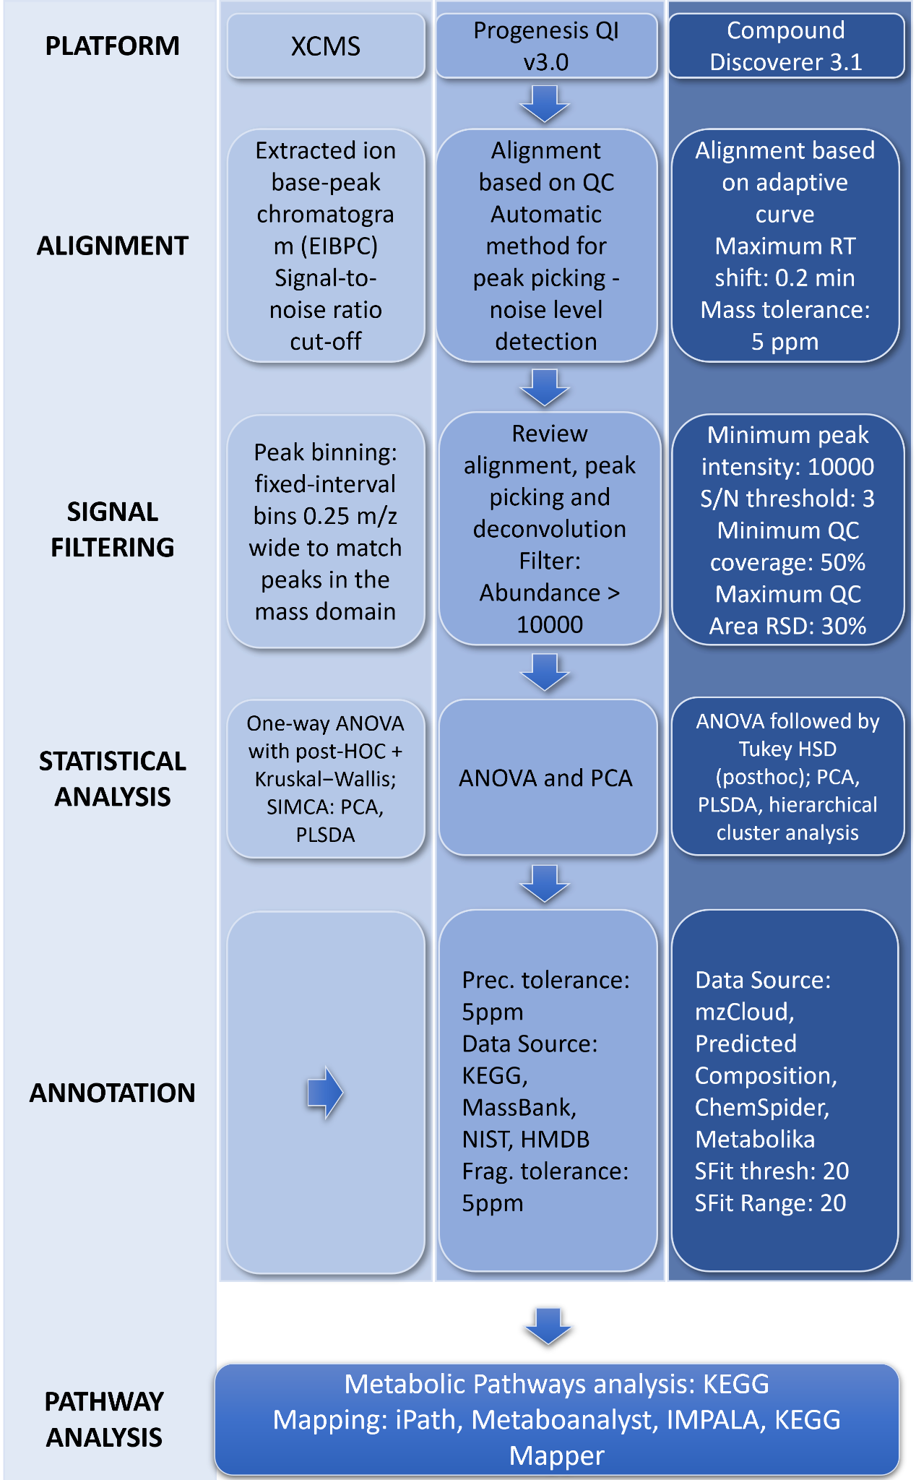
Fig. S2. PCA score plot of metabolic fingerprints in the positive mode: (a) prespermiating males (PSM) vs. spermiating males (SM); (b) preovulatory females (POF) vs. ovulatory females (OF); (c) OF vs. SM; (d) POF vs. PSM. Blue circles: PSM; purple circles: SM; yellow circles: QC males; pink circles: POF; red circles: OF; green circles: QC females.

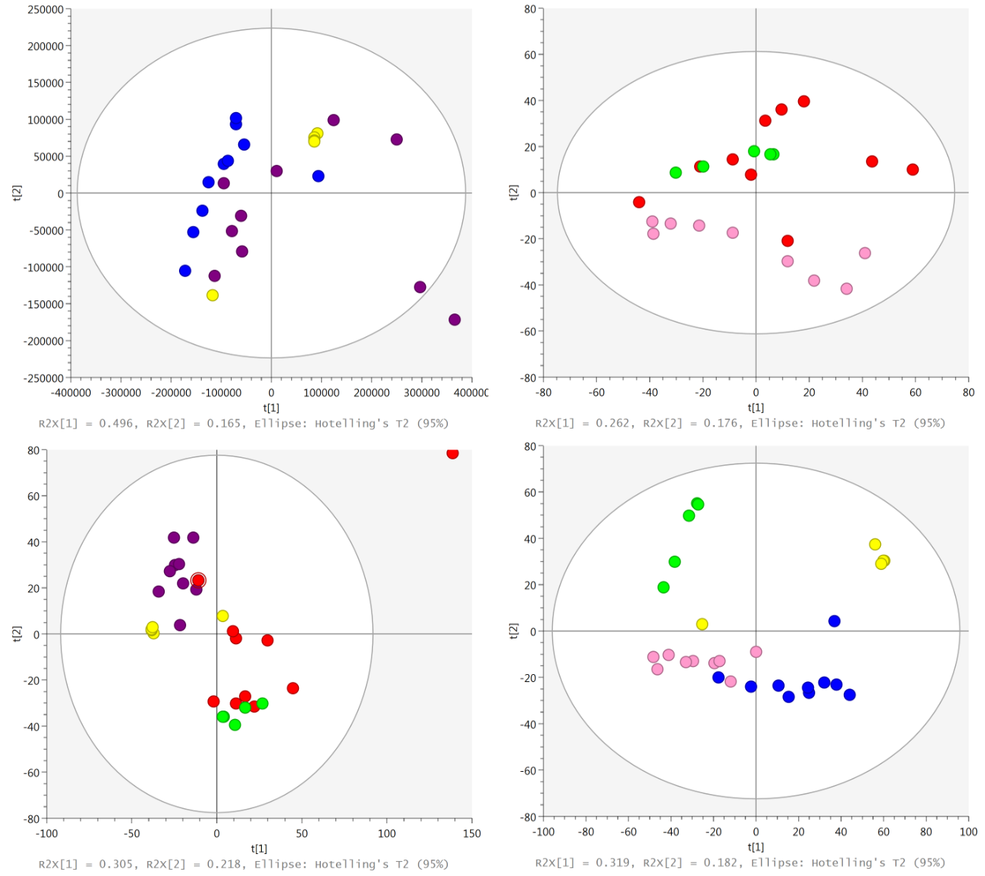

Fig. S3. PLS-DA plot of metabolic fingerprints in the positive mode: (a) prespermiating males (PSM) vs. spermiating males (SM); (b) preovulatory females (POF) vs. ovulatory females (OF); (c) OF vs. SM; (d) POF vs. PSM. Blue circles: PSM; purple circles: SM; yellow circles: QC males; pink circles: POF; red circles: OF; green circles: QC females.

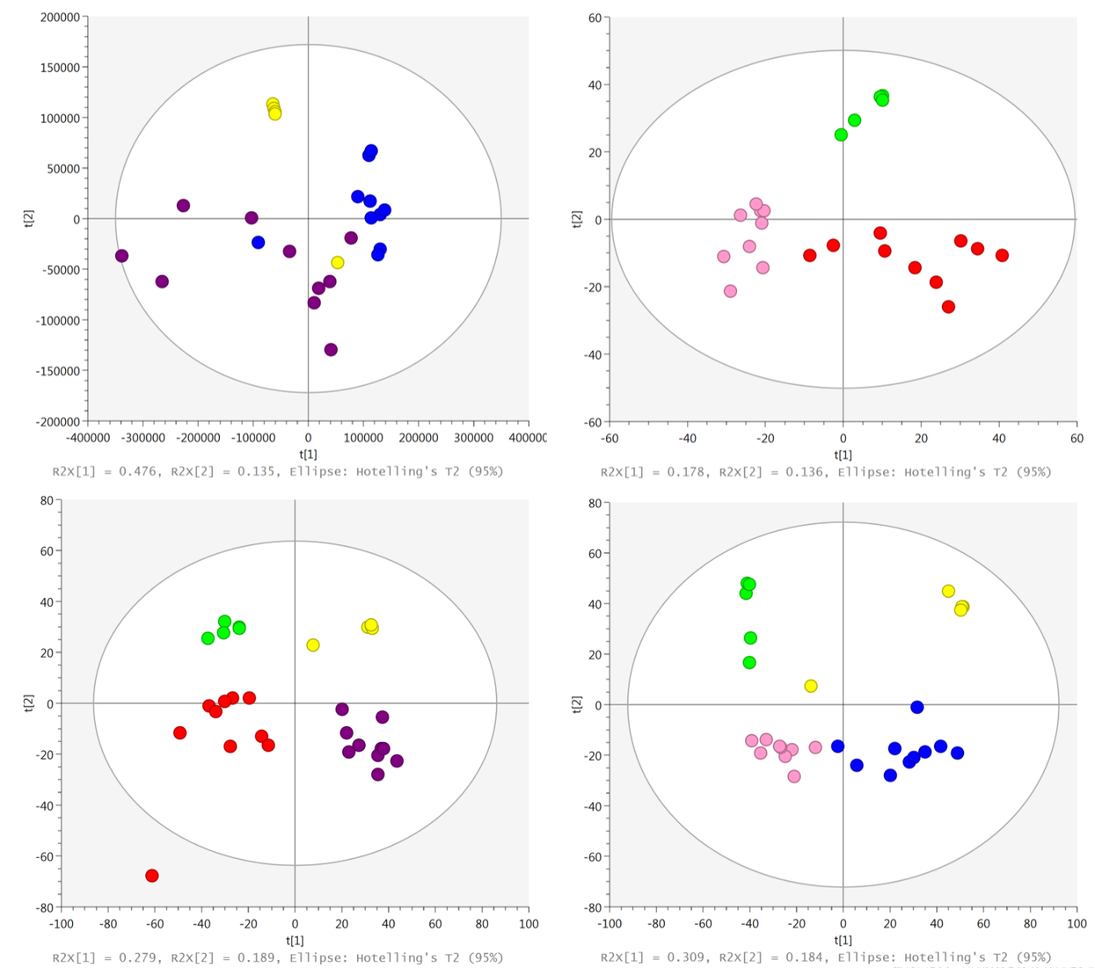

Fig. S4. PLS-DA plot of metabolic fingerprints in the negative mode: (a) prespermiating males (PSM) vs. spermiating males (SM); (b) preovulatory females (POF) vs. ovulatory females (OF); (c) OF vs. SM; (d) POF vs. PSM. Blue circles: PSM; purple circles: SM; yellow circles: QC males; pink circles: POF; red circles: OF; green circles: QC females.

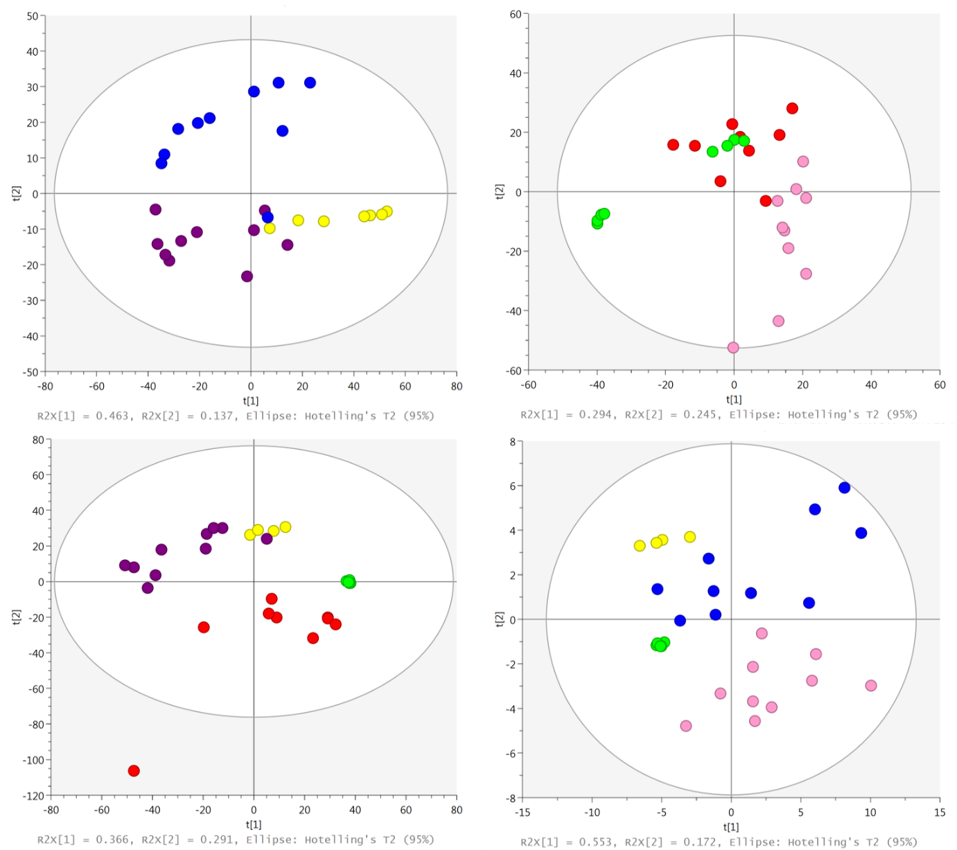

Table S2. PCA and PLS-DA fit and prediction parameters
Group | Plot | R2X | R2Y | Q2
POF vs OF (+) | PCA | 0.614 | - | 0.375
POF vs OF (-) | PCA | 0.715 | - | 0.505
PSM vs SM (+) | PCA | 0.799 | - | 0.587
PSM vs SM (-) | PCA | 0.69 | - | 0.574
OF vs SM (+) | PCA | 0.768 | - | 0.454
OF vs SM (-) | PCA | 0.751 | - | 0.562
POF vs PSM (+) | PCA | 0.767 | - | 0.598
POF vs PSM (-) | PCA | 0.917 | - | 0.793
POF vs OF (+) | PLS-DA | 0.619 | 0.974 | 0.849
POF vs OF (-) | PLS-DA | 0.687 | 0.964 | 0.832
PSM vs SM (+) | PLS-DA | 0.818 | 0.896 | 0.521
PSM vs SM (-) | PLS-DA | 0.737 | 0.97 | 0.768
OF vs SM (+) | PLS-DA | 0.842 | 0.986 | 0.884
OF vs SM (-) | PLS-DA | 0.737 | 0.974 | 0.857
POF vs PSM (+) | PLS-DA | 0.577 | 0.861 | 0.768
POF vs PSM (-) | PLS-DA | 0.925 | 0.951 | 0.796

Table S3. Concentration of plasma bile acids from targeted analysis in male and female sea lamprey in different maturation states
Metabolites | PSM | SM | POF | OF
3kPZS | 83.1 | 2251.21 | 0.27 | 1.14
PZS | 2043.73 | 19270.3 | 3.55 | 44.25
PAMS-24 | 1172.58 | 2595.91 | 1.35 | 5.58
ACA | 1035.64 | 2076.56 | 13.93 | 25.21
3kACA | 25.34 | 2536.18 | 0.81 | 15.9
CA | 2.05 | 111.04 | 0.9 | 1.4
DCA | 5.76 | 163.35 | 0.22 | 2.57
TCDCA | 3.37 | 0.76 | 1.95 | 1.24
All the concentrations are in ng/ml of plasma. POF: preovulatory females; OF: ovulatory females; PSM: prespermiating males; SM: spermiating males.

Table S4. Fold change of plasma bile acids from targeted analyses comparing male and female sea lamprey in different maturation states
Group | Metabolite | Regulation | FC
PSM vs SM | 3kPZS | ↑ | 23.99
PSM vs SM | PZS | ↑ | 8.63
PSM vs SM | PAMS-24 | ↑ | 1.75
PSM vs SM | ACA | ↑ | 87.44
PSM vs SM | 3kACA | ↑ | 42.05
PSM vs SM | CA | ↑ | 36.20
PSM vs SM | DCA | ↓ | 1.19
PSM vs SM | TCDCA | ↓ | 2.02
POF vs OF | 3kPZS | ↑ | 4.31
POF vs OF | PZS | ↑ | 11.78
POF vs OF | PAMS-24 | ↑ | 1.69
POF vs OF | ACA | ↑ | 15.41
POF vs OF | 3kACA | ↑ | 1.20
POF vs OF | CA | ↑ | 11.72
POF vs OF | DCA | ↑ | 1.00
POF vs OF | TCDCA | ↓ | 2.58
OF vs SM | 3kPZS | ↑ | 59.10
OF vs SM | PZS | ↑ | 387.76
OF vs SM | PAMS-24 | ↑ | 71.02
OF vs SM | ACA | ↑ | 137.93
OF vs SM | 3kACA | ↑ | 82.70
OF vs SM | CA | ↑ | 62.69
OF vs SM | DCA | ↑ | 1.03
OF vs SM | TCDCA | ↑ | 4.26
POF vs PSM | 3kPZS | ↑ | 254.64
POF vs PSM | PZS | ↑ | 529.34
POF vs PSM | PAMS-24 | ↑ | 68.58
POF vs PSM | ACA | ↑ | 24.31
POF vs PSM | 3kACA | ↑ | 2.35
POF vs PSM | CA | ↑ | 22.98
POF vs PSM | DCA | ↑ | 1.16
POF vs PSM | TCDCA | ↑ | 3.34
Down regulation (↓) in intra-sex comparison groups means the expression of metabolite is lower in the mature sea lamprey than the immature ones. Down regulation (↓) in inter-sex comparison groups means the expression of metabolites in females is greater than in males. Up regulation (↑) in intra-sex comparison groups means the expression of metabolites in mature sea lamprey is greater than the immature ones. Up regulation (↑) in inter-sex comparison groups means the expression of metabolites in males is greater than in females. POF: preovulatory females; OF: ovulatory females; PSM: prespermiating males; SM: spermiating males.

Table S5. List of metabolic pathways impacted according to the MetaboAnalyst 5.0 platform. Total is the total number of compounds in the pathway; the Hits is the actually matched number from the user uploaded data; the Raw p is the original p value calculated from the enrichment analysis; the Holm p is the p value adjusted by Holm-Bonferroni method; the FDR p is the p value adjusted using False Discovery Rate; the Impact is the pathway impact value calculated from pathway topology analysis. In bold and cursive: pathways impacted at a value > 0.15. POF: preovulatory females; OF: ovulatory females; PSM: prespermiating males; SM: spermiating males.
 |  | Total | Expected | Hits | Raw p | log p | Holm adjust | FDR | Impact
PSM vs SM | D-Glutamine and D-glutamate metabolism | 6 | 0.073548 | 3 | 0.00003 | 4.51480 | 0.00257 | 0.00257 | 1.00000
PSM vs SM | Arginine biosynthesis | 14 | 0.17161 | 3 | 0.00052 | 3.28180 | 0.04338 | 0.02195 | 0.25380
PSM vs SM | Histidine metabolism | 16 | 0.19613 | 3 | 0.00079 | 3.10150 | 0.06492 | 0.02217 | 0.04918
PSM vs SM | Arginine and proline metabolism | 38 | 0.46581 | 3 | 0.01005 | 1.99790 | 0.81400 | 0.21104 | 0.25449
PSM vs SM | Aminoacyl-tRNA biosynthesis | 48 | 0.58839 | 3 | 0.01906 | 1.71980 | 1 | 0.32025 | 0.00000
PSM vs SM | Glutathione metabolism | 28 | 0.34323 | 2 | 0.04453 | 1.35140 | 1 | 0.47139 | 0.01966
PSM vs SM | Alanine, aspartate, and glutamate metabolism | 28 | 0.34323 | 2 | 0.04453 | 1.35140 | 1 | 0.47139 | 0.19712
PSM vs SM | Phenylalanine, tyrosine, and tryptophan biosynthesis | 4 | 0.049032 | 1 | 0.04818 | 1.31710 | 1 | 0.47139 | 0.50000
PSM vs SM | Porphyrin and chlorophyll metabolism | 30 | 0.36774 | 2 | 0.05051 | 1.29670 | 1 | 0.47139 | 0.07465
PSM vs SM | Glyoxylate and dicarboxylate metabolism | 32 | 0.39226 | 2 | 0.05676 | 1.24600 | 1 | 0.47678 | 0.03175
PSM vs SM | Nitrogen metabolism | 6 | 0.073548 | 1 | 0.07144 | 1.14600 | 1 | 0.54556 | 0.00000
PSM vs SM | Ubiquinone and other terpenoid-quinone biosynthesis | 9 | 0.11032 | 1 | 0.10532 | 0.97747 | 1 | 0.73727 | 0.00000
PSM vs SM | Phenylalanine metabolism | 10 | 0.12258 | 1 | 0.11636 | 0.93421 | 1 | 0.75183 | 0.00000
PSM vs SM | Butanoate metabolism | 15 | 0.18387 | 1 | 0.16960 | 0.77056 | 1 | 1 | 0.00000
PSM vs SM | Purine metabolism | 65 | 0.79677 | 2 | 0.18784 | 0.72621 | 1 | 1 | 0.02179
PSM vs SM | Citrate cycle (TCA cycle) | 20 | 0.24516 | 1 | 0.21980 | 0.65796 | 1 | 1 | 0.09038
PSM vs SM | beta-Alanine metabolism | 21 | 0.25742 | 1 | 0.22949 | 0.63923 | 1 | 1 | 0.00000
PSM vs SM | Propanoate metabolism | 23 | 0.28194 | 1 | 0.24853 | 0.60462 | 1 | 1 | 0.00000
PSM vs SM | Lysine degradation | 25 | 0.30645 | 1 | 0.26712 | 0.57329 | 1 | 1 | 0.14085
PSM vs SM | Tyrosine metabolism | 42 | 0.51484 | 1 | 0.40847 | 0.38884 | 1 | 1 | 0.13972
PSM vs SM | Primary bile acid biosynthesis | 46 | 0.56387 | 1 | 0.43775 | 0.35877 | 1 | 1 | 0.00000
POF vs OF | Glycine, serine, and threonine metabolism | 33 | 0.38323 | 2 | 0.054382 | 1.2645 | 1 | 1 | 0.0242
POF vs OF | Glycerolipid metabolism | 16 | 0.18581 | 1 | 0.17123 | 0.76643 | 1 | 1 | 0.09346
POF vs OF | Pantothenate and CoA biosynthesis | 19 | 0.22065 | 1 | 0.20008 | 0.6988 | 1 | 1 | 0.02857
POF vs OF | beta-Alanine metabolism | 21 | 0.24387 | 1 | 0.21878 | 0.65998 | 1 | 1 | 0.10448
POF vs OF | Pentose phosphate pathway | 22 | 0.25548 | 1 | 0.22798 | 0.6421 | 1 | 1 | 0
POF vs OF | Alanine, aspartate, and glutamate metabolism | 28 | 0.32516 | 1 | 0.28105 | 0.55122 | 1 | 1 | 0
POF vs OF | Glyoxylate and dicarboxylate metabolism | 32 | 0.37161 | 1 | 0.31449 | 0.50239 | 1 | 1 | 0.07937
POF vs OF | Cysteine and methionine metabolism | 33 | 0.38323 | 1 | 0.32262 | 0.4913 | 1 | 1 | 0.10446
POF vs OF | Biosynthesis of unsaturated fatty acids | 36 | 0.41806 | 1 | 0.34647 | 0.46034 | 1 | 1 | 0
POF vs OF | Arginine and proline metabolism | 38 | 0.44129 | 1 | 0.36192 | 0.44139 | 1 | 1 | 0.01212
POF vs OF | Fatty acid elongation | 39 | 0.4529 | 1 | 0.36951 | 0.43237 | 1 | 1 | 0
POF vs OF | Fatty acid degradation | 39 | 0.4529 | 1 | 0.36951 | 0.43237 | 1 | 1 | 0
POF vs OF | Pyrimidine metabolism | 39 | 0.4529 | 1 | 0.36951 | 0.43237 | 1 | 1 | 0.01318
POF vs OF | Valine, leucine, and isoleucine degradation | 40 | 0.46452 | 1 | 0.37703 | 0.42363 | 1 | 1 | 0.02264
POF vs OF | Fatty acid biosynthesis | 47 | 0.54581 | 1 | 0.42728 | 0.36928 | 1 | 1 | 0.01473
POF vs OF | Aminoacyl-tRNA biosynthesis | 48 | 0.55742 | 1 | 0.43414 | 0.36237 | 1 | 1 | 0
OF vs SM | Riboflavin metabolism | 4 | 0.025806 | 1 | 0.025582 | 1.5921 | 1 | 1 | 0.5
OF vs SM | Citrate cycle (TCA cycle) | 20 | 0.12903 | 1 | 0.12213 | 0.91319 | 1 | 1 | 0.04498
OF vs SM | Glyoxylate and dicarboxylate metabolism | 32 | 0.20645 | 1 | 0.18879 | 0.72402 | 1 | 1 | 0
OF vs SM | Glycine, serine, and threonine metabolism | 33 | 0.2129 | 1 | 0.19413 | 0.7119 | 1 | 1 | 0
OF vs SM | Arginine and proline metabolism | 38 | 0.24516 | 1 | 0.22038 | 0.65683 | 1 | 1 | 0.01212
OF vs SM | Pyrimidine metabolism | 39 | 0.25161 | 1 | 0.22554 | 0.64678 | 1 | 1 | 0.01584
OF vs SM | Primary bile acid biosynthesis | 46 | 0.29677 | 1 | 0.26078 | 0.58373 | 1 | 1 | 0
OF vs SM | Purine metabolism | 65 | 0.41935 | 1 | 0.34928 | 0.45682 | 1 | 1 | 0.00528
POF vs SM | Riboflavin metabolism | 4 | 0.020645 | 1 | 0.020506 | 1.6881 | 1 | 1 | 0.5
POF vs SM | Tryptophan metabolism | 41 | 0.21161 | 1 | 0.19342 | 0.71349 | 1 | 1 | 0.14305
POF vs SM | Tyrosine metabolism | 42 | 0.21677 | 1 | 0.1977 | 0.704 | 1 | 1 | 0.02463
POF vs SM | Aminoacyl-tRNA biosynthesis | 48 | 0.24774 | 1 | 0.22294 | 0.65181 | 1 | 1 | 0
POF vs SM | Purine metabolism | 65 | 0.33548 | 1 | 0.29073 | 0.53651 | 1 | 1 | 0.00528

Fig. S5. Metabolic pathway map comparing plasma metabolomes in prespermiating and spermiating male sea lampreys
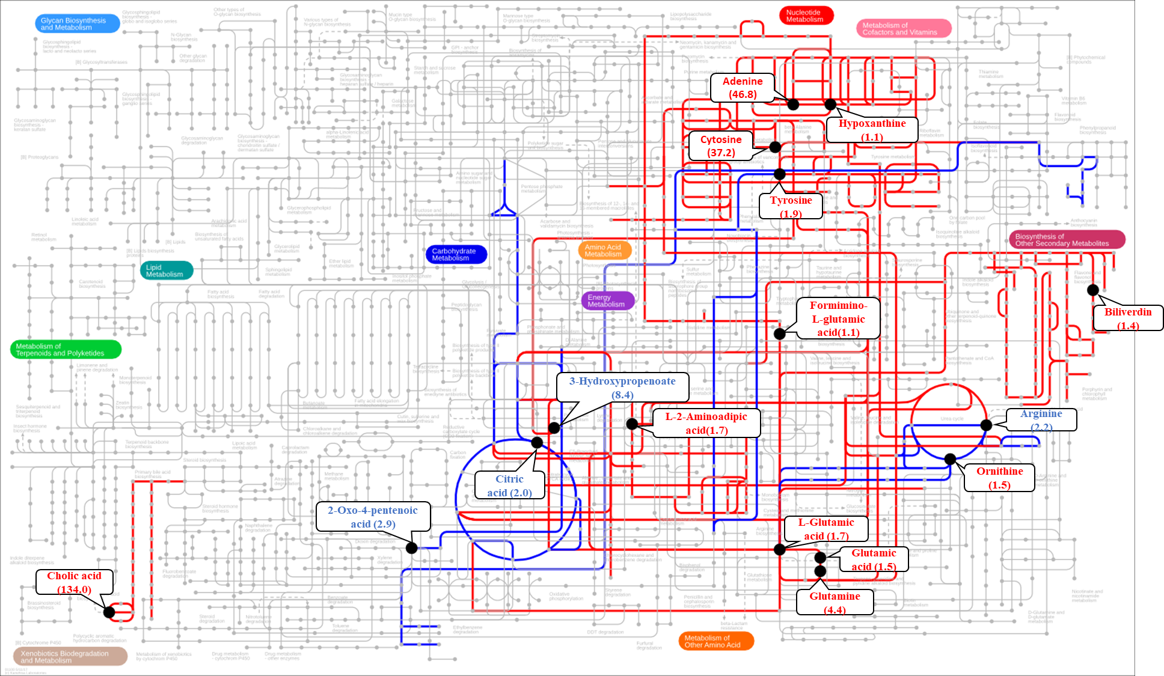
The black nodes represent the most discriminant metabolites in the group. The red and blue edges represent the upregulated and downregulated pathways respectively. The numbers in the bracket indicate the fold change. The map has been generated using Interactive Pathways Explorer (iPath) v3.

Fig. S6. Metabolic pathway map comparing plasma metabolomes of preovulatory and ovulatory female sea lampreys
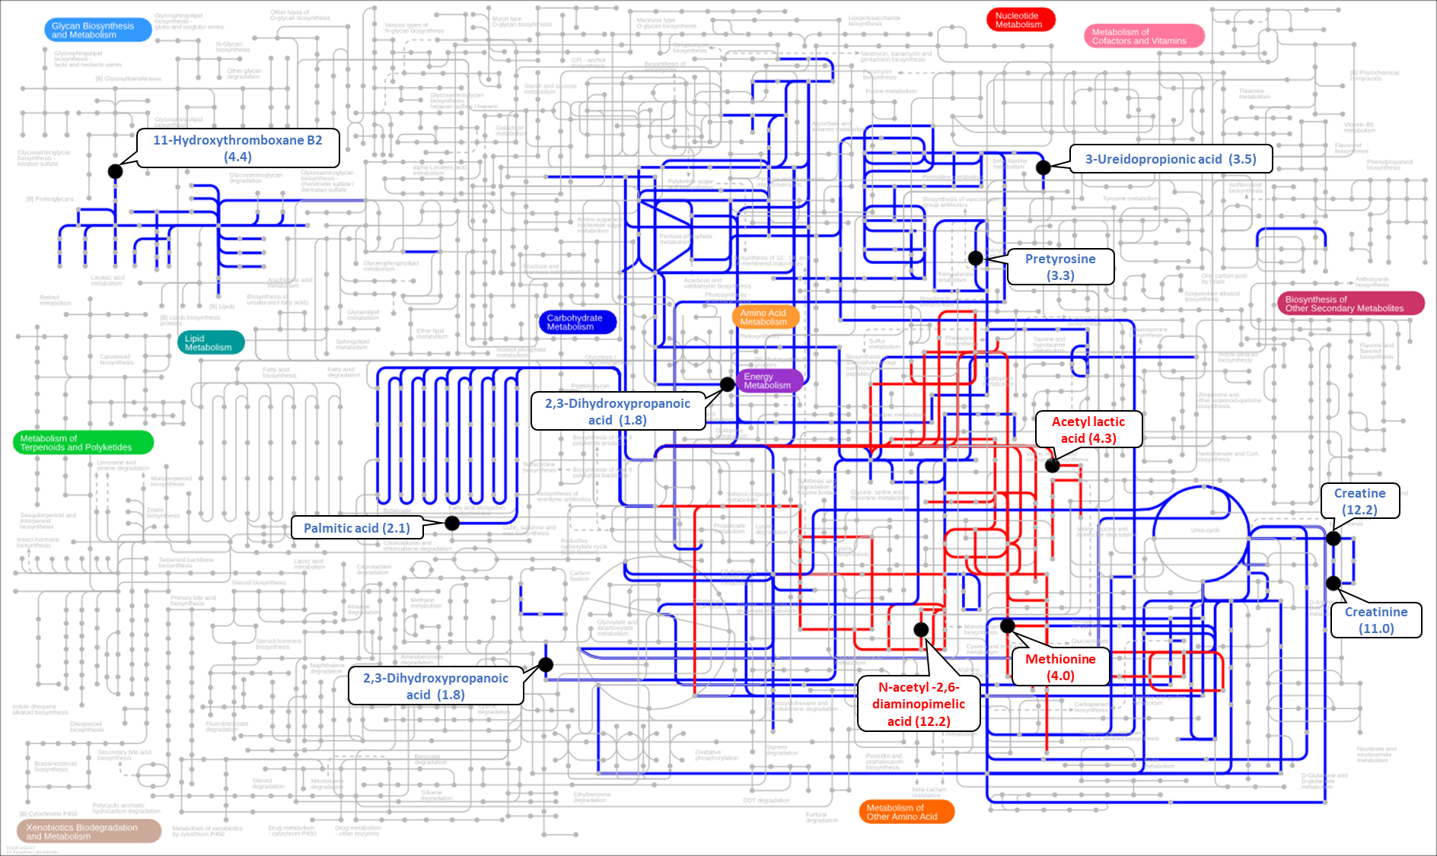
The black nodes represent the most discriminant metabolites in the group. The red and blue edges represent the upregulated and downregulated pathways respectively. The numbers in the bracket indicate the fold change. The map has been generated using Interactive Pathways Explorer (iPath) v3.

Fig. S7. Metabolic pathway map comparing plasma metabolomes of ovulatory female and spermiating male sea lampreys
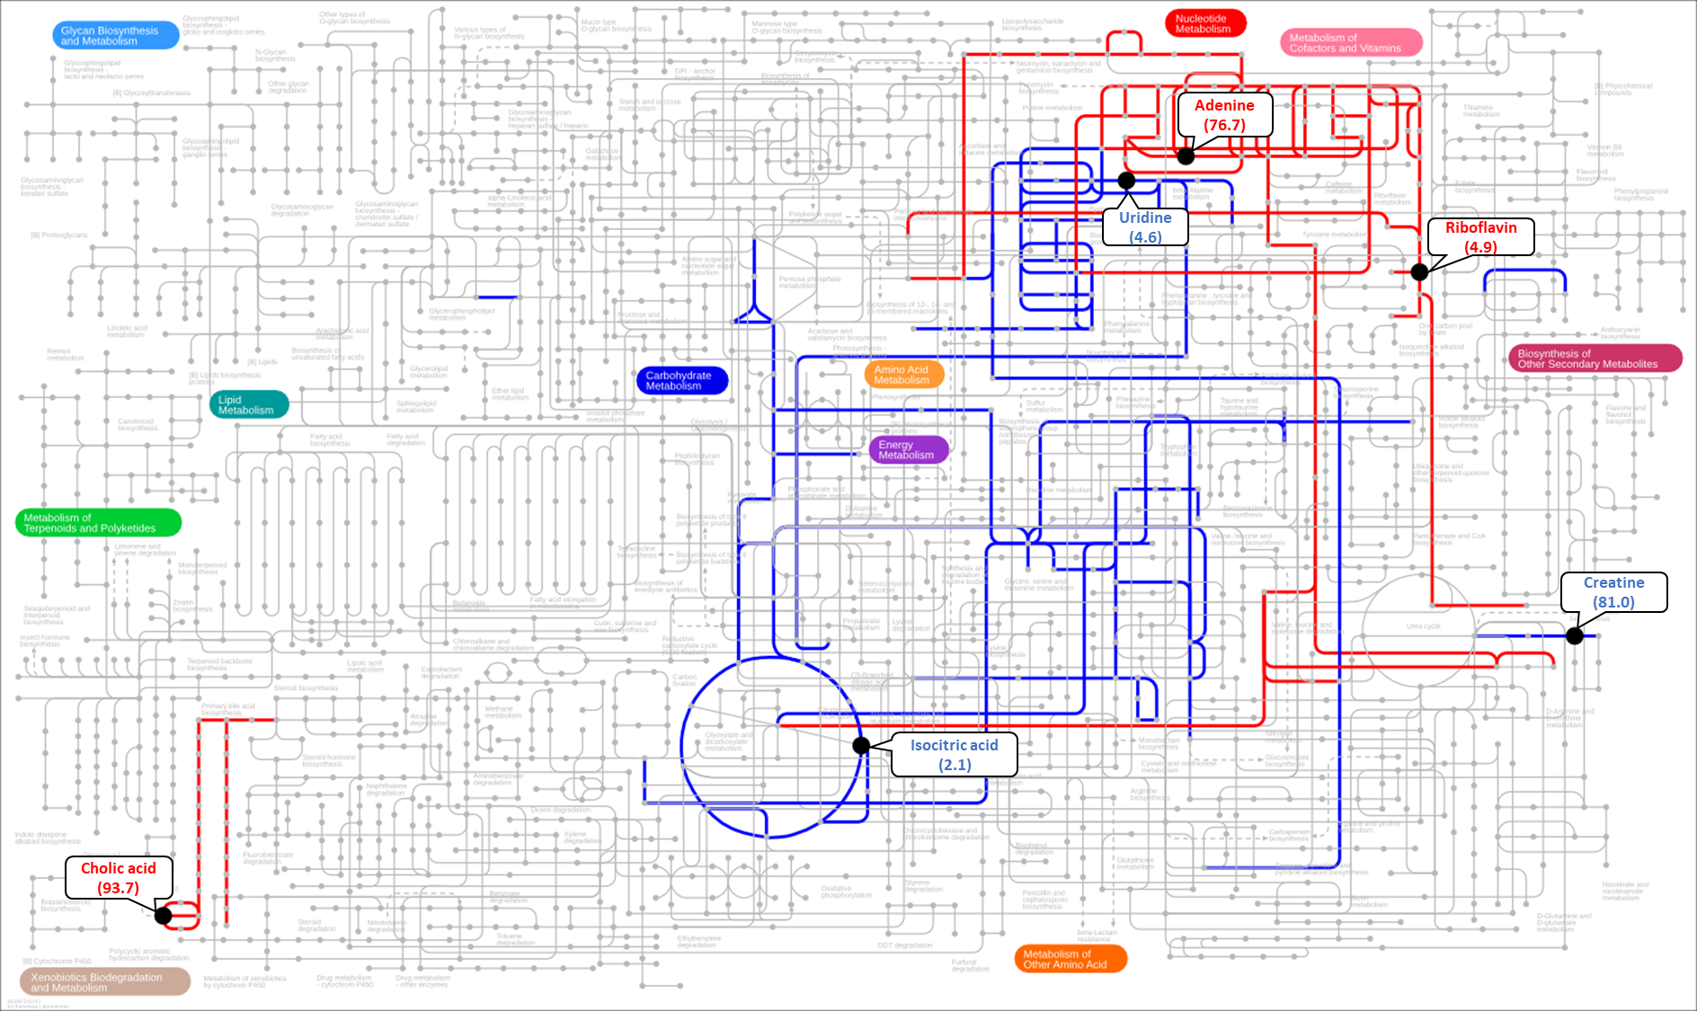
The black nodes represent the most discriminant metabolites in the group. The red and blue edges represent the upregulated and downregulated pathways respectively. The numbers in the bracket indicate the fold change. The map has been generated using Interactive Pathways Explorer (iPath) v3.
Fig. S8. Metabolic pathway map comparing plasma metabolomes of preovulatory female and prespermiating male sea lampreys
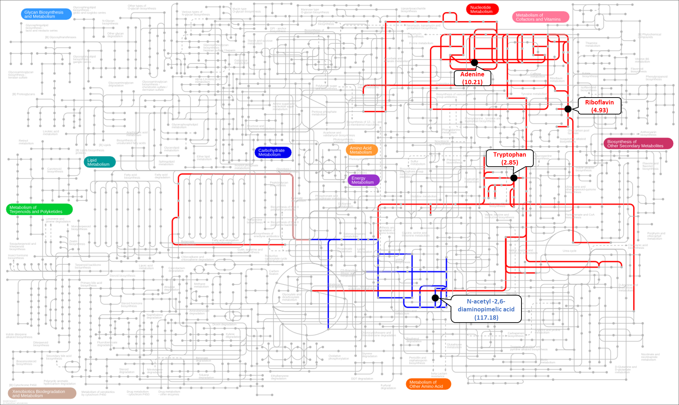
The black nodes represent the most discriminant metabolites in the group. The red and blue edges represent the upregulated and downregulated pathways respectively. The numbers in the bracket indicate the fold change. The map has been generated using Interactive Pathways Explorer (iPath) v3.

