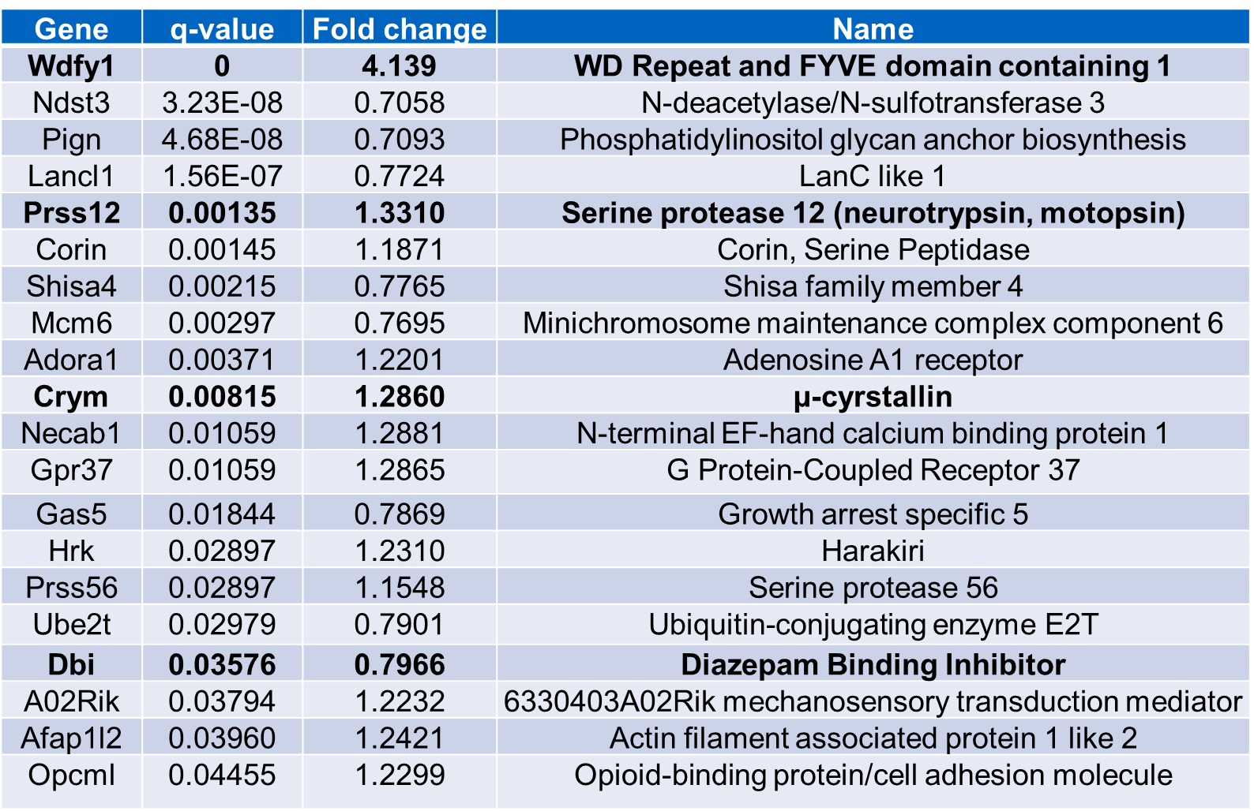

Table 1: Genes whose expression levels in the E15.5 brain are significantly altered by loss of ErbB4. Genes analyzed by qRT-PCR are shown in bold.

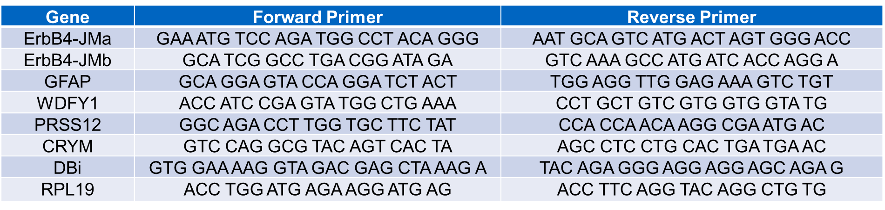
Table 2: List of primers used for qRT-PCR.

